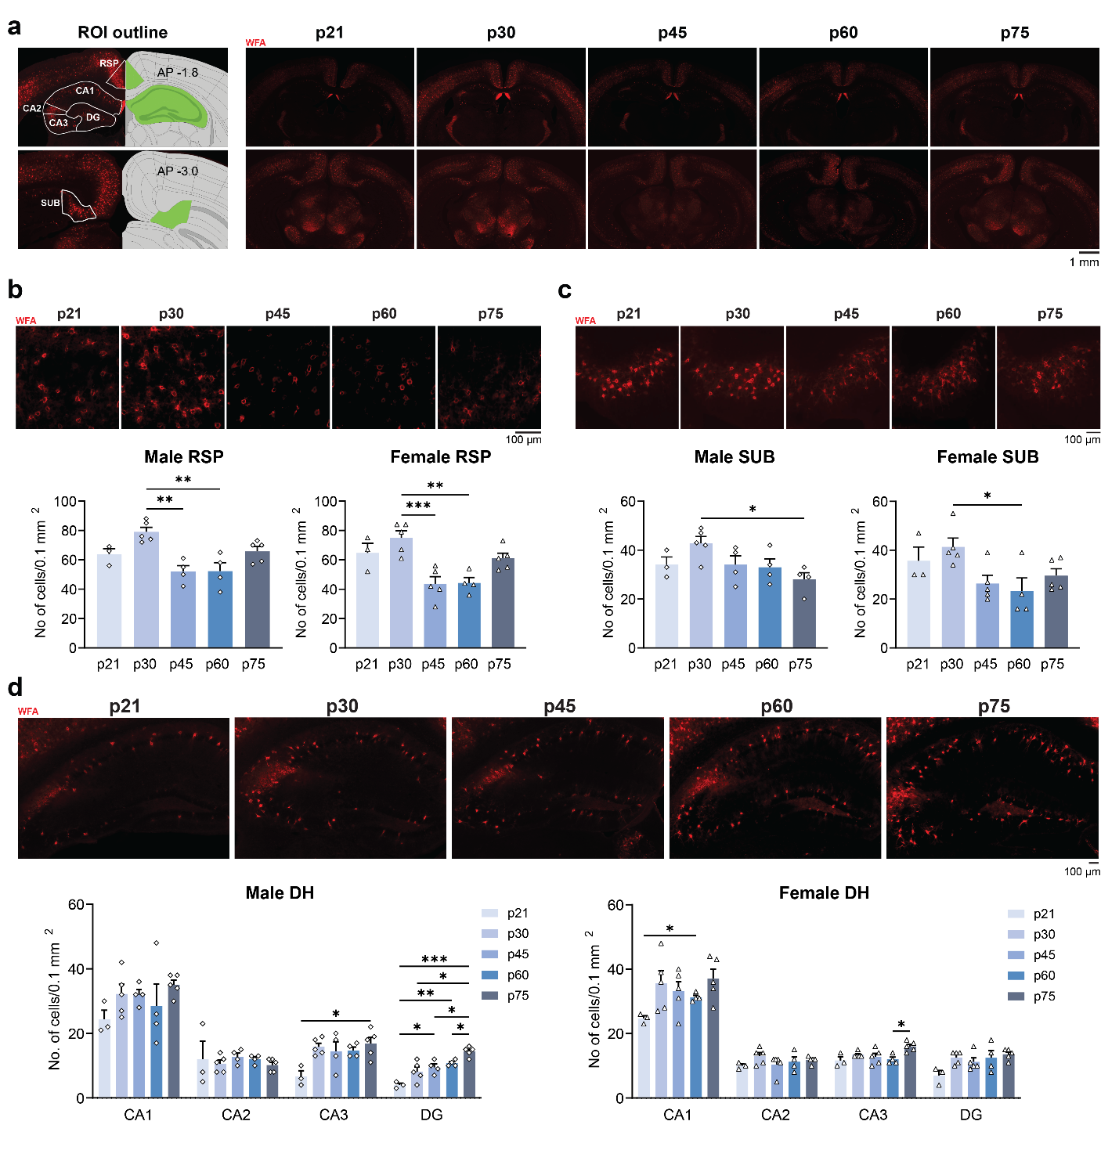
Supplementary Fig. 1: PNN changes throughout adolescence by region and sex.
a Left: the outline of ROI for RSP, DH, and SUB; right: representative images of p21, p30, p45, p60, and p75 male brain sections stained with WFA. b Representative images for WFA staining in RSP (top, males) and quantification for the number of PNN⁺ cells demonstrating significant post-adolescent decreases in the number of PNN (males bottom left; p21: n = 3, p30 and p75: n = 5, p45 and p60: n = 4; one-way ANOVA: F = 8.124, p < 0.001; Tukey’s post-hoc test: p30 vs. p45: p = 0.002, p30 vs. p60: p = 0.002; females bottom right, p21: n = 3, p60: n = 4, others: n = 5; one-way ANOVA: F = 9.032, p < 0.001; Tukey’s post-hoc test: p30 vs. p45: p < 0.001, p30 vs. p60: p = 0.002) RSP. c Representative images for WFA staining in SUB (top, males) and quantification for the number of PNN⁺ cells revealing similar decreases in SUB (males bottom left; p21: n = 3, p30: n = 5, others: n = 4; one-way ANOVA: F = 3.197, p = 0.044; Tukey’s post-hoc test: p30 vs. p75: p = 0.025; females bottom right, p21: n = 3, p60: n = 4, others: n = 5; one-way ANOVA: F = 3.429, p < 0.031; Tukey’s post-hoc test: p30 vs. p60: p = 0.034) SUB. d Representative images for WFA staining in DH (top, males) and quantification for the number of PNN⁺ cells showing stable or increased numbers of PNN (males bottom left; p21: n = 3, p30 and p75: n = 5, p45 and p60: n = 4; two-way RM ANOVA: Region: F_{(1.905,30.48)} = 95.74 p < 0.001, Age: F_{(4, 16)} = 3.533 p = 0.030, Region ´ Age: F_{(12,48)} = 1.273 p = 0.265; Tukey’s post-hoc test: CA3: p21 vs. p75: p = 0.048, DG: p21 vs. p45: p = 0.035, p21 vs. p60: p = 0.003, p21 vs. p75: p < 0.001, p30 vs. p75: p = 0.036, p45 vs. p75: p = 0.048, p60 vs. p75: p = 0.020; females bottom right, p21: n = 3, p60: n = 4, others: n = 5; two-way RM ANOVA: Region: F_{(1.893,32.17)} = 149.1 p < 0.001, Age: F_{(4, 17)} = 7.984 p < 0.001, Region ´ Age: F_{(12,51)} = 0.928 p = 0.053; Tukey’s post-hoc test: CA1: p21 vs. p60: p = 0.019, CA3: p60 vs. p75: p = 0.031) CA1, CA2, CA3, and DG. Data represent mean ± s.e.m., ***p < 0.001; **p < 0.01; *p < 0.05.

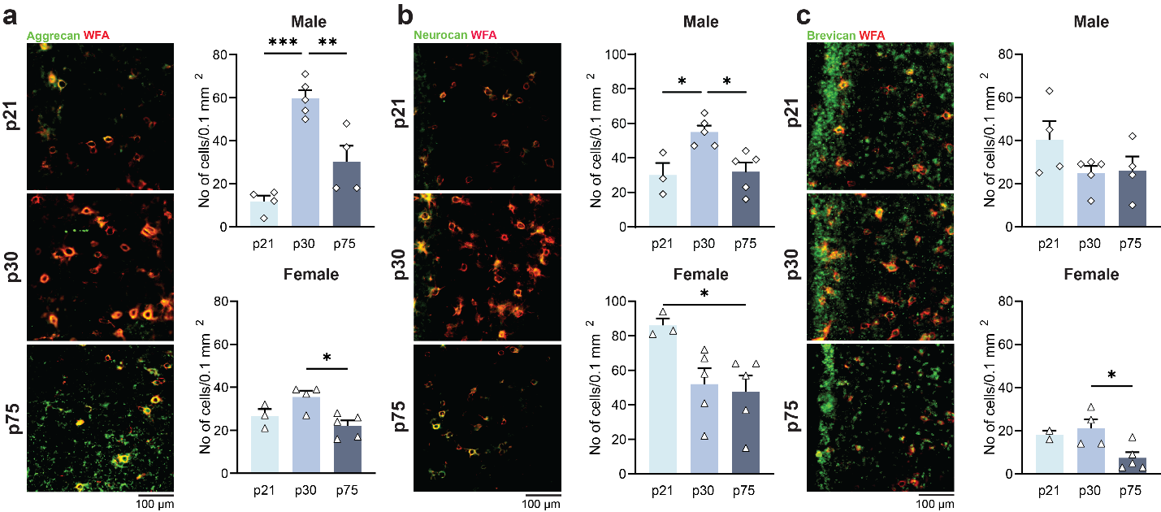
Supplementary Fig. 2: Developmental changes of aggrecan, neurocan and brevican in RSP in males and females.
a Left: representative image of aggrecan (green) and WFA (red) labeling in RSP. Right: quantification of the number of WFA⁺ aggrecan+ cells in RSP showing significant decrease in males (top; p30: n = 5, others: n = 4; one-way ANOVA: F = 25.75, p < 0.001; Tukey’s post-hoc test: p21 vs. p30: p < 0.001, p30 vs p75: p = 0.004) and females (bottom; p21: n = 3, p30: n = 4, p75: n = 5; one-way ANOVA: F = 6.475, p = 0.018; Tukey’s post-hoc test: p30 vs p75: p = 0.015). b Left: representative image of neurocan (green) and WFA (red) labeling in RSP. Right: quantification for the number of WFA⁺ neurocan+ cells in RSP with reduced neurocan expression in males (top; p21: n = 3, others: n = 5; one-way ANOVA: F = 7.686, p = 0.010; Tukey’s post-hoc test: p21 vs. p30: p = 0.023, p30 vs p75: p = 0.017) and females (bottom; p21: n = 3, others: n = 5; one-way ANOVA: F = 4.319, p = 0.045; Tukey’s post-hoc test: p21 vs p75: p = 0.046). c Left: representative image of brevican (green) and WFA (red) labeling in RSP. Right: quantification of the number of WFA⁺ brevican+ cells in RSP with levels in males (top; p30: n = 5, others: n = 4; one-way ANOVA: F = 1.855, p = 0.207) and significant reduction in females (bottom; p21: n = 2, p30: n = 4, p75: n = 5; one-way ANOVA: F = 4.928, p = 0.040; Tukey’s post-hoc test: p30 vs p75: p = 0.040). Data represent mean ± s.e.m., ***p < 0.001; **p < 0.01; *p < 0.05.

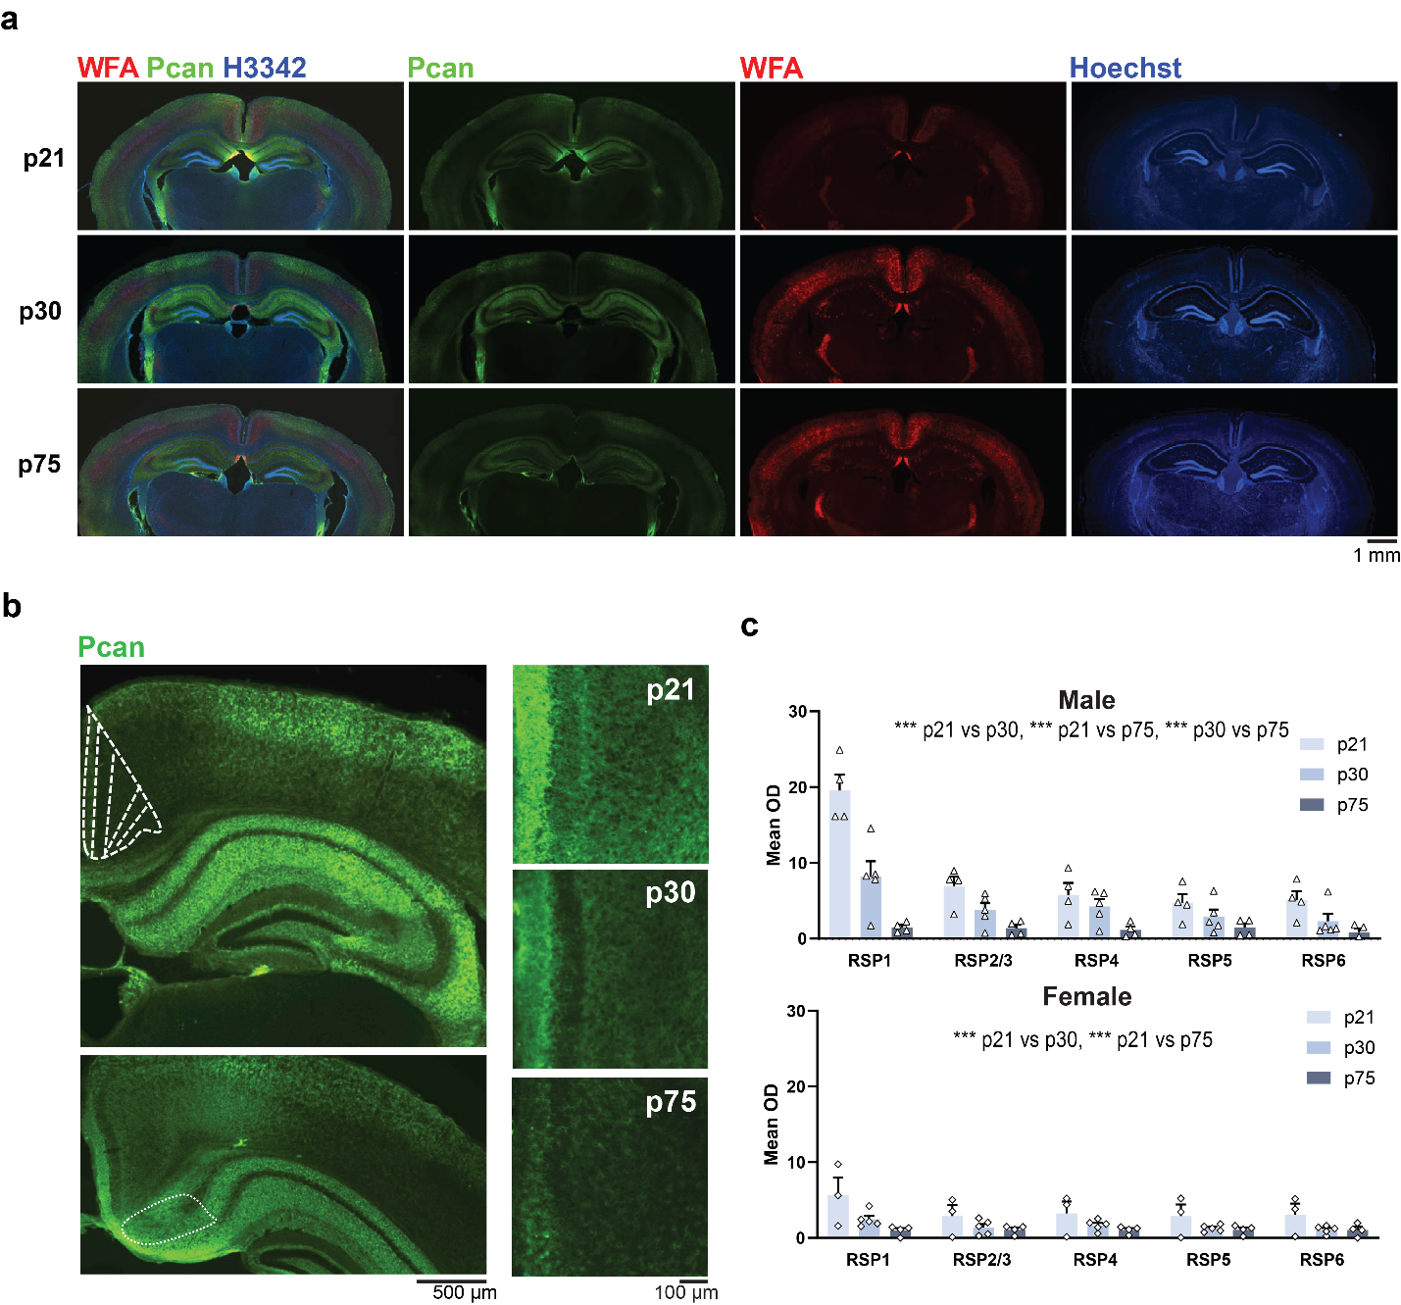
Supplementary Fig. 3: Levels and developmental changes of phosphocan across RSP layers.
a Low magnification images demonstrating the cortical, hippocampal, and thalamic distribution of phosphacan and WFA at p21 (males n = 4, females n = 3), p30 (males, n = 5, females n = 5), and p75 (males n = 4, females n = 4). At p30, the highest levels are obtained in layer 1, containing the cortical axons. b High magnification images showing progressive post-adolescent down-regulation of phosphacan across layers and ECM compartments including but not restricted to PNN. c Layer-by-layer quantification of phosphocan optical density demonstrating significant effects in males (two-way ANOVA: Age: F (2, 50) = 42.32, p < 0.001, Layer: F (4, 50) = 17.70, p < 0.001, Age × Layer: F _{(8, 50)} = 6.574, p < 0.001, Tukey’s post-hoc test: p21 vs. p30: p < 0.001, p21 vs. p75: p < 0.001, p30 vs. p75: p < 0.001) and females (two-way ANOVA: Age: F_{(2,45)} = 12.36, p < 0.001, Layer: F_{(4,45)} = 1.478, p = 0.225, Age × Layer: F_{(8,45)} = 0.5702, p = 0.797, Tukey’s post-hoc test: p21 vs. p30: p < 0.001, p21 vs. p75: p < 0.001). Data represent mean ± s.e.m., ***p < 0.001; **p < 0.01; *p < 0.05.
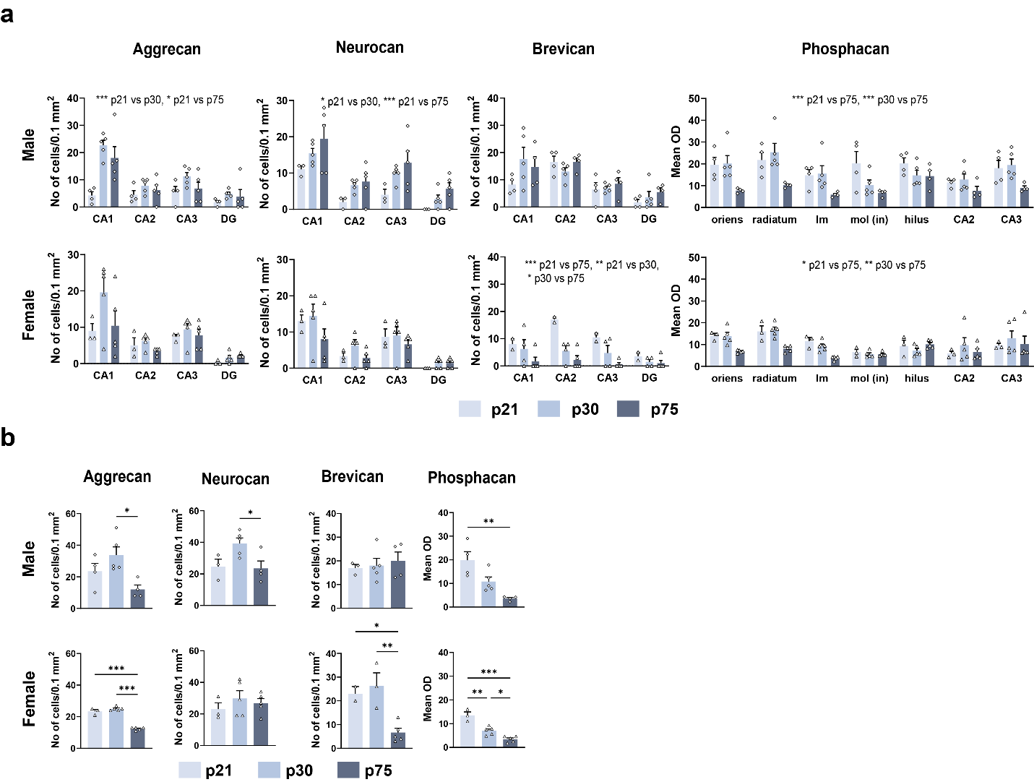
Supplementary Fig. 4: Post-adolescent levels of PNN-associated lecticans in DH and SUB
a Developmental decreases of PNN composition in DH (male aggrecan: p21: n = 4, other: n = 5, two-way ANOVA: Age: F (2, 44) = 12.14, p < 0.001, Area: F (3, 44) = 15.71, p < 0.001, Age × Area: F _{(6, 44)} = 3.146, p = 0.012, Tukey’s post-hoc test: p21 vs. p30: p < 0.001, p21 vs. p75: p = 0.011; female aggrecan: p21: n = 3, other: n = 5, two-way ANOVA: Age: F (2, 40) = 3.515, p = 0.039, Area: F (3, 40) = 14.21, p < 0.001, Age × Area: F _{(6, 40)} = 1.438, p = 0.225; male neurocan: p21: n = 3, other: n = 5, two-way ANOVA: Age: F (2, 40) = 9.519, p < 0.001, Area: F (3, 40) = 17.99, p < 0.001, Age × Area: F _{(6, 40)} = 0.2076, p = 0.972, Tukey’s post-hoc test: p21 vs. p30: p = 0.027, p21 vs. p75: p < 0.001; female neurocan: p21: n = 3, other: n = 5, two-way ANOVA: Age: F (2, 40) = 2.812, p = 0.072, Area: F (3, 40) = 16.57, p < 0.001, Age × Area: F _{(6, 40)} = 0.7006, p = 0.651; male brevican: p30: n = 5, other: n = 4, two-way ANOVA: Age: F (2, 40) = 1.567, p = 0.221, Area: F (3, 40) = 15.22, p < 0.001, Age × Area: F _{(6, 40)} = 1.302, p = 0.279; female brevican: p21: n = 2, p30: n = 4, p75: n = 5, two-way ANOVA: Age: F (2, 32) = 15.37, p < 0.001, Area: F (3, 32) = 4.618, p = 0.009, Age × Area: F _{(6, 32)} = 1.735, p = 0.145, Tukey’s post-hoc test: p21 vs. p30: p = 0.006, p21 vs. p75: p < 0.001, p30 vs. p75: p = 0.038; male phosphacan: p21: n = 4, other: n = 5, two-way ANOVA: Age: F (2, 70) = 20.37, p < 0.001, Area: F (6, 70) = 3.190, p = 0.008, Age × Area: F _{(12, 70)} = 1.307, p = 0.235, Tukey’s post-hoc test: p21 vs. p75: p < 0.001, p30 vs. p75: p < 0.001; female phosphacan: p21: n = 3, other: n = 5, two-way ANOVA: Age: F (2, 70) = 7.449, p = 0.001, Area: F (6, 70) = 5.615, p < 0.001, Age × Area: F _{(12, 70)} = 1.868, p = 0.054, Tukey’s post-hoc test: p21 vs. p75: p = 0.017, p30 vs. p75: p = 0.002). b Developmental change of PNN composition in SUB (male aggrecan: p30: n = 5, other: n = 4, one-way ANOVA: F = 5.746, p = 0.022; Tukey’s post-hoc test: p30 vs. p75: p = 0.017; female aggrecan: p21: n = 3, other: n = 5, one-way ANOVA: F = 124.9, p < 0.001; Tukey’s post-hoc test: p21 vs. p75: p < 0.001, p30 vs. p75: p < 0.001; male neurocan: p21: n = 3, p30: n = 5, p75: n = 4, one-way ANOVA: F = 4.951, p = 0.036; Tukey’s post-hoc test: p30 vs. p75: p = 0.047; female neurocan: p21: n = 3 other: n = 5, one-way ANOVA: F = 0.5794, p = 0.578; male brevican: p21: n = 3, p30: n = 5, p75: n = 4, one-way ANOVA: F = 0.2091, p = 0.815; female brevican: p21: n = 2, p30: n = 3, p75: n = 5, one-way ANOVA: F = 11.40, p = 0.006, Tukey’s post-hoc test: p21 vs. p75: p = 0.036, p30 vs. p75: p = 0.008; male phosphacan: p30: n = 5, other: n = 4, one-way ANOVA: F = 11.01, p = 0.003, Tukey’s post-hoc test: p21 vs. p75: p = 0.002; female phosphacan: p21: n = 3, other: n = 5, one-way ANOVA: F = 29.62, p < 0.001, Tukey’s post-hoc test: p21 vs. p30: p = 0.001, p21 vs. p75: p < 0.001, p30 vs. p75: p = 0.027). Data represent mean ± s.e.m., ***p < 0.001; **p < 0.01; *p < 0.05.

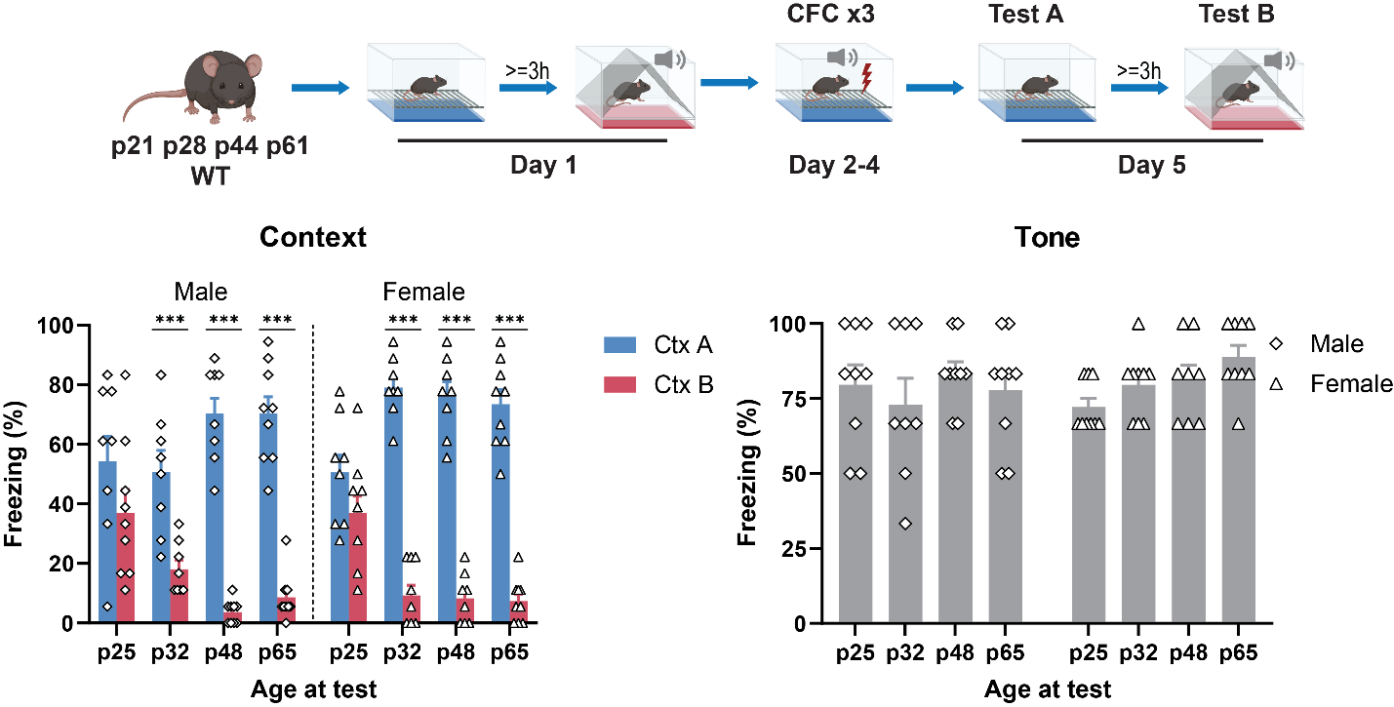
Supplementary Fig. 5: Context specificity of CFC memories acquired during early adolescence (p25-p35).
Context discrimination task (top) shows that mice were able to form specific contextual fear memory after p28 (: n = 8- 9/age group and sex, bottom left, three-way RM ANOVA, Sex: F_{(1,62)} = 1.413, p = 0.239, Age: F_{(3,62)} = 0.7597, p = 0.521, Ctx: F_{(1,62)} = 588.2, p < 0.001, Age × Sex: F_{(3,62)} = 0.7293, p = 0.538, Age × Ctx: F_{(3,62)} = 34.50, p < 0.001, Sex × Ctx: F_{(1,62)} = 5.748, p = 0.020, Age × Sex × Ctx: F_{(3,62)} = 5.065, p = 0.003, Tukey’s post-hoc test: Ctx A vs. Ctx B in all groups other than p25 male and p25 female: p < 0.001). And that they show normal fear response to auditory cue since p21 (p32 male and p48 female: n = 8, other: n = 9, bottom right, two-way ANOVA: Age × Sex: F_{(3,62)} = 1.247, p = 0.300, Age: F_{(3,62)} = 1.069, p = 0.369, Sex: F_{(1,62)} = 0.3027, p = 0.584). Data represent mean ± s.e.m., ***p < 0.001.

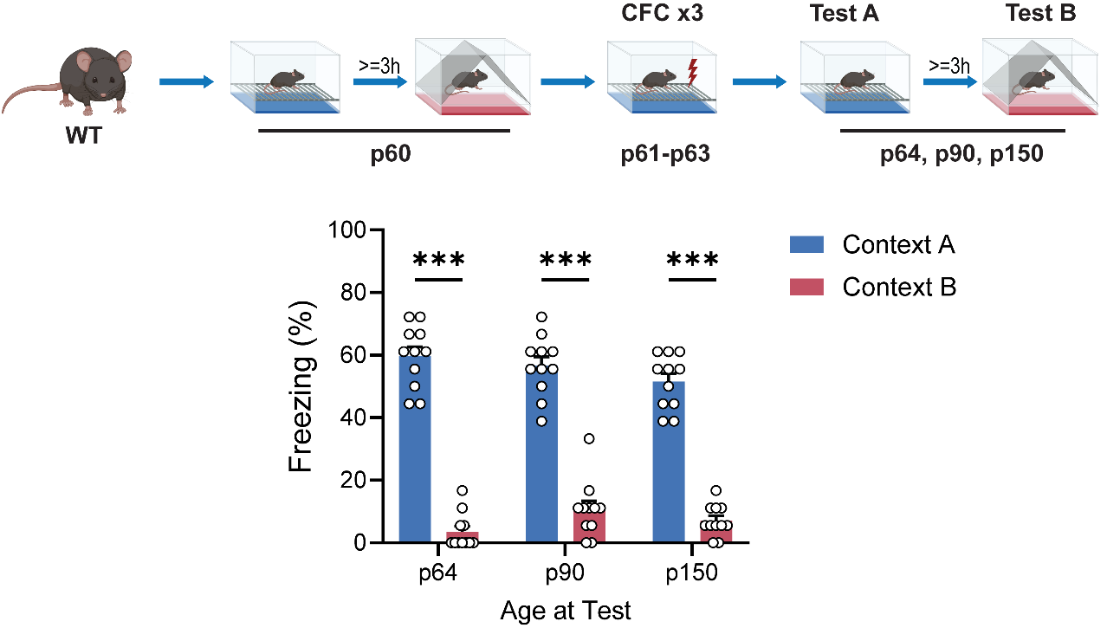
Supplementary Fig. 6 Specificity of recent and remote contextual fear memory formed during late adolescence (p60-p63).
Contextual discrimination task performed on p60 mice shows a prolonged memory specificity in distinguishing dissimilar contexts (same setup used in this study for p28 mice, without tone) up to p150(two-way RM ANOVA: Age of test: F_{(1.890, 18.90)} = 2.209 p = 0.139, Context: F_{(1, 10)} = 370.2 p < 0.001, Age of test x Context: F_{(1.897, 18.97)} = 2.532 p = 0.108). Data represent mean ± s.e.m., ***p < 0.001.

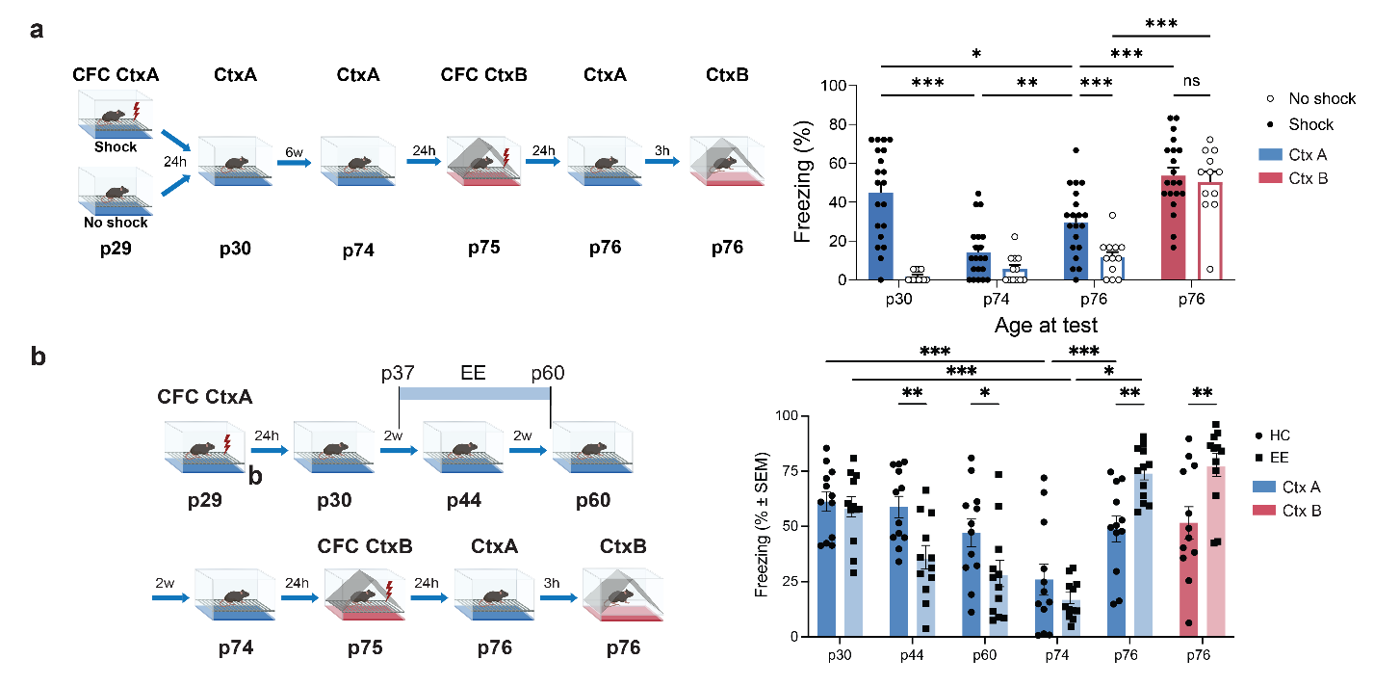
Supplementary Fig. 7: Freezing behavior after shock re-exposure in a different context.
a Left, Experimental paradigm; Right, Shock in a novel context (Context B, CtxB) on p75 resulted in Context B-specific freezing, but also in increased freezing to the conditioned context (Context A, CtxA) (n = 24 for shock group, n = 12 for no shock group; two-way RM ANOVA: Test: F_{(3,102)} = 36.20 p < 0.001, Shock: F_{(1, 34)} = 25.95 p < 0.001, Test ´ Shock: F_{(3,102)} = 7.009 p < 0.001; Šídák's post-hoc test: shock group: Test1 vs. Test2 and Test3 vs. Test4: p < 0.001, no shock group: Test4 vs. all other tests: p < 0.001). b Anterograde interference with CFC by introducing a 2-week environmental enrichment (EE) exposure one week after training (p37-p60) accelerated the impairment of memory expression in the EE group (n = 12) relative to home cage (HC) controls (n= 12). Despite initial impairments, the retention of the adolescent CtxA-shock memory was significantly enhanced by EE (two-way RM ANOVA effects of Test F _{(3.477, 76.48)} = 35.04, P < 0.001; and Test x Group interaction F _{(5, 110)} = 14.28, P < 0.001, Tukey’s post-hoc test: EE vs. HC p44: p = 0.004, p60: p = 0.037, p76 CtxA: p = 0.002, p76 CtxB: p = 0.010; p30 vs. p74: HC and EE: p < 0.001, p74 vs. p76 CtxA: HC: p = 0.044, EE: p < 0.001). Data represent mean ± s.e.m. ***p < 0.001; **p < 0.01; *p < 0.05.

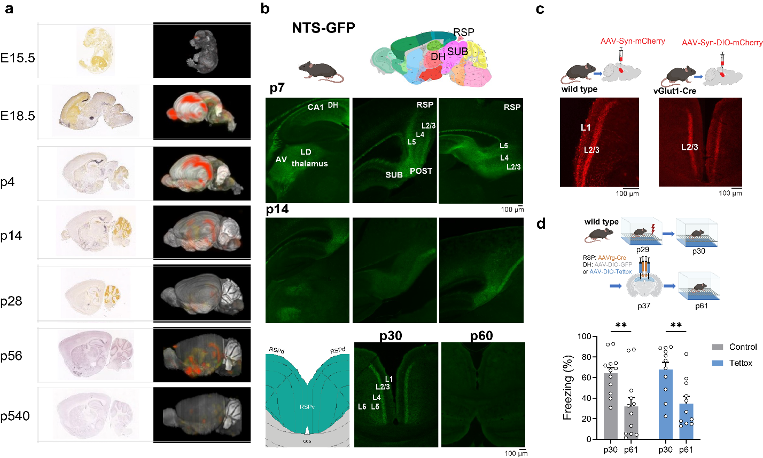
Supplementary Fig. 8: Effect of inactivating DH to RSP projections during late adolescence on the retrieval of previously acquired memories.
a Left, Delineation of brain areas showing strong NTS labeling in thalamic, hippocampal, and RSP regions during early development (p7-p14) in NTS-GFP mice. Right, Representative images of NTS labeling showing two projections from SUB to RSP terminating in L2/3 and L5. b Disappearance of NTS from DH to RSP projections between p30 and p60. c Mature DH to RSP projections to RSP L1 and L2/3 (left), with excitatory projections terminating in L2/3 (middle) and lack of terminals in L% (right). d Inhibition of DH to RSP projections does not affect the impaired retrieval of adolescent memories (n = 12, two-way RM ANOVA: Tettox: F_{(1,21)} = 0.1627 p = 0.691, Age of test: F_{(1, 21)} = 30.14 p < 0.001 Infusion x Age of test: F_{(1,21)} = 0.0040 p = 0.950; Šídák's post-hoc test: Control p30 vs. p61: p = 0.002 , Tettox p30 vs. p61: p = 0.002). Data represent mean ± s.e.m., **p < 0.01.

