Additional Information
Table S1. Overview of participant characteristics, related to Figure 1.
Table S2. Immune cell counts from flow cytometry analysis, related to Figure 1 and S1
Table S3. Detailed statistical results from analysis of exercise-induced changes in immune cell counts, related to Figure S1.
Table S4. Lymphocyte proportions, related to Figure 1.
Table S5. Detailed statistical results from analysis of exercise-induced changes in protein abundance of PBMCs, related to Figure 2 and 3.
Table S6. Detailed results of Gene ontology over-representation analysis, related to Figure 3.
Table S7. Membership values and fold changes from baseline of all proteins used for fuzzy c-means clustering, related to Figure 4.
Table S8. Detailed results of biological theme comparison, related to Figure S3.
Table S9. Detailed results of all Gene ontology gene set enrichment analyses, related to Figure 4, and S4.
Table S10. Detailed results of V̇O_{2peak} prediction, related to Figure 5.

SUPPLEMENTAL FIGURES
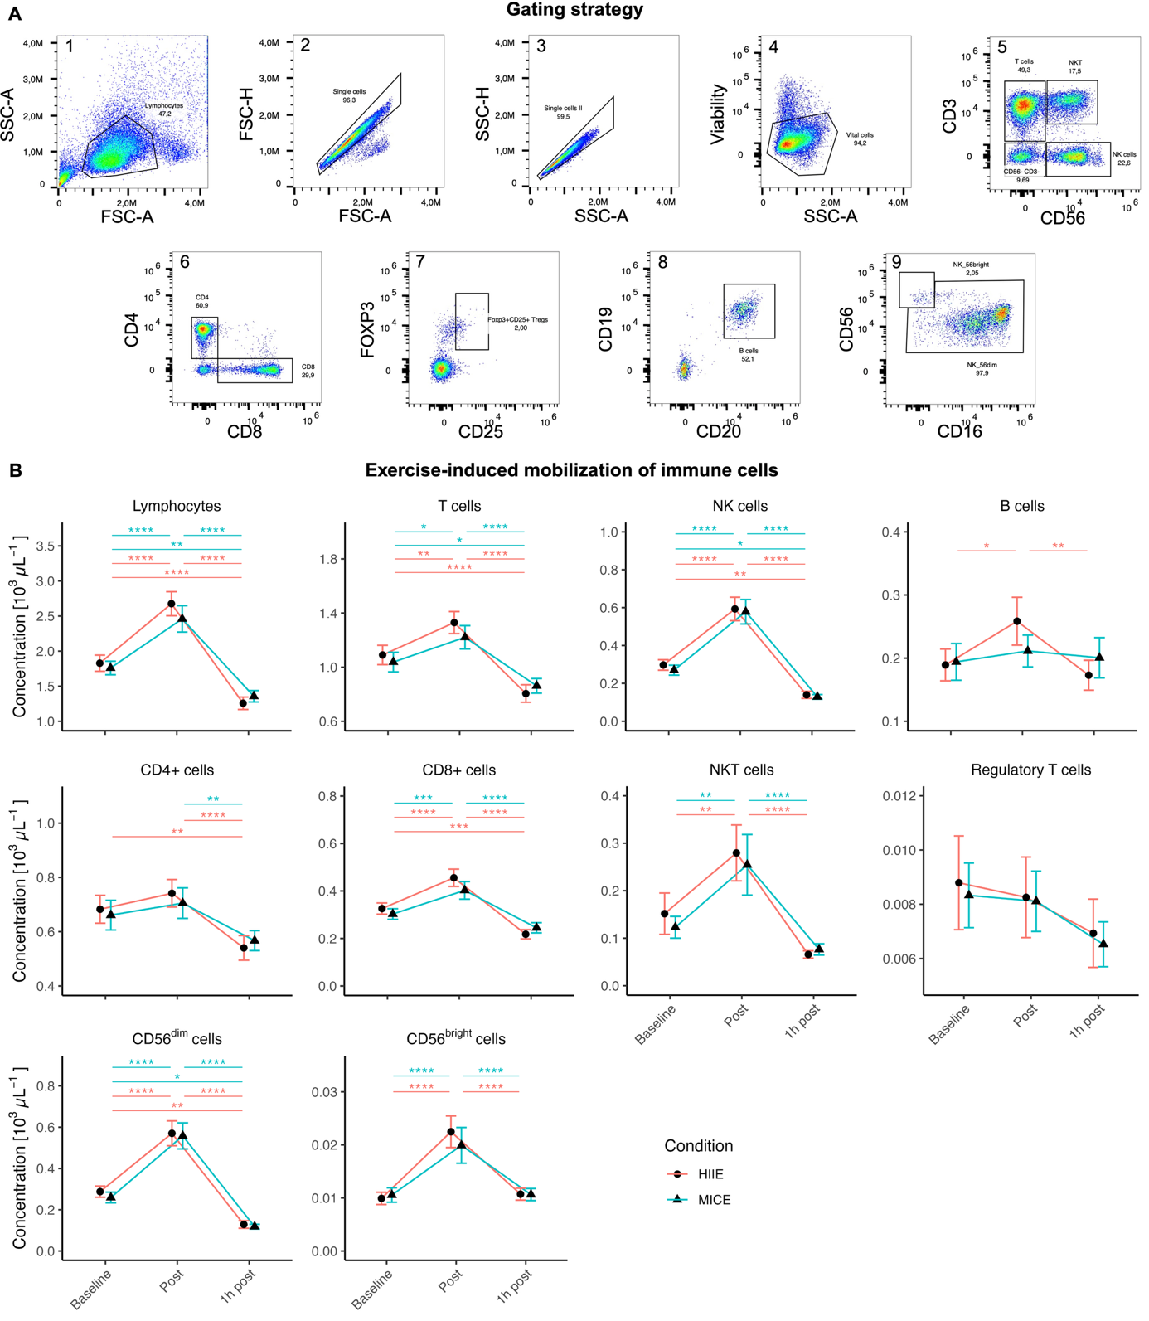
Figure S1 Immune cell mobilization is independent of exercise intensity, related to Figure 1 and Table S2, S3, and S4.
(A) Gating strategy applied to PBMCs. Gated immune cell populations included vital lymphocytes, T cells, CD4+ T cells, CD8+ T cells, natural killer (NK) T cells, regulatory T cells, NK cells, CD56^{dim} cells, CD56^{bright} cells, and B cells.
(B) Mobilization kinetics of total lymphocytes and lymphocyte subsets in response to high-intensity interval exercise (HIIE) and moderate-intensity continuous exercise (MICE). Linear mixed models with subsequent analyses of variance and Bonferroni-corrected pairwise comparisons were applied. Data are represented as mean ± SEM (n = 22). Time effects : **** p < 0.0001, *** p < 0.001, ** p < 0.01, * p < 0.05.

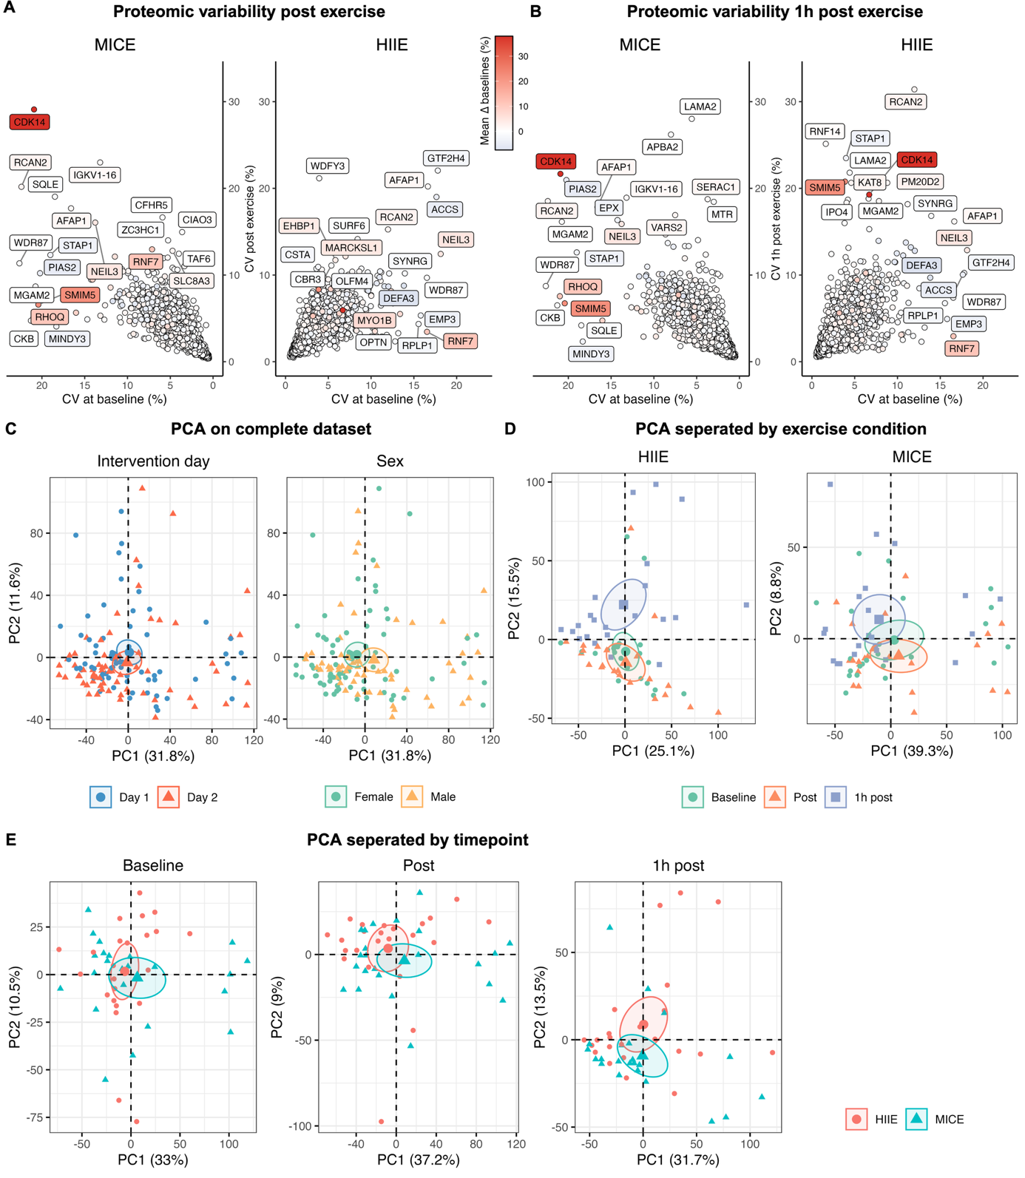
Figure S2 Proteomic variability and principal component analyses (PCA) separated by exercise condition and measurement timepoint, related to Figure 2
(A) Proteomic variability immediately after HIIE and MICE.
(B) Proteomic variability 1h after HIIE and MICE.
(C) PCA on complete dataset to evaluate the impact of intervention day and sex.
(D) PCA separated by exercise condition to evaluate the impact of measurement timepoint.
(E) PCA separated by measurement timepoint to evaluate the impact of exercise condition.

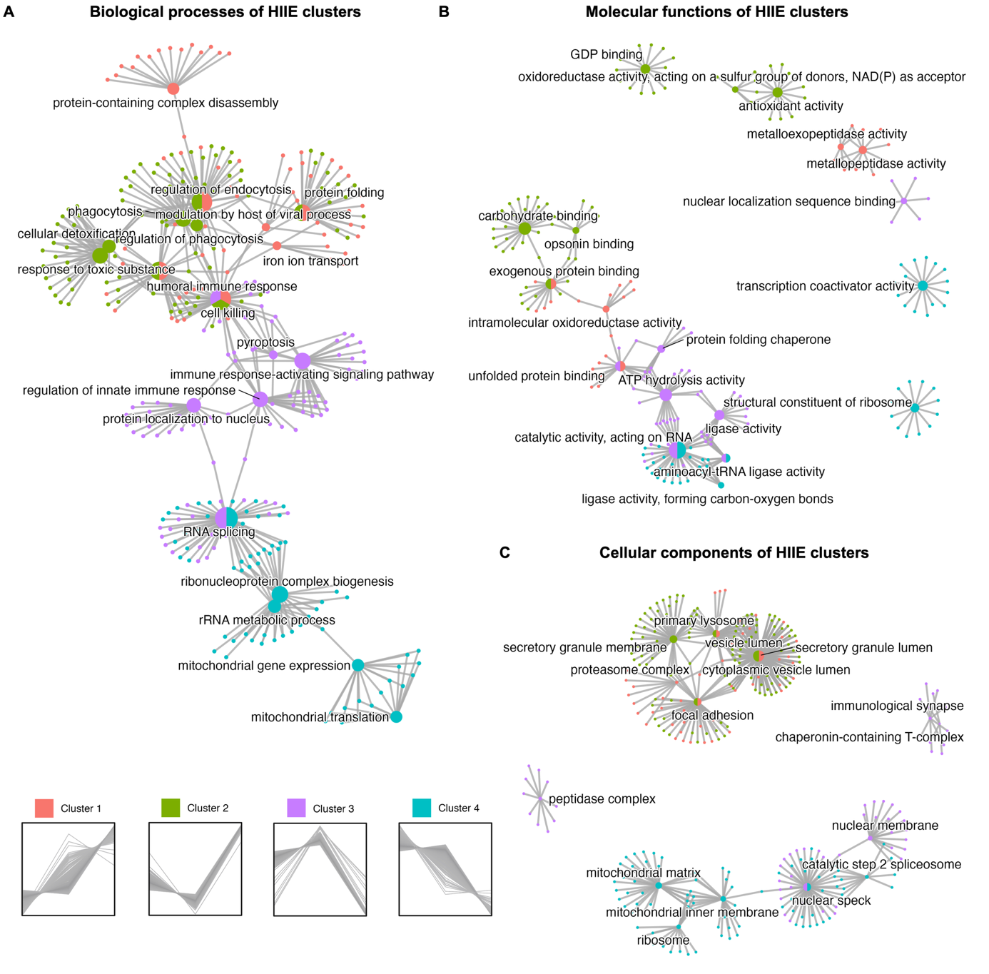
Figure S3 Biological theme comparison suggests shared and unique GO terms across protein clusters in HIIE
(A) Relative cluster membership of proteins altered by HIIE.
(B) Comparison of biological processes in clusters 1 – 4.
(C) Comparison of molecular functions in clusters 1 – 4.
(D) Comparison of cellular components in clusters 1 – 4.
See also Table S7 and S8.

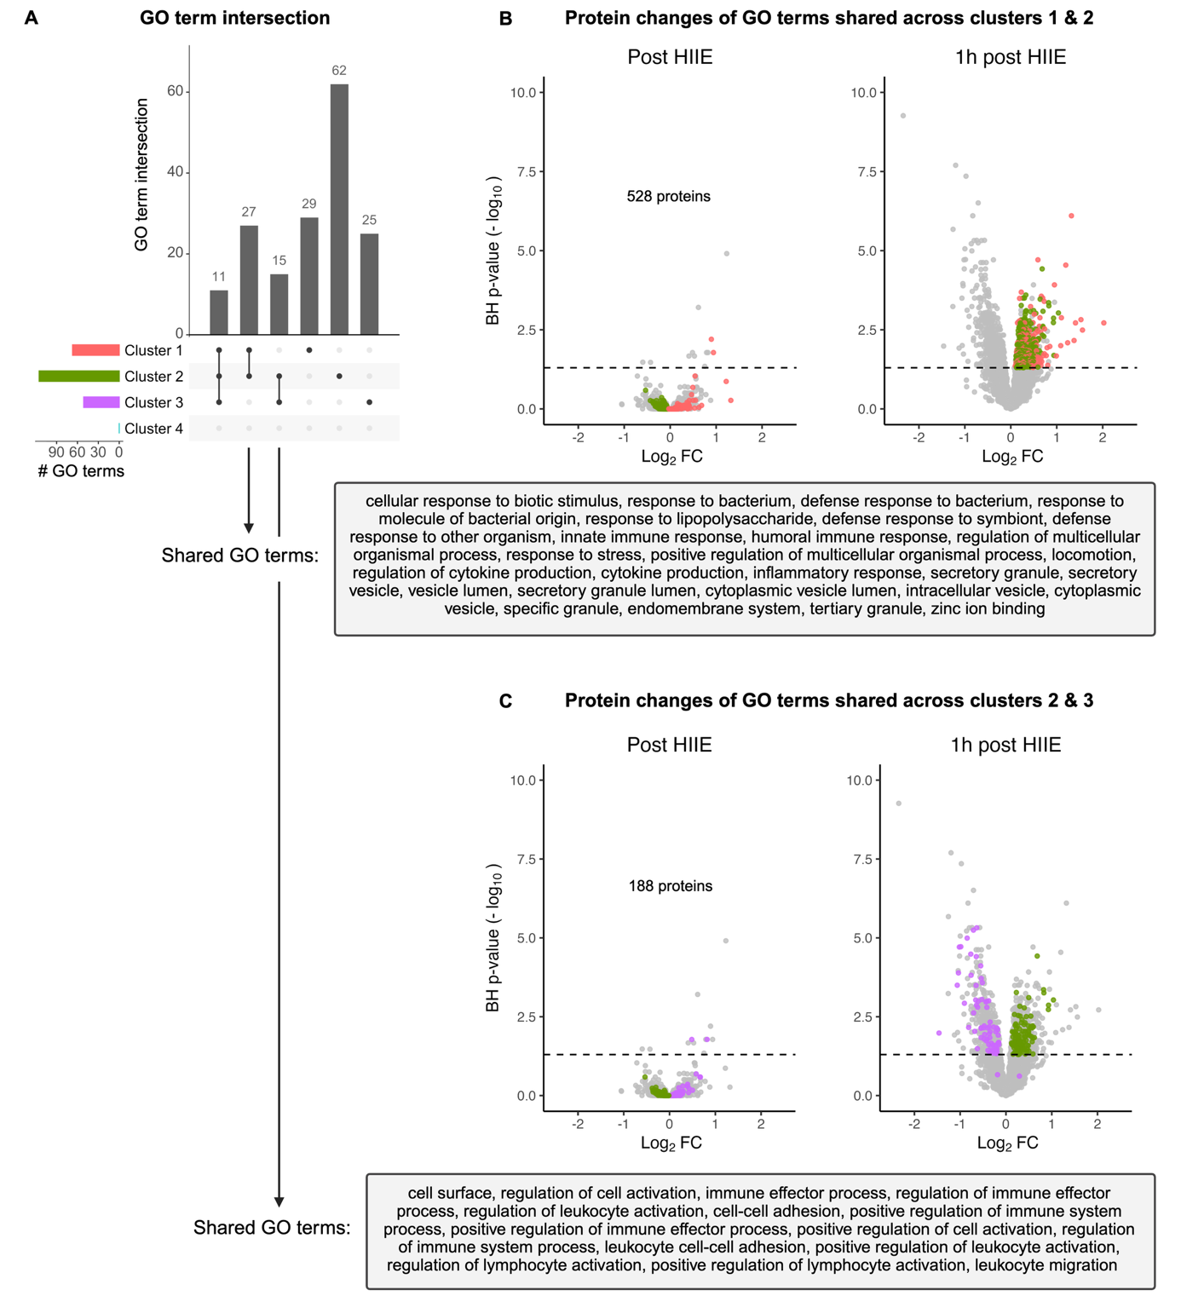
Figure S4 GO terms overlap between clusters 1 & 2 and 2 & 3, respectively, related to Figure 5 and Table S9
(A) Overview of shared and unique GO terms across all clusters.
(B) GO terms shared between clusters 1 and 2.
(C) GO terms shared between clusters 2 and 3.

