Supplementary materials
Mapping spatial zones of climate vulnerability and adaptive potential for major crops in the Texas High Plains

Model description, calibration, and validation
The DSSAT version 4.8 (Hoogenboom et al., 2019) a process-based agroecosystem model that simulates crop growth, development, and yield by integrating soil properties, daily weather, and crop management practices. It dynamically models crop phenology, biomass accumulation, and root and shoot development while accounting for water and nutrient balances. Soil water content is modeled layer-by-layer using a water balance approach, incorporating precipitation, irrigation, evaporation, transpiration, runoff, and drainage (Ritchie et al., 2009).
The SOC dynamics are simulated using the CENTURY-based soil module, which includes three SOC pools—(i) active, easily decomposable SOC, (ii) slow, recalcitrant SOC (such as lignin and cell walls), and (iii) passive, stable SOC—along with two fresh organic C (litter) pools (Porter et al., 2010). These litter pools consist of surface and soil metabolic litter (easily decomposable) and structural litter (recalcitrant). The model continuously tracks SOC changes across different crop rotations, allowing carry-over effects of soil water, organic N, and SOC between seasons (Hoogenboom et al., 2019).
To initialize SOC dynamics, two SOC pools were considered: (i) total SOC measured at different soil depths and (ii) stable SOC. Since stable SOC is difficult to measure directly, it is estimated using a regression approach based on soil texture or historical site management records (Porter et al., 2010). This regression approach, applied to soils in the Texas High Plains, aligns with estimates by Six et al. (2002) and provides a reliable method for estimating stable SOC. The remaining total SOC is then divided into active SOC (5%) and recalcitrant SOC (95%).
Model calibration was conducted to optimize the simulation performance of the DSSAT-CROPGRO model for Austrian winter pea and associated soil processes. As shown in Fig. S1, simulated values of aboveground biomass and nitrogen uptake aligned closely with observed data, demonstrating the model's capability to capture crop growth and nitrogen dynamics in the semi-arid northwest Texas. The root mean square error (RMSE) and visual agreement support the reliability of the parameter adjustments shown in Table S1. Additionally, Fig. S2 illustrates the comparison of observed and simulated soil water content (0–80 cm) during the long-term cotton rotation experiment with cover crops. The model reasonably captured the temporal dynamics of soil moisture under dryland conditions, with simulation trends tracking the seasonal variation and magnitude of measured data, thereby validating the water balance submodule under different cover cropping and rotations. This was demonstrated by nRMSE < 20% and MPE < 10%. These results confirm that the calibrated parameters provide a robust basis for simulating long-term agroecosystem outcomes in the region.

Table S1. Design of the suggested improved 4-year crop rotation with cover crops in the Texas High Plains.
Crop | Plant Date | Harvest Date | Synthetic N (kg/ha) | Organic N (kg/ha) | Total N (kg/ha) | Application Dates
Sorghum | June 25, 1990 | Nov 15, 1990 | 55 + 55 | 40 | 150 | July 20 (10d planting) + Aug 20 (tillering stage)
Winter Legume CC (Austrian Pea) | Nov 20, 1990 | April 20, 1991 | 0 | 0 | Fixes ~50 kg N/ha | No synthetic or organic N applied
Maize | April 25, 1991 | September 15, 1991 | 50 + 50† | 50 | 150 | April 25 (10d planting) + June 25 (V6 stage)
Winter Legume CC (Austrian Pea) | October 10, 1991 | April 20, 1992 | 0 | 0 | Fixes ~50 kg N/ha | No synthetic or organic N applied
Cotton | May 1, 1992 | October 15, 1992 | 50 + 50 | 0 | 100 | May 10 (10d planting) + June 20 (midseason)
Winter Wheat | October 20, 1992 | June 20, 1993 | 30 + 30 +  30 | 50 | 140 | October 30 (10d planting) + March 1 (tillering stage)

Table S2. Calibration parameters for Austrian Winter Pea using the DSSAT-CROPGRO model.
Coefficient type | Abbreviation | Description | Initial | Adjusted
ECO | JU-R0 | Juvenile to Floral Induction Duration (days) | 5.0 | 7.0
ECO | FL-VS | First Flower to Last Leaf Expansion (days) | 19.0 | 25.00
ECO | OPTBI | Minimum Daily Temperature for Flowering (°C) | 0.0 | 5.0
ECO | SLOBI | Slope of Temperature Effect on Flowering | 0.0 | 0.15
CUL | CSDL | Critical Short Daylength (hours) | 11.0 | 10.00
CUL | PPSEN | Photoperiod Sensitivity Coefficient | -0.14 | -0.15
CUL | EM-FL | Emergence to Flowering Time (photothermal days) | 28.0-42.0 | 23.00
CUL | FL-SD | Flowering to First Seed (photothermal days) | 12.5-16.5 | 14.00
CUL | SD-PM | Seed to Physiological Maturity (days) | 26.0-40.0 | 30.00
CUL | WTPSD | Maximum Seed Weight per Plant (g) | 0.150-0.30 | 0.170
CUL | SFDUR | Seed Filling Duration (days) | 22.0 – 29.0 | 31.00
CUL | XFRT | Max Fraction Partitioned to Seed/Shell | 0.94-1.0 | 0.90
SPE | PARMAX | Maximum Photosynthesis Rate | 39.00 | 35.00
SPE | PHTMAX | Maximum Photosynthetic Threshold | 54.00 | 50.00
SPE | CCMAX | Maximum Canopy Conductance | 2.09 | 1.80
SPE | CCEFF | CO₂ Effectiveness on Photosynthesis | 0.0105 | 0.0110
SPE | RNO3C | Respiration Coefficient for NO₃ | 2.556 | 2.300
SPE | RNH4C | Respiration Coefficient for NH₄ | 2.556 | 2.300
SPE | NODRGM | Nodule Growth Rate | 0.200 | 0.275
SPE | NDTHMX | Maximum Nitrogen Fixation Duration | 2.00 | 2.80
SPE | RFIXN | Nitrogen Fixation Efficiency | 2.83 | 3.20
SPE | RFAC1 | Root Depth Factor | 7500 | 8500
SPE | SLWREF | Specific Leaf Weight Reference | 0.0050 | 0.0048
Climate models and soil data
The Multivariate Adaptive Constructed Analogs team employed a statistical downscaling technique to refine global climate model outputs to a higher spatial resolution of 6 km, making them more applicable for regional studies (Abatzoglou and Brown, 2012; Taylor et al., 2012). The downscaling process utilizes the MACA method, which enhances coarse-resolution climate data by incorporating observed weather patterns and maintaining relationships among multiple climate variables. This approach ensures that the downscaled data accurately reflect local climatic conditions and preserves variable interdependencies, which is crucial for comprehensive climate impact assessments. These downscaled datasets provide region-specific climate projections that improve the accuracy of agricultural system simulations in the THP.
Table S3. List of GCM used with DSSAT model for climate change impact assessment.
Global model (GCM) | Model Country | Ensemble used | Scenario name | Model Agency | Atmosphere resolution (Lon x Lat)
CCSM4 | USA | r6i1p1 | RCP4.5;8.5 | National Center of Atmospheric Research, USA | 1.25 deg x 0.94 deg
CNRM-CM5 | France | r1i1p1 | RCP4.5;8.5 | National Centre of Meteorological Research, France | 1.4 deg x 1.4 deg
CSIRO-Mk3-6-0 | Australia | r1i1p1 | RCP4.5;8.5 | Commonwealth Scientific and Industrial Research Organization/Queensland Climate Change Centre of Excellence, Australia | 1.8 deg x 1.8 deg
IPSL-CM5A-MR | France | r1i1p1 | RCP4.5; 8.5 | Institut Pierre Simon Laplace, France | 2.5° x 1.25°
MIROC5 | Japan | r1i1p1 | RCP4.5; 8.5 | Atmosphere and Ocean Research Institute (The University of Tokyo), National Institute for Environmental Studies, and Japan Agency for Marine-Earth Science and Technology | 1.4° x 1.4°

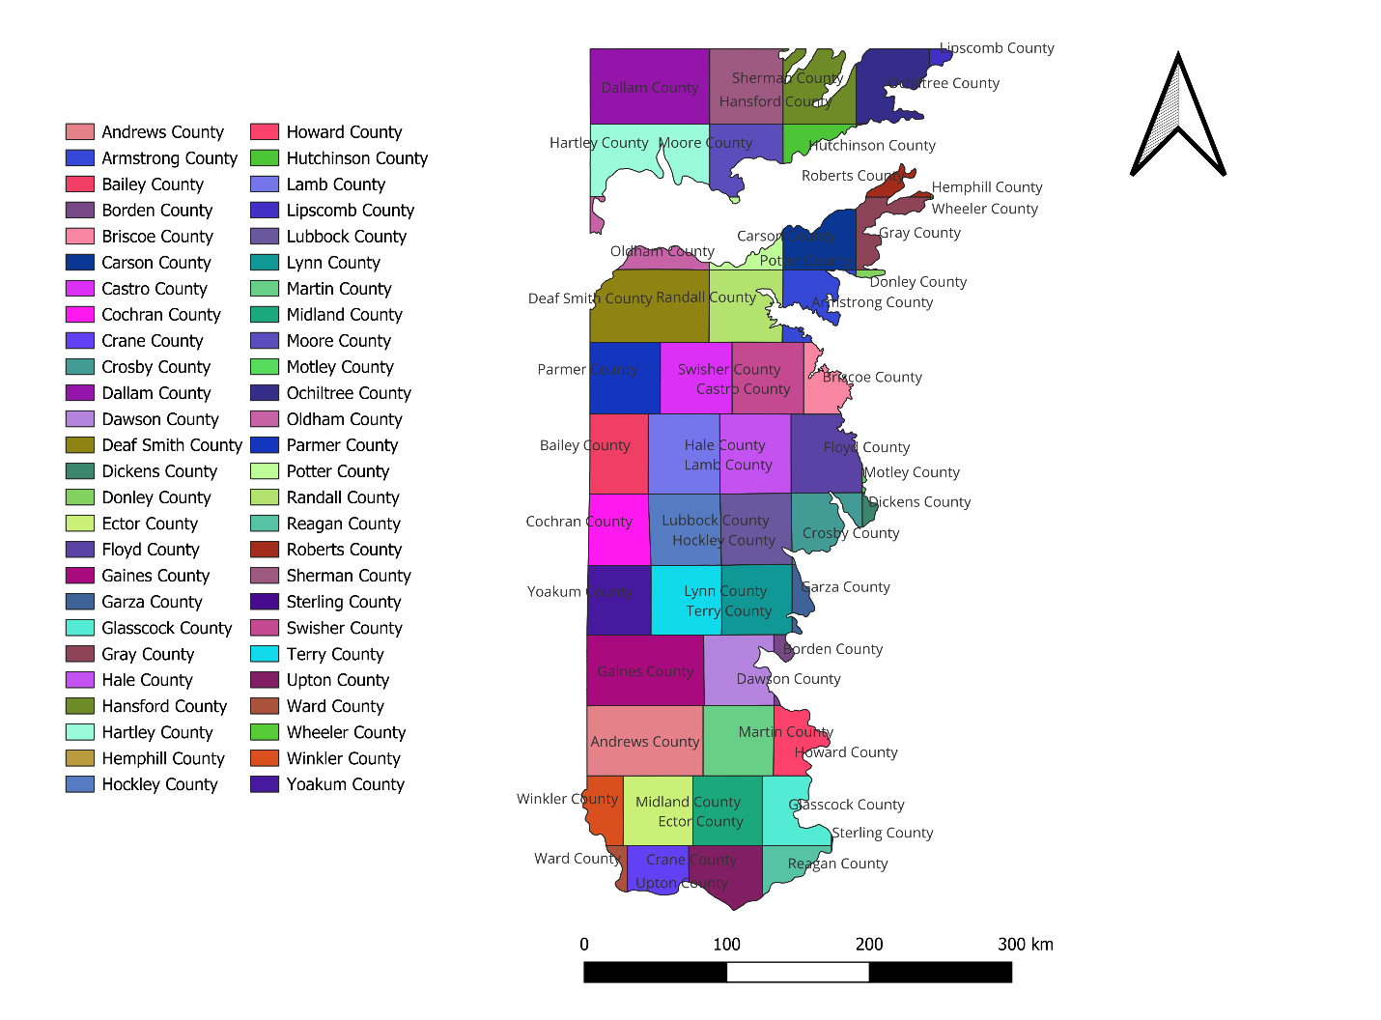
Fig. S1. Texas High Plains counties.

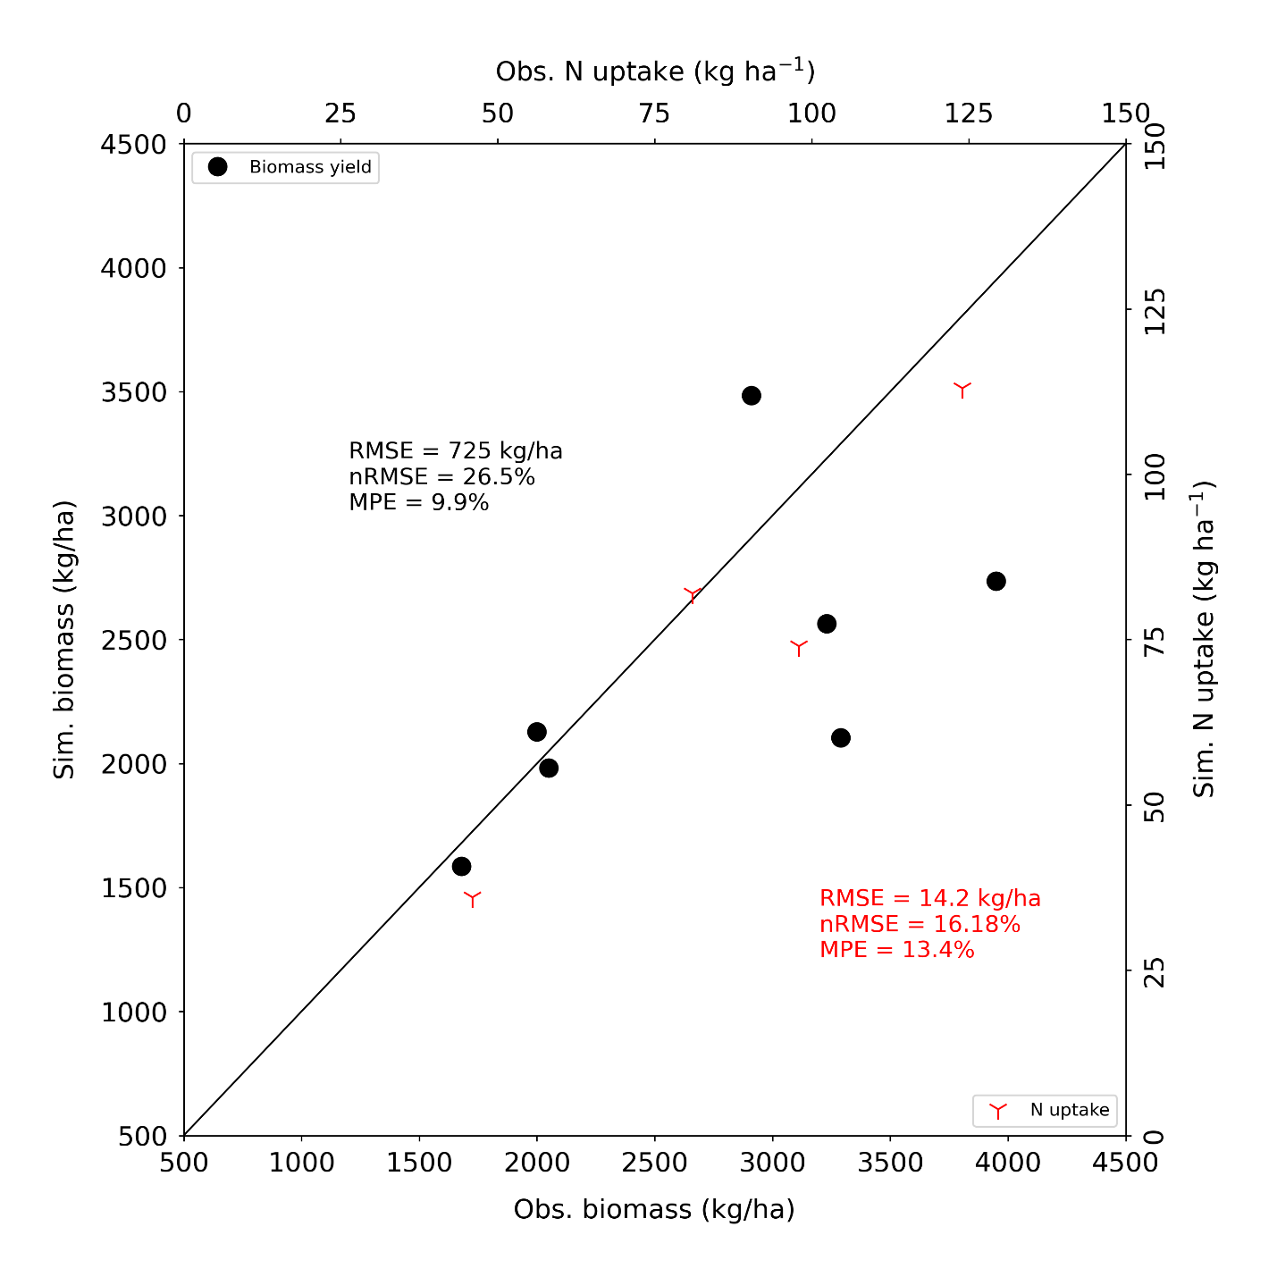
Fig. S2. Comparison between simulated and observed biomass yield and N uptake of Austrian winter pea in Texas.
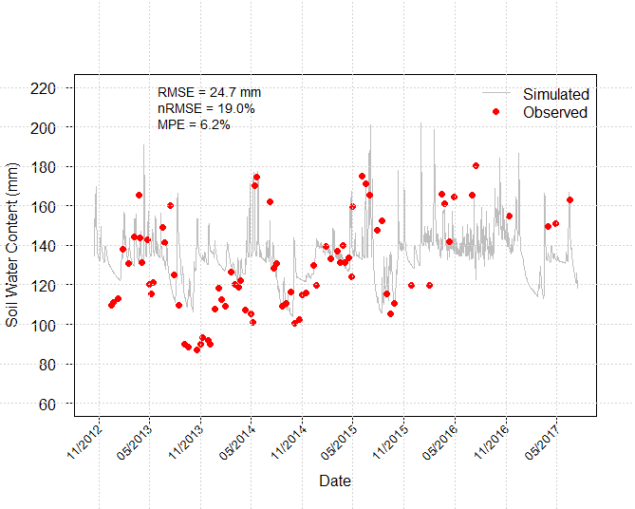
Fig. S3. Comparison between simulated and observed soil moisture content in 0-80 cm soil depth during long term cotton experiment with cover crops including Austrian winter pea in Chillicothe, Texas.

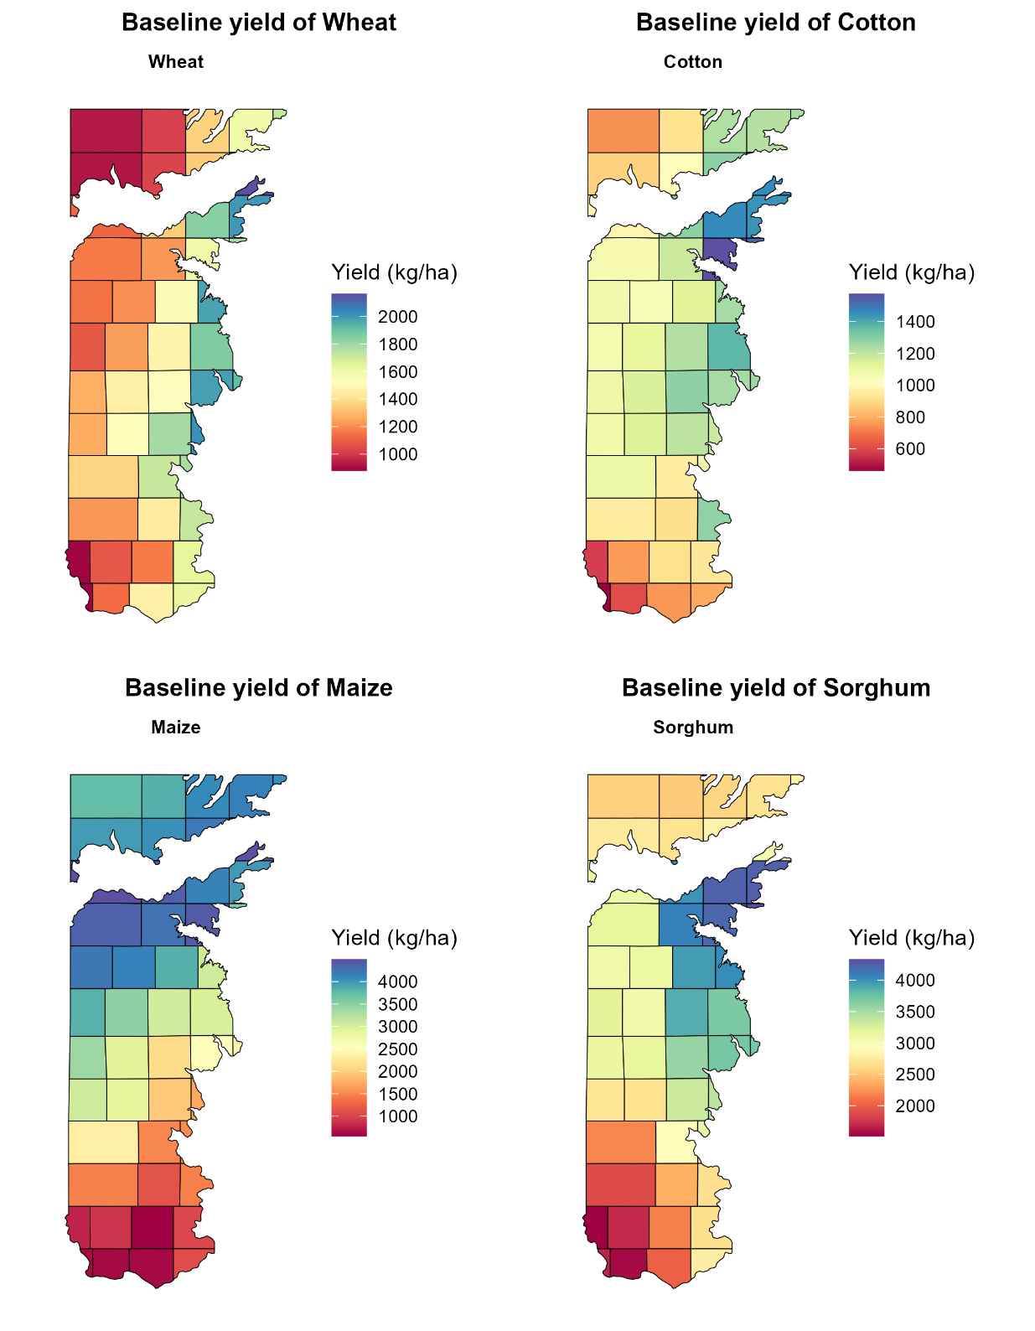
Fig. S4. County level baseline (1991-2020) simulated yield for wheat, cotton, maize, and sorghum in Texas High Plains.

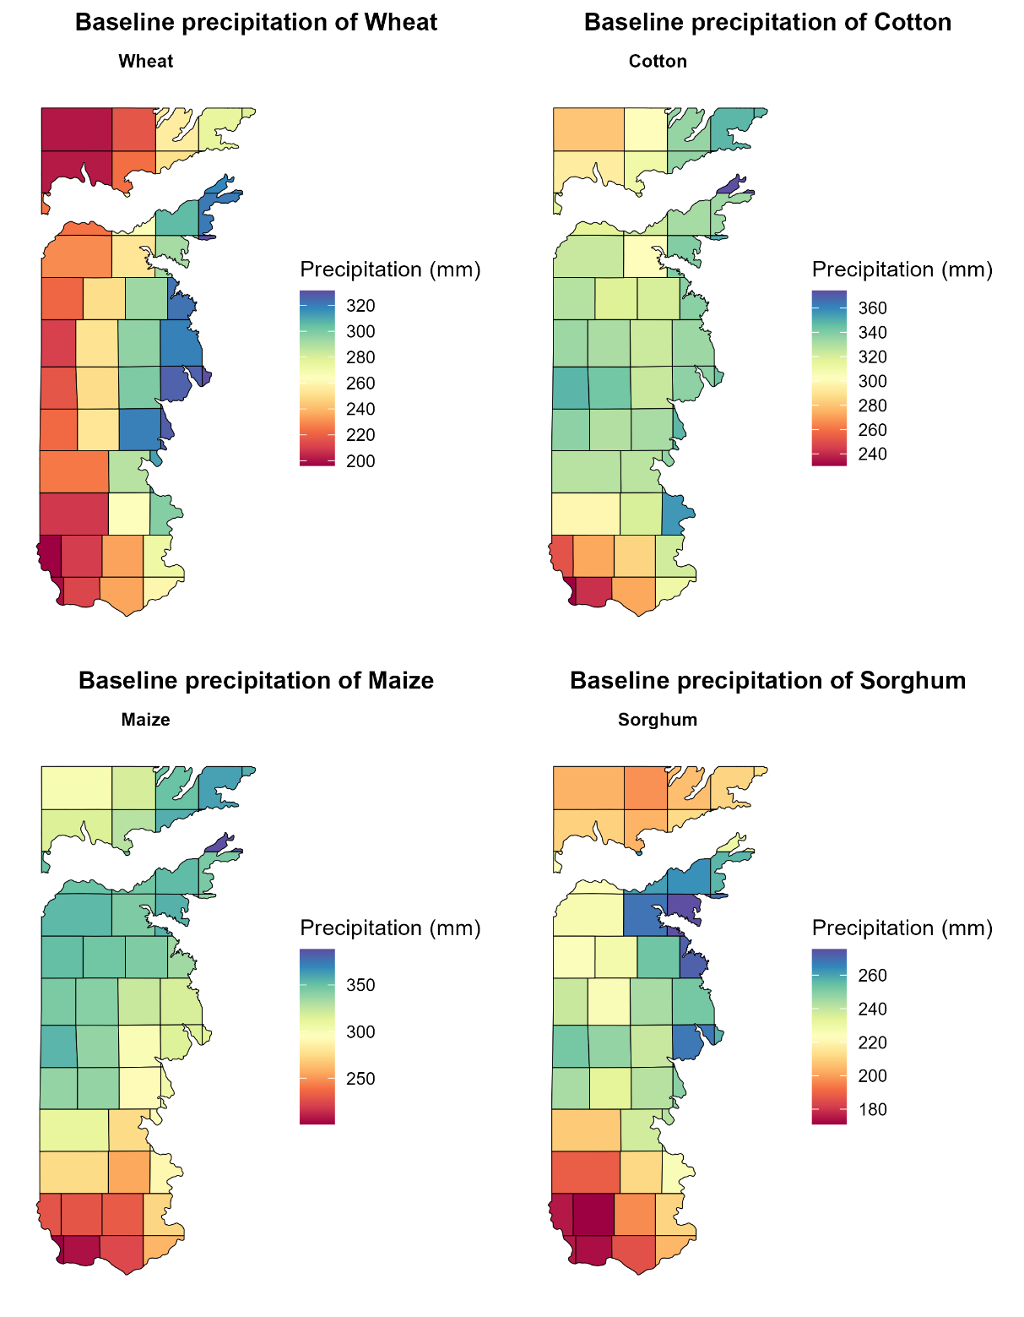

Fig. S5. County level baseline (1991-2020) precipitation during the growing season for wheat, cotton, maize, and sorghum in Texas High Plains.

References
Abatzoglou JT, & Brown TJ (2012). A comparison of statistical downscaling methods suited for wildfire applications. Int. J. Climatol., 32(5), 772-780.
Hoogenboom G, Porter CH, Boote KJ, Shelia V, Wilkens PW, et al. (2019). The DSSAT crop modeling ecosystem. Advances in crop modelling for a sustainable agriculture (pp. 173-216). Burleigh Dodds Science Publishing.
Porter CH, Jones JW, Adiku S, Gijsman AJ, Gargiulo O, et al. (2010). Modeling organic carbon and carbon-mediated soil processes in DSSAT v4. 5. Oper. Res., 10, 247-278.
Ritchie JT, Porter CH, Judge J, Jones JW, & Suleiman AA (2009). Extension of an existing model for soil water evaporation and redistribution under high water content conditions. Soil Sci. Soc. Am. J., 73(3), 792-801.
Six J, Conant RT, Paul EA, & Paustian K (2002). Stabilization mechanisms of soil organic matter: implications for C-saturation of soils. Plant Soil, 241, 155-176.
Taylor KE, Stouffer RJ, & Meehl GA (2012). An overview of CMIP5 and the experiment design. Bull. Am. Meteorol. Soc., 93(4), 485-498.

