Supporting information for

Design of ternary TiO₂-based nanocomposite for enhanced photocatalysis of MNZ: application to pharmaceutical wastewater treatment

Noha I. Abdelaziz^{1*}, Medhat A. Al-Ghobashy², Marianne Nebsen², Ahmed H. Nadim ²

¹Department of Chemistry, School of Pharmacy, Newgiza University, Giza 12256, Egypt
²Analytical Chemistry Department, Faculty of Pharmacy, Cairo University, Cairo 11562, Egypt

*Correspondence:
Ahmed H. Nadim, Department of Analytical Chemistry, Faculty of Pharmacy, Cairo University, Cairo 11566, Egypt.
Email: ahmed.nagib@cu.edu.eg

Supplementary materials

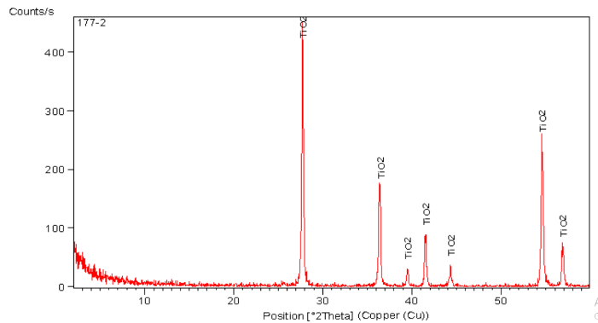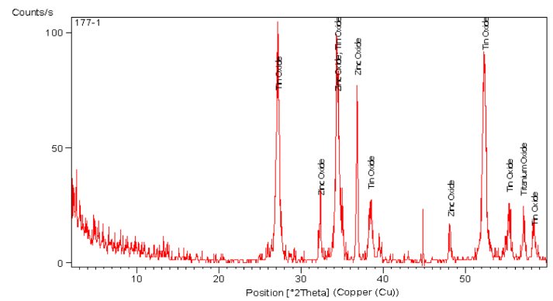
b
a
Figure 1: XRD Pattern of (a) commercially available pure TiO₂ rutile and anatase nanoparticles, and (b) synthesized TiO₂/ZnO/SnO₂ ternary nanostructures.

Figure 2: XPS Spectra of TiO₂/ZnO/SnO₂ nanocomposites (a) the survey spectra (b) O 1s (c) Sn 3d (d) Ti 2p (e) Zn 2p

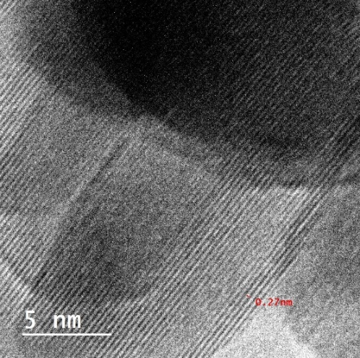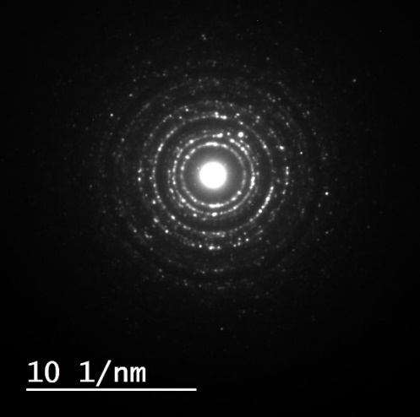
(g)
(h)
Figure 3: TEM image (a,b, and C) of TiO₂ readymade nanoparticles and (b,c,d,e,f,g and h) of synthesized TiO₂/ZnO/SnO₂ at different levels.

Figure 4: SEM images (a, b and c) of the synthesized nanocomposite at different magnifications.

Table 1. Summary of System Suitability and Validation Parameters for HPLC Analysis of Metronidazole

System Suitability Parameters
Retention time (min) | 3.82
Theoretical plates (N) | 7650
Tailing factor (T) | 1.12
Capacity factor (k′) | 1.15
Selectivity (α) | 1.28
Resolution (Rs) | 4.87
Height equivalent to theoretical plate (mm) | 0.032

Validation Parameters
Linearity range (µg/mL) | 1 – 50
Correlation coefficient (R²) | 0.9999
Regression equation | y = 15.832x + 1.268
LOD (µg/mL) | 0.14
LOQ (µg/mL) | 0.42
Accuracy (mean ± SD) | 99.85 ± 1.02
Repeatability (intra-day RSD %) | 0.56
Intermediate precision (inter-day RSD %) | 1.75
Robustness (% RSD)
Asymmetric factor (T) | 0.55
Capacity factor (k′) | 1.15
Figure 5: (a) HPLC chromatogram of the recovered MNZ using the method stated (b) HPLC chromatogram of the degraded MNZ showing the elution of its degradation products at lower retention time.

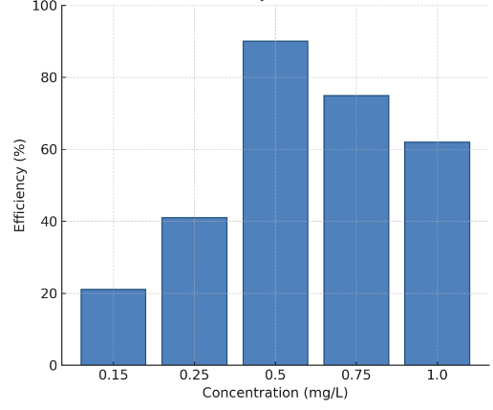
Figure 6. The effect on initial photocatalyst concentration on the degradation of MNZ, showing an optimum activity at 0.5mg/L

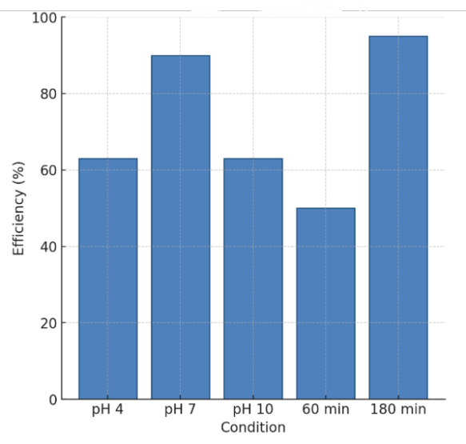
Figure 7. Effect of pH and time on MNZ photocatalytic degradation showing neutral pH 7 at time 120 minutes to be of optimal activity and expected the 180 minutes has improved degradation

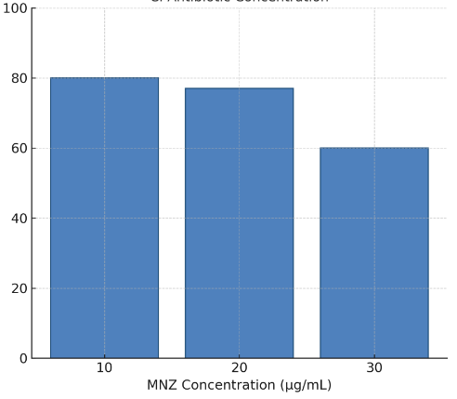
Figure 8. The effect of initial MNZ concentration on the efficiency of the photocatalytic degradation

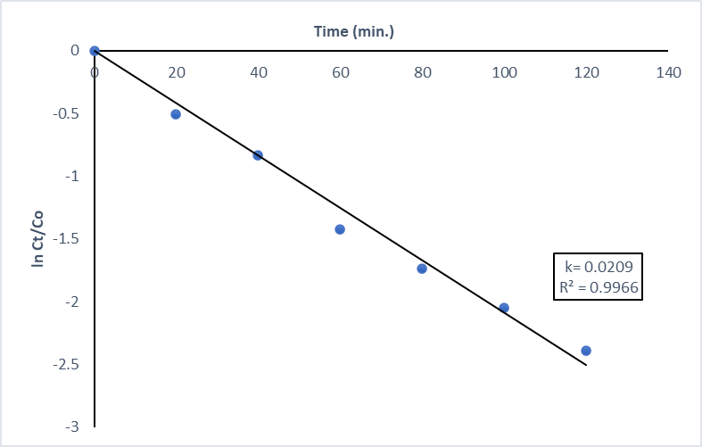
t_{1/2 =} 36.1 minutes

Figure 9: Kinetic profile of the photodegradation of 250 µg/mL initial MNZ concentration at pH 7 with 0.5 mg/mL of ZnO/SnO₂/TiO₂ nanocatalyst

Reference values for HPLC parameters: k′ ≥ 1, α ≥ 1, Rs ≥ 1.5, T ≤ 2 and N ≥ 2000
LOD determined by the formula 3.3 × (SD of the response/slope)
LOQ determined by the formula 10 × (SD of the response/slope)
Mean of nine determinations over three concentration levels
Average of nine determinations with deliberate method parameter variations
Studied factors: wavelength (±2 nm), flow rate (±0.1 mL/min), and mobile phase pH (±1%)

