Supplementary Material
Surrounded by genes: Parental genetic effects on children’s mental health
Supplementary figures

- Supplementary Figure S1a-d: Density and Box-and-whisker plots comparing distributions of complete and imputed data for each outcome measure
- Supplementary Figure S2: A visual overview of the single-polygenic score models

Supplementary tables

- Supplementary Table S1: Genome-wide association study summary statistics used to compute polygenic scores
- Supplementary Table S2: Auxiliary variables included in the multiple imputation model
- Supplementary Table S3: Statistics single-polygenic score models

Supplementary Notes

- Supplementary Methods S1: Summary statistics used to conduct polygenic scores
- Supplementary Methods S2: Description of polygenic score creation
- Supplementary Methods S3: Description of Multiple Imputation of the Phenotypic Data
- Supplementary References
- Extended Acknowledgements
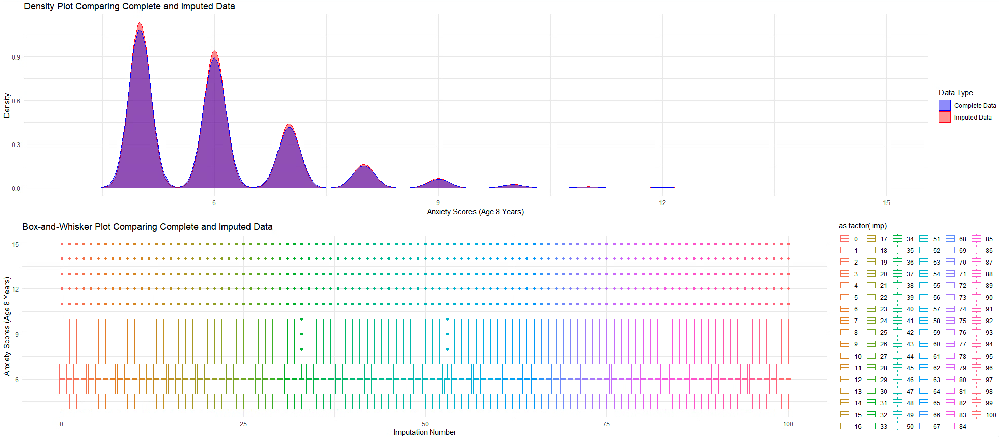
Supplementary Figure S1. (a) Density and Box-and-whisker plots comparing distributions of complete and imputed data for anxiety scores at age 8

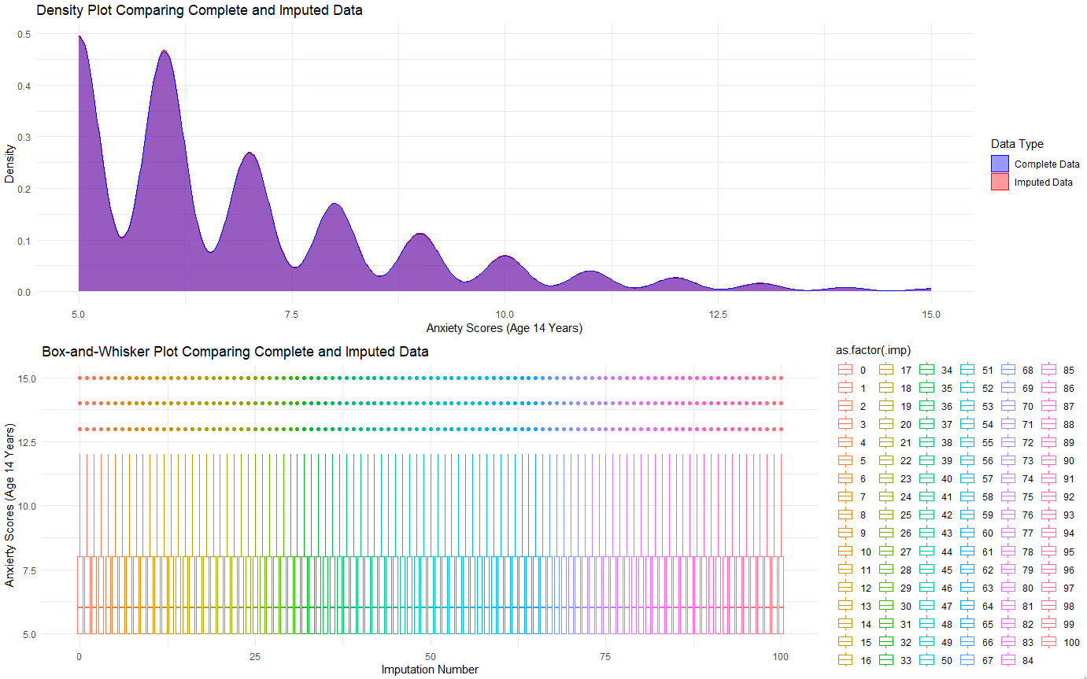
Supplementary Figure S1. (b) Density and Box-and-whisker plots comparing distributions of complete and imputed data for anxiety scores at age 14

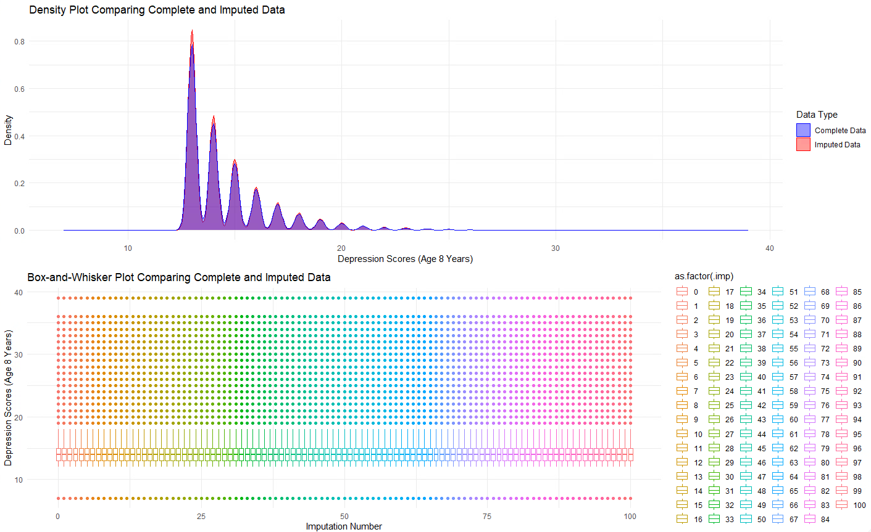
Supplementary Figure S1. (c) Density and Box-and-whisker plots comparing distributions of complete and imputed data for depression scores at age 8

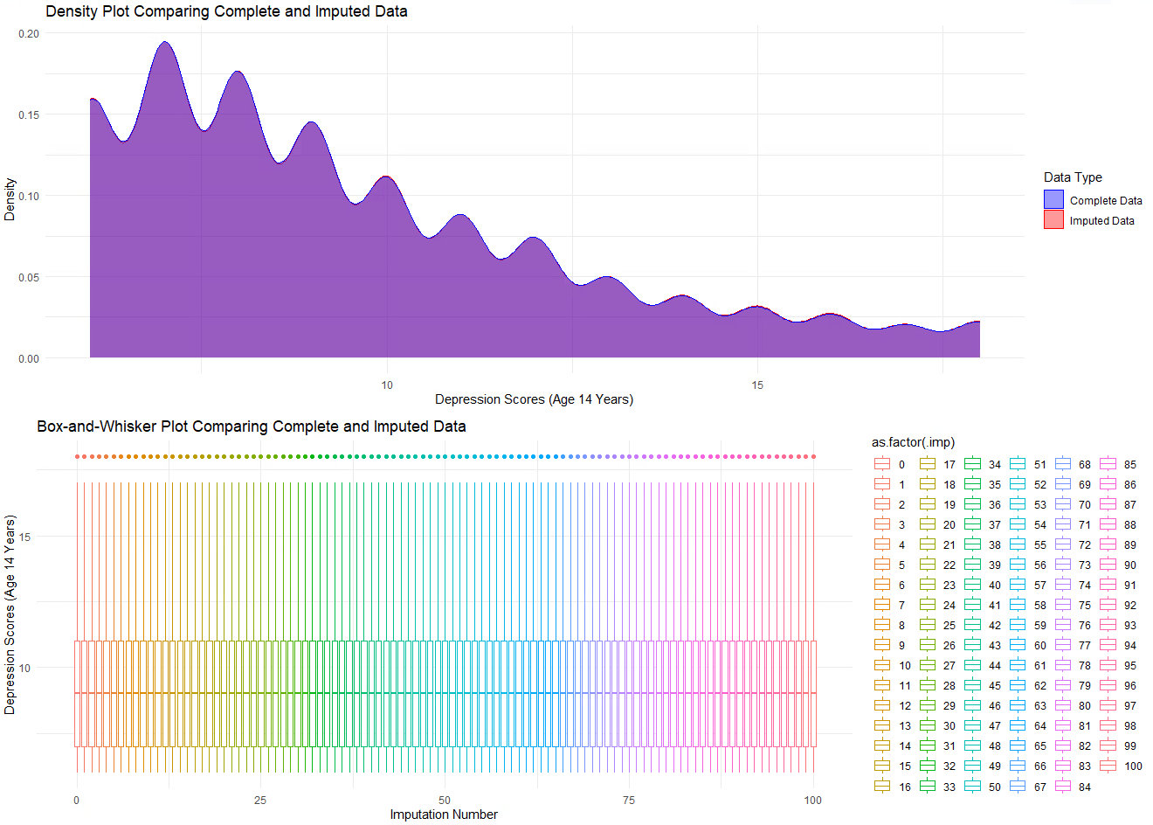
Supplementary Figure S1. (d) Density and Box-and-whisker plots comparing distributions of complete and imputed data for depression scores at age 14

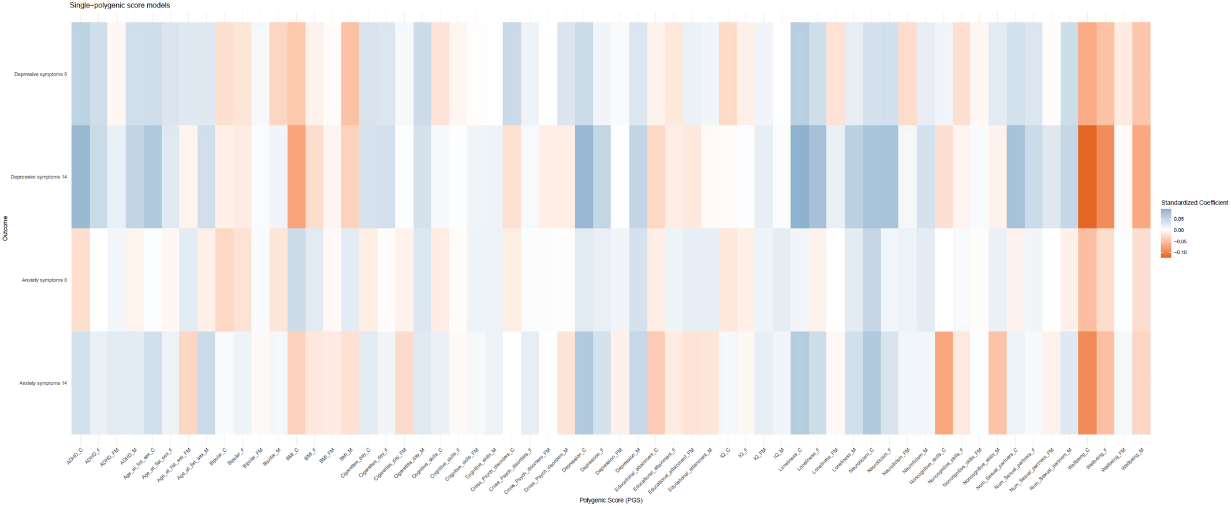
Supplementary Figure S2. A visual overview of the single-polygenic score models
Supplementary Table S1. Genome-wide association study summary statistics used to compute polygenic scores
phenotype | Study | N | N_SNP | SNP-h² | SE | PMID
Educational attainment | Okbay et al. (2022) | 765,283 | 3,952 | 0.132 | 0.008 | 35361970
BMI | Yengo et al., (2018) | 681,275 | 3,290 | 0.060 | - | 30124842
Number of sexual partners | Karlsson Linnér et al. (2019) | 370,711 | 38 | 0.058 | 0.003 | 30643258
Age at first sex | Karlsson Linnér et al. (2019) | 125,667 | 38 | 0.058 | 0.003 | 30643258
IQ | Savage et al. (2018) | 269,867 | 205 | 0.19 | 0.010 | 29942086
Cognitive skills ª | Demange et al. (2021) | 510,795 | - | 0.148 | 0.004 | 33414549
Non-cognitive skills ª | Demange et al. (2021) | 510,795 | - | 0.115 | 0.004 | 33414549
Depression | Howard et al. (2019) | 500,199 | 102 | 0.089 | - | 30718901
Bipolar disorder | Mullins et al. (2021) | 413,466 | 64 | 0.186 | 0.008 | 34002096
ADHD | Demontis et al. (2023) | 225,534 | 27 | 0.140 | 0.010 | 36702997
Cross psychiatric disorders (CPD) | Lee et al. (2019) | 727,126 | 109 | 0.20-0.50 | - | 31835028
Neuroticism | Turley et al.‚ 2019 | 168,105 | 9 | - | - | 29292387
Number of cigarettes/day | Liu et al. (2019) | 245,876 | 406 | - | - | 30643251
Loneliness | Day et al. (2018) | 452,302 | 15 | 0.42 | 0.020 | 29970889
Well-being spectrum | Baselmans et al. (2019) | 2,311,180 | 304 | 0.04-0.10 | 0.004-0.01 | 30643256
ª GWAS-by-subtraction; Note: SNP-h2 = Single nucleotide polymorphism (SNP) heritability; SE = Standard Error; BMI = Body mass index; ADHD = Attention-deficit/hyperactivity disorder

Supplementary Table S2. Auxiliary variables included in the multiple imputation model.
Auxiliary variable | Age assessed (years) | Informant | Variable type | How variable is transformed in the imputation model
Child’s emotional reactivity (CBCL) | 1.5, 3, 5 | Mother | Numeric | Continous
Child’s Emotionality (EAS) | 1.5, 3, 5 | Mother | Numeric | Continous
Child’s social behavior (SDQ) | 3, 5 | Mother | Numeric | Continous
Child’s social development/interest in others (SCQ) | 3, 5 | Mother | Numeric | Continous
Child’s social play (PPBS) | 5 | Mother | Numeric | Continous
CBCL = Child Behavior Checklist; EAS = Emotionality, Acticity and Shyness Temperament Questionnaire; SDQ = Strength and Difficulties Questionnaire; SCQ = Social Communication Questionnaire; PPBS = Preschool Play Behavior Scale

Supplementary Table S3: Statistics single-polygenic score models

[see attachment: ‘Supplementary Table S3.xlsx’]

Supplementary Notes
Supplementary Methods S1: Summary statistics used to conduct polygenic scores
Polygenic scores were computed for risk factors using GWAS summary statistics from samples of European descent. The GWAS selected had sufficient power for polygenic score analysis based on established criteria: SNP-heritability (SNP-h²) estimates higher than 0.05 and SNP-h² Z-scores (calculated as SNP-h² scores divided by its standard error) higher than 2.
Supplementary Methods S2: Description of polygenic score creation
Polygenic scores are single values that represent an individual’s genetic predisposition for a specific trait. These scores are computed by summing the weighted effects of trait-associated single nucleotide polymorphisms (SNPs), where the weights are derived from large and independent GWAS discovery samples. SNP effects are assumed to contribute additively to genetic liability. Polygenic scores can be computed based on a subset of SNPs (typically selected as those SNPs reaching specific p-value thresholds in GWAS) or across the entire genome.
Ldpred1 (Privé et al., 2020) was used to compute the polygenic scores. Ldpred1 is Basysian approach that uses a prior on the expected polygenicity of a trait (assumed fraction of non-zero effect markers) and adjusts for linkage disequilibrium based on a reference panel to compute SNPs weights. We used the infinitesimal prior and the UK Biobank sample as a reference panel for the LD structure.
To control for population stratification, we adjusted for polygenic scores by residualizing them for the first 10 principal components (estimated from the genome-wide SNP data and number of batches), sex, and age. For interpretability, all polygenic scores will be standardized to have a mean of 0 and a standard deviation of 1.

Supplementary Methods S3: Description of Multiple Imputation of the Phenotypic Data
For the imputation of missing data, R package mice was used (van Buuren & Groothuis-Oudshoorn, 2011). To address potential violations of the missing-at-random assumption, we incorporated auxiliary variables previously identified as being associated with internalizing problems. These variables were selected from earlier assessments, which were less affected by attrition, encompassing the Emotional reactivity subscale of the Child Behavior Checklist (CBCL; Achenbach, 1992) and child’s emotionality subscale from the Emotionality, Activity and Shyness Temperament Questionnaire (EAS; Mathiesen & Tambs, 1999) from maternal report when the child was 1.5, 3, and 5 years old, child’s social and prosocial behavior and interest in others at age 3 and 5 from the Strength and Difficulties Questionnaire (SDQ; Goodman, 1997), the social play subscale of the Preschool Play Behavior Scale (PPBS; Coplan & Rubin, 1998) at age 5 and the mothers responses to SMFQ and SCARED at age 14. All the 17 polygenic scores included in the main analysis of the trio were also included in the mulyiple imputation processes. We included the trio polygenic scores in the imputtaion process in line with current recommendations to impute based on all varaibles used in the main analysis (Kontopantelis et al., 2017; van Buuren, 2018; van Ginkel et al., 2020). Density and Box-and-whisker plots comparing distributions of complete and imputed data for each outcome measure can be seen in Supplementary Figure 2a-d.

Supplementary References
Achenbach, T. M., McConaughy, S. H., Ivanova, M. Y., & Rescorla, L. A. (2017). Manual for the ASEBA Brief problem monitor for ages 6–18 (BPM/6–18). Burlington: University of Vermont Research Center for Children, Youth, and Families.
Baselmans, B. M., Jansen, R., Ip, H. F., van Dongen, J., Abdellaoui, A., van de Weijer, M. P., ... & Bartels, M. (2019). Multivariate genome-wide analyses of the well-being spectrum. Nature Genetics, 51(3), 445-451.
Buss, A. H., & Plomin, R. (2014). Temperament (PLE: Emotion): Early developing personality traits. Psychology press.
Chang, C. C., Chow, C. C., Tellier, L. C., Vattikuti, S., Purcell, S. M., & Lee, J. J. (2015). Second-generation PLINK: rising to the challenge of larger and richer datasets. GigaScience, 4(1), s13742-015.
Choi, S. W., & O'Reilly, P. F. (2019). PRSice-2: Polygenic Risk Score software for biobank-scale data. GigaScience, 8(7), giz082.
Coombes, B. J., Ploner, A., Bergen, S. E., & Biernacka, J. M. (2020). A principal component approach to improve association testing with polygenic risk scores. Genetic Epidemiology, 44(7), 676-686.
Coplan, R. J. & Rubin, K. H. (1998). Exploring and assessing non-social play in the preschool: The development and validation of the preschool play behaviour scale. Social Development 7 (1): 72-91.
Day, F. R., Ong, K. K., & Perry, J. R. (2018). Elucidating the genetic basis of social interaction and isolation. Nature communications, 9(1), 2457.
Demontis, D., Walters, R. K., Martin, J., Mattheisen, M., Als, T. D., Agerbo, E., et al. (2019). Discovery of the first genome-wide significant risk loci for attention deficit/hyperactivity disorder. Nature Genetics, 51(1), 63–75.
Goodman, R., Meltzer, H., & Bailey, V. (1998). The Strengths and Difficulties Questionnaire: A pilot study on the validity of the self-report version. European child & adolescent psychiatry, 7(3), 125-130.
Howard, D. M., Adams, M. J., Clarke, T.-K., Hafferty, J. D., Gibson, J., Shirali, M., et al. (2019). Genome-wide meta-analysis of depression identifies 102 independent variants and highlights the importance of the prefrontal brain regions. Nature Neuroscience, 22(3), 343–352.
International Obsessive Compulsive Disorder Foundation Genetics Collaborative (IOCDF-GC) & OCD Collaborative Genetics Association Studies (OCGAS). (2017). Revealing the complex genetic architecture of obsessive–compulsive disorder using meta-analysis. Molecular Psychiatry, 23(5), 1181-1188.
Karlsson Linnér, R., Biroli, P., Kong, E., Meddens, S. F. W., Wedow, R., Fontana, M. A., ... & Beauchamp, J. P. (2019). Genome-wide association analyses of risk tolerance and risky behaviors in over 1 million individuals identify hundreds of loci and shared genetic influences. Nature Genetics, 51(2), 245-257.
Kontopantelis, E., White, I. R., Sperrin, M., & Buchan, I. (2017). Outcome-sensitive multiple imputation: a simulation study. BMC Medical Research Methodology, 17(1), 2.
Lee, J. J., Wedow, R., Okbay, A., Kong, E., Maghzian, O., Zacher, M., ... & Cesarini, D. (2018). Gene discovery and polygenic prediction from a genome-wide association study of educational attainment in 1.1 million individuals. Nature Genetics, 50(8), 1112-1121.
Liu, M., Jiang, Y., Wedow, R., Li, Y., Brazel, D. M., Chen, F., ... & Vrieze, S. (2019). Association studies of up to 1.2 million individuals yield new insights into the genetic etiology of tobacco and alcohol use. Nature genetics, 51(2), 237-244.
Manichaikul, A., Mychaleckyj, J. C., Rich, S. S., Daly, K., Sale, M., & Chen, W. M. (2010). Robust relationship inference in genome-wide association studies. Bioinformatics, 26(22), 2867-2873.
Mathiesen, K. S. & Tambs, K. (1999). The EAS Temperament Questionnaire—factor structure, age trends, reliability, and stability in a Norwegian sample. Journal of Child Psychology and Psychiatry 40: 431-439.
Nagel, M., Jansen, P. R., Stringer, S., Watanabe, K., De Leeuw, C. A., Bryois, J., ... & Posthuma, D. (2018). Meta-analysis of genome-wide association studies for neuroticism in 449,484 individuals identifies novel genetic loci and pathways. Nature Genetics, 50(7), 920-927.
Nievergelt, C. M., Maihofer, A. X., Klengel, T., Atkinson, E. G., Chen, C. Y., Choi, K. W., ... & Stevens, J. S. (2019). International meta-analysis of PTSD genome-wide association studies identifies sex-and ancestry-specific genetic risk loci. Nature Communications, 10(1), 4558.
Okbay, A., Baselmans, B. M., De Neve, J. E., Turley, P., Nivard, M. G., Fontana, M. A., ... & Power, C. (2016). Genetic variants associated with subjective well-being, depressive symptoms, and neuroticism identified through genome-wide analyses. Nature Genetics, 48(6), 624-633.
Pardiñas, A. F., Holmans, P., Pocklington, A. J., Escott-Price, V., Ripke, S., Carrera, N., ... & Walters, J. T. (2018). Common schizophrenia alleles are enriched in mutation-intolerant genes and in regions under strong background selection. Nature Genetics, 50(3), 381-389.
Rutter, M., Bailey, A., & Lord, C. (2003). SCQ The Social Communication Questionnaire: Manual. Los Angeles: Western Psychological Services.
Savage, J. E., Jansen, P. R., Stringer, S., Watanabe, K., Bryois, J., De Leeuw, C. A., ... & Posthuma, D. (2018). Genome-wide association meta-analysis in 269,867 individuals identifies new genetic and functional links to intelligence. Nature Genetics, 50(7), 912-919.
Stahl, E. A., Breen, G., Forstner, A. J., McQuillin, A., Ripke, S., Trubetskoy, V., ... & Reif, A. (2019). Genome-wide association study identifies 30 loci associated with bipolar disorder. Nature Genetics, 51(5), 793-803.
Turley, P., Walters, R. K., Maghzian, O., Okbay, A., Lee, J. J., Fontana, M. A., ... & Benjamin, D. J. (2018). Multi-trait analysis of genome-wide association summary statistics using MTAG. Nature genetics, 50(2), 229-237.
van Buuren, S. (2018). Flexible imputation of missing data. CRC Press.
van Buuren, S., & Groothuis-Oudshoorn, K. (2011). mice: Multivariate imputation by chained equations in R. Journal of Statistical Software, 45(3), 67.
van Ginkel, J. R., Linting, M., Rippe, R. C. A., & van der Voort, A. (2020). Rebutting existing misconceptions about multiple imputation as a method for handling missing data. Journal of Personality Assessment, 102(3), 297-308.
Wootton, R. E., Richmond, R. C., Stuijfzand, B. G., Lawn, R. B., Sallis, H. M., Taylor, G. M., ... & Munafò, M. R. (2020). Evidence for causal effects of lifetime smoking on risk for depression and schizophrenia: a Mendelian randomisation study. Psychological Medicine, 50(14), 2435-2443.
Yengo, L., Sidorenko, J., Kemper, K. E., Zheng, Z., Wood, A. R., Weedon, M. N., ... & Giant Consortium. (2018). Meta-analysis of genome-wide association studies for height and body mass index in ~700000 individuals of European ancestry. Human Molecular Genetics, 27(20), 3641-3649.

