Supporting Information
Reversible hydrogenation and dehydrogenation of N-heteroaryl with heterogeneous palladium catalyst for hydrogen storage and transport application
Amardipsing Girase, ¹ Chandrakant Nichinde, ^{1,2} Baliram Patil, ^{1,2} Suryakant Chaudhari, ^{1,2}Anil Kinage*^{1,2}
¹ Chemical Engineering and Process Development Division, Council of Scientific and Industrial Research-National Chemical Laboratory (CSIR-NCL), Pune 411008, India.
² Academy of Scientific and Innovative Research (AcSIR), Ghaziabad-201002, India.
* Correspondence to: Dr. Anil K. Kinage (E-mail: ak.kinage@ncl.res.in)

Contents
1. General information.
2. Optimization of Reaction Condition
3. Experimental Procedure
4. Stability of catalyst
5. Comparison study of H₂ wt. % with recent or state of the art LOHC systems.
6. Calculation molar heat (enthalpy) of reaction.
7. Electrical energy consumption (unit) for reaction
8. GC Traces
9. GCMS Traces
10. Product Characterization
11. NMR Spectra
12. References

1. General information.

¹H NMR and ¹³C NMR spectra were recorded on an AV-400, AV-500 Bruker equipment. All chemical shifts (δ) are reported in parts per million (ppm) downfield of tetramethylsilane and coupling constants (J) in hertz (Hz). The residual solvent signals were used as references for ¹H and ¹³C NMR spectra (CDCl₃: δH = 7.26 , δC = 77.16 ) (DMSO-d6: δH = 2.50 , δC = 39.52). Abbreviations used in the reported NMR experiments: br, broad; s, singlet; d, doublet; t, triplet; q, quartet; m, multiplet. All measurements were carried out at room temperature. Also, LC-HRMS was measured in Hybrid Quadrupole Orbitrap Mass Spectrometer coupled to UHPLC system.
The Product distribution of distereomers was determined by GC total area %.
The hydrogen storage capacity was calculated (H₂ wt %) by using following calculation[1],
1) For Hydrogenation reaction:
H₂ capacity (wt %) $=\frac{Theoratical amount of hydrogen gain in gram }{weight of hydrogenated compound in gram}$ X 100
2) For dehydrogenation reaction:
H₂ capacity (wt %) $=\frac{Theoratical amount of hydrogen realesed in gram }{weight of dehydrogenated compound in gram}$ X 100
For Hydrogen recovery was calculated by using following calculation¹,
H₂ recovery (%)$=\frac{Amount of H2 released in the experiment }{Theoretical amount of H2 released }$ X 100
The X-ray diffraction pattern (powder XRD) of catalyst was recorded using a Rigaku 600 (Cu Kα) diffractometer. All XRD pattern was recorded on 2θ range of 5-70⁰ at scanning rate of 2.5⁰ S⁻¹. The textural properties of the Pd/C were characterized by N₂ adsorption–desorption measurements. Specific surface areas of the Pd/C catalysts were measured by N₂ physisorption using a quanta chrome. A quartz tube with 50 mg of the sample was dried and degassed for 10 h at 250 °C and under 1 MPa vacuum. After the pre-treatment, the adsorption and de-sorption experiment was carried out with N₂ as the ad-sorbed gas and He as the balance gas. High resolution transition electron microscope (HR-TEM) characterization was carried out on JEOL JEM F200.

2. Optimization of Reaction Condition
2.1. Optimization of catalyst wt% for hydrogenation of quinoline
Table-S1 Optimization of catalyst wt% for hydrogenation of quinolineª
Sr.No. | Catalyst (by wt%) | Conversion (%)^{b} | Yield (%) THQ(2a)^{b} | Yield (%) DHQ(3a'+3a'')^{b} | d.r. (3a':3a'')^{c}
1 | 10 | ˃99 | 53.7 | 46.3 | 82:18
2 | 15 | ˃99 | 28.8 | 71.2 | 85:15
3 | 20 | ˃99 | 0 | ˃99 | 80:20

ª unless to otherwise noted, a mixture of 1a (10 g, 77.3 mmol), 20% w/w Pd/C catalyst at 200⁰C , under pressure H₂ gas in 50 ml autoclave for 12 h . ^{b} conversion and yield determined by GC using DMF as the internal standard. ^{c} product distribution determined by GC.
2.2. Optimization of catalyst wt% for dehydrogenation of decahydroquinoline
Table-S2 Optimization of catalyst wt% for dehydrogenation of decahydroquinolineª
Sr. No. | Catalyst (by wt%) | Conversion (%)^{b} | Selectivity of Quinoline(%) (1a)^{b}
1 | 10 | 76.2 | 83.3
2 | 15 | 86.4 | 89.8
3 | 20 | 95.9 | 98.7

ª Unless to otherwise noted, a mixture of 3a (5 mmol), 5 wt% Pd/C at 250⁰C for 14 hours . ^{b} Conversion and selectivity determined by GC using DMF as the internal standard.

3. Experimental Procedure
- Hydrogenation of N-Heterocycles
The catalytic hydrogenation of aromatic heterocyclic compounds was performed in a 50 mL stainless steel autoclave. In a typical experiment, aromatic heterocycle (77.3 mmol), the catalyst (20% w/w) were charged in the reactor. After the removal of the air in the reactor by the exchange with hydrogen gas 5 times, the reactor is pressurized by hydrogen pressure to 5 MPa at room temperature. Then the reaction was carried out at 200⁰C with stirring at 1000 rpm with continues addition of hydrogen. After reaction, the autoclave was cooled to room temperature and the H₂ gas was released from autoclave. Then catalyst was separated by filtration. The product was analysed by gas chromatography and product was confirmed by GCMS. All products were also confirmed by NMR and HRMS after isolation by column chromatography.

- Dehydrogenation of N-Heterocycles
The catalytic dehydrogenation of hydrogenated cyclic N-heterocyclic compounds was conducted in a pear-shaped flask equipped with a magnetic needle and cooling condenser. Saturated N-heterocycle (5 mmol) was charged in flask along with a catalyst (20% w/w) under solvent free condition. The reaction mixture was then heated to the 250⁰C with continuous stirring for the 14 hours. Then, the reaction mixture was cooled to ambient temperature, and the catalyst was separated by filtration followed by washing with methanol. The product mixture was analysed by GC and products were confirmed by GC-MS. After isolation of products through silica-gel column chromatography compounds further characterized by ¹H-NMR, ¹³C-NMR and HRMS
4. Stability of catalyst
4.1. Recycling Experiment and Stability of the 5 wt% Pd/C after the hydrogenation reaction
Cycle No. | 1 | 2 | 3 | 4 | 5
Conversion (%) | 100 | 100 | 98.3 | 98.2 | 97.9
Selectivity (%)  DHQ (3a'+3a'')^{b} | 100 | 100 | 98.8 | 98.5 | 98.3
Table-S3 catalyst recycling experiment using Pd/C catalyst for hydrogenation reaction

4.2. Recycling Experiment and Stability of the 5 wt% Pd/C after the dehydrogenation reaction

Cycle No. | 1 | 2 | 3 | 4 | 5
Conversion (%) | 95.9 | 95.2 | 94.8 | 94.4 | 94.2
Selectivity(%)  Quinoline | 98.7 | 98.4 | 97.8 | 97.5 | 97.2
Table-S4 catalyst recycling experiment using Pd/C catalyst for dehydrogenation reaction

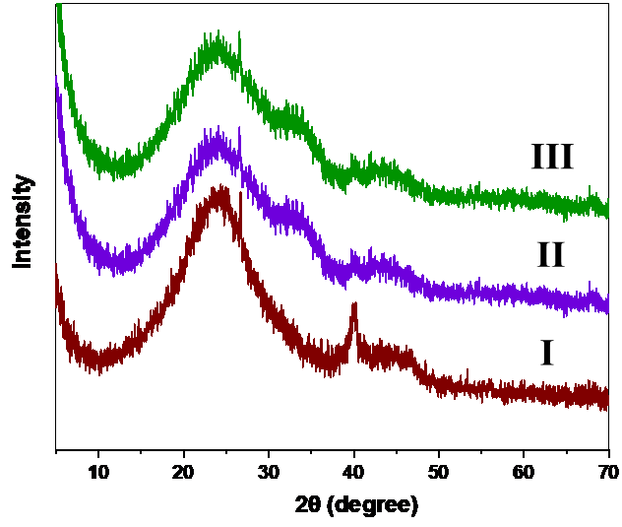
Figure S1 XRD of I) Pd/C fresh catalyst, II) Pd/C catalyst after hydrogenation reaction and III) Pd/C catalyst after dehydrogenation reaction

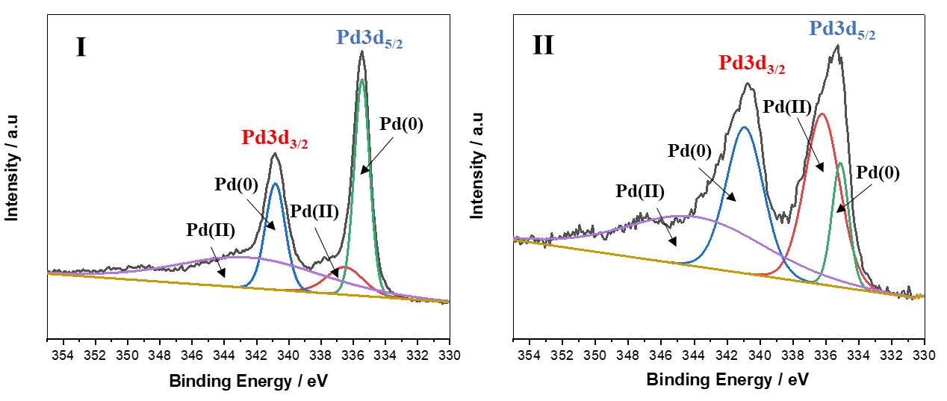
Figure S2 XPS Spectra of Pd 3d region for Pd/C I] Fresh Catalyst & II] Used catalyst [2]

5. Comparison study of H₂ wt. % with recent or state of the art LOHC systems.

LOHC System | H₂ Storage Capacity (wt. %) | Ref.
N-Ethylcarbazole | 5.8 | [3]
Indole | 6.4 | [4]
2,2'- Bipyridine | 7.1 | [5]
Quinoline/DHQ | 7.1 / 6.7 | This work
Table-S5 Comparison study of H2 wt. % with Others LOHC

6. Calculation molar heat (enthalpy) of reaction.

Calculation of molar heat (enthalpy) ΔH by theoretically, [6-8]
$ΔH=ΣΔHproduct-ΣΔHreactant$ -------------------- (1)
If the ΔH is positive then the reaction is endothermic and ΔH is negative then the reaction is exothermic.

Calculation of molar heat (enthalpy) ΔH by experimentally, [9]
$ΔH=\frac{q}{n}$ -------------------- (2)
Where,
ΔH is molar heat
q is rate of heat released or absorbed
n is no. of moles of reactant

But,
$q=V×I$ (Power compensation method) -------------- (3)

Where,
q is rate of heat released or absorbed
V is Voltage supplier to the heater
I is Current supplier to the heater

6.1 Calculation molar heat (enthalpy) for hydrogenation of quinoline reaction.

Calculation of molar heat (enthalpy) ΔH by theoretically [6-8]
In the hydrogenation quinoline with 5moles of H₂ gives the decahydroquinoline as product. In that Enthalpy of quinoline is 141.22 KJ/mole, for H₂ is 0 KJ/mole because of H₂ is in its standard state and for decahydroquinoline is -166.2 KJ/mole. ^{(Reported in ref. 2-4)}
By equation No. 1
$ΔH=ΣΔHproduct-ΣΔHreactant$
= -166.2 – 141.22 ^{(ref. 2-4)}
ΔH = -307.42 KJ/mole -------------- (4)
The negetive value of ΔH indicates that the hydrogenation of quinoline to decahydroquinoline is exothermic.

Calculation of molar heat (enthalpy) ΔH by experimentally [9]
In the hydrogenation of quinoline we carry out with 77.3 mmol that is 0.0773 mole. For hydrogenation reaction requires 200⁰C temperature for 12 hours. From all above we have calculated molar heat (enthalpy) of reaction.

No. of moles of substrate (n) = 0.077 mole
Voltage supplier to the heater (V) = 230 V (Measured by using Voltmeter instrument)
Current supplier to the heater (I) = 1.6 A (Measured by using Clamp meter instrument)

Firstly, calculated the rate of heat released or absorbed by eq. no. 3
$q=V×I$
$q=230×1.6$
$q=368 J$
Then we calculated the molar heat (enthalpy) ΔH by eq. no. 2,
$$ΔH=\frac{q}{n}$$

$$ΔH=\frac{368}{0.077}$$

$$ΔH=4714.3 J/Mole$$

$$ΔH=4.7143 KJ/Mole$$

$$ΔH=-4.7143 KJ/Mole$$

In the hydrogenation of quinoline to decahydroquinoline molar heat obtain is -73.6 KJ/mole. Negative Sign indicating the hydrogenation of quinoline reaction is exothermic by equation no. 4.

6.2 Calculation molar heat (enthalpy) for dehydrogenation of decahydroquinoline reaction.

Calculation of molar heat (enthalpy) ΔH by theoretically [6-8]
In the dehydrogenation of decahydroquinoline gave 5 moles of H₂ as product. In this enthalpy of decahydroquinoline is -166.2 KJ/mole and quinoline is 141.22 KJ/mole and H₂ is 0 KJ/mole because of H₂ is in its standard state. ^{(Reported in ref. 2-4)}
By equation No. 1
$ΔH=ΣΔHproduct-ΣΔHreactant$
= 141.22- (-166.2) ^{(ref. 2-4)}
ΔH = 307.42 KJ/mole -------------- (5)
The positive value of ΔH indicates that the dehydrogenation of decahydroquinoline to quinoline is endothermic.

Calculation of molar heat (enthalpy) ΔH by experimentally [9]
In the dehydrogenation of decahydroquinoline we use 5 mmol that is 0.005 mole. For dehydrogenation reaction requires 250⁰C temperature for 14 hours. From all above we have calculated molar heat (enthalpy) of reaction.

No. of moles of substrate (n) = 0.005 mole (5mmol)
Voltage supplier to the heater (V) = 230 V
Current supplier to the heater (I) = 5.5 A

Firstly we calculated the rate of heat released or absorbed by eq. no. 3
$q=V×I$
$q=230×5.5$
$q=1265 J$
Then we calculated the molar heat (enthalpy) ΔH by eq. no. 2,
$$ΔH=\frac{q}{n}$$

$$ΔH=\frac{1265}{0.005}$$

$$ΔH=253000 J/Mole$$

$$ΔH=253 KJ/Mole$$

In the dehydrogenation of decahydroquinoline to quinoline molar heat obtained was 253KJ/mole. Positive Sign indicating the dehydrogenation of decahydroquinoline reaction is endothermic by equation no. 5.

7. Electrical energy consumption (unit) for reaction

7.1. Electrical energy consumption (unit) for hydrogenation reaction.
In the hydrogenation of quinoline initial temperature is 28⁰C and final temperature was 200 ⁰C and time required to reaching the temperature is 18 minutes.
So, electrical energy required for reaching 200 ⁰C is 0.09 kWh
Then, continues the temperature 200⁰C for 12 hours Electrical energy required is 2.35 kWh
Total electrical energy consumption for hydrogenation reaction is 2.5 kWh per reaction. Estimated cost for one reaction is 0.29 $.

7.2. Electrical energy consumption (unit) for dehydrogenation reaction.
In the dehydrogenation of decahydroquinoline initial temperature is 30⁰C and final temperature is 250 ⁰C and time required to reach the temperature is 34 minutes.
So, electrical energy required for reaching 250 ⁰C is 0.675 kWh
Then, continues the temperature 250⁰C for 14 hours for this electrical energy required is 7.084 kWh.
Total Electrical energy consumption for dehydrogenation reaction is 7.759 kWh per reaction. Estimated cost for one reaction is 0.89 $.

8. GC Traces
Hydrogenation of 1a (Quinoline):
Figure S3 GC spectrum of the products formed in the hydrogenation of 1a

Hydrogenation of 1b (2-Methyl Quinoline):
Figure S4 GC spectrum of the products formed in the hydrogenation of 1b

Hydrogenation of 1c (4-Methyl Quinoline):
Figure S5 GC spectrum of the products formed in the hydrogenation of 1c

Dehydrogenation of 3a (Decahydroquinoline):
Figure S6 GC spectrum of the products formed in the dehydrogenation of 3a
Dehydrogenation of 3b (2-Methyl Decahydroquinoline):

Figure S7 GC spectrum of the products formed in the dehydrogenation of 3b

Dehydrogenation of 3c (4-Methyl Decahydroquinoline):
Figure S8 GC spectrum of the products formed in the dehydrogenation of 3C

9. GCMS Traces

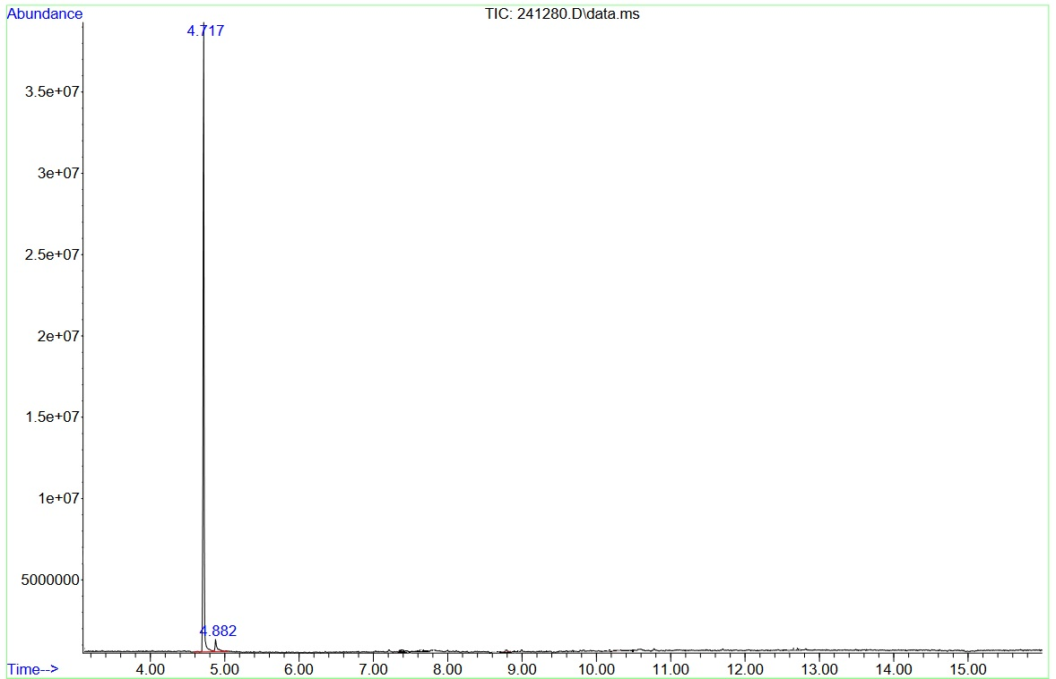
Counts (%) vs. Acquisition Time (min)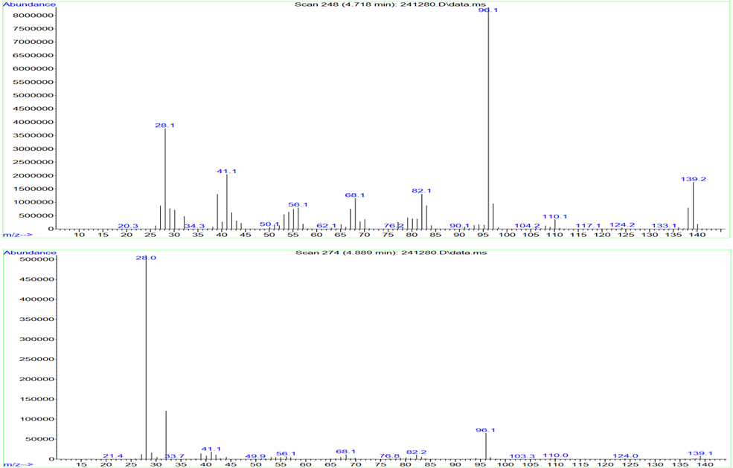
Counts vs. Mass-to-Charge (m/z)
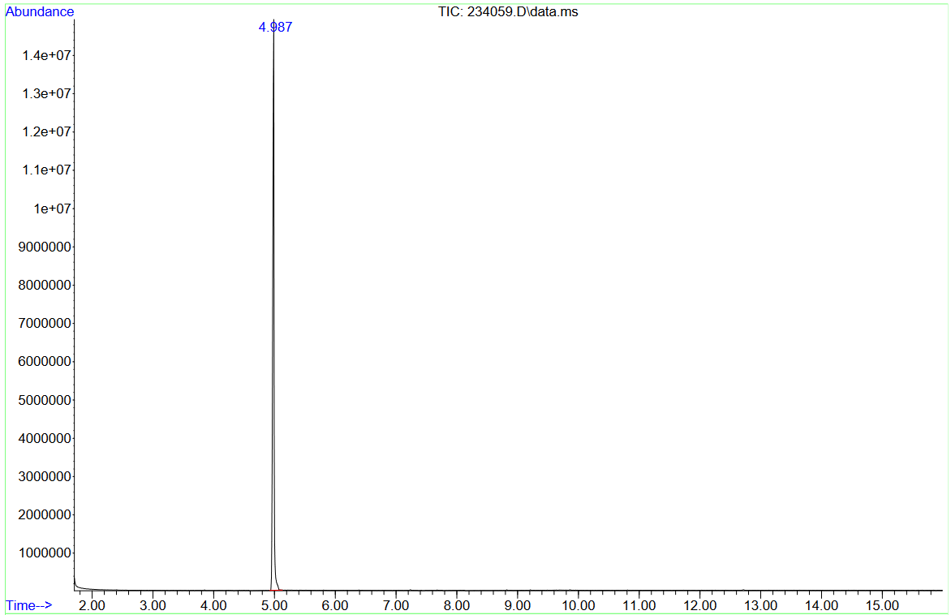
Counts (%) vs. Acquisition Time (min)

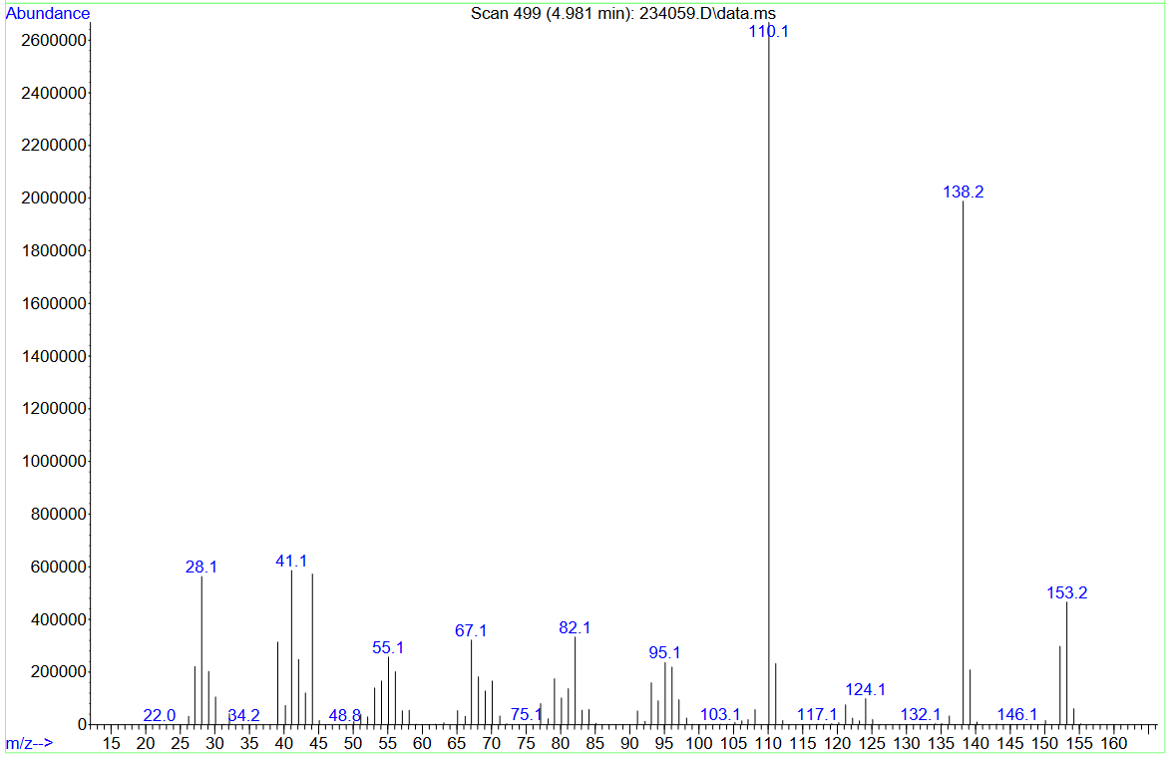
Counts vs. Mass-to-Charge (m/z)
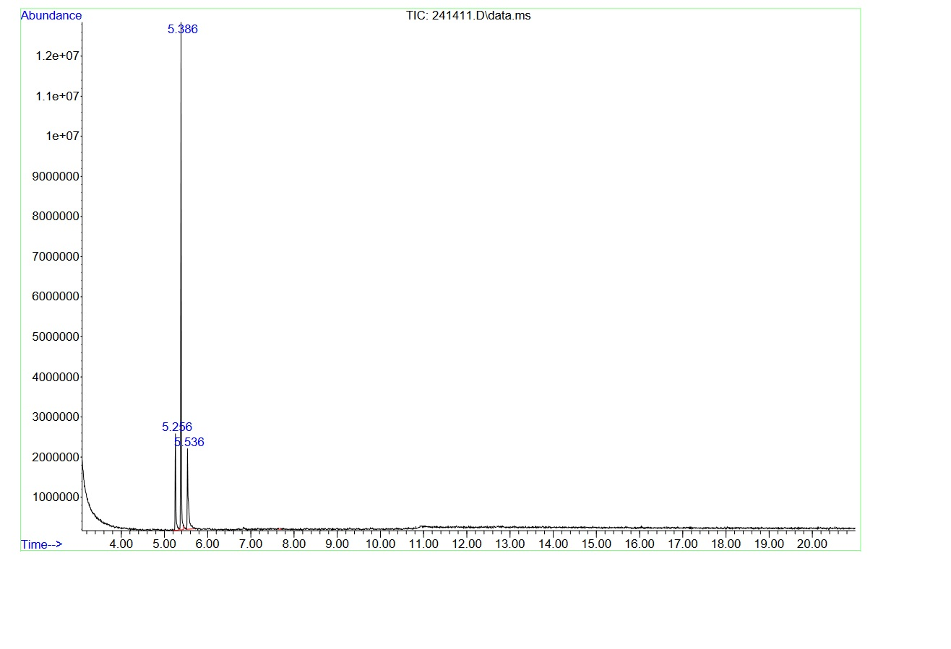
Counts (%) vs. Acquisition Time (min)
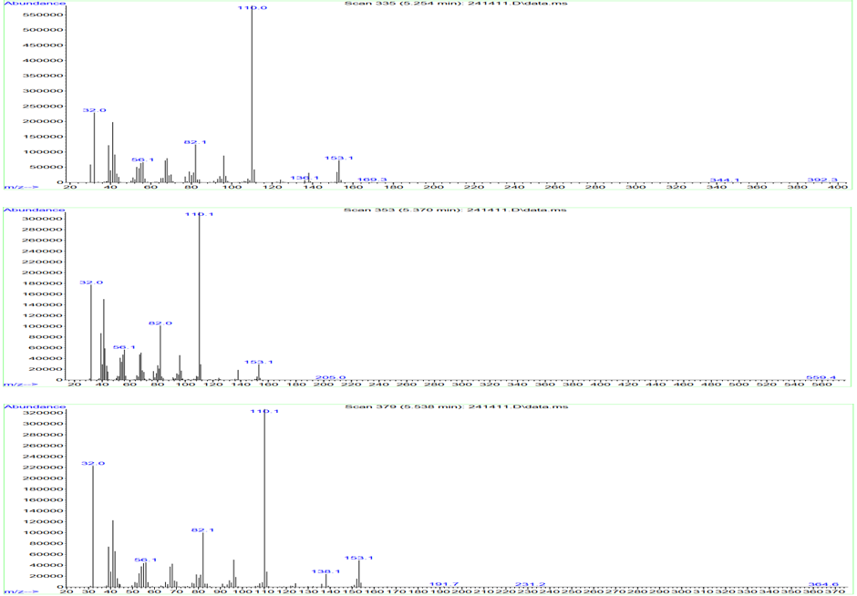
Counts vs. Mass-to-Charge (m/z)

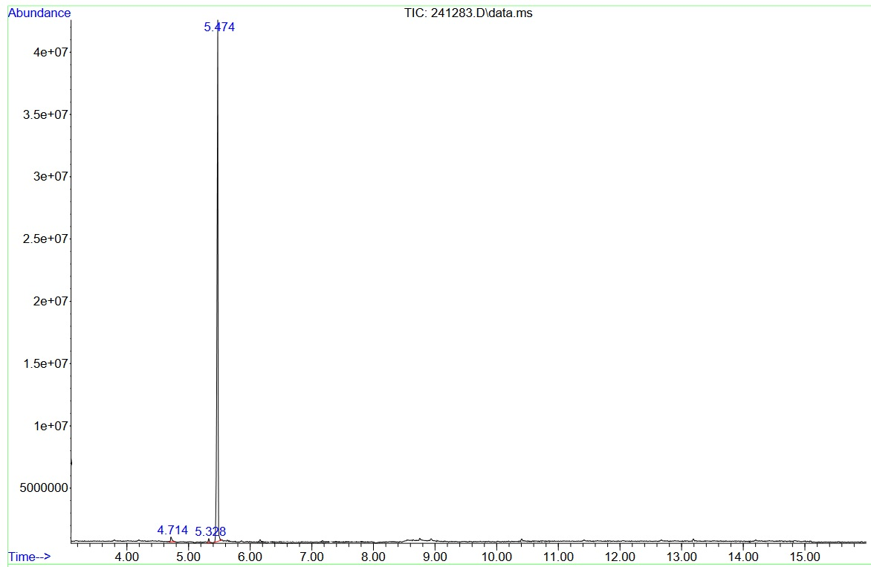
Counts (%) vs. Acquisition Time (min)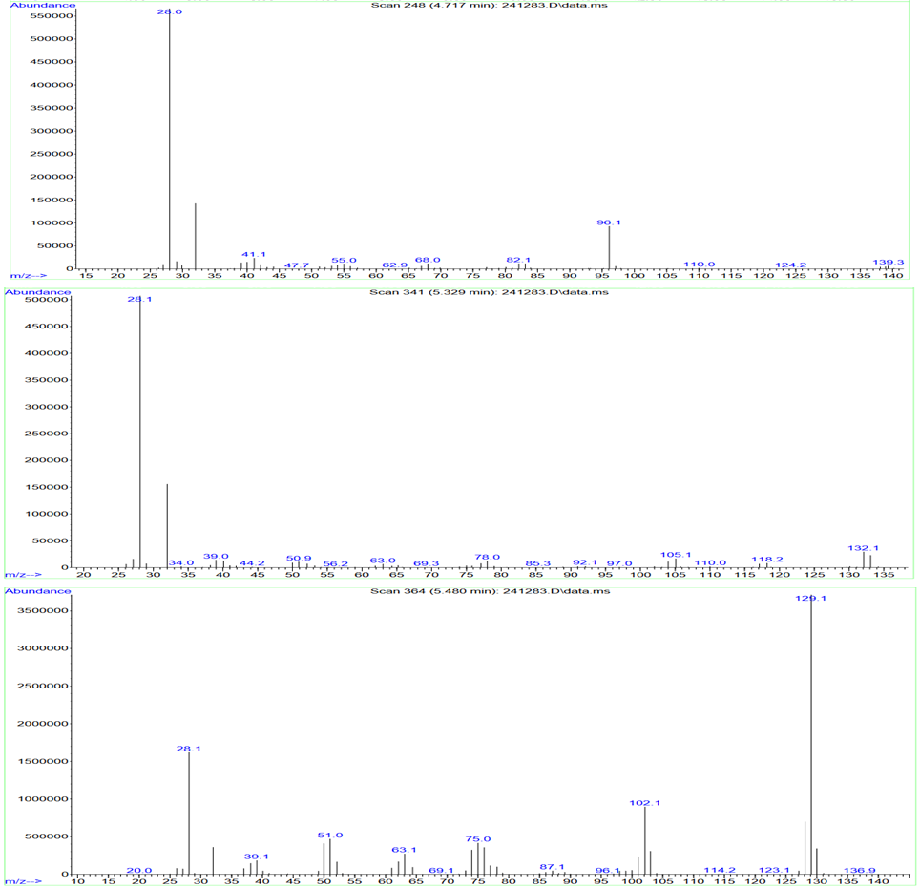
Counts vs. Mass-to-Charge (m/z)
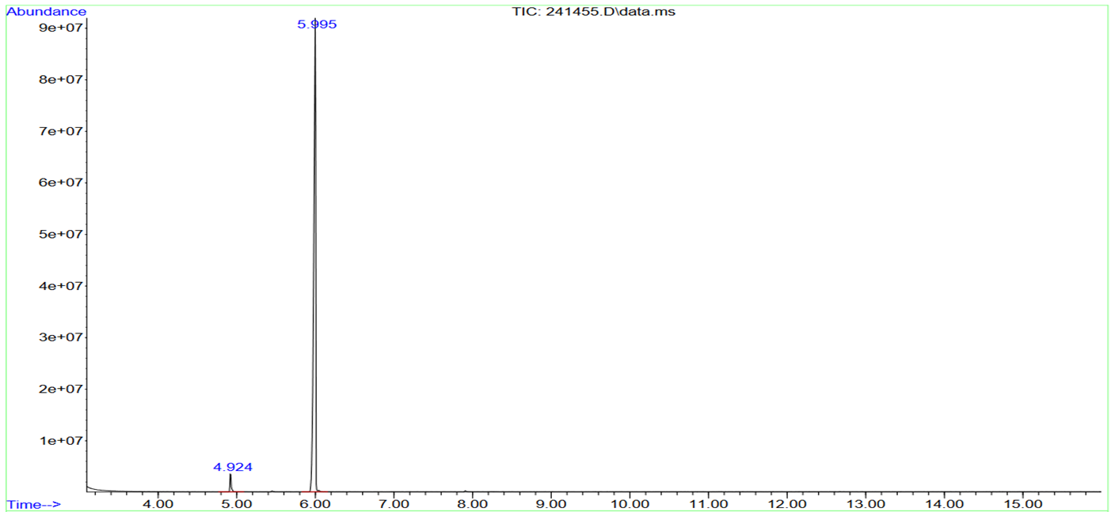
Counts (%) vs. Acquisition Time (min) 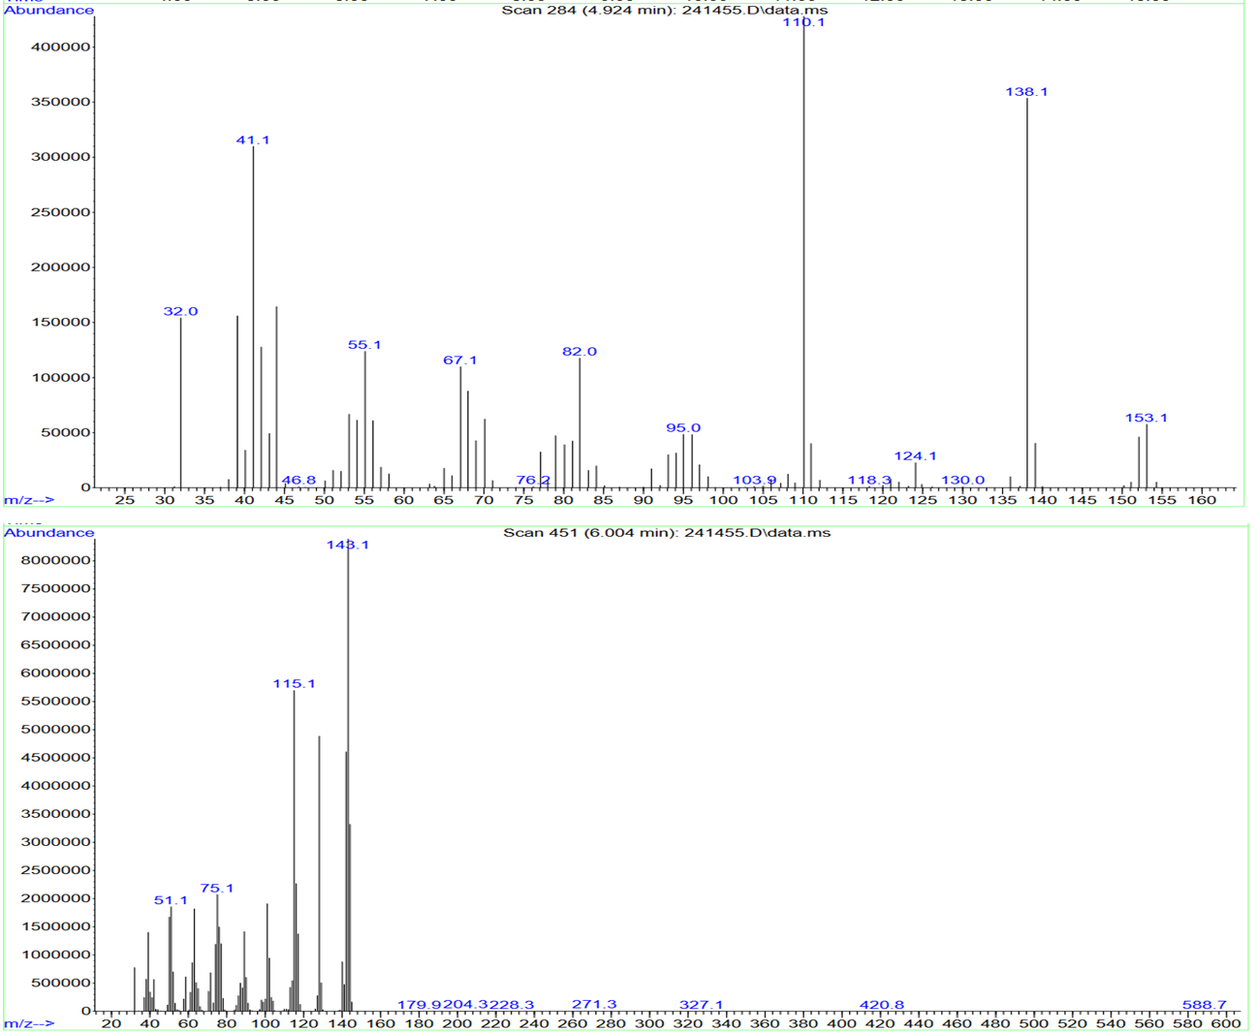
Counts vs. Mass-to-Charge (m/z)
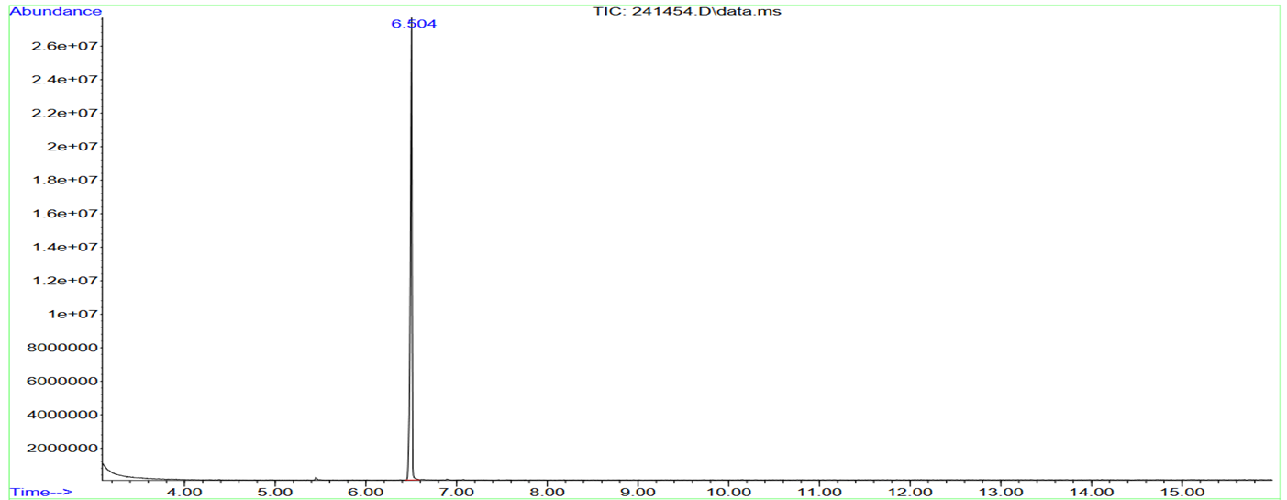
Counts (%) vs. Acquisition Time (min)

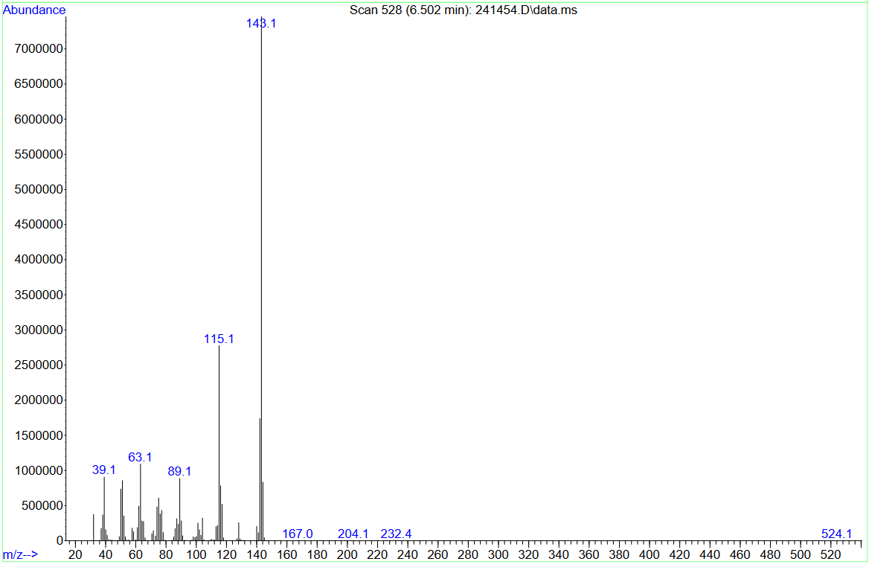
Counts vs. Mass-to-Charge (m/z)

10. Product Characterization (All reported yield are isolated)
Decahydroquinoline (3a)
The title compound was prepared by the optimized hydrogenation procedure 1.
Obtained as a liquid (10.6 g, 98% yield). NMR value matches with previous report [10].
¹H NMR (400 MHz, CDCl₃) δ 2.96 - 3.16 (m, 1 H) 2.79 - 2.92 (m, 1 H) 2.57 - 2.75 (m, 1 H) 0.81 - 2.02 (m, 14 H); ¹³C NMR (101 MHz, CDCl₃) δ 61.9, 54.9, 47.1, 43.1, 35.6, 33.8, 32.5, 27.0, 26.1; HRMS (ESI) m/z Calculated for C₉H₁₇N [H]⁺: 140.14, found: 140.1433

2-Methyl Decahydroquinoline (3b)
The title compound was prepared by the optimized hydrogenation procedure 1.
Obtained as a liquid (11.4 g, 96% yield) NMR value matches with previous report [10].
¹H NMR (400 MHz, CDCl₃) δ 2.53 - 2.73 (m, 1 H) 2.05 - 2.29 (m, 1 H) 1.36 - 1.80 (m, 7 H) 0.72 - 1.35 (m, 12 H); ¹³C NMR (101 MHz, CDCl₃) δ 61.92, 52.70, 42.03, 34.56, 33.44, 32.37, 32.31, 26.20, 25.53, 22.67. HRMS (ESI) m/z Calculated for C₁₀H₁₉N [H]⁺: 154.16, found: 154.1591

4-Methyl Decahydroquinoline (3c)
The title compound was prepared by the optimized hydrogenation procedure 1.
Obtained as a liquid (11.5 g, 97% yield).
¹H NMR (400 MHz, CDCl₃) δ 2.82 - 3.17 (m, 1 H) 2.55 - 2.73 (m, 1 H) 1.04 - 2.26 (m, 14 H) 0.78 - 1.04 (m, 3 H); ¹³C NMR (101 MHz, CDCl₃) δ 55.93, 47.25, 40.85, 34.73, 32.72, 29.18, 25.95, 20.62, 18.91, 18.88; HRMS (ESI) m/z Calculated for C₁₀H₁₉N [H]⁺: 154.16, found: 154.1592

Quinoline (1a)
The title compound was prepared by the optimized dehydrogenation procedure 2.
Obtained as a liquid (587.9 mg, 91% yield) NMR value matches with previous report [11].
¹H NMR (500 MHz, CDCl₃) δ 8.91 (d, J=1.38 Hz, 1 H) 8.12 (d, J=8.38 Hz, 2 H) 7.79 (d, J=8.13 Hz, 1 H) 7.65 - 7.75 (m, 1 H) 7.47 - 7.60 (m, 1 H) 7.31 - 7.42 (m, 1 H); ¹³C NMR (125 MHz, CDCl₃) δ 150.42, 148.30, 136.03, 129.46, 129.45, 128.28, 127.79, 126.53, 121.07; HRMS (ESI) m/z Calculated for C₉H₇N [H]+: 130.07, found: 130.0654

2-Methyl Quinoline (1b)
The title compound was prepared by the optimized dehydrogenation procedure 2.
Obtained as a liquid (644.4 mg, 90% yield) NMR value matches with previous report [11].
¹H NMR (400 MHz, CDCl₃) δ 7.94 (d, J=8.38 Hz, 2 H) 7.67 (d, J=8.13 Hz, 1 H) 7.59 (t, J=7.63 Hz, 1 H) 7.34 - 7.42 (m, 1 H) 7.18 (d, J=8.38 Hz, 1 H) 2.66 (s, 3 H); ¹³C NMR (101 MHz, CDCl₃) δ 159.24, 148.13, 136.40, 129.66, 128.88, 127.73, 126.73, 125.90, 122.24, 25.63; HRMS (ESI) m/z Calculated for C₁₀H₉N [H]+: 144.08, found: 144.0808

4-Methyl Quinoline (1c)
The title compound was prepared by the optimized dehydrogenation procedure 2.
Obtained as a liquid (701.7 mg, 98% yield).
¹H NMR (400 MHz, CDCl₃) δ 8.77 (d, J=4.38 Hz, 1 H) 8.11 (d, J=8.38 Hz, 1 H) 7.98 (dd, J=8.32, 0.94 Hz, 1 H) 7.70 (ddd, J=8.35, 6.91, 1.38 Hz, 1 H) 7.55 (ddd, J=8.25, 6.94, 1.19 Hz, 1 H) 7.16 - 7.23 (m, 1 H) 2.69 (s, 3 H); ¹³C NMR (101 MHz, CDCl₃) δ 150.18, 147.9, 144.29, 130.02, 129.11, 128.29, 126.28, 123.81, 121.86, 18.65; HRMS (ESI) m/z Calculated for C₁₀H₉N [H]+: 144.08, found: 144.0808

11. NMR Spectra
¹H NMR Spectrum of Compound 3a (400 MHz, CDCl₃)
¹³C NMR Spectrum of Compound 3a (101 MHz, CDCl₃)

¹H NMR Spectrum of Compound 3b (400 MHz, CDCl₃)
¹³C NMR Spectrum of Compound 3b (101 MHz, CDCl₃)

¹H NMR Spectrum of Compound 3c (400 MHz, CDCl₃)
¹³C NMR Spectrum of Compound 3c (101 MHz, CDCl₃)

¹H NMR Spectrum of Compound 1a (500 MHz, CDCl₃)
¹³C NMR Spectrum of Compound 1a (125 MHz, CDCl₃)

¹H NMR Spectrum of Compound 1b (400 MHz, CDCl₃)
¹³C NMR Spectrum of Compound 1b (101 MHz, CDCl₃)

¹H NMR Spectrum of Compound 1c (400 MHz, CDCl₃)
¹³C NMR Spectrum of Compound 1c (101 MHz, CDCl₃)

12. References

- Sotoodeh F, Zhao L, Smith K. J (2009) Kinetics of H2 recovery from dodecahydro-N-ethylcarbazole over a supported Pd catalyst. Appl. Catal. A: General 362: 155−162. https://doi.org/10.1016/j.apcata.2009.04.039.
- He C, Tao J, He G, Shen P. K, Qiu Y (2016) Unravelling the promoting effect of the ultrathin TaC/RGO nanosheet hybrid for enhanced catalytic activity of Pd nanoparticles. Catal. Sci. Technol 6: 7086-7093. https://doi.org/10.1039/C6CY01043A.
- Amende M, Gleichweit C, Werner K. Schernich S, Zhao W, Lorenz M. P. A, Höfert O, Papp C, Koch M, Wasserscheid P, et al. (2014) Model catalytic studies of liquid organic hydrogen carriers: Dehydrogenation and decomposition mechanisms of dodecahydro-N-ethylcarbazole on Pt (111). ACS Catal 4 (2): 657−665. https://doi.org/10.1021/cs400946x.
- Ouma C. N. M, Modisha P. M, Bessarabov D (2019) Catalytic dehydrogenation of the liquid organic hydrogen carrier octahydroindole on Pt (111) surface: Ab initio insights from density functional theory calculations. Appl. Surf. Sci 471: 1034−1040. https://doi.org/10.1016/j.apsusc.2018.12.110.
- Steinhauer J, Bachmann P, Bauer U, Düll F, Steinrück H, Papp C (2021) Model Catalytic Studies of the LOHC System 2,2′-Bipiperidine/2,2′-Bipyridine on Ni(111). J. Phys. Chem. C 125: 8216–8223. https://doi.org/10.1021/acs.jpcc.1c00726.
- Verevkin S, Safronov S, Samarov A, Vostrikov S (2021) Hydrogen Storage: Thermodynamic Analysis of Alkyl-Quinolines and Alkyl-Pyridines as Potential Liquid Organic Hydrogen Carriers (LOHC). Applied Sci 11(24): 11758. https://doi.org/10.3390/app112411758.
- Steele W, Archer D, Chirico R, Collier W, Hossenlopp A, Nguyen A, Smith N, Gammon B (1988) The thermodynamic properties of quinoline and isoquinoline. J. Chem. Thermodyn 20: 1233-1264
- Steele W, Chirico R, Nguyen A, Knipmeyer S (1994) The thermodynamic properties of 2-methylaniline and trans-(R,S)-decahydroquinoline. J. Chem. Thermodyn 26: 515-544. https://doi.org/10.1006/jcht.1994.1061.
- Singh J (1997) Reaction calorimetry for process development: Recent advances. Process Saf. Prog16: 43–49. https://doi.org/10.1002/prs.680160113.
- Bourriquen F, Hervochon J, Bartling S, Rockstroh N, Fischmeister C, Junge K, and Beller M (2023) Teaching an Old Dog New Tricks: Simple Selective and Regiodivergent Quinoline Hydrogenation. ACS Sustainable Chem. Eng 11 (34): 12853-12858. https://doi.org/10.1021/acssuschemeng.3c04254.
- Ding T, Qu J, Kang Y (2020) Visible-Light-Induced, Base-Promoted Transition-Metal-Free Dehalogenation of Aryl Fluorides, Chlorides, Bromides, and Iodides. Org. Lett 22: 3084 —3088. https://doi.org/10.1021/acs.orglett.0c00827.

