Appendix I
Configural invariance estimate using male groups

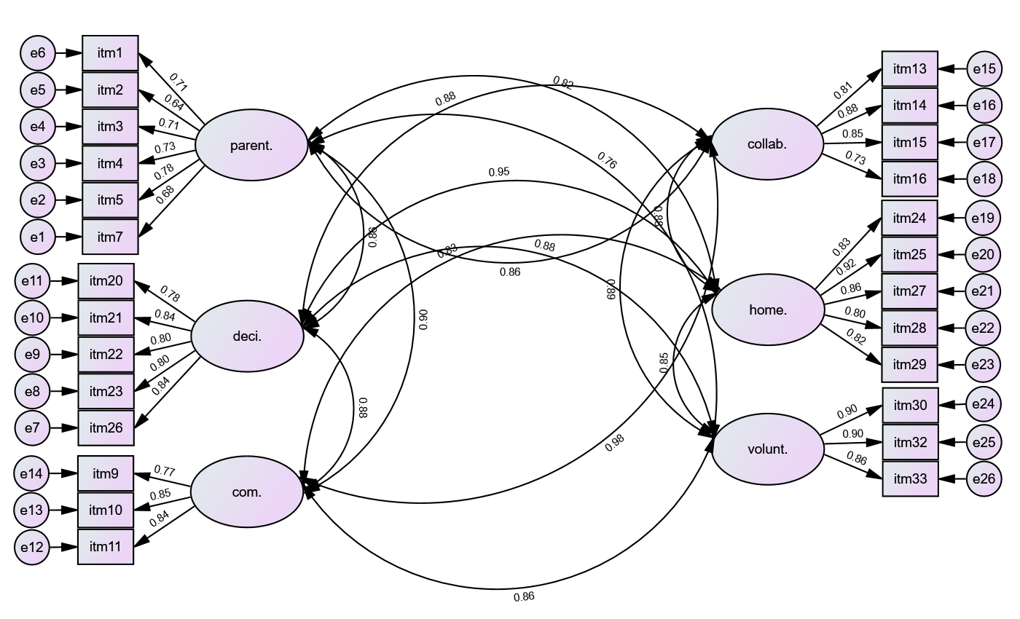

Note: parent.=parenting; deci=decision-making; collab.=collaboration; com.=communication, home.=home-support and volunt.=volunteering

Appendix II
Configural invariance estimate using female groups

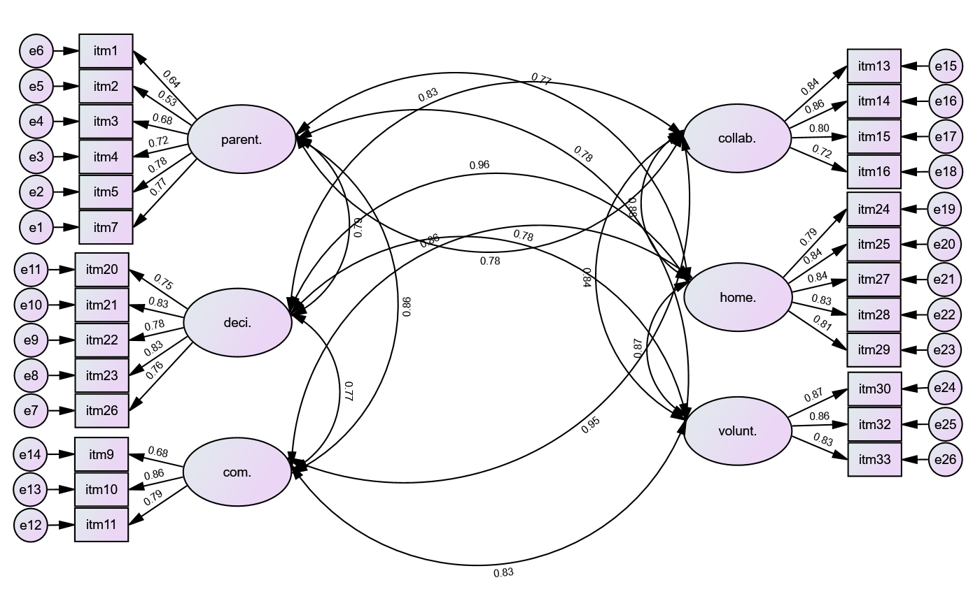

Note: parent.=parenting; deci=decision-making; collab.=collaboration; com.=communication, home.=home-support and volunt.=volunteering

Appendix III
Means scores for items
 | Items | M | SD
 | Parenting
Item1 | I know that fathers accept their children with disabilities. | 3.85 | .763
Item2 | I know that fathers believe that children with disabilities should be given equal opportunities in society | 4.28 | .697
Item3 | I know that fathers are committed towards the development of their children. | 3.97 | .80
Item4 | I know that fathers are pleased to have children with disabilities | 3.68 | .91
Item5 | I know that fathers are excited to have children with disabilities who need assistance with daily activities | 3.78 | .84
Item7 | I know that children with disabilities in families bring out the best parenting skills of fathers | 3.85 | .88
 | Communication
Item9 | The fathers regularly check and sign children’s activities or notes | 3.96 | .78
Item10 | The fathers read letters and brochures sent home and respond to them | 3.62 | .99
Item11 | The fathers of children with disabilities respond or contribute to discussions on progress or development | 3.72 | .93
 | Collaboration
Item13 | The fathers of children with disabilities participate in all our programmes or activities | 3.60 | .91
Item14 | The fathers of children with disabilities attend meetings to discuss child’s progress and related plans | 3.76 | .93
Item15 | The fathers of children with disabilities regularly monitor and send update about progress at home | 3.65 | .90
Item16 | The fathers of children with disabilities are involved or collaborate in the organization or attend events with their children | 3.63 | .87
 | Decision-making
Item20 | The fathers of children with disabilities take their children to local reading events/workshops or programmes organized in the community | 3.61 | .87
Item21 | The fathers of children with disabilities are actively looking for avenues or programmes which could benefit their children | 3.67 | .85
Item22 | The fathers of children with disabilities provide or contribute to the creation of a conducive home environment for development of their children | 3.53 | .88
Item23 | The fathers of children with disabilities searches for suitable programmes for their children | 3.65 | .85
Item26 | The fathers of children with disabilities are actively searching for people to assist them at home | 3.68 | .85
 | Home-support
Item24 | The fathers of children with disabilities help their children to do activities such as homework or implementing recommended strategies. | 3.66 | .87
Item25 | The fathers of children with disabilities are the primary implementers of strategies recommended to their children at home | 3.55 | .88
Item27 | The fathers of children with disabilities use different strategies (reading story out loud, acting it, drawing it, etc) with them at home | 3.43 | .89
Item28 | The fathers of children with disabilities read different literature genres/types of books to their children | 3.59 | .86
Item29 | The fathers of children with disabilities provide direct guidance to them at home. | 3.49 | .91
 | Volunteering
Item30 | I am satisfied the willingness and preparedness of fathers to help their children. | 3.62 | .99
Item32 | I am satisfied with how fathers voluntarily attend meeting to discuss issues concerning their children with disabilities | 3.61 | 1.01
Item33 | I am satisfied with how fathers voluntarily purchase assistive devices to children with disabilities | 3.52 | .94

