Table 4. Changes in eating disorder symptoms by diagnostic status, presence of co-occurring conditions, engagement in treatment and residing in the state of Victoria during the pandemic
 | Eating Disorder Diagnosis |  |  |  | Co-occurring Condition |  |  |  |  |  |  | Receiving Eating Disorder treatment |  |  |  | Victorian Resident
 | Diagnosis | No diagnosis | χ² (p) | RR (95%CI) | Co-occurring condition |  |  | No co-occurring condition |  | χ² (p) | RR (95%CI) | Receiving treatment | Not receiving treatment | χ² (p) | RR (95%CI) | Yes | No | χ² (p) | RR (95%CI)
Body image concern
Increased | 594 | 923 | 0.20 (.655) | 0.96  (0.805, 1,145) | 1206 |  |  | 311 |  | 7.13 (.008) | 1.11  (1.018, 1.219) | 728 | 789 | 0.06  (.808) | 1.02  (0.874, 1.189) | 711 | 806 | 3.64 (.056) | 1.18  (0.987, 1.404)
Not Increased | 84 | 122 | 0.20 (.655) | 0.96  (0.805, 1,145) | 147 |  |  | 59 |  | 7.13 (.008) | 1.11  (1.018, 1.219) | 97 | 109 | 0.06  (.808) | 1.02  (0.874, 1.189) | 82 | 124 | 3.64 (.056) | 1.18  (0.987, 1.404)
Food restriction/ dieting
Increased | 525 | 751 | 6.64 (.010) | 1.20  (1.041, 1.389) | 1019 |  |  | 257 |  | 5.18 (.023) | 1.07  (1.006, 1.135) | 627 | 649 | 3.11 (.078) | 1.11  (0.986, 1.248) | 615 | 661 | 9.35  (.002) | 1.21  (1.066, 1.375)
Not Increased | 153 | 294 | 6.64 (.010) | 1.20  (1.041, 1.389) | 334 |  |  | 113 |  | 5.18 (.023) | 1.07  (1.006, 1.135) | 198 | 249 | 3.11 (.078) | 1.11  (0.986, 1.248) | 178 | 269 | 9.35  (.002) | 1.21  (1.066, 1.375)
Binge/over-eating
Increased | 403 | 737 | 22.58 (<.001) | 0.75  (0.667, 0.842) | 894 |  |  | 246 |  | 0.22  (.882) | 1.00  (0.946, 1.049) | 497 | 643 | 24.79 (<.001) | 0.78  (0.703, 0.854) | 535 | 605 | 1.11 (.292) | 1.06  (0.952, 1.184)
Not Increased | 275 | 308 | 22.58 (<.001) | 0.75  (0.667, 0.842) | 459 |  |  | 124 |  | 0.22  (.882) | 1.00  (0.946, 1.049) | 328 | 255 | 24.79 (<.001) | 0.78  (0.703, 0.854) | 258 | 325 | 1.11 (.292) | 1.06  (0.952, 1.184)
Self-induced vomiting
Increased | 237 | 193 | 59.68 (<.001) | 1.62  (1.442, 1.811) | 341 |  |  | 89 |  | 0.21  (.651) | 1.01  (0.958, 1.072) | 254 | 176 | 28.74 (<.001) | 1.34  (1.211, 1.478) | 181 | 249 | 3.57 (.059) | 0.889  (0.785, 1.008)
Not Increased | 441 | 852 | 59.68 (<.001) | 1.62  (1.442, 1.811) | 1012 |  |  | 281 |  | 0.21  (.651) | 1.01  (0.958, 1.072) | 571 | 722 | 28.74 (<.001) | 1.34  (1.211, 1.478) | 612 | 681 | 3.57 (.059) | 0.889  (0.785, 1.008)
Driven/over exercise
Increased | 347 | 476 | 5.22 (.022) | 1.15  (1.020, 1.289) | 654 |  |  | 169 |  | 0.83  (.364) | 1.02  (0.974, 1.075) | 427 | 396 | 10.11  (.001) | 1.17  (1.063, 1.295) | 395 | 428 | 2.46 (.117) | 1.09  (0.980, 1.202)
Not Increased | 331 | 569 | 5.22 (.022) | 1.15  (1.020, 1.289) | 699 |  |  | 201 |  | 0.83  (.364) | 1.02  (0.974, 1.075) | 398 | 502 | 10.11  (.001) | 1.17  (1.063, 1.295) | 398 | 502 | 2.46 (.117) | 1.09  (0.980, 1.202)
Laxative and/or pill misuse
Increased | 131 | 109 | 27.11 (<.001) | 1.48  (1.295, 1.691) | 200 | 40 |  |  | 3.82 (.051) |  | 1.07  (1.007, 1.141) | 148 | 92 | 21.23 (<.001) | 1.35  (1.205, 1.514) | 100 | 140 | 2.13  (.144) | 0.89  (0.760, 1.046)
Not Increased | 547 | 936 | 27.11 (<.001) | 1.48  (1.295, 1.691) | 1153 |  | 330 |  |  |  | 1.07  (1.007, 1.141) | 677 | 806 | 21.23 (<.001) | 1.35  (1.205, 1.514) | 693 | 790 | 2.13  (.144) | 0.89  (0.760, 1.046)
Diet pill misuseª
Increased | 4 | 1 | 3.47 (.062) | 2.04  (1.310, 3.173) | 5 |  | 0 |  | 1.37  (.242) |  | 1.27  (1.243, 1.306) | 4 | 1 | 2.07  (.150) | 1.67  (1.077, 2.602) | 2 | 3 | 0.07  (.787) | 0.87  (0.297, 2.545)
Not Increased | 674 | 1044 | 3.47 (.062) | 2.04  (1.310, 3.173) | 1348 |  | 370 |  |  |  | 1.27  (1.243, 1.306) | 821 | 897 | 2.07  (.150) | 1.67  (1.077, 2.602) | 791 | 927 | 0.07  (.787) | 0.87  (0.297, 2.545)
n=sample size; χ²=Chi-square Statistic; p=p-value significant at p<.05; CI=Confidence Interval; RR=Relative Risk; t=t-statistic; df=degrees of freedom
ªNumber of participants reporting diet pill misuse as a symptom was very low so analysis unreliable and no interpretation drawn

Table 5: Pandemic experience and impact on eating disorder index
Pandemic experience | EDE Global Score
Pandemic experience | Negatively Impacted |  | Not Negatively Impacted^{b} |  |  |  |  |  |  |  | Overall impact of experience
Pandemic experience | nª | M (SD) | nª | M (SD) | MD | t | df | 95%CI for Mean Difference |  | p | Negative | Neutral^{b} | Positive^{b}
Racial discrimination | 135 | 4.25 (1.13) | 765 | 4.08 (1.17) | 0.17 | 1.61 | 898 | (-0.04, 0.39) |  | .108 | 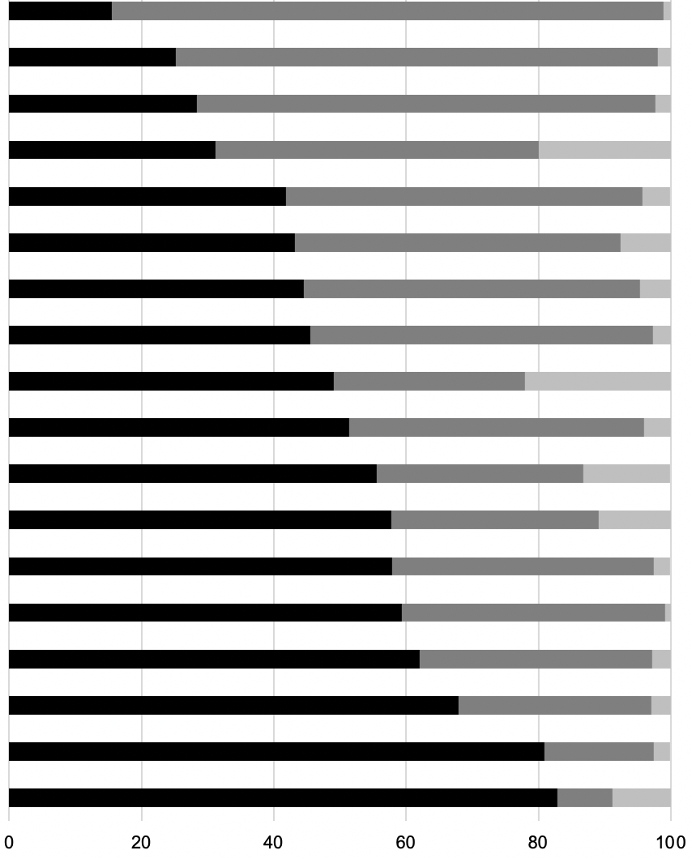
Home schooling children | 160 | 4.28 (1.17) | 450 | 4.13 (1.17) | 0.15 | 1.39 | 608 | (-0.06, 0.36) |  | .166
Virus contamination | 310 | 4.23 (1.25) | 786 | 4.08 (1.13) | 0.15 | 1.99 | 1094 | (0.00, 0.31) |  | .047
Increased focus on cleaning/hygiene | 383 | 4.36 (1.19) | 833 | 3.98 (1.14) | 0.39 | 5.42 | 1214 | (0.25, 0.53) |  | <.001
Changes in access to supermarkets | 529 | 4.24 (1.17) | 701 | 3.98 (1.17) | 0.26 | 3.81 | 1228 | (0.12, 0.39) |  | <.001
Change to paid employment | 428 | 4.19 (1.10) | 554 | 4.00 (1.22) | 0.19 | 2.59 | 980 | (0.05, 0.34) |  | .010
Availability of safe foods or foods on meal plan | 565 | 4.35 (1.13) | 616 | 3.93 (1.16) | 0.41 | 6.19 | 1179 | (0.28, 0.54) |  | <.001
Stockpiling of food | 565 | 4.29 (1.10) | 642 | 3.93 (1.20) | 0.36 | 5.47 | 1205 | (0.23, 0.49) |  | <.001
Promotion of exercise as an essential activity | 632 | 4.36 (1.07) | 613 | 3.81 (1.21) | 0.55 | 8.49 | 1243 | (0.42, 0.68) |  | <.001
Changes access to health professionals/treatment | 634 | 4.27 (1.12) | 568 | 3.90 (1.20) | 0.38 | 5.62 | 1200 | (0.25, 0.50) |  | <.001
Working from home | 569 | 4.20 (1.15) | 452 | 3.94 (1.19) | 0.26 | 3.50 | 1019 | (0.11, 0.40) |  | <.001
Social distancing | 727 | 4.09 (1.20) | 517 | 4.10 (1.14) | -0.01 | -0.15 | 1242 | (-0.14, 0.12) |  | .882
Closure of fitness facilities | 684 | 4.14 (1.17) | 511 | 4.03 (1.18) | 0.11 | 1.66 | 1193 | (-0.02, 0.25) |  | .098
Restricted access to support people | 665 | 4.25 (1.13) | 408 | 4.00 (1.17) | 0.25 | 3.48 | 1071 | (0.11, 0.39) |  | <.001
News coverage of the pandemic | 780 | 4.10 (1.14) | 450 | 4.09 (1.23) | 0.01 | 0.16 | 1228 | (-0.12, 0.14) |  | .872
Social media reaction to the pandemic | 837 | 4.15 (1.12) | 392 | 3.99 (1.29) | 0.16 | 2.23 | 1227 | (0.02, 0.30) |  | .026
Restricted access to family/friends | 1006 | 4.09 (1.17) | 224 | 4.13 (1.19) | -0.04 | -0.50 | 1228 | (-0.21, 0.13) |  | .620
Change in daily routine | 1053 | 4.18 (1.14) | 203 | 3.64 (1.23) | 0.54 | 6.08 | 1254 | (0.37, 0.71) |  | <.001
n=subsample size; M=mean; SD=standard deviation; MD=mean difference; CI=confidence interval; p=p-value significant at p<.05; t = t-statistic; df = degrees of freedom  ªAnalysis includes participants who reported presence of Eating Disorder symptom and completed formal measure  ^{b}Not Negatively Impacted = Neutral+Positive impact to compare with Negatively Impacted for EDE Global Score comparison |  |  |  |  |  |  |  |  |  |  | % of participants

