Supplementary information - Fitness related effects of titanium dioxide nanoparticles and glyphosate exposure on Cardiocondyla obscurior
Danae Nyckees*¹, Raquel Gonzalez de Vega², Reinhard Sittinger², David Clases² and Dalial Freitak¹
¹Institute of Biology, Karl-Franzens-Universitat Graz, Graz, Styria 8010, Austria
²Institute of Chemistry, Karl-Franzens-Universitat Graz, Graz, Styria 8010, Austria
*Corresponding author: danae.nyckees@uni-graz.at / +43 (0)316 380 – 3915

Supplementary material
Supplementary table 1 Primers
Target organism | Target gene | Primer | Sequence | Reference
Wolbachia | cytochrome | coxA_forward | TTGGTCATCCAGAAGTTTACGT | Ün et al. 2021
 | oxidase | coxA_reverse | TGAGCCCAAACCATAAAGCC
Cand. | nrdb | nrdB_forward | GGAAGGAGTCCTAATGTTGCG | Klein et al. 2016
Westeberhardia |  | nrdB_reverse | ACCAGAAATATCTTTTGCACGTT
C.obscurior | elongation factor | EF1_forward | TCACTGGTACCTCGCAAGCCGA | Klein et al. 2016
(reference) | 1-alpha 1 | EF1_reverse | AGCGTGCTCACGAGTTTGTCCG
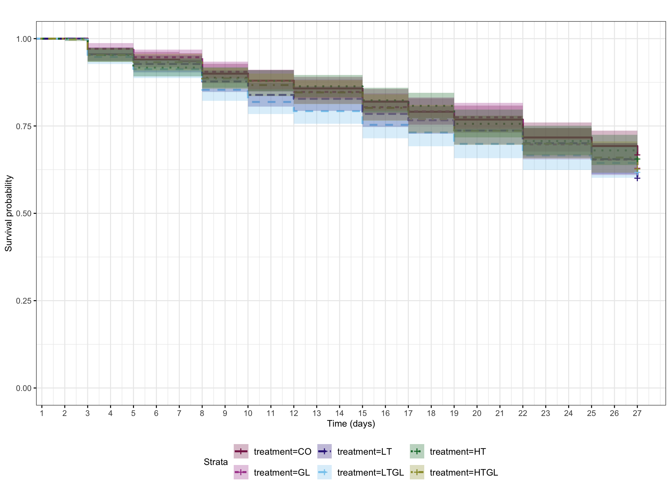
Supplementary fig. 1 Daily survival probability. The shaded areas represent the 05% CI. CO: Control; GL: Glyphosate; HT: High TiO₂NPs; HTGL: High TiO₂NPs with glyphosate; LT: Low TiO₂NPs; LTGL: Low TiO₂NPs with glyphosate. N_{treatment} = 12, except for GL: N = 11
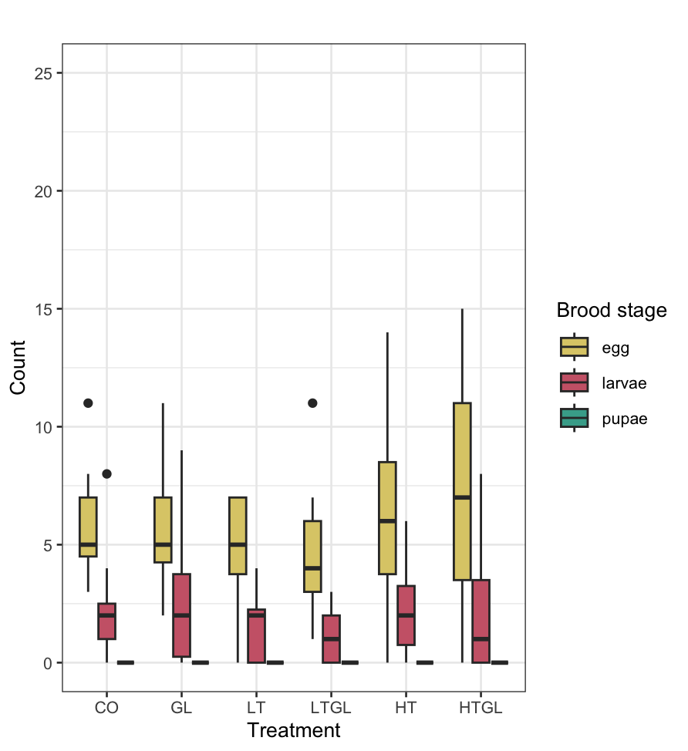
Supplementary fig. 3 Brood count per stage at week 1. The error bars represent the 05% CI. CO: Control; GL: Glyphosate; HT: High TiO₂NPs; HTGL: High TiO₂NPs with glyphosate; LT: Low TiO₂NPs; LTGL: Low TiO₂NPs with glyphosate. N_{CO and HTGL} = 11; N_{GL and HT} = 10; N_{LT and LTGL} = 12

