Supplement 6
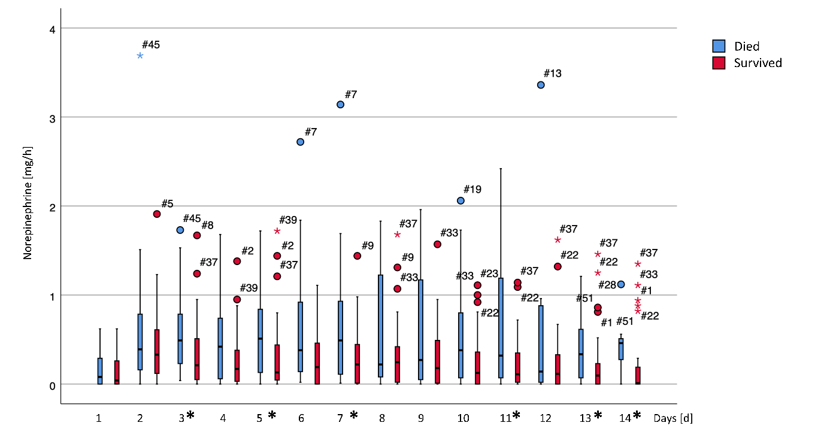
Figure 1 Daily mean hourly dosage of norepinephrine (Nor). Significant differences between the two groups are marked with an asterisk in the legend of the x-axis.

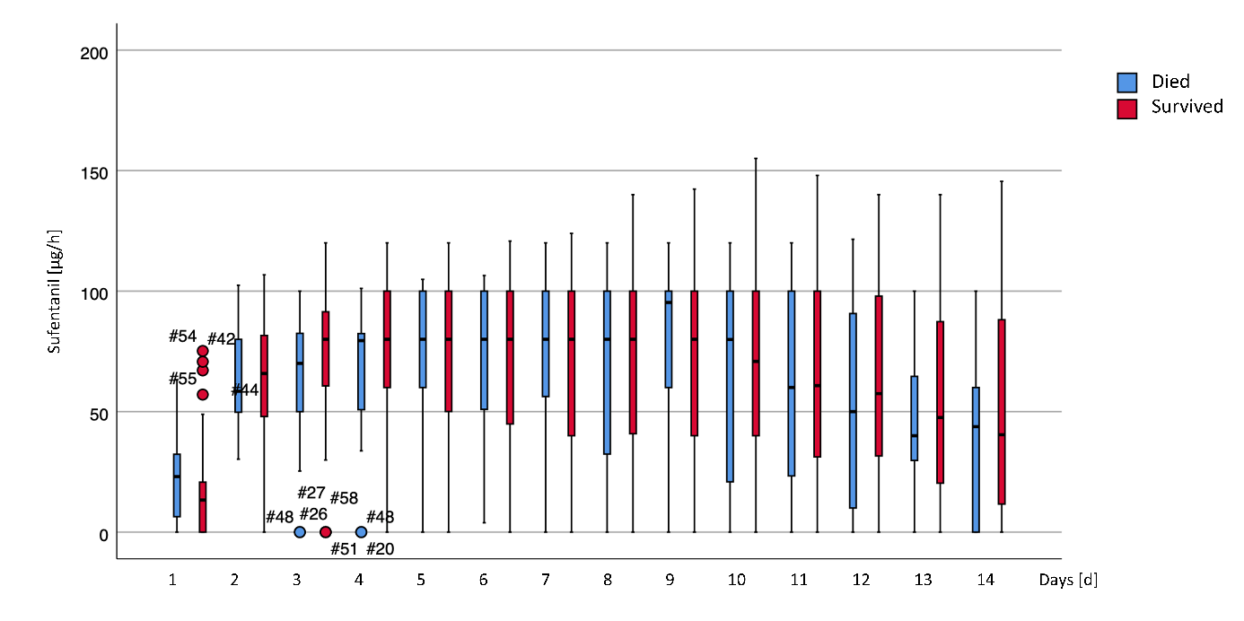
Figure 2 Daily mean hourly dosage of sufentanil (Sufenta). Significant differences between the two groups are marked with an asterisk in the legend of the x-axis.
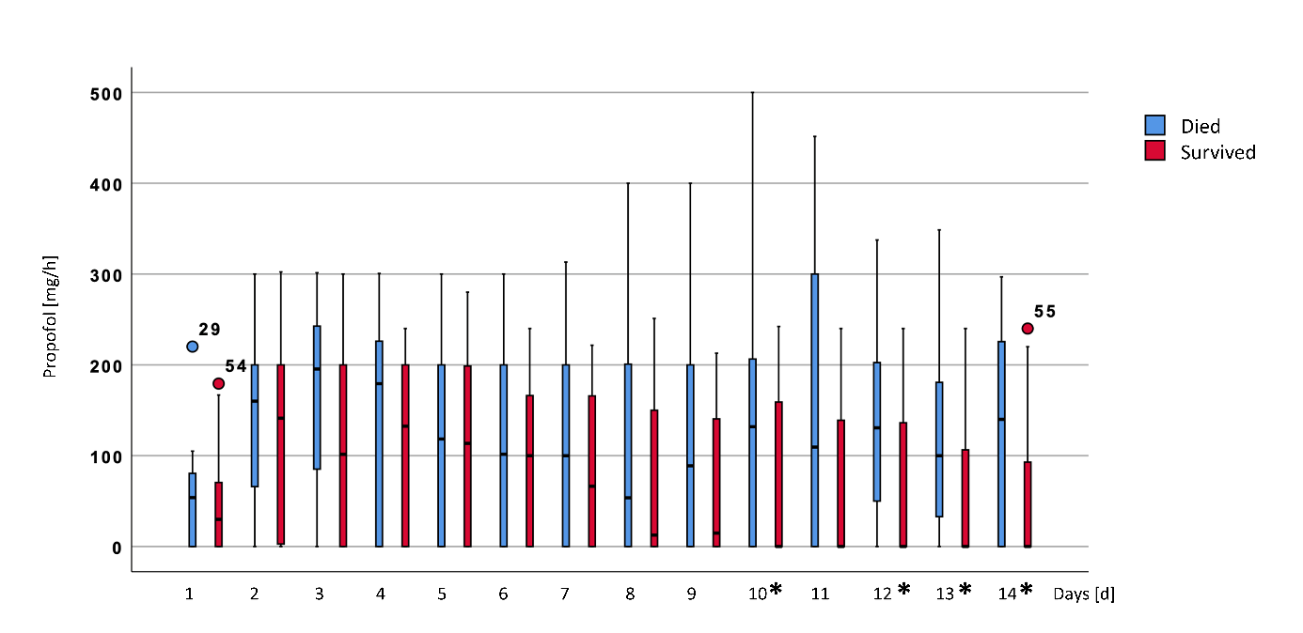
Figure 3 Daily mean hourly dosage of propofol. Significant differences between the two groups are marked with an asterisk in the legend of the x-axis.

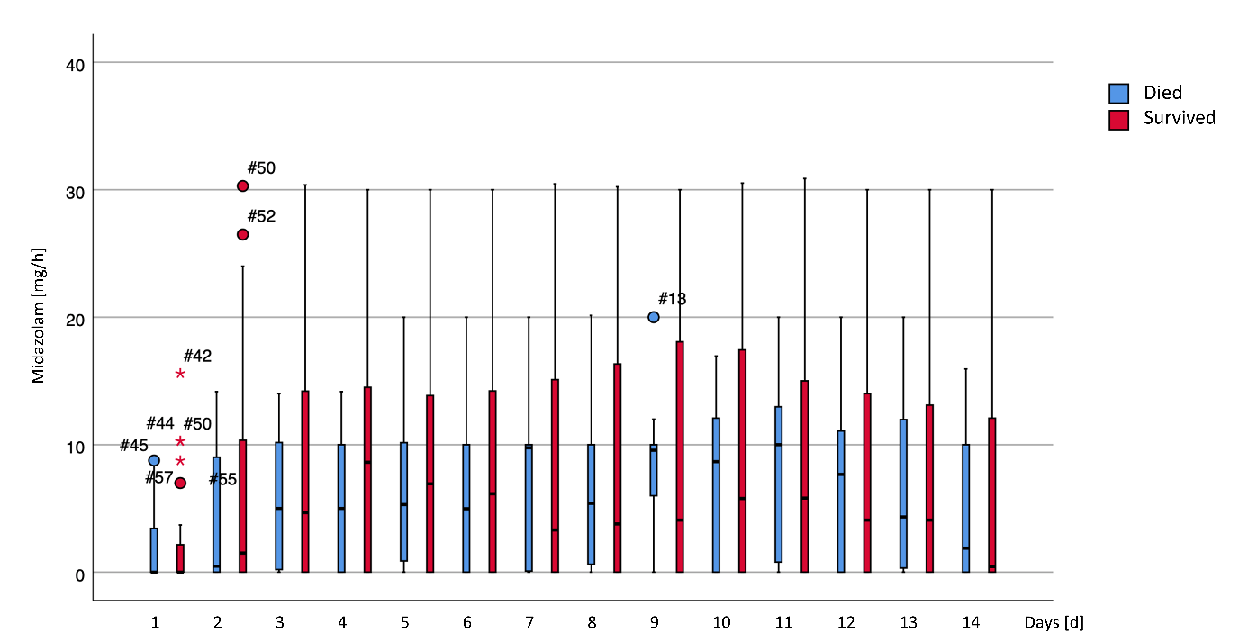
Figure 4 Daily mean hourly dosage of midazolam (Mida). Significant differences between the two groups are marked with an asterisk in the legend of the x-axis.
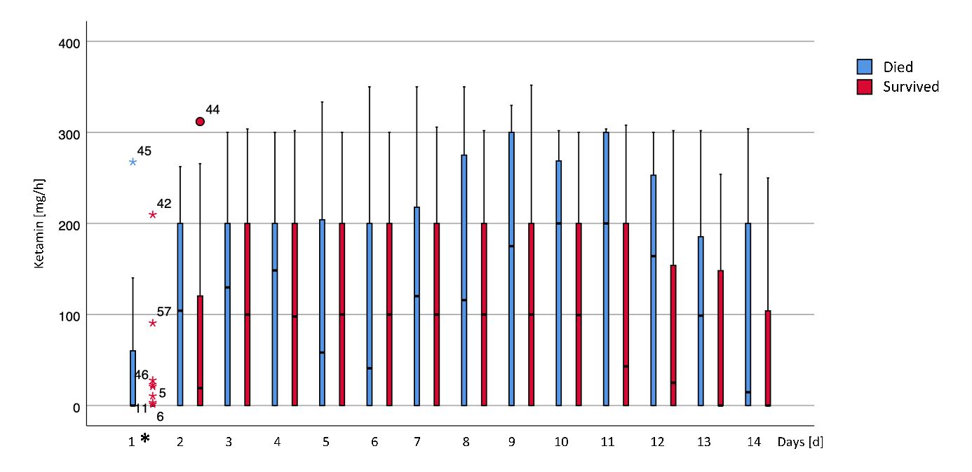
Figure 5 Daily mean hourly dosage of ketamine. Significant differences between the two groups are marked with an asterisk in the legend of the x-axis.

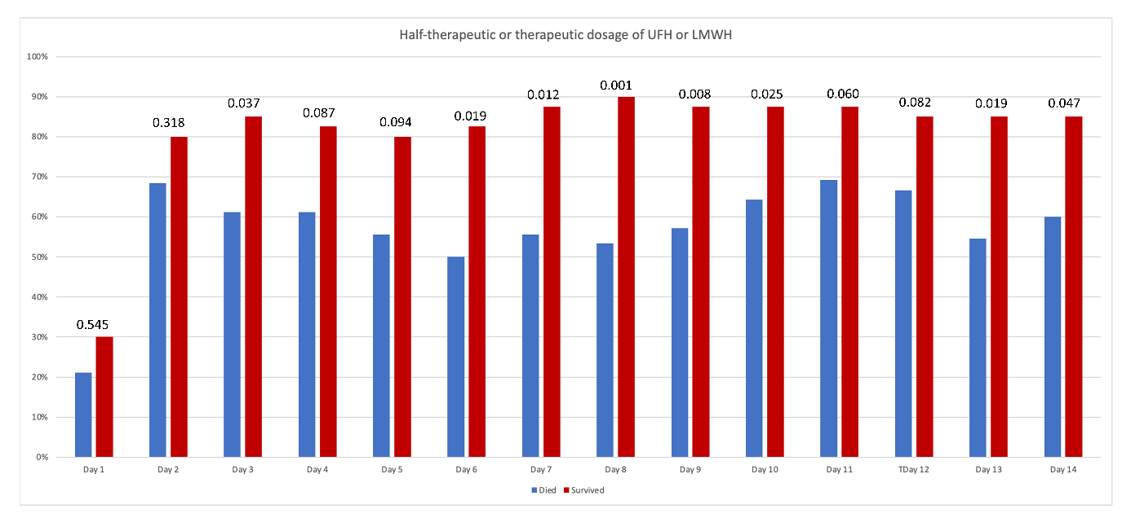
Figure 6 Frequencies of more than prophylactical doses of unfractionated heparin (UFH) or low molecular weight heparin (LMWH) during the observation period; p-values for comparison between the two groups are stated above the bars.
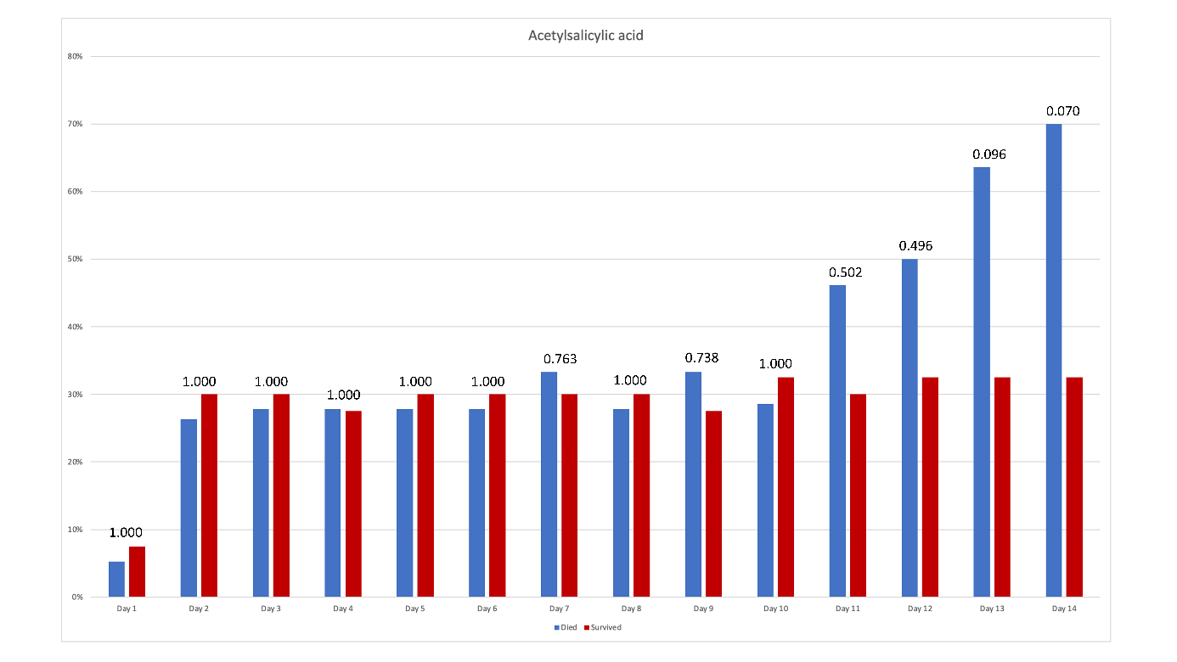
Figure 7 Frequencies of administration of acetylsalicylic acid during the observation period; p-values for comparison between the two groups are stated above the bars.

