Supplement 10
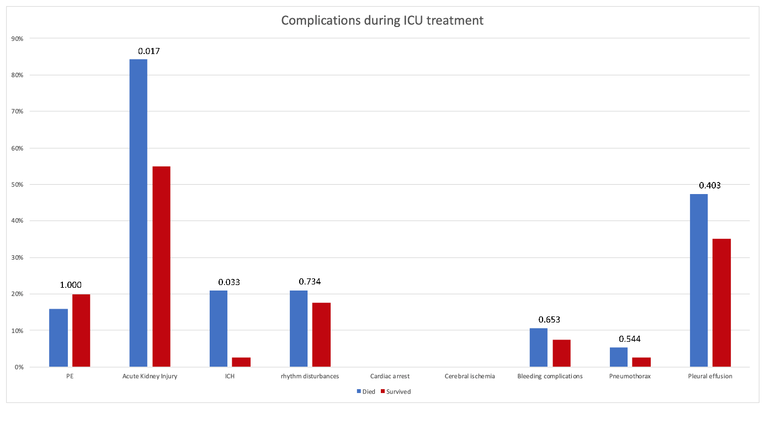
Figure 1 Classification and frequencies of complications that occurred during the observation period. Pulmonary embolism, PE; intracerebral hemorrhage, ICH; p-values for comparison between the two groups are stated above the bars.
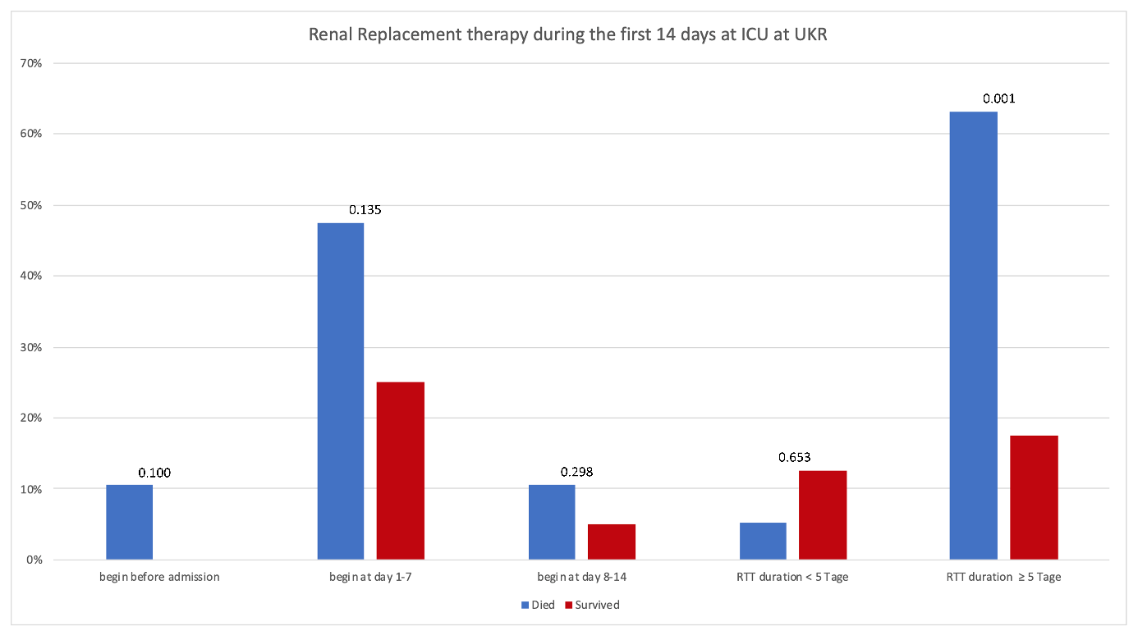
Figure 2 Classification and frequencies of renal replacement therapy (RRT); p-values for comparison between the two groups are stated above the bars.

