Supplement 8
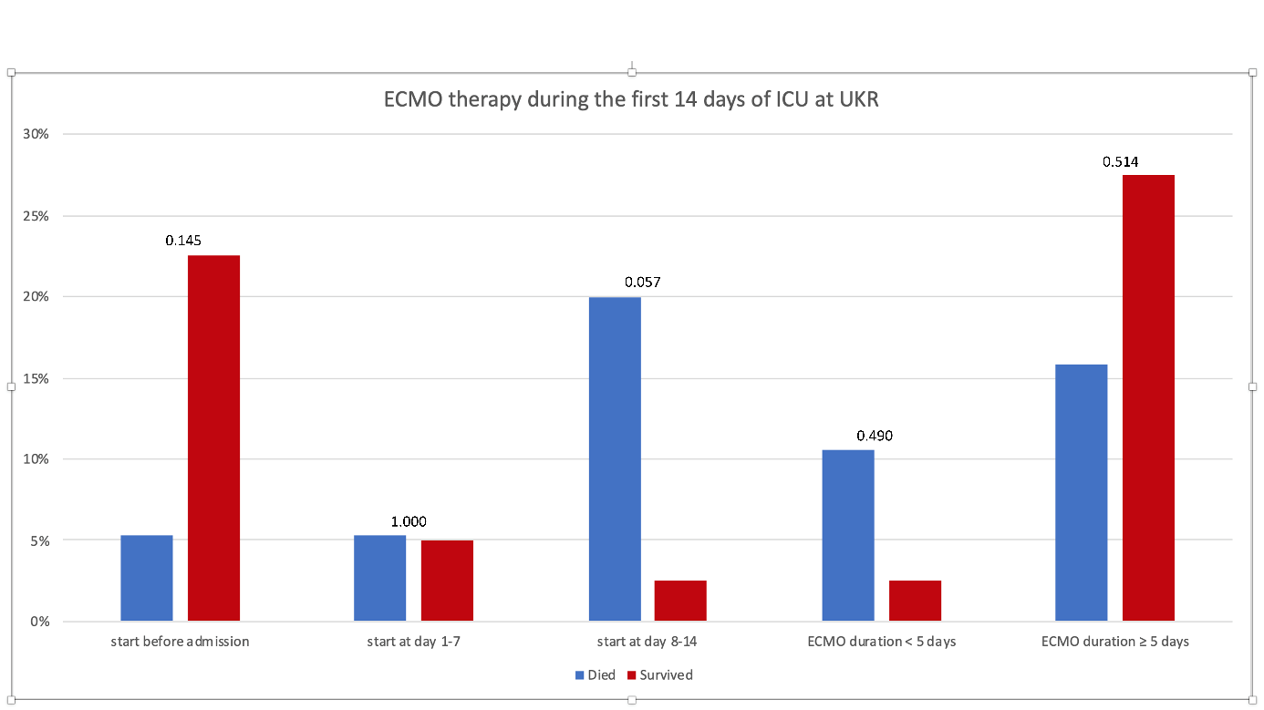
Figure 1 Classification and frequencies of therapy with extracorporeal membrane oxygenation (ECMO); p-values for comparison between the two groups are stated above the bars.

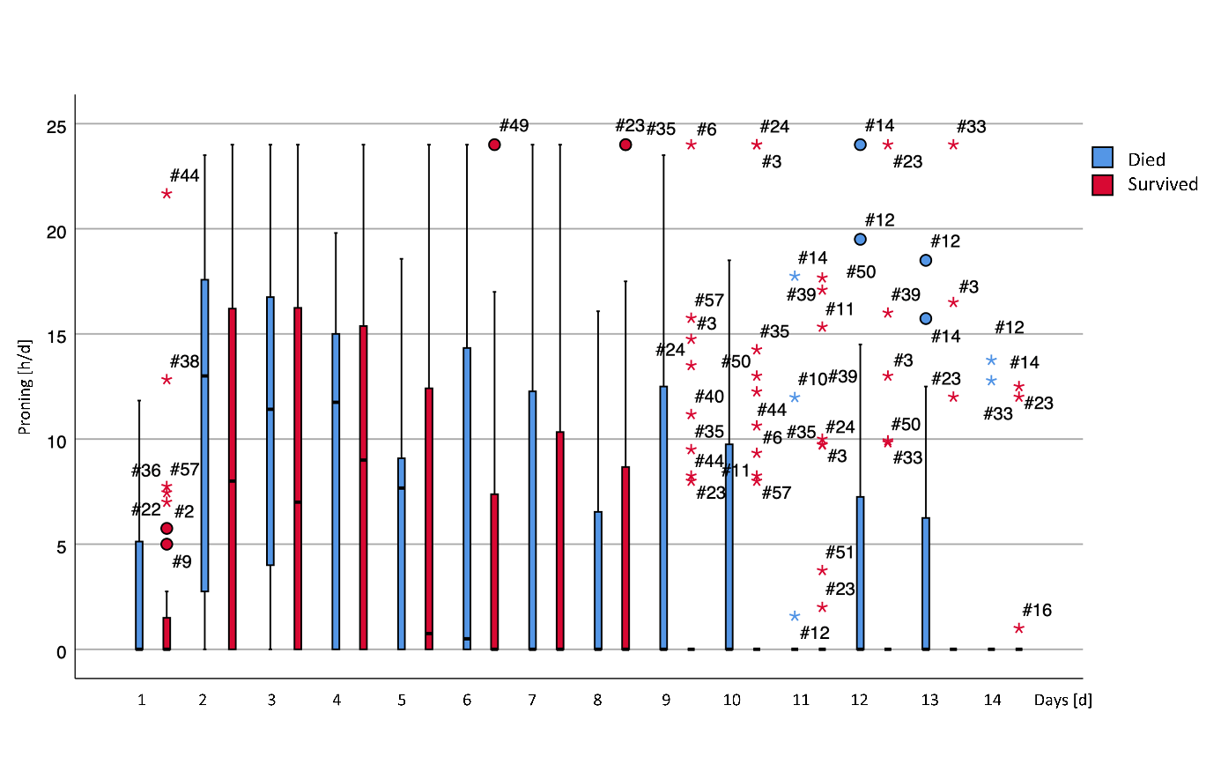
Figure 2 Daily time of prone positioning (proning). Significant differences between the two groups are marked with an asterisk in the legend of the x-axis.
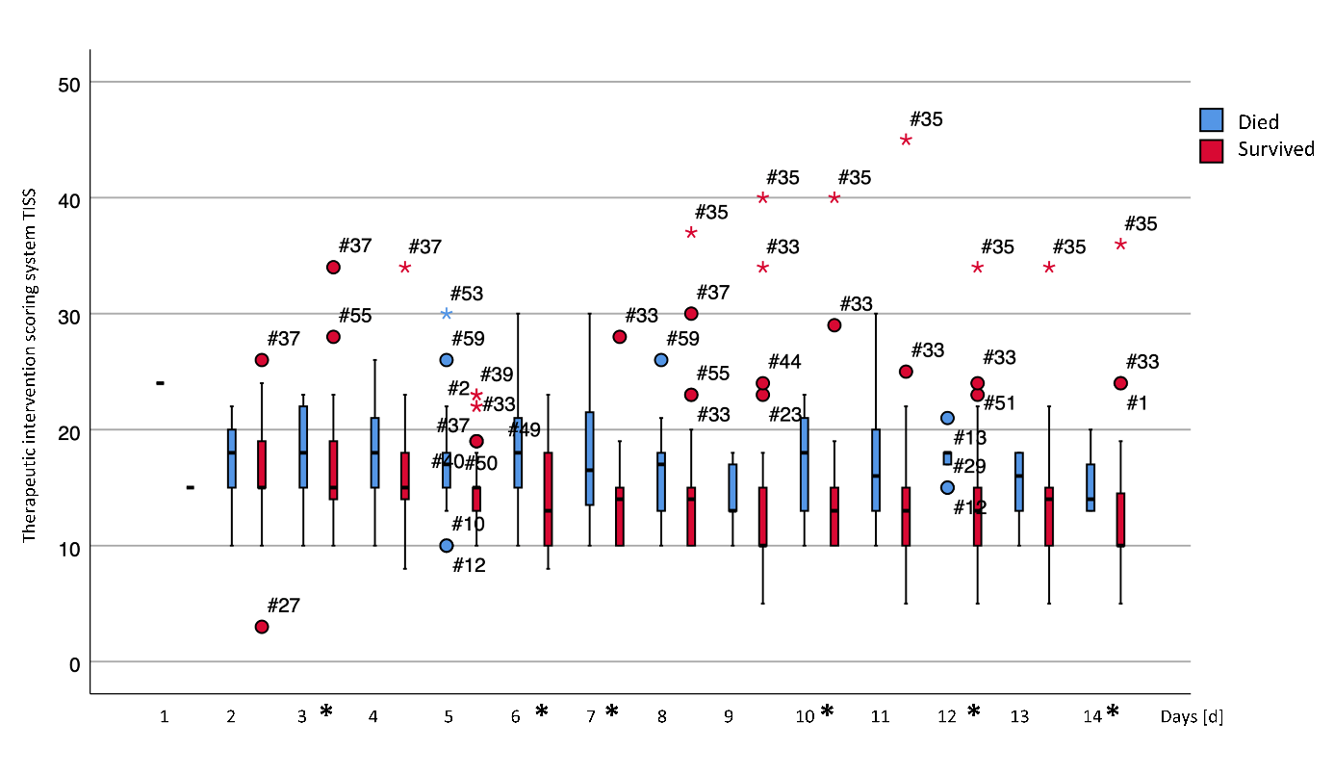
Figure 3 Daily TISS (therapeutic intervention scoring system) values. Significant differences between the two groups are marked with an asterisk in the legend of the x-axis.
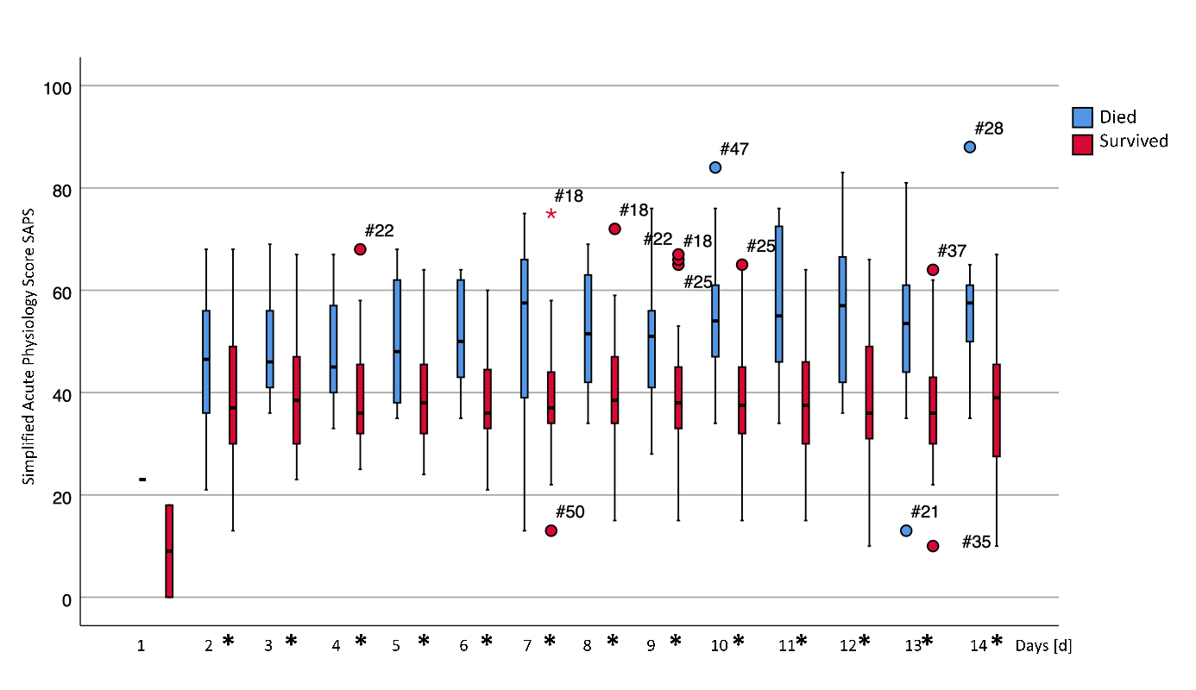Figure 4 Daily SAPS (simplified acute physiology score) values. Significant differences between the two groups are marked with an asterisk in the legend of the x-axis.

