Supplement 7
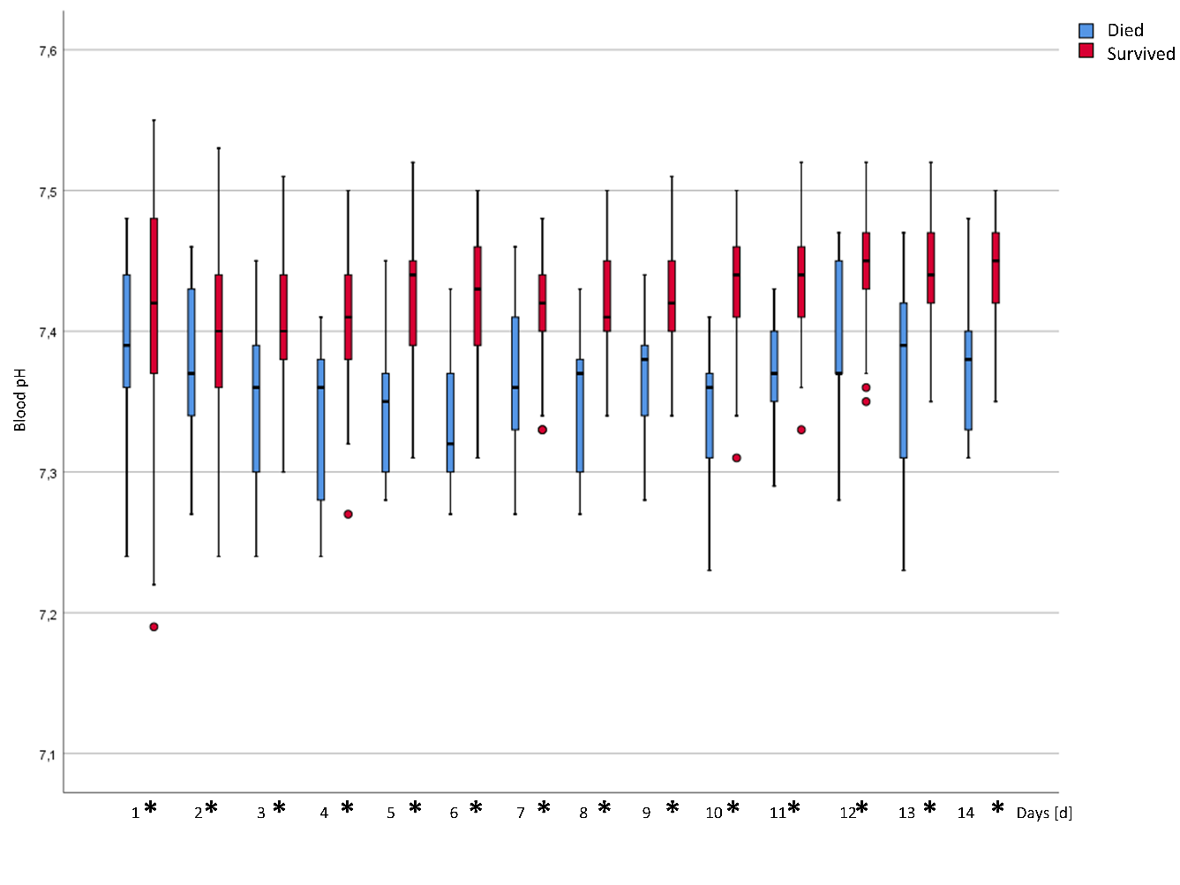
Figure 1 Daily mean blood pH values. Significant differences between the two groups are marked with an asterisk in the legend of the x-axis.
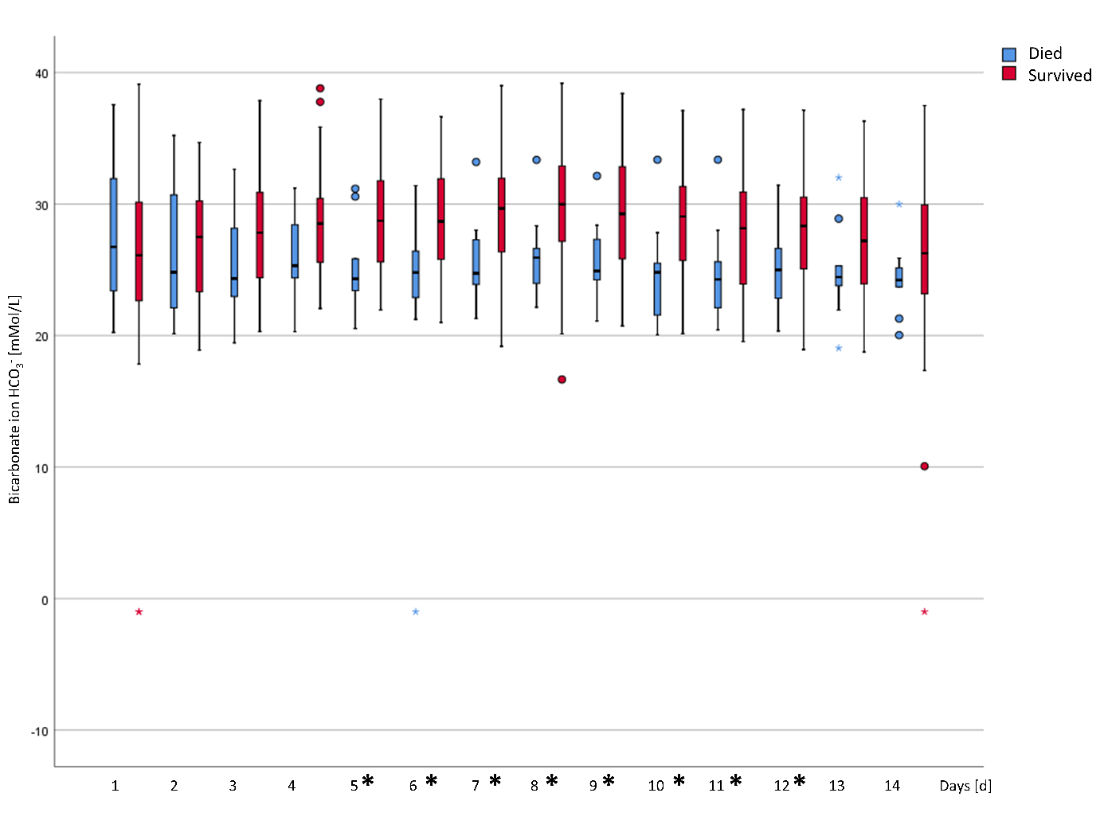
Figure 2 Daily mean standard bicarbonate values. Significant differences between the two groups are marked with an asterisk in the legend of the x-axis.
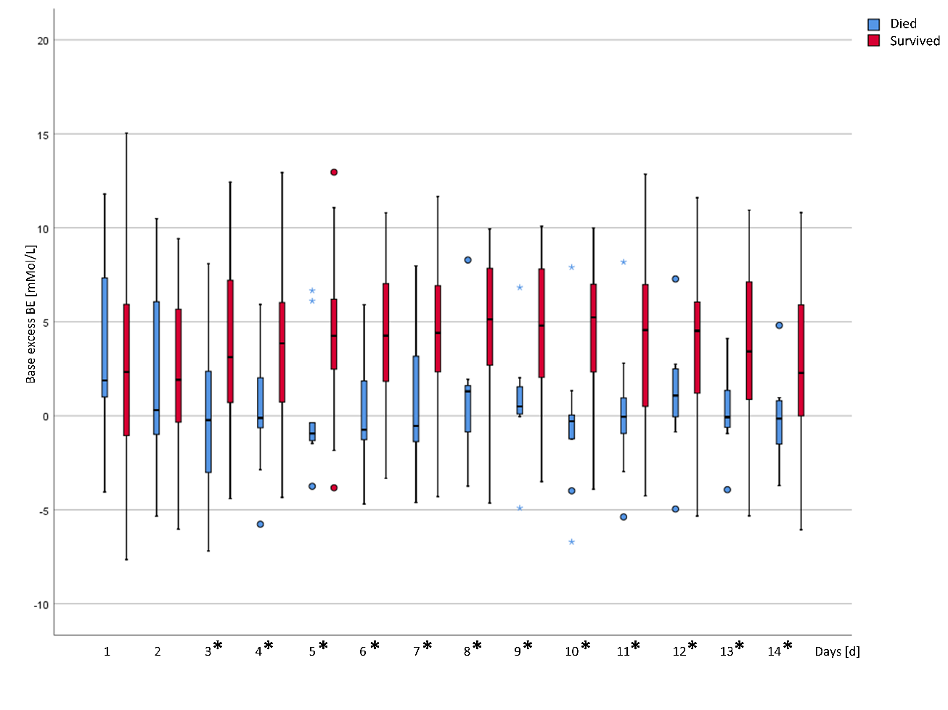
Figure 3 Daily mean base excess (BE) values. Significant differences between the two groups are marked with an asterisk in the legend of the x-axis
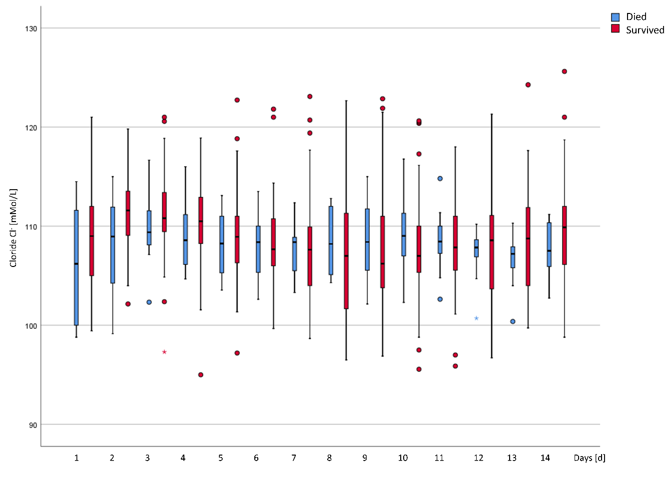
Figure 4 Daily mean blood chloride values. Significant differences between the two groups are marked with an asterisk in the legend of the x-axis.
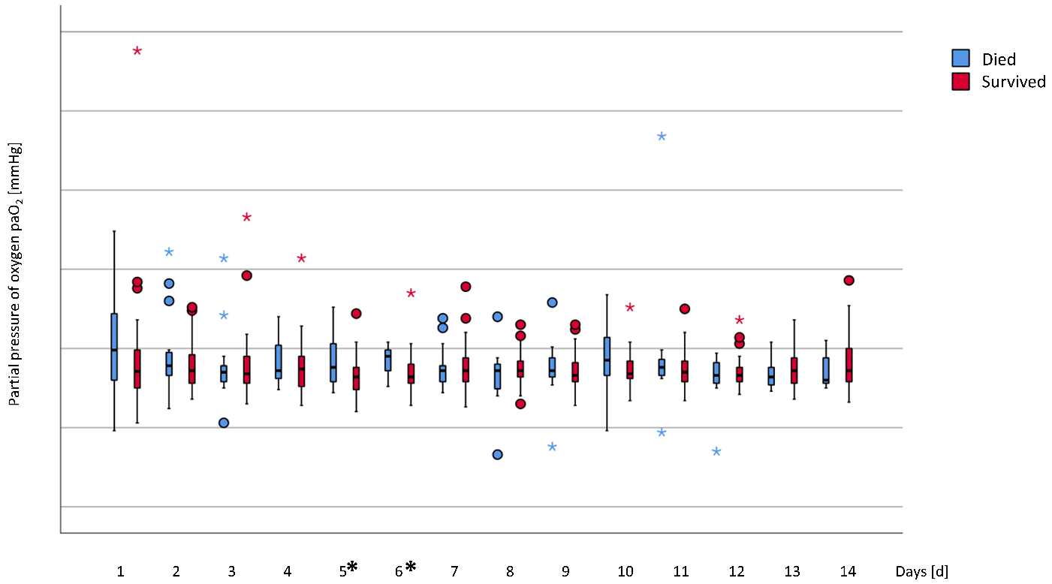
Figure 5 Daily mean values for arterial partial pressure of oxygen (paO₂). Significant differences between the two groups are marked with an asterisk in the legend of the x-axis.
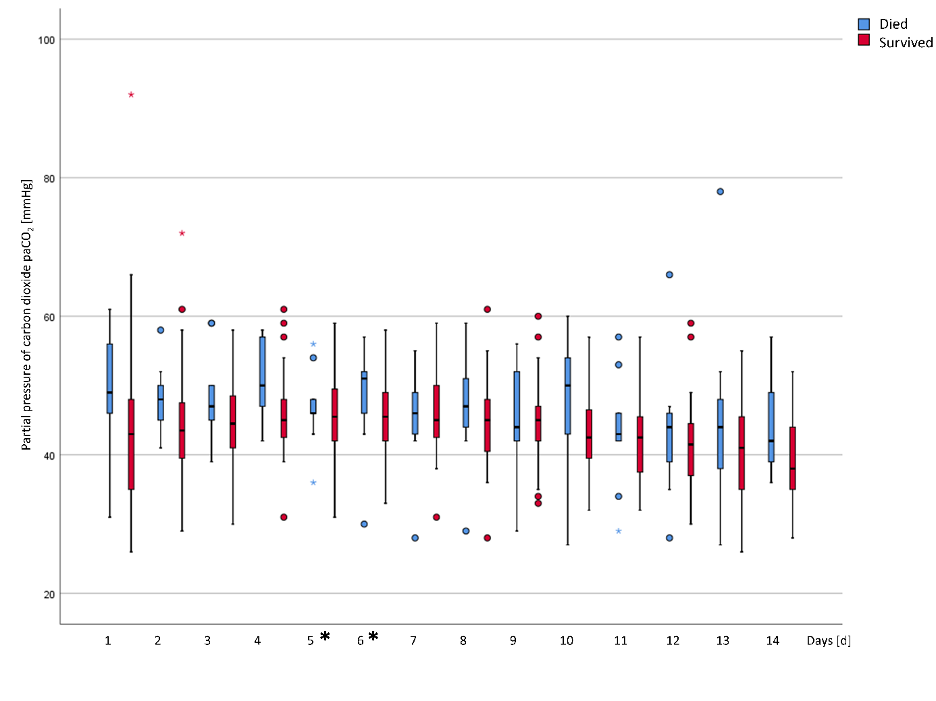
Figure 6 Daily mean values for arterial partial pressure of carbon dioxide (paCO₂). Significant differences between the two groups are marked with an asterisk in the legend of the x-axis.
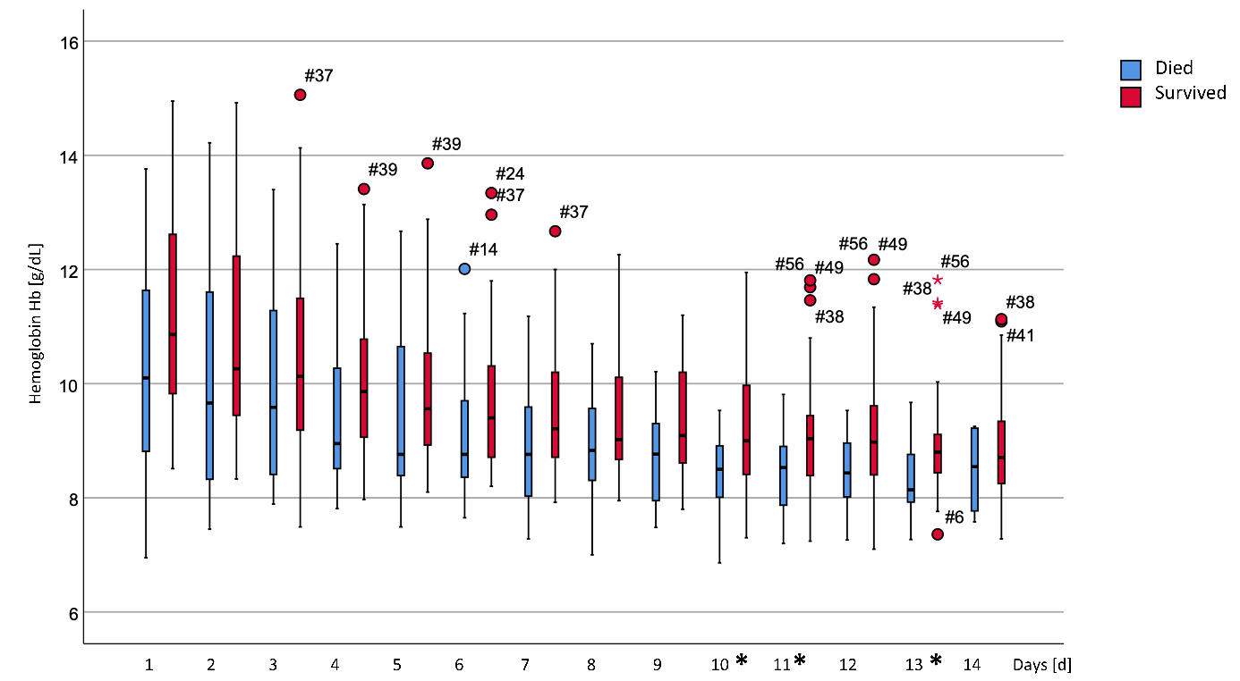
Figure 7 Daily mean values for hemoglobin (Hb). Significant differences between the two groups are marked with an asterisk in the legend of the x-axis.
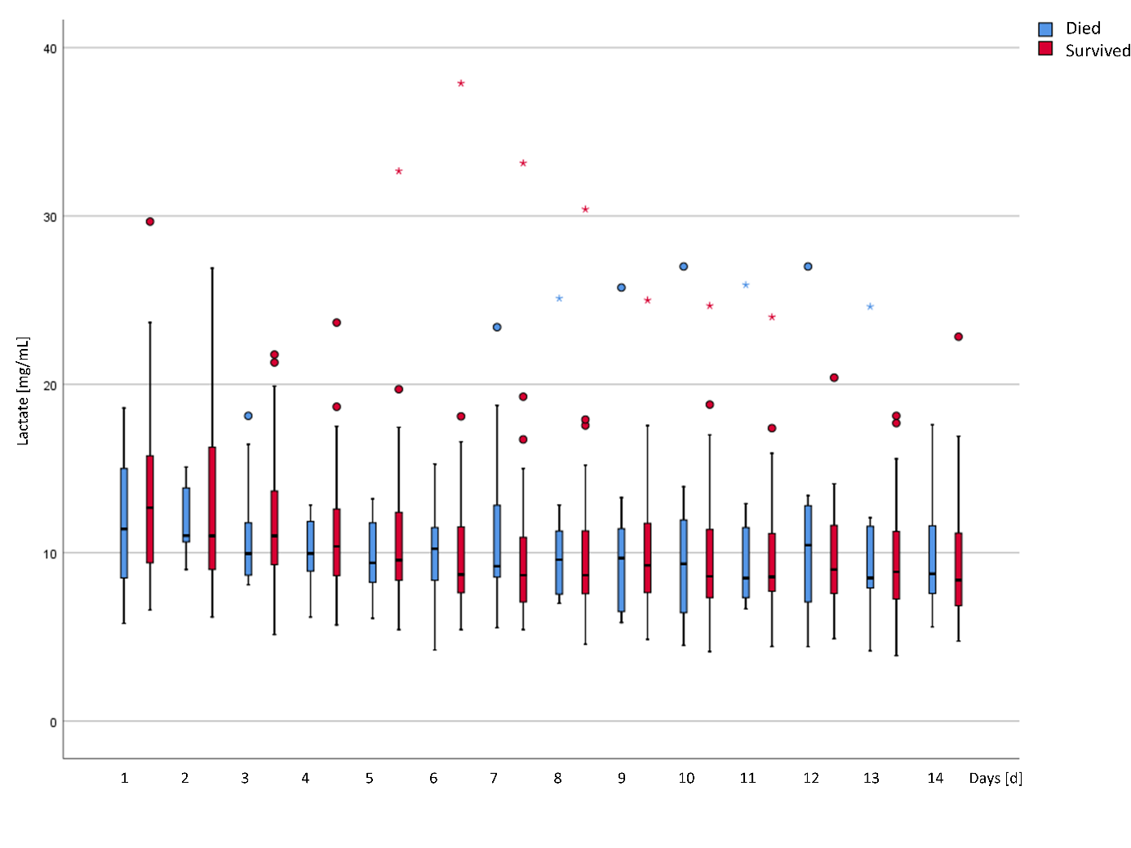
Figure 8 Daily mean values for blood lactate. Significant differences between the two groups are marked with an asterisk in the legend of the x-axis.
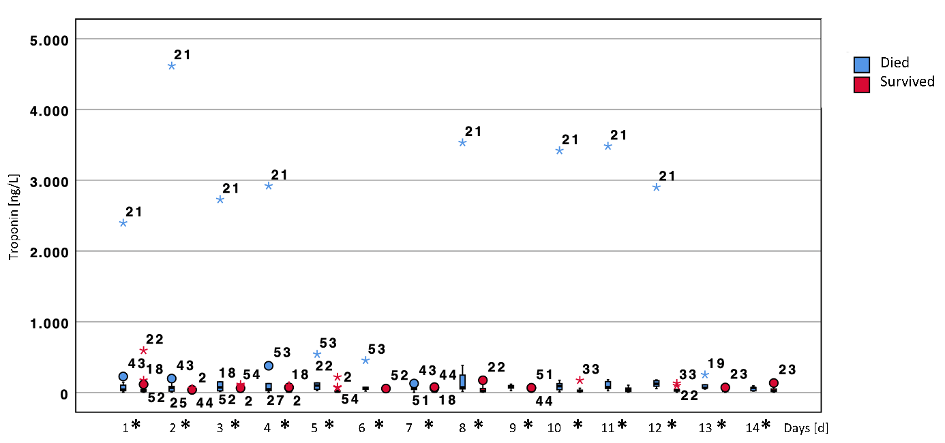
Figure 9 Daily values for troponin T. Significant differences between the two groups are marked with an asterisk in the legend of the x-axis.

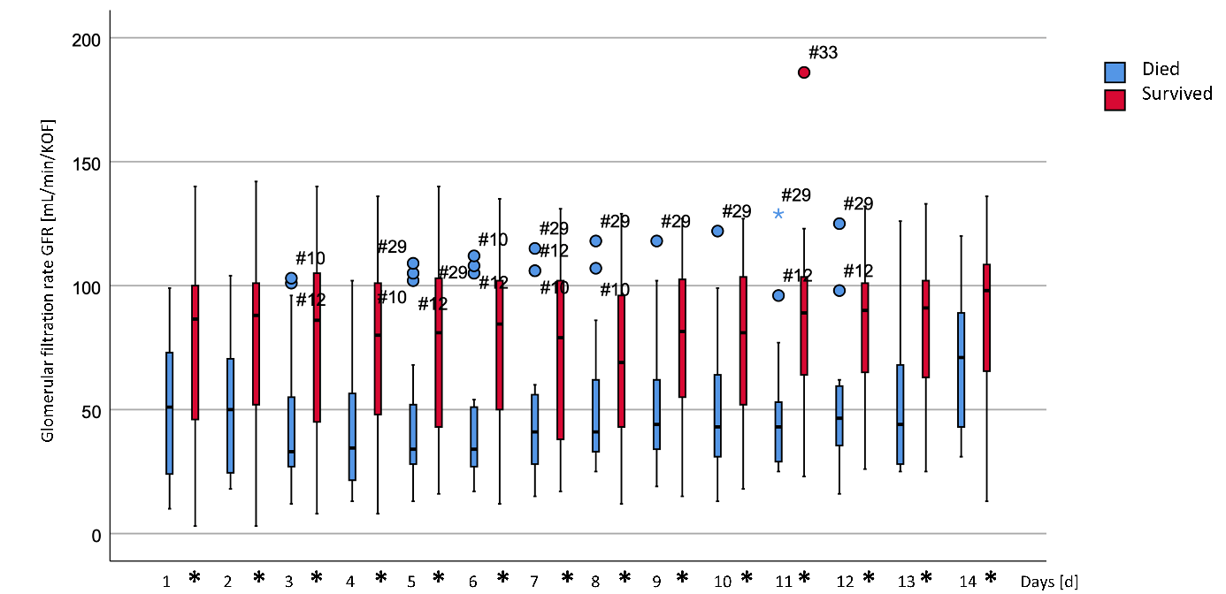
Figure 10 Daily values for the troponin estimated glomerular filtration rate (eGFR). Significant differences between the two groups are marked with an asterisk in the legend of the x-axis.
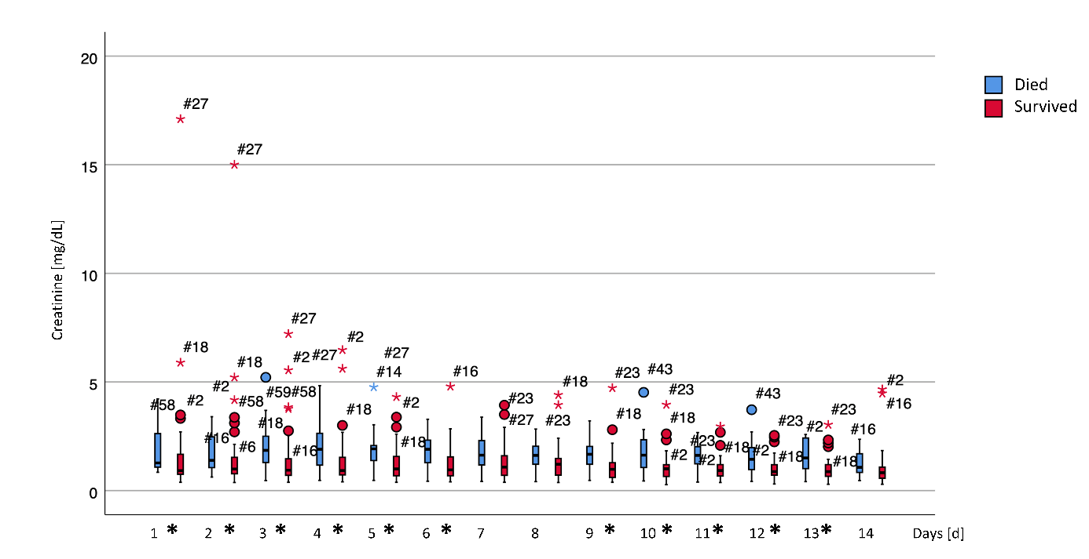
Figure 11 Daily values for blood creatinine (Crea). Significant differences between the two groups are marked with an asterisk in the legend of the x-axis.
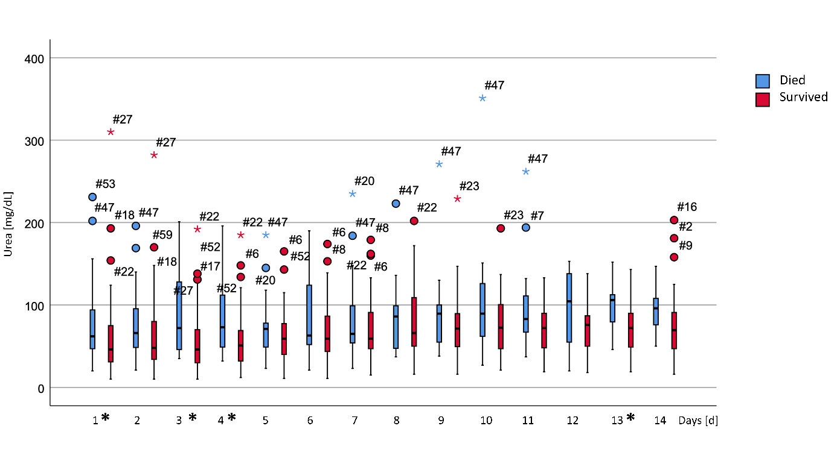
Figure 12 Daily values for urea. Significant differences between the two groups are marked with an asterisk in the legend of the x-axis.
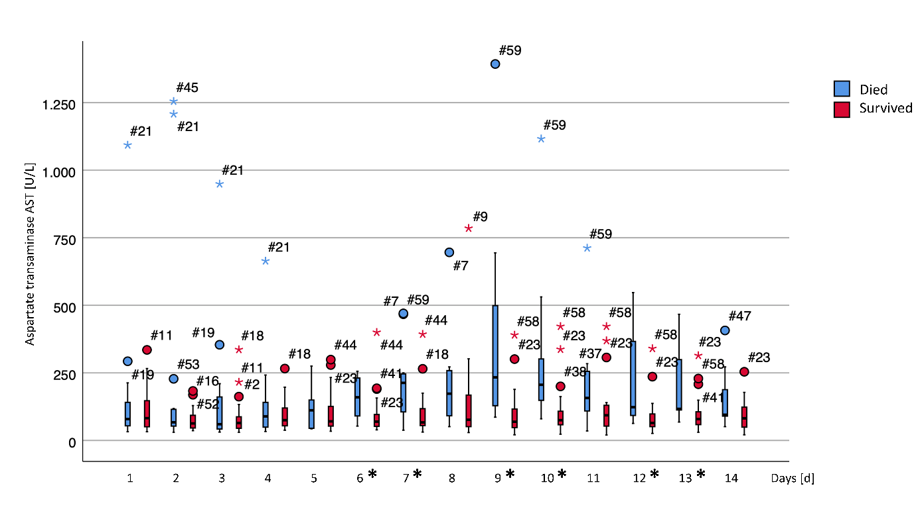
Figure 13 Daily values for aspartate transaminase (AST). Significant differences between the two groups are marked with an asterisk in the legend of the x-axis.
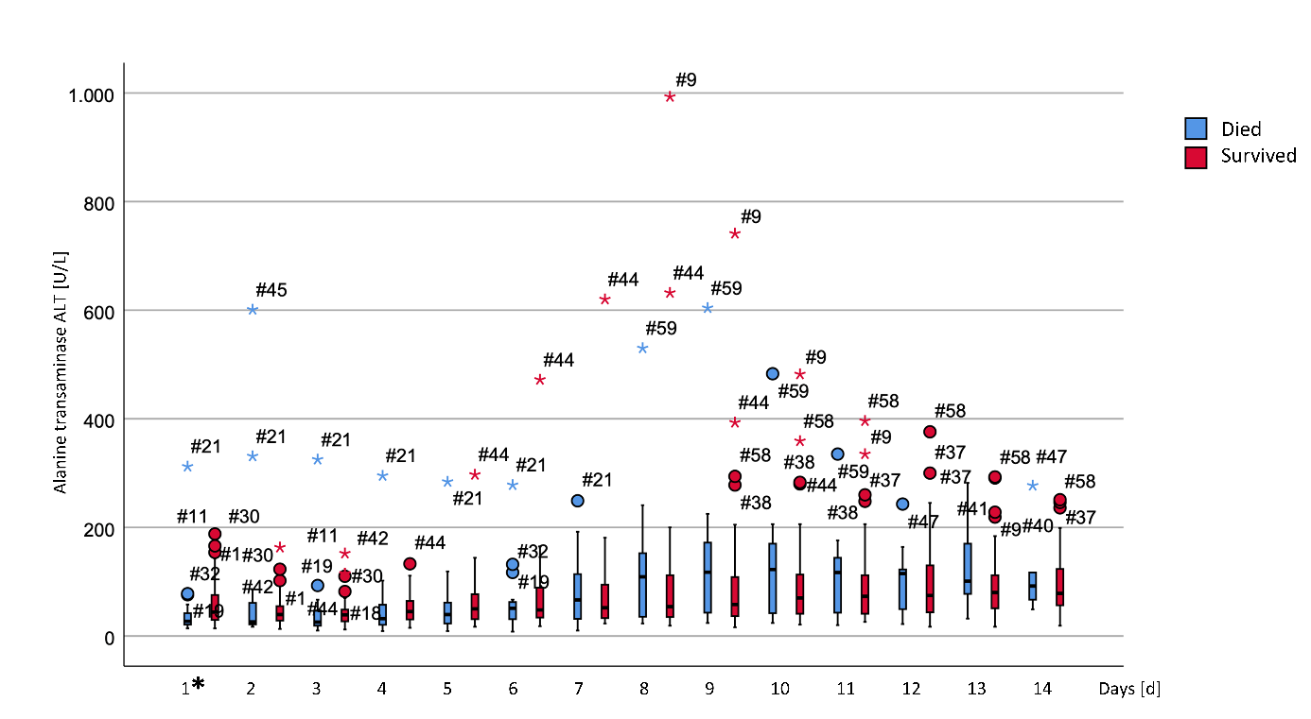
Figure 14 Daily values for alanine transaminase (ALT). Significant differences between the two groups are marked with an asterisk in the legend of the x-axis.
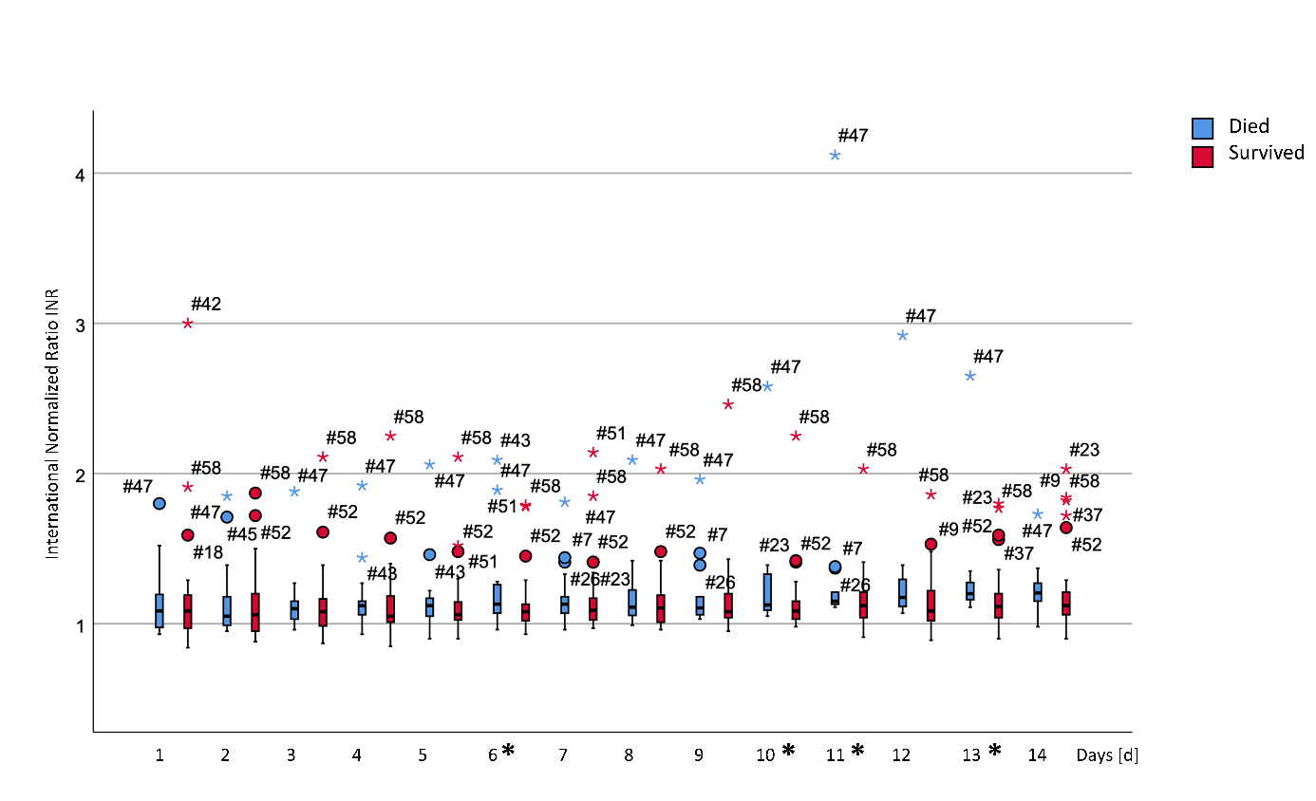
Figure 15 Daily values for the international normalized ratio (INR). Significant differences between the two groups are marked with an asterisk in the legend of the x-axis.
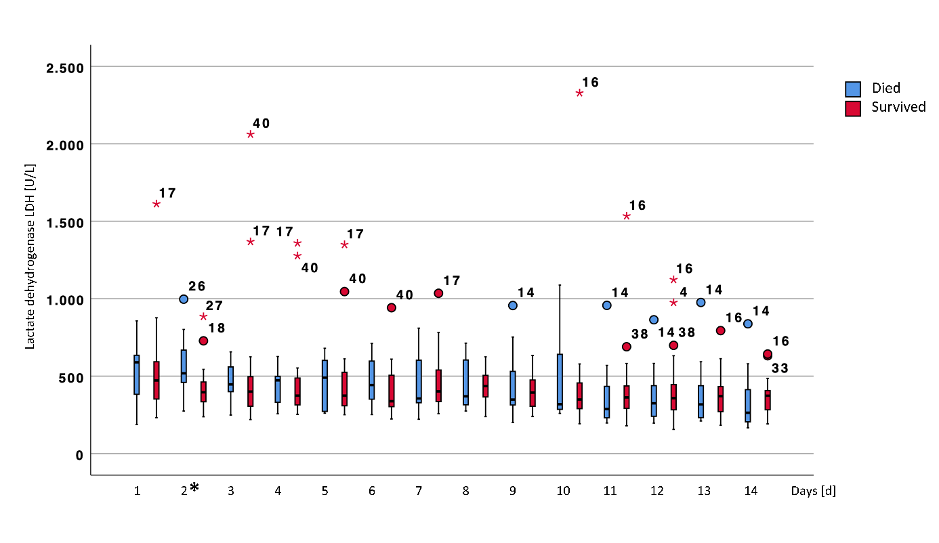
Figure 16 Daily values for lactate dehydrogenase (LDH). Significant differences between the two groups are marked with an asterisk in the legend of the x-axis.
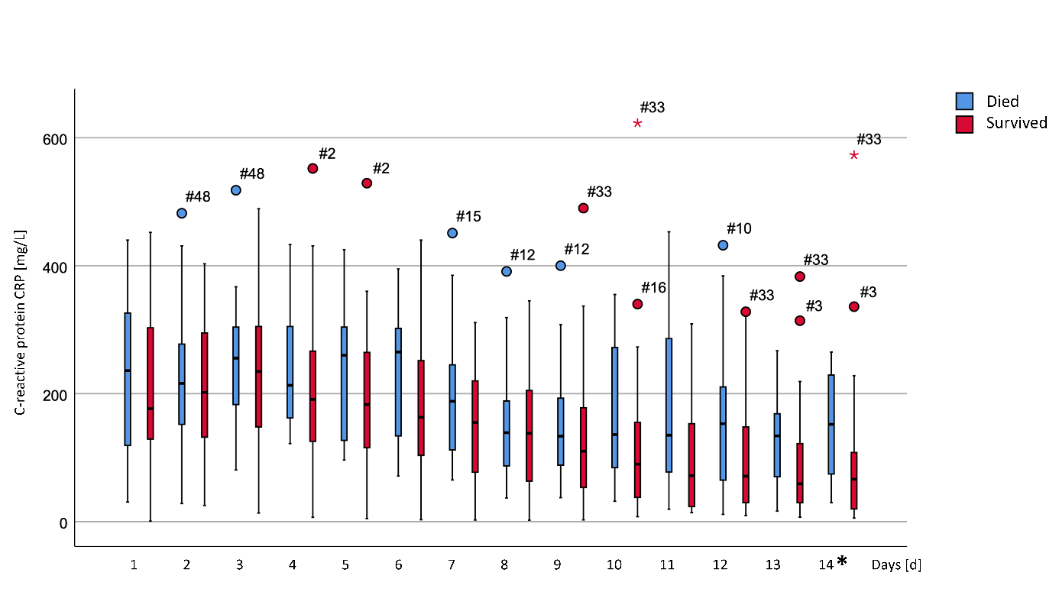
Figure 17 Daily values for C-reactive protein (CRP). Significant differences between the two groups are marked with an asterisk in the legend of the x-axis.
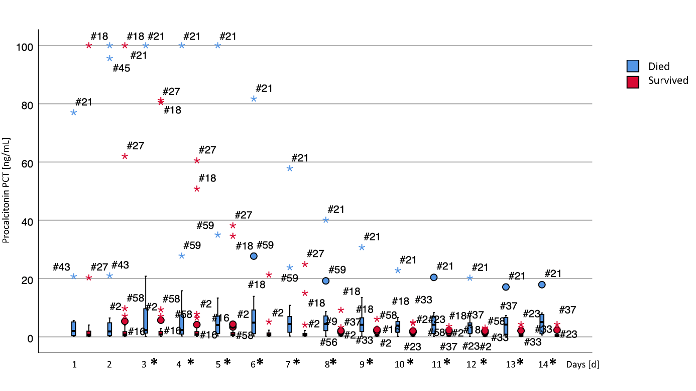
Figure 18 Daily values for procalcitonin (PCT). Significant differences between the two groups are marked with an asterisk in the legend of the x-axis.
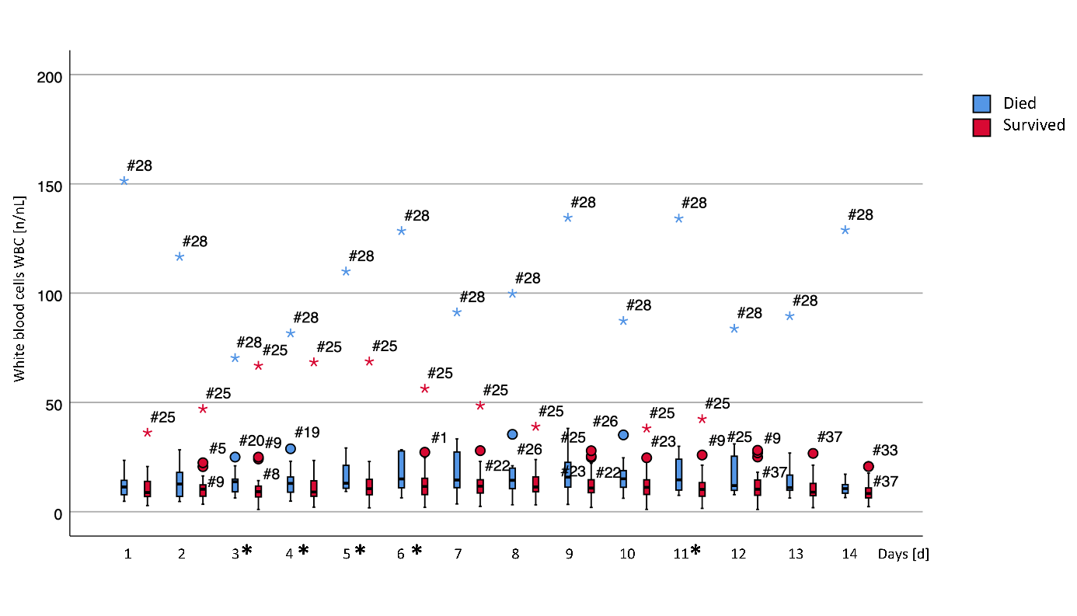
Figure 19 Daily values for the white blood cell count (WBC). Significant differences between the two groups are marked with an asterisk in the legend of the x-axis.
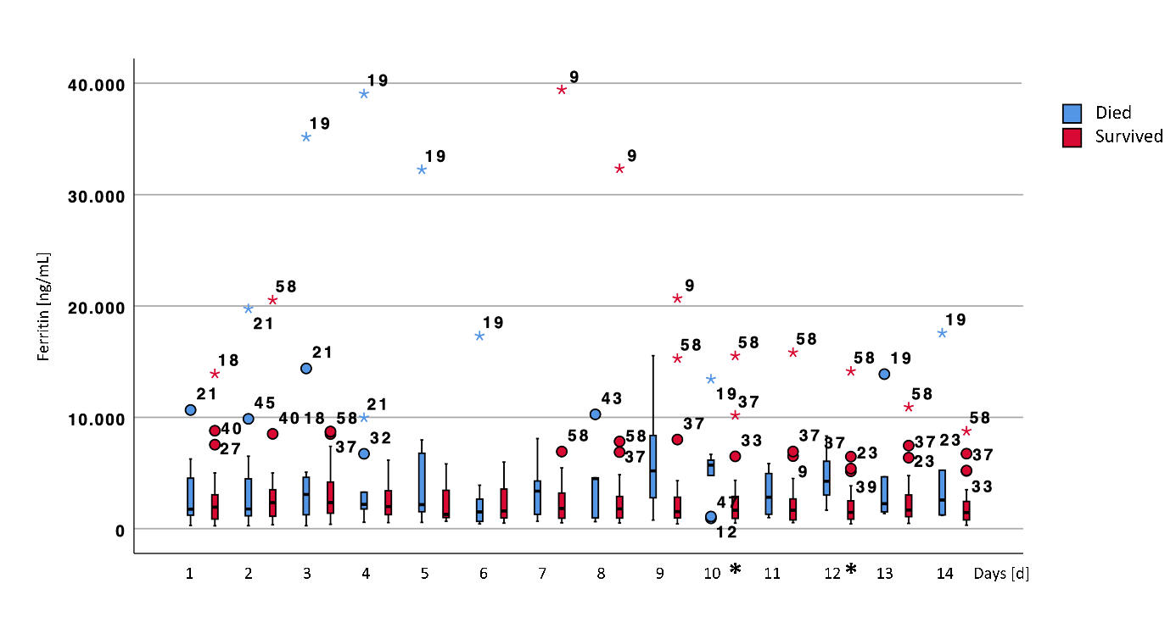
Figure 20 Daily values for ferritin. Significant differences between the two groups are marked with an asterisk in the legend of the x-axis.
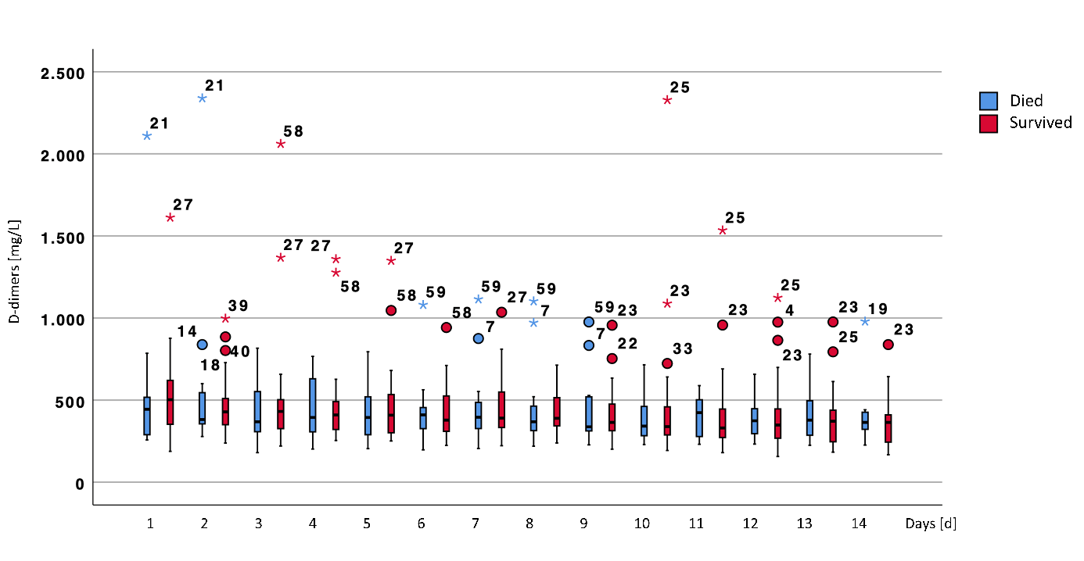
Figure 21 Daily values for D-dimers. Significant differences between the two groups are marked with an asterisk in the legend of the x-axis.
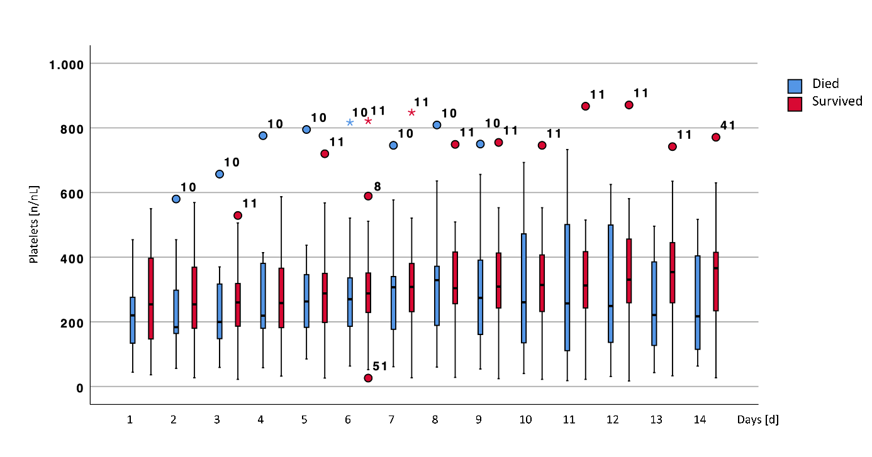
Figure 22 Daily values for the platelet count. Significant differences between the two groups are marked with an asterisk in the legend of the x-axis.
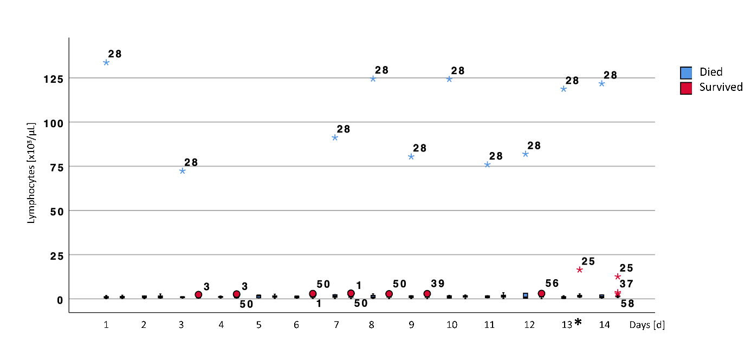
Figure 23 Daily values for the lymphocytes count. Significant differences between the two groups are marked with an asterisk in the legend of the x-axis.
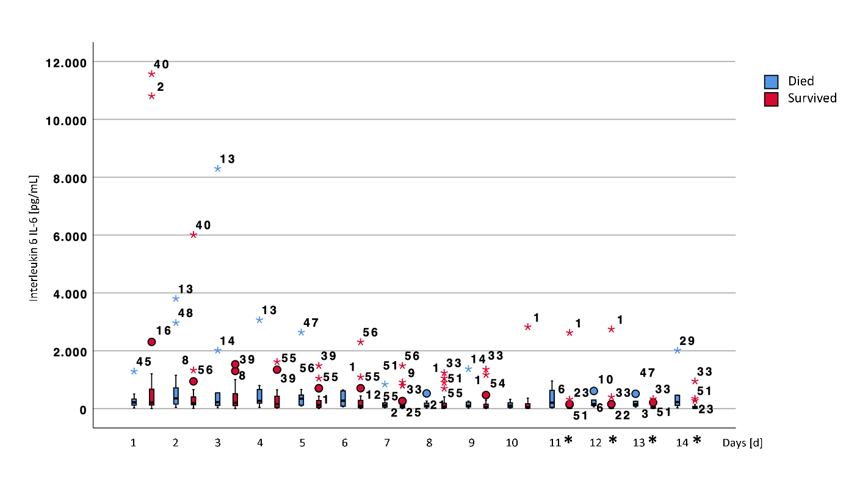
Figure 24 Daily values for interleukin 6 (IL-6). Significant differences between the two groups are marked with an asterisk in the legend of the x-axis.
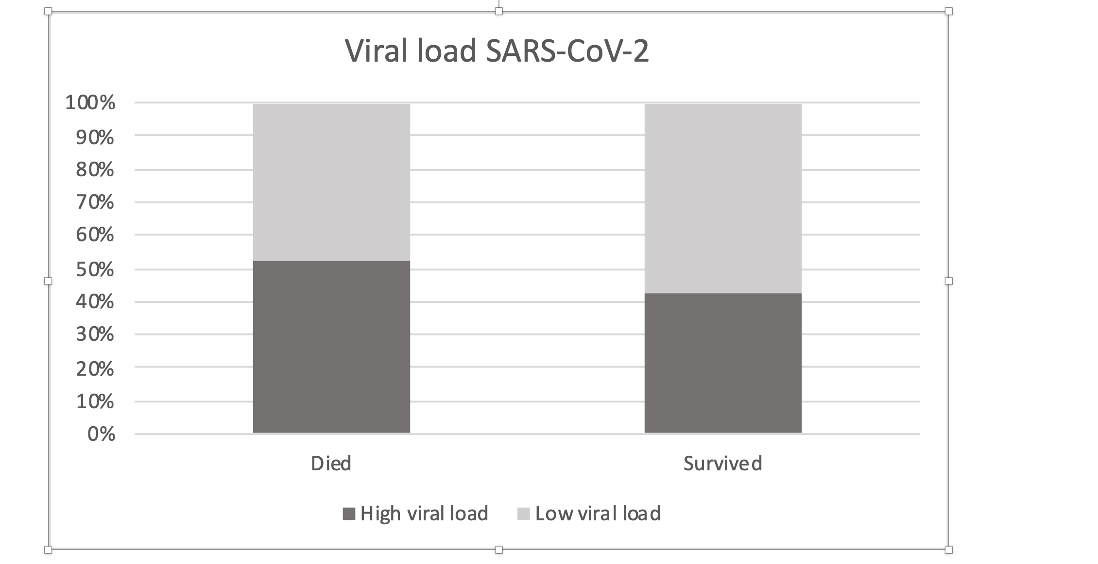
Figure 25 Frequencies of patients with high viral load (>1*10⁶ copies at least in one probe during the observation period). There was no significant difference between survivors and non-survivors (p=0.579).

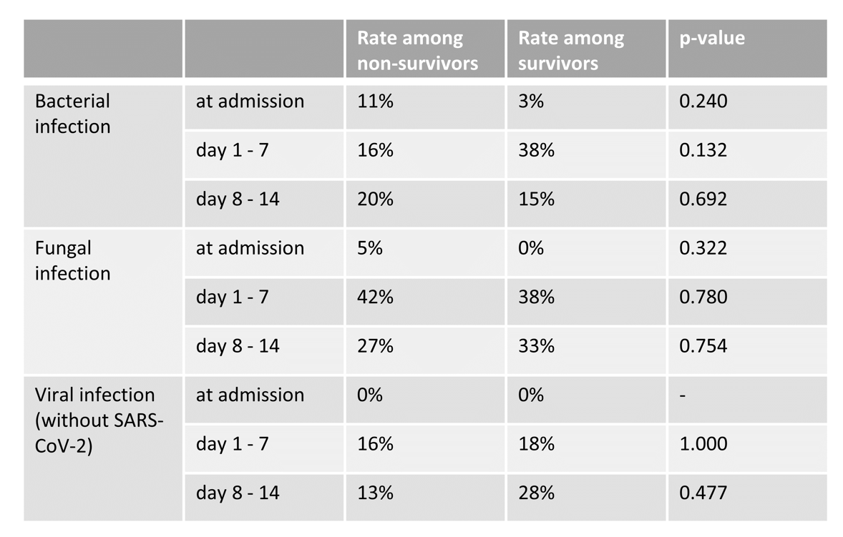
Figure 26 Frequencies of bacterial, fungal, or additional viral infection.

