Supplement 3

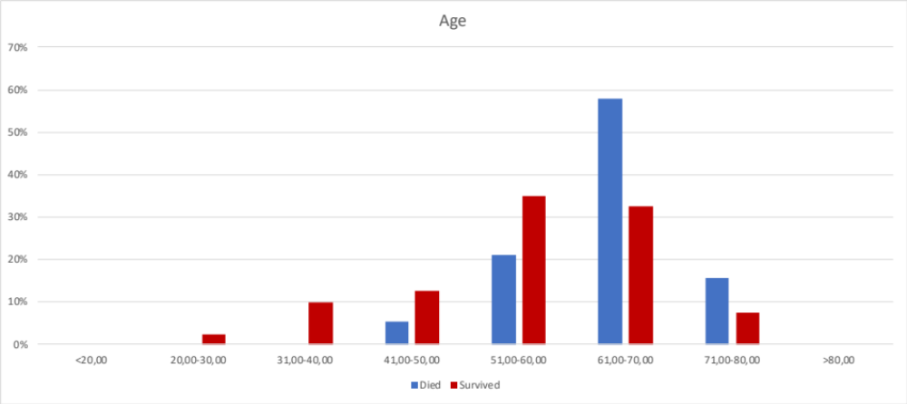
Figure 1 Distribution of age

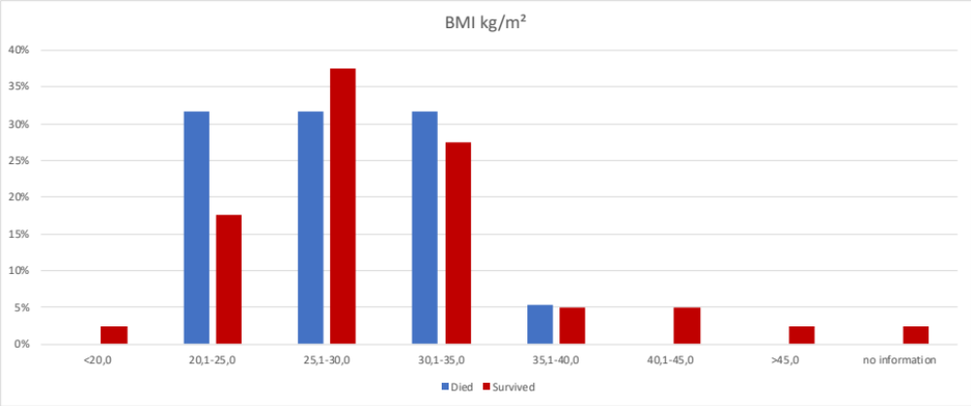
Figure 2 Distribution of body-massindex (BMI)

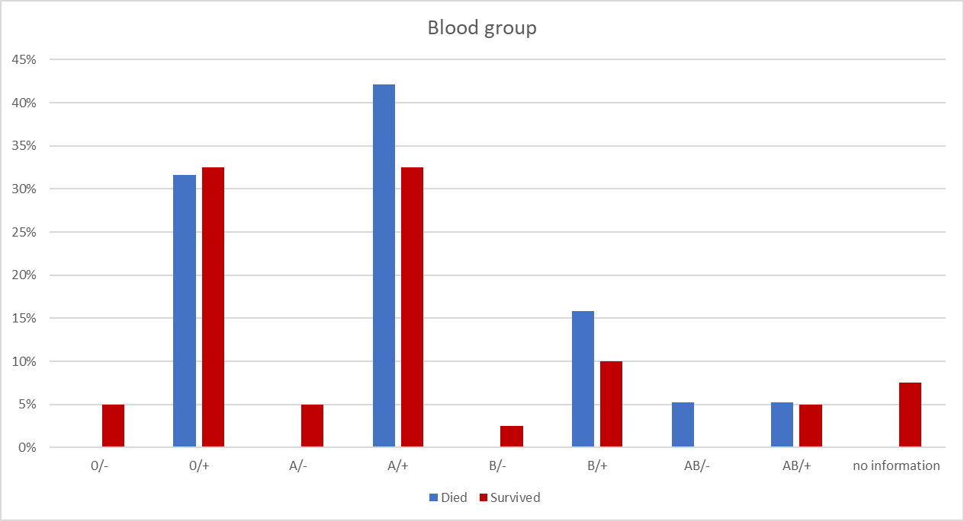
Figure 3 Distribution of the blood groups

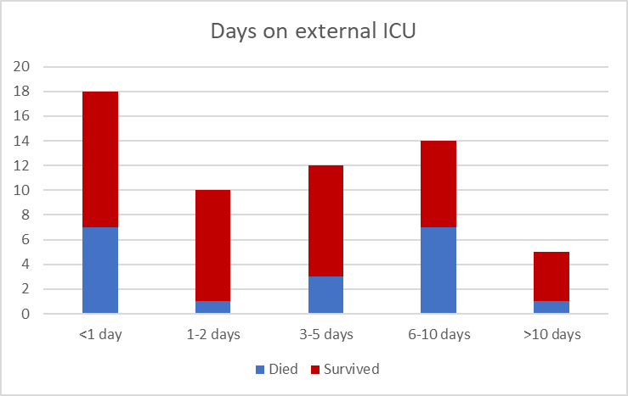
Figure 4 Number of days treated at an external intensive care unit (ICU) before transfer to an ICU at the University Medical Center Regensburg

