Supplement 4
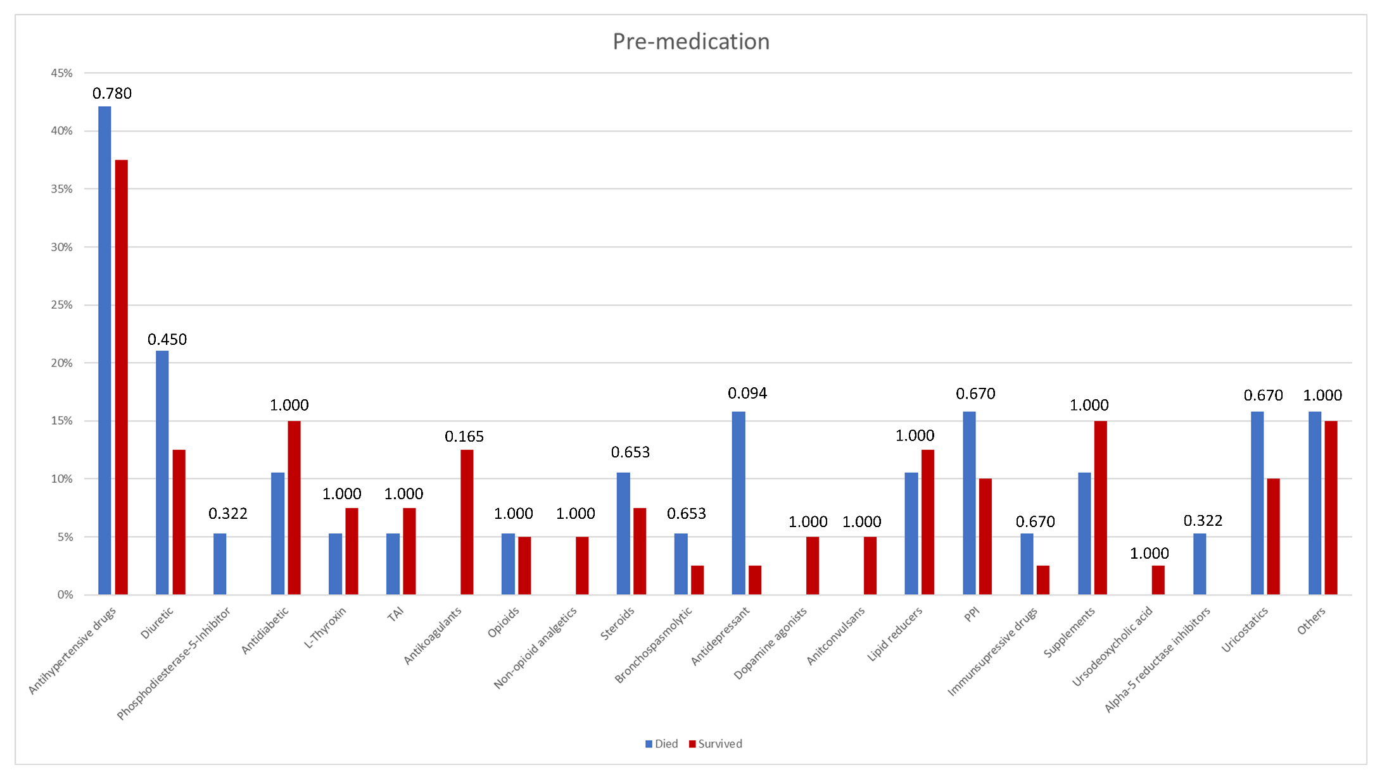
Figure 1 Classification and frequencies of pre-medication; p-values for comparison between the two groups are stated above the bars.

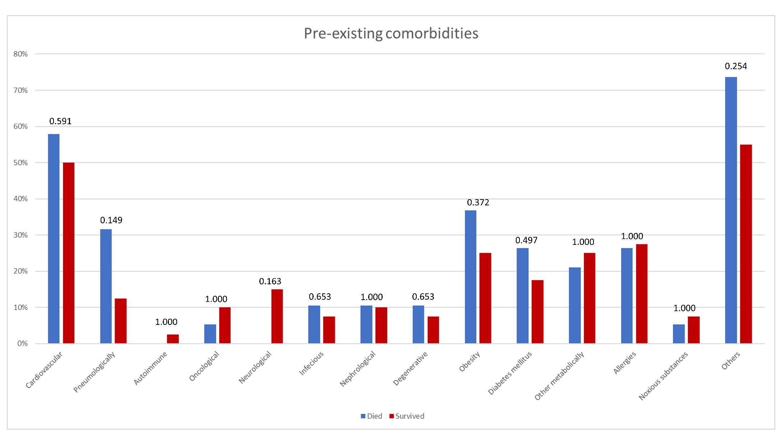
Figure 2 Classification and frequencies of pre-existing comorbidities; p-values for comparison between the two groups are stated above the bars.

