Supplement 5
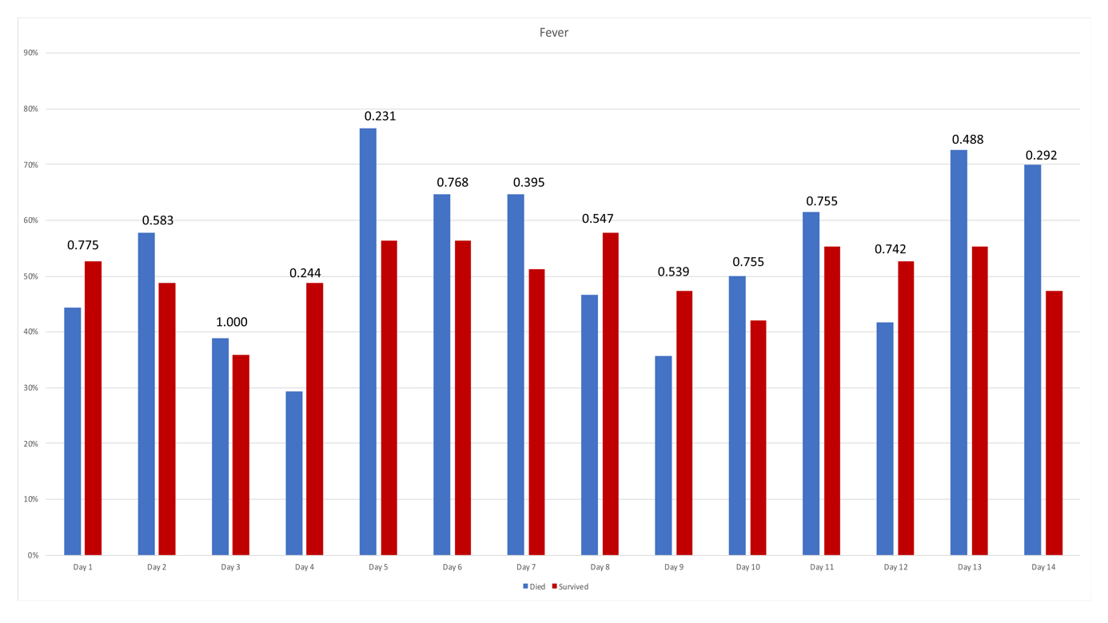
Figure 1 Frequencies of ‘days of fever’ (daily peak temperature ≥38°C) during the observation period; p-values for comparison between the two groups are stated above the bars.
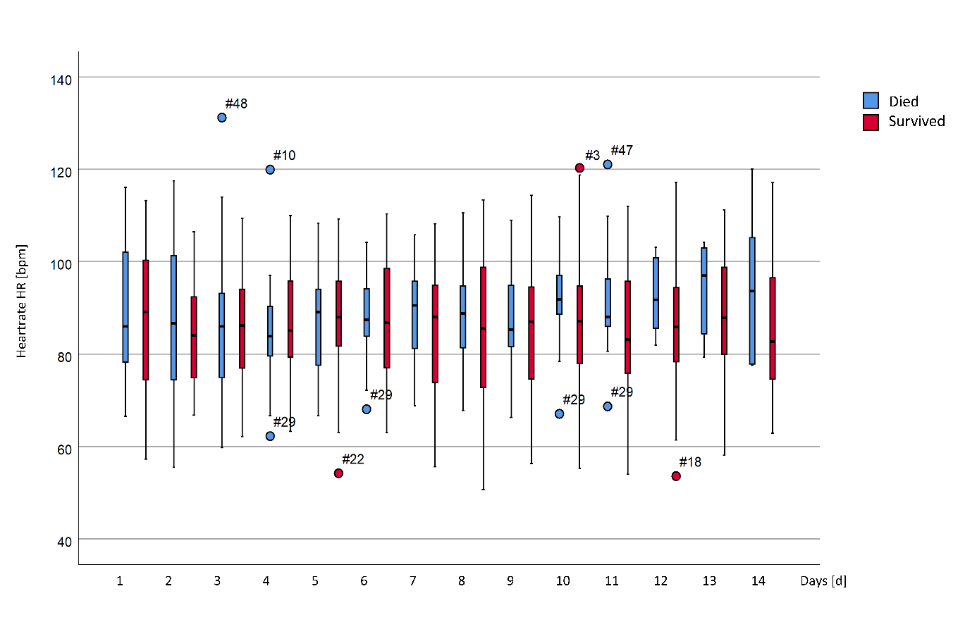Figure 2 Daily mean heartrate (HR). Significant differences between the two groups are marked with an asterisk in the legend of the x-axis.
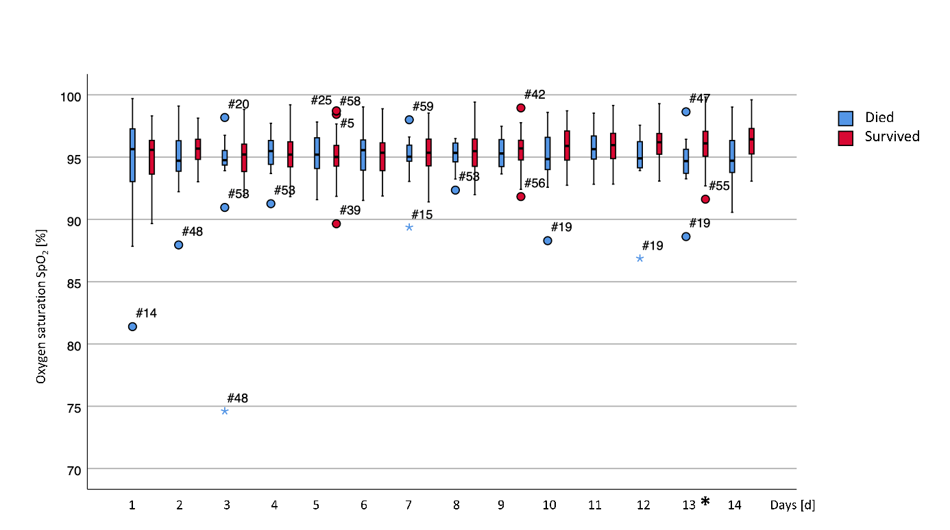
Figure 3 Daily mean oxygen saturation (SpO₂). Significant differences between the two groups are marked with an asterisk in the legend of the x-axis.
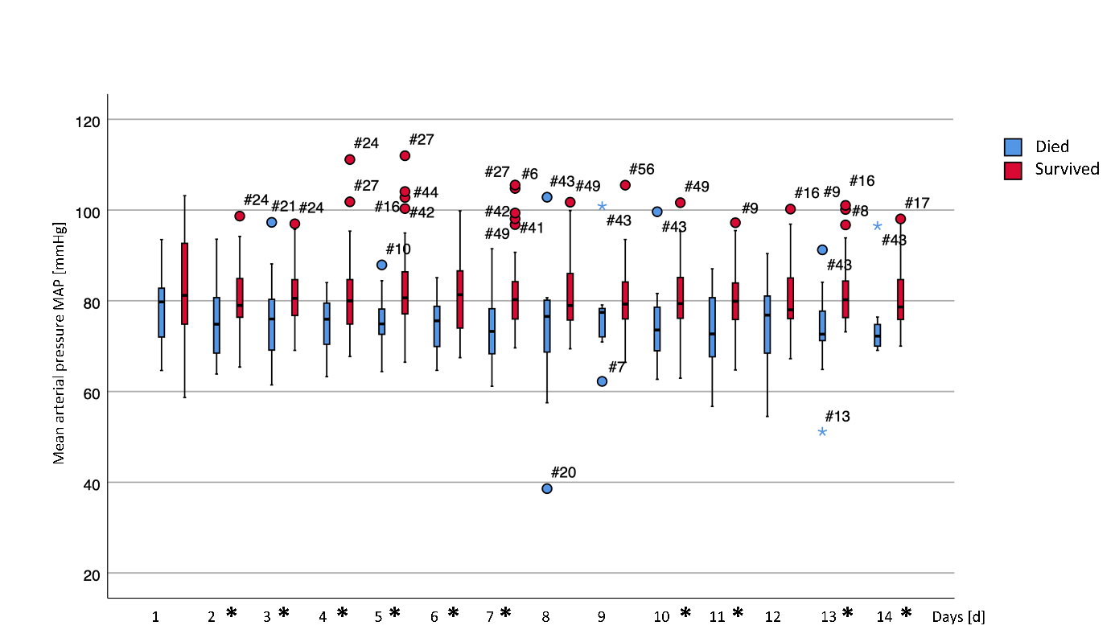

Figure 4 Daily mean MAP (mean arterial pressure). Significant differences between the two groups are marked with an asterisk in the legend of the x-axis.

