  - Study design: Cross sectional study

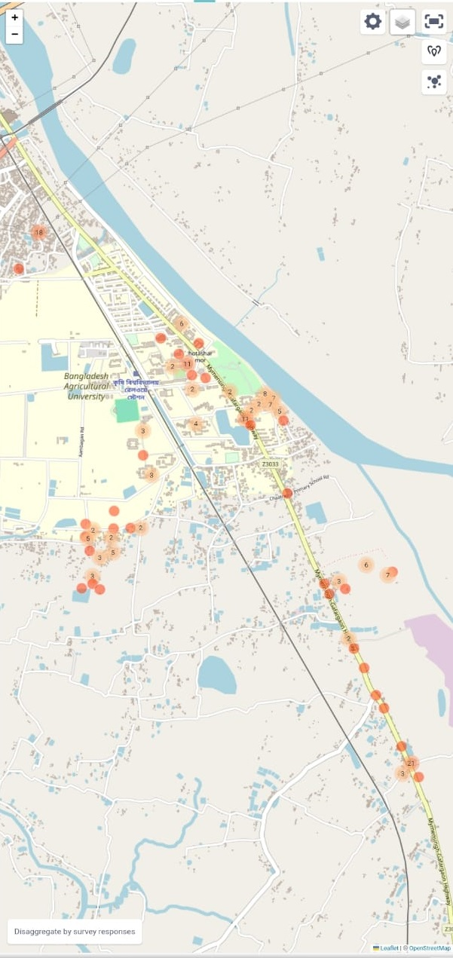
Figure 2: Map of Study site(Mymensingh

7 | Disease Mapping:
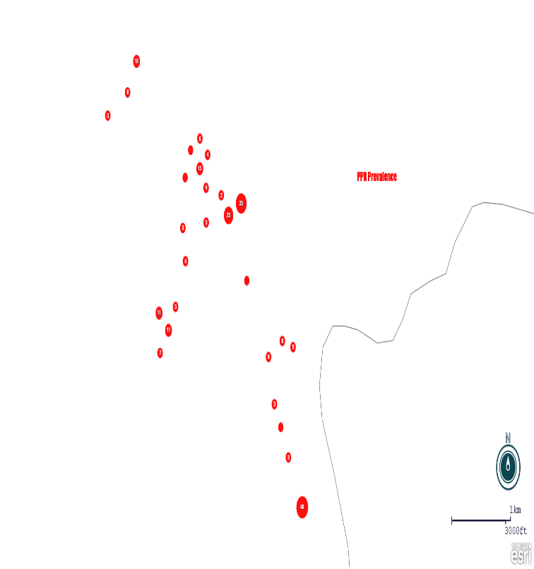 | 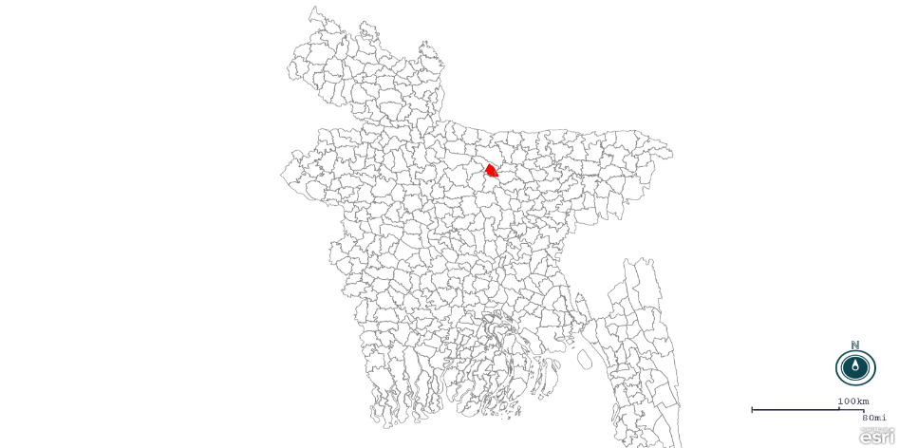
 | 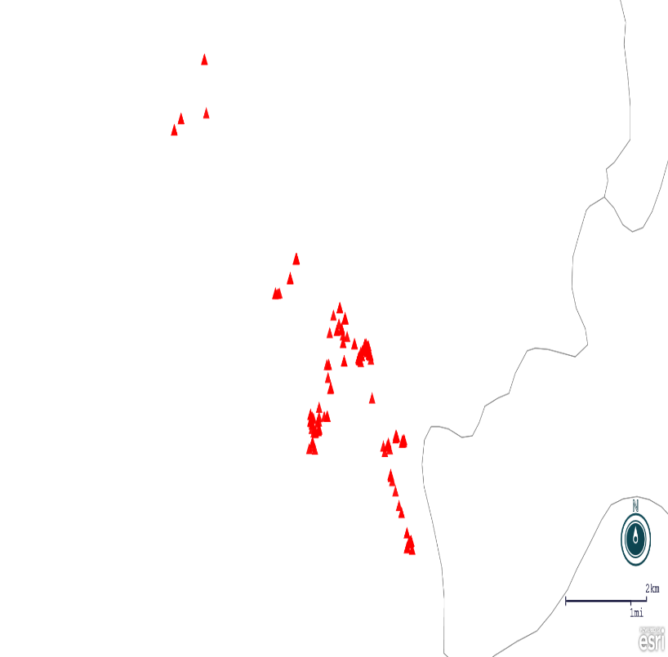
■ Present ■ Unknown/N.A
Fig 7.1 : The figure shows randomly selected study area where disease mapping was done .

