MGF100 but not MGF300 family is a superior multigene-deleted target for African swine fever virus attenuation and live attenuated vaccine development

Supplemental Flies

Table S1 Summary of amino acid diversity of protein encoded by MGF100-1R gene.
Isolate | Geno  type | length | Identities (%) | Positives (%) | Gaps
South_Africa_Warmbaths_1987_QGM12799.1 | Ⅰ | 124 | 123/124 (99%) | 124/124 (100%)
Portugal_OURT_88.3_1988_CAN10362.1 | Ⅰ | 124 | 117/124 (94%) | 123/124 (99%)
Portugal_NHV_1968_AIY22364.1 | Ⅰ | 124 | 117/124 (94%) | 123/124 (99%)
Reference strain  ASFV_CN/GS/2018 | Ⅱ | 124 | 124/124 (100%) | 124/124 (100%)
Poland_Pol16_20186_o7_2016-2017_AXZ95780.1 | Ⅱ | 124 | 124/124 (100%) | 124/124 (100%)
Poland_Pol16_20538_o9_2016-2017_QGM12799.1 | Ⅱ | 124 | 124/124 (100%) | 124/124 (100%)
Poland_Pol16_20540_o10_2016-2017_QGM12799.1 | Ⅱ | 124 | 124/124 (100%) | 124/124 (100%)
Poland_Pol16_29413_o23_2016-2017_AXZ95960.1 | Ⅱ | 124 | 124/124 (100%) | 124/124 (100%)
Poland_Pol17_03029_C201_2016-2017_AXZ95977.1 | Ⅱ | 124 | 124/124 (100%) | 124/124 (100%)
Poland_Pol17_04461_C210_2016-2017_AXZ96072.1 | Ⅱ | 124 | 124/124 (100%) | 124/124 (100%)
Poland_Pol17_05838_C220_2016-2017_QGM12799.1 | Ⅱ | 124 | 124/124 (100%) | 124/124 (100%)
Poland_ASFV_POL_Podlaskie_2015_QGM12799.1 | Ⅱ | 124 | 124/124 (100%) | 124/124 (100%)
Russia_Georgia_2007_CBW46660.1 | Ⅱ | 124 | 124/124 (100%) | 124/124 (100%)
Russia_Odintsovo_2014_QGM12799.1 | Ⅱ | 124 | 124/124 (100%) | 124/124 (100%)
Russia_Kashino_2013_QGM12799.1 | Ⅱ | 124 | 124/124 (100%) | 124/124 (100%)
Malawi_Tengani_1962_QGM12799.1 | Ⅱ | 124 | 124/124 (100%) | 124/124 (100%)
China_AnhuiXCGQ_2018_AYW33961.1 | Ⅱ | 124 | 124/124 (100%) | 124/124 (100%)
China_HLJ_2018_QBH90483.1 | Ⅱ | 124 | 124/124 (100%) | 124/124 (100%)
China_LN_2018_QBH90668.1 | Ⅱ | 124 | 124/124 (100%) | 124/124 (100%)
China_wbBS01_2018_QDL88025.1 | Ⅱ | 124 | 124/124 (100%) | 124/124 (100%)
Ukraine_Kyiv_2014_QED21553.1 | Ⅱ | 124 | 124/124 (100%) | 124/124 (100%)
Belgium_Etalle_wb_2018_QED90440.1 | Ⅱ | 124 | 124/124 (100%) | 124/124 (100%)
Lithuania_LT14_2014_QEY87799.1 | Ⅱ | 124 | 124/124 (100%) | 124/124 (100%)
China_ASFV-SY18_2018_CAN10362.1 | Ⅱ | 125 | 124/124 (100%) | 124/124 (100%)
South_Africa_KNP_Pretorisuskop_1996_AJL34021.1 | Ⅱ | 121 | 120/121 (99%) | 121/121 (100%)
Namibia_Warthog_1980_CAN10112.1 | Ⅳ | 124 | 123/124 (99%) | 124/124 (100%)
South_Africa_MGR_Mkuzi_1979_CAN10112.1 | Ⅶ | 124 | 122/124 (98%) | 123/124 (99%)
Note: a relatively big gap was observed in genotype Ⅰ strains, with amino acid identity of 94% in Portugal_OURT_88.3 and Portugal_NHV_1968 and of 99% in South_Africa_Warmbaths_1987_QGM12799.1.

Table S2 Summary of amino acid diversity of protein encoded by MGF100-2L gene.
Isolate | Geno  type | length | Identities (%) | Positives (%) | Gaps
Spain_BA71_1971_AKO62828.1 | Ⅰ | 141 | 137/141 (97%) | 139/141 (98%)
Italy_26544_OG10_2010_AJZ77159.1 | Ⅰ | 141 | 137/141 (97%) | 139/141 (98%)
Italy_47_Ss_2008_2008_AOO54522.1 | Ⅰ | 141 | 137/141 (97%) | 139/141 (98%)
Spain_E75_1975_CBH29248.1 | Ⅰ | 141 | 137/141 (97%) | 139/141 (98%)
Portugal_L60_1960_AIY22338.1 | Ⅰ | 141 | 137/141 (97%) | 139/141 (98%)
Benin_1997_CAN10246.1 | Ⅰ | 141 | 137/141 (97%) | 139/141 (98%)
Portugal_OURT_88.3_1988_CAN10496.1 | Ⅰ | 125 | 119/124 (95%) | 122/124 (98%)
Portugal_NHV_1968_AIY22496.1 | Ⅰ | 125 | 119/124 (95%) | 122/124 (98%)
Reference strain  ASFV_CN/GS/2018 | Ⅱ | 141 | 141/141 (100%) | 141/141 (100%)
Ukraine_Kyiv_2014_QED21767.1 | Ⅱ | 48 | 46/47 (97%) | 47/47 (100%)
Malawi_Tengani_1962_CAN10246.1 | Ⅱ | 141 | 138/141 (97%) | 140/141 (99%)
Ukraine_Kyiv_2014_QED21766.1 | Ⅱ | 75 | 75/75 (100%) | 75/75 (100%)
China_AnhuiXCGQ_2018_AYW34118.1 | Ⅱ | 141 | 141/141 (100%) | 141/141 (100%)
China_ASFV-SY18_2018_AKO62828.1 | Ⅱ | 141 | 141/141 (100%) | 141/141 (100%)
Poland_Pol16_20186_o7_2016-2017_AXZ95918.1 | Ⅱ | 141 | 141/141 (100%) | 141/141 (100%)
Poland_Pol16_20538_o9_2016-2017_CAN10246.1 | Ⅱ | 141 | 141/141 (100%) | 141/141 (100%)
Poland_Pol16_20540_o10_2016-2017_CAN10246.1 | Ⅱ | 141 | 141/141 (100%) | 141/141 (100%)
Poland_Pol16_29413_o23_2016-2017_CAN10246.1 | Ⅱ | 141 | 141/141 (100%) | 141/141 (100%)
Poland_Pol17_03029_C201_2016-2017_CAN10246.1 | Ⅱ | 141 | 141/141 (100%) | 141/141 (100%)
Poland_Pol17_04461_C210_2016-2017_AXZ96201.1 | Ⅱ | 141 | 141/141 (100%) | 141/141 (100%)
Poland_Pol17_05838_C220_2016-2017_CAN10246.1 | Ⅱ | 141 | 141/141 (100%) | 141/141 (100%)
Poland_ASFV_POL_Podlaskie_2015_CAN10246.1 | Ⅱ | 141 | 141/141 (100%) | 141/141 (100%)
Estonia_2014_SPS73570.1 | Ⅱ | 141 | 141/141 (100%) | 141/141 (100%)
Russia_Georgia_2007_CBW46815.1 | Ⅱ | 141 | 141/141 (100%) | 141/141 (100%)
Russia_Odintsovo_2014_CAN10246.1 | Ⅱ | 141 | 141/141 (100%) | 141/141 (100%)
Russia_Kashino_2013_CAN10246.1 | Ⅱ | 141 | 141/141 (100%) | 141/141 (100%)
China_HLJ_2018_QBH90636.1 | Ⅱ | 141 | 141/141 (100%) | 141/141 (100%)
China_LN_2018_QBH90821.1 | Ⅱ | 141 | 141/141 (100%) | 141/141 (100%)
China_wbBS01_2018_QDL88179.1 | Ⅱ | 141 | 141/141 (100%) | 141/141 (100%)
Belgium_Etalle_wb_2018_QED90590.1 | Ⅱ | 141 | 141/141 (100%) | 141/141 (100%)
Lithuania_LT14_2014_QEY87953.1 | Ⅱ | 141 | 141/141 (100%) | 141/141 (100%)
South_Africa_KNP_Pretorisuskop_1996_CAN10246.1 | Ⅱ | 141 | 138/141 (97%) | 141/141 (100%)
South_Africa_Warmbaths_1987_CAN10246.1 | Ⅱ | 141 | 139/141 (98%) | 141/141 (100%)
Uganda_R8_2015_AXB49375.1 | Ⅸ | 141 | 126/141 (89%) | 135/141 (95%)
Uganda_R7_2015_AXB49549.1 | Ⅸ | 141 | 126/141 (89%) | 135/141 (95%)
Uganda_R25_2015_AXB49721.1 | Ⅸ | 141 | 126/141 (89%) | 135/141 (95%)
Uganda_N10_2015_AXB49892.1 | Ⅸ | 141 | 126/141 (89%) | 135/141 (95%)
Uganda_R35_2015_AXB50065.1 | Ⅸ | 141 | 126/141 (89%) | 135/141 (95%)
Kenya_Bus_2006_AJL34323.1 | Ⅸ | 141 | 126/141 (89%) | 135/141 (95%)
Kenya_Tk1_2005_AJL34159.1 | Ⅸ | 141 | 127/141 (90%) | 135/141 (95%)
Namibia_Warthog_1980_CAN10246.1 | Ⅳ | 141 | 140/141 (99%) | 141/141 (100%)
South_Africa_MGR_Mkuzi_1979_CAN10246.1 | Ⅶ | 141 | 139/141 (98%) | 140/141 (99%)
Malawi_Lil_1983_CAN10246.1 | Ⅷ | 141 | 125/141 (88%) | 137/141 (97%)
Zambia_LIV_1983_CAN10246.1 | Ⅺ | 115 | 97/115 (84%) | 107/115 (93%)
South_Africa_1985_CAN10246.1 | Ⅺ | 115 | 96/115 (83%) | 107/115 (93%)
South_Africa_2_2008_CAN10246.1 | Ⅺ | 115 | 95/115 (82%) | 107/115 (93%)
Kenya_1950_CAN10246.1 | ⅩⅩ | 141 | 127/141 (90%) | 135/141 (95%)
Note: two genotype Ⅱ variants with truncated version of MGF100-2L were observed, with the size of 48 amino acids in Ukraine_Kyiv_2014_QED21767.1 and 75 amino acids in Ukraine_Kyiv_2014_QED21766.1. Also, a relatively high conservation is observed, ranging from 95% to 97% in genotype Ⅰ strains and from 82% to 90% in other genotypes

Table S3 Summary of amino acid diversity of protein encoded by MGF100-3L gene.
Isolate | Geno  type | length | Identities (%) | Positives (%) | Gaps
Spain_BA71_1971_AKO62829.1 | Ⅰ | 146 | 85/101 (84%) | 90/101 (89%)
Italy_26544_OG10_2010_AJZ77157.1 | Ⅰ | 146 | 85/101 (84%) | 90/101 (89%)
Italy_47_Ss_2008_2008_AOO54523.1 | Ⅰ | 146 | 85/101 (84%) | 90/101 (89%)
Portugal_OURT_88.3_1988_CAN10497.1 | Ⅰ | 146 | 85/101 (84%) | 90/101 (89%)
Spain_E75_1975_CBH29249.1 | Ⅰ | 146 | 85/101 (84%) | 90/101 (89%)
Portugal_L60_1960_AIY22339.1 | Ⅰ | 146 | 85/101 (84%) | 90/101 (89%)
Portugal_NHV_1968_AIY22497.1 | Ⅰ | 146 | 85/101 (84%) | 90/101 (89%)
Benin_1997_CAN10247.1 | Ⅰ | 146 | 85/101 (84%) | 90/101 (89%)
Reference strain  ASFV_CN/GS/2018 | Ⅱ | 102 | 102/102 (100%) | 102/102 (100%)
South_Africa_KNP_Pretorisuskop_1996_CAN10247.1 | Ⅱ | 146 | 94/101 (93%) | 98/101 (97%)
Malawi_Tengani_1962_CAN10247.1 | Ⅱ | 146 | 92/101 (91%) | 96/101 (95%)
China_AnhuiXCGQ_2018_CAN10247.1 | Ⅱ | 102 | 102/102 (100%) | 102/102 (100%)
China_ASFV-SY18_2018_SPS73571.1 | Ⅱ | 102 | 102/102 (100%) | 102/102 (100%)
Poland_Pol16_20186_o7_2016-2017_CAN10247.1 | Ⅱ | 102 | 102/102 (100%) | 102/102 (100%)
Poland_Pol16_20538_o9_2016-2017_CAN10247.1 | Ⅱ | 102 | 102/102 (100%) | 102/102 (100%)
Poland_Pol16_20540_o10_2016-2017_CAN10247.1 | Ⅱ | 102 | 102/102 (100%) | 102/102 (100%)
Poland_Pol16_29413_o23_2016-2017_CAN10247.1 | Ⅱ | 102 | 102/102 (100%) | 102/102 (100%)
Poland_Pol17_03029_C201_2016-2017_CAN10247.1 | Ⅱ | 102 | 102/102 (100%) | 102/102 (100%)
Poland_Pol17_04461_C210_2016-2017_CAN10247.1 | Ⅱ | 102 | 102/102 (100%) | 102/102 (100%)
Poland_Pol17_05838_C220_2016-2017_CAN10247.1 | Ⅱ | 102 | 102/102 (100%) | 102/102 (100%)
Poland_ASFV_POL_Podlaskie_2015_CAN10247.1 | Ⅱ | 102 | 102/102 (100%) | 102/102 (100%)
Estonia_2014_SPS73571.1 | Ⅱ | 102 | 102/102 (100%) | 102/102 (100%)
Russia_Georgia_2007_CAN10247.1 | Ⅱ | 102 | 102/102 (100%) | 102/102 (100%)
Russia_Odintsovo_2014_CAN10247.1 | Ⅱ | 102 | 102/102 (100%) | 102/102 (100%)
Russia_Kashino_2013_CAN10247.1 | Ⅱ | 102 | 102/102 (100%) | 102/102 (100%)
China_HLJ_2018_CAN10247.1 | Ⅱ | 102 | 102/102 (100%) | 102/102 (100%)
China_LN_2018_CAN10247.1 | Ⅱ | 102 | 102/102 (100%) | 102/102 (100%)
China_wbBS01_2018_CAN10247.1 | Ⅱ | 102 | 102/102 (100%) | 102/102 (100%)
Ukraine_Kyiv_2014_QED21768.1 | Ⅱ | 102 | 102/102 (100%) | 102/102 (100%)
Belgium_Etalle_wb_2018_QED90591.1 | Ⅱ | 102 | 102/102 (100%) | 102/102 (100%)
Lithuania_LT14_2014_QEY87954.1 | Ⅱ | 102 | 102/102 (100%) | 102/102 (100%)
South_Africa_Warmbaths_1987_CAN10247.1 | Ⅱ | 146 | 97/101 (96%) | 98/101 (97%)
Uganda_R8_2015_AXB49376.1 | Ⅸ | 146 | 82/101 (77%) | 88/101 (83%)
Uganda_R7_2015_AXB49550.1 | Ⅸ | 146 | 82/101 (78%) | 88/101 (84%)
Uganda_R25_2015_AXB49722.1 | Ⅸ | 146 | 82/101 (79%) | 88/101 (85%)
Uganda_N10_2015_AXB49893.1 | Ⅸ | 146 | 82/101 (80%) | 88/101 (86%)
Uganda_R35_2015_AXB50066.1 | Ⅸ | 146 | 82/101 (81%) | 88/101 (87%)
Kenya_Bus_2006_AJL34324.1 | Ⅸ | 146 | 82/101 (81%) | 88/101 (87%)
Kenya_Tk1_2005_AJL34160.1 | Ⅸ | 146 | 83/101 (82%) | 89/101 (88%)
Namibia_Warthog_1980_CAN10247.1 | Ⅳ | 146 | 98/101 (97%) | 99/101 (98%)
South_Africa_MGR_Mkuzi_1979_CAN10247.1 | Ⅶ | 146 | 86/101 (85%) | 91/101 (90%)
Zambia_LIV_1983_CAN10247.1 | Ⅺ | 121 | 76/101 (75%) | 86/101 (85%)
Note: genotype I strains all carry a 146 amino-acid MGF100-3L protein with an identity of 84% when compared to our reference strain protein. The amino acid identity in genotype Ⅳ, Ⅶ, Ⅸand Ⅺ strains is divergent, ranging from 75% to 97%.

Table S4 Summary of amino acid diversity of protein encoded by MGF300-1L gene.
Isolate | Geno  type | length | Identities (%) | Positives (%) | Gaps
Spain_BA71_1971_AKO62695.1 | Ⅰ | 250 | 239/250 (95%) | 240/250 (96%)
Italy_26544_OG10_2010_AJZ77111.1 | Ⅰ | 250 | 239/250 (95%) | 240/250 (96%)
Italy_47_Ss_2008_2008_AOO54327.1 | Ⅰ | 250 | 239/250 (95%) | 240/250 (96%)
Portugal_OURT_88.3_1988_CAN10368.1 | Ⅰ | 250 | 239/250 (95%) | 240/250 (96%)
Spain_E75_1975_CBH29113.1 | Ⅰ | 250 | 239/250 (95%) | 240/250 (96%)
Portugal_L60_1960_AIY22204.1 | Ⅰ | 250 | 239/250 (95%) | 240/250 (96%)
Portugal_NHV_1968_AIY22370.1 | Ⅰ | 250 | 239/250 (95%) | 240/250 (96%)
Benin_1997_CAN10112.1 | Ⅰ | 250 | 239/250 (95%) | 240/250 (96%)
Reference strain  ASFV_CN/GS/2018 | Ⅱ | 250 | 250/250 (100%) | 250/250 (100%)
South_Africa_KNP_Pretorisuskop_1996_CAN10112.1 | Ⅱ | 250 | 238/249 (95%) | 240/249 (96%)
South_Africa_Warmbaths_1987_CAN10112.1 | Ⅱ | 250 | 236/249 (94%) | 241/249 (96%)
Malawi_Tengani_1962_CAN10112.1 | Ⅱ | 250 | 241/250 (96%) | 243/250 (97%)
China_ASFV-SY18_2018_AKO62695.1 | Ⅱ | 250 | 250/250 (100%) | 250/250 (100%)
China_AnhuiXCGQ_2018_AYW33970.1 | Ⅱ | 250 | 250/250 (100%) | 250/250 (100%)
Poland_Pol16_20186_o7_2016-2017_AXZ95792.1 | Ⅱ | 250 | 250/250 (100%) | 250/250 (100%)
Poland_Pol17_05838_C220_2016-2017_AXZ96218.1 | Ⅱ | 250 | 250/250 (100%) | 250/250 (100%)
Estonia_2014_SPS73435.1 | Ⅱ | 250 | 250/250 (100%) | 250/250 (100%)
Russia_Georgia_2007_CBW46679.1 | Ⅱ | 250 | 250/250 (100%) | 250/250 (100%)
China_HLJ_2018_QBH90501.1 | Ⅱ | 250 | 250/250 (100%) | 250/250 (100%)
China_LN_2018_QBH90686.1 | Ⅱ | 250 | 250/250 (100%) | 250/250 (100%)
China_wbBS01_2018_QDL88044.1 | Ⅱ | 250 | 250/250 (100%) | 250/250 (100%)
Ukraine_Kyiv_2014_QED21565.1 | Ⅱ | 250 | 250/250 (100%) | 250/250 (100%)
Belgium_Etalle_wb_2018_QED90455.1 | Ⅱ | 250 | 250/250 (100%) | 250/250 (100%)
Lithuania_LT14_2014_QEY87818.1 | Ⅱ | 250 | 250/250 (100%) | 250/250 (100%)
Poland_Pol16_20538_o9_2016-2017_CAN10112.1 | Ⅱ | 250 | 250/250 (100%) | 250/250 (100%)
Poland_Pol16_20540_o10_2016-2017_CAN10112.1 | Ⅱ | 250 | 250/250 (100%) | 250/250 (100%)
Poland_Pol16_29413_o23_2016-2017_CAN10112.1 | Ⅱ | 250 | 250/250 (100%) | 250/250 (100%)
Poland_Pol17_03029_C201_2016-2017_CAN10112.1 | Ⅱ | 250 | 250/250 (100%) | 250/250 (100%)
Poland_Pol17_04461_C210_2016-2017_CAN10112.1 | Ⅱ | 250 | 250/250 (100%) | 250/250 (100%)
Poland_ASFV_POL_Podlaskie_2015_CAN10112.1 | Ⅱ | 250 | 250/250 (100%) | 250/250 (100%)
Russia_Odintsovo_2014_CAN10112.1 | Ⅱ | 250 | 250/250 (100%) | 250/250 (100%)
Russia_Kashino_2013_CAN10112.1 | Ⅱ | 250 | 250/250 (100%) | 250/250 (100%)
Kenya_Tk1_2005_AJL34030.1 | Ⅸ | 250 | 227/250 (90%) | 237/250 (94%)
Uganda_R8_2015_AXB49244.1 | Ⅸ | 250 | 225/250 (90%) | 237/250 (94%)
Uganda_R7_2015_AXB49418.1 | Ⅸ | 250 | 225/250 (90%) | 237/250 (94%)
Uganda_R25_2015_AXB49590.1 | Ⅸ | 250 | 225/250 (90%) | 237/250 (94%)
Uganda_N10_2015_AXB49763.1 | Ⅸ | 250 | 225/250 (90%) | 237/250 (94%)
Uganda_R35_2015_AXB49934.1 | Ⅸ | 250 | 225/250 (90%) | 237/250 (94%)
Kenya_Bus_2006_AJL34194.1 | Ⅸ | 250 | 227/250 (90%) | 237/250 (94%)
Namibia_Warthog_1980_CAN10112.1 | Ⅳ | 250 | 236/249 (94%) | 241/249 (96%)
South_Africa_MGR_Mkuzi_1979_CAN10112.1 | Ⅶ | 250 | 240/250 (96%) | 245/250 (98%)
Malawi_Lil_1983_CAN10112.1 | Ⅷ | 250 | 227/250 (90%) | 234/250 (93%)
Kenya_1950_CAN10112.1 | ⅩⅩ | 250 | 229/250 (91%) | 237/250 (94%)
Note: the identity in genotype Ⅰ strains is all the same as 95% compared with our reference strain.

Table S5 Summary of amino acid diversity of protein encoded by MGF300-2R gene.
Isolate | Geno  type | length | Identities (%) | Positives (%) | Gaps
Spain_BA71_1971_AKO62697.1 | Ⅰ | 160 | 156/160 (97%) | 158/160 (98%)
Italy_26544_OG10_2010_AJZ77150.1 | Ⅰ | 160 | 156/160 (97%) | 158/160 (98%)
Italy_47_Ss_2008_2008_AOO54329.1 | Ⅰ | 160 | 156/160 (97%) | 158/160 (98%)
Portugal_OURT_88.3_1988_CAN10370.1 | Ⅰ | 160 | 156/160 (97%) | 158/160 (98%)
Spain_E75_1975_CBH29115.1 | Ⅰ | 160 | 156/160 (97%) | 158/160 (98%)
Portugal_L60_1960_AIY22206.1 | Ⅰ | 160 | 156/160 (97%) | 158/160 (98%)
Portugal_NHV_1968_AIY22372.1 | Ⅰ | 160 | 156/160 (97%) | 158/160 (98%)
Benin_1997_CAN10113.1 | Ⅰ | 160 | 156/160 (97%) | 158/160 (98%)
Reference strain  ASFV_CN/GS/2018 | Ⅱ | 161 | 160/160 (100%) | 160/160 (100%)
Malawi_Tengani_1962_CAN10113.1 | Ⅱ | 161 | 151/160 (94%) | 156/160 (97%)
South_Africa_KNP_Pretorisuskop_1996_CAN10113.1 | Ⅱ | 161 | 156/160 (97%) | 158/160 (98%)
Ukraine_Kyiv_2014_QED21568.1 | Ⅱ | 75 | 75/75 (100%) | 75/75 (100%)
China_AnhuiXCGQ_2018_CAN10113.1 | Ⅱ | 161 | 160/160 (100%) | 160/160 (100%)
Poland_Pol16_20186_o7_2016-2017_CAN10113.1 | Ⅱ | 161 | 160/160 (100%) | 160/160 (100%)
Poland_Pol16_20538_o9_2016-2017_CAN10113.1 | Ⅱ | 161 | 160/160 (100%) | 160/160 (100%)
Poland_Pol16_20540_o10_2016-2017_CAN10113.1 | Ⅱ | 161 | 160/160 (100%) | 160/160 (100%)
Poland_Pol16_29413_o23_2016-2017_CAN10113.1 | Ⅱ | 161 | 160/160 (100%) | 160/160 (100%)
Poland_Pol17_03029_C201_2016-2017_CAN10113.1 | Ⅱ | 161 | 160/160 (100%) | 160/160 (100%)
Poland_Pol17_04461_C210_2016-2017_CAN10113.1 | Ⅱ | 161 | 160/160 (100%) | 160/160 (100%)
Poland_Pol17_05838_C220_2016-2017_CAN10113.1 | Ⅱ | 161 | 160/160 (100%) | 160/160 (100%)
Poland_ASFV_POL_Podlaskie_2015_CAN10113.1 | Ⅱ | 161 | 160/160 (100%) | 160/160 (100%)
Russia_Kashino_2013_CAN10113.1 | Ⅱ | 161 | 160/160 (100%) | 160/160 (100%)
China_HLJ_2018_CAN10113.1 | Ⅱ | 161 | 160/160 (100%) | 160/160 (100%)
China_LN_2018_CAN10113.1 | Ⅱ | 161 | 160/160 (100%) | 160/160 (100%)
China_wbBS01_2018_CAN10113.1 | Ⅱ | 161 | 160/160 (100%) | 160/160 (100%)
Estonia_2014_SPS73436.1 | Ⅱ | 160 | 160/160 (100%) | 160/160 (100%)
Belgium_Etalle_wb_2018_QED90456.1 | Ⅱ | 160 | 160/160 (100%) | 160/160 (100%)
Lithuania_LT14_2014_QEY87819.1 | Ⅱ | 160 | 160/160 (100%) | 160/160 (100%)
Ukraine_Kyiv_2014_QED21567.1 | Ⅱ | 82 | 74/75 (98%) | 75/75 (100%)
South_Africa_Warmbaths_1987_CAN10113.1 | Ⅱ | 161 | 152/160 (95%) | 156/160 (97%)
Kenya_Bus_2006_AJL34195.1 | Ⅸ | 160 | 146/160 (91%) | 152/160 (95%)
Kenya_Tk1_2005_AJL34031.1 | Ⅸ | 160 | 146/160 (91%) | 151/160 (94%)
Uganda_R8_2015_AXB49245.1 | Ⅸ | 160 | 146/160 (91%) | 152/160 (95%)
Uganda_R7_2015_AXB49419.1 | Ⅸ | 160 | 146/160 (91%) | 152/160 (95%)
Uganda_R25_2015_AXB49591.1 | Ⅸ | 160 | 146/160 (91%) | 152/160 (95%)
Uganda_N10_2015_AXB49764.1 | Ⅸ | 160 | 146/160 (91%) | 152/160 (95%)
Uganda_R35_2015_AXB49935.1 | Ⅸ | 160 | 146/160 (91%) | 152/160 (95%)
Namibia_Warthog_1980_CAN10113.1 | Ⅳ | 161 | 153/160 (95%) | 157/160 (98%)
South_Africa_2_2008_QGM12805.1 | Ⅺ | 160 | 127/160 (79%) | 140/160 (87%)
South_Africa_1985_QGM12887.1 | Ⅺ | 154 | 120/154 (77%) | 133/154 (86%)
Zambia_LIV_1983_QGM12682.1 | Ⅺ | 154 | 123/154 (79%) | 132/154 (85%)
Kenya_1950_CAN10113.1 | ⅩⅩ | 161 | 145/160 (90%) | 151/160 (94%)
Note: there are also two kinds of C-terminally truncated mutants of MGF300-2R, as one type is from genotype Ⅱ strains of Ukraine_Kyiv_2014_QED21568.1 (75 amino acid length and 100% identity) and Ukraine_Kyiv_2014_QED21567.1 (82 amino acid length and 98% identity), and the other type is 154 amino acid length from genotype Ⅺ strains with identity of 77% to 79%.

Table S6 Summary of amino acid diversity of protein encoded by MGF300-4L gene.
Isolate | Geno  type | length | Identities (%) | Positives (%) | Gaps
Spain_E75_1975_CBH29117.1 | Ⅰ | 104 | 100/104 (96%) | 103/104 (99%)
Benin_1997_CAN10114.1 | Ⅰ | 104 | 100/104 (96%) | 103/104 (99%)
Spain_BA71_1971_AKO62698.1 | Ⅰ | 328 | 307/330 (93%) | 318/330 (97%)
Portugal_OURT_88.3_1988_CAN10371.1 | Ⅰ | 328 | 307/330 (93%) | 318/330 (97%)
Spain_E75_1975_CBH29116.1 | Ⅰ | 328 | 307/330 (93%) | 318/330 (96%)
Portugal_L60_1960_AIY22207.1 | Ⅰ | 328 | 307/330 (93%) | 318/330 (96%)
Portugal_NHV_1968_AIY22373.1 | Ⅰ | 328 | 307/330 (93%) | 318/330 (96%)
Benin_1997_CAN10115.1 | Ⅰ | 328 | 307/330 (93%) | 318/330 (96%)
Italy_26544_OG10_2010_AJZ77173.1 | Ⅰ | 104 | 99/104 (95%) | 102/104 (98%)
Italy_47_Ss_2008_2008_AOO54331.1 | Ⅰ | 104 | 99/104 (95%) | 102/104 (98%)
Italy_26544_OG10_2010_AJZ77096.1 | Ⅰ | 328 | 306/330 (92%) | 317/330 (96%)
Italy_47_Ss_2008_2008_AOO54332.1 | Ⅰ | 328 | 306/330 (92%) | 317/330 (96%)
Reference strain  ASFV_CN/GS/2018 | Ⅱ | 330 | 330/330 (100%) | 330/330 (100%)
South_Africa_Warmbaths_1987_AJL34032.1 | Ⅱ | 254 | 246/254 (96%) | 249/254 (98%)
South_Africa_KNP_Pretorisuskop_1996_AJL34032.1 | Ⅱ | 330 | 315/330 (95%) | 322/330 (97%)
Malawi_Tengani_1962_AJL34032.1 | Ⅱ | 254 | 243/254 (95%) | 249/254 (98%)
China_ASFV-SY18_2018_CAN10114.1 | Ⅱ | 104 | 104/104 (100%) | 104/104 (100%)
Ukraine_Kyiv_2014_QED21569.1 | Ⅱ | 148 | 148/148 (100%) | 148/148 (100%)
China_AnhuiXCGQ_2018_AJL34032.1 | Ⅱ | 254 | 254/254 (100%) | 254/254 (100%)
Poland_Pol16_20186_o7_2016-2017_AJL34032.1 | Ⅱ | 254 | 254/254 (100%) | 254/254 (100%)
Poland_Pol16_20538_o9_2016-2017_AJL34032.1 | Ⅱ | 254 | 254/254 (100%) | 254/254 (100%)
Poland_Pol16_20540_o10_2016-2017_AJL34032.1 | Ⅱ | 254 | 254/254 (100%) | 254/254 (100%)
Poland_Pol16_29413_o23_2016-2017_AJL34032.1 | Ⅱ | 254 | 254/254 (100%) | 254/254 (100%)
Poland_Pol17_03029_C201_2016-2017_AJL34032.1 | Ⅱ | 254 | 254/254 (100%) | 254/254 (100%)
Poland_Pol17_04461_C210_2016-2017_AJL34032.1 | Ⅱ | 254 | 254/254 (100%) | 254/254 (100%)
Poland_Pol17_05838_C220_2016-2017_AJL34032.1 | Ⅱ | 254 | 254/254 (100%) | 254/254 (100%)
Poland_ASFV_POL_Podlaskie_2015_AJL34032.1 | Ⅱ | 254 | 254/254 (100%) | 254/254 (100%)
Estonia_2014_AJL34032.1 | Ⅱ | 254 | 254/254 (100%) | 254/254 (100%)
Russia_Georgia_2007_AJL34032.1 | Ⅱ | 254 | 254/254 (100%) | 254/254 (100%)
Russia_Odintsovo_2014_AJL34032.1 | Ⅱ | 254 | 254/254 (100%) | 254/254 (100%)
Russia_Kashino_2013_AJL34032.1 | Ⅱ | 254 | 254/254 (100%) | 254/254 (100%)
China_HLJ_2018_AJL34032.1 | Ⅱ | 254 | 254/254 (100%) | 254/254 (100%)
China_LN_2018_AJL34032.1 | Ⅱ | 254 | 254/254 (100%) | 254/254 (100%)
China_wbBS01_2018_AJL34032.1 | Ⅱ | 254 | 254/254 (100%) | 254/254 (100%)
Belgium_Etalle_wb_2018_AJL34032.1 | Ⅱ | 254 | 254/254 (100%) | 254/254 (100%)
Lithuania_LT14_2014_AJL34032.1 | Ⅱ | 254 | 254/254 (100%) | 254/254 (100%)
Ukraine_Kyiv_2014_QED21570.1 | Ⅱ | 88 | 86/87 (98%) | 87/87 (100%)
China_AnhuiXCGQ_2018_AYW33971.1 | Ⅱ | 330 | 330/330 (100%) | 330/330 (100%)
China_ASFV-SY18_2018_AKO62698.1 | Ⅱ | 330 | 330/330 (100%) | 330/330 (100%)
Poland_Pol16_20186_o7_2016-2017_AXZ95793.1 | Ⅱ | 330 | 330/330 (100%) | 330/330 (100%) | 2/330 (0%)
Poland_Pol17_05838_C220_2016-2017_AXZ96219.1 | Ⅱ | 330 | 330/330 (100%) | 330/330 (100%) | 2/330 (0%)
Estonia_2014_SPS73437.1 | Ⅱ | 330 | 330/330 (100%) | 330/330 (100%) | 2/330 (0%)
Russia_Georgia_2007_CBW46680.1 | Ⅱ | 330 | 330/330 (100%) | 330/330 (100%) | 2/330 (0%)
China_HLJ_2018_QBH90502.1 | Ⅱ | 330 | 330/330 (100%) | 330/330 (100%) | 2/330 (0%)
China_LN_2018_QBH90687.1 | Ⅱ | 330 | 330/330 (100%) | 330/330 (100%) | 2/330 (0%)
China_wbBS01_2018_QDL88045.1 | Ⅱ | 330 | 330/330 (100%) | 330/330 (100%)
Belgium_Etalle_wb_2018_QED90457.1 | Ⅱ | 330 | 330/330 (100%) | 330/330 (100%)
Lithuania_LT14_2014_QEY87820.1 | Ⅱ | 330 | 330/330 (100%) | 330/330 (100%) | 2/330 (0%)
Kenya_Tk1_2005_AJL34032.1 | Ⅸ | 331 | 289/331 (87%) | 310/331 (93%) | 1/331 (0%)
Uganda_R8_2015_AXB49246.1 | Ⅸ | 330 | 281/330 (85%) | 307/330 (93%)
Uganda_R7_2015_AXB49420.1 | Ⅸ | 330 | 281/330 (85%) | 307/330 (93%)
Uganda_R25_2015_AXB49592.1 | Ⅸ | 330 | 281/330 (85%) | 307/330 (93%)
Uganda_N10_2015_AXB49765.1 | Ⅸ | 330 | 281/330 (85%) | 307/330 (93%)
Uganda_R35_2015_AXB49936.1 | Ⅸ | 330 | 281/330 (85%) | 307/330 (93%)
Kenya_Bus_2006_AJL34196.1 | Ⅸ | 330 | 280/330 (84%) | 306/330 (92%)
Namibia_Warthog_1980_AJL34032.1 | Ⅳ | 254 | 243/254 (95%) | 250/254 (98%) | 2/330 (0%)
South_Africa_MGR_Mkuzi_1979_AJL34032.1 | Ⅶ | 254 | 241/254 (94%) | 241/254 (94%)
Malawi_Lil_1983_AJL34032.1 | Ⅷ | 331 | 291/331 (87%) | 313/331 (94%) | 1/331 (0%)
Kenya_1950_AJL34032.1 | ⅩⅩ | 330 | 281/330 (85%) | 307/330 (93%)

Table S7 Summary of differences between the full-length genome sequence of ASFV-Δ100 and the parental ASFV CN/GS/2018 (except 3 deleted genes).
Nucleotide position number | Region of ORF | Description
102 | Noncoding region | Insertion of A
430 | Noncoding region | Insertion of CC
797 | Noncoding region | Deletion of A
2382 | MGF360-2L | Deletion of A
9730 | MGF110-7L | Deletion of C
13271-13272 | MGF110-14L | Deletion of CC
14716 | MGF110-13L | Insertion of CC
19033-19036 | Noncoding region | Deletion of GGGG
20834 | Noncoding region | Insertion of G
21433 | MGF300-2R | Deletion of C
26348 | MGF360-10L | A to G | Leu to Pro
34352 | MGF505-2R | Deletion of A
49562 | MGF360-15R | Deletion of A
54525 | Noncoding region | Deletion of T
76273 | M1249L | T to C | Asp to Gly
77251 | M1249L | A to G | Ile to Thr
123544 | CP2475L | A to G | Ile to Thr
128448 | O174L | A to G | Ser to Pro
128552 | O174L | A to G | Phe to Ser
128577 | O174L | A to G | Ser to Pro
137816 | D205R | A to C | Asn to Ser
166159 | E199L | T to G | Gln to His
166218 | E199L | C to G | Ala to Pro
183531 | MGF360-18R | Deletion of C

Table S8 Summary of differences between the full-length genome sequence of ASFV-Δ300 and the parental ASFV CN/GS/2018 (except 3 deleted genes).
Nucleotide position number | Region of ORF | Description
102 | Noncoding region | Insertion of A
430 | Noncoding region | Insertion of CCC
797 | Noncoding region | Deletion of A
2382 | MGF360-2L | Deletion of A
9730 | MGF110-7L | Deletion of C
13271-13272 | MGF110-14L | Deletion of CC
14716 | MGF110-13L | Insertion of CC
26348 | MGF360-10L | A to G | Leu to Pro
34352 | MGF505-2R | Deletion of A
49562 | MGF360-15R | Deletion of A
54525 | Noncoding region | Deletion of T
76273 | M1249L | T to C | Asp to Gly
77251 | M1249L | A to G | Ile to Thr
123544 | CP2475L | A to G | Ile to Thr
128448 | O174L | A to G | Ser to Pro
128552 | O174L | A to G | Phe to Ser
128577 | O174L | A to G | Ser to Pro
137816 | D205R | A to C | Asn to Ser
166159 | E199L | T to G | Gln to His
166218 | E199L | C to G | Ala to Pro
183531 | MGF360-18R | Deletion of C

Table S9 Swine survival and fever response of the pigs following challenge with the lethal ASFV CN/GS/2018.
Viruses | No. of survivors | Time to death (Mean [SD])  (days) | Daily temperature  (Mean [SD])  (℃) | Minimum daily temperature  (℃) | Maximum daily temperature  (℃)
ASFV CN/GS/2018 | 0/5 | 8 [1.00] | 39.93 [0.80] | 38.8 | 41.6
ASFV-Δ100 | 4/5 | 16.2 [4.02] | 39.64 [0.45] | 38.2 | 40.7
ASFV-Δ300 | 4/5 | 17 [2.24] | 39.61 [0.58] | 36.3 | 41.3

Table S10 List of primers and primer sequences for traditional PCR.
Gene | Primers | Sequence
MGF100-1R | Forward | ACCACCCTCCAGAAGATTGTTG
MGF100-1R | Reverse | CCACCGAATCCTTTACGACC
MGF100-2L | Forward | AGATCCTCCTGGAGCCATTTG
MGF100-2L | Reverse | ATCTGGAGATGTGCTCGGAAG
MGF100-3L | Forward | TTGCATCGTCCGTAAGCAGA
MGF100-3L | Reverse | ACCGCCTTAACGGAAGTTACC
MGF300-1L | Forward | CAACGTCCTTGCTACGGCTA
MGF300-1L | Reverse | GTACTCAATGCAACGGCGTC
MGF300-2R | Forward | TAAAACACCCCGATAGCCGT
MGF300-2R | Reverse | ACACAGTCGCATCCCTTGTT
MGF300-4L | Forward | CAAAGATGCCGTACCTCCGA
MGF300-4L | Reverse | GCTACGGAATGGAATGGGCT
B646L | Forward | CTTCGGCGAGCGCTTTATCAC
B646L | Reverse | GGAAATTCATTCACCAAATCCTT

Table S11 List of primers and primer sequences for qPCR.
Gene | Primers | Sequence
MGF100-1R | Forward | ACCACCCTCCAGAAGATTGTTG
MGF100-1R | Reverse | CCACCGAATCCTTTACGACC
MGF100-2L | Forward | AGATCCTCCTGGAGCCATTTG
MGF100-2L | Reverse | ATCTGGAGATGTGCTCGGAAG
MGF100-3L | Forward | TTGCATCGTCCGTAAGCAGA
MGF100-3L | Reverse | ACCGCCTTAACGGAAGTTACC
MGF300-1L | Forward | CAACGTCCTTGCTACGGCTA
MGF300-1L | Reverse | GTACTCAATGCAACGGCGTC
MGF300-2R | Forward | TAAAACACCCCGATAGCCGT
MGF300-2R | Reverse | ACACAGTCGCATCCCTTGTT
MGF300-4L | Forward | CAAAGATGCCGTACCTCCGA
MGF300-4L | Reverse | GCTACGGAATGGAATGGGCT
B646L | Forward | CTTCGGCGAGCGCTTTATCAC
B646L | Reverse | GGAAATTCATTCACCAAATCCTT
CP204L | Forward | GACGGAATCCTCAGCATCTTC
CP204L | Reverse | CAGCTTGGAGTCTTTAGGTACC
GAPDH | Forward | ACATGGCCTCCAAGGAGTAAGA
GAPDH | Reverse | GATCGAGTTGGGGCTGTGACT

Table S12 List of LAVs harboring deletions of MGF genes.
ASFV strain | Genotype | Gene deleted | Vaccinate survival | Challenge survival | Protection | Growth curve | Reference
GZ201801 | II | MGF100-1R | 0/3 | - | - | Similar | ^{[1]}
Georgia | II | MGF110-1L | 0/5 | - | - | Similar | ^{[2]}
Georgia | II | MGF110-5L-6L | 0/5 | - | - | Similar | ^{[3]}
CN/GS/2018 | II | MGF110-9L | 3/5 | - | - | Reduce | ^{[4]}
LV17/WB/Rie1 | I | MGF110-11L | 5/5 | 5/5 | Heterologous  Armenia/07 | Similar | ^{[5]}
ASFV HLJ/18 | II | MGF300-2R | 4/4 | - | - | Similar | ^{[6]}
ASFV HLJ/18 | II | MGF300-4L | 2/4 | - | - | Reduce | ^{[7]}
Georgia | II | MGF360-1L | 0/5 | 0 | - | Similar | ^{[8]}
CN/GS/2018 | II | MGF360-9L | 3/5 | - | - | Similar | ^{[9]}
Georgia | II | MGF360-16R | 0/5 | - | - | Similar | ^{[10]}
Armenia2007 | II | MGF505-2R | 4/4 | 3/4 | Homologous  Heterologous  Korea/pig/PaJu1/2019 | Increase | ^{[11]}
ASFV-HLJ/18 | II | MGF505-7R | 5/7 | 0 | - | Similar | ^{[12]}
CN/GS/2018 | II | MGF110-9L  MGF505-7R | 5/5 | 5/5 | Homologous | Reduce | ^{[13]}
CN/GS/2018 | II | MGF110-9L  MGF360-9L | 6/6 | 6/6 | Homologous | Reduce | ^{[14]}
Georgia | II | MGF360-13L  MGF360-14L | 0/5 | 0 | - | Similar | ^{[15]}
ASFV-HLJ/18 | II | MGF505-7R  H240R | 5/5 | 5/5 | Homologous | Reduce | ^{[16]}
BA71V | I | MGF360-9L  MGF505-2R  MGF505-3R | - | - | - | Similar | ^{[17]}
CN/GS/2018 | II | MGF360-18R  DP71L (NL)  DP96R (UK) | 5/5 | 5/5 | Homologous | Similar | ^{[18]}
K49 | I | MGF360-11L  MGF505-1R  MGF360-12L  MGF360-13L  MGF360-14L  MGF505-2R | 10/10 | - | Homologous | Similar | ^{[19]}
Georgia | II | MGF505-1R  MGF360-12L  MGF360-13L  MGF360-14L  MGF505-2R  MGF505-3R | 10/10 | 10/10 | Homologous | Similar | ^{[20]}
ASFV-HLJ/18 | II | CD2v  MGF505-1R  MGF505-2R  MGF505-3R  MGF360-12L  MGF360-13L  MGF360-14L | 5/5 | 5/5 | Homologous |  | ^{[21]}
Georgia | II | MGF360-10L  MGF360-11L  MGF360-12L  MGF360-13L  MGF360-14L  MGF505-1R  MGF505-2R  MGF505-3R | 8/8 | 2/8 | Homologous | Reduce | ^{[22]}
Benin 97/1 | I | MGF360-10L  MGF360-11L  MGF360-12L  MGF360-13L  MGF360-14L  MGF505-1R  MGF505-2R  MGF505-3R | 5/5 | 5/5  3/4 | Homologous  Heterologous  OURT88/3 | Reduce | ^{[23]}
Armenia2007 | II | MGF300-4L  MGF360-8L  MGF360-9L  MGF360-10L  MGF360-11L  MGF505-1R  MGF360-12L  MGF360-13L  MGF360-14L  MGF505-2R  MGF505-3R | 5/5 | 4/6 | Homologous | Similar | ^{[24]}
Korea/Wild boar/Hwacheon/2020 | II | MGF110-8L  MGF100-1R  MGF110-9L  MGF110-10L-14L  MGF110-12L  MGF110-13La  MGF110-13Lb  MGF360-4L  MGF360-6L  MGF300-1L  MGF300-2R  MGF300-4L | 3/3 | 3/3 | Homologous | Similar | ^{[25]}

Table S13 Pathological scoring criteria (health (0), minimal (1), mild (2), moderate (3), severe (4), critical (5)).
Organic tissue | Heart
Lesion score | 0 | 1 | 2 | 3 | 4 | 5
Lesion description | Health | There was mild proliferation of fibrous tissue in the interstitial space of local muscle bundles in the heart tissue, mild expansion of muscle bundles with diffuse infiltration of inflammatory cells (black arrow)
Representative pathological presentation | 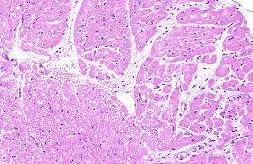 | 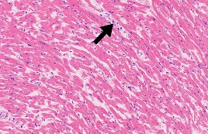

Organic tissue | Liver
Lesion score | 0 | 1 | 2 | 3 | 4 | 5
Lesion description | Health | A small amount of inflammatory cells with diffuse infiltration can be seen locally in the liver tissue (black arrow) | A small amount of small focal infiltration of inflammatory cells can be seen locally in the liver tissue (black arrow); Some liver sinusoids were slightly congested, and a large number of red blood cells could be seen (green arrow) | Diffuse infiltration of inflammatory cells can be seen in some liver sinusoids of liver tissue (black arrow); Fibrous tissue hyperplasia and a large amount of collagen fiber deposition can be seen locally (blue arrow) | Focal infiltration of a large number of inflammatory cells can be seen locally in the liver tissue (black arrow); The liver sinusoids in the tissue are congested, and a large number of red blood cells can be seen gathering (green arrow); Fibrous tissue hyperplasia and a large amount of collagen fiber deposition can be seen locally (blue arrow) | Focal infiltration of a large number of inflammatory cells can be seen in the liver tissue; The liver sinusoids in the tissue are congested severely, and a large number of red blood cells can be seen (green arrow)
Representative pathological presentation | 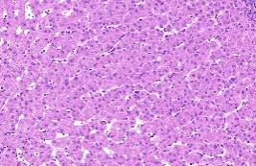 | 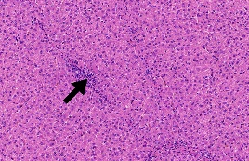 | 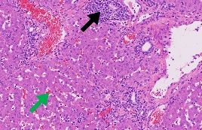 | 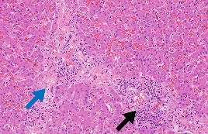 | 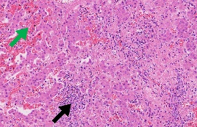 | 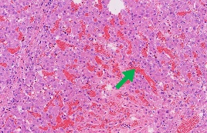

Organic tissue | Spleen
Lesion score | 0 | 1 | 2 | 3 | 4 | 5
Lesion description | Health | The shape of spleen nodules in spleen tissue was slightly scattered, and the boundary between red and white pulp of spleen was blurred (black arrow) | A large number of splenic nodules in spleen tissue were slightly scattered, and the boundary between red and white pulp of spleen was blurred (black arrow) | A large number of splenic nodules in spleen tissue were slightly scattered, and the boundary between red and white pulp of spleen was blurred (black arrow); The morphology of some cells disappeared; Red blood cell aggregation is visible (green arrow) | The cells in a large number of splenic nodules in spleen tissue were severely necrotic, and the morphological structure of splenic nodules was scattered, and the boundary between splenic nodules and red pulp was blurred (black arrow); Massive red blood cell aggregation can be seen in the red pulp hemorrhage of spleen tissue (green arrow) | he splenic tissue was necrotic in large area, and the structure of splenic nodules basically disappeared (black arrow); Massive red blood cell aggregation can be seen in the red pulp hemorrhage of spleen tissue (green arrow)
Representative pathological presentation | 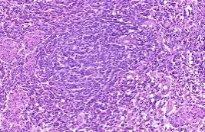 | 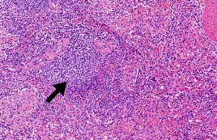 | 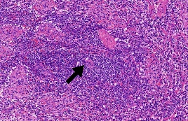 | 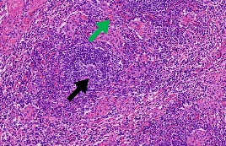 | 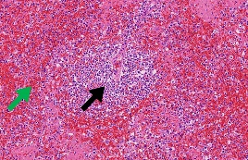 | 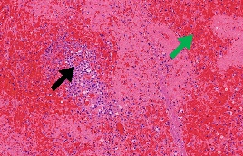

Organic tissue | Lung
Lesion score | 0 | 1 | 2 | 3 | 4 | 5
Lesion description | Health | Diffuse infiltration of a small number of inflammatory cells can be seen locally in the lung tissue (black arrow); Some alveolar epithelial cells in the lung tissue slightly proliferate, and the alveolar septum is thickened (blue arrow) | Diffuse infiltration of a small number of inflammatory cells can be seen locally in the lung tissue (black arrow); Some alveolar epithelial cells in the lung tissue were mildly proliferated, the alveolar septum was thickened, and a large number of alveolar cavities were atrophic (blue arrows) | Diffuse infiltration of a large number of inflammatory cells can be seen locally in the lung tissue (black arrow); Some alveolar epithelial cells in the lung tissue were mildly proliferated, the alveolar septum was thickened, a large number of alveolar cavities were atrophic, and the tissue was mildly parenchymated locally (blue arrow) | Diffuse infiltration of a large number of inflammatory cells can be seen locally in the lung tissue (black arrow); Some alveolar epithelial cells in the lung tissue were mildly proliferated, the alveolar septum was thickened, and a large number of alveolar cavities were atrophic (blue arrows); A large amount of protein mucus exudation can be seen in some alveolar cavities (yellow arrow) | Large area of cell necrosis in lung tissue, collagen deposition in tissue, massive atrophy and disappearance of alveolar cavity, severe parenchyma of tissue, accompanied by a large number of inflammatory cell infiltration (black arrow)
Representative pathological presentation | 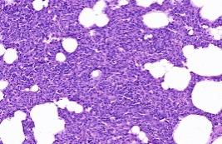 | 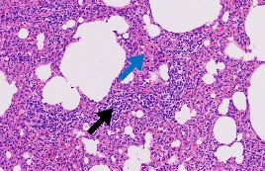 | 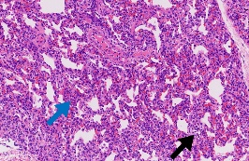 | 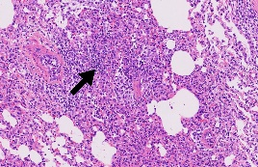 | 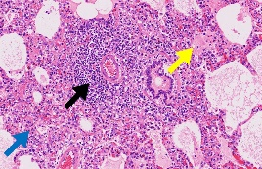 | 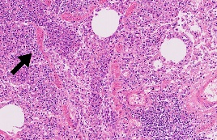

Organic tissue | Kidney
Lesion score | 0 | 1 | 2 | 3 | 4 | 5
Lesion description | Health | Some renal tubules were injured, and the brush border of epithelial cells fell off (blue arrow) | Some renal tubular epithelial cells in the cortical area of renal tissue were slightly edematous, with swollen cells, pale staining of cytoplasm, and irregular vacuoles (black arrows) | A large number of renal tubular epithelial cells in the cortical area of renal tissue were mildly edematous, with swelling of cells, pale staining of cytoplasm, and irregular vacuoles in the cells (black arrows); Some glomerular capsule cavities in the cortical area are dilated, and proteinaceous mucus exudation can be seen in the capsule cavity (red arrow) | A large number of renal tubules in the renal tissue were severely necrotic, and a large number of tubular epithelial cells were pyknotic (yellow arrow); Tissue tubulointerstitial blood vessels are heavily congested (green arrow) | Large area of renal tissue necrosis, a large number of tubular epithelial cells necrosis, pyknosis (yellow arrow)
Representative pathological presentation | 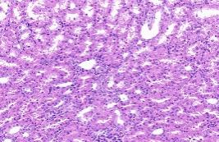 | 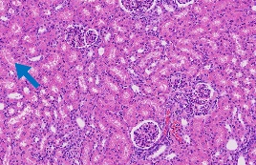 | 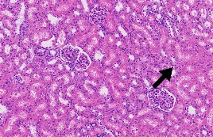 | 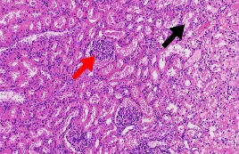 | 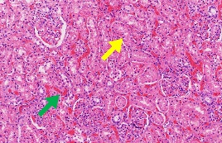 | 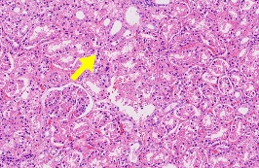

Organic tissue | Submandibular Lymph Nodes
Lesion score | 0 | 1 | 2 | 3 | 4 | 5
Lesion description | Health | A large number of cells in the germinal center of lymph nodes were slightly edematous, swollen and lightly stained, and the arrangement of cells in the germinal center was slightly loose and disordered (black arrow) | Some cells in the germinal center of lymph nodes were mildly edematous, with swollen cells and pale staining of cytoplasm, and the arrangement of cells in the germinal center was slightly loose and disordered (black arrow); Diffuse infiltration of inflammatory cells can be seen in the interstitial area of germinal center of tissue lymph nodes (red arrow) | Some cells in the germinal center of lymph nodes were moderately edematous, with swelling of cells and pale staining of cytoplasm, and the arrangement of cells in the germinal center was slightly loose and disordered (black arrow); Focal infiltration of inflammatory cells can be seen in the interstitial area of germinal center of tissue lymph nodes (red arrow) | Coagulative necrosis and structural destruction of some cells (green arrow) | A large number of germinal center cells in the tissue were coagulated and necrotic, the germinal center structure was severely damaged, and the boundary disappeared (green arrow)
Representative pathological presentation | 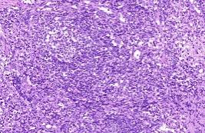 | 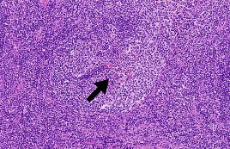 | 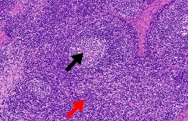 | 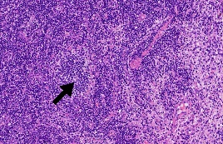 | 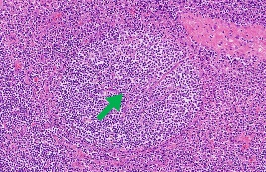 | 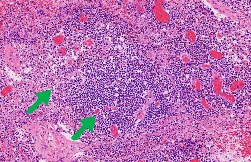

Organic tissue | Hepatogastric Lymph Nodes
Lesion score | 0 | 1 | 2 | 3 | 4 | 5
Lesion description | Health | Some cells in the germinal center of lymph nodes are slightly edematous, swollen and lightly stained, and the arrangement of cells in the germinal center is slightly loose and disordered (black arrow) | Some cells in the germinal center of lymph nodes were mildly edematous, with swollen cells and pale staining of cytoplasm, and the arrangement of cells in the germinal center was slightly loose and disordered (black arrow); Diffuse infiltration of inflammatory cells can be seen in the interstitial area of germinal center of tissue lymph nodes (red arrow) | Some cells in the germinal center of lymph nodes were moderately edematous, with swelling of cells and pale staining of cytoplasm, and the arrangement of cells in the germinal center was slightly loose and disordered (black arrow); A large number of inflammatory cells were diffusely infiltrated in the interstitial area (red arrow) | Some cells in the germinal center of lymph nodes were severely edematous, with swelling of cells and pale staining of cytoplasm, and the arrangement of cells in the germinal center was slightly loose and disordered (black arrow); A large number of coagulative necrosis of germinal center cells and severe structural damage (green arrow); A large number of inflammatory cells were diffusely infiltrated in the interstitial area (red arrow) | A large number of coagulative necrosis of germinal center cells, severe destruction of germinal center structure, and disappearance of boundary (green arrow); Massive red blood cell aggregation (blue arrow) due to local bleeding of tissue
Representative pathological presentation | 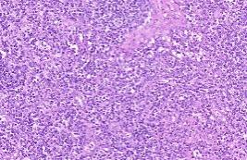 | 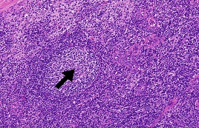 | 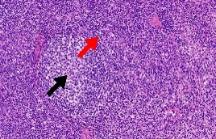 | 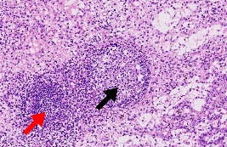 | 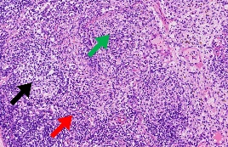 | 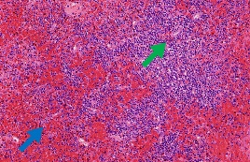

Organic tissue | Mesenteric Lymph Nodes
Lesion score | 0 | 1 | 2 | 3 | 4 | 5
Lesion description | Health | Some cells in the germinal center of lymph nodes were slightly edematous, and the arrangement of cells in the germinal center was slightly loose and disordered (black arrow) | Some cells in the germinal center of lymph nodes were slightly edematous, and the arrangement of cells in the germinal center was slightly loose and disordered (black arrow); Diffuse infiltration of inflammatory cells can be seen in the interstitial area of germinal center of tissue lymph nodes (red arrow) | Some cells in germinal centers of lymph nodes were moderately edematous, swollen and lightly stained, and some cells in germinal centers of lymph nodes were disorderly arranged and moderately scattered in morphology and structure (black arrow); Diffuse infiltration of inflammatory cells can be seen in the interstitial area of germinal center of tissue lymph nodes (red arrow) | Some cells in the germinal center of lymph nodes were mildly edematous, with swollen cells and pale staining of cytoplasm, and the arrangement of cells in the germinal center was slightly loose and disordered (black arrow); Diffuse infiltration of inflammatory cells can be seen in the interstitial area of germinal center of tissue lymph nodes (red arrow) | A large number of cells in the germinal center of lymphoid tissue are pyknotic and necrotic, and the germinal center structure is seriously scattered, and the tissue morphological structure is damaged (black arrow)
Representative pathological presentation | 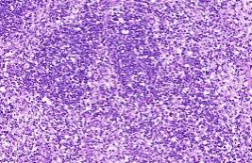 | 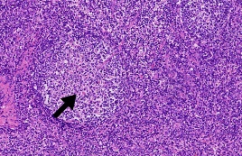 | 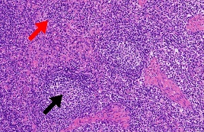 | 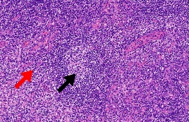 | 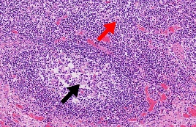 | 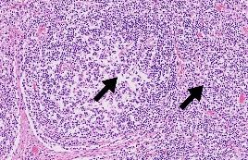

Figure S1 The gene conservation of the MGF100 family.
Multiple sequence alignment of (A) MGF100-1R, (B) MGF100-2L and (C) MGF100-3L among 21 ASFV isolates. The homology analysis at amino acid level was conducted on Jalview software version 2.11.4.1, using the ClustalW algorithm. To clearly demonstrate the highlights, only representative regions were shown.

Figure S2 The gene conservation of the MGF300 family.
Multiple sequence alignment of (A) MGF300-1L, (B) MGF300-2R and (C) MGF300-4L among 21 ASFV isolates. Likewise, only representative regions were shown.

Figure S3 Construction of ASFV-Δ100 and ASFV-Δ300 mutants.
(A) Schematic representation of the gene(s) and region(s) deleted in MGF100 and MGF300 single-gene-deleted ASFV mutants. The numbers above the genome indicate the nucleotide position of targeted gene relative to the genome of ASFV CN/GS/2018. The deleted gene segments were replaced with the fluorescent reporters driven by the VP72 promotor. As a result, the cells infected with the corresponding reporter-labelled mutant virus were observed with Fluorescent Microscopy. To primarily prove the complete deletion of genes, six pairs of specific primers targeting the MGF100-1R, MGF100-2L, MGF100-3L, MGF300-1L, MGF300-2R or MGF300-4L were used for traditional PCR (lane 2) marker. Deionized water is used as negative control (lane 3) and ASFV-WT genome is loaded as positive control (lane 4). (B) The genomic modifications of ASFV-Δ100 mutant were further detected by high-throughput whole-genome sequencing using MGI platform. The deleted genes were labelled in the figure. (C) Whole genome sequencing of ASFV-Δ300 mutant.

Figure S4 Characterization of single-gene deleted ASFV mutants.
(A) and (B) In vitro replication characteristics of single-gene-deleted strains. BMDMs were infected at an MOI of 0.1 with single-gene-deleted strains. The cell cultures were collected at each indicated time point, and growth curves were constructed by using the HAD titer of virus suspension at each time point. The data represent the results of four independent experiments with two replicates each. Error bars denote standard errors of the means. The significance of differences between groups (n = 3) was determined using Multiple t-test (**, P < 0.01; ***, P < 0.001). (C) and (D) The replication kinetics of single-gene deleted mutants were further measured by Western blot in the aim of probing the expression kinetics of three well-characterized structural proteins.

Figure S5 Viral shedding in pigs during the vaccination period and challenge period.
Oral, nasal and fecal swabs were collected and rinsed in ddH₂O. The genomic copies of ASFV DNA in these samples was detected using qPCR.

References
1. Liu, Y. N.et al. Development and evaluation of deletion mutant in an African swine fever virus Chinese strain. Veterinary Microbiology 261, (2021).
2. Ramirez-Medina, E.et al. Development and In Vivo Evaluation of a MGF110-1L Deletion Mutant in African Swine Fever Strain Georgia. Viruses-Basel 13, (2021).
3. Ramirez-Medina, E.et al. Evaluation of the Deletion of MGF110-5L-6L on Swine Virulence from the Pandemic Strain of African Swine Fever Virus and Use as a DIVA Marker in Vaccine Candidate ASFV-G-ΔI177L. Journal of Virology 96, (2022).
4. Li, D.et al. African Swine Fever Virus MGF-110-9L-deficient Mutant Has Attenuated Virulence in Pigs. Virologica Sinica 36, 187-195 (2021).
5. Tamás, V.et al. Involvement of the MGF 110-11L Gene in the African Swine Fever Replication and Virulence. Vaccines-Basel 11, (2023).
6. Wang, T.et al. The MGF300-2R protein of African swine fever virus is associated with viral pathogenicity by promoting the autophagic degradation of IKKα and IKKβ through the recruitment of TOLLIP. PLoS Pathog 19, e1011580 (2023).
7. Wang, T.et al. The African swine fever virus MGF300-4L protein is associated with viral pathogenicity by promoting the autophagic degradation of IKKβ and increasing the stability of IκBα. Emerg Microbes Infect 13, 2333381 (2024).
8. Ramirez-Medina, E.et al. Evaluation in Swine of a Recombinant African Swine Fever Virus Lacking the MGF-360-1L Gene. Viruses 12, (2020).
9. Zhang, K. S.et al. MGF360-9L Is a Major Virulence Factor Associated with the African Swine Fever Virus by Antagonizing the JAK/STAT Signaling Pathway. Mbio 13, (2022).
10. Ramírez-Medina, E.et al. The MGF360-16R ORF of African Swine Fever Virus Strain Georgia Encodes for a Nonessential Gene That Interacts with Host Proteins SERTAD3 and SDCBP. Viruses-Basel 12, (2020).
11. Sunwoo, S. Y.et al. Deletion of MGF505-2R Gene Activates the cGAS-STING Pathway Leading to Attenuation and Protection against Virulent African Swine Fever Virus. Vaccines (Basel) 12, (2024).
12. Li, J.et al. pMGF505-7R determines pathogenicity of African swine fever virus infection by inhibiting IL-1β and type I IFN production. PLoS Pathog 17, e1009733 (2021).
13. Ding, M. Y.et al. Sequential Deletions of Interferon Inhibitors MGF110-9L and MGF505-7R Result in Sterile Immunity against the Eurasia Strain of Africa Swine Fever. Journal of Virology 96, (2022).
14. Li, D.et al. Deletions of and from African swine fever virus are highly attenuated in swine and confer protection against homologous challenge. Journal of Biological Chemistry 299, (2023).
15. Borca, M. V.et al. Development of a fluorescent ASFV strain that retains the ability to cause disease in swine. Scientific reports 7, (2017).
16. Li, J.et al. Development of a new effective African swine fever virus vaccine candidate by deletion of the H240R and MGF505-7R genes results in protective immunity against the Eurasia strain. J Virol 97, e0070423 (2023).
17. Abrams, C. C. and Dixon, L. K. Sequential deletion of genes from the African swine fever virus genome using the cre/loxP recombination system. Virology 433, 142-148 (2012).
18. Qi, X.et al. Deletion of DP148R, DP71L, and DP96R Attenuates African Swine Fever Virus, and the Mutant Strain Confers Complete Protection against Homologous Challenges in Pigs. J Virol 97, e0024723 (2023).
19. Kholod, N.et al. Comparison of Attenuated and Virulent Strains of African Swine Fever Virus Genotype I and Serogroup 2. Viruses 15, (2023).
20. O'donnell, V.et al. African Swine Fever Virus Georgia Isolate Harboring Deletions of MGF360 and MGF505 Genes Is Attenuated in Swine and Confers Protection against Challenge with Virulent Parental Virus. Journal of Virology 89, 6048-6056 (2015).
21. Wang, Z.et al. The attenuated African swine fever vaccine HLJ/18-7GD provides protection against emerging prevalent genotype II variants in China. Emerg Microbes Infect 13, 2300464 (2024).
22. Rathakrishnan, A.et al. Differential Effect of Deleting Members of African Swine Fever Virus Multigene Families 360 and 505 from the Genotype II Georgia 2007/1 Isolate on Virus Replication, Virulence, and Induction of Protection. Journal of Virology 96, (2022).
23. Reis, A. L.et al. Deletion of African swine fever virus interferon inhibitors from the genome of a virulent isolate reduces virulence in domestic pigs and induces a protective response. Vaccine 34, 4698-4705 (2016).
24. Kitamura, T.et al. A Spontaneously Occurring African Swine Fever Virus with 11 Gene Deletions Partially Protects Pigs Challenged with the Parental Strain. Viruses-Basel 15, (2023).
25. Kim, M. H.et al. Development and characterization of high-efficiency cell-adapted live attenuated vaccine candidate against African swine fever. Emerg Microbes Infect 13, 2432372 (2024).

