Supplementary Information
Enhancing electrical performance of cement-based materials by acetylene carbon black addition: applications in paste, mortar, and concrete.

Nattapong Chuewangkam¹, Ploychanok Iadrat², Tarabordin Yurata², Chuchawin Changtong², Supree Pinitsoontorn^{1, 3,*}
¹Department of Physics, Faculty of Science, Khon Kaen University, Khon Kaen 40002, THAILAND
²R&D Materials and Chemical Department, IRPC Innovation Center, IRPC Public Company Limited, Rayong 21000, THAILAND
³Institute of Nanomaterials Research and Innovation for Energy (IN-RIE), Khon Kaen University, Khon Kaen 40002, THAILAND
* Corresponding author’s e-mail address: psupree@kku.ac.th

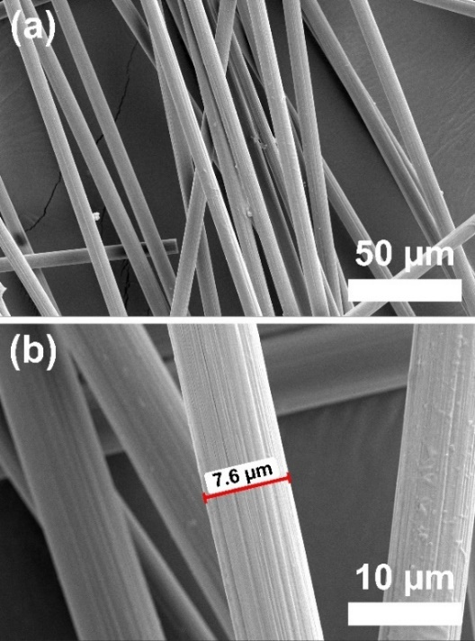
Figure S1. The SEM micrographs of CF.

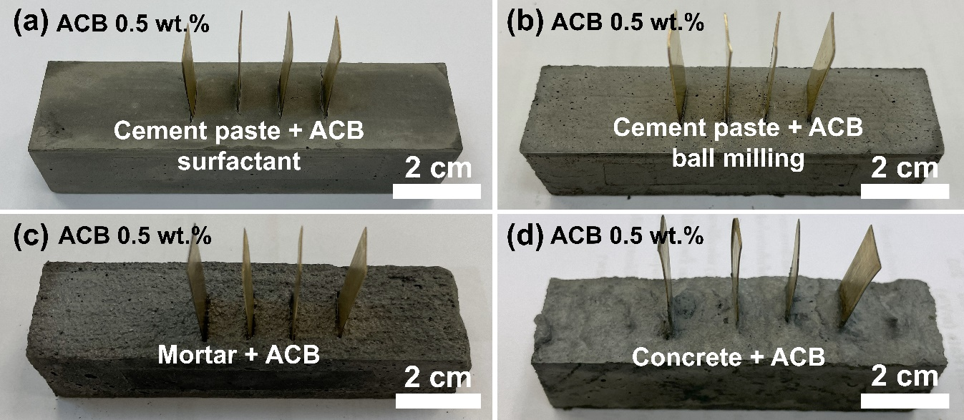
Figure S2. Samples cast for the electrical resistivity test containing 0.5 wt.% ACB: (a) Cement paste + ACB: surfactant, (b) Cement paste + ACB: ball milling, (c) Mortar + ACB, and (d) Concrete + ACB.
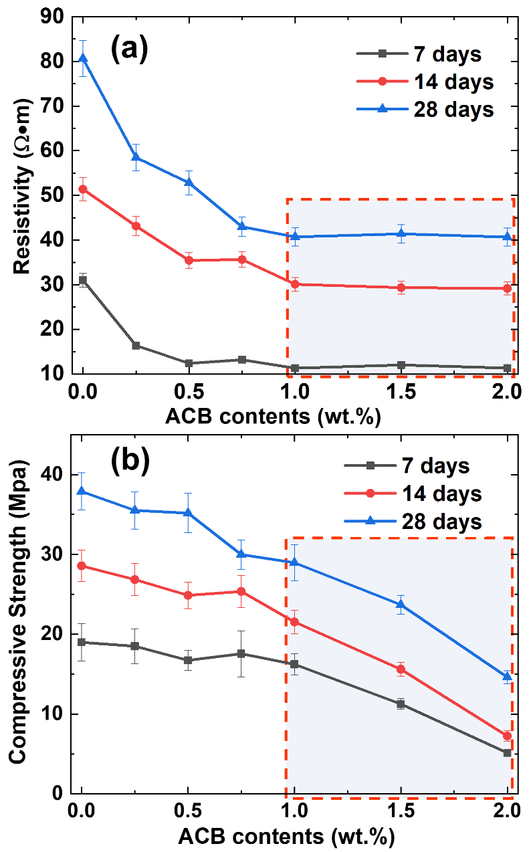
Figure S3. Effect of adding ACB in cement paste with ball milling in amounts ranging from 0 to 2 wt.% on (a) electrical resistivity and (b) compressive strength.

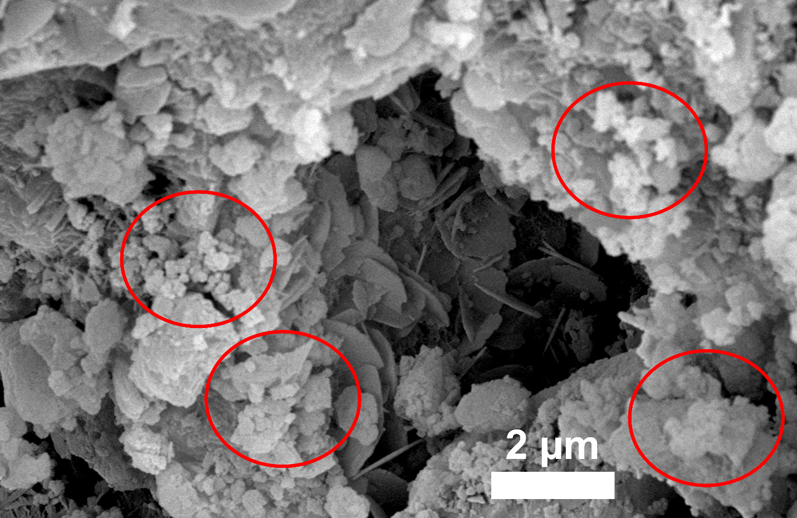
Figure S4. High-magnification SEM image of Cement paste + ACB (surfactant) with 1 wt.% ACB, providing a closer view of the ACB morphology and distribution within the cement matrix (zoomed-in from Figure 5d).

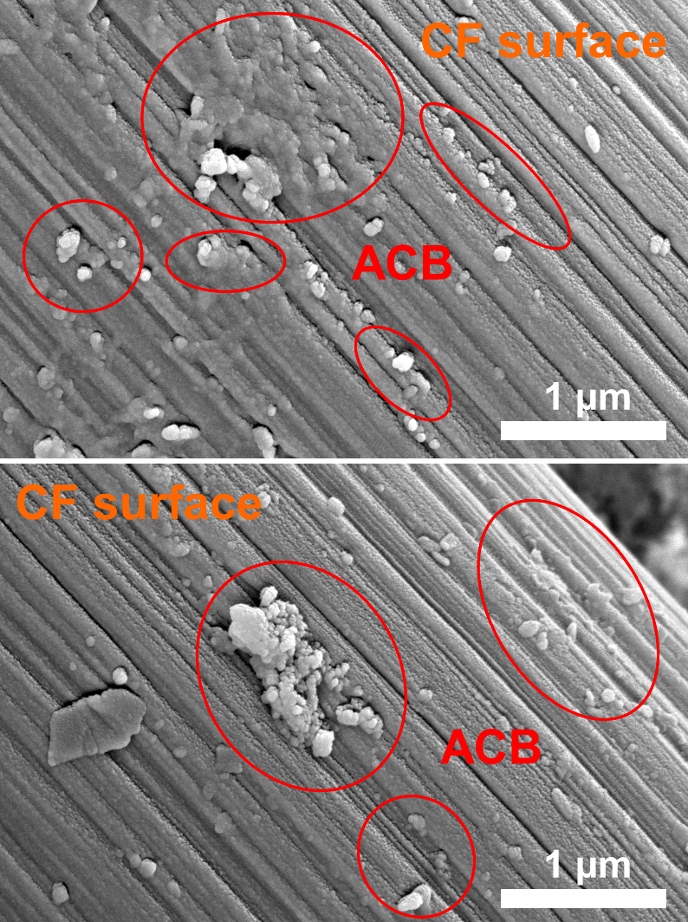
Figure S5. Shows the contact between ACB particles and the CF surface in Mortar + ACB specimens.

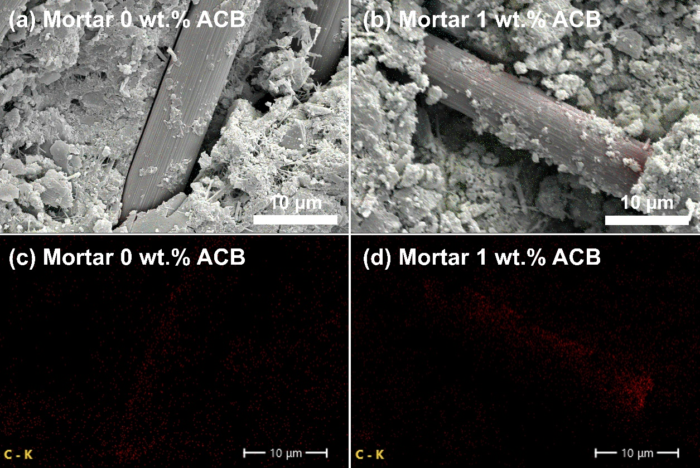
Figure S6. Micrograph of Mortar + ACB for EDX mapping analysis: (a) without ACB, (b) with 1 wt.% ACB; and EDX mapping for carbon in these micrographs: (c) without ACB, (d) with 1 wt.% ACB.

The EDX mapping for carbon, shown in Figures S6c and S6d, illustrates the presence of carbon in the composites. The carbon mapping highlights the increased presence of ACB in the sample with 1 wt.% ACB, indicating a more extensive conductive network that enhances electrical properties.

Table S1. Chemical composition of Mortar + ACB from EDX mapping analysis of the SEM micrograph corresponding in Figure S6 (a) without ACB (b) 1 wt.% ACB.
ACB  (wt. %) | Composition (at%)
ACB  (wt. %) | C | O | Si | Ca
0 | 15.39±0.2 | 54.17±0.6 | 10.65±0.1 | 19.79±0.3
1 | 18.84±0.1 | 49.05±0.5 | 10.26±0.1 | 21.85±0.2

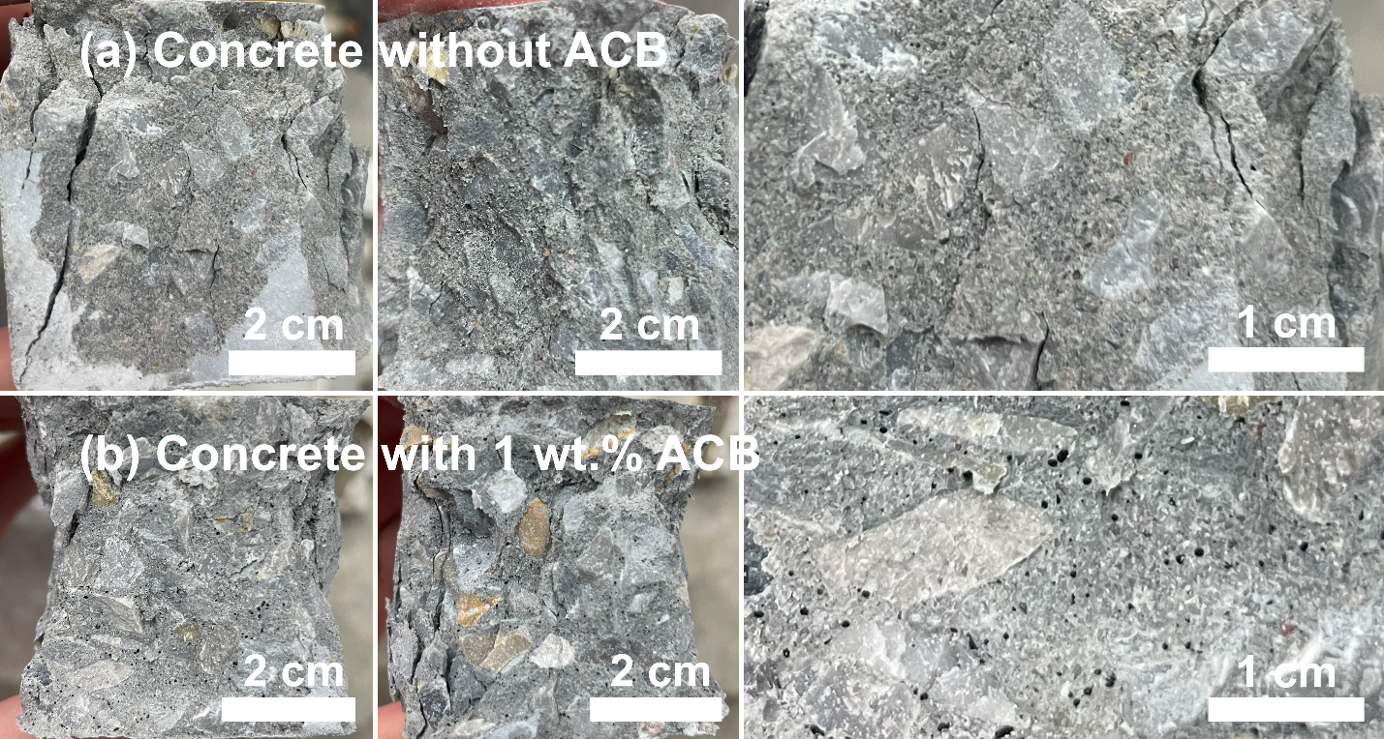
Figure S7. Observed macrostructure of concrete (a) without ACB and (b) with adding 1 wt. %ACB.

