Supplementary materials
Table S1. Anthropometric data and number of children measured at each point in time.
Table S2. Growth velocity of anthropometric indicators at different ages.
Table S3. Association between maternal HIP and offspring birth size categories.
Table S4. Association between maternal HIP and offspring anthropometries at different periods.
Table S5. Association between maternal HIP and offspring anthropometries at different periods stratified by infant sex.
Table S6. Association between maternal HIP and offspring anthropometries at different periods stratified by duration of breastfeeding (less than 6 months vs. 6 months or longer).
Table S7. Sensitivity analyses for associations between maternal HIP and offspring anthropometries at different periods, excluding mothers with hypertensive disorders during pregnancy.
Table S8. Sensitivity analyses for associations between maternal HIP and offspring anthropometries at different periods, excluding mothers with IVF/ICSI conception.
Table S9. Sensitivity analyses for associations between maternal HIP and offspring anthropometries at different periods, excluding preterm birth infants.
Table S10. Sensitivity analyses for associations between maternal HIP and offspring anthropometries at different periods, excluding infants born to mothers with BMI > 24kg/m².
Table S11. Sensitivity analyses for associations between maternal HIP and offspring anthropometries at different periods, excluding mothers with pre-gestational diabetes.
Table S12. Model fit and number of participants for different numbers of infant growth trajectory groups in the study.
Table S13. Association between HIP subtypes and WFL growth trajectories identified in three groups.
Table S14. Sensitivity analyses for associations between maternal HIP and WFL trajectories identified in four groups.

Figure S1. Flow chart for the study participants selection.
Figure S2. The directed acyclic graph (DAG) for all potential confounders considered in the statistical analyses.
Figure S3. Anthropometric measures in children at each time points.
Figure S4. Association between maternal HIP and offspring anthropometries at different periods stratified by infant sex.
Figure S5. Association between maternal HIP and offspring anthropometries at different periods stratified by duration of breastfeeding (less than 6 months vs. 6 months or longer).
Figure S6. Sensitivity analyses for associations between maternal HIP and offspring anthropometries at different periods, excluding mothers with hypertensive disorders during pregnancy.
Figure S7. Sensitivity analyses for associations between maternal HIP and offspring anthropometries at different periods, excluding mothers with IVF/ICSI conception.
Figure S8. Sensitivity analyses for associations between maternal HIP and offspring anthropometries at different periods, excluding preterm birth infants.
Figure S9. Sensitivity analyses for associations between maternal HIP and offspring anthropometries at different periods, excluding infants born to mothers with BMI > 24kg/m².
Figure S10. Sensitivity analyses for associations between maternal HIP and offspring anthropometries at different periods, excluding mothers with pre-gestational diabetes.
Figure S11. Trajectory groups identified in two to five growth pattern groups for weight-for-length trajectory.

Table S1. Anthropometric data and number of children measured at each point in time.
 | Mean (SD)
 | At birth | 1 month | 3 months | 6 months | 8 months | 12 months | 18 months | 24 months | 30 months | 36 months
Weight
N | 8752 | 6527 | 6322 | 6559 | 6422 | 8324 | 7563 | 7359 | 6012 | 8110
Original value (kg) | 3.36 (0.45) | 4.92 (0.82) | 6.86 (0.85) | 8.57 (1.05) | 9.17 (1.08) | 10.14 (1.16) | 11.39 (1.24) | 12.73 (1.42) | 13.98 (1.63) | 15.06 (1.89)
z-score | 0.29 (0.90) | 0.27 (0.93) | 0.68 (0.98) | 0.80 (1.00) | 0.73 (0.97) | 0.64 (0.94) | 0.51 (0.89) | 0.51 (0.89) | 0.46 (0.91) | 0.42 (0.95)
Length/height
N | / | 6497 | 6321 | 6550 | 6410 | 8326 | 7536 | 7341 | 6011 | 8105
Original value (cm) | / | 56.08 (2.74) | 62.42 (2.36) | 68.66 (2.59) | 71.42 (2.49) | 76.38 (2.70) | 83.03 (2.92) | 88.28 (3.22) | 93.29 (3.40) | 97.77 (3.64)
z-score | / | 0.26 (1.05) | 0.54 (1.06) | 0.61 (1.05) | 0.55 (1.01) | 0.49 (1.04) | 0.42 (1.01) | 0.45 (1.00) | 0.45 (0.95) | 0.54 (0.95)
Weight-for-length
N | / | 6483 | 6311 | 6528 | 6401 | 8311 | 7513 | 7332 | 5996 | 8099
z-score | / | 0.10 (1.05) | 0.48 (1.03) | 0.72 (1.02) | 0.67 (0.98) | 0.57 (0.96) | 0.42 (0.89) | 0.32 (0.90) | 0.28 (0.94) | 0.18 (1.00)
SD, standard deviation.

Table S2. Growth velocity of anthropometric indicators at different ages.
Month | Velocity (mean [SD]) | Overall | non-HIP | HIP | P
0-3 | N | 6046 | 4640 | 1406
 | Weight (kg/month) | 1.16 (0.24) | 1.16 (0.24) | 1.15 (0.24) | 0.033
3-6 | N | 4386 | 3378 | 1008
 | Weight (kg/month) | 0.56 (0.19) | 0.55 (0.19) | 0.56 (0.20) | 0.355
 | Length/Height (cm/month) | 2.00 (0.57) | 2.00 (0.56) | 2.00 (0.59) | 0.966
 | BMI (kg/m²·month) | 0.21 (0.41) | 0.20 (0.41) | 0.22 (0.41) | 0.184
6-8 | N | 4287 | 3319 | 968
 | Weight (kg/month) | 0.34 (0.20) | 0.34 (0.20) | 0.33 (0.20) | 0.112
 | Length/Height (cm/month) | 1.49 (0.66) | 1.48 (0.66) | 1.51 (0.67) | 0.215
 | BMI (kg/m²·month) | -0.08 (0.47) | -0.08 (0.47) | -0.11 (0.47) | 0.036
8-12 | N | 3442 | 2689 | 753
 | Weight (kg/month) | 0.24 (0.15) | 0.25 (0.15) | 0.24 (0.15) | 0.796
 | Length/Height (cm/month) | 1.27 (0.41) | 1.27 (0.41) | 1.27 (0.40) | 0.949
 | BMI (kg/m²·month) | -0.16 (0.29) | -0.16 (0.29) | -0.15 (0.28) | 0.697
12-18 | N | 3373 | 2575 | 798
 | Weight (kg/month) | 0.21 (0.11) | 0.21 (0.11) | 0.21 (0.11) | 0.982
 | Length/Height (cm/month) | 1.10 (0.28) | 1.10 (0.29) | 1.10 (0.28) | 0.865
 | BMI (kg/m²·month) | -0.14 (0.18) | -0.14 (0.18) | -0.14 (0.18) | 0.729
18-24 | N | 4180 | 3187 | 993
 | Weight (kg/month) | 0.22 (0.12) | 0.22 (0.12) | 0.22 (0.13) | 0.323
 | Length/Height (cm/month) | 0.98 (0.28) | 0.97 (0.27) | 0.99 (0.30) | 0.131
 | BMI (kg/m²·month) | -0.03 (0.17) | -0.03 (0.17) | -0.03 (0.17) | 0.719
24-30 | N | 3012 | 2317 | 695
 | Weight (kg/month) | 0.20 (0.13) | 0.20 (0.13) | 0.21 (0.13) | 0.160
 | Length/Height (cm/month) | 0.84 (0.28) | 0.85 (0.28) | 0.84 (0.28) | 0.599
 | BMI (kg/m²·month) | -0.06 (0.16) | -0.06 (0.16) | -0.05 (0.16) | 0.057
30-36 | N | 2461 | 1901 | 560
 | Weight (kg/month) | 0.19 (0.14) | 0.19 (0.14) | 0.19 (0.14) | 0.527
 | Length/Height (cm/month) | 0.67 (0.29) | 0.67 (0.28) | 0.65 (0.34) | 0.189
 | BMI (kg/m²·month) | -0.05 (0.16) | -0.05 (0.15) | -0.05 (0.18) | 0.931
SD, standard deviation; BMI, body mass index; HC, head circumference.

Table S3. Association between maternal HIP and offspring birth size categories.
Metrics | HIP (n, %) | Non-HIP (n/N, %) | Crude |  |  | Adjusted ª
Metrics | HIP (n, %) | Non-HIP (n/N, %) | RR (95% CI) | P |  | RR (95% CI) | P
LGA | 353 (17.23) | 794 (11.8) | 1.56 (1.36, 1.78) | <0.001 |  | 1.17 (1.01, 1.36) | 0.035
SGA | 78 (3.81) | 279 (4.15) | 0.92 (0.71, 1.18) | 0.497 |  | 1.02 (0.78, 1.34) | 0.883
Macrosomia | 191 (9.32) | 470 (6.98) | 1.37 (1.15, 1.63) | 0.001 |  | 1.07 (0.88, 1.29) | 0.516
LBW | 74 (3.61) | 171 (2.54) | 1.44 (1.09, 1.90) | 0.010 |  | 1.23 (0.91, 1.65) | 0.171
RR, risk ratio; CI, confidence interval; HIP, hyperglycemia in pregnancy; LGA, large-for-gestational age; SGA, small-for-gestational age; Macrosomia, birth weight > 5000g; LBW, low birth weight (birth weight < 2500g).
ª Adjusted for pre-pregnancy BMI, parity, maternal education, maternal age at delivery, passive smoking during pregnancy, area of residence, household income and child sex.

Table S4 Association between maternal HIP and offspring anthropometries at different periods.
Age in month | WAZ |  |  | LAZ |  |  | WFL
Age in month | β (95% CI)ª | Pª |  | β (95% CI)ª | Pª |  | β (95% CI)ª | Pª
LMM | -0.065 (-0.105 -0.026) | <0.001 |  | -0.054 (-0.099, -0.009) | 0.020 |  | -0.061 (-0.100, -0.022) | 0.002
0 | 0.021 (-0.025, 0.067) | 0.378 |  | - | - |  | - | -
1 | -0.055 (-0.112, 0.001) | 0.053 |  | -0.064 (-0.128, 0.001) | 0.052 |  | 0.001 (-0.063, 0.065) | 0.969
3 | -0.098 (-0.158, -0.037) | 0.002 |  | -0.090 (-0.156, -0.025) | 0.007 |  | -0.046 (-0.109, 0.016) | 0.148
6 | -0.078 (-0.139, -0.018) | 0.011 |  | -0.089 (-0.153, -0.025) | 0.006 |  | -0.038 (-0.100, 0.024) | 0.228
8 | -0.106 (-0.165, -0.046) | 0.001 |  | -0.081 (-0.143, -0.019) | 0.010 |  | -0.085 (-0.145, -0.026) | 0.005
12 | -0.100 (-0.150, -0.050) | <0.001 |  | -0.041 (-0.097, 0.014) | 0.145 |  | -0.106 (-0.158, -0.055) | <0.001
18 | -0.076 (-0.126, -0.026) | 0.003 |  | -0.048 (-0.105, 0.009) | 0.099 |  | -0.066 (-0.116, -0.015) | 0.011
24 | -0.092 (-0.142, -0.042) | <0.001 |  | -0.009 (-0.066, 0.047) | 0.748 |  | -0.124 (-0.175, -0.073) | <0.001
30 | -0.061 (-0.118, -0.005) | 0.034 |  | -0.024 (-0.084, 0.037) | 0.439 |  | -0.071 (-0.130, -0.012) | 0.018
36 | -0.081 (-0.132, -0.031) | 0.002 |  | -0.047 (-0.098, 0.004) | 0.073 |  | -0.083 (-0.136, -0.030) | 0.002
WAZ, weight-for-age z-score; LAZ, length/height-for-age z-score; WFL: weight-for-length z-score; CI, confidence interval.
ª Adjusted for pre-pregnancy BMI, parity, maternal education, maternal age at delivery, passive smoking during pregnancy, area of residence, household income and child sex.

Table S5 Association between maternal HIP and offspring anthropometries at different periods stratified by infant sex.
Subgroup | WAZ |  |  | LAZ |  |  | WFL
Subgroup | β (95% CI)ª | Pª |  | β (95% CI)ª | Pª |  | β (95% CI)ª | Pª
LMM | -0.075 (-0.117, -0.034) | <0.001 |  | -0.054 (-0.099, -0.009) | 0.020 |  | -0.061 (-0.100, -0.022) | 0.002
Boys | -0.109 (-0.167, -0.050) | <0.001 |  | -0.079 (-0.143, -0.015) | 0.015 |  | -0.087 (-0.141, -0.033) | 0.002
Girls | -0.037 (-0.095, 0.022) | 0.217 |  | -0.023 (-0.087, 0.040) | 0.478 |  | -0.032 (-0.087, 0.024) | 0.264
0 m | 0.021 (-0.025, 0.067) | 0.378 |  | - | - |  | - | -
Boys | -0.008 (-0.071, 0.055) | 0.809 |  | - | - |  | - | -
Girls | 0.054 (-0.013, 0.122) | 0.114 |  | - | - |  | - | -
P_{het} |  | 0.301 |  |  | - |  |  | -
1 m | -0.055 (-0.112, 0.001) | 0.053 |  | -0.064 (-0.128, 0.001) | 0.052 |  | 0.001 (-0.063, 0.065) | 0.969
Boys | -0.082 (-0.161, -0.003) | 0.041 |  | -0.077 (-0.168, 0.015) | 0.100 |  | -0.022 (-0.112, 0.069) | 0.637
Girls | -0.024 (-0.104, 0.056) | 0.554 |  | -0.048 (-0.138, 0.042) | 0.292 |  | 0.027 (-0.063, 0.117) | 0.552
P_{het} |  | 0.333 |  |  | 0.788 |  |  | 0.420
3 m | -0.098 (-0.158, -0.037) | 0.001 |  | -0.090 (-0.156, -0.025) | 0.007 |  | -0.046 (-0.109, 0.016) | 0.148
Boys | -0.129 (-0.215, -0.042) | 0.004 |  | -0.127 (-0.221, -0.033) | 0.008 |  | -0.056 (-0.146, 0.034) | 0.223
Girls | -0.065 (-0.149, 0.018) | 0.125 |  | -0.049 (-0.139, 0.042) | 0.295 |  | -0.040 (-0.127, 0.047) | 0.368
P_{het} |  | 0.429 |  |  | 0.444 |  |  | 0.786
6 m | -0.078 (-0.139, -0.018) | 0.011 |  | -0.089 (-0.153, -0.025) | 0.006 |  | -0.038 (-0.100, 0.024) | 0.228
Boys | -0.124 (-0.211, -0.037) | 0.005 |  | -0.141 (-0.233, -0.050) | 0.003 |  | -0.062 (-0.149, 0.026) | 0.166
Girls | -0.028 (-0.111, 0.056) | 0.515 |  | -0.028 (-0.116, 0.061) | 0.542 |  | -0.014 (-0.102, 0.073) | 0.748
P_{het} |  | 0.223 |  |  | 0.208 |  |  | 0.504
8 m | -0.106 (-0.165, -0.046) | <0.001 |  | -0.081 (-0.143, -0.019) | 0.010 |  | -0.085 (-0.145, -0.026) | 0.005
Boys | -0.125 (-0.210, -0.041) | 0.004 |  | -0.093 (-0.182, -0.005) | 0.039 |  | -0.102 (-0.185, -0.019) | 0.016
Girls | -0.085 (-0.168, -0.002) | 0.045 |  | -0.068 (-0.155, 0.018) | 0.121 |  | -0.067 (-0.152, 0.019) | 0.128
P_{het} |  | 0.472 |  |  | 0.896 |  |  | 0.417
12 m | -0.100 (-0.150, -0.050) | <0.001 |  | -0.041 (-0.097, 0.014) | 0.145 |  | -0.106 (-0.158, -0.055) | <0.001
Boys | -0.150 (-0.221, -0.079) | <0.001 |  | -0.067 (-0.145, 0.012) | 0.097 |  | -0.155 (-0.226, -0.084) | <0.001
Girls | -0.039 (-0.110, 0.031) | 0.273 |  | -0.011 (-0.089, 0.067) | 0.782 |  | -0.047 (-0.123, 0.028) | 0.215
P_{het} |  | 0.035 |  |  | 0.457 |  |  | 0.031
18 m | -0.076 (-0.126, -0.026) | 0.003 |  | -0.048 (-0.105, 0.009) | 0.099 |  | -0.066 (-0.116, -0.015) | 0.011
Boys | -0.116 (-0.186, -0.046) | 0.001 |  | -0.091 (-0.171, -0.011) | 0.026 |  | -0.092 (-0.162, -0.022) | 0.010
Girls | -0.024 (-0.095, 0.046) | 0.499 |  | 0.008 (-0.074, 0.089) | 0.855 |  | -0.032 (-0.105, 0.040) | 0.383
P_{het} |  | 0.057 |  |  | 0.161 |  |  | 0.123
24 m | -0.092 (-0.142, -0.042) | <0.001 |  | -0.009 (-0.066, 0.047) | 0.748 |  | -0.124 (-0.175, -0.073) | <0.001
Boys | -0.115 (-0.185, -0.045) | 0.001 |  | -0.025 (-0.105, 0.055) | 0.538 |  | -0.149 (-0.220, -0.078) | <0.001
Girls | -0.064 (-0.136, 0.007) | 0.078 |  | 0.010 (-0.071, 0.092) | 0.802 |  | -0.096 (-0.168, -0.023) | 0.010
P_{het} |  | 0.452 |  |  | 0.600 |  |  | 0.412
30 m | -0.061 (-0.118, -0.005) | 0.034 |  | -0.024 (-0.084, 0.037) | 0.439 |  | -0.071 (-0.130, -0.012) | 0.018
Boys | -0.077 (-0.155, 0.002) | 0.057 |  | -0.062 (-0.144, 0.021) | 0.143 |  | -0.068 (-0.152, 0.015) | 0.108
Girls | -0.042 (-0.124, 0.040) | 0.318 |  | 0.023 (-0.066, 0.112) | 0.605 |  | -0.074 (-0.157, 0.008) | 0.077
P_{het} |  | 0.577 |  |  | 0.185 |  |  | 0.910
36 m | -0.081 (-0.132, -0.031) | 0.002 |  | -0.047 (-0.098, 0.004) | 0.073 |  | -0.083 (-0.136, -0.030) | 0.002
Boys | -0.108 (-0.179, -0.037) | 0.003 |  | -0.057 (-0.127, 0.014) | 0.118 |  | -0.115 (-0.190, -0.041) | 0.003
Girls | -0.051 (-0.122, 0.020) | 0.159 |  | -0.036 (-0.109, 0.038) | 0.347 |  | -0.047 (-0.121, 0.027) | 0.215
P_{het} |  | 0.260 |  |  | 0.628 |  |  | 0.208
WAZ, weight-for-age z-score; LAZ, length/height-for-age z-score; WFL: weight-for-length z-score; CI, confidence interval; P_{het}, P for heterogeneity.
ª Adjusted for pre-pregnancy BMI, parity, maternal education, maternal age at delivery, passive smoking during pregnancy, area of residence, household income and child sex.

Table S6 Association between maternal HIP and offspring anthropometries at different periods stratified by duration of breastfeeding (less than 6 months vs. 6 months or longer).
Subgroup | WAZ |  |  | LAZ |  |  | WFL
Subgroup | β (95% CI)ª | Pª |  | β (95% CI)ª | Pª |  | β (95% CI)ª | Pª
LMM | -0.075 (-0.117, -0.034) | <0.001 |  | -0.054 (-0.099, -0.009) | 0.020 |  | -0.061 (-0.100, -0.022) | 0.002
<6 | -0.093 (-0.149, -0.037) | 0.001 |  | -0.065 (-0.127, -0.003) | 0.040 |  | -0.073 (-0.126, -0.021) | 0.006
≥6 | -0.053 (-0.117, 0.011) | 0.103 |  | -0.041 (-0.108, 0.027) | 0.243 |  | -0.044 (-0.105, 0.016) | 0.148
0 m | 0.021 (-0.025, 0.067) | 0.378 |  | - | - |  | - | -
<6 | 0.019 (-0.044, 0.082) | 0.556 |  | - | - |  | - | -
≥6 | 0.033 (-0.036, 0.103) | 0.349 |  | - | - |  | - | -
P_{het} |  | 0.625 |  |  | - |  |  | -
1 m | -0.055 (-0.112, 0.001) | 0.053 |  | -0.064 (-0.128, 0.001) | 0.052 |  | 0.001 (-0.063, 0.065) | 0.969
<6 | -0.094 (-0.170, -0.017) | 0.017 |  | -0.088 (-0.176, 0.001) | 0.052 |  | -0.016 (-0.103, 0.070) | 0.716
≥6 | -0.001 (-0.084, 0.081) | 0.977 |  | -0.025 (-0.119, 0.070) | 0.611 |  | 0.019 (-0.079, 0.116) | 0.705
P_{het} |  | 0.101 |  |  | 0.480 |  |  | 0.457
3 m | -0.098 (-0.158, -0.037) | 0.001 |  | -0.090 (-0.156, -0.025) | 0.007 |  | -0.046 (-0.109, 0.016) | 0.148
<6 | -0.144 (-0.225, -0.062) | 0.001 |  | -0.097 (-0.187, -0.006) | 0.037 |  | -0.103 (-0.188, -0.018) | 0.017
≥6 | -0.031 (-0.122, 0.061) | 0.510 |  | -0.066 (-0.163, 0.032) | 0.186 |  | 0.020 (-0.078, 0.118) | 0.685
P_{het} |  | 0.043 |  |  | 0.624 |  |  | 0.031
6 m | -0.078 (-0.139, -0.018) | 0.011 |  | -0.089 (-0.153, -0.025) | 0.006 |  | -0.038 (-0.100, 0.024) | 0.228
<6 | -0.107 (-0.187, -0.026) | 0.009 |  | -0.094 (-0.181, -0.006) | 0.035 |  | -0.072 (-0.154, 0.010) | 0.083
≥6 | -0.027 (-0.123, 0.069) | 0.584 |  | -0.065 (-0.163, 0.033) | 0.196 |  | 0.014 (-0.085, 0.113) | 0.781
P_{het} |  | 0.096 |  |  | 0.651 |  |  | 0.067
8 m | -0.106 (-0.165, -0.046) | <0.001 |  | -0.081 (-0.143, -0.019) | 0.010 |  | -0.085 (-0.145, -0.026) | 0.005
<6 | -0.101 (-0.180, -0.021) | 0.013 |  | -0.074 (-0.160, 0.011) | 0.087 |  | -0.083 (-0.163, -0.003) | 0.043
≥6 | -0.103 (-0.197, -0.009) | 0.031 |  | -0.071 (-0.165, 0.024) | 0.142 |  | -0.087 (-0.182, 0.008) | 0.072
P_{het} |  | 0.846 |  |  | 0.890 |  |  | 0.765
12 m | -0.100 (-0.150, -0.050) | <0.001 |  | -0.041 (-0.097, 0.014) | 0.145 |  | -0.106 (-0.158, -0.055) | <0.001
<6 | -0.119 (-0.186, -0.051) | 0.001 |  | -0.065 (-0.141, 0.011) | 0.095 |  | -0.117 (-0.186, -0.048) | 0.001
≥6 | -0.078 (-0.156, 0.000) | 0.050 |  | -0.016 (-0.101, 0.068) | 0.707 |  | -0.092 (-0.173, -0.011) | 0.026
P_{het} |  | 0.328 |  |  | 0.588 |  |  | 0.388
18 m | -0.076 (-0.126, -0.026) | 0.003 |  | -0.048 (-0.105, 0.009) | 0.099 |  | -0.066 (-0.116, -0.015) | 0.011
<6 | -0.084 (-0.151, -0.017) | 0.013 |  | -0.050 (-0.128, 0.027) | 0.204 |  | -0.076 (-0.144, -0.009) | 0.026
≥6 | -0.061 (-0.139, 0.018) | 0.131 |  | -0.042 (-0.129, 0.046) | 0.351 |  | -0.047 (-0.127, 0.034) | 0.256
P_{het} |  | 0.512 |  |  | 0.973 |  |  | 0.339
24 m | -0.092 (-0.142, -0.042) | <0.001 |  | -0.009 (-0.066, 0.047) | 0.748 |  | -0.124 (-0.175, -0.073) | <0.001
<6 | -0.092 (-0.160, -0.025) | 0.007 |  | -0.021 (-0.097, 0.056) | 0.592 |  | -0.117 (-0.186, -0.049) | 0.001
≥6 | -0.096 (-0.174, -0.019) | 0.015 |  | -0.009 (-0.098, 0.080) | 0.842 |  | -0.131 (-0.210, -0.052) | 0.001
P_{het} |  | 0.951 |  |  | 0.764 |  |  | 0.874
30 m | -0.061 (-0.118, -0.005) | 0.034 |  | -0.024 (-0.084, 0.037) | 0.439 |  | -0.071 (-0.130, -0.012) | 0.018
<6 | -0.073 (-0.150, 0.004) | 0.062 |  | -0.042 (-0.124, 0.040) | 0.319 |  | -0.072 (-0.152, 0.008) | 0.077
≥6 | -0.039 (-0.127, 0.050) | 0.389 |  | -0.006 (-0.098, 0.087) | 0.907 |  | -0.057 (-0.149, 0.035) | 0.224
P_{het} |  | 0.506 |  |  | 0.816 |  |  | 0.485
36 m | -0.081 (-0.132, -0.031) | 0.002 |  | -0.047 (-0.098, 0.004) | 0.073 |  | -0.083 (-0.136, -0.030) | 0.002
<6 | -0.094 (-0.163, -0.025) | 0.008 |  | -0.054 (-0.124, 0.015) | 0.125 |  | -0.094 (-0.166, -0.021) | 0.011
≥6 | -0.063 (-0.140, 0.014) | 0.108 |  | -0.052 (-0.129, 0.026) | 0.194 |  | -0.056 (-0.137, 0.025) | 0.174
P_{het} |  | 0.519 |  |  | 0.816 |  |  | 0.321
WAZ, weight-for-age z-score; LAZ, length/height-for-age z-score; WFL: weight-for-length z-score; CI, confidence interval; P_{het}, P for heterogeneity.
ª Adjusted for pre-pregnancy BMI, parity, maternal education, maternal age at delivery, passive smoking during pregnancy, area of residence, household income and child sex.

Table S7 Sensitivity analyses for associations between maternal HIP and offspring anthropometries at different periods, excluding mothers with hypertensive disorders during pregnancy.
Age in month | WAZ |  |  | LAZ |  |  | WFL
Age in month | β (95% CI)ª | Pª |  | β (95% CI)ª | Pª |  | β (95% CI)ª | Pª
LMM | -0.070 (-0.112, -0.027) | 0.001 |  | -0.061 (-0.107, -0.014) | 0.010 |  | -0.049 (-0.089, -0.009) | 0.015
0 | 0.024 (-0.023, 0.071) | 0.312 |  | - | - |  | - | -
1 | -0.048 (-0.105, 0.008) | 0.094 |  | -0.063 (-0.128, 0.002) | 0.058 |  | 0.007 (-0.059, 0.073) | 0.828
3 | -0.092 (-0.154, -0.031) | 0.003 |  | -0.095 (-0.162, -0.028) | 0.005 |  | -0.034 (-0.099, 0.031) | 0.302
6 | -0.064 (-0.127, -0.002) | 0.043 |  | -0.085 (-0.151, -0.020) | 0.011 |  | -0.023 (-0.087, 0.041) | 0.481
8 | -0.099 (-0.160, -0.039) | 0.001 |  | -0.092 (-0.155, -0.028) | 0.005 |  | -0.071 (-0.132, -0.009) | 0.024
12 | -0.097 (-0.148, -0.045) | <0.001 |  | -0.048 (-0.105, 0.009) | 0.097 |  | -0.099 (-0.152, -0.046) | <0.001
18 | -0.065 (-0.117, -0.014) | 0.013 |  | -0.053 (-0.112, 0.005) | 0.075 |  | -0.049 (-0.101, 0.003) | 0.063
24 | -0.094 (-0.145, -0.043) | <0.001 |  | -0.028 (-0.087, 0.030) | 0.345 |  | -0.114 (-0.167, -0.062) | <0.001
30 | -0.061 (-0.120, -0.003) | 0.040 |  | -0.026 (-0.088, 0.037) | 0.420 |  | -0.070 (-0.131, -0.010) | 0.023
36 | -0.080 (-0.132, -0.028) | 0.002 |  | -0.055 (-0.107, -0.003) | 0.040 |  | -0.075 (-0.129, -0.021) | 0.007
WAZ, weight-for-age z-score; LAZ, length/height-for-age z-score; WFL: weight-for-length z-score; CI, confidence interval.
ª Adjusted for pre-pregnancy BMI, parity, maternal education, maternal age at delivery, passive smoking during pregnancy, area of residence, household income and child sex.

Table S8 Sensitivity analyses for associations between maternal HIP and offspring anthropometries at different periods, excluding mothers with IVF/ICSI conception.
Age in month | WAZ |  |  | LAZ |  |  | WFL
Age in month | β (95% CI)ª | Pª |  | β (95% CI)ª | Pª |  | β (95% CI)ª | Pª
LMM | -0.101 (-0.150, -0.053) | <0.001 |  | -0.071 (-0.124, -0.018) | 0.008 |  | -0.084 (-0.130, -0.039) | <0.001
0 | 0.017 (-0.036, 0.071) | 0.530 |  | - | - |  | - | -
1 | -0.081 (-0.146, -0.016) | 0.015 |  | -0.088 (-0.163, -0.014) | 0.020 |  | -0.010 (-0.087, 0.066) | 0.789
3 | -0.118 (-0.187, -0.049) | 0.001 |  | -0.106 (-0.181, -0.030) | 0.006 |  | -0.061 (-0.135, 0.013) | 0.104
6 | -0.095 (-0.166, -0.025) | 0.008 |  | -0.106 (-0.180, -0.031) | 0.006 |  | -0.049 (-0.122, 0.024) | 0.189
8 | -0.129 (-0.198, -0.060) | <0.001 |  | -0.099 (-0.172, -0.027) | 0.007 |  | -0.106 (-0.175, -0.036) | 0.003
12 | -0.124 (-0.182, -0.066) | <0.001 |  | -0.071 (-0.136, -0.006) | 0.033 |  | -0.122 (-0.182, -0.062) | <0.001
18 | -0.103 (-0.161, -0.045) | 0.001 |  | -0.048 (-0.116, 0.019) | 0.159 |  | -0.099 (-0.158, -0.040) | 0.001
24 | -0.119 (-0.177, -0.061) | <0.001 |  | -0.031 (-0.097, 0.034) | 0.351 |  | -0.144 (-0.203, -0.085) | <0.001
30 | -0.112 (-0.178, -0.046) | 0.001 |  | -0.050 (-0.122, 0.022) | 0.174 |  | -0.123 (-0.191, -0.054) | <0.001
36 | -0.110 (-0.168, -0.052) | <0.001 |  | -0.064 (-0.124, -0.003) | 0.040 |  | -0.113 (-0.174, -0.051) | <0.001
WAZ, weight-for-age z-score; LAZ, length/height-for-age z-score; WFL: weight-for-length z-score; CI, confidence interval.
ª Adjusted for pre-pregnancy BMI, parity, maternal education, maternal age at delivery, passive smoking during pregnancy, area of residence, household income and child sex.

Table S9 Sensitivity analyses for associations between maternal HIP and offspring anthropometries at different periods, excluding preterm birth infants.
Age in month | WAZ |  |  | LAZ |  |  | WFL
Age in month | β (95% CI)ª | Pª |  | β (95% CI)ª | Pª |  | β (95% CI)ª | Pª
LMM | -0.074 (-0.116, -0.032) | 0.001 |  | -0.051 (-0.097, -0.006) | 0.027 |  | -0.062 (-0.102, -0.022) | 0.002
0 | 0.024 (-0.023, 0.071) | 0.324 |  | - | - |  | - | -
1 | -0.037 (-0.090, 0.016) | 0.175 |  | -0.050 (-0.111, 0.011) | 0.111 |  | 0.009 (-0.056, 0.075) | 0.777
3 | -0.085 (-0.144, -0.025) | 0.005 |  | -0.071 (-0.134, -0.008) | 0.028 |  | -0.049 (-0.114, 0.015) | 0.135
6 | -0.078 (-0.139, -0.016) | 0.013 |  | -0.083 (-0.147, -0.018) | 0.012 |  | -0.042 (-0.105, 0.022) | 0.196
8 | -0.106 (-0.166, -0.045) | 0.001 |  | -0.068 (-0.131, -0.005) | 0.034 |  | -0.094 (-0.155, -0.033) | 0.003
12 | -0.105 (-0.157, -0.054) | <0.001 |  | -0.043 (-0.099, 0.014) | 0.141 |  | -0.112 (-0.165, -0.060) | <0.001
18 | -0.081 (-0.132, -0.031) | 0.002 |  | -0.048 (-0.106, 0.011) | 0.110 |  | -0.073 (-0.125, -0.022) | 0.005
24 | -0.095 (-0.146, -0.044) | <0.001 |  | -0.014 (-0.072, 0.044) | 0.637 |  | -0.126 (-0.178, -0.074) | <0.001
30 | -0.061 (-0.119, -0.003) | 0.041 |  | -0.021 (-0.083, 0.041) | 0.508 |  | -0.072 (-0.132, -0.012) | 0.019
36 | -0.080 (-0.131, -0.028) | 0.003 |  | -0.054 (-0.107, -0.002) | 0.044 |  | -0.075 (-0.129, -0.021) | 0.007
WAZ, weight-for-age z-score; LAZ, length/height-for-age z-score; WFL: weight-for-length z-score; CI, confidence interval.
ª Adjusted for pre-pregnancy BMI, parity, maternal education, maternal age at delivery, passive smoking during pregnancy, area of residence, household income and child sex.

Table S10 Sensitivity analyses for associations between maternal HIP and offspring anthropometries at different periods, excluding infants born to mothers with BMI > 24kg/m².
Age in month | WAZ |  |  | LAZ |  |  | WFL
Age in month | β (95% CI)ª | Pª |  | β (95% CI)ª | Pª |  | β (95% CI)ª | Pª
LMM | -0.082 (-0.129, -0.035) | 0.001 |  | -0.061 (-0.112, -0.010) | 0.020 |  | -0.067 (-0.111, -0.023) | 0.003
0 | -0.003 (-0.055, 0.048) | 0.896 |  | - | - |  | - | -
1 | -0.049 (-0.112, 0.014) | 0.131 |  | -0.057 (-0.129, 0.016) | 0.128 |  | -0.003 (-0.076, 0.071) | 0.942
3 | -0.097 (-0.165, -0.029) | 0.005 |  | -0.094 (-0.167, -0.020) | 0.013 |  | -0.045 (-0.116, 0.027) | 0.222
6 | -0.072 (-0.140, -0.003) | 0.040 |  | -0.089 (-0.162, -0.017) | 0.016 |  | -0.029 (-0.099, 0.041) | 0.420
8 | -0.104 (-0.172, -0.037) | 0.002 |  | -0.078 (-0.148, -0.008) | 0.029 |  | -0.086 (-0.154, -0.018) | 0.013
12 | -0.113 (-0.170, -0.056) | <0.001 |  | -0.058 (-0.121, 0.006) | 0.074 |  | -0.114 (-0.172, -0.055) | <0.001
18 | -0.073 (-0.129, -0.017) | 0.011 |  | -0.046 (-0.111, 0.019) | 0.164 |  | -0.064 (-0.122, -0.007) | 0.028
24 | -0.107 (-0.163, -0.050) | <0.001 |  | -0.019 (-0.083, 0.046) | 0.566 |  | -0.139 (-0.197, -0.081) | <0.001
30 | -0.089 (-0.153, -0.026) | 0.006 |  | -0.024 (-0.092, 0.044) | 0.489 |  | -0.111 (-0.177, -0.044) | 0.001
36 | -0.111 (-0.167, -0.055) | <0.001 |  | -0.060 (-0.118, -0.003) | 0.040 |  | -0.116 (-0.175, -0.056) | <0.001
WAZ, weight-for-age z-score; LAZ, length/height-for-age z-score; WFL: weight-for-length z-score; CI, confidence interval.
ª Adjusted for pre-pregnancy BMI, parity, maternal education, maternal age at delivery, passive smoking during pregnancy, area of residence, household income and child sex.

Table S11 Sensitivity analyses for associations between maternal HIP and offspring anthropometries at different periods, excluding mothers with pre-gestational diabetes.
Age in month | WAZ |  |  | LAZ |  |  | WFL
Age in month | β (95% CI)ª | Pª |  | β (95% CI)ª | Pª |  | β (95% CI)ª | Pª
LMM | -0.075 (-0.117, -0.033) | 0.001 |  | -0.049 (-0.095, -0.003) | 0.037 |  | -0.065 (-0.104, -0.025) | 0.001
0 | 0.025 (-0.021, 0.072) | 0.286 |  | - | - |  | - | -
1 | -0.047 (-0.104, 0.010) | 0.106 |  | -0.053 (-0.118, 0.013) | 0.115 |  | 0.000 (-0.065, 0.066) | 0.993
3 | -0.091 (-0.152, -0.030) | 0.004 |  | -0.079 (-0.146, -0.012) | 0.020 |  | -0.048 (-0.112, 0.016) | 0.145
6 | -0.074 (-0.136, -0.012) | 0.019 |  | -0.078 (-0.144, -0.013) | 0.019 |  | -0.040 (-0.103, 0.023) | 0.218
8 | -0.107 (-0.167, -0.046) | 0.001 |  | -0.075 (-0.139, -0.012) | 0.020 |  | -0.090 (-0.151, -0.029) | 0.004
12 | -0.100 (-0.151, -0.049) | <0.001 |  | -0.037 (-0.094, 0.019) | 0.196 |  | -0.109 (-0.162, -0.057) | <0.001
18 | -0.081 (-0.132, -0.030) | 0.002 |  | -0.045 (-0.104, 0.013) | 0.128 |  | -0.074 (-0.126, -0.023) | 0.005
24 | -0.092 (-0.143, -0.041) | <0.001 |  | -0.011 (-0.069, 0.047) | 0.711 |  | -0.123 (-0.175, -0.072) | <0.001
30 | -0.062 (-0.120, -0.004) | 0.036 |  | -0.022 (-0.083, 0.040) | 0.494 |  | -0.074 (-0.134, -0.014) | 0.016
36 | -0.087 (-0.138, -0.036) | 0.001 |  | -0.047 (-0.099, 0.005) | 0.079 |  | -0.091 (-0.145, -0.038) | 0.001
WAZ, weight-for-age z-score; LAZ, length/height-for-age z-score; WFL: weight-for-length z-score; CI, confidence interval.
ª Adjusted for pre-pregnancy BMI, parity, maternal education, maternal age at delivery, passive smoking during pregnancy, area of residence, household income and child sex.

Table S12 Model fit and number of participants for different numbers of infant growth trajectory groups in the study.
 | Anthropometrics | BIC | n1 (%) | n2 (%) | n3 (%) | n4 (%) | n5 (%) | n6 (%)
WAZ
2 |  | 117585.1 | 7282(82.94) | 1498(17.06)
3* |  | 116932.3 | 255(2.90) | 3263(37.16) | 5262(59.93)
4 |  | 116567.4 | 3442(39.20) | 4885(55.64) | 304(3.46) | 149(1.70)
5 |  | 116419.0 | 135(1.54) | 163(1.86) | 4997(56.91) | 1070(12.19) | 2415(27.51)
6 |  | 116401.4 | 5216(59.41) | 114(1.30) | 1914(21.80) | 136(1.55) | 1241(14.13) | 159(1.81)
 | LAZ
 | 2 | 128041.6 | 5525(62.93) | 3255(37.07)
 | 3* | 127094.6 | 262(2.98) | 4785(54.50) | 3733(42.52)
 | 4 | 126930.0 | 4852(55.26) | 3222(36.70) | 508(5.79) | 198(2.26)
 | 5 | 126796.9 | 4088(46.56) | 208(2.37) | 334(3.80) | 29(0.33) | 4121(46.94)
 | 6 | 126756.8 | 137(1.56) | 4759(54.2) | 58(0.66) | 13(0.15) | 2797(31.86) | 1016(11.57)
 | WFL
 | 2 | 145570.4 | 6766(77.06) | 2014(22.94)
 | 3* | 145295.8 | 533(6.07) | 2666(30.36) | 5581(63.56)
 | 4 | 144971.0 | 5329(60.69) | 2958(33.69) | 116(1.32) | 377(4.29)
 | 5 | 144898.9 | 129(1.47) | 711(8.10) | 33(0.38) | 6117(69.67) | 1790(20.39)
 | 6 | 144901.3 | 34(0.39) | 6271(71.42) | 726(8.27) | 130(1.48) | 94(1.07) | 1525(17.37)
BIC, Bayesian information criterion; LAZ, length/height-for-age z-score; WAZ, weight-for-age z-score; WFL: weight-for-length z-score.

Table S13 Association between HIP subtypes and WFL growth trajectories identified in three groups..
Outcome | Subtypes | n/N (%) | Crude model |  |  | Model ^{b}
Outcome | Subtypes | n/N (%) | RR (95% CI) | P |  | RR (95% CI) | P
High-decreasing | GDM | 623/1794 (34.7%) | 1.15 (1.03, 1.28) | 0.014 |  | 1.16 (1.03, 1.30) | 0.015
High-decreasing | pGDM | 39/121 (32.2%) | 1.03 (0.70, 1.51) | 0.893 |  | 1.00 (0.67, 1.49) | 0.995
Low-increasing | GDM | 121/1292 (9.4%) | 1.12 (0.90, 1.38) | 0.307 |  | 0.97 (0.77, 1.21) | 0.765
Low-increasing | pGDM | 12/94 (12.8%) | 1.58 (0.86, 2.93) | 0.143 |  | 0.90 (0.44, 1.86) | 0.779
RR, risk ratio; CI, confidence interval; GDM, gestational diabetes mellitus; pGDM, pre-gestational diabetes mellitus.
ª Adjusted for pre-pregnancy BMI, parity, maternal education, maternal age at delivery, passive smoking during pregnancy, area of residence, household income, child sex, gestational weight gain and delivery model.

Table S14 Sensitivity analyses for associations between maternal HIP and WFL trajectories identified in four groups.
 | High-decreasing |  |  | High-increasing |  |  | Low-increasing
 | RR (95% CI) | P |  | RR (95% CI) | P |  | RR (95% CI) | P
Crude | 1.15 (1.03, 1.28) | 0.010 |  | 1.85 (1.25, 2.73) | 0.002 |  | 1.23 (0.97, 1.57) | 0.084
Adjustedª | 1.19 (1.07, 1.33) | 0.002 |  | 1.28 (0.83, 1.97) | 0.268 |  | 1.09 (0.85, 1.41) | 0.501
Adjusted^{b} | 1.14 (1.00, 1.30) | 0.052 |  | 1.56 (0.95, 2.54) | 0.076 |  | 1.06 (0.79, 1.41) | 0.709
WFL, weight-for-length z-score; RR, risk ratio; CI, confidence interval.
ª Adjusted for pre-pregnancy BMI, parity, maternal education, maternal age at delivery, passive smoking during pregnancy, area of residence, household income and child sex.
^{b} Additionally adjusted for gestational weight gain and delivery mode.

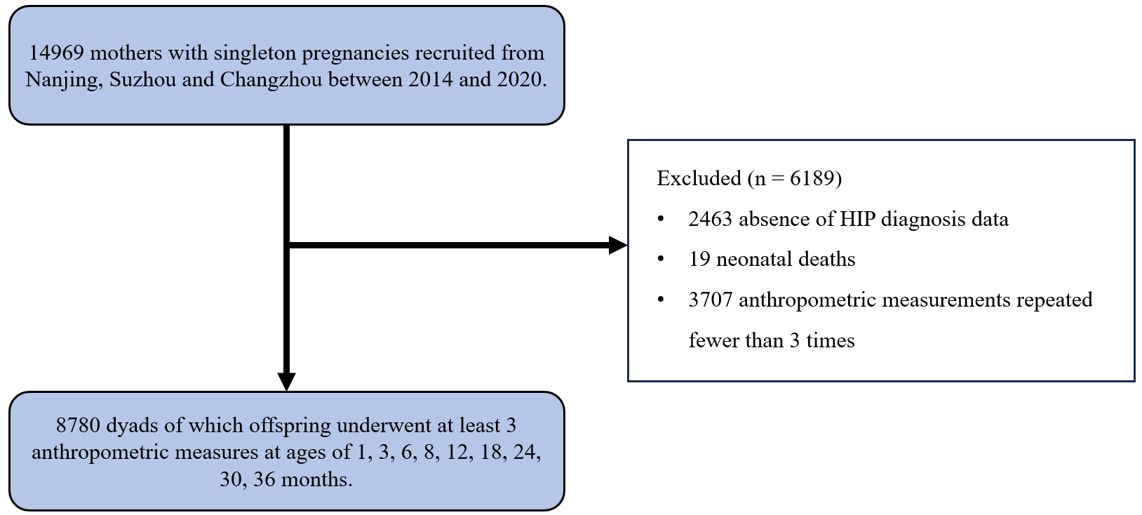
Figure S1 Flow chart of the study participants selection.

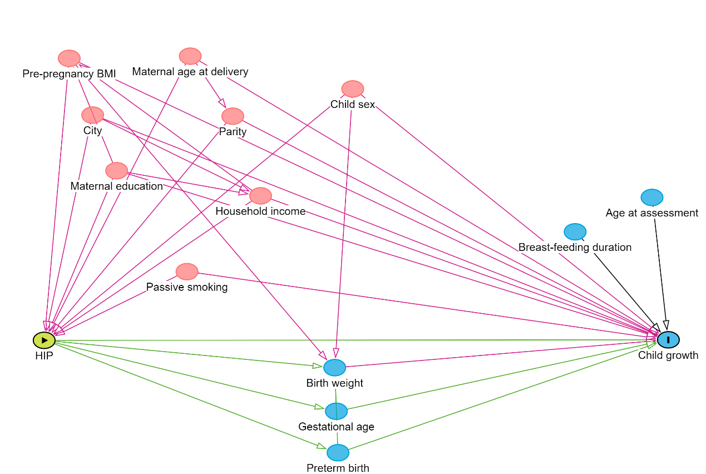
Figure S2 Directed acyclic graph (DAG) used to identified covariates and potential confounders.
Green ovals represent exposures or ancestors of the exposure. Pink ovals represent ancestors of the exposure and the outcome. Blue ovals represent ancestors the outcome.
Abbreviations: HIP, Hyperglycemia in pregnancy. BMI, body-mass index.
Minimal sufficient adjustment sets for estimating the total effect of HIP on Child growth: child sex, city, household income, maternal age at delivery, maternal education, parity, passive smoking, pre-pregnancy BMI.

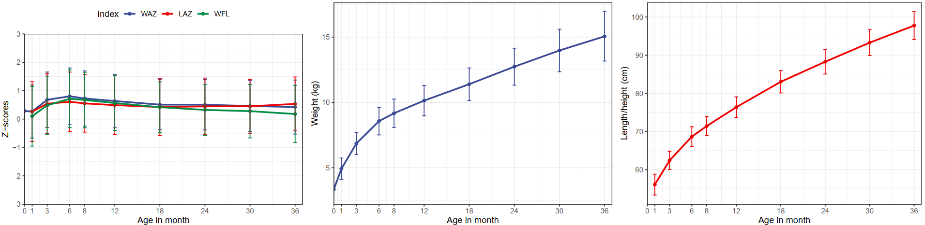
Figure S3 Anthropometric measures in children at each time points.

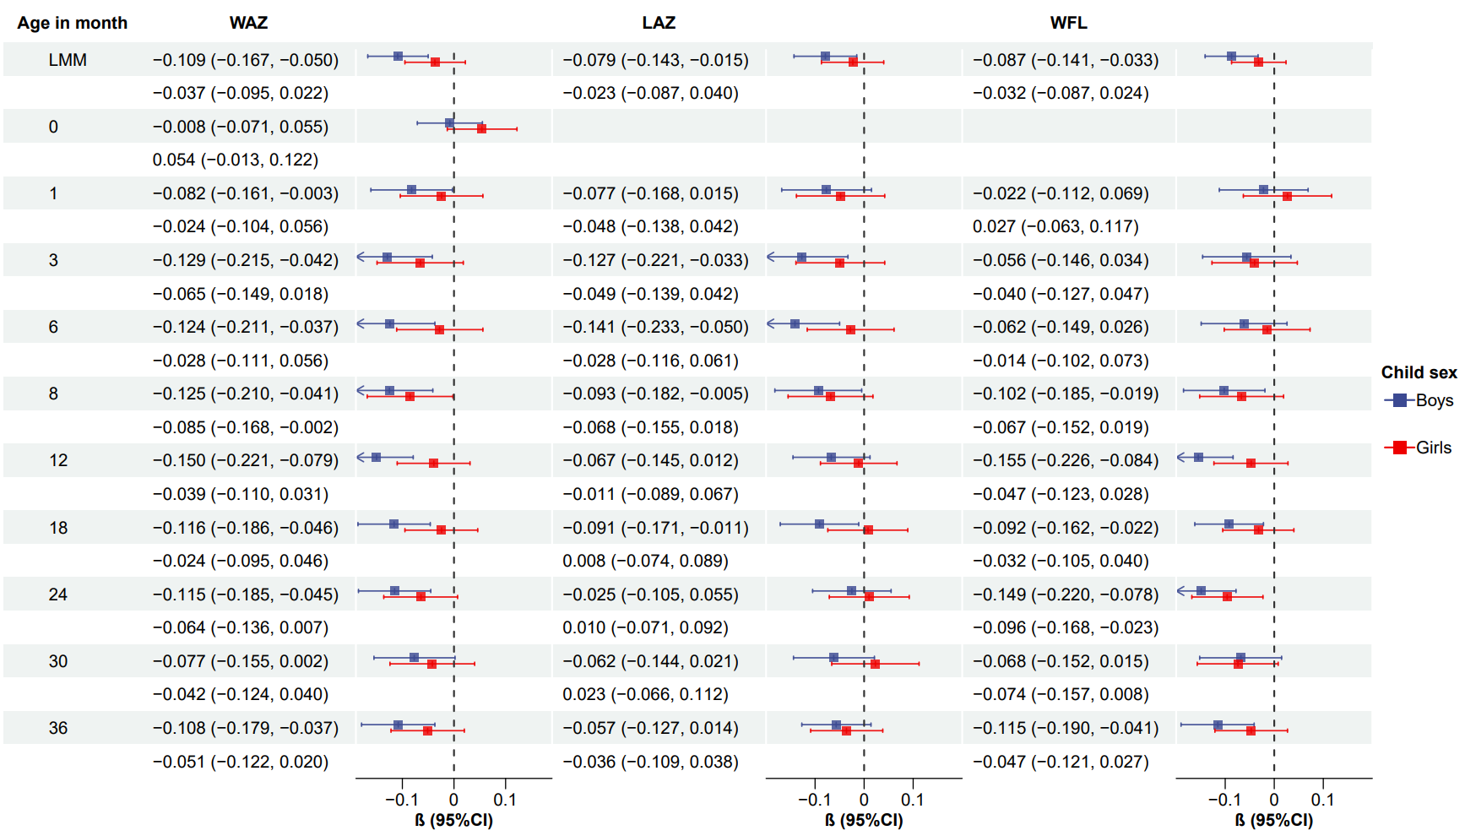
Figure S4 Forest plot of the association between maternal HIP and infant anthropometric z-scores at ten time points from birth to 3 years stratified by infant sex. β and 95% CI for each anthropometrical measures according to maternal HIP in general linear models. All models were adjusted for pre-pregnancy BMI, parity, maternal education, maternal age at delivery, passive smoking during pregnancy, area of residence, household income and child sex.
Abbreviations: HIP, hyperglycemia in pregnancy; BMI, body mass index; CI, confidence interval; LAZ, length/height-for-age z-score; WAZ, weight-for-age z-score; WFL, weight-for-length z-score.

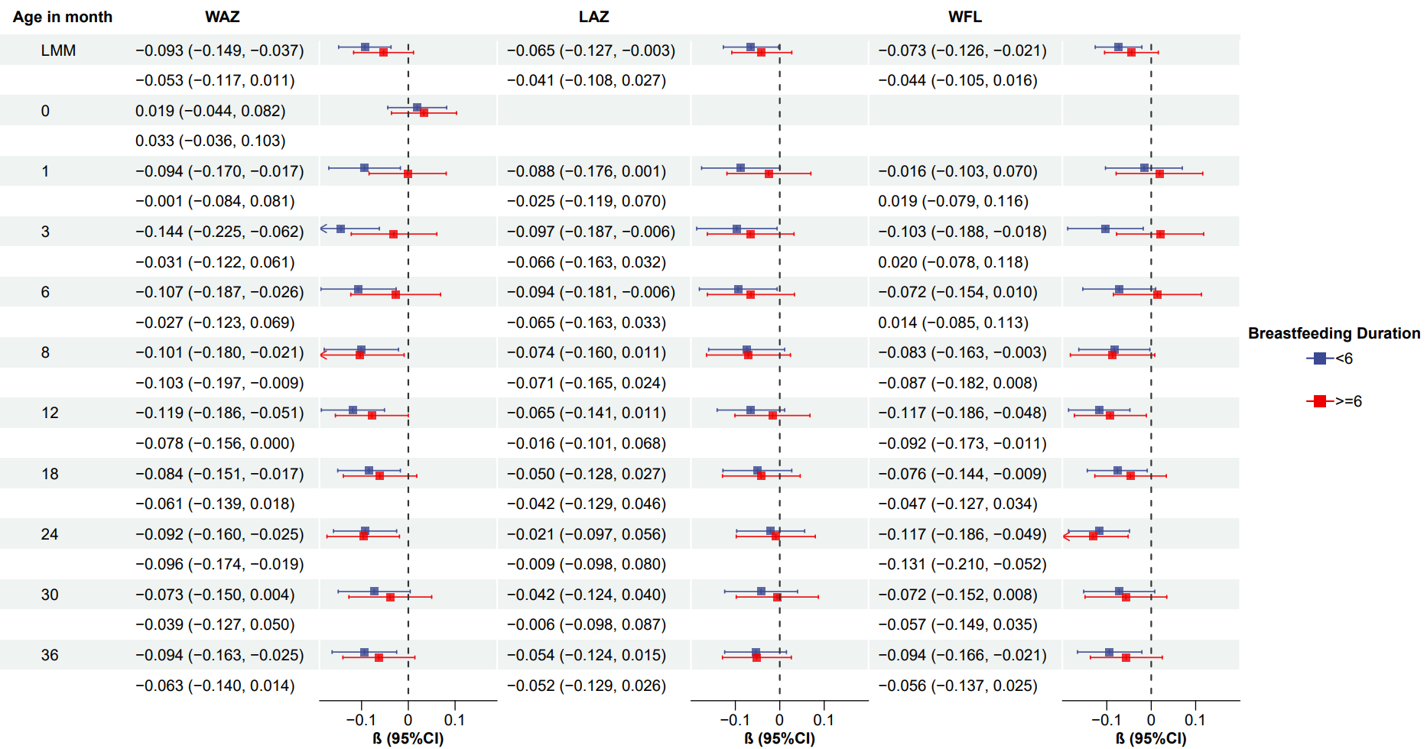
Figure S5 Forest plot of the association between maternal HIP and infant anthropometric z-scores at ten time points from birth to 3 years stratified by duration of breastfeeding (less than 6 months vs. 6 months or longer). β and 95% CI for each anthropometrical measures according to maternal HIP in general linear models. All models were adjusted for pre-pregnancy BMI, parity, maternal education, maternal age at delivery, passive smoking during pregnancy, area of residence, household income and child sex.
Abbreviations: HIP, hyperglycemia in pregnancy; BMI, body mass index; CI, confidence interval; LAZ, length/height-for-age z-score; WAZ, weight-for-age z-score; WFL, weight-for-length z-score.
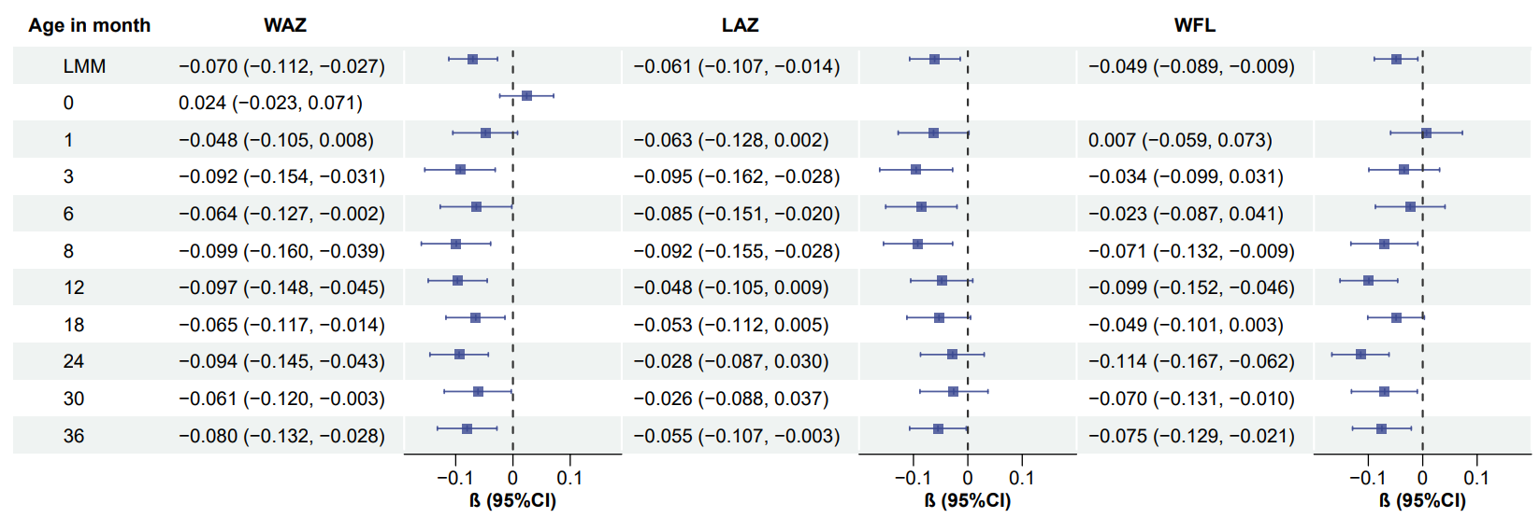
Figure S6 Sensitivity analyses for associations between maternal HIP and offspring anthropometries at different periods, excluding mothers with hypertensive disorders during pregnancy. β and 95% CI for each anthropometrical measures according to maternal HIP in general linear models. All models were adjusted for pre-pregnancy BMI, parity, maternal education, maternal age at delivery, passive smoking during pregnancy, area of residence, household income and child sex.
Abbreviations: HIP, hyperglycemia in pregnancy; BMI, body mass index; CI, confidence interval; LAZ, length/height-for-age z-score; WAZ, weight-for-age z-score; WFL, weight-for-length z-score.

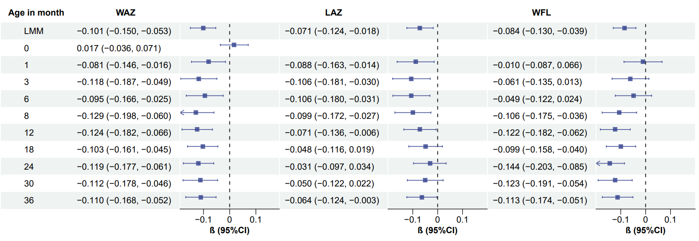
Figure S7 Sensitivity analyses for associations between maternal HIP and offspring anthropometries at different periods, excluding mothers with IVF/ICSI conception. β and 95% CI for each anthropometrical measures according to maternal HIP in general linear models. All models were adjusted for pre-pregnancy BMI, parity, maternal education, maternal age at delivery, passive smoking during pregnancy, area of residence, household income and child sex.
Abbreviations: HIP, hyperglycemia in pregnancy; BMI, body mass index; CI, confidence interval; LAZ, length/height-for-age z-score; WAZ, weight-for-age z-score; WFL, weight-for-length z-score.

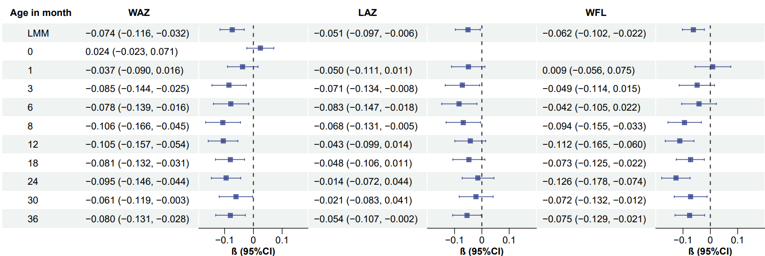
Figure S8 Sensitivity analyses for associations between maternal HIP and offspring anthropometries at different periods, excluding preterm birth infants. β and 95% CI for each anthropometrical measures according to maternal HIP in general linear models. All models were adjusted for pre-pregnancy BMI, parity, maternal education, maternal age at delivery, passive smoking during pregnancy, area of residence, household income and child sex.
Abbreviations: HIP, hyperglycemia in pregnancy; BMI, body mass index; CI, confidence interval; LAZ, length/height-for-age z-score; WAZ, weight-for-age z-score; WFL, weight-for-length z-score.

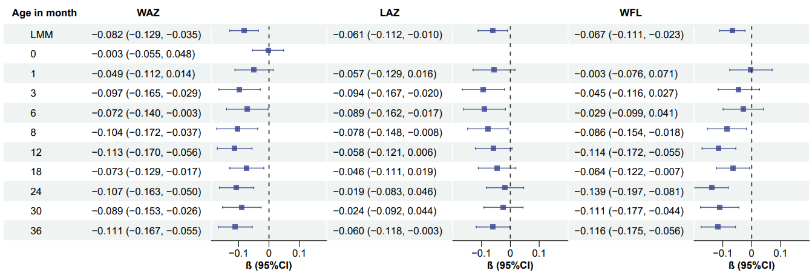
Figure S9 Sensitivity analyses for associations between maternal HIP and offspring anthropometries at different periods, excluding infants born to mothers with BMI > 24kg/m². β and 95% CI for each anthropometrical measures according to maternal HIP in general linear models. All models were adjusted for pre-pregnancy BMI, parity, maternal education, maternal age at delivery, passive smoking during pregnancy, area of residence, household income and child sex.
Abbreviations: HIP, hyperglycemia in pregnancy; BMI, body mass index; CI, confidence interval; LAZ, length/height-for-age z-score; WAZ, weight-for-age z-score; WFL, weight-for-length z-score.

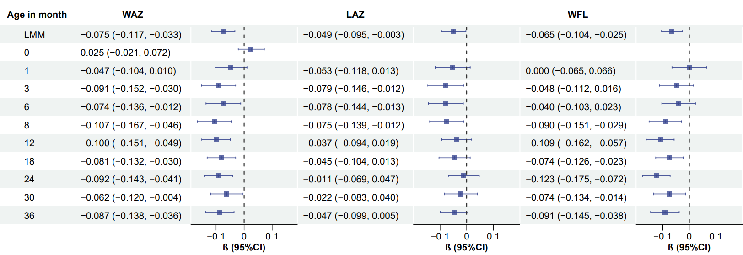
Figure S10 Sensitivity analyses for associations between maternal HIP and offspring anthropometries at different periods, excluding mothers with pre-gestational diabetes. β and 95% CI for each anthropometrical measures according to maternal HIP in general linear models. All models were adjusted for pre-pregnancy BMI, parity, maternal education, maternal age at delivery, passive smoking during pregnancy, area of residence, household income and child sex.
Abbreviations: HIP, hyperglycemia in pregnancy; BMI, body mass index; CI, confidence interval; LAZ, length/height-for-age z-score; WAZ, weight-for-age z-score; WFL, weight-for-length z-score.

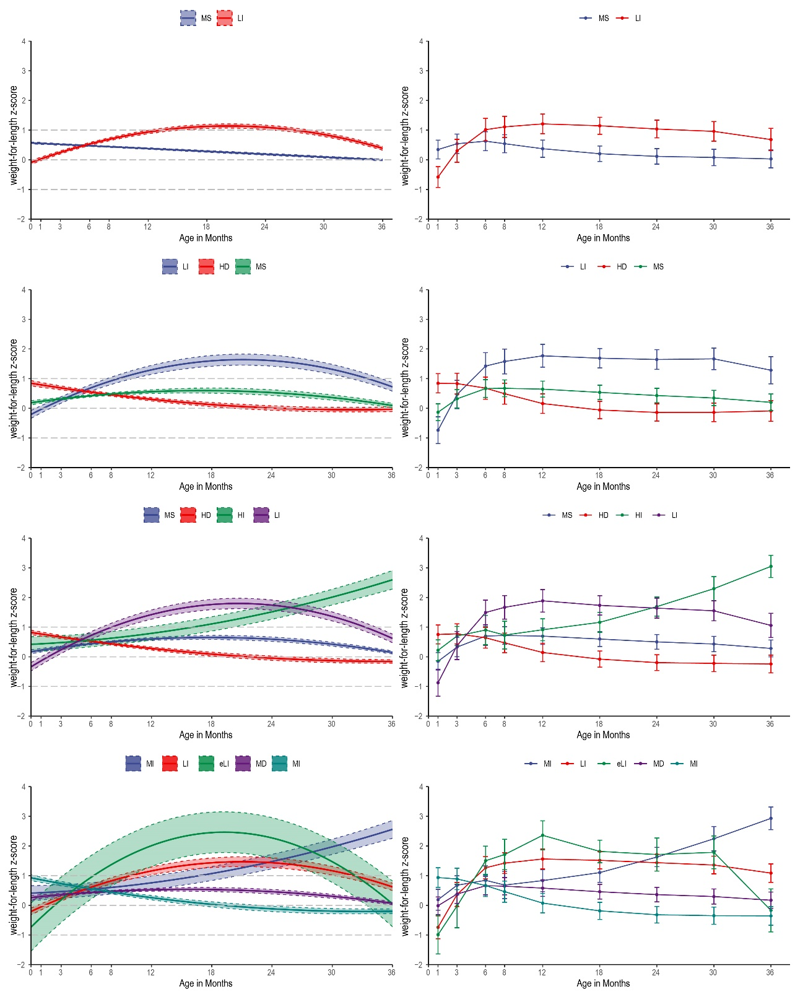

Figure S11 Trajectory groups identified in two to five growth pattern groups for weight-for-length z-score. The groups are labeled according to the initial value and following trend (LI: low-increasing; MS: moderate-stable; HD: high-decreasing; MI: moderate-increasing; HI, high-increasing; eLI: extremely low-increasing). The solid line indicates predicted trajectory and the shaded areas around represent the 95% confidence intervals for the calculated trajectories. Line graphs in the right column indicate observed trajectories.

