Health impact assessment of auto rickshaw and cab drivers due to exposure to vehicular pollution in Delhi: An integrated approach
Contents
S1 Survey Questionnaire
S2 Pulmonary Function Test
S3 perception of air quality and its health impacts

Supplementary Information

S1. Survey questionnaire
This section presents the structured questionnaire used for data collection from autorickshaw and cab drivers.

Note: We are conducting this survey to understand the impacts of air pollution and extreme climate events on the health and livelihood vulnerability of auto-rickshaw drivers, street sweepers and street vendors. The collected information will not be revealed or shared with any person or agency and will be used for research and academic purpose only.

Interviewer name: ……………………………………… Date….............................
S. No.: …. Survey Site: ……………………………………… Geo Code: …………………………….
Type of Work: ………………………............................. Auto/ Cab: …………………………...

A. Respondent Information
1. Name: …………………………….. 2. Age: ………………………….
3. Residential Address: …………………………………………………………………………………………….
4. Migrant (Yes/No) ……Where from? ……………………
5. Individual details:
Gender
Age
Education
Occupation
Height
Weight
Smoking (Y/N)
Alcohol (Y/N)
Tobacco (Y/N)
Mode of Travel
Travel (km/day)
Physical activity

6. Monthly income: 1000-5000 5000-10,000 10,000- 15,000 15,000- 25,000 > 25,000
7. Which all fuels do you use to cook?
Coal LPG PNG Biomass-burning Wood Gas and biomass burning others (specify)

B. EXPOSURE CYCLE ASSESSMENT: What is the number of hours spent in-
Home | Workplace | Transit/ Travel | Outdoor

C. Work Details:
1. Work areas: …………………………………………………………………
2. Working days: 7 days 6 days 5 days Random
3. Working hours (per day): 1-3 hrs. 3-5hrs. 5-8hrs.8-10hrs More than 10
4. Since when have you been working? .........................................................................................
5. Area (in km)
Auto-Rickshaw Drivers

- AIR QUALITY PERCEPTION:
1. How would you rate the air quality in your working areas?
Excellent Good Moderate Unhealthy Hazardous Not aware
2. How would you rate the air quality inside your house?
Excellent Good Moderate Unhealthy Hazardous Not aware
3. According to you, which of the following are prominent sources of air pollution in your area?
Vehicles Industries Cooking fuels Biomass burning Cigarette smoking Road dust Power plants Construction activity other sources
4. How would you rate air quality impact on your health?
No Mild Moderate Severe
5. Are there any remedial/protective measures being taken?
Gloves Face Mask/Cloth for covering face Headgear AC during travel avoiding highly polluted areas Shades Any other measures
D. Health Symptoms
Symptoms | Since When | Occurrence |  |  |  | Severity
Symptoms | Since When | During work | After work | Frequency (in a day) | Seasonal | Severity
Respiratory Symptoms
Runny nose
Sneezing
Chronic Cough
Breathlessness
Wheezing
Phlegm
Common cold
Asthma
Congestion
Sore throat
Ophthalmic Symptoms
Redness
Irritation
Blurred vision
Dryness
Burning
Watering
Dermatological Symptoms
Skin rashes
Redness
Itching
Skin aging
Dryness
Cardiovascular Symptoms
Chest pain
Irregular Heartbeat
Chest discomfort
Musculoskeletal Symptoms
Back-ache
Shoulder Pain
Pain in Joints
Other Symptoms (Generally in all seasons)
Headache
Dizziness
General Weakness

Spirometry and personal monitoring: Yes No

Declaration: The respondent has given permission for using this information in the research. Yes/No
Name: …………………………………………….Signature: …………………………………
S2. Pulmonary Function Test
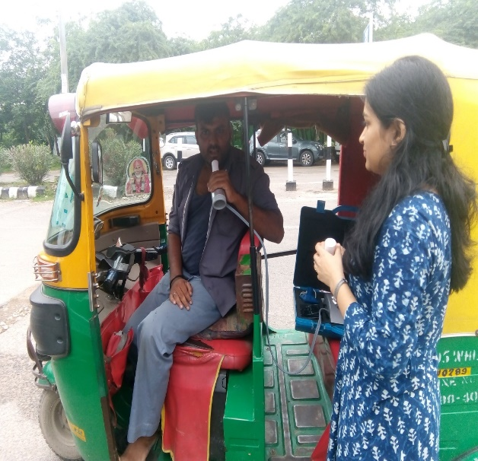
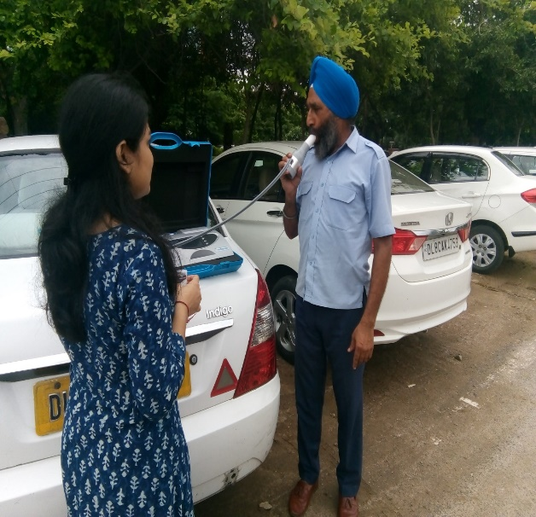

Figure S1: Pulmonary Function Test of Respondents

Figure S2: Criteria for interpretation of spirometry results

S3. Perception of air quality and its health impacts

Figure S3: Perception of air quality and its health impacts (a) Perception of air quality at workplace- Autorickshaw drivers (b) Perception of air quality at workplace- Cab drivers (c) Perception of air quality at residence- Autorickshaw drivers (d) Perception of air quality at residence- Cab drivers (e) Perception of impact of air quality on health- Autorickshaw drivers (f) Perception of impact of air quality on health- Cab drivers

S4. Use of protective measures by the study population

Figure S4: Use of protective measures (a) Auto rickshaw drivers (b) Cab drivers

