Supplementary Material

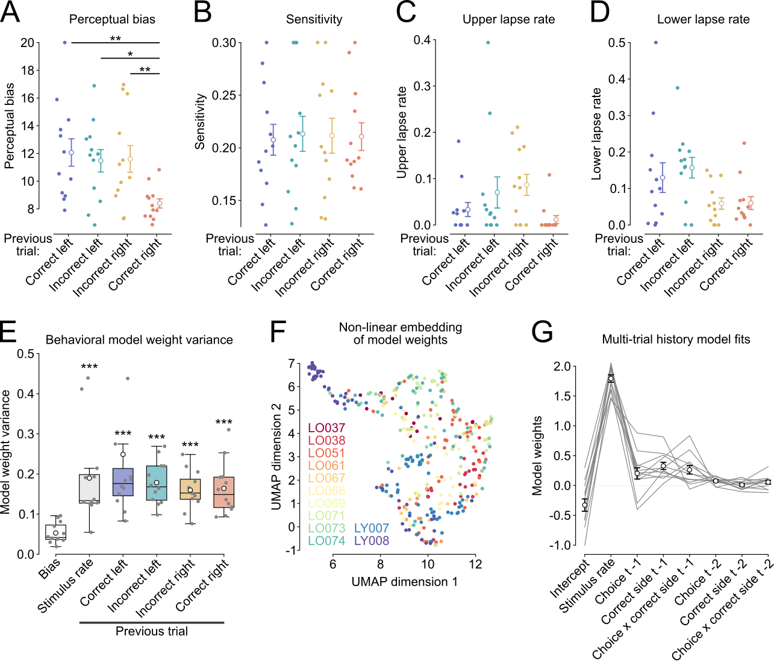
Supplementary figure 1. The behavioral influence of most recent trial history varies between sessions. (A, B, C, D) Estimates of the psychometric parameters, bias (A), sensitivity (B), upper lapse rate (C), and lower lapse rate (D). Scatter points on the left represent individual subjects while dots with errorbars depict mean ± sem over subjects. *P < 0.05, **P < 0.01. (E) Variance of the session-by-session weights of the behavioral choice decoding. Boxes represent median ± interquartile range and dots depict the mean. All comparisions are made agains the bias (intercept). ***P < 0.001. (F) Non-linear embedding of the behavioral choice decoding weights. Scatter points represent sessions color-coded by subject. (G) Behavioral decoding models including regressors for most recent trial history (t-1) and trial history from two trials back (t-2). Lines are individual subjects while dots with errorbars show mean ± sem over subjects.

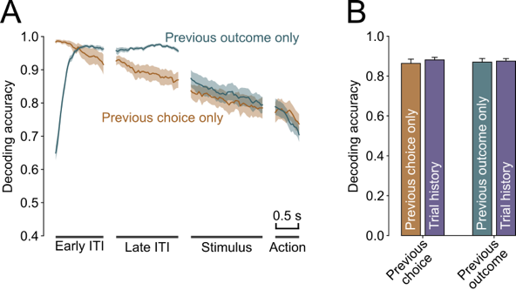
Supplementary Figure 2. Decoders trained on trial history decode previous choice and outcome equally well as corresponding binary classifiers. (A) Mean ± sem. decoding accuracy across trial time for decoders trained on previous choice- (orange) or previous outcome (teal) only. (B) Mean ± sem. neural decoding accuracy for previous choice or previous outcome for their corresponding binary decoders or trial history decoders (trained to decode combinations of previous choices and outcomes), linear mixed-effects model with session nested in subject as random effects.

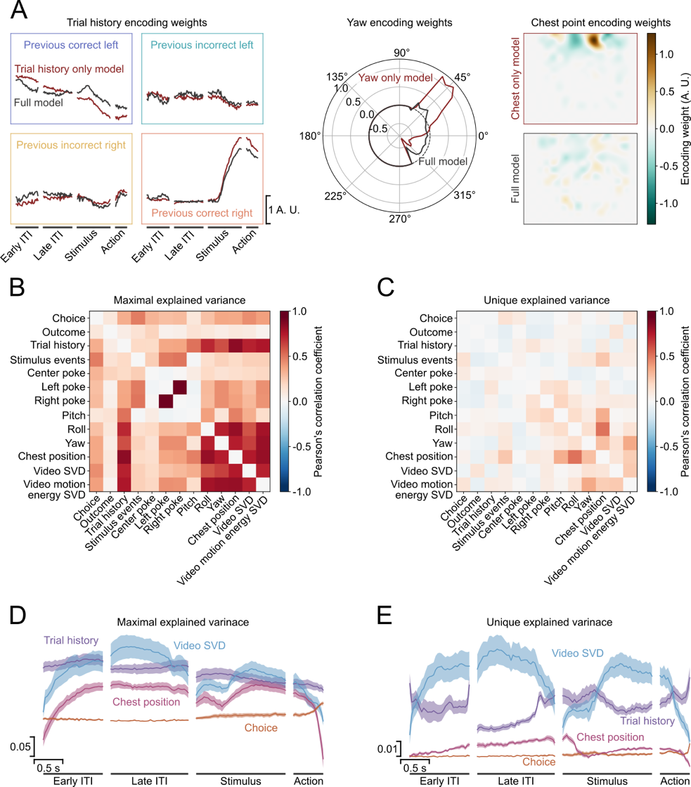
Supplementary Figure 3. The linear encoding model identifies the unique contribution of the regressors to the neural activity. (A) Comparison of encoding model weights from an example neuron for model where the regressors for all except a single variable are shuffled (red) and the full models without shuffling (dark grey). Trial history weights (left), yaw tuning (center) and chest point tuning (right) are shown. (B) Correlation between maximal explained variance for different variables in all neurons from an example session. Note the high correlation between trial history and yaw and chest point. (C) Correlation of the unique explained variance between variables for the same session as in (B). (D and E) Mean ± sem reconstructed time course of maximal (D) and unique explained variance (E) for different variables.
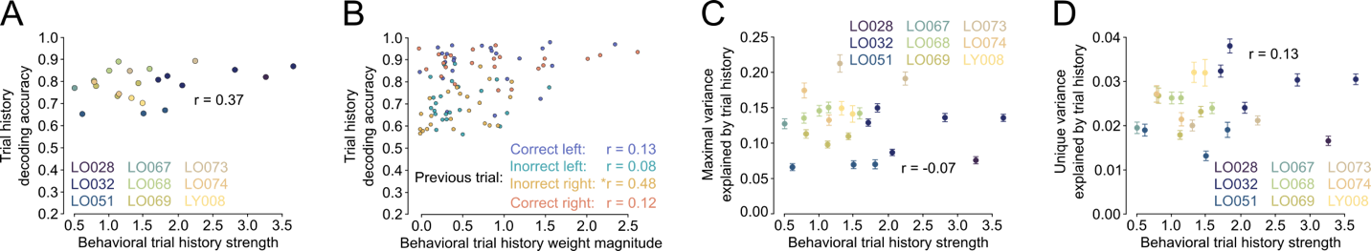
Supplementary figure 4. Neural encoding of trial history in ACC is not correlated with the strength of trial history biases. (A) Neural population decoding of trial history is not correlated with the behavioral usage of trial history information. Each point is a single animal. (B) Decoding accuracy for specific trial history contexts is independent of the magnitude of the corresponding behavioral model weight. (C and D) Neither maximal nor unique variance of individual neurons explained by trial history are correlated with behavioral trial history biases.

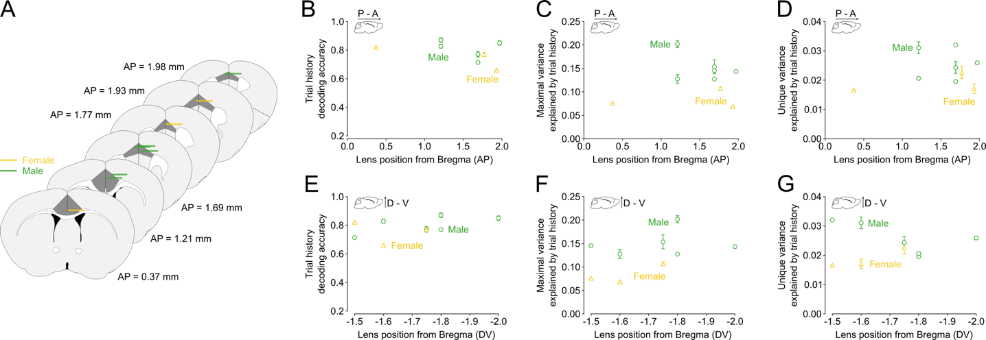Supplementary Figure 5: Female mice show weaker trial history representations than male mice. (A) Anatomical reconstruction of GRIN lens position (its center) separated by subject sex. (B and E) Mean trial history decoding accuracy by lens position along the anterior-posterior (B) and dorsal-ventral axis (E) separated by subject sex. We found a significant main effect of sex (p > 0.01) but no effects for AP or DV lens position or their interaction, linear-mixed effects model with subject as random effect. (C and F) Mean maximal explained variance for trial history as a function of GRIN lens position and color-coded by sex. We observed significant effects of sex (p < 0.01), AP position (p < 0.01), DV position (p < 0.01) and the interaction between AP and DV position (p < 0.01), linear mixed effects model with random effect for subject. (D and G) Average unique explained variance for trial history by GRIN lens AP (D) and DV (G) position separated by subject sex. We found significant effects of sex (p < 0.01), but no effects for AP or DV position or their interaction, linear mixed-effects model with subject as random effect.

Subject ID | Sex | Stimulus modality | Included in behavioral analyses | Included in imaging analyses | Imaging session  number | Lens AP coordinates | Lens ML coordinates | Lens DV coordinates
LO028 | F | Auditory | No | Yes | 1 | 0.37 mm | 0.5 mm | -2.00 mm
LO032 | M | Auditory | No | Yes | 5 | 1.21 mm | 0.5 mm | -1.90 mm
LO037 | M | Visual | Yes | No | - | - | - | -
LO038 | M | Visual | Yes | No | - | - | - | -
LO051 | F | Visual | Yes | Yes | 3 | 1.93 mm | 0.4 mm | -1.90 mm
LO061 | F | Visual | Yes | No | - | - | - | -
LO067 | M | Visual | Yes | Yes | 1 | 1.69 mm | 0.5 mm | -1.70 mm
LO068 | M | Visual | Yes | Yes | 4 | 1.97 mm | 0.3 mm | -1.50 mm
LO069 | F | Visual | Yes | Yes | 3 | 1.77 mm | 0.5 mm | -1.75 mm
LO071 | F | Visual | Yes | No | - | - | - | -
LO073 | M | Visual | Yes | Yes | 2 | 1.21 mm | 0.8 mm | -1.70 mm
LO074 | M | Visual | Yes | Yes | 2 | 1.69 mm | 0.2 mm | -1.70 mm
LO090 | F | Visual | No | No | - | - | - | -
LO091 | F | Visual | No | Yes | - | - | - | -
LY007 | M | Visual | Yes | No | - | - | - | -
LY008 | M | Visual | Yes | Yes | 2 | 1.69 mm | 0.6 mm | -2.00 mm

Supplementary Table 1: Summary of included subjects, task conditions, imaging sessions and coordinates.

