Depletion, Metabolism, and Risk Assessment of Clopidol in Broilers

Seong-Hoon Jeong^{a,†}, Hyeong-Jin Youn^{a,†}, Ji-young Anª, Jung-Hoon Jungª, Jong-Su Seoª, Min Jeong-Ran^{b}, Sang-Hee Jeong^{b,*}, and Jong-Hwan Kim^{a,c,*}

ª Environmental Safety-Assessment Center, Korea Institute of Toxicology (KIT), Jinju, 52834, Republic of Korea
^{b} GLP Research Center, College of Natural Science, Hoseo University, Asan, 336795, Republic of Korea
^{c}Human and Environmental Toxicology Program, Korea University of Science and Technology (UST), Daejeon, Republic of Korea

† Authors are equally contributed as first author

* Corresponding authors

Sang-Hee Jeong
Phone: +82-41-540-9675, Fax: +82-41-540-9829

E-mail: jeongsh@hoseo.edu

Jong-Hwan Kim
Phone: +82-55-750-3752, Fax: +82-55-750-3768
E-mail: jjong@kitox.re.kr

Clopidol
[³H]-clopidol
Fig. S1 Chromatograms of [³H]-clopidol and non-labeled clopidol obtained by radio-HPLC equipped with radio (A and B) and DAD (C and D) detectors. (A) blank, (B) [³H]-clopidol, (C) blank, and (D) non-labeled clopidol

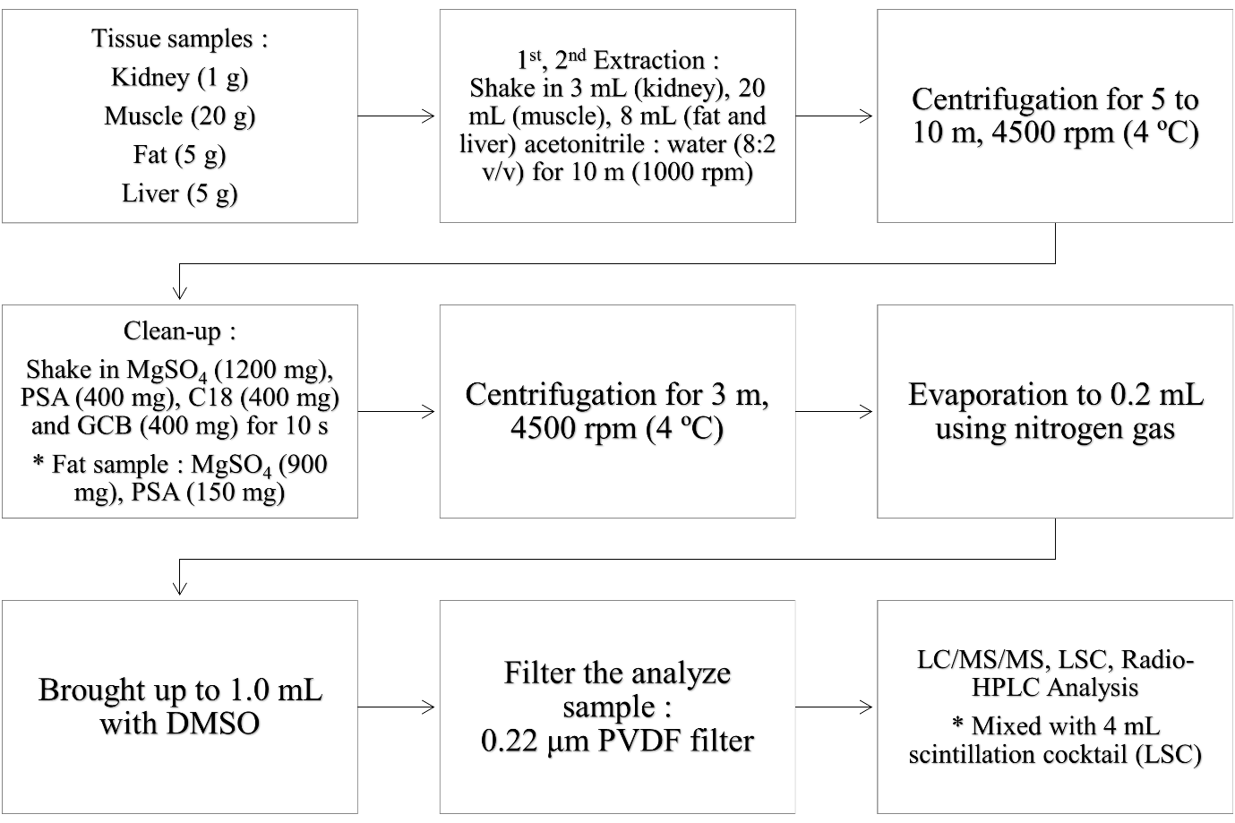
Fig. S2 Sample pretreatment and extraction methods

Table S1 Conditions of Radio-HPLC
Parameter
HPLC system | Agilent 1260 infinity, USA
Column | Agilent, Eclipse XDB-C18, 5 μm, 4.6 x 250 mm
Column temp. | 25℃
Injected volume | 300 μL
Mobile phase | Solvent A: 0.05% TFA in ACN  Solvent B: 0.05% TFA in water
Gradient | Time (min) | 0 | 1 | 7 | 8 | 16
Gradient | A (%) | 5 | 5 | 85 | 85 | 5
Gradient | B (%) | 95 | 95 | 15 | 15 | 95
Flow rate | 1.0 mL/min
Wavelength | 220 nm
³H detector | Ramona Star (ELYSIA RAYTEST, S/N: 26663)  Flow rate: 1.0 mL/min (Ultima-Flo AP scintillation cocktail)

Table S2 Conditions of HPLC/LC–MS
Parameter
HPLC system | Agilent 1260 infinity, USA
Column | Agilent, Eclipse C18, 1.8 μm, 2.1 x 100 mm
Column temp. | 35℃
Injected volume | 1 μL
Mobile phase | Solvent A: 0.1% formic acid in ACN  Solvent B: 0.1% formic acid in water
Gradient | Time (min) | 0 | 1 | 7 | 8 | 16
Gradient | A (%) | 5 | 5 | 85 | 85 | 5
Gradient | B (%) | 95 | 95 | 15 | 15 | 95
Flow rate | 1.0 mL/min
MS system | Agilent Technologies 6420 Triple Quad LC/MS, USA.
Ion mode | ESI, positive

Table S3 LOD and LOQ of tissue extracts for LSC analysis
Tissues | Actual Concentration (ug/kg)
Tissues | LOD | LOQ
Liver | 0.62 | 2.31
Kidney | 3.75 | 13.5
Muscle | 0.28 | 0.95
Fat | 0.68 | 2.48

Table S4 Estimated daily intake of muscle (meat) and all tissues (muscle, kidney, liver, and fat) for the average (p50) and high (p90) intake groups by sex and age
p50 group | EDI, muscle |  | EDI, all tissues
Ages | Males | Females | Males | Females
1-2y | 9.22±1.55 | 17.08±2.88 | 9.22±1.55 | 17.08±2.88
3-5y | 22.25±3.74 | 12.78±2.15 | 22.25±3.74 | 12.78±2.15
6-11y | 15.87±2.67 | 13.51±2.27 | 15.91±2.69 | 13.51±2.27
12-18y | 14.55±2.45 | 10.22±1.72 | 14.55±2.45 | 10.22±1.72
19-29y | 12.53±2.11 | 8.72±1.47 | 12.55±2.12 | 8.72±1.47
30-49y | 11.67±1.97 | 6.00±1.01 | 11.69±1.98 | 6.03±1.03
50-64y | 5.60±0.94 | 3.82±0.64 | 5.66±0.97 | 3.82±0.64
65y ≤ | 1.68±0.28 | 1.43±0.24 | 1.73±0.31 | 1.45±0.25

p90 group | EDI, muscle |  | EDI, all tissues
Ages | Males | Females | Males | Females
1-2y | 25.65±4.32 | 14.98±2.52 | 25.65±4.32 | 14.98±2.52
3-5y | 35.07±5.90 | 22.81±3.84 | 35.07±5.90 | 22.81±3.84
6-11y | 21.51±3.62 | 29.09±4.90 | 21.55±3.64 | 29.09±4.90
12-18y | 24.21±4.08 | 16.98±2.86 | 24.21±4.08 | 16.98±2.86
19-29y | 25.10±4.23 | 30.42±5.12 | 25.12±4.23 | 30.42±5.12
30-49y | 20.13±3.39 | 17.17±2.89 | 20.15±3.4 | 17.20±2.91
50-64y | 8.09±1.36 | 6.23±1.05 | 8.14±1.39 | 6.23±1.05
65y ≤ | 1.16±0.20 | 1.52±0.26 | 1.21±0.22 | 1.55±0.27

Table S5 Hazard quotients of muscle (meat) and all tissues (muscle, kidney, liver, and fat) for average (p50) and high (p90) intake groups by sex and age
p50 group | HQ, muscle |  | HQ, all tissues
Ages | Males | Females | Males | Females
1-2y | 0.23±0.04 | 0.43±0.07 | 0.23±0.04 | 0.43±0.07
3-5y | 0.56±0.09 | 0.32±0.05 | 0.56±0.09 | 0.32±0.05
6-11y | 0.40±0.07 | 0.34±0.06 | 0.40±0.07 | 0.34±0.06
12-18y | 0.36±0.06 | 0.26±0.04 | 0.36±0.06 | 0.26±0.04
19-29y | 0.31±0.05 | 0.22±0.04 | 0.31±0.05 | 0.22±0.04
30-49y | 0.29±0.05 | 0.15±0.03 | 0.29±0.05 | 0.15±0.03
50-64y | 0.14±0.02 | 0.10±0.02 | 0.14±0.02 | 0.10±0.02
65y ≤ | 0.04±0.01 | 0.04±0.01 | 0.04±0.01 | 0.04±0.01

p90 group | HQ, muscle |  | HQ, all tissues
Ages | Males | Females | Males | Females
1-2y | 0.64±0.11 | 0.37±0.06 | 0.64±0.11 | 0.37±0.06
3-5y | 0.88±0.15 | 0.57±0.10 | 0.88±0.15 | 0.57±0.10
6-11y | 0.54±0.09 | 0.73±0.12 | 0.54±0.09 | 0.73±0.12
12-18y | 0.61±0.10 | 0.42±0.07 | 0.61±0.10 | 0.42±0.07
19-29y | 0.63±0.11 | 0.76±0.13 | 0.63±0.11 | 0.76±0.13
30-49y | 0.50±0.08 | 0.43±0.07 | 0.50±0.09 | 0.43±0.07
50-64y | 0.20±0.03 | 0.16±0.03 | 0.20±0.03 | 0.16±0.03
65y ≤ | 0.03±0.01 | 0.04±0.01 | 0.03±0.01 | 0.04±0.01

