Supplemental information
Document S1. Extended Figure 1 legend.
Figures S1-S7. Additional figures to support the data and further illustrate the findings.

Document S1.
Figure 1. Cell alterations induced by the amino acid starvation.
(A-D) Double immunofluorescence labelling of MannII (red) and LC3/p62 (green) in control and starved cells. (A) In control HeLa cells only a few LC3-positive dots are visible. The GC (Man-II; red) was not fragmented. (B) In starved cells LC3-positive dots (green) were accumulated. The GC started to fragment. (C) Control cells exhibited rarep62-positive dots (green) with a solid GC (red). (D) Starved cells showed moreLC3-positive (red) dots than p62-positive (green) dots. (E) Sec bodies-positive for Sec13 (nano-gold) were inside the IAV (left) or surrounded by phagophores (see Figure S1A, B). (F) Branched elongated mitochondria with irregular shape in starved cells. (G) Number of LC3-positive dots. Experimental bars 2, 4, 6, 8 are significantly (p<0.05) higher than their corresponding control bars (1, 3, 5, 7). (H) The number of p62-positive dots. Experimental bars 2, 4, 6, 8 are significantly (p<0.05) higher than their corresponding control bars (1, 3, 5, 7). (I) The number of DAV per a cell is significantly higher after starvation (second bar) compared to control cells (first bar, p<0.05). Control microinjection (third bar) did not induce formation of DAVs (the third bar does not differ from the first one). Following control microinjection and starvation of microinjected cells (fourth bar) the number of DAV significantly increased. In starved cells lacking Sar1A et B the number of DAVs was higher than in cells transfected with control oligos (the fifth and sixth bars, [p<0.05]). COPII inhibitors did not affect DAVs accumulation during starvation (the 7-9th bars are significantly (p<0.05) higher than the second bar). Similarly, lipid inhibitors did not affect DAVs accumulation (the 11th bar is significantly (p<0.05) higher than the second bar). (J) In SNAP29-deficient cells after starvation (siCTR+ST), the mean number of DAVs is significantly (p<0.05) higher than in control cells (siCTR). Elimination of SNAP29 (with or without starvation) did not induce DAVs accumulation (compare N1, N2 and N3 bars). In heterokaryon formed after fusion between the SNAP29 KD cells subjected to starvation and normal cells (the bar N5), DAVs numbers increased significantly (p<0.05; see the last bar). (K) Total cell membrane surface area remains unchanged after starvation alone or with lipid inhibitor (L) Cell volume was also unaffected by starvation or with lipid inhibitor. (M) Total ER surface area did not vary with starvation, COPII or lipid inhibitors, or in SNAP29 or STX17-deficient cells. (N) The ratio of IMM to OMM surface decreased with starvation alone (fourth bar), mitochondrial fusion inhibitor (second bar) and in cells lacking SNAP29 or STX17 (sixth and eighth bars). Eliminating SNAP209 or STX17 did not affect significantly this ratio (the 5th and 7th bars). Inhibitor of fission also had no effect significantly impact (third bar). (O, P) Cells transfected with YFP-MITO-cb5TM (green). (O) Non-starved control cells show no co-localization. between round green spot and dots-positive for LC3 (red) in the enlargements (green, red and merged images) of the blue box in (O). (P) The starved cells display co-localization between round green spot and dots-positive for LC3 (red) in the enlargements (green, red and merged images) of the dashed yellow box. (Q-S) Effect of inhibitors of mitochondria fusion (R) and fission (S) by Tomm20 immunolabeling. (Q) Control cells. (R) Cells with the fusion inhibitor (6h) show shorter mitochondria. (S) Cells with fission inhibitor (6h) show longer mitochondria (T). Surface area of IMM was similar in control (CTR) and starved (ST) cells. (U) Control HeLa cell labelled for LC3 (green) shows few LC3-positive dots. (V) Starved cells labelled for Man II (red) and LC3 (green) exhibit accumulation of LC3-positive dots. (W, X) Starved cells microinjected with the αSNAP mutant + TRITC (red cell). (X) LC3–positive spots are visible in injected and non-injected cells. Red color was eliminated. (Y) Accumulation of COPI vesicles and IAV after microinjection with aSNAP mutant. Accumulation of COPI vesicles (round profiles) and IAV (red arrow). (Z) HeLa cell microinjected with anti NSF antibody and starved. Accumulation of COPI vesicles (black arrows) and IAV (red box). White arrows indicate microinjected gold particles. (Z1) MLO in starved cell. (Z2) Surface area of IAVs significantly increases after starvation and microinjection of NSF antibodies or αSNAP mutant. (Z3) Enlargement of the red box. Protrusion of the outer membrane of IAV. Scale bars: 5 µm (A-D, O, P); 15 µm (Q, R, S); 10 µm (U-X); 300 nm (Y); 175 nm (Z); 150 nm (Z1, Z3).

Supplemental Figures
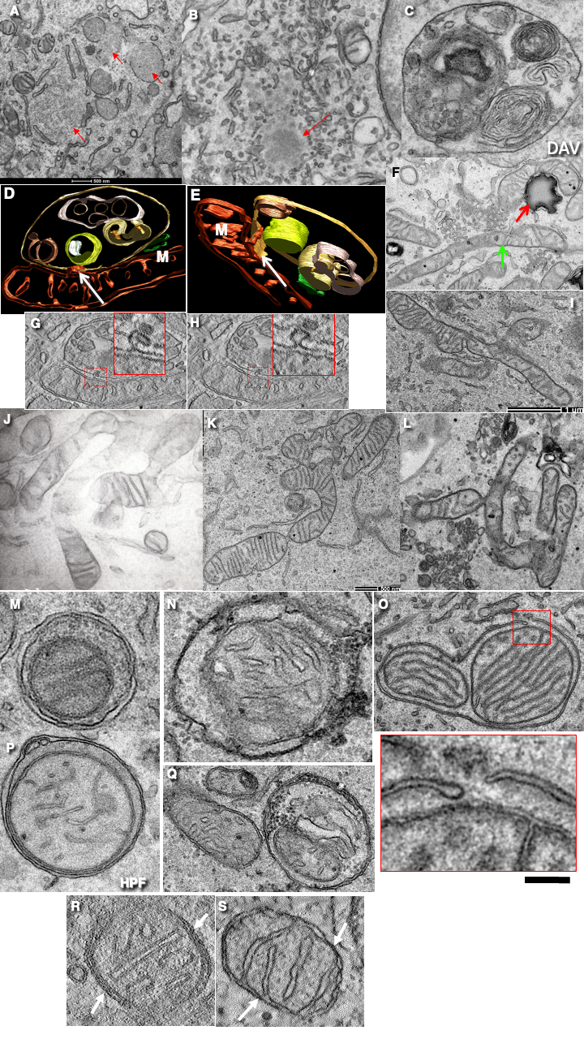
Figure S1. Alterations of cells induced by starvation.
(A, B) Sec bodies in starved cells. (C-E, G, H) DAVs in starved cells. “M” on images indicates mitochondria. (F) Mitochondrion attached to lipid droplet. (I-L) Blanched mitochondria in starved cells. (M-Q) Signs of mitophagy. Mitochondria inside IAVs. In (O; see red box enlargement). Phagophore surrounds two mitochondria. (P, R) High pressure freezing (HPF). (R, S) Attachment of IMM to OMM in quickly frozen (R) and chemically fixed cells. White arrows show the close contacts between IMM and OMM. Scale bars: 500 nm (D, G, H, J, K); 250 nm (D, E, G, H, M-S); 1 µm (I, J, L).
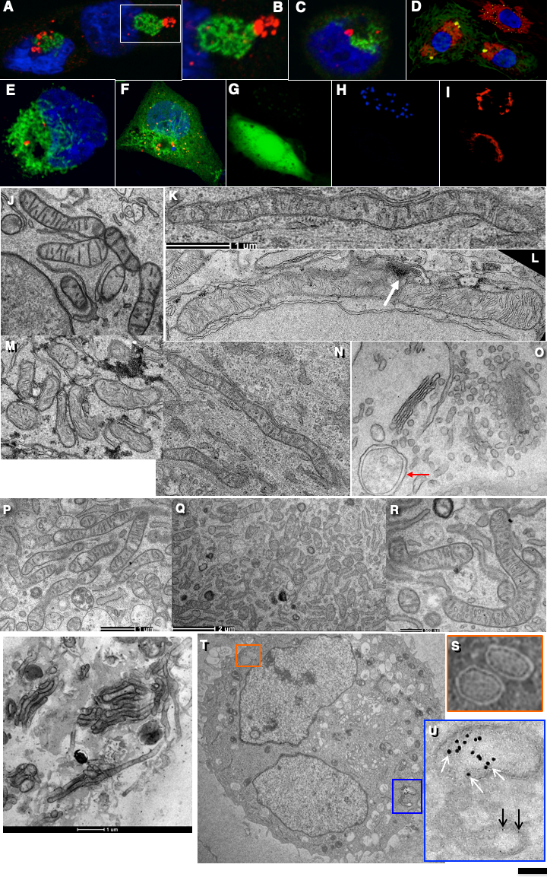
Figure S2. Mitochondria after different conditions of starvation.
(A-D) HEK cells were transiently transfected with HA-Mf2K109T and then (A) not starved or (C) subjected to starvation. (A-C) Mitochondria (green), LC3 (red). Nuclei (blue). (A, B) In the cells transfected with HA-Mfn2K109T, blockage of mitochondria fusion led to aggregation and uncompleted fusion of mitochondria. (B) Enlargement of the area within the white box in (A). (C) LC3-positive dots were visible within mitochondria aggregate. (D) In cells transfected with HA-Mf2K109T (green background) no accumulation of LC3-positive spots (yellow) was observed whereas in non-transfected cells (the third, most right cell) these spots became more numerous. Mitochondria (red). Nuclei (blue). (E, F) HEK cells were transiently transfected with YFP-MITO-cb5TM and then (E) not starved or (F) subjected to starvation. Starvation (F) increased co-localization of YFP-MITO-cb5TM (green) with p62 (red) at p62-positive dots. (G-I) In cells microinjected with the inhibitory antibodies against Mfn1 and Mfn2 to block mitochondrial fusion (green cell in G), the formation of starvation-induced p62-positive spots (blue in H) was prevented (note blue p62-positive dots only in the cell not injected with inhibitory antibodies). (I) The GC is labelled with anti-mannosidase II antibody (red) in both cells. Mock injection had no effect (not shown). (J, M) Attachment of mitochondria with each other in cells transfected with HA-Mf2K109T. (K, L, N) Very long mitochondria are visible. (O) The cell treated with net and subjected to starvation. IAV and COPI-dependent vesicles are visible. (R-T) Effect of inhibitors of mitochondria fusion (Q) and fission (R1, R2). (P) Control. (S-U) The heterokaryon assay. (S) Enlargement of the red box area in (T), showing two IAVs. (T) Cell with two nuclei and gold particles of different sizes in the endosome (blue box). . (U) Enlargement of the blue box area in (T). Scale bars: 5 μm (A-I); 300 nm (J, K, L, R); 450 nm (M, N, Q); 150 nm (O); 600 nm (Q); 1 µm (T).
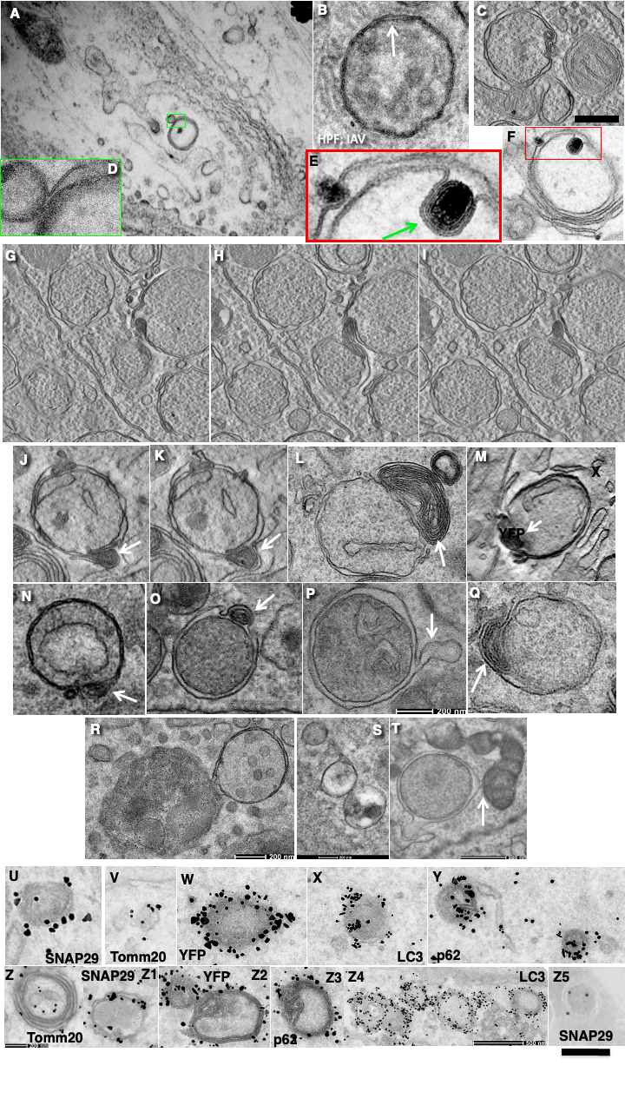
Figure S3. IAVs and their connections. Additional examples of IAVs formed in the SNAP29 KD cells after starvation.
(A, B) IAV after high pressure freezing shows very tight attachment of its membranes to each other. (B) After chemical fixation the above-mentioned effect is less evident. (C, T) IAV connected with mitochondrion. (E, F) IAV with MLO inside (green arrow). (E) Enlargement of the red box over the (F) image. (G-I) Serial EM tomo-slices of two IAVs connected through MLO. (J, K) Serial EM tomo-images of IAV containing MLO. (L-O, Q) Examples of IAVs containing MLOs. (P) IAV with protrusion of its outer membrane. (R) IAV connected with lysosome. (S) IAVs connected through a thin tubule. (U-Z5) IAVs labelled for LC3, p62, SNAP29, Tomm20 and YFP (in HEK cells that were transiently transfected with YFP-MITO-cb5TM and then subjected to starvation). Markers are indicated on images. Scale bars: 300 nm (A, S); 100 nm (B, C, J-Q, R, T-Z5); 150 nm (G-I, R, T).
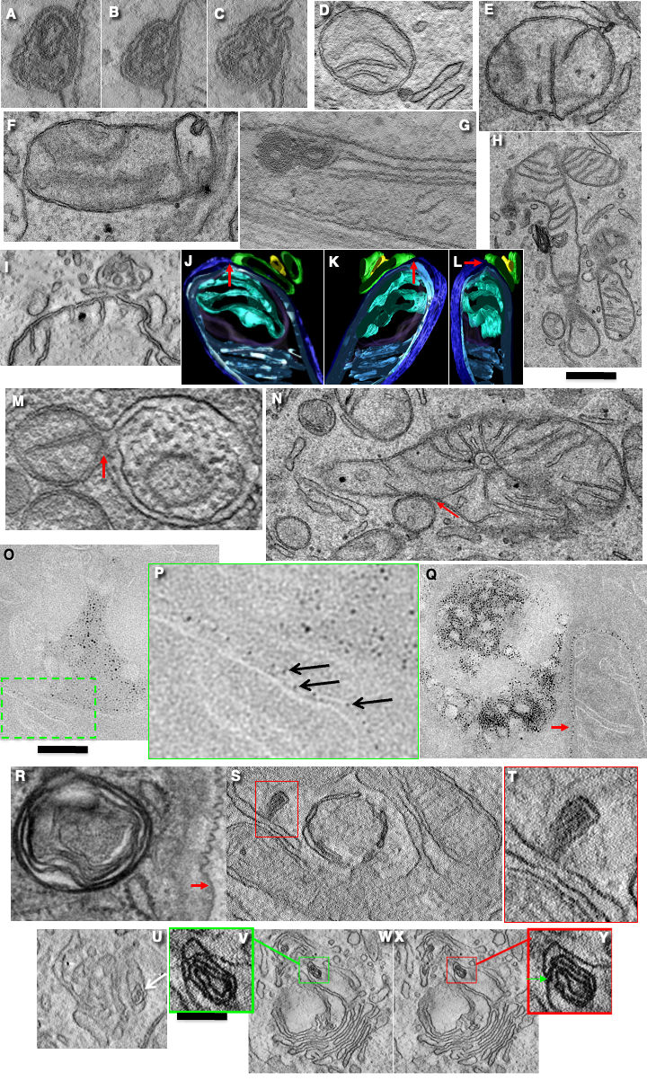
Figure S4. Mitochondria connected with MLOs.
Boxes over original images are shown as their enlargements in the boxes with corresponded colours. (A-C) Serial images of MLO presented in Figure 3A-F. (D-L) MLOs connected with OMMs of the mitochondria. (M. N) Mitochondria connected with IAVs (red arrows). (O-Q) Examples of OMMs (arrows) containing increased concentration of gold NPs. (R) Membrane of MLO is not affected with filipin. In contrast, basolateral PM (red arrow) contains characteristic curved domains. (S) MLO (in red box) connected with ER. (T) Enlargement of red box in (S). (U) MLO inside the lumen of ER exit site (white arrow). (V-Y). MLO inside the lumen of Golgi cisterna distension. Serial tomo-slices. Green (V) and red (Y) boxes show enlargement of corresponding boxes in (W) and (X). In (Y) MLO membrane is connected with the membrane of Golgi cisterna. Scale bars: 250 nm (H); 170 nm (D-F, G, J-L, M, Q); 220 nm (N); 120 nm (O); 260 (R); 40 nm (U); 500 nm (W, X).
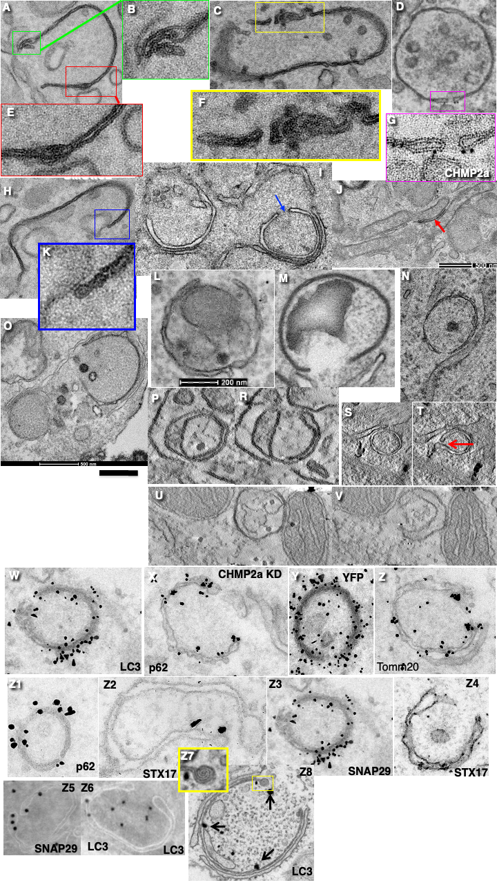
Figure S5. Features of phagophores in starved cells.
(A-C, E-F, H, K) In SNAP29 KD cells subjected to starvation, most of phagophores contain MLO within their ends. Phagophores were rarely visible in starved cells. (D, G) Labelling for CHMP2A. (I, N) In starved cells lacking CHMP2A, phagophores were often attached to ER. (J) Phagophore (red arrow) attached to OMM. (L-O) Immature phagophores surrounding different organelles. (P, R; S, T and U, V) Examples of the three-dimensional reconstructions when initially the structures appeared as IAV. However, examination of serial images revealed openings. Immune EM labelling of phagophores for different markers in cells lacking CHMP2a and subjected to starvation. Phagophores are positive for LC3 (W, Z6-Z8), p62 (X, Z1), YFP (Y) (only in cells transfected with YFP-MITOcb5TM), Tomm20 (Z), STX17 (Z2, Z4), SNAP29 (Z3, Z5). Z7 is an enlargement of yellow boxed area in Z8. Scale bars: 260 nm (A-D, F, H, I, N, O); 500 nm (J, S, T); 200 nm (L, M, P, R, U, V); 300 nm (W-Z8).
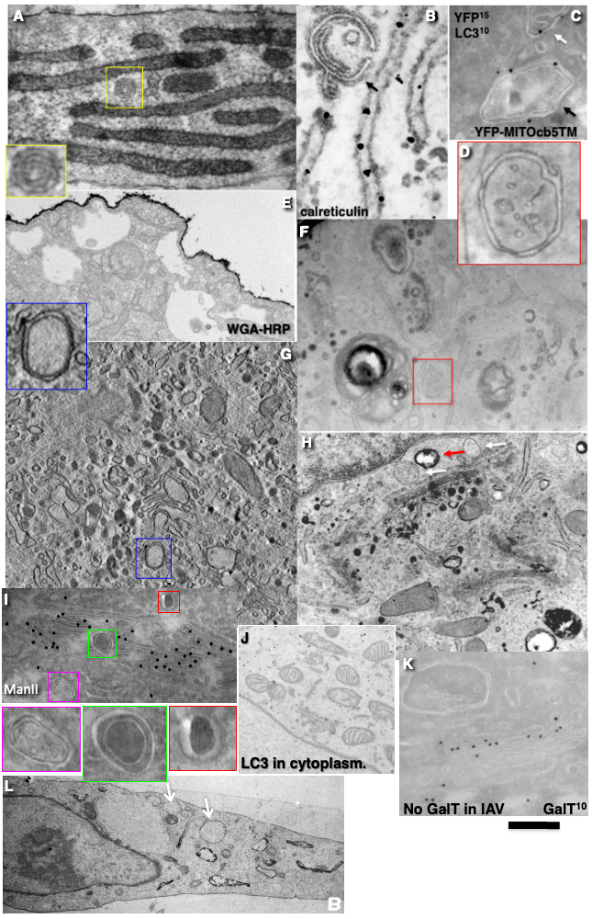
Figure S6. Markers of main cell organelles do not label IAVs, phagophores and MLOs.
(A, B) MLO (yellow box) does not contain Sec61 (A) and calreticulin (B). (C) In starved cells transfected with YFP-MITOcb5TM but lacking membrane fusion, IAV (black arrow) is labelled for YFP (15 nm gold) and LC3 (10 nm gold). White arrow shows mitochondrion. The cryosection with double labelling (see indication over the image. (D) Enlargement of the area inside the red box inside (F). (E-H) Markers of the endocytosis system are depleted in IAVs and MLOs. (E) Labelling of the PM after incubation of WGA on ice. (F-H) Labelling of endosomal structures with WGA. IAVs (red and blue boxes) do not contain WGA. (I) IAVs are negative for ManII (GC marker). Coloured boxes below are enlargements of the corresponding coluored boxes over (I). (J) Labelling for LC3 in cell not subjected to starvation. (K) IAV is negative for Galactosyl transferase (the GC marker). (L) IAVs (white arrows) are negative for WGA-HRP. Exclusion of GC, ER and endosome markers from membrane of phagophores (L). Scale bars: 160 nm (A-D); 320 nm (E-I, K); 500 nm (J); 2 µm (L).

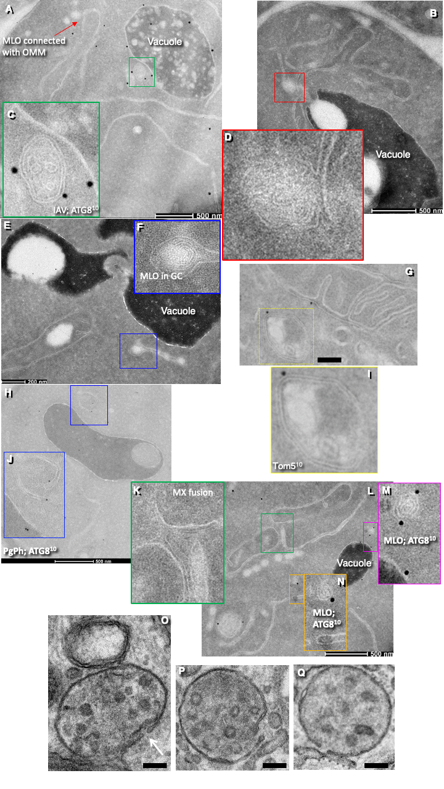
Figure S7. Autophagic structures in S. cerevisiae after nitrogen starvation.
Coloured boxes over images are enlarged in the boxes with the same colours. They are situated nearby. (A, C) IAV positive for ATG8. (B, D) Starvation induced fusion of mitochondria and formation of MLO connected with OMM. (E, F) MLO inside the lumen of GC (in order to be sure that this structure is the GC see images of GC in our paper ¹³³. (G, I) IAV (yellow box) positive for Tom5. (H, J) Phagophore positive for ATG8. (K-N) MLOs positive for ATG8. (O-Q) Examples of phagophores formed during cytokinesis to eliminate COPI-dependent 52-nm vesicles. Scale bars: 500 nm (A, B, H, K); 200 nm (E, G); 100 nm (O-Q).

References
1. Klionsky, D.J. et al. Guidelines for the use and interpretation of assays for monitoring autophagy (4th edition)(1). Autophagy 17, 1-382 (2021).
2. Zaffagnini, G. et al. Mouse oocytes sequester aggregated proteins in degradative super-organelles. Cell 187, 1109-1126.e1121 (2024).
3. Yang, Y., Zheng, L., Zheng, X. & Ge, L. Autophagosomal Membrane Origin and Formation. Adv Exp Med Biol 1208, 17-42 (2021).
4. Axe, E.L. et al. Autophagosome formation from membrane compartments enriched in phosphatidylinositol 3-phosphate and dynamically connected to the endoplasmic reticulum. J Cell Biol 182, 685-701 (2008).
5. Ylä-Anttila, P., Vihinen, H., Jokitalo, E. & Eskelinen, E.L. 3D tomography reveals connections between the phagophore and endoplasmic reticulum. Autophagy 5, 1180-1185 (2009).
6. Ylä-Anttila, P., Vihinen, H., Jokitalo, E. & Eskelinen, E.L. Monitoring autophagy by electron microscopy in Mammalian cells. Methods Enzymol 452, 143-164 (2009).
7. Hayashi-Nishino, M. et al. A subdomain of the endoplasmic reticulum forms a cradle for autophagosome formation. Nat Cell Biol 11, 1433-1437 (2009).
8. Itakura, E. & Mizushima, N. Characterization of autophagosome formation site by a hierarchical analysis of mammalian Atg proteins. Autophagy 6, 764-776 (2010).
9. Tooze, S.A. & Yoshimori, T. The origin of the autophagosomal membrane. Nat Cell Biol 12, 831-835 (2010).
10. Itakura, E., Kishi-Itakura, C. & Mizushima, N. The hairpin-type tail-anchored SNARE syntaxin 17 targets to autophagosomes for fusion with endosomes/lysosomes. Cell 151, 1256-1269 (2012).
11. Takahashi, R., Miller, J. & Klionsky, D.J. SNARE Dance: a musical interpretation of Atg9 transport to the tubulovesicular cluster. Autophagy 8, 294-296 (2012).
12. Ge, L., Melville, D., Zhang, M. & Schekman, R. The ER-Golgi intermediate compartment is a key membrane source for the LC3 lipidation step of autophagosome biogenesis. Elife 2, e00947 (2013).
13. Ge, L., Zhang, M. & Schekman, R. Phosphatidylinositol 3-kinase and COPII generate LC3 lipidation vesicles from the ER-Golgi intermediate compartment. Elife 3, e04135 (2014).
14. Uemura, T. et al. A cluster of thin tubular structures mediates transformation of the endoplasmic reticulum to autophagic isolation membrane. Mol Cell Biol 34, 1695-1706 (2014).
15. Guo, B. et al. O-GlcNAc-modification of SNAP-29 regulates autophagosome maturation. Nat Cell Biol 16, 1215-1226 (2014).
16. Biazik, J., Ylä-Anttila, P., Vihinen, H., Jokitalo, E. & Eskelinen, E.L. Ultrastructural relationship of the phagophore with surrounding organelles. Autophagy 11, 439-451 (2015).
17. Uematsu, M., Nishimura, T., Sakamaki, Y., Yamamoto, H. & Mizushima, N. Accumulation of undegraded autophagosomes by expression of dominant-negative STX17 (syntaxin 17) mutants. Autophagy 13, 1452-1464 (2017).
18. Hara, T. et al. FIP200, a ULK-interacting protein, is required for autophagosome formation in mammalian cells. J Cell Biol 181, 497-510 (2008).
19. Mizushima, N., Yoshimori, T. & Levine, B. Methods in mammalian autophagy research. Cell 140, 313-326 (2010).
20. Kumar, S. et al. Mammalian hybrid pre-autophagosomal structure HyPAS generates autophagosomes. Cell 184, 5950-5969.e5922 (2021).
21. Bhattacharya, A. et al. A lysosome membrane regeneration pathway depends on TBC1D15 and autophagic lysosomal reformation proteins. Nat Cell Biol 25, 685-698 (2023).
22. van der Vaart, A. & Reggiori, F. The Golgi complex as a source for yeast autophagosomal membranes. Autophagy 6, 800-801 (2010).
23. van der Vaart, A., Griffith, J. & Reggiori, F. Exit from the Golgi is required for the expansion of the autophagosomal phagophore in yeast Saccharomyces cerevisiae. Mol Biol Cell 21, 2270-2284 (2010).
24. Guo, Y. et al. AP1 is essential for generation of autophagosomes from the trans-Golgi network. J Cell Sci 125, 1706-1715 (2012).
25. Ravikumar, B., Moreau, K. & Rubinsztein, D.C. Plasma membrane helps autophagosomes grow. Autophagy 6, 1184-1186 (2010).
26. Ravikumar, B., Moreau, K., Jahreiss, L., Puri, C. & Rubinsztein, D.C. Plasma membrane contributes to the formation of pre-autophagosomal structures. Nat Cell Biol 12, 747-757 (2010).
27. Longatti, A. & Tooze, S.A. Recycling endosomes contribute to autophagosome formation. Autophagy 8, 1682-1683 (2012).
28. Kondylis, V. et al. Endosome-mediated autophagy: an unconventional MIIC-driven autophagic pathway operational in dendritic cells. Autophagy 9, 861-880 (2013).
29. Moreau, K., Renna, M. & Rubinsztein, D.C. Connections between SNAREs and autophagy. Trends Biochem Sci 38, 57-63 (2013).
30. Hailey, D.W. et al. Mitochondria supply membranes for autophagosome biogenesis during starvation. Cell 141, 656-667 (2010).
31. Cook, K.L. et al. Mitochondria directly donate their membrane to form autophagosomes during a novel mechanism of parkin-associated mitophagy. Cell & bioscience 4, 16 (2014).
32. Mironov, A.A., Beznoussenko, G.V., Morelli, E. & Vaccari, T. Early autophagosomes are formed from myelin-like structures derived from outer membranes of mitochondria. Ultrastructural Pathology 41, 73-74 (2017).
33. Mironov, A.A., Mironov, A., Derganc, J. & Beznoussenko, G.V. Membrane Curvature, Trans-Membrane Area Asymmetry, Budding, Fission and Organelle Geometry. Int J Mol Sci 21 (2020).
34. Aguilera-Gomez, A. et al. Phospho-Rasputin Stabilization by Sec16 Is Required for Stress Granule Formation upon Amino Acid Starvation. Cell Rep 20, 2277 (2017).
35. Davis, S., Wang, J. & Ferro-Novick, S. Crosstalk between the Secretory and Autophagy Pathways Regulates Autophagosome Formation. Dev Cell 41, 23-32 (2017).
36. Davis, S. et al. Sec24 phosphorylation regulates autophagosome abundance during nutrient deprivation. Elife 5 (2016).
37. Zoppino, F.C., Militello, R.D., Slavin, I., Alvarez, C. & Colombo, M.I. Autophagosome formation depends on the small GTPase Rab1 and functional ER exit sites. Traffic 11, 1246-1261 (2010).
38. Ishihara, N. et al. Autophagosome requires specific early Sec proteins for its formation and NSF/SNARE for vacuolar fusion. Mol Biol Cell 12, 3690-3702 (2001).
39. Deretic, V., Jiang, S. & Dupont, N. Autophagy intersections with conventional and unconventional secretion in tissue development, remodeling and inflammation. Trends Cell Biol 22, 397-406 (2012).
40. Shima, T., Kirisako, H. & Nakatogawa, H. COPII vesicles contribute to autophagosomal membranes. J Cell Biol 218, 1503-1510 (2019).
41. Li, B., Zeng, Y. & Jiang, L. COPII vesicles in plant autophagy and endomembrane trafficking. FEBS Lett 596, 2314-2323 (2022).
42. Li, S. et al. A new type of ERGIC-ERES membrane contact mediated by TMED9 and SEC12 is required for autophagosome biogenesis. Cell Res 32, 119-138 (2022).
43. Mironov, A.A., Jr. & Mironov, A.A. Estimation of subcellular organelle volume from ultrathin sections through centrioles with a discretized version of the vertical rotator. J Microsc 192, 29-36 (1998).
44. Mironov, A.A. & Beznoussenko, G.V. Molecular mechanisms responsible for formation of Golgi ribbon. Histol Histopathol 26, 117-133 (2011).
45. Eura, Y., Ishihara, N., Yokota, S. & Mihara, K. Two mitofusin proteins, mammalian homologues of FZO, with distinct functions are both required for mitochondrial fusion. J Biochem 134, 333-344 (2003).
46. Sawa-Makarska, J. et al. Reconstitution of autophagosome nucleation defines Atg9 vesicles as seeds for membrane formation. Science 369 (2020).
47. Rambold, A.S., Cohen, S. & Lippincott-Schwartz, J. Fatty acid trafficking in starved cells: regulation by lipid droplet lipolysis, autophagy, and mitochondrial fusion dynamics. Dev Cell 32, 678-692 (2015).
48. Drizyte-Miller, K., Schott, M.B. & McNiven, M.A. Lipid Droplet Contacts With Autophagosomes, Lysosomes, and Other Degradative Vesicles. Contact (Thousand Oaks) 3, 1-13 (2020).
49. Jahn, R., Cafiso, D.C. & Tamm, L.K. Mechanisms of SNARE proteins in membrane fusion. Nat Rev Mol Cell Biol 25, 101-118 (2024).
50. Kweon, H.S. et al. Golgi enzymes are enriched in perforated zones of golgi cisternae but are depleted in COPI vesicles. Mol Biol Cell 15, 4710-4724 (2004).
51. Cutrona, M.B. et al. Silencing of mammalian Sar1 isoforms reveals COPII-independent protein sorting and transport. Traffic 14, 691-708 (2013).
52. Denisova, G.N. et al. Overloading of differentiated Caco-2 cells during lipid transcytosis induces glycosylation mistakes in the Golgi complex. Biocell 45, 773-783 (2021).
53. Sou, Y.S. et al. The Atg8 conjugation system is indispensable for proper development of autophagic isolation membranes in mice. Mol Biol Cell 19, 4762-4775 (2008).
54. Kishi-Itakura, C., Koyama-Honda, I., Itakura, E. & Mizushima, N. Ultrastructural analysis of autophagosome organization using mammalian autophagy-deficient cells. J Cell Sci 127, 4089-4102 (2014).
55. Runwal, G. et al. LC3-positive structures are prominent in autophagy-deficient cells. Sci Rep 9, 10147 (2019).
56. Beznoussenko, G.V., Kweon, H.S., Sesorova, I.S. & Mironov, A.A. Comparison of the Cisterna Maturation-Progression Model with the Kiss-and-Run Model of Intra-Golgi Transport: Role of Cisternal Pores and Cargo Domains. Int J Mol Sci 23 (2022).
57. Zhou, F. et al. Rab5-dependent autophagosome closure by ESCRT. J Cell Biol 218, 1908-1927 (2019).
58. Puri, C., Gratian, M.J. & Rubinsztein, D.C. Mammalian autophagosomes form from finger-like phagophores. Dev Cell 58, 2746-2760.e2745 (2023).
59. Takahashi, Y. et al. An autophagy assay reveals the ESCRT-III component CHMP2A as a regulator of phagophore closure. Nat Commun 9, 2855 (2018).
60. Zhen, Y. et al. ESCRT-mediated phagophore sealing during mitophagy. Autophagy 16, 826-841 (2020).
61. Cai, H., Chen, L., Zhang, M., Xiang, W. & Su, P. Low expression of MFN2 is associated with early unexplained miscarriage by regulating autophagy of trophoblast cells. Placenta 70, 34-40 (2018).
62. Zhou, F., Wang, Y., Tan, Y., Wu, C. & Chen, Y. HMGB1 regulates lipopolysaccharide-induced cellular dysfunction in HTR8/SVneo cells: Implications for the role of HMGB1 in unexplained spontaneous miscarriage. Placenta 112, 16-22 (2021).
63. Sanavio, B. et al. Distribution of superparamagnetic Au/Fe nanoparticles in an isolated guinea pig brain with an intact blood brain barrier. Nanoscale 10, 22420-22428 (2018).
64. Verma, A. et al. Surface-structure-regulated cell-membrane penetration by monolayer-protected nanoparticles. Nat Mater 7, 588-595 (2008).
65. Carney, R.P. et al. Electrical method to quantify nanoparticle interaction with lipid bilayers. ACS Nano 7, 932-942 (2013).
66. Van Lehn, R.C. et al. Effect of particle diameter and surface composition on the spontaneous fusion of monolayer-protected gold nanoparticles with lipid bilayers. Nano Lett 13, 4060-4067 (2013).
67. Yang, Y.S., Carney, R.P., Stellacci, F. & Irvine, D.J. Enhancing radiotherapy by lipid nanocapsule-mediated delivery of amphiphilic gold nanoparticles to intracellular membranes. ACS Nano 8, 8992-9002 (2014).
68. Elias, P.M., Friend, D.S. & Goerke, J. Membrane sterol heterogeneity. Freeze-fracture detection with saponins and filipin. J Histochem Cytochem 27, 1247-1260 (1979).
69. Friend, D.S. & Bearer, E.L. beta-Hydroxysterol distribution as determined by freeze-fracture cytochemistry. Histochem J 13, 535-546 (1981).
70. Bieber, A. et al. In situ structural analysis reveals membrane shape transitions during autophagosome formation. Proc Natl Acad Sci U S A 119, e2209823119 (2022).
71. Yaffe, M.P. The machinery of mitochondrial inheritance and behavior. Science 283, 1493-1497 (1999).
72. Mishra, P. & Chan, D.C. Mitochondrial dynamics and inheritance during cell division, development and disease. Nat Rev Mol Cell Biol 15, 634-646 (2014).
73. Horbay, R. & Bilyy, R. Mitochondrial dynamics during cell cycling. Apoptosis 21, 1327-1335 (2016).
74. Hughes, L., Borrett, S., Towers, K., Starborg, T. & Vaughan, S. Patterns of organelle ontogeny through a cell cycle revealed by whole-cell reconstructions using 3D electron microscopy. J Cell Sci 130, 637-647 (2017).
75. Schmitt, K. et al. Circadian Control of DRP1 Activity Regulates Mitochondrial Dynamics and Bioenergetics. Cell Metab 27, 657-666.e655 (2018).
76. Carlton, J.G., Jones, H. & Eggert, U.S. Membrane and organelle dynamics during cell division. Nat Rev Mol Cell Biol 21, 151-166 (2020).
77. Wu, Y. et al. Contacts between the endoplasmic reticulum and other membranes in neurons. Proc Natl Acad Sci U S A 114, E4859-e4867 (2017).
78. Steegmaier, M. et al. Three novel proteins of the syntaxin/SNAP-25 family. J Biol Chem 273, 34171-34179 (1998).
79. Capitanio, C., Bieber, A. & Wilfling, F. How Membrane Contact Sites Shape the Phagophore. Contact (Thousand Oaks) 6, 25152564231162495 (2023).
80. Marion, J., Le Bars, R., Besse, L., Batoko, H. & Satiat-Jeunemaitre, B. Multiscale and Multimodal Approaches to Study Autophagy in Model Plants. Cells 7 (2018).
81. Stolinski, C. A freeze-fracture replication apparatus for biological specimens. J Microsc 104, 235-244 (1975).
82. Réz, G. & Meldolesi, J. Freeze-fracture of drug-induced autophagocytosis in the mouse exocrine pancreas. Lab Invest 43, 269-277 (1980).
83. Hirsimäki, Y., Hirsimäki, P. & Lounatmaa, K. Vinblastine-induced autophagic vacuoles in mouse liver and Ehrlich ascites tumor cells as assessed by freeze-fracture electron microscopy. Eur J Cell Biol 27, 298-301 (1982).
84. Severs, N.J. & Robenek, H. Detection of microdomains in biomembranes. An appraisal of recent developments in freeze-fracture cytochemistry. Biochim Biophys Acta 737, 373-408 (1983).
85. Unger, A.K., Geimer, S., Harner, M., Neupert, W. & Westermann, B. Analysis of Yeast Mitochondria by Electron Microscopy. Methods Mol Biol 1567, 293-314 (2017).
86. Griffith, J., Mari, M., De Mazière, A. & Reggiori, F. A cryosectioning procedure for the ultrastructural analysis and the immunogold labelling of yeast Saccharomyces cerevisiae. Traffic 9, 1060-1072 (2008).
87. Quinn, P., Griffiths, G. & Warren, G. Density of newly synthesized plasma membrane proteins in intracellular membranes II. Biochemical studies. J Cell Biol 98, 2142-2147 (1984).
88. Joshi, A.S., Zhang, H. & Prinz, W.A. Organelle biogenesis in the endoplasmic reticulum. Nat Cell Biol 19, 876-882 (2017).
89. Nähse, V., Stenmark, H. & Schink, K.O. Omegasomes control formation, expansion, and closure of autophagosomes. Bioessays 46, e2400038 (2024).
90. Arstila, A.U. & Trump, B.F. Studies on cellular autophagocytosis. The formation of autophagic vacuoles in the liver after glucagon administration. Am J Pathol 53, 687-733 (1968).
91. Gubas, A. & Dikic, I. ER remodeling via ER-phagy. Mol Cell 82, 1492-1500 (2022).
92. Mochida, K. & Nakatogawa, H. ER-phagy: selective autophagy of the endoplasmic reticulum. EMBO Rep 23, e55192 (2022).
93. Chino, H. & Mizushima, N. ER-Phagy: Quality and Quantity Control of the Endoplasmic Reticulum by Autophagy. Cold Spring Harbor perspectives in biology 15 (2023).
94. Knupp, J., Pletan, M.L., Arvan, P. & Tsai, B. Autophagy of the ER: the secretome finds the lysosome. The FEBS journal 290, 5656-5673 (2023).
95. Zacharogianni, M., Aguilera-Gomez, A., Veenendaal, T., Smout, J. & Rabouille, C. A stress assembly that confers cell viability by preserving ERES components during amino-acid starvation. Elife 3 (2014).
96. Kasberg, W., Luong, P., Swift, K. & Audhya, A. Nutrient deprivation alters the rate of COPII coat assembly to tune secretory protein transport. Research square (2023).
97. Mironov, A.A., Savin, M.A. & Beznoussenko, G.V. COVID-19 Biogenesis and Intracellular Transport. Int J Mol Sci 24 (2023).
98. Zhang, C. et al. Activation of IRE1, PERK and salt-inducible kinases leads to Sec body formation in Drosophila S2 cells. J Cell Sci 134 (2021).
99. Suzuki, K., Akioka, M., Kondo-Kakuta, C., Yamamoto, H. & Ohsumi, Y. Fine mapping of autophagy-related proteins during autophagosome formation in Saccharomyces cerevisiae. J Cell Sci 126, 2534-2544 (2013).
100. Graef, M., Friedman, J.R., Graham, C., Babu, M. & Nunnari, J. ER exit sites are physical and functional core autophagosome biogenesis components. Mol Biol Cell 24, 2918-2931 (2013).
101. Yang, J.S. et al. GAPDH inhibits intracellular pathways during starvation for cellular energy homeostasis. Nature 561, 263-267 (2018).
102. Schütter, M., Giavalisco, P., Brodesser, S. & Graef, M. Local Fatty Acid Channeling into Phospholipid Synthesis Drives Phagophore Expansion during Autophagy. Cell 180, 135-149.e114 (2020).
103. Chang, C., Jensen, L.E. & Hurley, J.H. Autophagosome biogenesis comes out of the black box. Nat Cell Biol 23, 450-456 (2021).
104. Kotani, T. et al. A mechanism that ensures non-selective cytoplasm degradation by autophagy. Nat Commun 14, 5815 (2023).
105. Hodson, L. & Frayn, K.N. Hepatic fatty acid partitioning. Curr Opin Lipidol 22, 216-224 (2011).
106. Brandes, D. & Anton, E. Lysosomes in uterine involution: intracytoplasmic degradation of myofilaments and collagen. Journal of gerontology 24, 55-69 (1969).
107. Henell, F., Ericsson, J.L. & Glaumann, H. An electron microscopic study of the post-partum involution of the rat uterus. With a note on apparent crinophagy of collagen. Virchows Arch B Cell Pathol Incl Mol Pathol 42, 271-287 (1983).
108. Inouye, S., Iyama, K., Araki, C. & Usuku, G. Phagocytosis of cytoplasmic blebs derived from smooth muscle cells by fibroblast-like cells and macrophages in the post-partum rat uterus. Virchows Arch B Cell Pathol Incl Mol Pathol 42, 235-242 (1983).
109. Orfanou, D.C. et al. Post-partum involution of the canine uterus - gross anatomical and histological features. Reproduction in domestic animals = Zuchthygiene 44 Suppl 2, 152-155 (2009).
110. Hsu, K.F. et al. Enhanced myometrial autophagy in postpartum uterine involution. Taiwanese journal of obstetrics & gynecology 53, 293-302 (2014).
111. Wang, X. et al. Hypoxia-induced autophagy inhibits myometrial proliferation in pregnant mice via the mTOR pathway in vitro. Reproduction 168 (2024).
112. Kuma, A. & Mizushima, N. Chromosomal mapping of the GFP-LC3 transgene in GFP-LC3 mice. Autophagy 4, 61-62 (2008).
113. Feng, W. et al. Dissection of autophagy in human platelets. Autophagy 10, 642-651 (2014).
114. Pieczarka, E.M., Yamaguchi, M., Wellman, M.L. & Judith Radin, M. Platelet vacuoles in a dog with severe nonregenerative anemia: evidence of platelet autophagy. Vet Clin Pathol 43, 326-329 (2014).
115. Zhang, Z., Singh, R. & Aschner, M. Methods for the Detection of Autophagy in Mammalian Cells. Current protocols in toxicology 69, 20.12.21-20.12.26 (2016).
116. Melchinger, H., Jain, K., Tyagi, T. & Hwa, J. Role of Platelet Mitochondria: Life in a Nucleus-Free Zone. Front Cardiovasc Med 6, 153 (2019).
117. Rizzuto, R., Brini, M., Pizzo, P., Murgia, M. & Pozzan, T. Chimeric green fluorescent protein as a tool for visualizing subcellular organelles in living cells. Curr Biol 5, 635-642 (1995).
118. Barnard, R.J., Morgan, A. & Burgoyne, R.D. Domains of alpha-SNAP required for the stimulation of exocytosis and for N-ethylmalemide-sensitive fusion protein (NSF) binding and activation. Mol Biol Cell 7, 693-701 (1996).
119. Kremer, J.R., Mastronarde, D.N. & McIntosh, J.R. Computer visualization of three-dimensional image data using IMOD. Journal of structural biology 116, 71-76 (1996).
120. Milesi, C. et al. Redundant and nonredundant organismal functions of EPS15 and EPS15L1. Life Sci Alliance 2 (2019).
121. Beznoussenko, G.V. et al. Transport of soluble proteins through the Golgi occurs by diffusion via continuities across cisternae. Elife 3 (2014).
122. Beznoussenko, G.V., Ragnini-Wilson, A., Wilson, C. & Mironov, A.A. Three-dimensional and immune electron microscopic analysis of the secretory pathway in Saccharomyces cerevisiae. Histochem Cell Biol 146, 515-527 (2016).
123. Iacovella, M.G. et al. Integrating Rio1 activities discloses its nutrient-activated network in Saccharomyces cerevisiae. Nucleic Acids Res 46, 7586-7611 (2018).
124. Sherman, F. Getting started with yeast. Methods Enzymol 194, 3-21 (1991).
125. Krämer, A. et al. Small molecules intercept Notch signaling and the early secretory pathway. Nature chemical biology 9, 731-738 (2013).
126. Subramanian, A. et al. Auto-regulation of Secretory Flux by Sensing and Responding to the Folded Cargo Protein Load in the Endoplasmic Reticulum. Cell 176, 1461-1476.e1423 (2019).
127. Aridor, M. & Balch, W.E. Kinase signaling initiates coat complex II (COPII) recruitment and export from the mammalian endoplasmic reticulum. J Biol Chem 275, 35673-35676 (2000).
128. Lee, T.H. & Linstedt, A.D. Potential role for protein kinases in regulation of bidirectional endoplasmic reticulum-to-Golgi transport revealed by protein kinase inhibitor H89. Mol Biol Cell 11, 2577-2590 (2000).
129. Omari, S. et al. Mechanisms of procollagen and HSP47 sorting during ER-to-Golgi trafficking. Matrix biology : journal of the International Society for Matrix Biology 93, 79-94 (2020).
130. Omari, S. et al. Noncanonical autophagy at ER exit sites regulates procollagen turnover. Proc Natl Acad Sci U S A 115, E10099-e10108 (2018).
131. Antonny, B., Madden, D., Hamamoto, S., Orci, L. & Schekman, R. Dynamics of the COPII coat with GTP and stable analogues. Nat Cell Biol 3, 531-537 (2001).
132. Zacharioudakis, E. et al. Modulating mitofusins to control mitochondrial function and signaling. Nat Commun 13, 3775 (2022).
133. Petiot, A., Ogier-Denis, E., Blommaart, E.F., Meijer, A.J. & Codogno, P. Distinct classes of phosphatidylinositol 3'-kinases are involved in signaling pathways that control macroautophagy in HT-29 cells. J Biol Chem 275, 992-998 (2000).
134. Kridel, S.J., Axelrod, F., Rozenkrantz, N. & Smith, J.W. Orlistat is a novel inhibitor of fatty acid synthase with antitumor activity. Cancer Res 64, 2070-2075 (2004).
135. Korenić, A., Andjus, P., Radenović, L. & Spasojević, I. The role of autophagy and lipolysis in survival of astrocytes under nutrient deprivation. Neurosci Lett 595, 128-133 (2015).
136. Ross, M.G., Kobayashi, K., Han, G. & Desai, M. Modulation of Milk and Lipid Synthesis and Secretion in a3-Dimensional Mouse Mammary Epithelial Cell Culture Model: Effects of Palmitate and Orlistat. Nutrients 14 (2022).
137. Alfhili, M.A. & Lee, M.H. Triclosan: An Update on Biochemical and Molecular Mechanisms. Oxid Med Cell Longev 2019, 1607304 (2019).
138. Sun, D., Zhao, T., Long, K., Wu, M. & Zhang, Z. Triclosan down-regulates fatty acid synthase through microRNAs in HepG2 cells. Eur J Pharmacol 907, 174261 (2021).
139. Duarte Lau, F. & Giugliano, R.P. Adenosine Triphosphate Citrate Lyase and Fatty Acid Synthesis Inhibition: A Narrative Review. JAMA Cardiol 8, 879-887 (2023).
140. Velez, B.C. et al. Combined inhibition of ACLY and CDK4/6 reduces cancer cell growth and invasion. Oncol Rep 49 (2023).
141. Schrader, F.C. et al. Novel type II fatty acid biosynthesis (FAS II) inhibitors as multistage antimalarial agents. ChemMedChem 8, 442-461 (2013).
142. Wang, J. et al. Ypt1/Rab1 regulates Hrr25/CK1δ kinase activity in ER-Golgi traffic and macroautophagy. J Cell Biol 210, 273-285 (2015).
143. Cooney, R. et al. NOD2 stimulation induces autophagy in dendritic cells influencing bacterial handling and antigen presentation. Nat Med 16, 90-97 (2010).
144. Kim, C. & Bergelson, J.M. Echovirus 7 entry into polarized caco-2 intestinal epithelial cells involves core components of the autophagy machinery. J Virol 88, 434-443 (2014).
145. Fusella, A., Micaroni, M., Di Giandomenico, D., Mironov, A.A. & Beznoussenko, G.V. Segregation of the Qb-SNAREs GS27 and GS28 into Golgi vesicles regulates intra-Golgi transport. Traffic 14, 568-584 (2013).
146. Guan, G. et al. Mechanism of interactions between endoplasmic reticulum stress and autophagy in hypoxia/reoxygenation‑induced injury of H9c2 cardiomyocytes. Mol Med Rep 20, 350-358 (2019).
147. Maekawa, Y. et al. A tetrazolium-based colorimetric assay for metabolic activity of stored blood platelets. Thrombosis research 109, 307-314 (2003).
148. Meshulam, T., Levitz, S.M., Christin, L. & Diamond, R.D. A simplified new assay for assessment of fungal cell damage with the tetrazolium dye, (2,3)-bis-(2-methoxy-4-nitro-5-sulphenyl)-(2H)-tetrazolium-5-carboxanil ide (XTT). The Journal of infectious diseases 172, 1153-1156 (1995).
149. Stockert, J.C., Horobin, R.W., Colombo, L.L. & Blázquez-Castro, A. Tetrazolium salts and formazan products in Cell Biology: Viability assessment, fluorescence imaging, and labeling perspectives. Acta histochemica 120, 159-167 (2018).
150. Taguchi, N., Ishihara, N., Jofuku, A., Oka, T. & Mihara, K. Mitotic phosphorylation of dynamin-related GTPase Drp1 participates in mitochondrial fission. J Biol Chem 282, 11521-11529 (2007).
151. Mizushima, N. & Yoshimori, T. How to interpret LC3 immunoblotting. Autophagy 3, 542-545 (2007).
152. Morishita, H. & Mizushima, N. Diverse Cellular Roles of Autophagy. Annu Rev Cell Dev Biol 35, 453-475 (2019).
153. Thorne-Tjomsland, G., Clermont, Y. & Tang, X.M. Glucose-6-phosphatase activity of endoplasmic reticulum and Golgi apparatus in spermatocytes and spermatids of the rat: an electron microscopic cytochemical study. Biol Cell 71, 33-41 (1991).
154. Nixon-Abell, J. et al. Increased spatiotemporal resolution reveals highly dynamic dense tubular matrices in the peripheral ER. Science 354 (2016).
155. Joensuu, M. et al. ER sheet persistence is coupled to myosin 1c-regulated dynamic actin filament arrays. Mol Biol Cell 25, 1111-1126 (2014).
156. Thyberg, J. & Moskalewski, S. Subpopulations of microtubules with differential sensitivity to nocodazole: role in the structural organization of the Golgi complex and the lysosomal system. J Submicrosc Cytol Pathol 21, 259-274 (1989).
157. Beznoussenko, G.V. et al. The Diffusion Model of Intra-Golgi Transport Has Limited Power. Int J Mol Sci 24 (2023).
158. Polishchuk, R.S., Polishchuk, E.V. & Mironov, A.A. Coalescence of Golgi fragments in microtubule-deprived living cells. Eur J Cell Biol 78, 170-185 (1999).
159. Sesorova, I.S. et al. Role of Endothelial Regeneration and Overloading of Enterocytes with Lipids in Capturing of Lipoproteins by Basement Membrane of Rat Aortic Endothelium. Biomedicines 10 (2022).
160. Nikonova, M.A., Sesorova, I.S., Dimov, I.D., Karelina, N.R. & Mironov, A.A. Effect of the First Feeding on Enterocytes of Newborn Rats. Int J Mol Sci 23 (2022).
161. Murk, J.L. et al. Influence of aldehyde fixation on the morphology of endosomes and lysosomes: quantitative analysis and electron tomography. J Microsc 212, 81-90 (2003).
162. Kreft, M.E. & Robenek, H. Freeze-fracture replica immunolabelling reveals urothelial plaques in cultured urothelial cells. PLoS One 7, e38509 (2012).
163. Brouns, I. et al. Triple immunofluorescence staining with antibodies raised in the same species to study the complex innervation pattern of intrapulmonary chemoreceptors. J Histochem Cytochem 50, 575-582 (2002).
164. Ropolo, A. et al. The pancreatitis-induced vacuole membrane protein 1 triggers autophagy in mammalian cells. J Biol Chem 282, 37124-37133 (2007).
165. Mironov, A.A. & Beznoussenko, G.V. Algorithm for Modern Electron Microscopic Examination of the Golgi Complex. Methods Mol Biol 2557, 161-209 (2023).
166. Sesorova, I.S. et al. Structure of the enterocyte transcytosis compartments during lipid absorption. Histochem Cell Biol 153, 413-429 (2020).
167. Beznoussenko, G.V. et al. Trans-membrane area asymmetry controls the shape of cellular organelles. Int J Mol Sci 16, 5299-5333 (2015).
168. Beznoussenko, G.V. & Mironov, A.A. Correlative video-light-electron microscopy of mobile organelles. Methods Mol Biol 1270, 321-346 (2015).
169. Kreft, M.E. et al. Golgi apparatus fragmentation as a mechanism responsible for uniform delivery of uroplakins to the apical plasma membrane of uroepithelial cells. Biol Cell 102, 593-607 (2010).
170. Beznoussenko, G.V. et al. Analogs of the Golgi complex in microsporidia: structure and avesicular mechanisms of function. J Cell Sci 120, 1288-1298 (2007).
171. Simon, V.R., Karmon, S.L. & Pon, L.A. Mitochondrial inheritance: cell cycle and actin cable dependence of polarized mitochondrial movements in Saccharomyces cerevisiae. Cell Motil Cytoskeleton 37, 199-210 (1997).
172. Vats, S. & Manjithaya, R. A reversible autophagy inhibitor blocks autophagosome-lysosome fusion by preventing Stx17 loading onto autophagosomes. Mol Biol Cell 30, 2283-2295 (2019).
173. Mironov, A.A., Beznusenko, G.V., Sesorova, I.S. & Banin, V.V. [How to measure structures, or new stereology: III. Stereology and electron microscopy]. Morfologiia 129, 72-75 (2006).
174. Lucocq, J.M. & Gawden-Bone, C. A stereological approach for estimation of cellular immunogold labeling and its spatial distribution in oriented sections using the rotator. J Histochem Cytochem 57, 709-719 (2009).
175. Griffiths, G., Warren, G., Quinn, P., Mathieu-Costello, O. & Hoppeler, H. Density of newly synthesized plasma membrane proteins in intracellular membranes. I. Stereological studies. J Cell Biol 98, 2133-2141 (1984).
176. Bannykh, S.I., Rowe, T. & Balch, W.E. The organization of endoplasmic reticulum export complexes. J Cell Biol 135, 19-35 (1996).
177. Pankiv, S. et al. p62/SQSTM1 binds directly to Atg8/LC3 to facilitate degradation of ubiquitinated protein aggregates by autophagy. J Biol Chem 282, 24131-24145 (2007).
178. Pohl, H., Sirovich, B. & Welch, H.G. Esophageal adenocarcinoma incidence: are we reaching the peak? Cancer Epidemiol Biomarkers Prev 19, 1468-1470 (2010).
179. Klionsky, D.J. et al. Guidelines for the use and interpretation of assays for monitoring autophagy (3rd edition). Autophagy 12, 1-222 (2016).
180. Pollard, D.A., Pollard, T.D. & Pollard, K.S. Empowering statistical methods for cellular and molecular biologists. Mol Biol Cell 30, 1359-1368 (2019).

