Supplementary Information
Table S1. Summary statistics of the Largest Patch Index (LPI) for bare ground derived from drone-based classifications at two different spatial resolutions: Landsat 8 (30-m) and PlanetScope (3-m). The table presents mean, standard deviation (SD), coefficient of variation (CV), and interquartile range (IQR) of LPI values, calculated for May and September in 2019 and 2023.
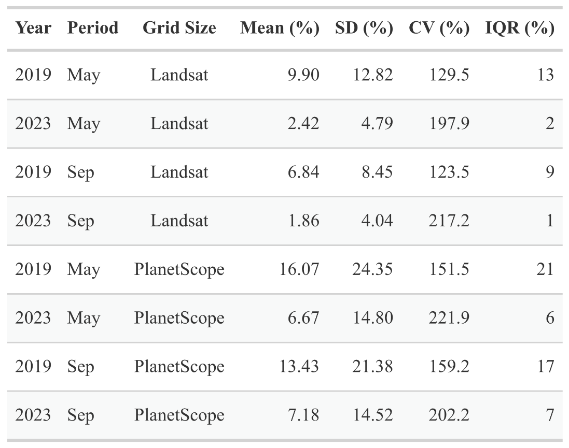

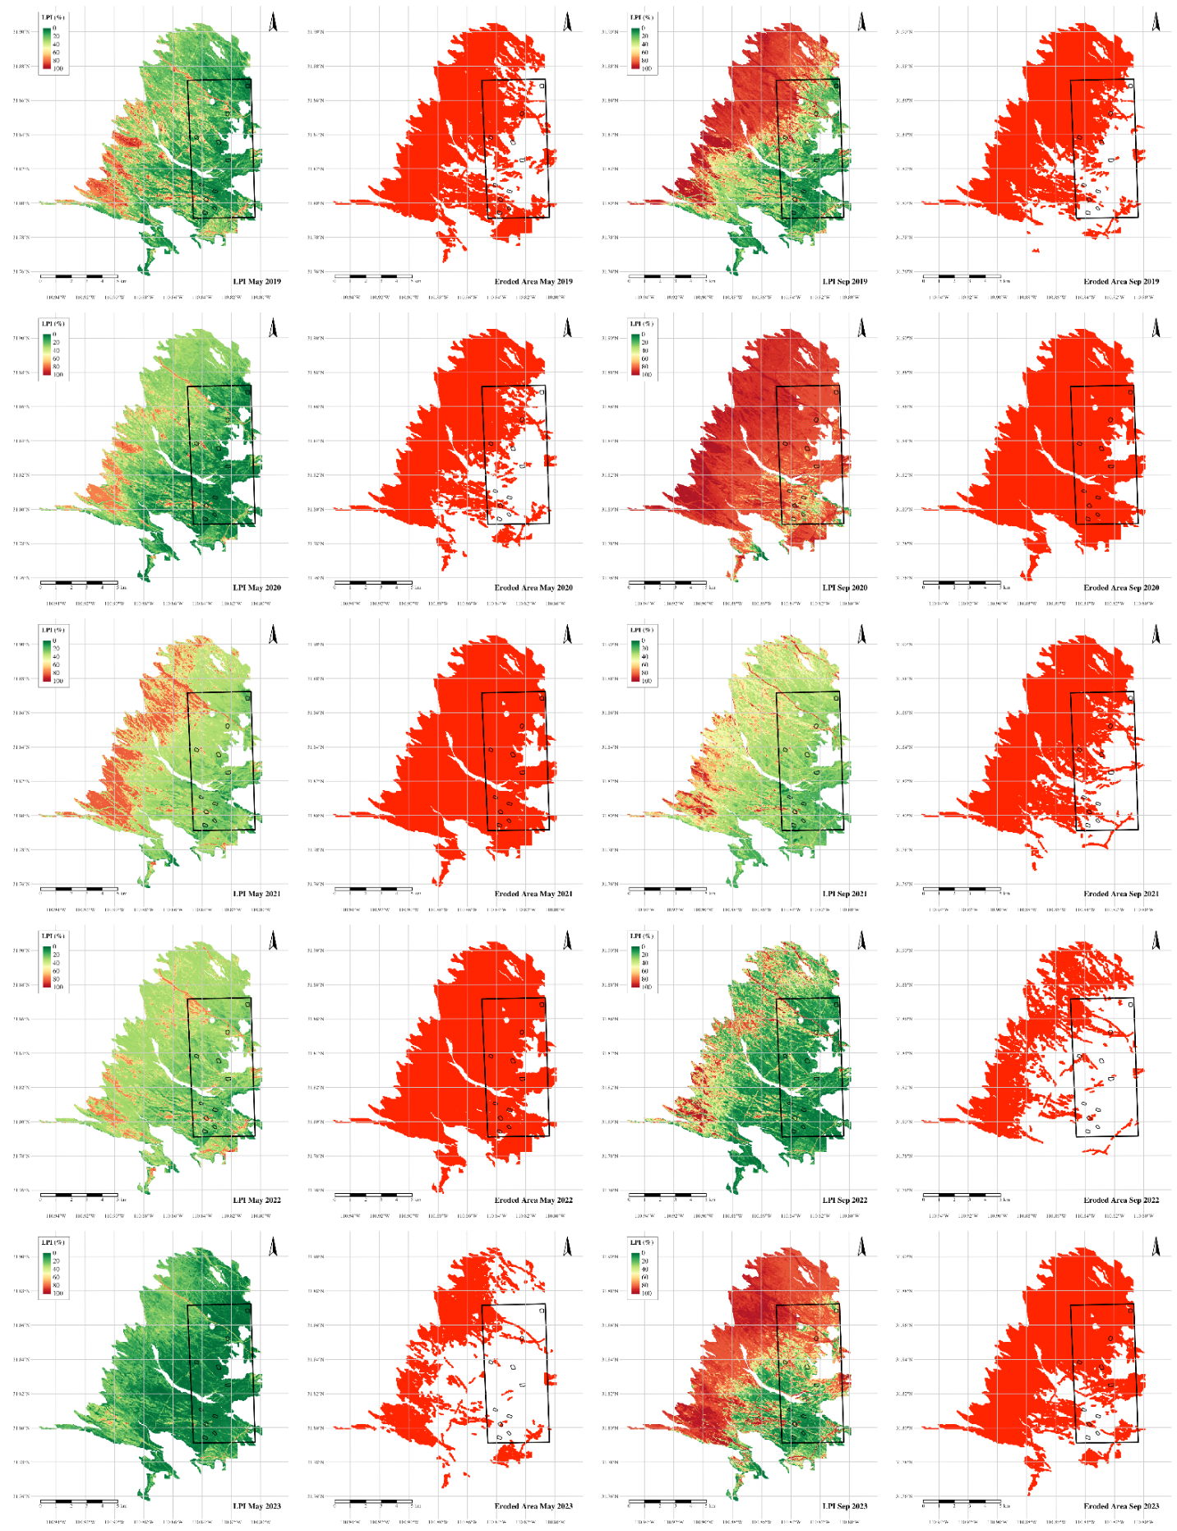
Figure S1. Landsat LPI and Eroded area from 2019 thru 2023 for May and September periods.
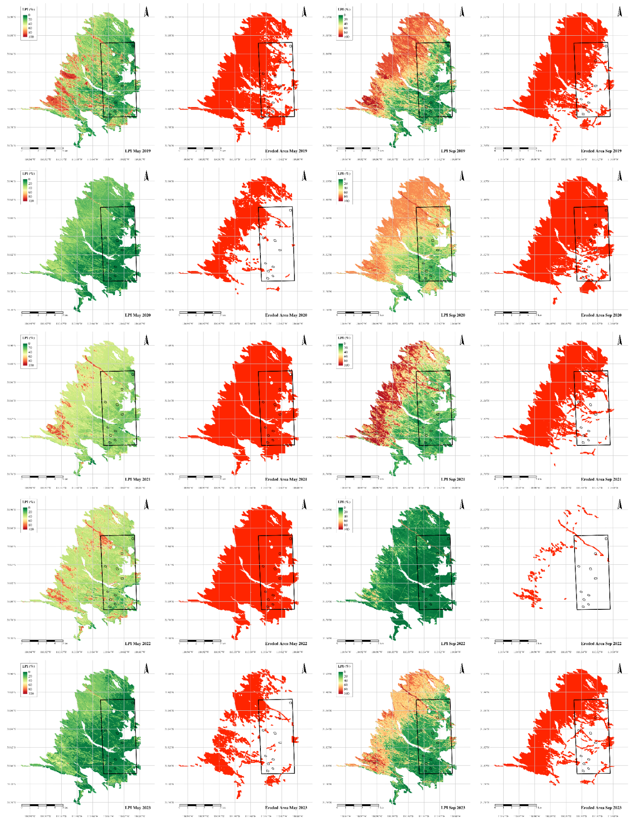
Figure S2. PlanetScope 30-m LPI and Eroded area from 2019 thru 2023 for May and September periods.

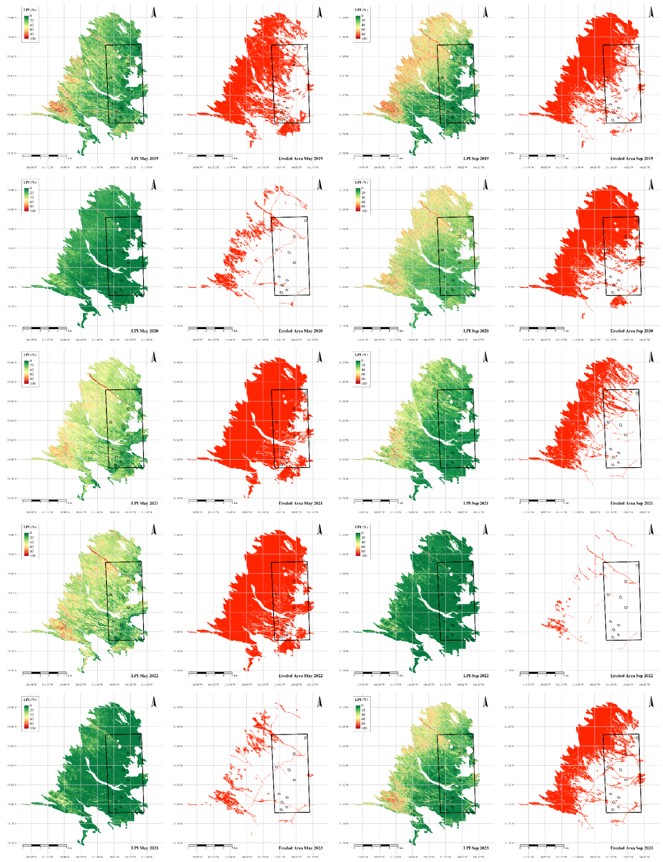
Figure S3. PlanetScope 3-m LPI and Eroded area from 2019 thru 2023 for May and September periods.

