Supporting Information
Article Title: Wet-Spun Supramolecular Lignin/Alginate Fibers from Agricultural Residues Journal: Waste and Biomass Valorization
Authors: Dorota B. Szlek ^{1,*}, Nara Han ², Isabel Schorn ¹, Jennifer Gerber ³, Chang Geun Yoo ², Margaret W. Frey ¹
¹Department of Human Centered Design, Cornell University, 37 Forest Home Drive, Ithaca, NY, 14853, USA
²Department of Chemical Engineering, College of Environmental Science and Forestry, State University of New York, 1 Forestry Drive, Syracuse, NY 13210
³School of Materials Science and Engineering, Georgia Institute of Technology, North Avenue, Atlanta, GA 30332
* Corresponding author. E-mail address: ds969@cornell.edu. ORCID: 0000-0002-9393-3154

Table S1. Fiber linear density.

Sample | SA | LCSL1 | HCSL1 | LCSL4 | HCSL4 | LCSL7 | HCSL7
Fiber Linear Density (denier) | 3822 ± 624 | 3055 ± 9529 | 6383 ± 215 | 18730 ± 9529 | 22635 ± 11266 | 29566 ± 3827 | 39169 ± 9715

Table S2. Comparison of average fiber diameter of as-spun and after-wash fibers.

Sample | SA | LCSL1 | HCSL1 | LCSL4 | HCSL4 | LCSL7 | HCSL7
Average As-Spun Fiber Diameter (mm) | 0.25 ± 0.01 | 0.29 ± 0.02 | 0.22 ± 0.02 | 0.51 ± 0.05 | 0.44 ± 0.03 | 0.57 ± 0.05 | 0.36 ± 0.01
Average After-Wash Fiber Diameter (mm) | 0.09 ± 0.02 | 0.15 ± 0.01 | 0.13 ± 0.01 | 0.56 ± 0.02 | 0.59 ± 0.03 | 0.61 ± 0.03 | 0.56 ± 0.02

Table S3: Comparison of decomposition onsets, weight loss and residual ash for fibers before (in red columns) and after (in blue columns) wash.

Fiber Sample | 2nd Weight Loss Onset (℃) | 2nd Weight Loss (%) | 3rd Weight Loss Onset (℃) | 3rd Weight Loss (%) | Residual Ash (%) | 2nd Weight Loss Onset (℃) | 2nd Weight Loss (%) | 3rd Weight Loss Onset (℃) | 3rd Weight Loss (%) | Residual Ash (%)
SA | 170.09 ± 3.38 | 67.89 ± 9.66 | NA | NA | 15.61 ± 1.04 | 213.65 ± 2.70 | 29.84 ± 9.67 | 301.77 ± 3.30 | 16.61 ± 0.35 | 34.19 ± 0.08
LCSL1 | 179.15 ± 2.01 | 69.84 ± 6.02 | NA | NA | 14.91 ± 2.25 | 219.60 ± 0.49 | 25.01 ± 0.23 | 297.04 ± 1.03 | 21.05 ± 0.52 | 30.71 ± 0.40
HCSL1 | 168.86 ± 17.11 | 60.72 ± 7.55 | NA | NA | 16.61 ± 0.47 | 223.45 ± 0.51 | 27.41 ± 1.01 | 266.66 ± 1.16 | 19.00 ± 2.04 | 29.07 ± 0.40
LCSL4 | 174.75 ± 19.51 | 36.78 ± 15.31 | 320.81 ± 12.22 | 20.12 ± 7.61 | 36.67 ± 1.82 | 220.10 ± 2.20 | 43.14 ± 3.49 | 396.84 ± 2.71 | 19.02 ± 0.98 | 32.68 ± 0.08
HCSL4 | 171.58 ± 11.86 | 54.41 ± 4.83 | 335.46 ± 23.42 | 17.86 ± 4.61 | 22.88 ± 2.07 | 216.87 ± 1.85 | 38.61 ± 3.57 | 488.86 ± 36.49 | 13.03 ± 3.83 | 41.46 ± 0.21
LCSL7 | 184.85 ± 12.13 | 58.84 ± 6.03 | 345.10 ± 53.78 | 10.85 ± 5.78 | 22.35 ± 1.33 | 214.39 ± 2.50 | 43.87 ± 0.93 | 419.11 ± 7.16 | 17.37 ± 0.79 | 35.22 ± 0.15
HCSL7 | 204.39 ± 33.11 | 33.18 ± 14.01 | 347.21 ± 5.31 | 20.78 ± 8.67 | 31.54 ± 10.12 | 216.71 ± 0.91 | 38.26 ± 0.24 | 471.96 ± 0.63 | 14.81 ± 0.90 | 42.54 ± 0.06
SA powder | 228.11 ± 0.61 | 31.74 ± 0.35 | 265.88 ± 0.51 | 20.89 ± 0.57 | 23.64 ± 0.10 | N/A | N/A | N/A | N/A | N/A
LCSL powder | 183.38 ± 0.47 | 44.97 ± 0.05 | 412.04 ± 2.68 | 23.18 ± 1.29 | 27.95 ± 0.09 | N/A | N/A | N/A | N/A | N/A
HCSL powder | 196.62 ± 1.48 | 66.87 ± 0.95 | N/A | N/A | 30.40 ± 0.08 | N/A | N/A | N/A | N/A | N/A

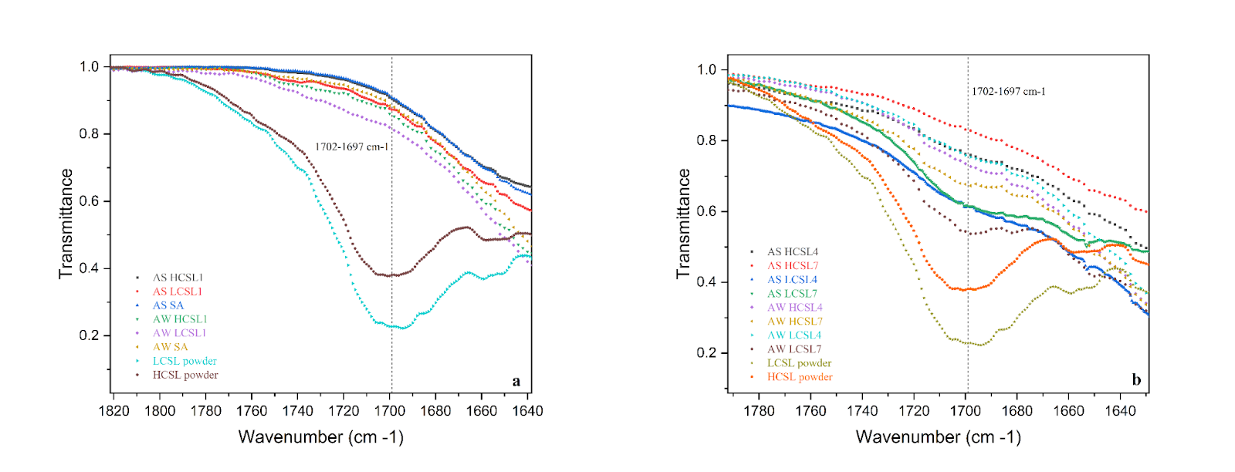
Fig. S1. FTIR spectra showing (a), an intensity comparison of 1702-1697 cm⁻¹ peaks correlated with cleavage of β-O-4 linkages and vanillin release, for raw materials and fibers with low or no lignin concentration
, and (b) a presence/absence comparison of these peaks for raw materials and fibers with higher lignin concentrations.

