Table 1 Comparison of Pig Genome Assemblies
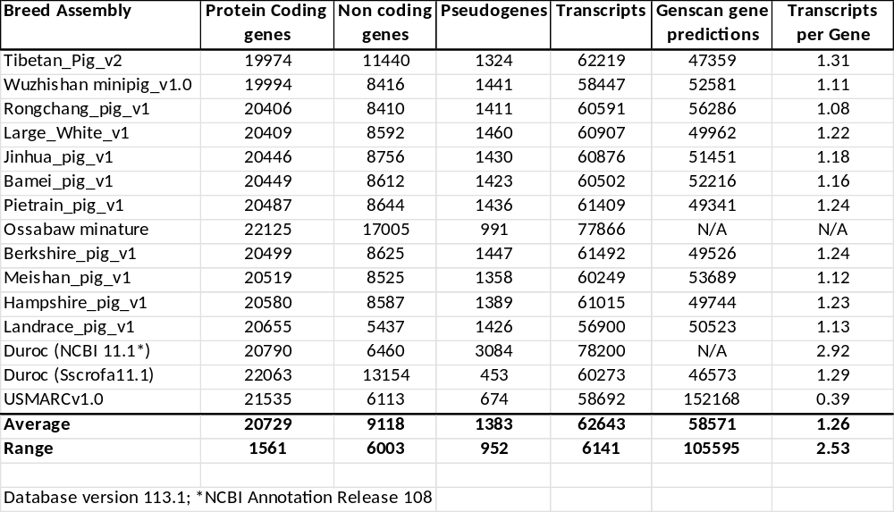

Table 2 Summary of 3 Genomes’ Build Errors (protein coding genes)

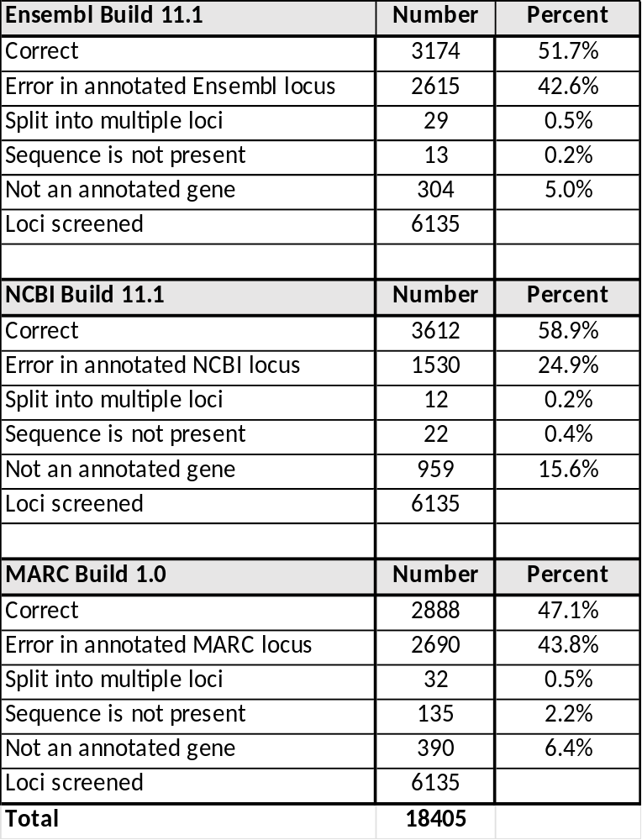

Table 3. Comparison of 3 Swine Genome Assemblies

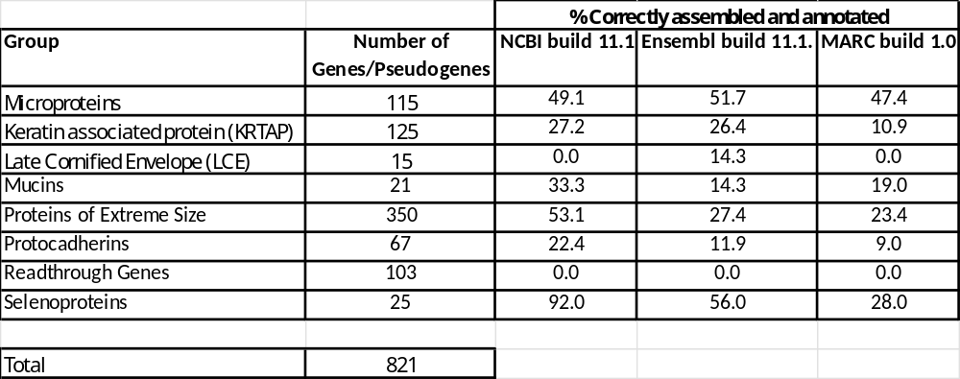

Table 4. Expanded Superfamilies
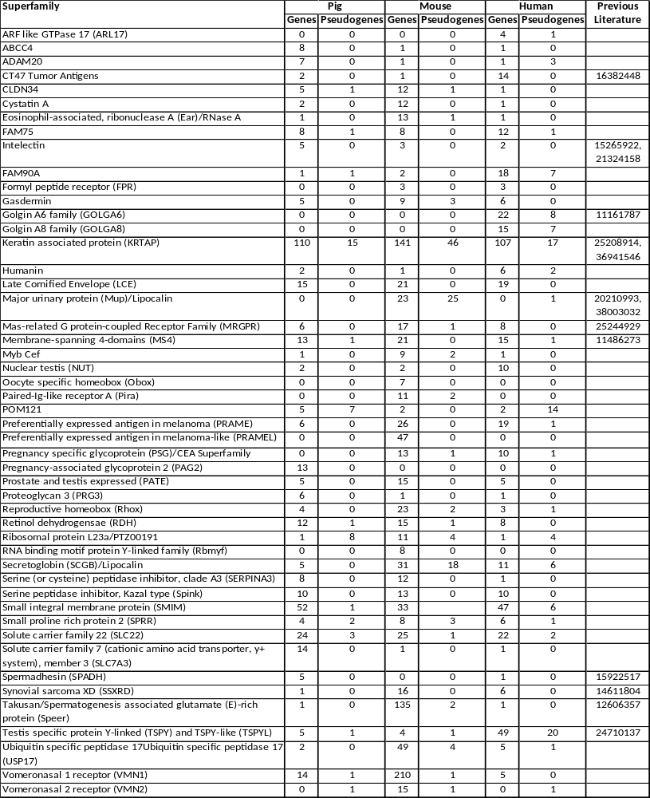
Table 5. Analysis of Differentially Encoded Proteins to Determine Pathway Enrichment
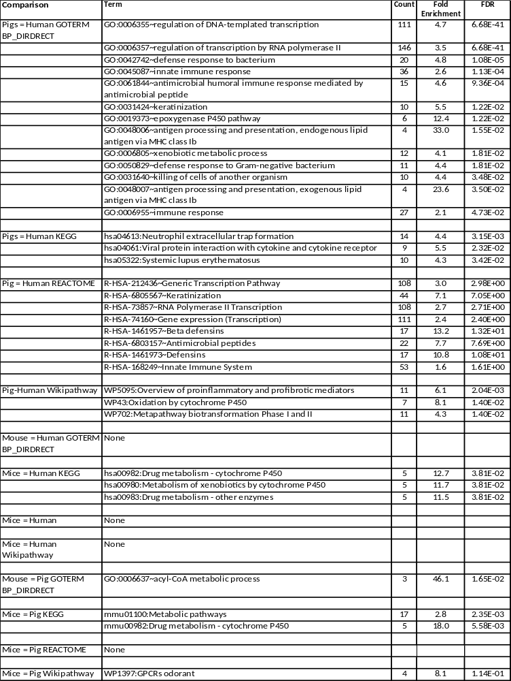
Table 6. Data Mining of Proteins with Differentially Expressed Functional Domains
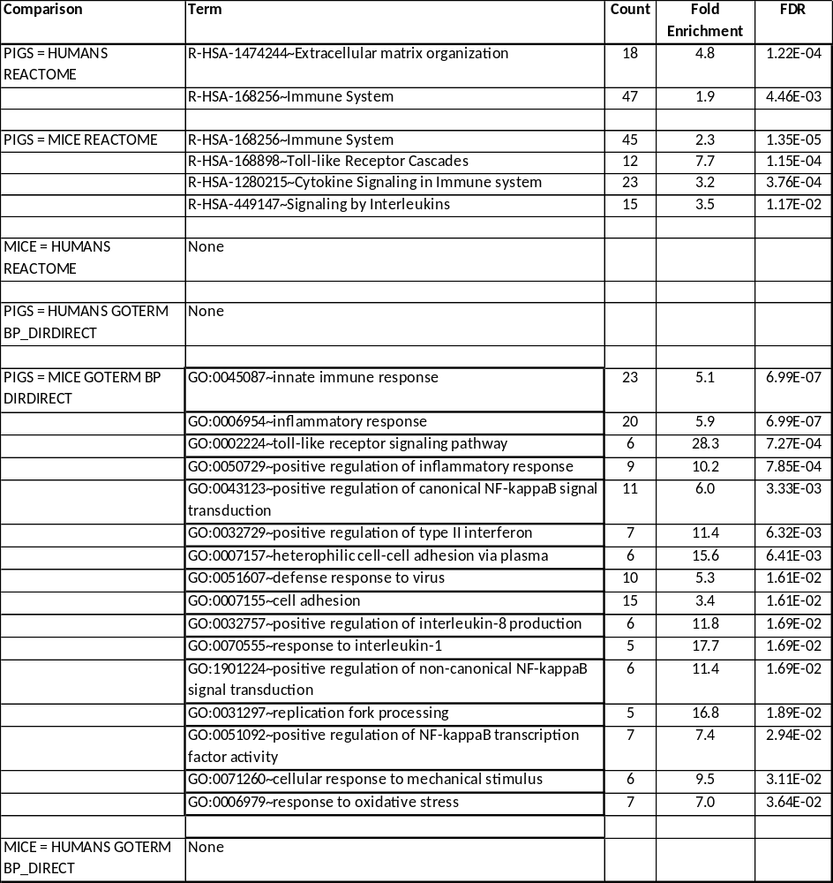

Table 7. Summation of Results

