APPENDICES
Table A1 Sample selection
 | people |  | year-to-person observations
Participants aged 50-79 | 7815 |  | 28904
Ever changed address | 344 | 4.4% | 1534 | 5.3%
Living in nursing house | 88 | 1.1% | 358 | 1.2%
Has no children | 1269 | 16.2% | 3916 | 13.5%
Has minor children under 18 | 1001 | 12.8% | 2270 | 7.9%
Has children over 50 | 1065 | 13.6% | 1917 | 6.6%
Never worked | 779 | 10.0% | 2683 | 9.3%
Permanently sick/disabled | 420 | 5.4% | 1460 | 5.1%
Unemployed | 711 | 9.1% | 1150 | 4.0%
Note: there are overlapping cases across groups. The percentage numbers give the proportion of each group in all observations aged between 50 and 79.

Table A2 Sample characteristics
 | All | Retired | Non-retired | T-diff
 | (N=13,437) | (N=7,450) | (N=5,987) | (p-value)
Individual characteristics
Age | 64.52 | 67.73 | 60.52 | <0.000
Partner’s age | 64.02 | 66.99 | 60.58 | <0.000
Male | 0.456 | 0.443 | 0.472 | 0.001
Married | 0.817 | 0.796 | 0.844 | <0.000
Widowed | 0.107 | 0.146 | 0.060 | <0.000
Education: primary/none | 0.207 | 0.243 | 0.161 | <0.000
Education: secondary | 0.427 | 0.406 | 0.453 | <0.000
Education: third/higher | 0.366 | 0.350 | 0.386 | <0.000
Dublin | 0.245 | 0.266 | 0.218 | <0.000
Other cities/towns | 0.283 | 0.302 | 0.260 | <0.000
Rural | 0.472 | 0.432 | 0.522 | <0.000
Household gross assets (in 1000 euro) | 488.9 | 463.3 | 520.4 | <0.000
Self-rated health: excellent | 0.173 | 0.153 | 0.198 | <0.000
Self-rated health: good | 0.371 | 0.351 | 0.396 | <0.000
Self-rated health: average | 0.329 | 0.336 | 0.319 | 0.032
Self-rated health: fair/poor | 0.110 | 0.134 | 0.079 | <0.000
Public sector | 0.346 | 0.35 | 0.341 | 0.311
Self-employed/farming | 0.143 | 0.056 | 0.277 | <0.000
Household size | 2.38 | 2.12 | 2.79 | <0.000
Children’s characteristics
The number of children | 3.24 | 3.34 | 3.12 | <0.000
The number of grandchildren | 3.20 | 4.12 | 2.06 | <0.000
The number of sons | 1.57 | 1.61 | 1.53 | <0.000
Mean age | 33.94 | 36.70 | 30.51 | <0.000
Proximity: co-residence | 0.354 | 0.258 | 0.474 | <0.000
Proximity: the same county | 0.468 | 0.553 | 0.363 | <0.000
Proximity: another county | 0.126 | 0.133 | 0.118 | 0.012
Proximity: another country | 0.051 | 0.056 | 0.045 | 0.005
Has a degree or above | 0.509 | 0.515 | 0.501 | 0.037
Employed | 0.788 | 0.809 | 0.761 | <0.000
Full-time employed | 0.657 | 0.668 | 0.643 | <0.000
Part-time employed | 0.081 | 0.084 | 0.077 | 0.025
Self-employed | 0.049 | 0.057 | 0.040 | <0.000
Unemployed | 0.063 | 0.059 | 0.068 | 0.001
In education or training | 0.079 | 0.046 | 0.120 | <0.000
Looking after home | 0.045 | 0.060 | 0.025 | <0.000
Married | 0.529 | 0.617 | 0.419 | <0.000
Note: The working sample includes 13,437 wave-to-person observations (4,342 people, 2,040 males, 2,302 females, 3,276 households) aged between 50 and 79 during all TILDA five waves (2009-2018).

Table A3 First stage regression
 | (1) | (2) | (3)
 | All | Male | Female
SPA eligibility | 0.179*** | 0.212*** | 0.144***
 | (0.015) | (0.023) | (0.020)
Age | 0.075*** | 0.139*** | 0.044**
 | (0.014) | (0.018) | (0.020)
Age-squared/100 | -0.041*** | -0.088*** | -0.017
 | (0.011) | (0.014) | (0.015)
Male | -0.116***
 | (0.012)
(Ref: Married)
Never married | -0.145** | -0.047 | -0.167**
 | (0.065) | (0.074) | (0.083)
Separated/divorced | -0.125*** | 0.005 | -0.163***
 | (0.035) | (0.049) | (0.045)
Widowed | -0.022 | 0.014 | -0.030
 | (0.032) | (0.044) | (0.044)
(Ref: Education: Primary/none)
Education: secondary | 0.020 | 0.055** | -0.037
 | (0.017) | (0.022) | (0.025)
Education: third level/higher | 0.010 | 0.106*** | -0.102***
 | (0.019) | (0.026) | (0.027)
(Ref: Dublin)
Other cities/towns | -0.002 | 0.012 | -0.007
 | (0.017) | (0.022) | (0.023)
Rural area | -0.055*** | -0.081*** | -0.018
 | (0.016) | (0.021) | (0.022)
Whether born in Ireland | -0.016 | 0.016 | -0.017
 | (0.022) | (0.030) | (0.029)
(Ref: Health condition: excellent)
Childhood health: average | 0.003 | -0.014 | 0.019
 | (0.013) | (0.018) | (0.018)
Childhood health: fair/poor | 0.077*** | 0.036 | 0.097***
 | (0.027) | (0.039) | (0.036)
(Ref: Financial condition: well-off)
Childhood financial condition: average | 0.015 | 0.019 | 0.013
 | (0.020) | (0.029) | (0.027)
Childhood financial condition: poor | 0.036 | 0.067** | -0.003
 | (0.025) | (0.033) | (0.035)
The number of children | -0.003 | -0.014* | 0.008
 | (0.007) | (0.008) | (0.008)
Son ratio | -0.016 | -0.016 | -0.020
 | (0.020) | (0.027) | (0.027)
Children's mean age | -0.004 | 0.024 | -0.036
 | (0.017) | (0.022) | (0.023)
Children's mean age squared/100 | 0.015 | -0.006 | 0.041*
 | (0.016) | (0.021) | (0.023)
Observations | 13,437 | 6,128 | 7,309
Household clusters | 3,276 | 2,040 | 2,302
R-squared | 0.339 | 0.424 | 0.294
Note: * p<0.1, **p<0.05, *** p<0.01. Standard errors clustered at household level are in bracket.
Some variables are not displayed: partner’s age groups, partner’s education group, children’s age groups, and wave dummies.
Table A4 Characteristics of compliers
Covariate | Mean |  |  |  | Balance test
 | Sample | Compliers | Always-takers | Never-takers | (P-value)
Age | 64.52 | 64.62 | 62.20 | 70.69 | <0.000
Male | 0.456 | 0.511 | 0.303 | 0.671 | <0.000
Married | 0.817 | 0.785 | 0.855 | 0.838 | <0.000
Education: primary/none | 0.207 | 0.209 | 0.165 | 0.315 | <0.000
Education: secondary | 0.427 | 0.407 | 0.466 | 0.394 | <0.000
Education: third/higher | 0.366 | 0.383 | 0.368 | 0.291 | <0.000
Dublin | 0.245 | 0.245 | 0.259 | 0.203 | <0.000
Other cities or towns | 0.283 | 0.303 | 0.285 | 0.203 | 0.002
Rural area | 0.472 | 0.453 | 0.456 | 0.594 | <0.000
Born in Ireland | 0.915 | 0.916 | 0.906 | 0.936 | 0.120
The number of children | 3.24 | 3.22 | 3.18 | 3.52 | <0.000
Son ratio | 0.483 | 0.480 | 0.478 | 0.507 | 0.267
Children’s mean age | 33.94 | 34.00 | 32.66 | 37.32 | <0.000
Childhood health: excellent | 0.588 | 0.582 | 0.595 | 0.589 | <0.000
Childhood health: average | 0.361 | 0.375 | 0.347 | 0.350 | <0.000
Childhood health: fair/poor | 0.051 | 0.043 | 0.058 | 0.060 | <0.000
Childhood SES: well-off | 0.110 | 0.117 | 0.103 | 0.107 | 0.175
Childhood SES: average | 0.705 | 0.682 | 0.727 | 0.735 | <0.000
Childhood SES: poor | 0.184 | 0.201 | 0.171 | 0.158 | <0.000
Public sector | 0.337 | 0.388 | 0.351 | 0.103 | 0.129
Private sector | 0.448 | 0.429 | 0.537 | 0.279 | 0.634
Self-employment/farming | 0.214 | 0.182 | 0.618 | 0.112 | 0.238
Professionals/managerial | 0.346 | 0.340 | 0.422 | 0.328 | 0.006
Non-manual | 0.310 | 0.292 | 0.341 | 0.291 | 0.043
Skilled | 0.150 | 0.171 | 0.118 | 0.157 | 0.053
Semi-skilled/unskilled | 0.165 | 0.176 | 0.178 | 0.091 | 0.898
Note: We implement the method by Marbach and Hangartner (2020) to profile the compliers. The observed always-takers (36.5% of the whole sample) are below SPA and retired. The observed never-takers (17.5%) are working beyond SPA. The potential compliers around 50.7% of the whole sample. The balance test in the last column tests the mean of a covariate by SPA eligibility.
Table A5 The coefficients of other covariates in regression of children’s employment and fertility
 | (1) | (2) | (3) | (4) | (5)
Outcome: | F-T employed | P-T employed | Home maker | Married | Grandchildren
Retirement | -0.117** | 0.036 | 0.049* | 0.014 | 1.592***
 | (0.059) | (0.035) | (0.029) | (0.056) | (0.538)
Age | 0.012 | -0.004 | -0.003 | -0.008 | -0.147*
 | (0.011) | (0.006) | (0.005) | (0.011) | (0.087)
Age-squared/100 | -0.005 | 0.0021 | 0.001 | 0.0041 | 0.060
 | (0.008) | (0.005) | (0.004) | (0.008) | (0.067)
Male | 0.003 | -0.003 | 0.005 | 0.005 | 0.181**
 | (0.010) | (0.005) | (0.005) | (0.009) | (0.089)
(Ref: Married)
Never married | -0.090 | -0.001 | 0.002 | -0.140*** | 0.500
 | (0.072) | (0.026) | (0.026) | (0.053) | (0.366)
Separated/divorced | -0.080*** | 0.009 | 0.001 | -0.055** | -0.068
 | (0.028) | (0.014) | (0.010) | (0.027) | (0.227)
Widowed | -0.039* | 0.007 | -0.008 | -0.063*** | -0.657***
 | (0.024) | (0.012) | (0.011) | (0.023) | (0.209)
(Ref: Education: Primary/none)
Education: secondary | 0.052*** | -0.011* | -0.021*** | -0.004 | -0.328***
 | (0.012) | (0.007) | (0.006) | (0.012) | (0.112)
Education: third level | 0.055*** | -0.013* | -0.031*** | -0.011 | -0.662***
 | (0.013) | (0.007) | (0.006) | (0.013) | (0.118)
(Ref: Dublin)
Other cities/towns | -0.005 | 0.009 | -0.008 | -0.035** | -0.075
 | (0.013) | (0.007) | (0.006) | (0.014) | (0.115)
Rural area | 0.022* | 0.011 | -0.021*** | -0.037*** | -0.152
 | (0.013) | (0.007) | (0.006) | (0.013) | (0.112)
Whether born in Ireland | 0.056*** | -0.028** | -0.015** | -0.003 | -0.095
 | (0.017) | (0.012) | (0.007) | (0.017) | (0.153)
The number of children | -0.002 | 0.00001 | 0.0001 | -0.005 | 1.337***
 | (0.005) | (0.002) | (0.002) | (0.004) | (0.074)
(Ref: Age group 40-49)
Children age group: 19-24 | 0.266*** | 0.027 | 0.001 | 0.083** | 1.820***
 | (0.042) | (0.027) | (0.014) | (0.035) | (0.293)
Children age group: 25-29 | 0.398*** | -0.008 | -0.018 | 0.014 | 0.206
 | (0.028) | (0.016) | (0.011) | (0.028) | (0.224)
Children age group: 30-34 | 0.280*** | -0.017 | -0.019* | 0.131*** | -0.179
 | (0.025) | (0.015) | (0.010) | (0.026) | (0.198)
Children age group: 35-39 | 0.119*** | -0.012 | -0.001 | 0.144*** | 0.468***
 | (0.021) | (0.012) | (0.010) | (0.021) | (0.160)
% of son | 0.113*** | -0.069*** | -0.068*** | 0.018 | -0.232*
 | (0.017) | (0.009) | (0.007) | (0.017) | (0.126)
Children's mean age | 0.106*** | 0.001 | 0.006 | 0.076*** | 0.476***
 | (0.015) | (0.009) | (0.006) | (0.014) | (0.130)
Children's mean age squared/100 | -0.117*** | -0.004 | -0.007 | -0.066*** | -0.020
 | (0.018) | (0.012) | (0.007) | (0.016) | (0.136)
R-squared | 0.152 | 0.022 | 0.086 | 0.393 | 0.554
Note: * p<0.1, **p<0.05, *** p<0.01. Standard errors clustered at household level are in bracket.
Some variables are not displayed: partner’s age groups, partner’s education group, children’s maximum and minimum age, early childhood health/financial conditions and wave dummies.

Table A6 The coefficients of other covariates in regression of financial and time transfers
 | (1) | (2) | (3) | (4)
Outcome: | Lump sum | Small Transfer | Chores | Grandparenting
Retirement | 0.146* | 0.060 | 0.076 | 0.041
 | (0.088) | (0.091) | (0.087) | (0.093)
Age | 0.052*** | -0.012 | -0.008 | -0.019
 | (0.016) | (0.015) | (0.015) | (0.016)
Age-squared/100 | -0.042*** | 0.005 | -0.002 | 0.006
 | (0.011) | (0.011) | (0.011) | (0.012)
Male | 0.043*** | 0.021 | 0.053*** | -0.010
 | (0.013) | (0.014) | (0.013) | (0.014)
(Ref: Married)
Never married | -0.196*** | -0.174*** | -0.077 | -0.229***
 | (0.050) | (0.066) | (0.064) | (0.067)
Separated/divorced | -0.092** | -0.005 | 0.008 | -0.040
 | (0.036) | (0.035) | (0.034) | (0.041)
Widowed | -0.037 | -0.024 | -0.003 | -0.052
 | (0.033) | (0.031) | (0.030) | (0.036)
(Ref: Education: Primary/none)
Education: secondary | 0.057*** | 0.063*** | 0.017 | 0.001
 | (0.013) | (0.015) | (0.015) | (0.016)
Education: third level | 0.160*** | 0.109*** | 0.001 | -0.053***
 | (0.016) | (0.016) | (0.016) | (0.018)
(Ref: Dublin)
Other cities/towns | -0.057*** | -0.027 | -0.039** | -0.056***
 | (0.019) | (0.018) | (0.018) | (0.019)
Rural area | -0.090*** | -0.070*** | -0.055*** | -0.076***
 | (0.018) | (0.017) | (0.017) | (0.018)
Whether born in Ireland | 0.041** | 0.035* | 0.018 | 0.017
 | (0.020) | (0.021) | (0.018) | (0.022)
The number of children | 0.012* | -0.003 | 0.004 | 0.031***
 | (0.007) | (0.006) | (0.006) | (0.007)
(Ref: Age group 40-49)
Children age group: 19-24 | 0.083 | 0.022 | -0.007 | 0.109*
 | (0.107) | (0.068) | (0.071) | (0.063)
Children age group: 25-29 | -0.066 | -0.067 | 0.002 | -0.002
 | (0.067) | (0.047) | (0.049) | (0.045)
Children age group: 30-34 | -0.011 | -0.086** | 0.049 | 0.101***
 | (0.048) | (0.039) | (0.038) | (0.039)
Children age group: 35-39 | -0.037 | -0.045 | 0.106*** | 0.133***
 | (0.036) | (0.034) | (0.031) | (0.033)
% of son | -0.024 | -0.027 | -0.097*** | -0.084***
 | (0.021) | (0.020) | (0.019) | (0.024)
Children's mean age | -0.051** | -0.046** | 0.003 | 0.143***
 | (0.025) | (0.022) | (0.021) | (0.022)
Children's mean age squared/100 | 0.051* | 0.020 | -0.002 | -0.160***
 | (0.029) | (0.025) | (0.024) | (0.026)
Observations | 10,145 | 12,987 | 13,219 | 10,399
Household clusters | 2,796 | 3,237 | 3,255 | 3,019
R-squared | 0.084 | 0.062 | 0.040 | 0.226
Note: * p<0.1, **p<0.05, *** p<0.01. Standard errors clustered at household level are in bracket.
Some variables are not displayed: partner’s age groups, partner’s education group, children’s maximum and minimum age, early childhood health/financial conditions and wave dummies.

Table A7 Non-IV estimation of retirement on intergenerational outcomes
 | (1) | (2) | (3) | (4) | (5) | (6)
Panel A: whether has transfer
 | Lump sum | Small transfer | Chores | Childcare | Transfer | Help
 | (>5000) | (250-5000) |  |  | (Received) | (Received)
All | -0.007 | -0.012 | 0.034*** | 0.018 | -0.002 | -0.005
 | (0.012) | (0.013) | (0.012) | (0.016) | (0.005) | (0.012)
N | 10,145 | 12,987 | 13,219 | 8,995 | 13,354 | 12,965
Male | -0.021 | 0.024 | 0.027 | -0.015 | -0.001 | -0.036**
 | (0.019) | (0.019) | (0.019) | (0.023) | (0.008) | (0.018)
N | 4,567 | 5,919 | 6,035 | 4,125 | 6,084 | 5,925
Female | 0.001 | -0.034** | 0.035** | 0.048** | -0.002 | 0.022
 | (0.015) | (0.016) | (0.015) | (0.020) | (0.008) | (0.015)
N | 5,578 | 7,068 | 7,184 | 4,870 | 7,255 | 7,040
Panel B: the intensity of transfer (log)
 | Lump sum | Small transfer | Chores | Childcare | Transfer | Help
 | (>5000) | (250-5000) |  |  | (Received) | (Received)
All | 0.029 | -0.061* | 0.074 | 0.188*** | -0.022 | -0.063
 | (0.049) | (0.035) | (0.049) | (0.043) | (0.094) | (0.048)
N | 2,684 | 6,191 | 3,941 | 5,936 | 765 | 3,494
Male | 0.025 | -0.075 | -0.018 | -0.036 | 0.030 | -0.198***
 | (0.082) | (0.056) | (0.071) | (0.065) | (0.166) | (0.074)
N | 1,261 | 2,833 | 1,910 | 2,668 | 302 | 1,519
Female | 0.043 | -0.058 | 0.131** | 0.322*** | -0.018 | -0.004
 | (0.059) | (0.045) | (0.063) | (0.054) | (0.124) | (0.061)
N | 1,423 | 3,358 | 2,031 | 3,268 | 463 | 1,975
Note: * p<0.1, **p<0.05, *** p<0.01. Standard errors clustered at household level are in bracket.
Panel A reports average marginal effect from logistic estimation. Panel B are OLS estimates.
Table A8 Heterogenous effect by educational level and household location
 | (1) | (2) | (3) | (4) | (5) | (6) | (7)
Outcome Y: | Employed | F-T employed | P-T employed | Self-employed | Home maker | Married | Grandchildren
Panel A: Education Level
Primary/none (N=2,780) | 0.113 | 0.226* | -0.036 | -0.078 | 0.031 | -0.044 | 1.390
 | (0.098) | (0.119) | (0.071) | (0.054) | (0.062) | (0.106) | (1.070)
Mean of Y | 0.768 | 0.618 | 0.098 | 0.053 | 0.079 | 0.617 | 4.70
Secondary (N=5,737) | -0.048 | -0.100 | 0.065 | -0.013 | 0.046 | 0.128 | 1.682*
 | (0.073) | (0.089) | (0.056) | (0.043) | (0.045) | (0.090) | (0.904)
Mean of Y | 0.795 | 0.670 | 0.080 | 0.046 | 0.043 | 0.524 | 3.19
Third/higher (N=4,920) | -0.258*** | -0.380*** | 0.026 | 0.096 | 0.089* | -0.088 | 1.857**
 | (0.089) | (0.125) | (0.059) | (0.064) | (0.048) | (0.107) | (0.933)
Mean of Y | 0.790 | 0.664 | 0.074 | 0.052 | 0.027 | 0.484 | 2.37
Panel B: Location
Dublin (N=3,286) | -0.147 | -0.244* | 0.031 | 0.067 | 0.137* | -0.219 | 1.861*
 | (0.116) | (0.145) | (0.088) | (0.070) | (0.080) | (0.140) | (1.106)
Mean of Y | 0.776 | 0.643 | 0.075 | 0.058 | 0.058 | 0.565 | 3.12
Other cities or towns (N=3,808) | -0.121 | -0.097 | 0.013 | -0.037 | 0.046 | -0.059 | 1.083
 | (0.088) | (0.106) | (0.061) | (0.050) | (0.053) | (0.102) | (0.876)
Mean of Y | 0.768 | 0.644 | 0.083 | 0.041 | 0.051 | 0.537 | 3.31
Rural area (N=6,343) | 0.034 | -0.050 | 0.052 | 0.032 | -0.004 | 0.153* | 1.694**
 | (0.064) | (0.082) | (0.048) | (0.042) | (0.036) | (0.081) | (0.858)
Mean of Y | 0.805 | 0.672 | 0.083 | 0.050 | 0.033 | 0.505 | 3.18
Note: * p<0.1, **p<0.05, *** p<0.01. Standard errors clustered at household level are in bracket.
In Panel A, Kleinbergen-Paap F statistic are 39.25, 55.18, 38.41 respectively. In Panel B, Kleinbergen-Paap F statistic are 24.71, 48.08, 24.00
Table A9 Heterogenous effect on financial and time transfers by educational level and location
 | (1) | (2) | (3) | (4) | (5) | (6)
Outcome Y: | Lump sum | Small Transfer | Chores | Grandparenting | Transfer Received | Help Received
Panel A: Education level
Primary/none | -0.241* | -0.069 | -0.012 | -0.211 | 0.091 | -0.368*
 | (0.138) | (0.171) | (0.164) | (0.186) | (0.084) | (0.195)
N | 1,940 | 2,700 | 2,751 | 2,307 | 2,758 | 2,729
Mean of Y | 0.128 | 0.385 | 0.309 | 0.645 | 0.062 | 0.355
Secondary | 0.411*** | 0.074 | 0.067 | 0.102 | -0.065 | 0.113
 | (0.155) | (0.148) | (0.135) | (0.149) | (0.069) | (0.139)
N | 4,385 | 5,556 | 5,648 | 4,502 | 5,707 | 5,519
Mean of Y | 0.232 | 0.474 | 0.312 | 0.598 | 0.062 | 0.280
Third/higher | 0.110 | 0.0874 | 0.161 | 0.214 | 0.013 | 0.174
 | (0.171) | (0.169) | (0.168) | (0.171) | (0.074) | (0.142)
N | 3,820 | 4,731 | 4,820 | 3,590 | 4,889 | 4,717
Mean of Y | 0.371 | 0.532 | 0.276 | 0.489 | 0.049 | 0.208
Panel B: Location
Dublin | -0.082 | -0.188 | -0.089 | -0.129 | 0.098 | -0.073
 | (0.237) | (0.248) | (0.226) | (0.217) | (0.101) | (0.199)
N | 2,467 | 3,169 | 3,229 | 2,557 | 3,267 | 3,144
Mean of Y | 0.335 | 0.519 | 0.334 | 0.613 | 0.047 | 0.255
Other cities or towns | 0.245 | 0.054 | 0.186 | 0.232 | -0.028 | 0.041
 | (0.161) | (0.151) | (0.151) | (0.181) | (0.068) | (0.148)
N | 2,859 | 3,671 | 3,728 | 3,001 | 3,789 | 3,682
Mean of Y | 0.259 | 0.487 | 0.299 | 0.571 | 0.054 | 0.245
Rural areas | 0.192 | 0.137 | 0.103 | 0.004 | -0.023 | 0.063
 | (0.121) | (0.129) | (0.120) | (0.123) | (0.062) | (0.123)
N | 4,819 | 6,147 | 6,262 | 4,841 | 6,298 | 6,139
Mean of Y | 0.232 | 0.449 | 0.279 | 0.548 | 0.065 | 0.292

Note: * p<0.1, **p<0.05, *** p<0.01. Standard errors clustered at household level are in bracket. Kleinbergen-Paap F statistic ranges between 19.07 to 62.3.
Table A10 Alternative specification of regression of children’s employment
Outcome: Full-time employment rate | (1) | (2) | (3) | (4) | (5) | (6) | (7) | (8)
OLS estimate | -0.019* | -0.019** | -0.019** | -0.015 | -0.009 | -0.014 | -0.010 | -0.011
 | (0.010) | (0.010) | (0.010) | (0.009) | (0.009) | (0.009) | (0.009) | (0.009)
IV estimate | -0.269*** | -0.233*** | -0.238*** | -0.117** | -0.096* | -0.119** | -0.142** | -0.132**
 | (0.059) | (0.058) | (0.059) | (0.059) | (0.058) | (0.059) | (0.057) | (0.057)
Reduced-form estimate | -0.053*** | -0.044*** | -0.045*** | -0.021** | -0.017* | 0.021** | -0.025** | -0.024**
 | (0.011) | (0.011) | (0.011) | (0.010) | (0.010) | (0.010) | (0.010) | (0.010)
First-stage estimate | 0.196*** | 0.190*** | 0.188*** | 0.179*** | 0.181*** | 0.179*** | 0.179*** | 0.179***
 | (0.015) | (0.015) | (0.015) | (0.015) | (0.015) | (0.015) | (0.015) | (0.015)
Kleinbergen-Paap F | 168.0 | 157.1 | 152.8 | 136.4 | 138.9 | 137.0 | 136.5 | 137.1
Individual characteristics
Demographics | YES | YES | YES | YES | YES | YES | YES | YES
Partner | NO | YES | YES | YES | YES | YES | YES | YES
Early childhood condition | NO | NO | YES | YES | YES | YES | YES | YES
Health status | NO | NO | NO | NO | YES | YES | NO | NO
Household assets | NO | NO | NO | NO | NO | YES | NO | NO
Children's characteristics
Number, gender, age | NO | NO | NO | YES | YES | YES | YES | YES
Education | NO | NO | NO | NO | NO | NO | YES | YES
Proximity | NO | NO | NO | NO | NO | NO | NO | YES
N | 13,437 | 13,437 | 13,437 | 13,437 | 13,273 | 13,437 | 13,422 | 13,421
Note: * p<0.1, **p<0.05, *** p<0.01. Standard errors clustered at household level are in bracket. (4) is the preferred specification.
Controls for children’s highest education are the proportions of children having a degree or above, diploma, intermediate degree, and others.
Controls for household assets are 4 quartile groups pf household assets and another indicator for the missing asset information.
Controls for health status at the first wave are all categorical variables regarding the chronic diseases (no disease, 1, 2, 3 or more), depression symptoms (none/mild, moderate, severe), and disability level (ADL only, IADL only, IADL and ADL)
Controls geographical proximity include four categorical variables: co-resident, at least one in the same county, in another county, all are in another country.

Table A11 Alternative specification of regression of children’s fertility
Outcome: Number of grandchildren | (1) | (2) | (3) | (4) | (5) | (6) | (7) | (8)
OLS estimate | 0.366*** | 0.276** | 0.278** | 0.114 | 0.0955 | 0.0826 | 0.108 | 0.101
 | (0.111) | (0.109) | (0.109) | (0.0798) | (0.0809) | (0.0806) | (0.0789) | (0.0774)
IV estimate | 3.987*** | 3.226*** | 3.277*** | 1.592*** | 1.546*** | 1.523*** | 1.669*** | 1.566***
 | (0.755) | (0.720) | (0.731) | (0.538) | (0.536) | (0.534) | (0.540) | (0.534)
Reduced-form estimate | 0.783*** | 0.613*** | 0.615*** | 0.285*** | 0.280*** | 0.276*** | 0.299*** | 0.281***
 | (0.139) | (0.130) | (0.130) | (0.094) | (0.094) | (0.094) | (0.094) | (0.093)
First-stage estimate | 0.196*** | 0.190*** | 0.188*** | 0.179*** | 0.181*** | 0.181*** | 0.179*** | 0.179***
 | (0.015) | (0.015) | (0.015) | (0.015) | (0.015) | (0.015) | (0.015) | (0.015)
Kleinbergen-Paap F | 167.9 | 157.1 | 152.8 | 136.4 | 138.9 | 139.4 | 136.5 | 137.0
Individual characteristics
Demographics | YES | YES | YES | YES | YES | YES | YES | YES
Partner | NO | YES | YES | YES | YES | YES | YES | YES
Early childhood condition | NO | NO | YES | YES | YES | YES | YES | YES
Health status | NO | NO | NO | NO | YES | YES | NO | NO
Household assets | NO | NO | NO | NO | NO | YES | NO | NO
Children's characteristics
Number, gender, age | NO | NO | NO | YES | YES | YES | YES | YES
Education | NO | NO | NO | NO | NO | NO | YES | YES
Proximity | NO | NO | NO | NO | NO | NO | NO | YES
N | 13,437 | 13,437 | 13,437 | 13,437 | 13,273 | 13,273 | 13,422 | 13,421
Note: * p<0.1, **p<0.05, *** p<0.01. Standard errors clustered at household level are in bracket. (4) is the preferred specification.
Controls for children’s highest education are the proportions of children having a degree or above, diploma, intermediate degree, and others.
Controls for household assets are 4 quartile groups pf household assets and another indicator for the missing asset information.
Controls for health status at the first wave are all categorical variables regarding the chronic diseases (no disease, 1, 2, 3 or more), depression symptoms (none/mild, moderate, severe), and disability level (ADL only, IADL only, IADL and ADL)
Controls geographical proximity include four categorical variables: co-resident, at least one in the same county, in another county, all are in another country.

Table A12 Sensitivity checks: alternative samples
 | (1) | (2) | (3) | (4) | (5) | (6)
 |  | Alternative Retirement |  | Alternative | Children’s age | No
 | Baseline | No paid work | Claim retired | Age threshold | 24-49 | Co-residence
Employment | -0.066 | -0.072 | -0.073* | -0.036 | -0.087* | -0.046
 | (0.047) | (0.049) | (0.042) | (0.092) | (0.051) | (0.056)
N | 13437 | 13238 | 11844 | 13437 | 11254 | 8688
F-T employment | -0.117** | -0.130** | -0.122** | 0.012 | -0.156** | -0.121*
 | (0.059) | (0.062) | (0.052) | (0.108) | (0.065) | (0.071)
N | 13437 | 13238 | 11254 | 13437 | 11254 | 8688
P-T employment | 0.036 | 0.041 | 0.027 | -0.039 | 0.045 | 0.045
 | (0.035) | (0.036) | (0.029) | (0.061) | (0.038) | (0.042)
N | 13437 | 13238 | 11844 | 13437 | 11254 | 8688
Self-employment | 0.015 | 0.017 | 0.022 | -0.009 | 0.024 | 0.030
 | (0.029) | (0.030) | (0.026) | (0.045) | (0.032) | (0.036)
N | 13437 | 13238 | 11844 | 13437 | 11254 | 8688
Home maker | 0.049* | 0.045 | 0.045* | -0.051 | 0.062* | 0.064*
 | (0.029) | (0.030) | (0.025) | (0.042) | (0.032) | (0.036)
N | 13437 | 13238 | 11844 | 13437 | 11254 | 8688
Married | 0.014 | 0.010 | -0.006 | 0.091 | 0.001 | -0.004
 | (0.056) | (0.059) | (0.051) | (0.099) | (0.062) | (0.067)
N | 13437 | 13238 | 11844 | 13437 | 11254 | 8688
Grandchildren | 1.592*** | 1.677*** | 1.165** | -0.262 | 1.771*** | 1.950***
 | (0.538) | (0.564) | (0.469) | (0.705) | (0.586) | (0.635)
N | 13437 | 13238 | 11844 | 13437 | 11254 | 8688
Whether has lump | 0.146* | 0.142 | 0.101 | 0.062 | 0.168* | 0.117
sum transfer | (0.088) | (0.090) | (0.080) | (0.221) | (0.095) | (0.099)
N | 10145 | 10037 | 8943 | 10145 | 8569 | 6560
Log (lump sum) | 0.116 | 0.160 | 0.126 | 0.622 | 0.128 | 0.087
 | (0.427) | (0.420) | (0.403) | (1.336) | (0.443) | (0.574)
N | 2684 | 2647 | 2421 | 2684 | 1955 | 1603
Whether has smaller | 0.060 | 0.041 | 0.038 | -0.198 | 0.046 | -0.015
transfers | (0.091) | (0.095) | (0.081) | (0.191) | (0.100) | (0.107)
N | 12987 | 12797 | 11436 | 12987 | 10903 | 8425
Log (small transfer) | -0.372 | -0.358 | -0.450* | -0.444 | -0.390 | -0.413
 | (0.272) | (0.282) | (0.243) | (0.520) | (0.308) | (0.304)
N | 6191 | 6094 | 5509 | 6191 | 4809 | 3700
Whether help chores | 0.076 | 0.093 | 0.116 | -0.334* | 0.083 | 0.036
 | (0.087) | (0.091) | (0.078) | (0.180) | (0.095) | (0.103)
N | 13219 | 13021 | 11650 | 13219 | 11120 | 8627
Log(help chores) | 0.666* | 0.746 | 0.652* | 0.264 | 0.513 | 0.541
 | (0.404) | (0.461) | (0.354) | (0.534) | (0.430) | (0.447)
N | 3941 | 3865 | 3451 | 3941 | 3309 | 2574
Whether grandparenting | 0.041 | 0.055 | 0.013 | 0.283 | 0.021 | 0.134
 | (0.093) | (0.098) | (0.084) | (0.199) | (0.101) | (0.107)
N | 10399 | 10239 | 9115 | 10399 | 9103 | 7084
Log (grandparenting) | 0.444 | 0.475 | 0.556** | 2.395** | 0.433 | 0.372
 | (0.286) | (0.302) | (0.264) | (1.219) | (0.311) | (0.343)
N | 5936 | 5936 | 5932 | 5936 | 5415 | 4195
Note: * p<0.1, **p<0.05, *** p<0.01. Standard errors clustered at household level are in bracket. Models included the same control variables as per Table 2.

Fig A1 Children's labour market status by parental age
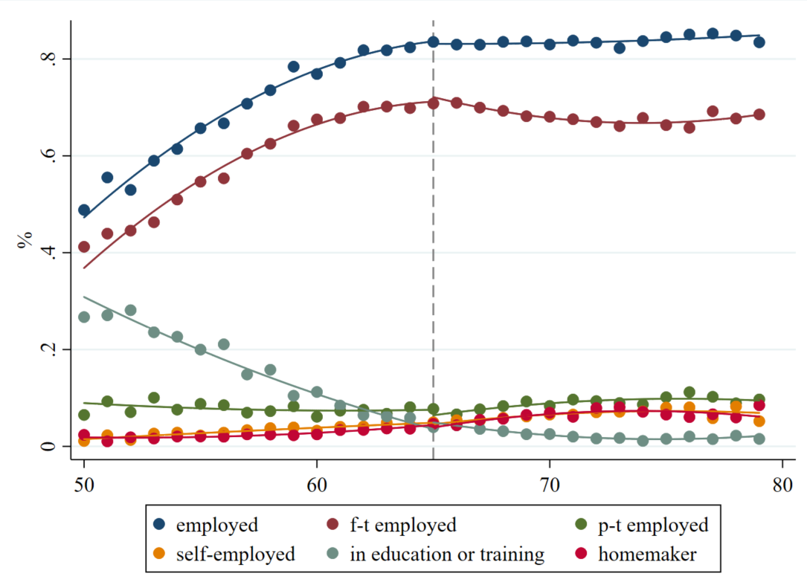

Fig A2 Children’s marital and fertility status by parental age
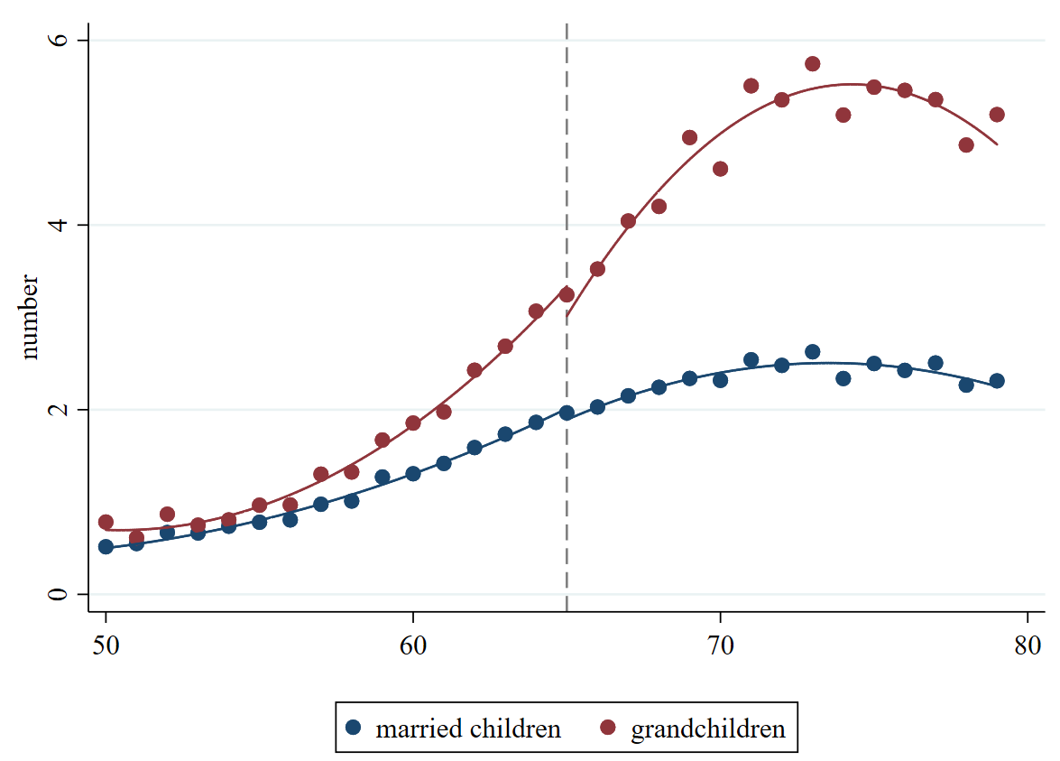

Fig A3 Financial Transfers by age
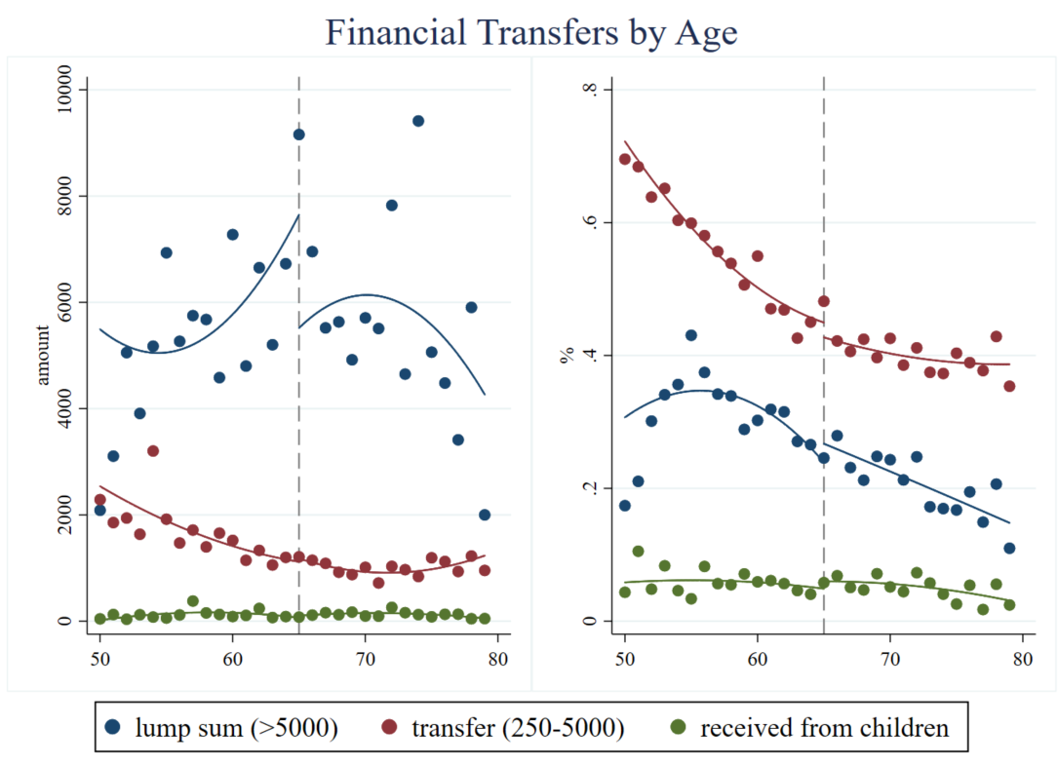

Fig A4 Non-financial transfers by age
