SUPPLEMENTARY MATERIAL

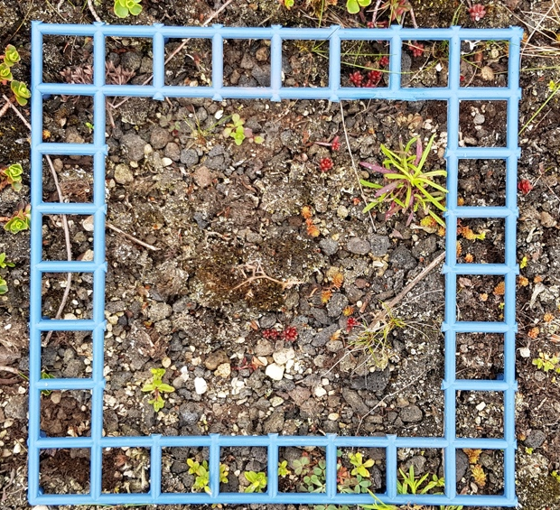


Fig. 3 Pictures used to estimate vegetation cover

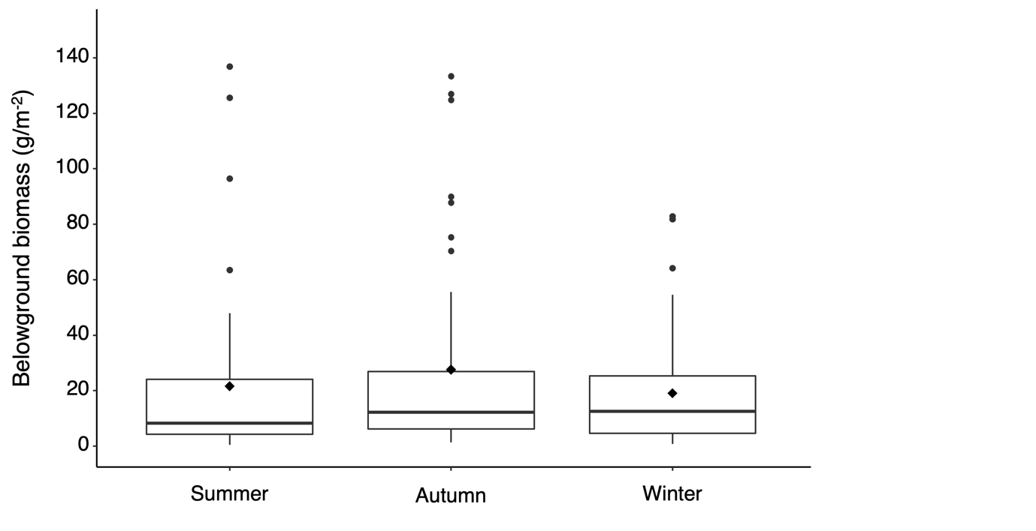
Fig. 4 Average belowground biomass (g m⁻²) per season. Boxplots show the 25th, 50th and 75th percentiles, with whiskers reaching 2.5% and 97.5% of the distribution, with the average as a dot inside the box and outliers outside the range

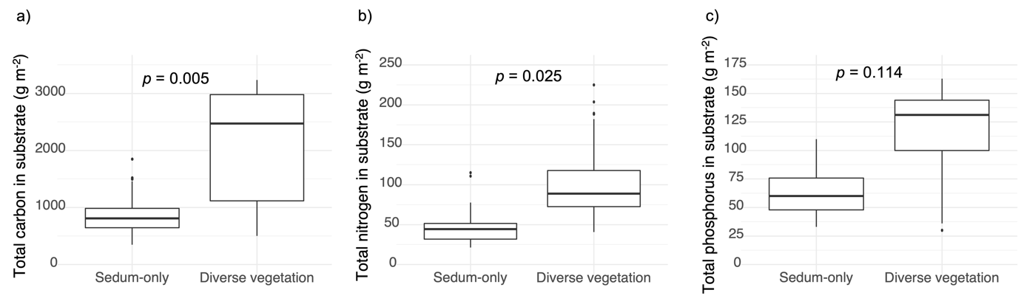
Fig. 5 Average (a) TC (g m⁻²), (b) TN (g m⁻²), and (c) TP (g m⁻²) in green roof substrate of fertilized Sedum-only roofs and diverse-vegetation roofs
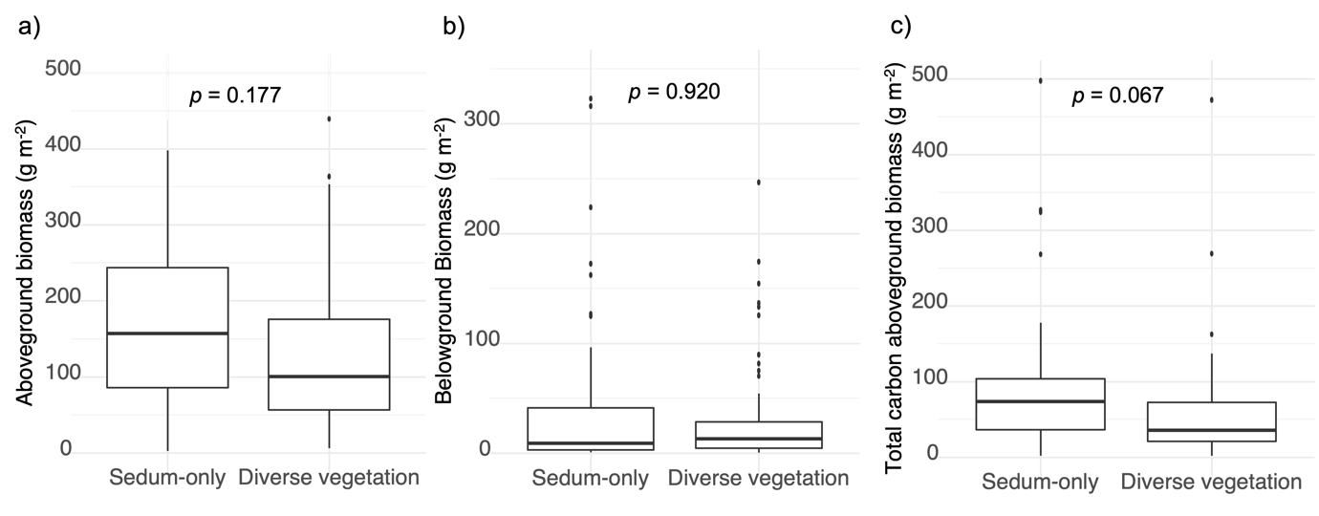
Fig. 6 Average (a) aboveground biomass (g m⁻²), (b) belowground biomass (g m⁻²), and (c) TC of aboveground biomass (g m⁻²) for Sedum-only roofs and diverse-vegetation roofs

Table 5 Minimum and maximum temperature (°C) per city per month per year (Data obtained from the Royal Institute of Meteorology of Belgium (KMI),2022)

 |  |  |  |  | Temperature (°C)
 | Antwerp |  |  | Ghent |  |  | Hasselt
 | Min. | Max. |  | Min. |  | Max. | Min. | Max.
January | 1.4 | 5.8 |  | 1.2 |  | 5.7 | 0.1 | 5.2
February | 1.1 | 11.8 |  | 1.9 |  | 11.5 | -0.3 | 11.8
March | 4.7 | 12.3 |  | 4.9 |  | 12.1 | 3.8 | 12.2
April | 4.9 | 16.6 |  | 4.9 |  | 16.0 | 4.2 | 16.2
May | 7.8 | 16.7 |  | 7.4 |  | 16.7 | 6.6 | 16.9
June | 13.1 | 24.1 |  | 13.0 |  | 23.4 | 12.7 | 24.8
July | 14.4 | 24.9 |  | 13.5 |  | 24.5 | 12.2 | 25.2
August | 14.0 | 24.9 |  | 13.2 |  | 24.4 | 11.9 | 24.8
September | 10.5 | 20.2 |  | 9.7 |  | 20.0 | 7.6 | 20.4
October | 9.0 | 15.4 |  | 9.2 |  | 15.3 | 9.0 | 15.4
November | 2.5 | 9.8 |  | 3.8 |  | 9.7 | 2.6 | 9.9
December | 2.5 | 8.9 |  | 3.1 |  | 8.9 | 2.5 | 8.7
Year average | 7.2 | 16.0 |  | 7.2 |  | 15.7 | 6.1 | 16.0

Table 6 Rainfall (mm) in Antwerp, Ghent and Hasselt per month and per year. Average rainfall in Flanders, Belgium is 910 mm year⁻¹ (Data obtained from KMI, 2022)

 | Rainfall (mm)
 | Antwerp | Ghent | Hasselt
January | 71.3 | 69.5 | 72.5
February | 45.6 | 51.9 | 45.3
March | 89.7 | 83.3 | 97.7
April | 28.1 | 21.8 | 17.8
May | 45 | 41.8 | 46.9
June | 87.9 | 90.2 | 93
July | 45.3 | 36.7 | 30.8
August | 51.2 | 39.1 | 71.4
September | 58.3 | 76.5 | 52.1
October | 91.8 | 70.0 | 102.8
November | 61 | 67.3 | 56.7
December | 70.7 | 82.4 | 66.3
Year total | 745.9 | 730.5 | 753.3

Table 7 Number of plant species that were identified during four monitoring periods (May, June, August and September 2019)

Roof ID | Number of plant species
1 | 40
2 | 39
3 | 22
4 | 22
5 | NA
6 | NA
7 | 33
8 | 42
9 | 15
10 | 17
11 | 27
12 | 27

