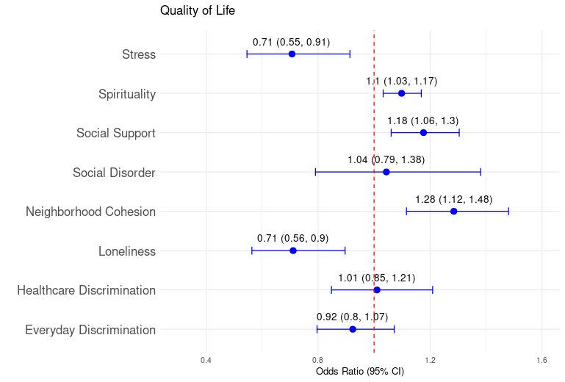
SUPPLEMENTAL FIGURES AND TABLES
Figure S1: SNOMED codes for diagnoses used in cancer and comorbidity analysis
 | Diagnosis | SNOMED Code(s)
Cancer | Anus | 255084004, 126849006, 126850006, 449416001, 93676009
Cancer | Biliary | 126853008, 363415003, 371970002, 312104005
Cancer | Colon | 126838000, 721698005, 126841009, 363406005, 109838007, 363407001
Cancer | Esophageal | 126818001, 276804009, 126820003, 126819009, 187722004, 372138000, 187724003, 187723009, 372017008, 371984007
Cancer | Liver | 109841003
Cancer | Pancreas | 126859007, 717919005, 126864006, 363418001, 187791002, 126860002, 126862005, 372142002, 254611009, 254613007, 735735001
Cancer | Rectum | 126847008, 721700001, 93984006, 713573006
Cancer | Small Intestine | 448664009, 721670007, 126832004, 109837002, 95088009, 445737002, 363509000, 276818002, 94048009
Cancer | Stomach | 363349007, 109836006, 408647009, 187734007, 126824007, 372014001, 399967006, 721194008, 721634009
Comorbidities | Anxiety | 197480006
Comorbidities | Congestive Heart Failure (CHF) | 194767001, 42343007, 426611007, 15781000119107, 194779001, 194781004, 5148006, 83105008
Comorbidities | Cirrhosis | 420054005, 1761006, 266468003, 19943007, 425413006
Comorbidities | Chronic Kidney Disease (CKD) | 709044004, 431855005, 431856006, 433144002, 431857002, 433146000
Comorbidities | Chronic Obstructive Pulmonary Disease (COPD) | 13645005
Comorbidities | Cerebrovascular Accident (CVA) | 230690007, 266257000
Comorbidities | Dementia | 26929004, 52448006, 191519005, 1591000119103, 416975007, 429998004
Comorbidities | Depression | 35489007
Comorbidities | Diabetes | 73211009, 111552007, 46635009, 313435000, 44054006, 313436004
Comorbidities | Hemiplegia | 50582007, 48601000119107, 442024001, 442155009, 441717007, 442668000, 609557004
Comorbidities | Myocardial Infarction (MI) | 57054005, 54329005, 70211005, 73795002, 76593002, 401314000, 401303003, 15713121000119105, 285981000119103, 194821006, 22298006, 16837681000119104, 1755008, 66189004, 194856005
Comorbidities | Peptic Ulcer Disease (PUD) | 13200003
Comorbidities | Peripheral Vascular Disease (PVD) | 840580004, 400047006, 34881000119105

Figure S2: Matched cohorts for binomial logistic regression by time from diagnosis to survey completion: A) 3 months, B) 6 months, C) 1 year
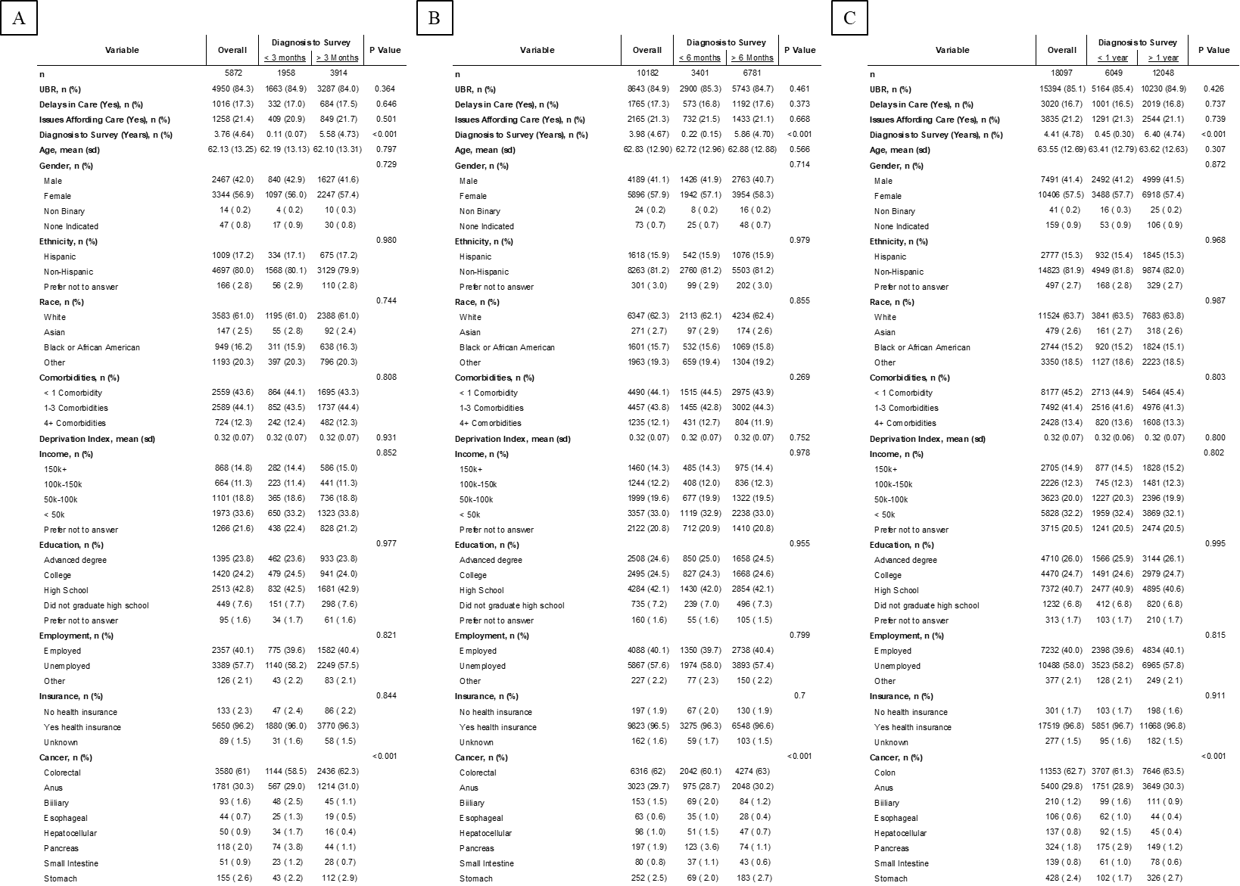
Figure S3: Number of reasons for A) delays in care or B) cost-related unmet needs for patients from diagnosis to survey completion
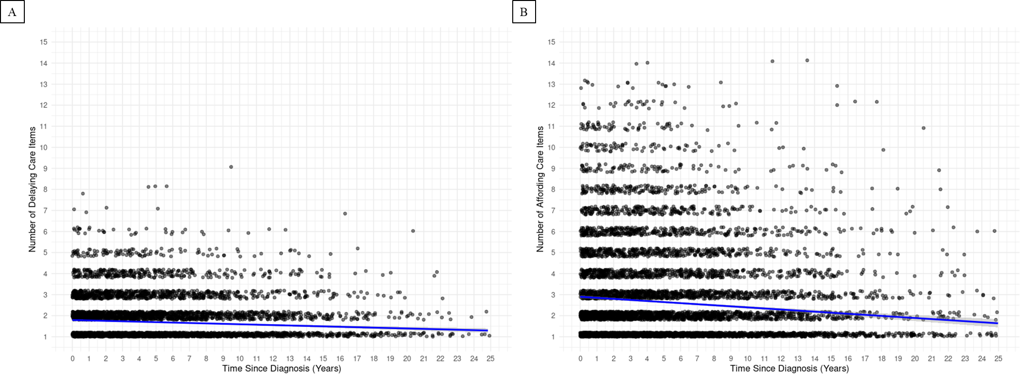

Figure S4: Sensitivity analysis for delays in care binomial logistic regression separated by time from diagnosis to survey completion: A) 3 months, B) 6 months, C) 1 year

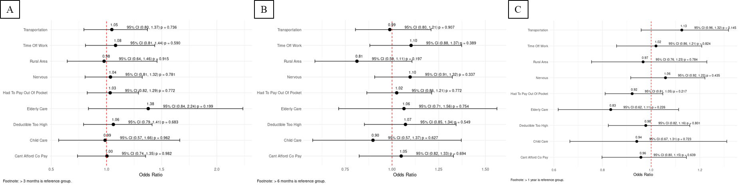

Figure S5: Sensitivity analysis for cost-related unmet needs binomial logistic regression separated by time from diagnosis to survey completion: A) 3 months, B) 6 months, C) 1 year

