Supplementary Material

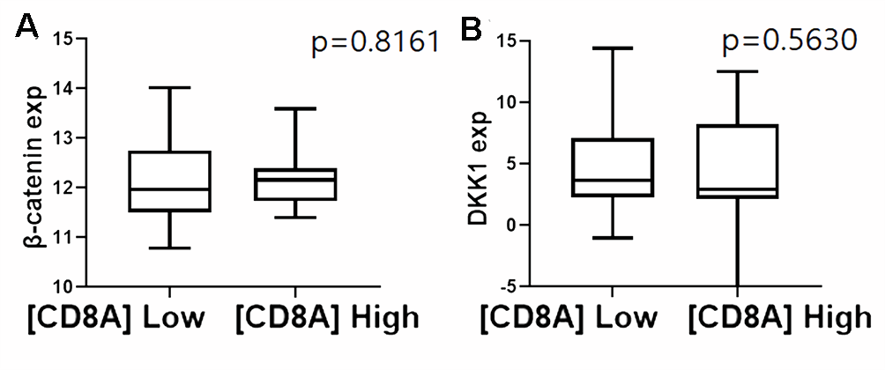
Supplementary Figure S1. Correlation among CD8A, DKK1, and CTNNB1 gene expression in BTC samples from TCGA database (n=45).
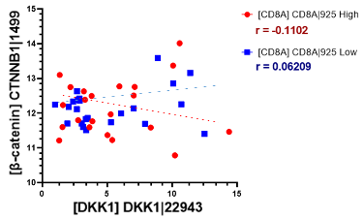
Supplementary Figure S2. Correlation among CD8A, DKK1, and CTNNB1 gene expression in BTC samples from TCGA database (n=45).
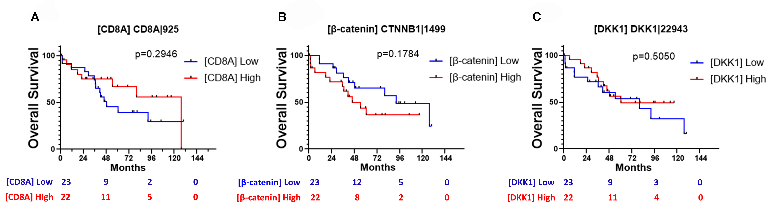
Supplementary Figure S3. Survival analysis according to the gene expression of (A) CD8A, (B) CD8A, and (C) DKK1.
A. CD8 [CD8A] plot B. β-catenin [CTNNB1] plot C. DKK1 [DKK1] plot
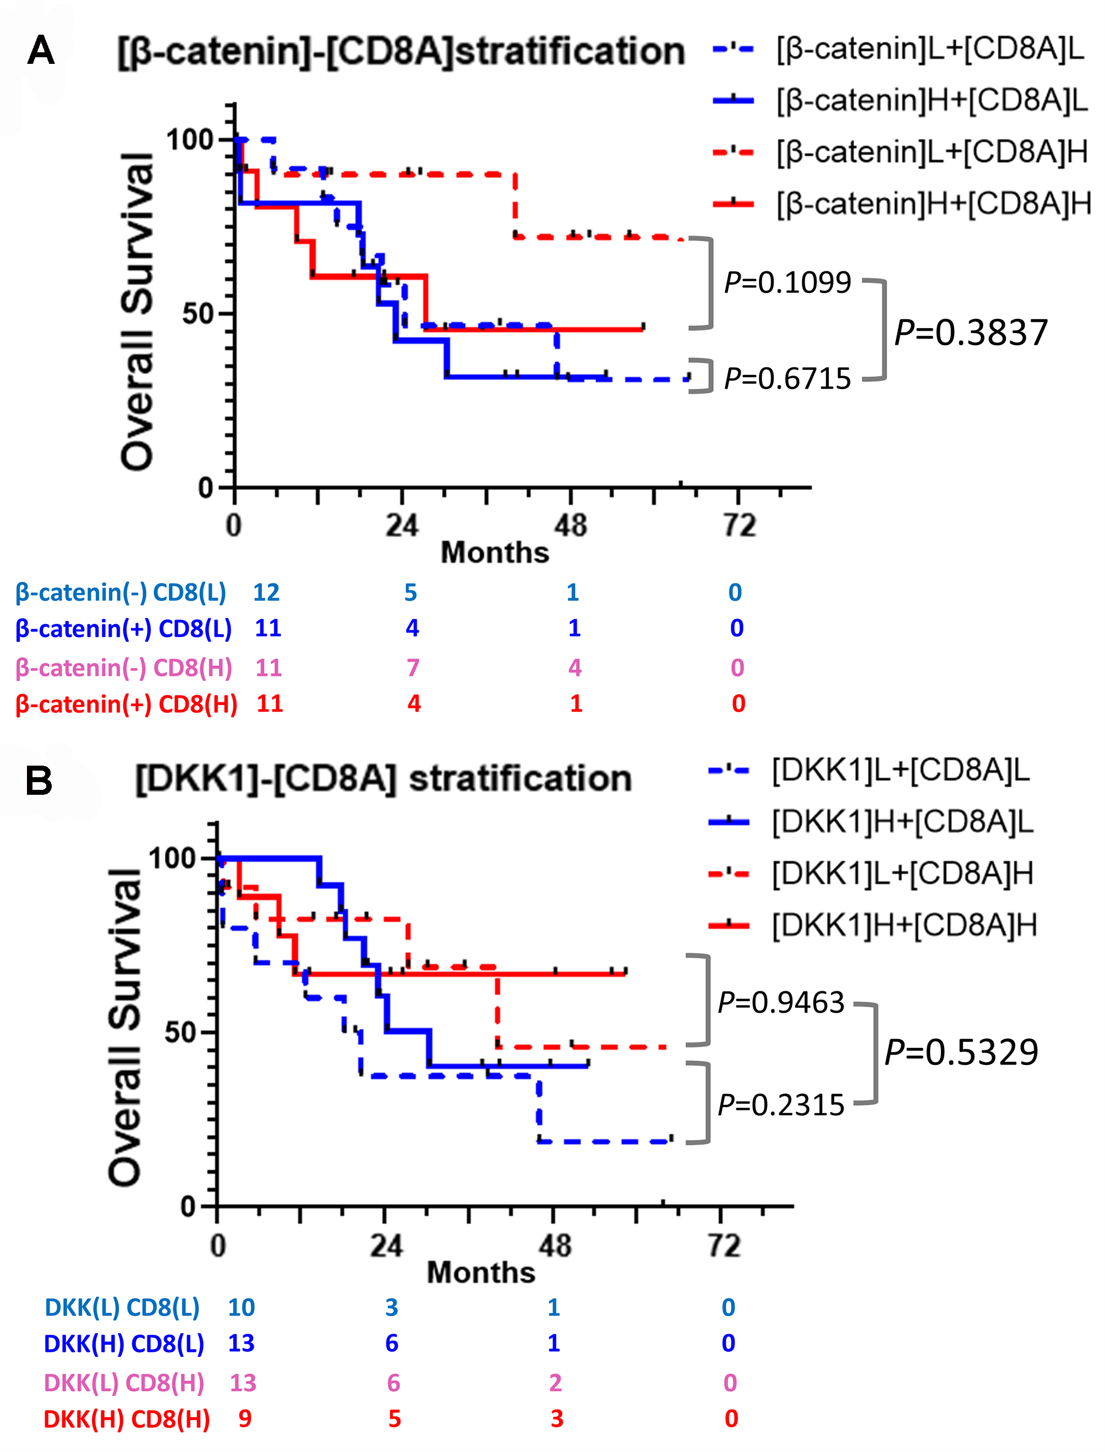
Supplementary Figure S4. Survival curves for (A) β-catenin and (B) DKK1 expression stratified according to CD8A gene expression.
A. β-catenin [CTNNB1] + CD8 [CD8A]
B. DKK1 [DKK1] + CD8 [CD8A]

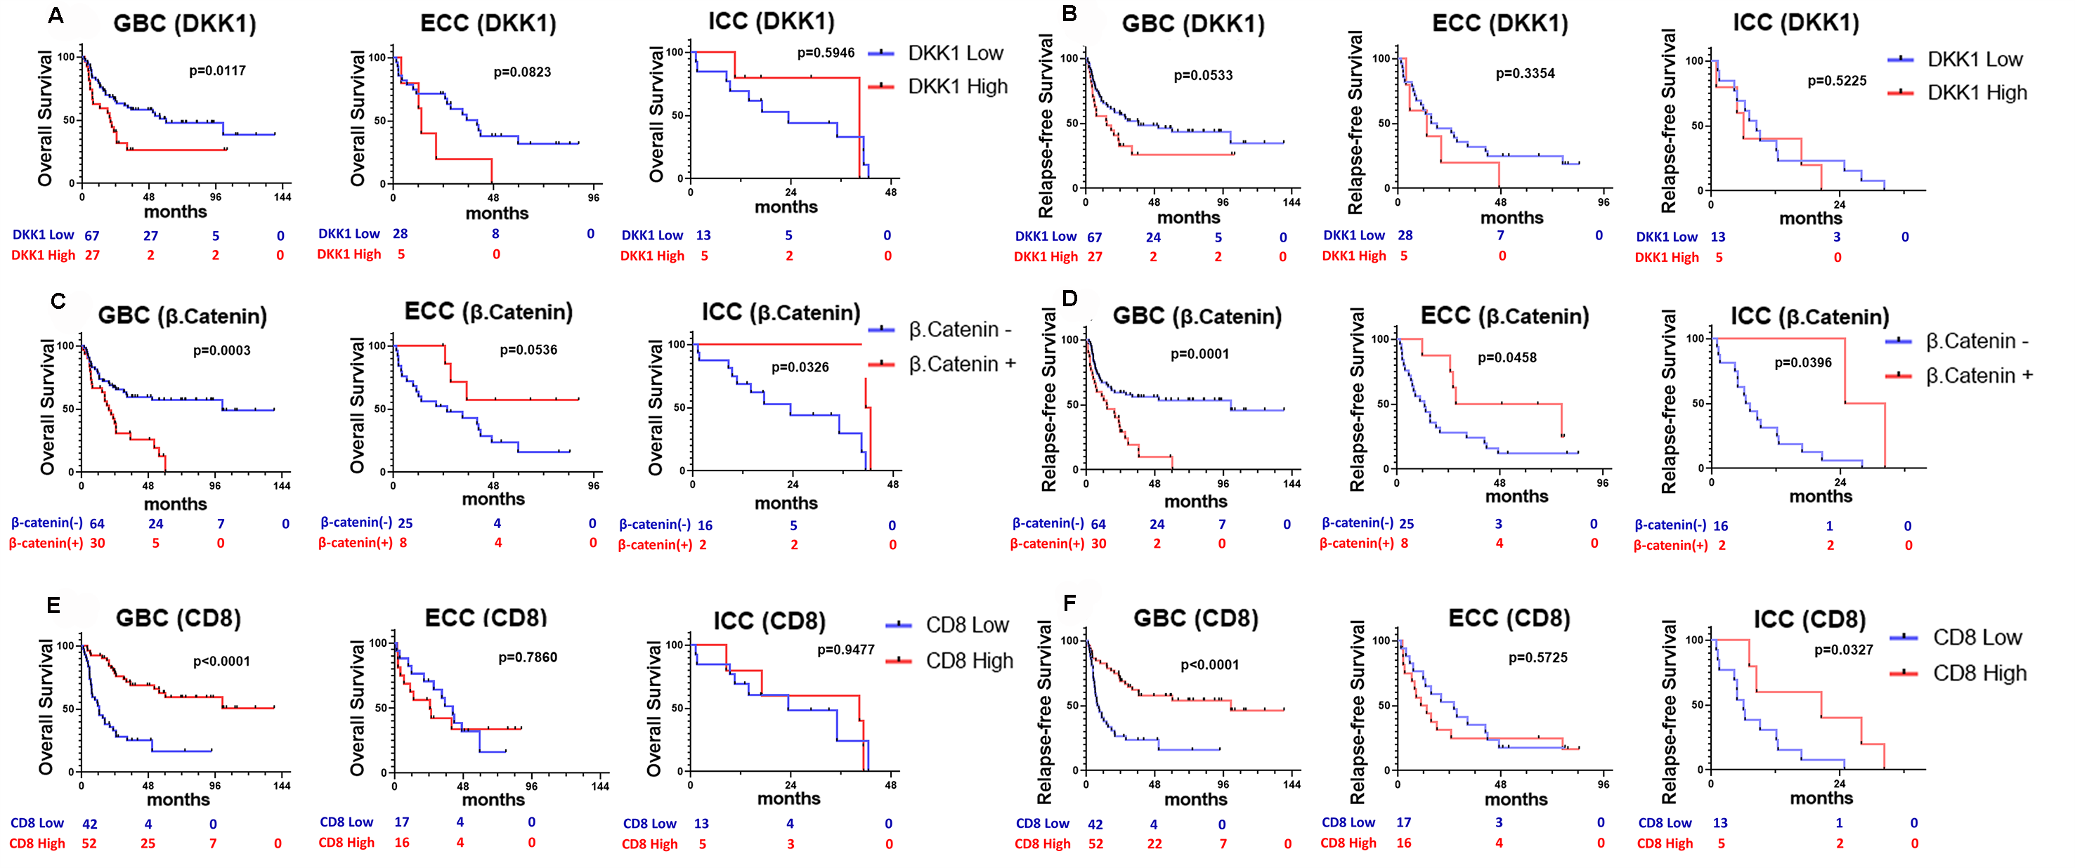Supplementary Figure S5. Comparison of clinical outcomes (overall survival and relapse-free survival) according to the levels of DKK1, beta-catenin, and CD8+TIL expression by primary tumor site.
GB, gallbladder; ECC, extrahepatic cholangiocarcinoma; ICC, intrahepatic cholangiocarcinoma
*ECC includes perihilar cholangiocarcinoma, common bile duct cancer, and distal common bile duct cancer.

