Supplementary figure
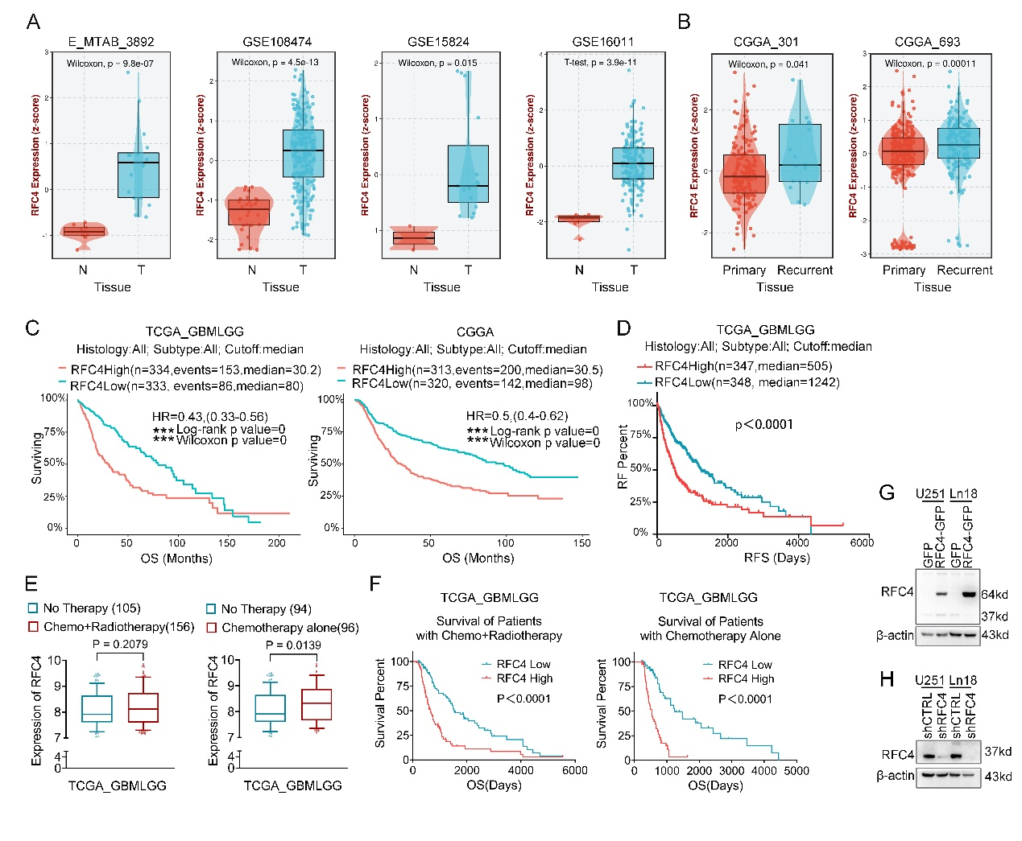
Fig. S1. RFC4 gene expression in TCGA PanCancer database.
A) Analysis of RFC4 mRNA expression across multiple glioblastoma cohorts in the BEST database (https://rookieutopia.hiplot.com.cn/app_direct/BEST/) revealed consistent upregulation in GBM specimens compared to non-tumor controls. B) BEST database analysis revealed higher RFC4 expression in recurrent tumors. C) Kaplan–Meier survival analysis on cases with RFC4^{High} vs. RFC4^{Low} from TCGA-GBMLGG (left) and CGGA (right) database. D) High RFC4 expression promotes tumor recurrence and shortens time to recurrence. E) Patients undergoing chemotherapy exhibited elevated RFC4 expression compared to untreated controls in TCGA-GBMLGG database. F) Kaplan–Meier survival analysis and recurrence curve on cases receiving chemotherapy without radiation therapy under specific gene expression patterns according to TCGA_GBMLGG database. Elevated RFC4 expression is associated with reduced overall survival (OS) in glioblastoma patients receiving chemoradiotherapy, particularly demonstrating pronounced prognostic impact in chemotherapy-only treated cohorts. G, H) Stable isogenic U251 and Ln18 cell lines with RFC4 overexpression (G) and shRNA-mediated knockdown (H) were established, with RFC4 expression levels validated by western blot (β-actin loading control).
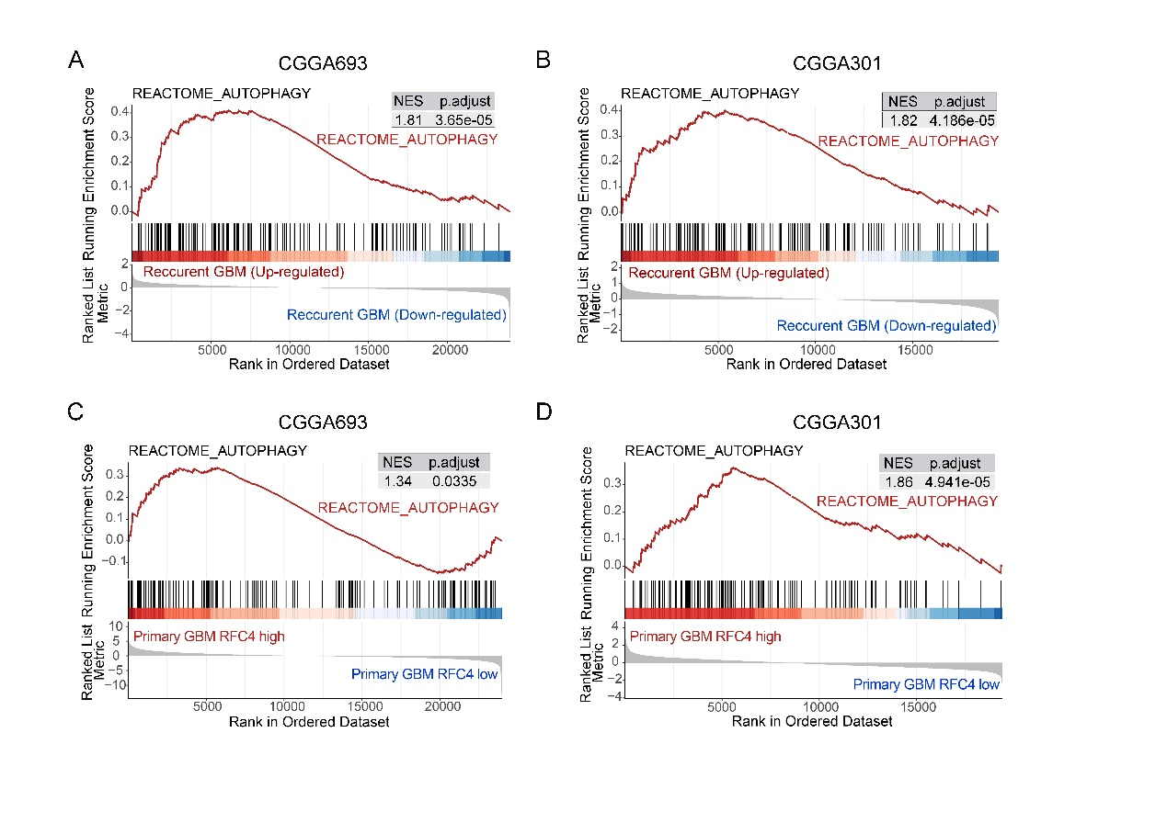
Fig. S2. Gene Set Enrichment Analysis (GSEA) reveals enrichment of autophagy pathway in recurrent glioblastoma and RFC4-high tumors.​​
A, B)​​ Significant enrichment of the REACTOME_AUTOPHAGY gene set in recurrent versus primary glioblastoma (rGBM vs. pGBM) was demonstrated by GSEA analysis of the CGGA database.​ C, D)​​ GSEA (CGGA): REACTOME_AUTOPHAGY enriched in RFC4-high vs. RFC4-low GBM tumors.
​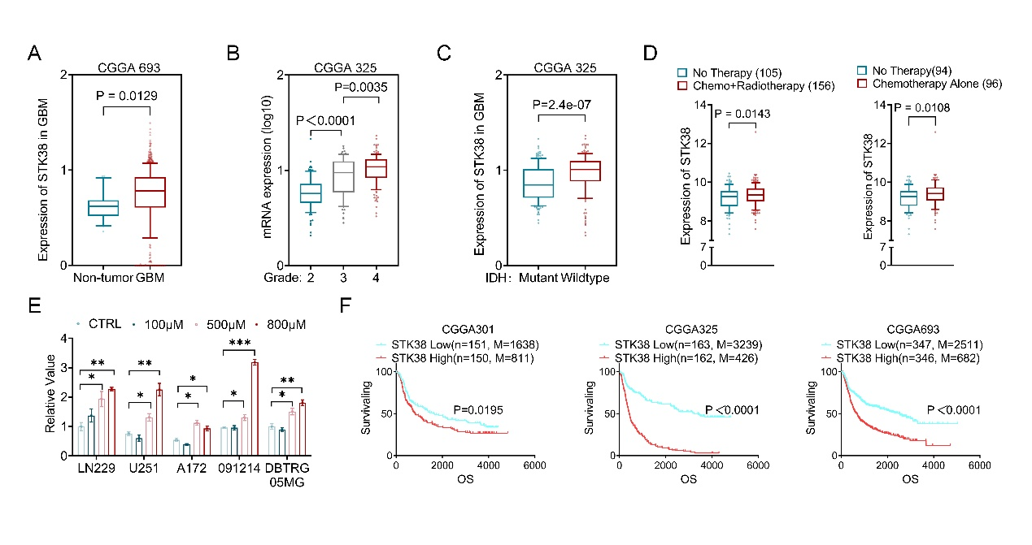
Fig. S3. The clinical and therapeutic significance of STK38 in GBM.
A-C) STK38 mRNA expression is significantly elevated in GBM compared to non-tumor tissues (A) and progressively increases with higher WHO tumor grades (​B), particularly in IDH-wildtype subtypes(C). D) Therapeutic exposures modulate STK38 levels, showing marked upregulation in chemotherapy-treated patients (​P=0.0108) and dose-dependent induction by TMZ across six GBM cell lines (E, 100-800μM, ​**​P<0.001). F) Survival analyses of three independent CGGA cohorts (301/325/693, total n=1,263) reveal STK38-high patients exhibit substantially reduced median overall survival.

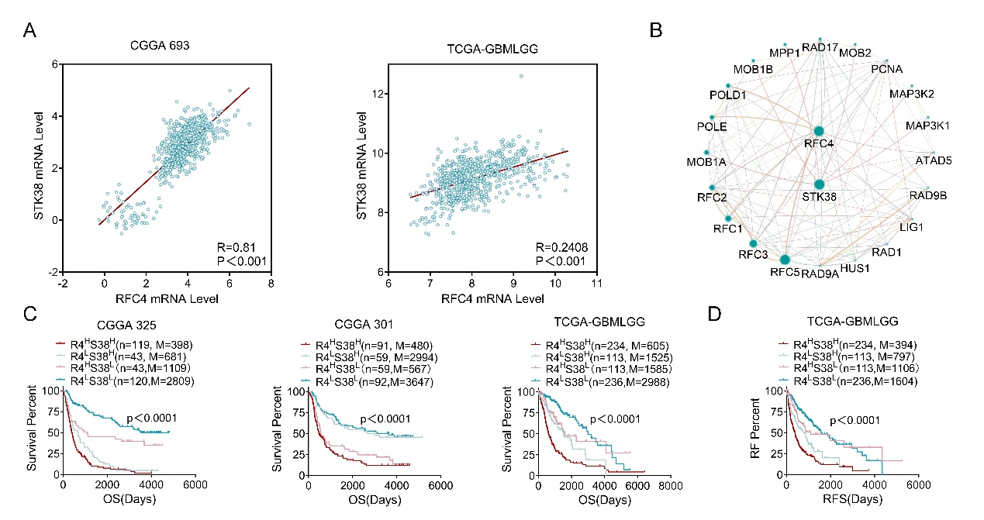
Fig. S4. Integrated analysis demonstrates the functional dependence of RFC4 on STK38 in glioma progression.
A) Scatter plots reveal a significant positive correlation between STK38 and RFC4 mRNA co-expression across CGGA693 and TCGA-GBMLGG cohorts. B) Protein-protein interaction network identifies STK38 as a key node functionally linked to RFC4, suggesting direct regulatory interplay. C, D) Survival analyses delineate markedly reduced overall survival (OS, C) and recurrence-free survival (RFS, D) in patients with dual high STK38/RFC4 expression compared to low-expression subgroups, underscoring the clinical relevance of their synergistic activity.

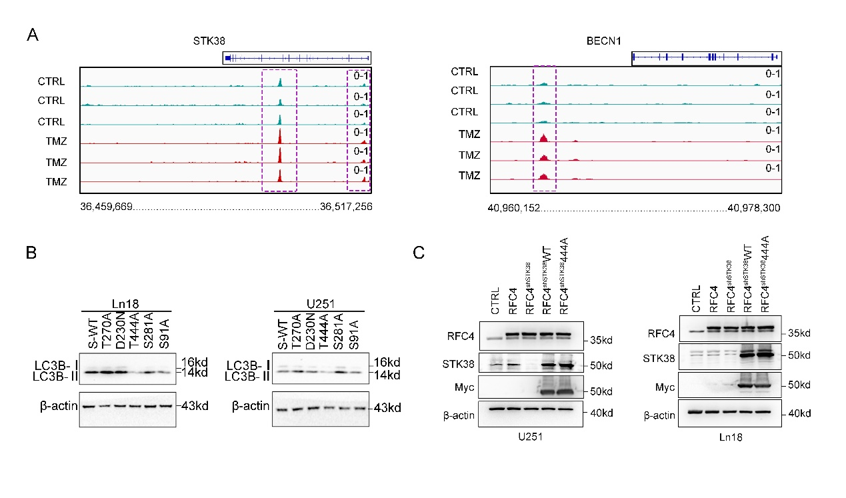
Fig. S5. The T444 mutation in STK38 inhibits autophagy.
A) ATAC-seq was used to detect the chromatin accessibility of STK38 (36,459,669-36,517,256) and BECN1 (40,960,152-40,978,300) in LN229 TMZ-resistant cells.
B) Different STK38 mutation plasmid was transfected in U251 and Ln18 GBM cells when STK38 was knocked out and RFC4 was overexpressed. LC3B was detected by Western Blot. T444A mutation of STK38 hindered the autophagic process induced by RFC4.
C) Western blot validates RFC4 overexpression and STK38 manipulation in U251/LN18 cells. RFC4 levels increase in overexpression groups (RFC4) compared to control (CTRL). STK38 knockdown (RFC4 shSTK38) abolishes endogenous STK38 while maintaining elevated RFC4. Rescue experiments were conducted using STK38-WT or T444A mutant plasmids engineered to resist shSTK38-mediated knockdown.

