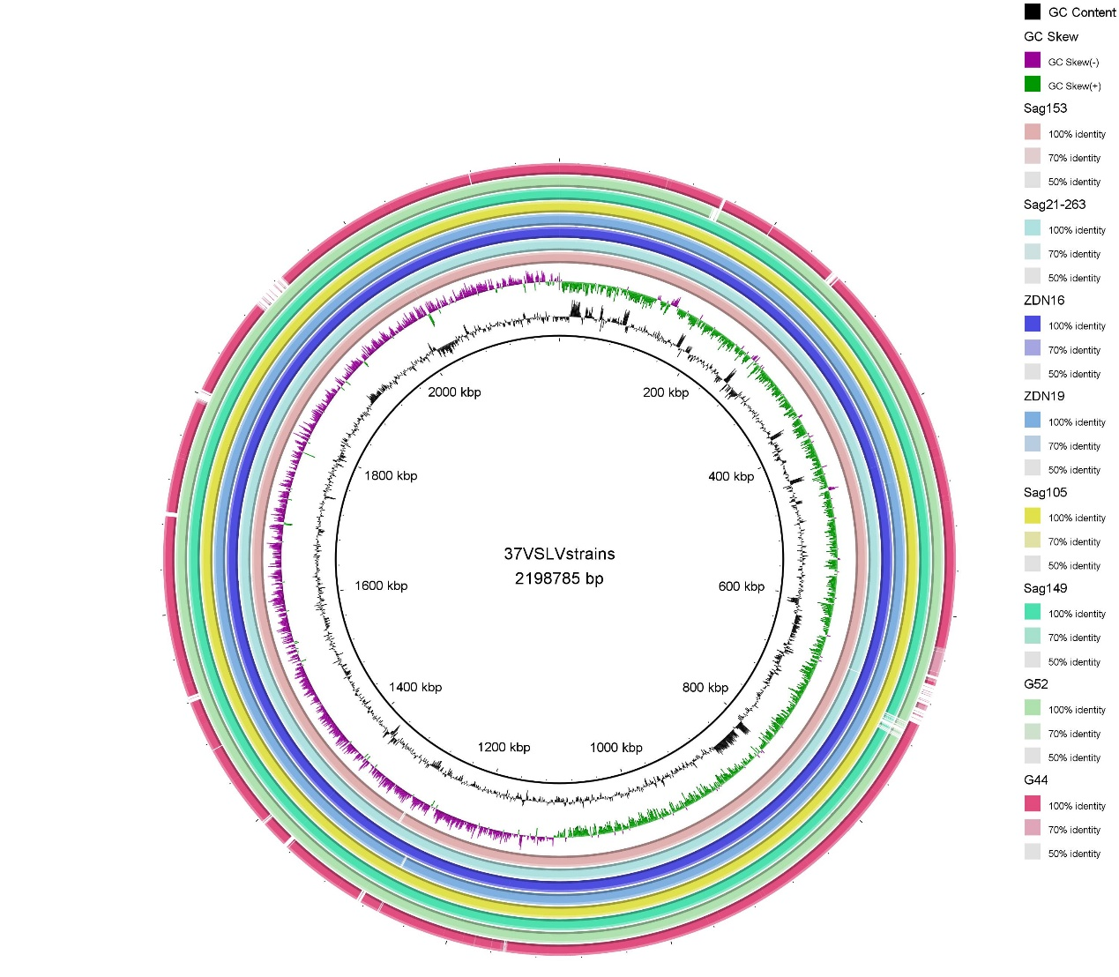

S-F1 Genome comparisons of hypervirulent S. agalactiae strain Sag37 against strains of low virulence.

