Supplementary Materials for
Lattice oxygen oxidation in Oxygen Vacancy-rich Co₃O₄ for the Electrooxidation of 5-Hydroxymethyfurfural
Yuxuan Lu,^{[a],+} Tianyang Liu,^{[b],+} Chunming Yang,^{[a,c],+} Chung-Li Dong,^{[d],+} Yucheng Huang,^{[d],+} Yafei Li,^{[b],+} Bo Zhou,^{[a]} Ling Zhou,^{[a]} Yujie Wu,^{[a]} Zhijie Kong,^{[a]} Ming Yang,^{[a]} Yandong Wu,^{[a]} Weixing Zhao,^{[a]} Yuqin Zou,^{*[a]} Shuangyin Wang^{*[a]}
⁺Y.H.L., T.Y.L, C.M.Y, C.L.D, Y.C.H and Y.F.L equally contributed to this work.
*Correspondence to: yuqin_zou@hnu.edu.cn

Supporting Figures

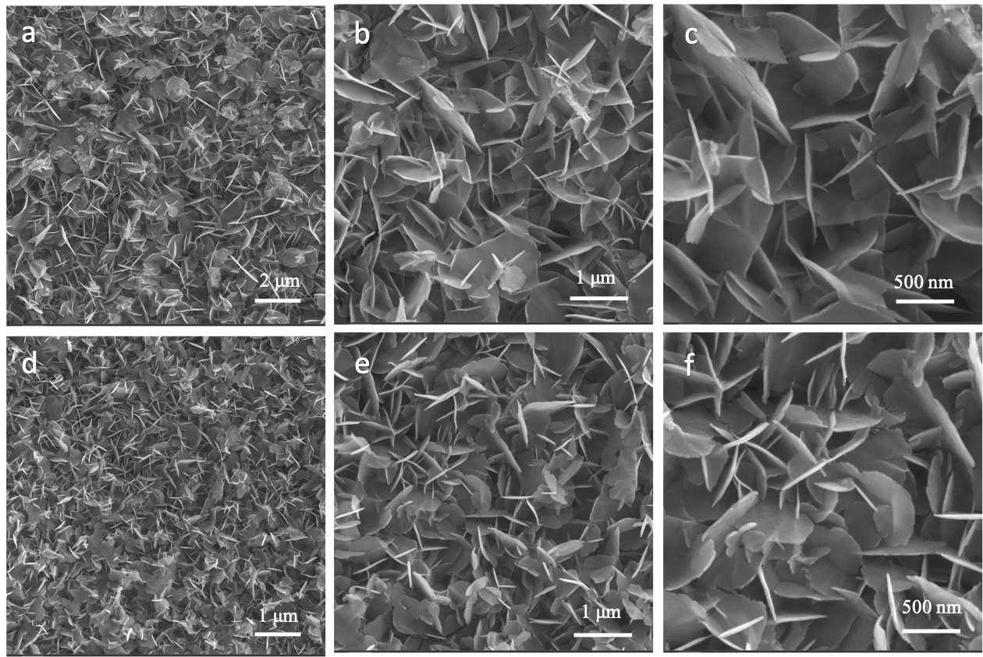
Supplementary Fig. 1 SEM images of (a-c) Co₃O₄; (d-f) Vo-Co₃O₄.

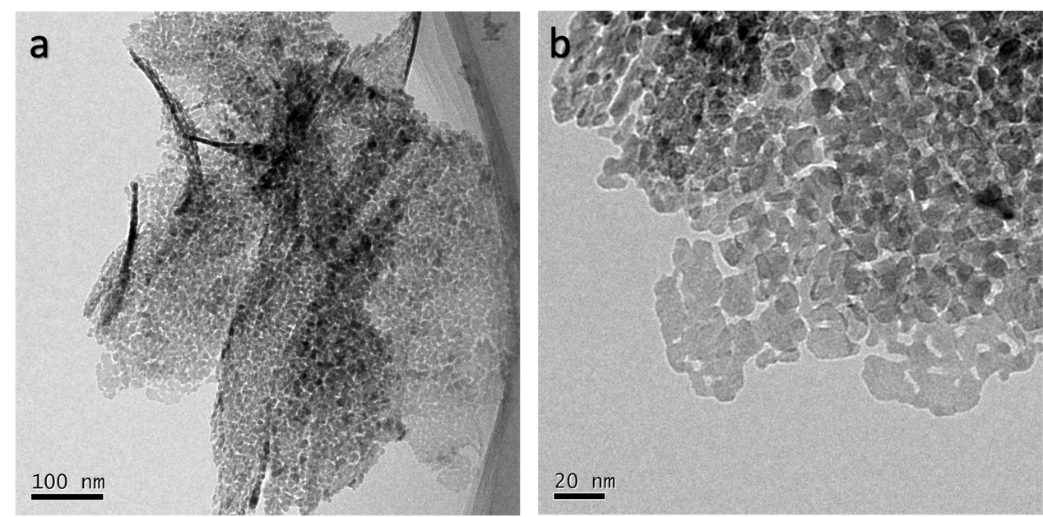
Supplementary Fig. 2 (a-b) TEM images of Co₃O₄.

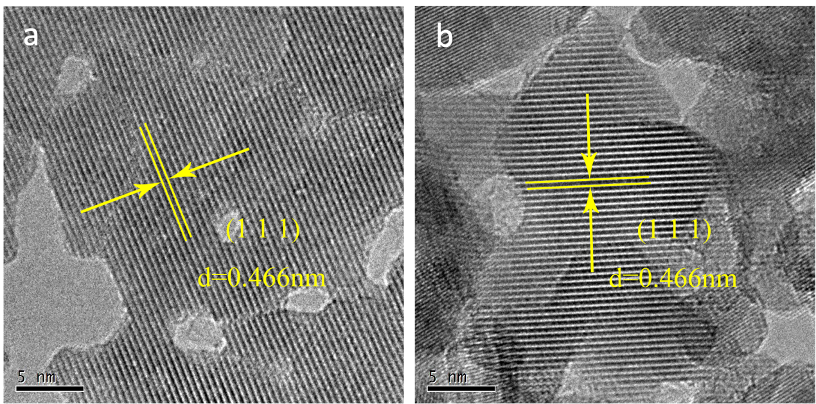
Supplementary Fig. 3 (a-b) HR-TEM image of Co₃O₄ .

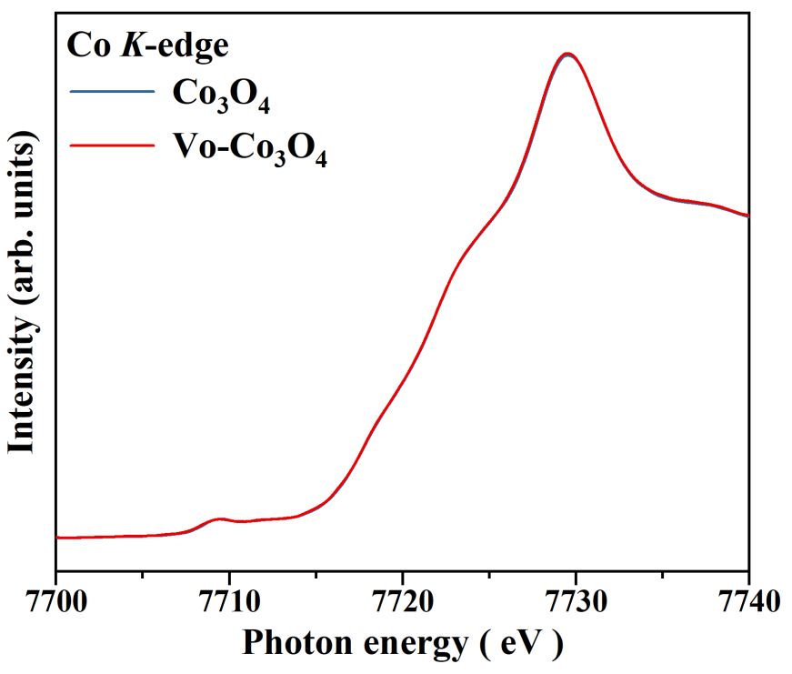
Supplementary Fig. 4 XANES spectra of Co₃O₄ and Vo-Co₃O₄;

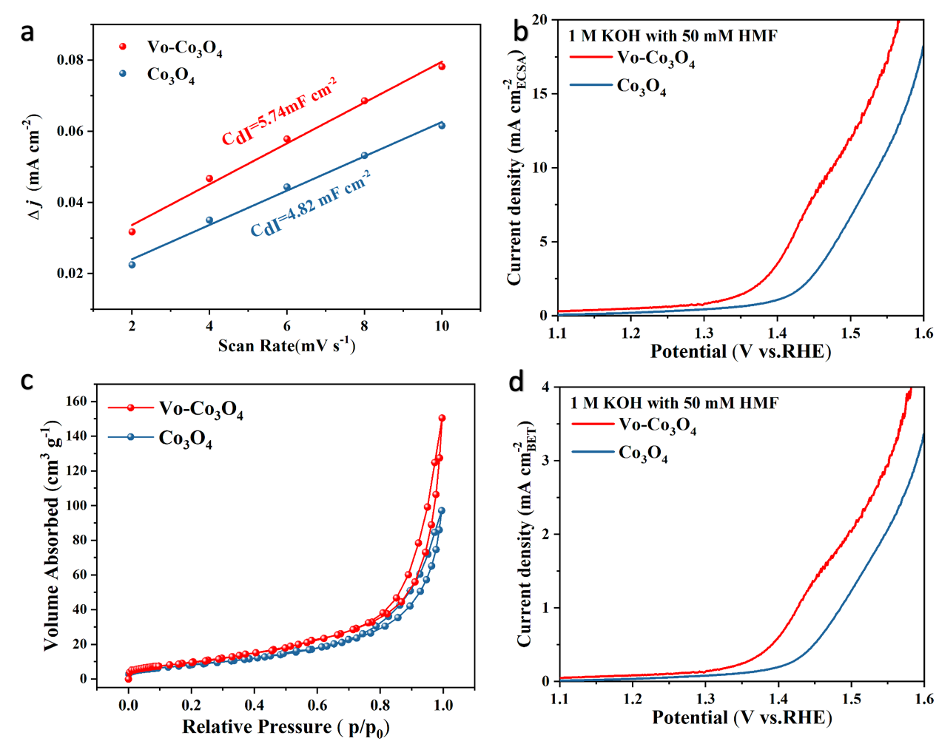
Supplementary Fig. 5 (a) The C_{dl} of Vo-Co₃O₄ and Co₃O₄; (b) The LSV curves of the Vo-Co₃O₄ and Co₃O₄ after normalized by ECSA area; (c) N₂ adsorption-desorption isotherms of Vo-Co₃O₄ and Co₃O₄. (d) The LSV curves of the Vo-Co₃O₄ and Co₃O₄ after normalized by BET area.

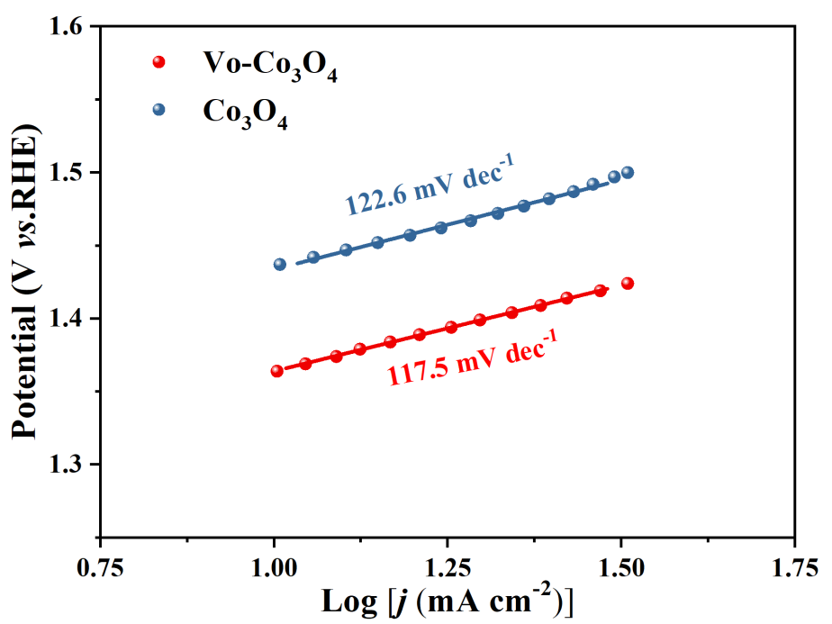
Supplementary Fig. 6 Tafel slope of Vo-Co₃O₄ and Co₃O₄.

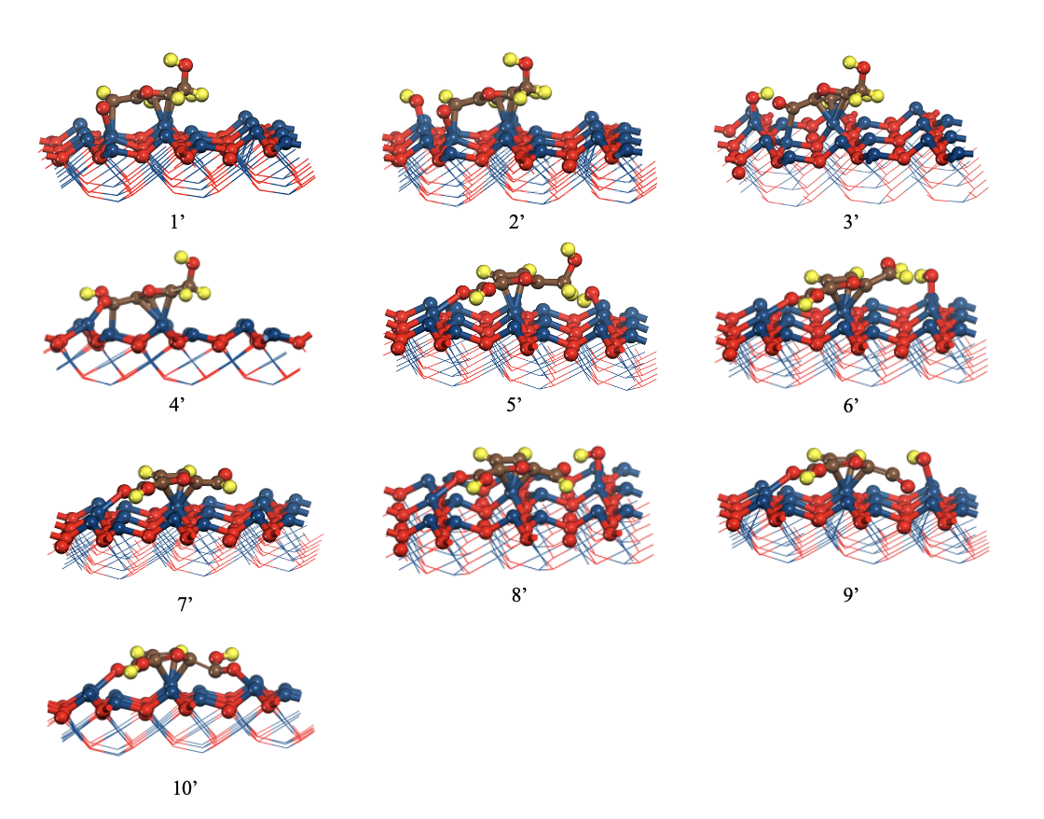
Supplementary Fig. 7 The reaction intermediate state models for Co₃O₄ during HMFOR process.

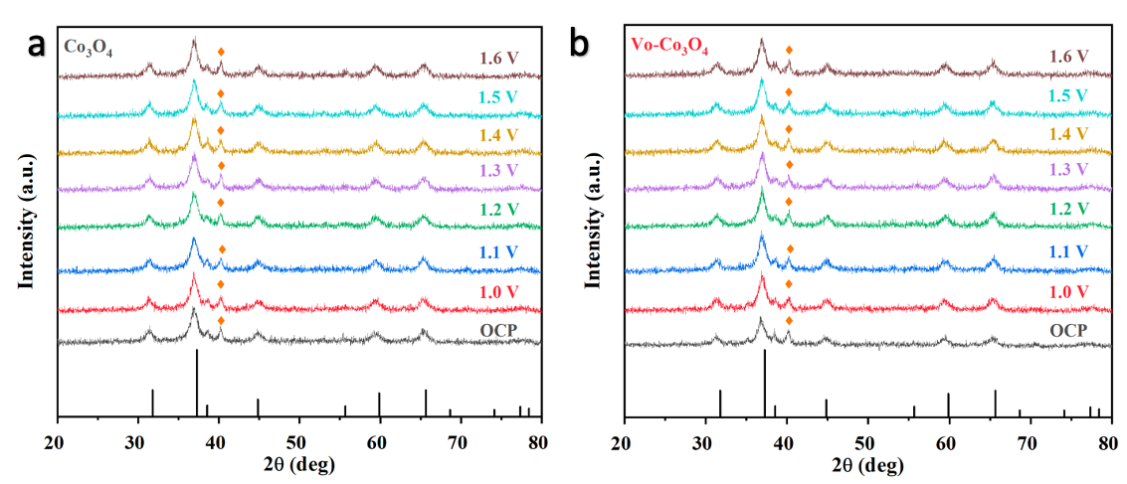
Supplementary Fig. 8 The XRD pattern of (a) Co₃O₄ and (b) Vo-Co₃O₄. The peak which marked by orange is attributed to Ti mesh.

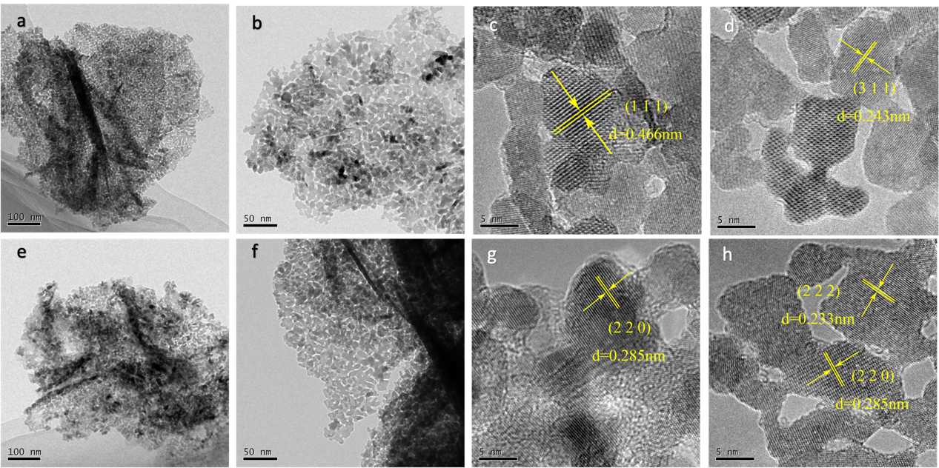
Supplementary Fig. 9 (a-b) The TEM images of Co₃O₄ after HMFOR; (c-d) The HRTEM images of Co₃O₄ after HMFOR; (e-f) The TEM images of Vo-Co₃O₄ after HMFOR; (g-h) The HRTEM images of Vo-Co₃O₄ after HMFOR;

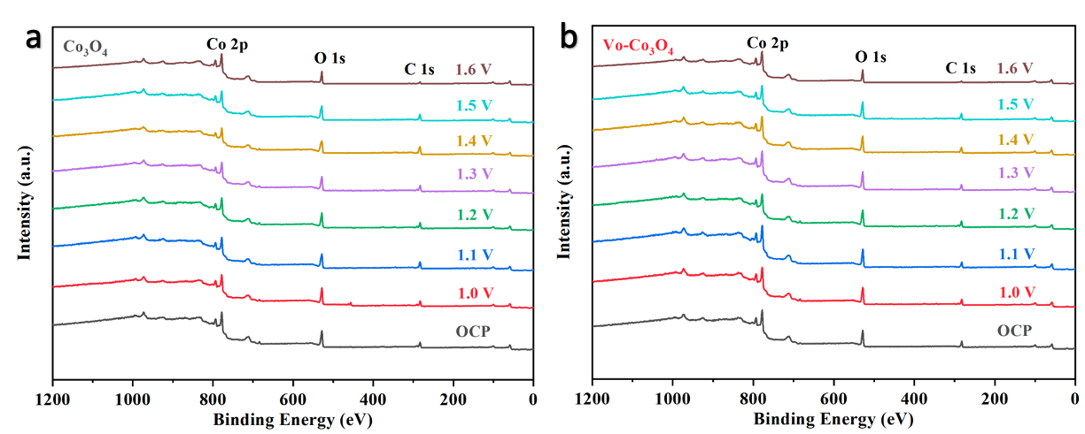
Supplementary Fig. 10 The XPS spectra for (a) Co₃O₄ and (b) Vo-Co₃O₄ at various applied potentials.

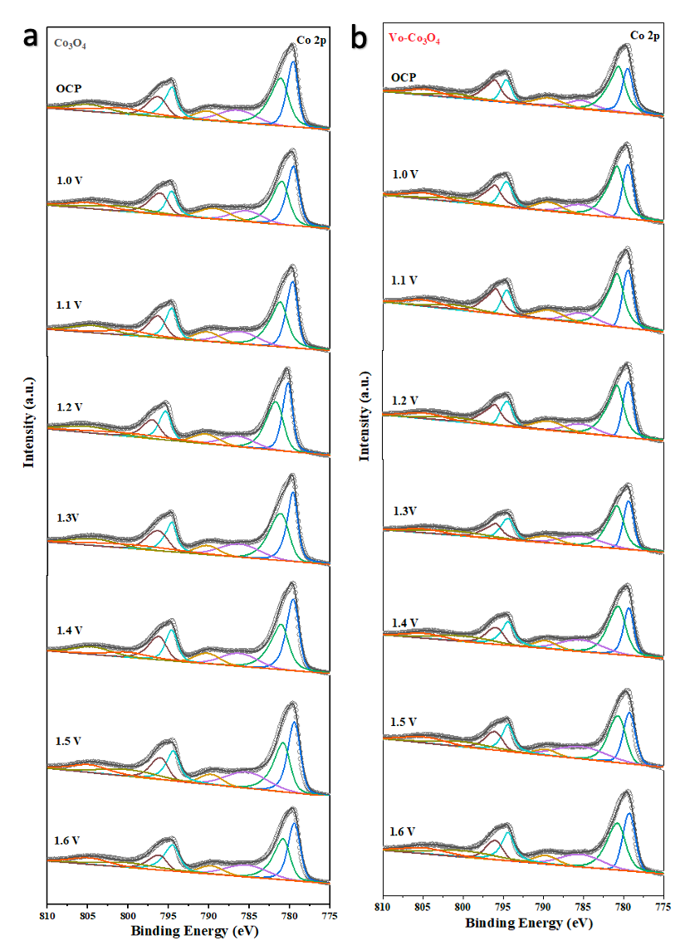
Supplementary Fig. 11 XPS spectra of Co 2p for (a) Co₃O₄ and (b) Vo-Co₃O₄ at various applied potentials.

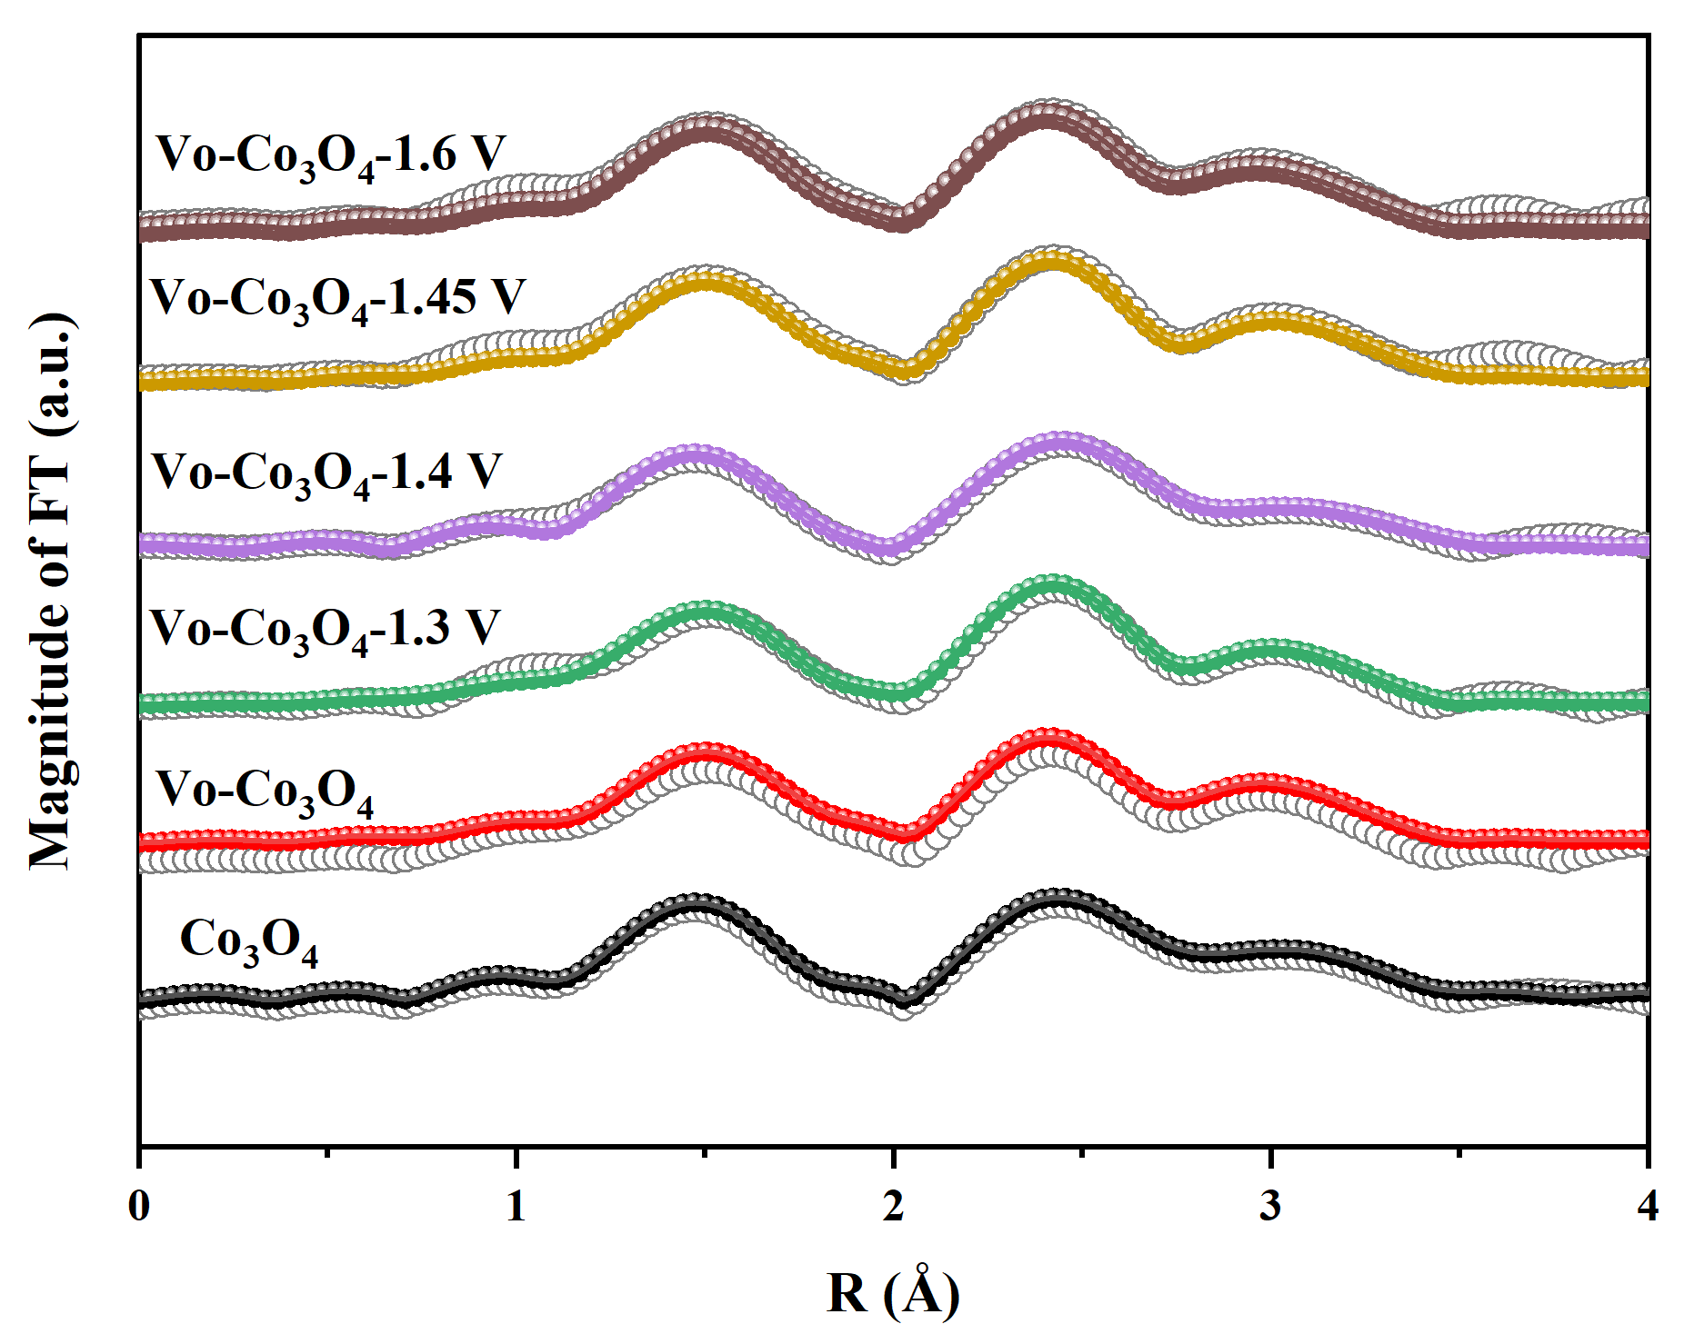
Supplementary Fig. 12 Operando EXAFS spectra and the corresponding fitting for Vo-Co₃O₄ and Co₃O₄ at critical potentials.

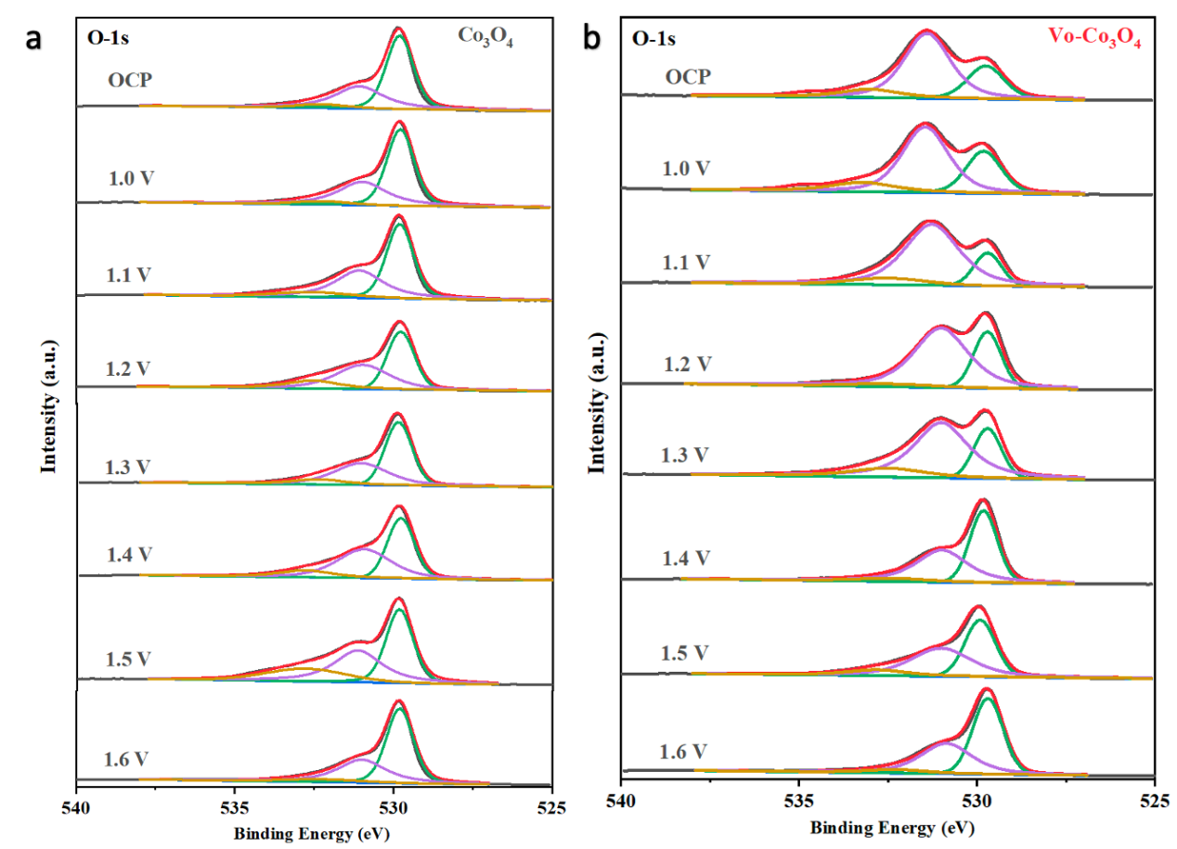
Supplementary Fig. 13 O 1s XPS spectra fitting for (a) Co₃O₄ and (b) Vo-Co₃O₄ at various applied potential.

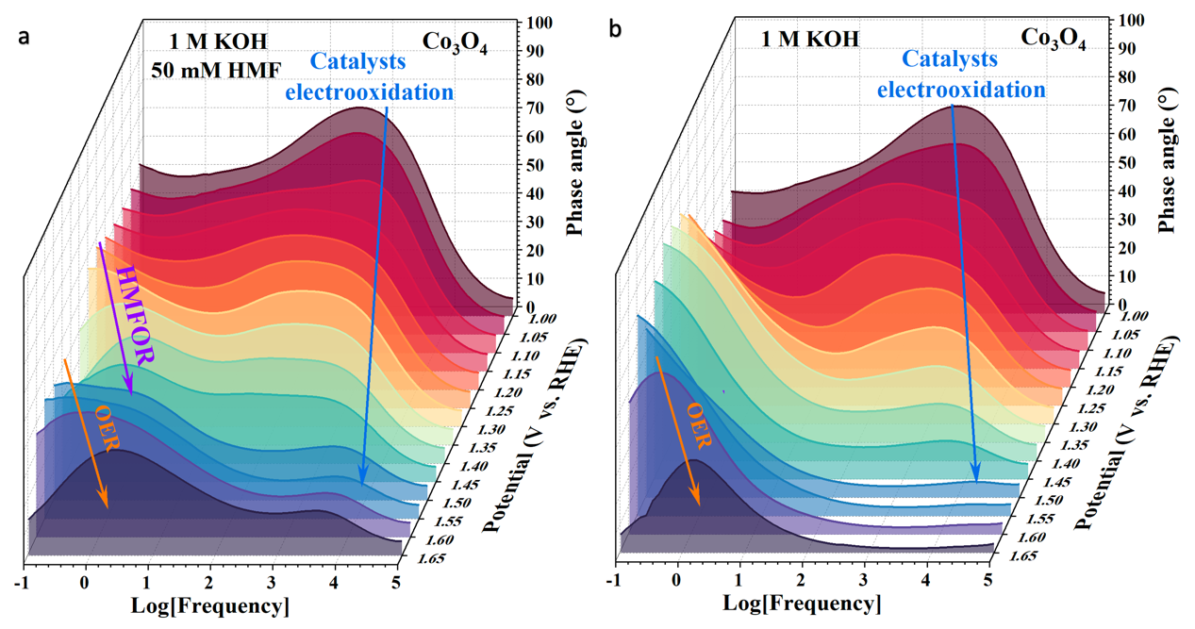
Supplementary Fig. 14 Bode phase plots of the in-situ EIS on Co₃O₄ in 1 M KOH (a) with and without (b) 50 mM HMF.

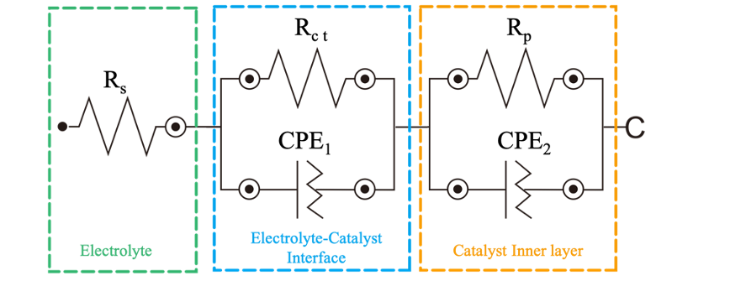
Supplementary Fig. 15 The equivalent circuit used for modeling the measured electrochemical response. The equivalent circuit image. R_{s} stands for the solution resistance, CPE₁ represents double layer capacitance, R_{ct} has contact with the interfacial charge transfer reaction, CPE₂ and R_{p} are related to the dielectric properties and the resistance of the electrode inner film.

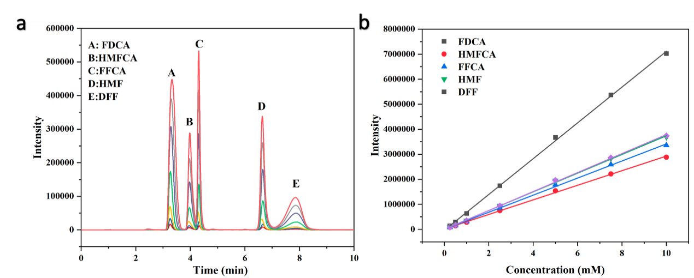
Supplementary Fig. 16 (a-b) HPLC standard curve measurements of pure HMF, HMFCA, FFCA, DFF and FDCA.

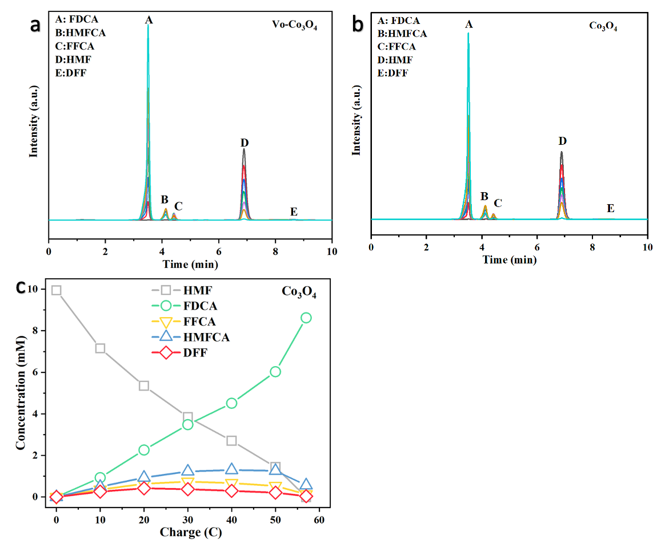
Supplementary Fig. 17 The HPLC chromatogram traces of the various products for (a) V_{o}-Co₃O₄ and (b) Co₃O₄ at different reaction times following an HMF electrochemical oxidation reaction in 1 M KOH; (c) The concentration of substrates, intermediates and products during the HMFOR for Co₃O₄.

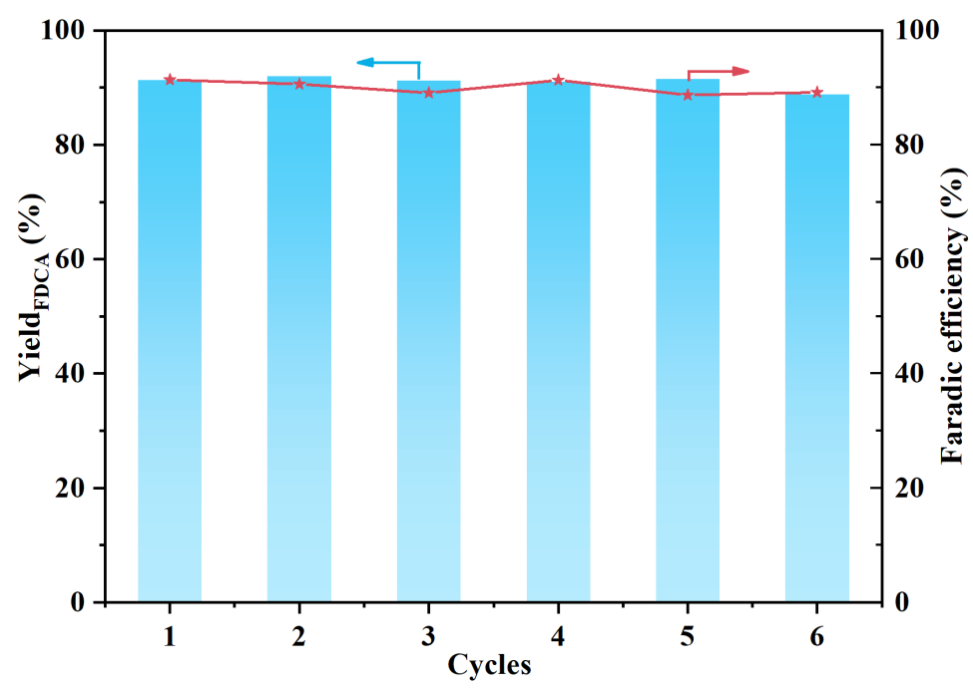
Supplementary Fig. 18 The yield (%) of FDCA and faradaic efficiency on Vo-Co₃O₄ under six successive electrolysis cycles.

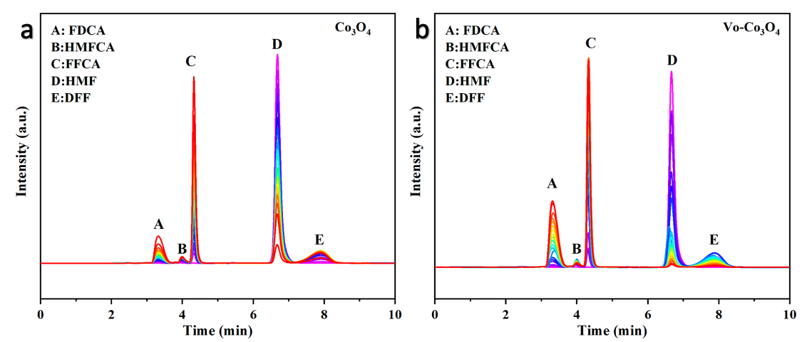
Supplementary Fig. 19 The HPLC chromatogram traces of the various products for (a) Co₃O₄ and (b) Vo-Co₃O₄ at different reaction times following an HMF electrochemical oxidation reaction in 1 M PBS.

Supporting Table.

Supplementary Table 1. Structural parameters of Vo-Co₃O₄ and Co₃O₄ extracted from the EXAFS fitting. (S₀²=0.738)
Potential | Sample | Path | CN | R(Å) | σ²(×10⁻³Å²) | △E₀ (eV) | R factor
OCP | Co₃O₄ | Co-O | 4.32 | 1.92 | 0.00242 | -4.744 | 0.005
 |  | Co-Co（Oh） | 4.06 | 2.85 | 0.00491 | -8.532 | 0.005
 |  | Co-Co（Td） | 9.72 | 3.35 | 0.00948 | -9.201 | 0.005
OCP | Vo-Co₃O₄ | Co-O | 4.08 | 1.91 | 0.00205 | -7.335 | 0.009
 |  | Co-Co（Oh） | 3.83 | 2.84 | 0.00447 | -9.703 | 0.009
 |  | Co-Co（Td） | 8.22 | 3.35 | 0.00822 | -9.509 | 0.009
1.3V | Vo-Co₃O₄ | Co-O | 4.43 | 1.91 | 0.00281 | -6.046 | 0.007
 |  | Co-Co（Oh） | 4.47 | 2.86 | 0.00448 | -6.797 | 0.007
 |  | Co-Co（Td） | 5.55 | 3.35 | 0.0044 | -8.727 | 0.007
1.4 V | Vo-Co₃O₄ | Co-O | 4.55 | 1.91 | 0.00265 | -6.386 | 0.007
 |  | Co-Co（Oh） | 3.79 | 2.84 | 0.00365 | -9.037 | 0.007
 |  | Co-Co（Td） | 8.56 | 3.34 | 0.00808 | -9.921 | 0.007
1.45 V | Vo-Co₃O₄ | Co-O | 4.82 | 1.91 | 0.00308 | -7.013 | 0.009
 |  | Co-Co（Oh） | 3.64 | 2.83 | 0.00329 | -11.684 | 0.009
 |  | Co-Co（Td） | 11.43 | 3.35 | 0.01119 | -8.936 | 0.009
1.6 V | Vo-Co₃O₄ | Co-O | 4.799 | 1.91 | 0.00261 | -8.065 | 0.011
 |  | Co-Co（Oh） | 3.768 | 2.83 | 0.00336 | -12.435 | 0.011
 |  | Co-Co（Td） | 12.92 | 3.36 | 0.01227 | -9.099 | 0.011
S₀² is the amolitude reduction factor (obtained by the fitting of Co foil). CN is the coordination number; R is interatomic distance (the bond length between Co central atoms and surrounding coordination atoms); σ² is Debye-Waller factor (a measure of thermal and static disorder in absorber-scatterer distances); ∆E₀ is potential correction.

Supplementary Table 2. The comparison of adsorption energies between two adsorption model.
Vo Adsorption site | HMF* | OH⁻
-CHO | -3.00 eV | -0.24 eV
OH⁻ | -3.21 eV | -1.33 eV

Supplementary Table 3. The resistance of each component for Vo-Co₃O₄ in 1 M KOH.
Potential | R_{s} | R_{ct} | Y₀ | N₀ | R_{p} | Y₁ | N₁
1 | 4.5531 |  |  |  | 4319.2 | 4.2541E-05 | 0.77029
1.05 | 4.8511 |  |  |  | 383.01 | 2.6153E-05 | 0.86639
1.1 | 4.5531 |  |  |  | 316.41 | 0.0001092 | 0.69822
1.15 | 4.5128 |  |  |  | 212.62 | 0.00024728 | 0.60872
1.2 | 4.7279 |  |  |  | 85.752 | 0.00040032 | 0.5733
1.25 | 4.4627 |  |  |  | 51.38 | 0.00104 | 0.4856
1.3 | 4.5531 |  |  |  | 19.045 | 0.00096195 | 0.51581
1.35 | 4.484 |  |  |  | 17.951 | 0.0043287 | 0.37496
1.4 | 3.4529 |  |  |  | 45.294 | 0.032046 | 0.18818
1.45 | 4.5531 |  |  |  | 20.67 | 0.06545 | 0.17678
1.5 | 4.5531 | 9462.8 | 0.036668 | 0.66331 | 1.6809 | 0.00058461 | 0.55235
1.55 | 4.5531 | 490.4 | 0.022644 | 0.79625 | 1.6582 | 0.011368 | 0.34548
1.6 | 5.6065 | 191.57 | 0.016195 | 0.83409 | 1.7944 | 0.011869 | 0.44616
1.65 | 6.1552 | 27.935 | 0.010071 | 0.92731 | 2.121 | 0.073323 | 0.38994

Supplementary Table 4. The resistance of each component for Vo-Co₃O₄ in 1 M KOH with 50 mM HMF.

Potential | R_{s} | R_{ct} | Y₀ | N₀ | R_{p} | Y₁ | N₁
1 | 6.3982 | 7866.9 | 0.000062961 | 0.79652 | 579.51 | 1.5377E-05 | 0.90874
1.05 | 6.1457 | 4643 | 0.00013259 | 0.72791 | 512.93 | 2.0343E-05 | 0.87291
1.1 | 5.6953 | 4564.2 | 0.00052393 | 0.65114 | 457.98 | 4.4222E-05 | 0.77114
1.15 | 5.5957 | 4590.3 | 0.001313 | 0.60068 | 211.53 | 0.00014403 | 0.66835
1.2 | 5.876 | 4542.44 | 0.0029965 | 0.59547 | 63.212 | 0.0003626 | 0.59624
1.25 | 6.0369 | 4564.9 | 0.0021135 | 0.59796 | 36.415 | 0.00062666 | 0.5528
1.3 | 5.496 | 2395.6 | 0.0027978 | 0.87155 | 28.928 | 0.0026245 | 0.41665
1.35 | 5.2759 | 323.49 | 0.0033116 | 0.90213 | 21.067 | 0.0067033 | 0.33806
1.4 | 6.3065 | 126.37 | 0.0062422 | 0.84321 | 9.6614 | 0.0063179 | 0.39173
1.45 | 6.7097 | 180.35 | 0.018319 | 0.72891 | 3.851 | 0.0072371 | 0.43217
1.5 | 6.4371 | 132.16 | 0.028949 | 0.70019 | 1.3361 | 0.02811 | 0.33507
1.55 | 6.5755 | 65.495 | 0.014339 | 0.86624 | 2.1294 | 0.085371 | 0.32432
1.6 | 6.6457 | 69.181 | 0.014408 | 0.853 | 1.5041 | 0.045657 | 0.40565
1.65 | 8.2706 | 21.213 | 0.010227 | 0.86726 | 2.0908 | 0.0091548 | 0.52672

Supplementary Table 5. The resistance of each component for Co₃O₄ in 1 M KOH.
Potential | R_{s} | R_{p} | Y₁ | N₁ | R_{ct} | Y₀ | N₀
1 | 5.3258 | 3845.5 | 0.000027345 | 0.83109
1.05 | 5.2351 | 2418.9 | 0.000032173 | 0.81692
1.1 | 5.2203 | 1285.3 | 0.00012932 | 0.70239
1.15 | 5.2805 | 532.26 | 0.00020556 | 0.67624
1.2 | 5.261 | 224.61 | 0.00023756 | 0.66254
1.25 | 5.2893 | 93.214 | 0.00020384 | 0.67299
1.3 | 5.2419 | 51.247 | 0.00027685 | 0.63857
1.35 | 5.5834 | 26.659 | 0.00022247 | 0.67436
1.4 | 5.5913 | 17 | 0.00037106 | 0.63367
1.45 | 4.7031 | 13.49 | 0.0033527 | 0.40421
1.5 | 4.75 | 4.5889 | 0.000044367 | 0.60023 | 11000 | 0.024836 | 0.59101
1.55 | 4.76 | 4.88 | 0.000077332 | 0.4798 | 934 | 0.017851 | 0.66484
1.6 | 4.93 | 3.83 | 0.00024286 | 0.44242 | 435 | 0.014252 | 0.75035
1.65 | 6.3009 | 5.7863 | 0.060348 | 0.43874 | 23.223 | 0.010851 | 0.94078

Supplementary Table 6. The resistance of each component for Co₃O₄ in 1 M KOH with 50 mM HMF.
Potential | R_{s} | R_{p} | Y₁ | N₁ | R_{ct} | Y₀ | N₀
1 | 5.5497 | 3872.7 | 0.000040807 | 0.76928
1.05 | 5.9134 | 1571.7 | 0.000035319 | 0.84144
1.1 | 5.7462 | 755.53 | 0.000098613 | 0.75438 | 22369 | 0.0001386 | 0.73558
1.15 | 5.7915 | 638.19 | 0.00016017 | 0.70528 | 28141 | 0.00024087 | 0.7125
1.2 | 5.7994 | 494.3 | 0.00017841 | 0.69803 | 35002 | 0.00033942 | 0.69
1.25 | 5.823 | 269.55 | 0.00016545 | 0.71008 | 119910 | 0.00044387 | 0.66603
1.3 | 5.8632 | 143.84 | 0.00017104 | 0.71011 | 118760 | 0.00054098 | 0.65965
1.35 | 5.8805 | 96.268 | 0.00023158 | 0.66647 | 4864.7 | 0.00059479 | 0.70039
1.4 | 5.8148 | 71.384 | 0.00034795 | 0.62204 | 1329.3 | 0.00072704 | 0.73765
1.45 | 5.7923 | 39.878 | 0.00051219 | 0.5955 | 1095.2 | 0.0014978 | 0.6496
1.5 | 6.0525 | 9.8872 | 0.00023711 | 0.67773 | 1471 | 0.0042636 | 0.56021
1.55 | 5.9461 | 7.6788 | 0.0004433 | 0.61212 | 1334 | 0.0041954 | 0.59762
1.6 | 5.9263 | 8.0541 | 0.0004349 | 0.61242 | 913.83 | 0.0034057 | 0.61593
1.65 | 5.9096 | 8.9649 | 0.00048884 | 0.60014 | 213.73 | 0.002574 | 0.66109

Supplementary Table 7. The comparison of activity for Vo-Co₃O₄ and Co₃O₄ and other reported catalysts.
Electrode Materials | Potential and current | FDCA yield | Faradaic efficiency | Ref.
Vo-Co₃O₄ | 1.37 V (10 mA cm⁻²) | 91.90% | 95% | This work
Co₃O₄ | 1.44 V (10 mA cm⁻²) | 86.7% | 94.8% | This work
NiCo₂O₄ | 1.43 V (14.83 mA cm⁻²) | 90.80% | 87.50% | (1)
NiB | 1.45 V (100 mA cm⁻²) | 98.50% | 100% | (2)
NiFe LDH | 1.43 V (100 mA cm⁻²) | 98% | 97% | (3)
Ni₂P | 1.423 V (>200 mA cm⁻²) | 100% | ~100% | (4)
Ni₂S₃ | 1.423 V (>200 mA cm⁻²) | 100% | 98% | (5)
CoNiFe LDH | 1.55 V (30 mA cm⁻²) | 84.90% | ~90% | (6)
hp-Ni | 1.423 V (>200 mA cm⁻²) | ~100% | ~95% | (7)
Ni₃N@C | 1.38 V (50 mA cm⁻²) | 98% | 99% | (8)

Reference
(1) Appl. Catal. B- Environ. 2019, 242,85.
(2) Angew. Chem. Int. Ed. 2018, 57, 11460.
(3) ACS Catal. 2018, 8, 5533.
(4) Angew. Chem. Int. Ed. 2016, 55, 9913.
(5) J. Am. Chem. Soc. 2016, 138, 13639.
(6) ACS Catal. 2020, 10, 5179.
(7) ACS Catal. 2017, 7, 4564.
(8) Angew. Chem. Int. Ed. 2019, 58, 15895.

