Supplementary Information

An anionic Covalent Organic Framework for the removal of Al³⁺ from contaminated water

Cristina Arquerosª, Lorena Welteª, Enrique García^{b,c},Carmen Montoro^{d,e*} and Félix Zamora^{d,c*}

^{a.} Kleinscale, Avenida Ciudad de Valencia S/N Parque Comercial Vera Plaza, 04621, Vera-Playa, Almería, Spain.
^{b.} Department of Condensed Matter Physics, Universidad Autónoma de Madrid, 28049 Madrid, Spain.
^{c.} Condensed Matter Physics Center (IFIMAC), Universidad Autónoma de Madrid, Madrid, 28049 Spain.
^{d.} Departament of Inorganic Chemistry, Universidad Autónoma de Madrid, 28049 Madrid, Spain.
^{e.} Institute for Advanced Research in Chemical Sciences (IAdChem), Universidad Autónoma de Madrid, 28049 Madrid, Spain.

Table of Contents
1. General materials and methods 3
2. Powder X-Ray Diffraction (PXRD) 5
3. Fourier-Transform Infrared Spectroscopy (FTIR) 6
4. Solid-State ¹³C Cross-Polarization with Magic Angle Spinning (¹³C CP-MAS) NMR Spectroscopy 7
5. Elemental Analysis (EA) 7
6. Thermogravimetric Analysis (TGA) 8
7. Nitrogen adsorption and desorption isotherms 8
8. Additional data from the adsorption studies 9
9. X-ray Photoelectron Spectroscopy (XPS) 11
10. References 12

1. General materials and methods
2,4,6-trihydroxy-1,3,5-benzenetricarbaldehyde (Tp)¹. To hexamethylenetetramine (HMTA) (15.098 g, 108 mmol) and dried phloroglucinol (6.014 g, 47.7 mmol) under Ar, TFA (90 mL) was added. The solution was refluxed at 100 ºC for 2.5 h. Then, HCl 3 M (150 mL) was added, and the solution was heated at 100 ºC for another 2 h. After cooling to room temperature, the solution was filtered through Celite and extracted with CH₂Cl₂ (4x150 mL). Finally, the extraction solution was dried over anhydrous MgSO₄ and filtered further. The solvent was removed via rotary evaporation, affording an orange solid. Washing the product with hot EtOH (3x30 mL), an off-white powder was obtained (η = 25 %).
¹H NMR (300 MHz, CDCl₃, δ ppm): 14.12 (s, 3H), 10.16 ppm (s, 3H).
FTIR ν (cm⁻¹): 2893, 1635, 1583, 1428, 1390, 1244, 1190, 964, 603.
Sodium 2,5-diaminobenzenesulfonate (Pa-SO₃Na)². An equal molar ratio of 2,5-diaminobenzenesulfonic acid (Pa-SO₃H) and NaOH was added into a round-bottom flask containing 50 mL of deionized water. The mixture was stirred for 2 hours at 60 ºC. The solvent was later removed, and the product was stored in a drying oven (η = 100 %).
Powder X-Ray Diffraction (PXRD). Diffractograms were collected with a Bruker D8 Advance X-ray diffractometer (Cu-Kα radiation; λ = 1.5418 Å) equipped with a Lynxeye detector. Samples were mounted on a flat sample plate. Patterns were collected with a step size of 0.03° and an exposure time of 1.3 s step⁻¹ in the range from 2θ = 2 – 40°.
Attenuated Total Reflectance Fourier-Transform Infrared Spectroscopy (ATR-FTIR). Infrared spectra were recorded in a Perkin Elmer Spectrum 100 with a PIKE Technologies MIRacle Single Reflection Horizontal ATR accessory with a spectral range of 4000 – 400 cm⁻¹.
N₂ adsorption-desorption isotherms. Adsorption N₂ isotherms were measured using a Micromeritics ASAP2020 volumetric instrument under static adsorption conditions. Before the measurement, samples were heated at 120 º overnight and outgassed to 10⁻⁶ Torr. Brunauer-Emmet-Teller (BET) and Langmuir analyses were carried out to determine the specific surface area values (S_{BET}) for the N₂ isotherms at 77 K. The nonlocal density functional theory (NLDFT) model was used to calculate the pore volume from the sorption curve using Microactive software v4.04.
¹H-Nuclear Magnetic Resonance (¹H NMR). ¹H NMR spectra were recorded on a Bruker Avance III-HD NANOBAY 300 MHz.
Solid-State ¹³C Cross-Polarization with Magic Angle Spinning (¹³C CP-MAS) NMR Spectroscopy. Solid-State ¹³C NMR spectra were recorded at room temperature on a Bruker AV 400 WB spectrometer using a triple channel, 4 mm probe with zirconia rotors, and a Kel-F cap. CP-MAS was used to acquire ¹³C data at 100.61 MHz. Carbon chemical shifts are expressed in parts per million (δ scale) relative to tetramethylsilane as zero ppm.
Thermogravimetric Analyses (TGA). TGA was carried out in a Thermobalance TGA Q-500 thermal gravimetric analyzer from TA Instruments. Samples were held in an aluminum pan, and N₂ was used as the purge gas. The samples were heated at 10 ºC min⁻¹ within a temperature range of 25-1000 ºC.
Elemental analysis (EA). EA was obtained using a LECO CHNS-932 elemental analyzer.
Scanning Electron Microscopy (SEM). SEM images were collected on a JEOL JSM 6335F scanning electron microscope at an acceleration voltage of 15 kV. Samples were dispersed over a slice of conductive adhesive adhered to a flat copper platform sample holder and then coated with 12 nm of chromium using a Quorum Q150T-S sputter coater.
Photometer. A HI-83300-02 Multi-parameter Benchtop Photometer from Hanna Instruments determined the Al³⁺ concentration in the aqueous solution.
Inductively coupled plasma mass spectrometry (ICP-MS). ICP-MS measurements were carried out using a triple quadrupole spectrometer from Thermoscientific iCAP TQ ICP-MS.
X-ray Photoelectron Spectroscopy (XPS). XPS analyses were performed on grounded powders using a K-Alpha™X-ray Photoelectron Spectrometer from ThermoFisher Scientific and an Al Kα X-ray source (1486.61 eV). An initial analysis of all the elements present was carried out (survey scan: step energy 1 eV, dwell time 0.1 s, pass energy 50 eV), and then a detailed analysis was performed (detailed scan: step energy 0.1 eV, dwell time 0.1 s, pass energy 20 eV) with an angle of 90º for the electrons exit (normal emission).

2. Powder X-Ray Diffraction (PXRD)

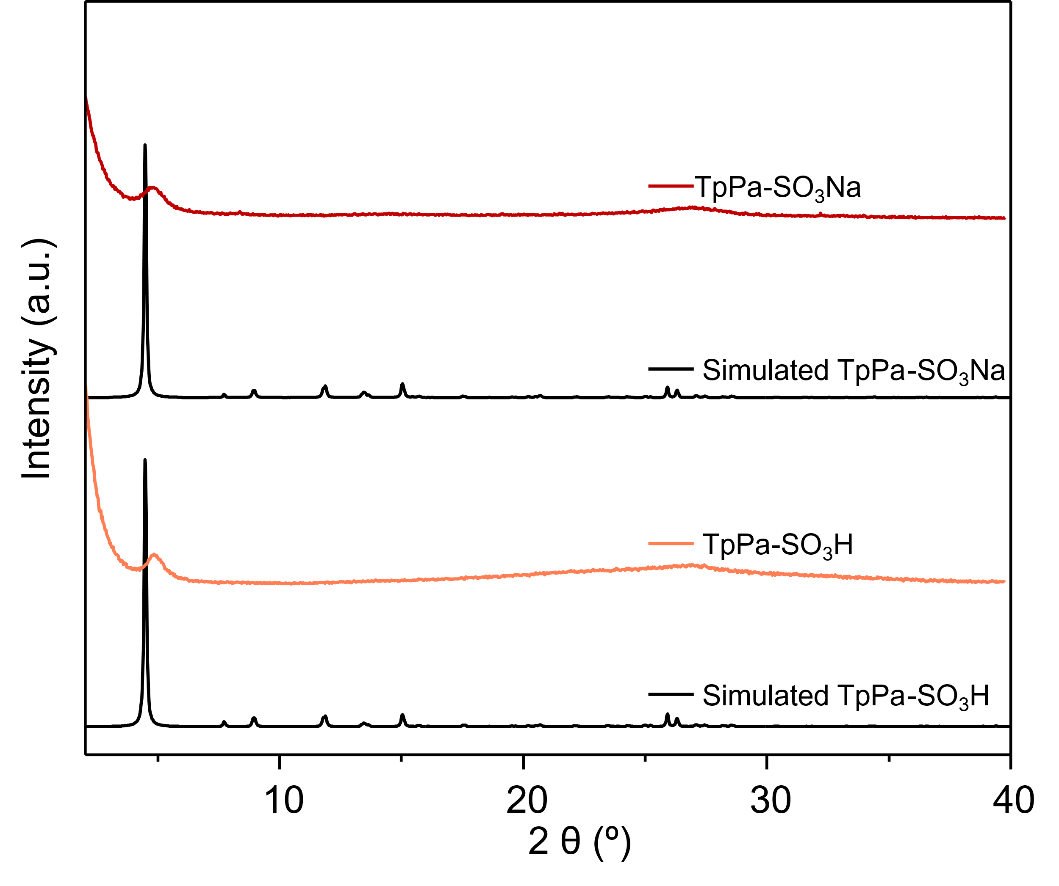
Supplementary Fig. 2.1. PXRD patterns of TpPa-SO₃H and TpPa-SO₃Na compared to the simulated ones in black.
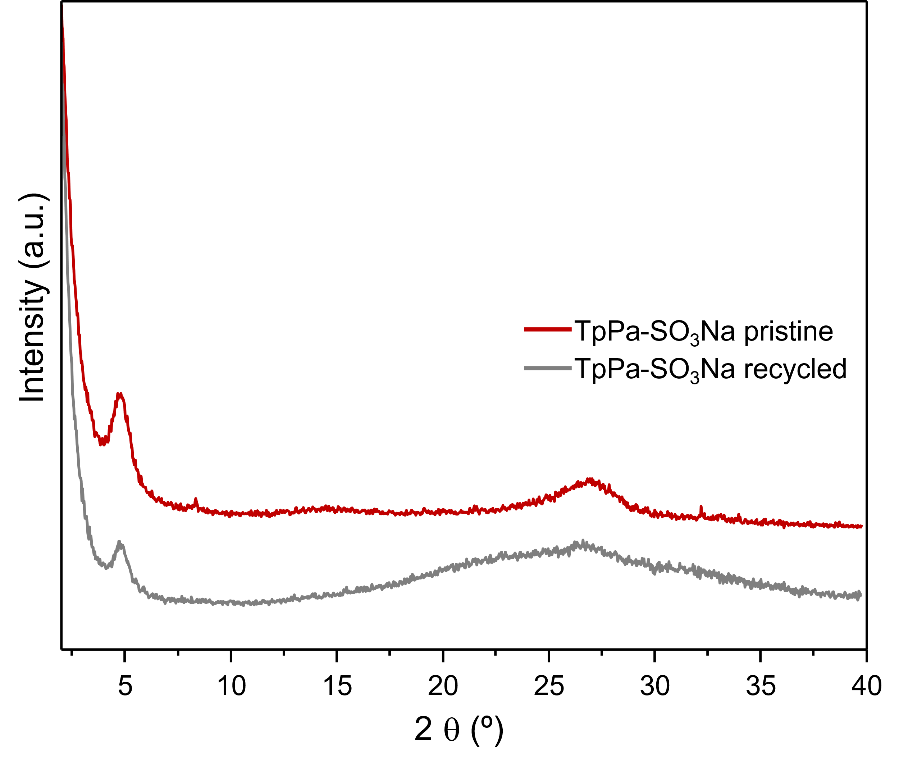
Supplementary Fig. 2.2. PXRD patterns of TpPa-SO₃Na before and after the recyclability test.

3. Fourier-Transform Infrared Spectroscopy (FTIR)
Supplementary Fig. 3.1. FTIR spectra of TpPa-SO₃H and the corresponding building blocks, Tp and Pa-SO₃H.
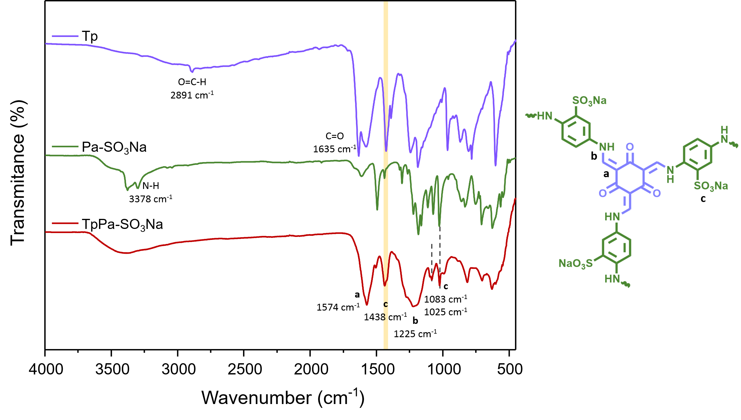
Supplementary Fig. 3.2. FTIR spectra of TpPa-SO₃Na and the corresponding building blocks, Tp and Pa-SO₃Na.

4. Solid-State ¹³C Cross-Polarization with Magic Angle Spinning (¹³C CP-MAS) NMR Spectroscopy
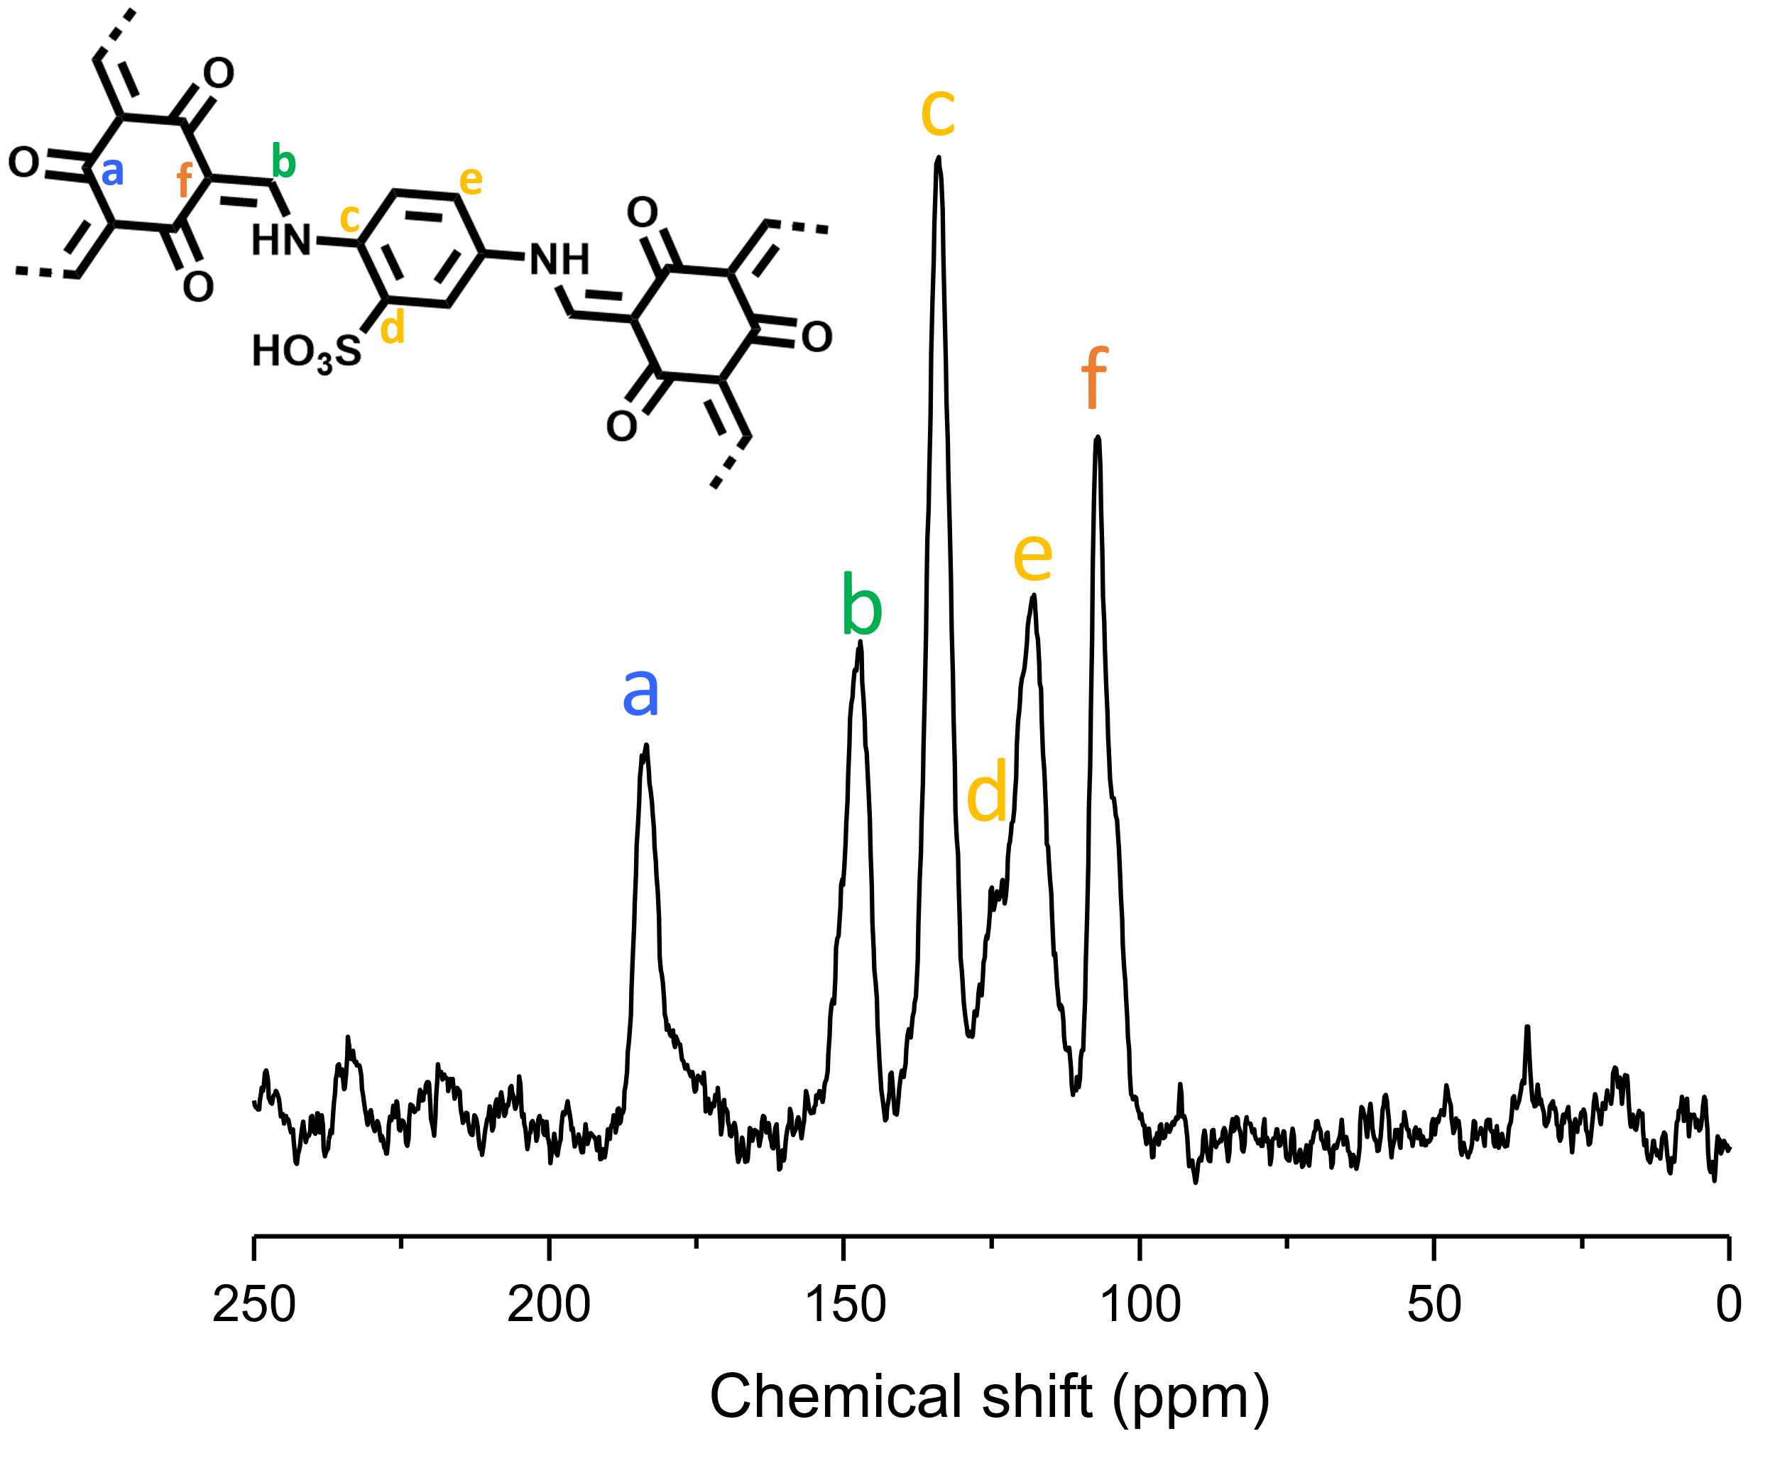
Supplementary Fig. 4.1. ss ¹³C CP-MAS NMR spectra of TpPa-SO₃H.
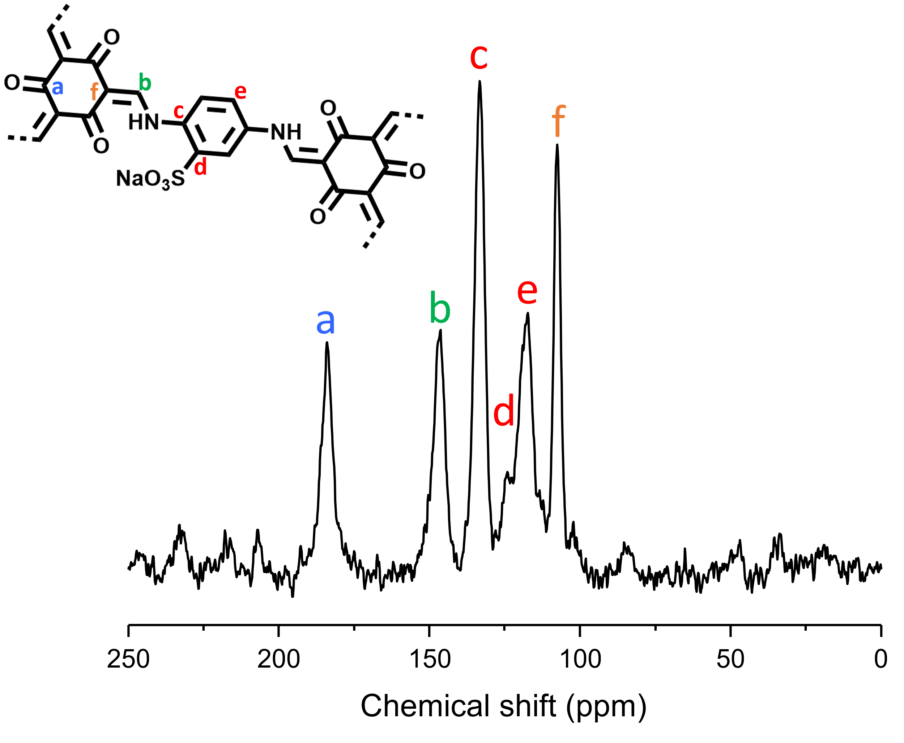
Supplementary Fig. 4.2. ss ¹³C CP-MAS NMR spectra of TpPa-SO₃Na.

5. Elemental Analysis (EA)
Supplementary Table 5.1. Composition of TpPa-SO₃H and TpPa-SO₃Na obtained by elemental analysis.

COF | Mm (g mol⁻¹) | Formula | % C | % H | % N | % S
TpPa-SO₃H | 1757.6 | C₇₂H₅₂N₁₂O₃₀S₆ | 40.2 | 4.8 | 7.2 | 8.5
TpPa-SO₃Na | 1885.5 | C₇₂H₄₂N₁₂Na₆O₃₀S₆ | 36.0 | 4.5 | 6.4 | 7.1

6. Thermogravimetric Analysis (TGA)
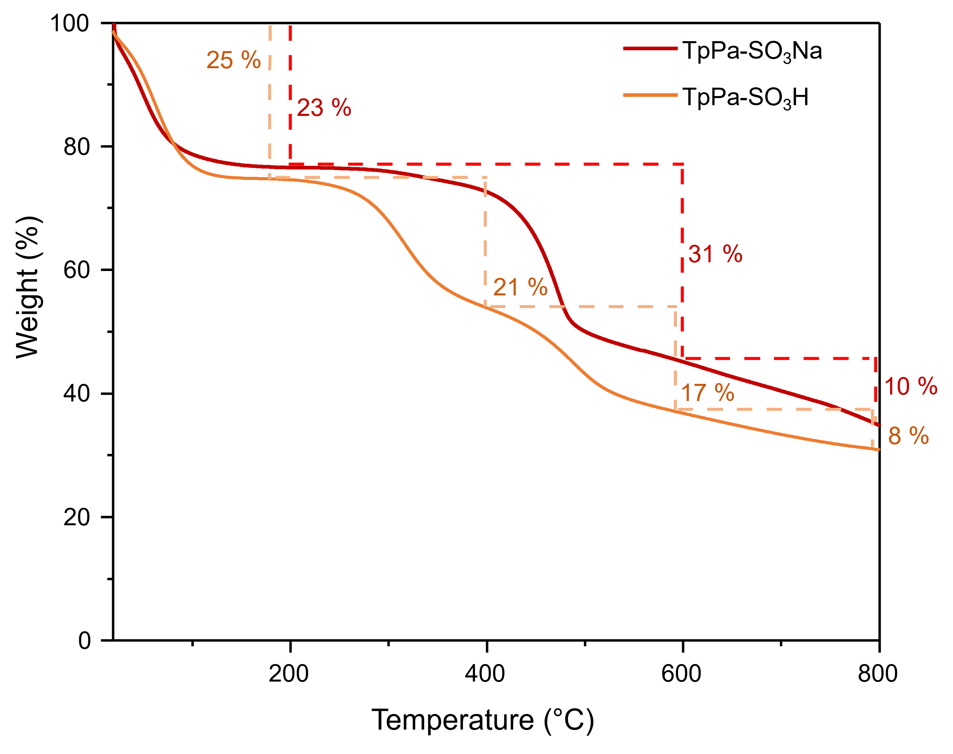
Supplementary Fig. 6.1. TGA profile of TpPa-SO₃H and TpPa-SO₃Na.

7. Nitrogen adsorption and desorption isotherms
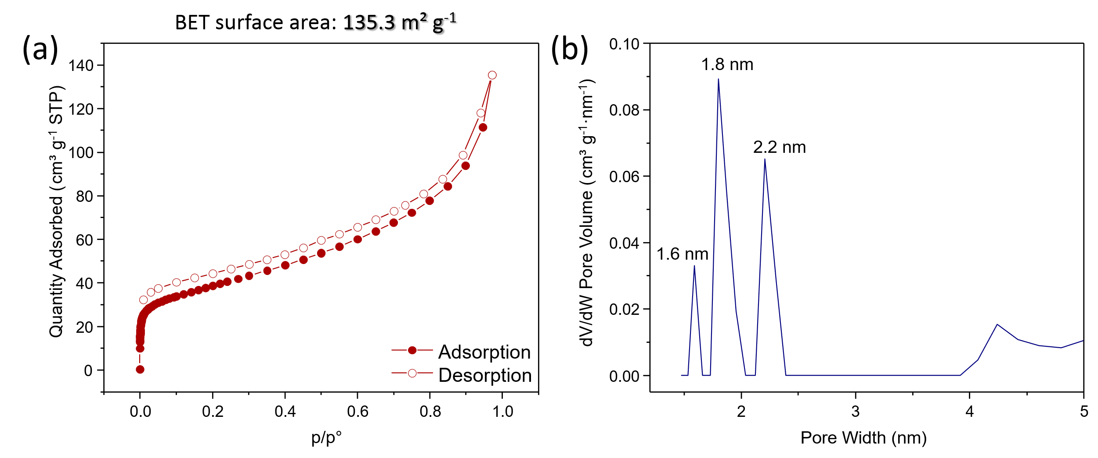
Supplementary Fig.7.1. (a) N₂ adsorption-desorption isotherm (b) and pore size of TpPa-SO₃Na.

8. Additional data from the adsorption studies
Supplementary Table 8.1. Data from the Al³⁺ adsorption studies of the synthesized COF materials. Experimental conditions: time = 1 h, V = 50 mL, T = 298 K, salt: AlCl₃.
COF | m (mg) | C_{i} (mg L⁻¹) | C_{f} (mg L⁻¹) | % Removal efficiency | Q_{e} (mg g⁻¹)
TpPa-SO₃H | 20.2 | 0.34 | 0.20 | 41.18 | 0.84
TpPa-SO₃Na | 20.1 | 0.34 | 0.00 | 100 | 0.35

Supplementary Table 8.2. Experimental results from the pH dependence study in the removal of Al³⁺ ions of TpPa-SO₃Na COF. Experimental conditions T = 298 K, time = 1 h, V = 50 mL, salt: AlCl₃.
m (mg) | pH | C_{i} (mg L⁻¹) | C_{f} (mg L⁻¹) | % Removal efficiency | Q_{e} (mg g⁻¹)
20.8 | 3.70 | 0.19 | 0.000 | 100 | 0.46
21.7 | 5.26 | 0.17 | 0.060 | 64.71 | 0.25
22.5 | 6.49 | 0.17 | 0.030 | 82.35 | 0.31
21.0 | 9.79 | 0.17 | 0.010 | 94.12 | 0.38

Supplementary Table 8.3. Experimental results from the adsorption isotherm of TpPa-SO₃Na towards Al³⁺. Experimental conditions T = 298 K, time = 2 h, V = 10 mL, salt: AlCl₃.
m (mg) | C_{i} (mg L⁻¹) | C_{f} (mg L⁻¹) | % Removal efficiency | Q_{e} (mg g⁻¹)
10.0 | 0 | 0 | 0 | 0
10.2 | 0.2088 | 0.0025 | 98.78 | 0.20
10.1 | 0.3042 | 0.0051 | 98.32 | 0.30
10.2 | 0.5703 | 0.0104 | 98.17 | 0.55
10.1 | 0.9895 | 0.0138 | 98.6 | 0.97
10.0 | 1.5757 | 0.0191 | 98.79 | 1.56
10.1 | 2.9475 | 0.0253 | 99.14 | 2.89
10.0 | 5.0088 | 0.0709 | 98.58 | 4.94
10.0 | 7.4544 | 0.2369 | 96.82 | 7.22
Supplementary Table 8.4. Experimental results from the adsorption kinetic of TpPa-SO₃Na towards Al³⁺. Conditions T = 298 K, c = 1.5 mg L⁻¹, salt: AlCl₃.
m (mg) | t (min) | C_{i} (mg L⁻¹) | C_{f} (mg L⁻¹) | % Removal efficiency | Q_{t} (mg g⁻¹)
10.0 | 1 | 1.469 | 0.101 | 93.12 | 1.37
10.0 | 3 | 1.469 | 0.072 | 95.10 | 1.40
10.0 | 5 | 1.469 | 0.107 | 92.72 | 1.36
10.0 | 10 | 1.469 | 0.031 | 97.89 | 1.44
10.0 | 15 | 1.469 | 0.048 | 96.73 | 1.42
10.0 | 30 | 1.469 | 0.042 | 97.14 | 1.43
10.0 | 60 | 1.469 | 0.016 | 99.91 | 1.45
10.0 | 120 | 1.469 | 0.018 | 98.77 | 1.45

Supplementary Fig. 8.1. Glass column packed with TpPa-SO₃Na used in this study.
Supplementary Table 8.5. Experimental results of Al³⁺ retention studies using TpPa-SO₃Na under dynamic conditions (Fig. 8.1).
Time (h) | C_{e} (mg g⁻¹) | Removal efficiency (%)
0 | 699.15 | 0
0.667 | 6.28 | 99.1
1.125 | 1.85 | 99.7
1.458 | 0.835 | 99.9
2.042 | 0.625 | 99.9
2.583 | 0.837 | 99.9
3.250 | 1.580 | 99.8

Supplementary Table 8.6. Adsorption capacities of different reported adsorbents for the removal of Al³⁺ from water.
Material | Dynamic conditions | Q_{máx} (mg g⁻¹) | RWS | Cycles | t_{máx.}(min) | Ref.
TpPa-SO₃Na | Y | 10.0 | Y | 5 | 1 | This work
Magnetic activated C/W nanocomposite | N | 184.12 | Y | 5 | 45 | ³
PAN-based adsorbents | N | 0.15–0.71 | N | N | - | ⁴
MWCNTs | N | 393.52 | N | N | 120 | ⁵
Rhodamine Functionalized Mesoporous Silica | N | 11.2 | Y | N | - | ⁶
L-propylsilyl@MCM-41 (MS4) | N | - | Y | 7 | - | ⁷
Silica/5-chloro-8-quinolinol Composite | N | 95.06 | Y | 4 | 60 | ⁸
Linde type A-zeolite | N | 19.29 | N | N | 5 | ⁹
Activated charcoal | N | 0.36 | N | N | 90 | ¹⁰
RWS: Tested under Real Water Sample; Y: Yes; N: No

9. X-ray Photoelectron Spectroscopy (XPS)
Supplementary Fig. 9.1. (a) Survey XPS spectra of the pristine TpPa-SO₃Na and TpPa-SO₃Na@Al. (b) Al 2p_{3/2} and Al 2p_{1/2} core level spectrum of TpPa-SO₃Na@Al.

10. References

1. Chen, T. et al. Highly crystalline ionic covalent organic framework membrane for nanofiltration and charge-controlled organic pollutants removal. Sep Purif Technol 256, 117787 (2021).
2. Jiang, W., Peng, D., Cui, W. R., Liang, R. P. & Qiu, J. D. Charge-Enhanced Separation of Organic Pollutants in Water by Anionic Covalent Organic Frameworks. ACS Omega 5, 32002–32010 (2020).
3. Saleh, T. A., Tuzen, M. & Sari, A. Magnetic activated carbon loaded with tungsten oxide nanoparticles for aluminum removal from waters. J Environ Chem Eng 5, 2853–2860 (2017).
4. Aly, Z., Graulet, A., Scales, N. & Hanley, T. Removal of aluminium from aqueous solutions using PAN-based adsorbents: Characterisation, kinetics, equilibrium and thermodynamic studies. Environ Sci Pollut Res 21, 3972–3986 (2014).
5. Basheer, A. O. et al. Synthesis and characterization of low-cost carbon nanotubes by chemical vapor deposition for aluminum removal from aqueous solution. Desalination Water Treat 214, 440–451 (2021).
6. Singha, D., Das, T., Satyanarayana, L., Roy, P. & Nandi, M. Rhodamine functionalized mesoporous silica as a chemosensor for the efficient sensing of Al3+, Cr3+ and Fe3+ ions and their removal from aqueous media. New J Chem 43, 15563–15574 (2019).
7. Chaudhary, G. & Pratap Singh, A. BODIPY Immobilized MCM-41 Based Multianalyte Sensor: Application in Detection and Removal of Trivalent (Al3+, Cr3+) and Divalent (Cu2+, Hg2+) Metal Ions in Aqueous Media. Eur J Inorg Chem 26, e202200537 (2023).
8. Al-Wasidi, A. S., Katouah, H. A., Saad, F. A. & Abdelrahman, E. A. Functionalization of Silica Nanoparticles by 5-Chloro-8-quinolinol as a New Nanocomposite for the Efficient Removal and Preconcentration of Al3+ Ions from Water Samples. ACS Omega 8, 15276–15287 (2023).
9. Lobo-Recio, M. Á. et al. Highly efficient removal of aluminum, iron, and manganese ions using Linde type-A zeolite obtained from hazardous waste. Chemosphere 267, (2021).
10. Choksi, P. M. & Joshi, V. Y. Adsorption kinetic study for the removal of nickel (II) and aluminum (III) from an aqueous solution by natural adsorbents. Desalination 208, 216–231 (2007).

