Primer | sequence (5’-3’) | serial number | The length of the amplification （bp）
SNAIL1 | Forward primer：CCTGTCTGCGTGGGTTTTTG  Reverse primer：ACCTGGGGGTGGATTATTGC | NM_005985.4 | 198
GAPDH | Forward primer： ACTCCTCCACCTTTGACGCT  Reverse primer： GGTCTCTCTCTTCCTCTTGTGC | NM_002046.6 | 187
PDGFB | Forward primer：ACTGATGGGGTCGCTCTTTG  Reverse primer：CAGGGATCAGGCAGGCTATG | NM_002608.4 | 126
FOS | Forward primer：GTGCCAACTTCATTCCCACG  Reverse primer：GGCCTCCTGTCATGGTCTTC | NM_005252.4 | 186

The agarose gel are shown below：
(1)
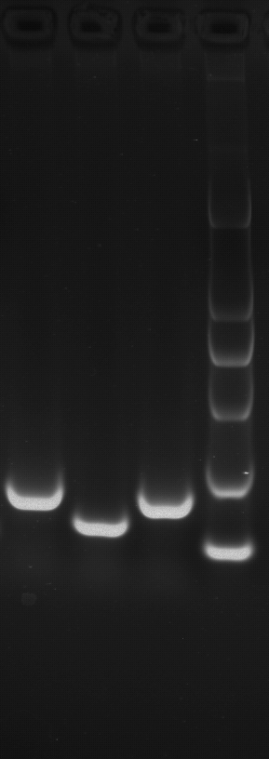
Note: The Marker from top to bottom in turn are 2000,1000,750,500,250,100bp. From left to right：GAPDH-PDGFB-FOS-marker
(2)
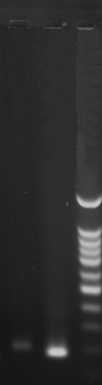
Note: The Marker from top to bottom in turn are 2000, 1000, 900, 800, 700, 600, 500, 400, 300, 200, 100bp. From left to right: SNAIL1-GAPDH-marker.
The sizes of the amplified fragments were the same as that of the designed fragments, the band was single, and no specific amplification and primer dimer were produced.

The experimental graph
- GAPDH
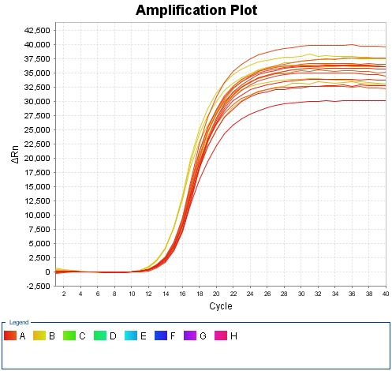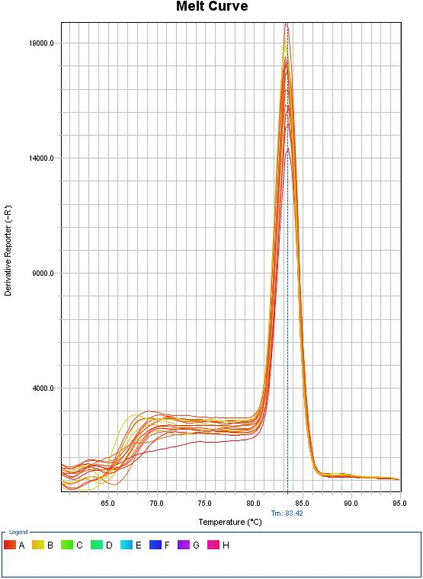
The exponential phase and plateau phase of the amplification curve were normal, and the melting curve presented a single crest, except for specific amplification and primer dimer.

- PDGFB
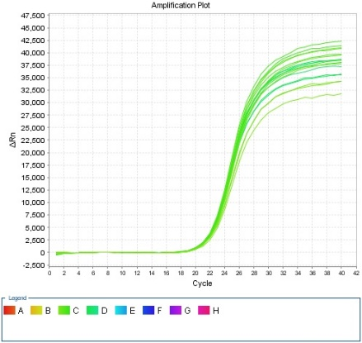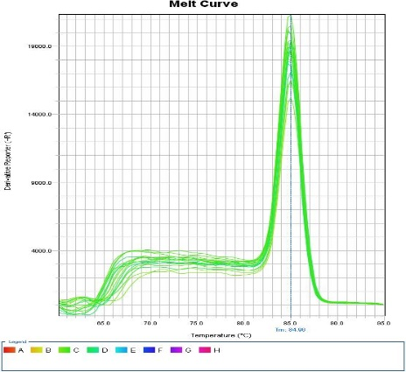
The exponential phase and plateau phase of the amplification curve were normal, and the melting curve presented a single crest, except for specific amplification and primer dimer.

- FOS
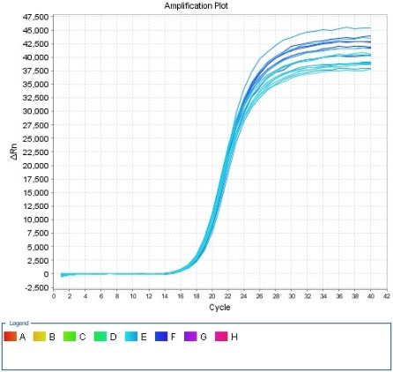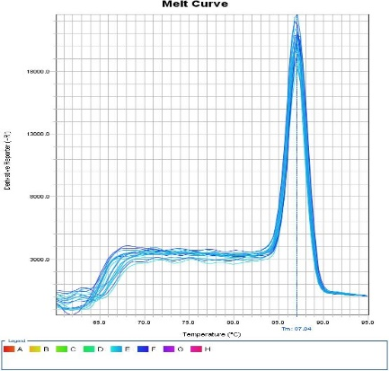
The exponential phase and plateau phase of the amplification curve were normal, and the melting curve presented a single crest, except for specific amplification and primer dimer.

- SNAIL1

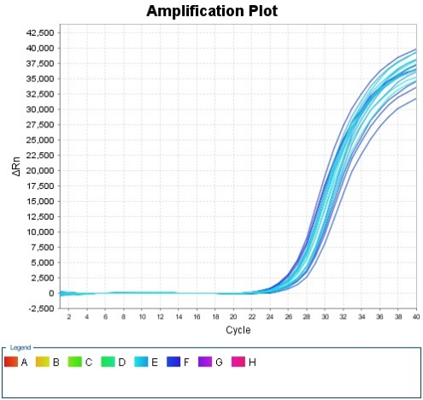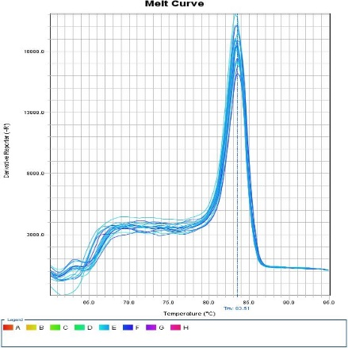
The exponential phase and plateau phase of the amplification curve were normal, and the melting curve presented a single crest, except for specific amplification and primer dimer.

