Supplementary Information
United we stand: Perovskite quantum dot/AIEgen hybrids with high optical stability and efficiency
Shan He,^{1,5} Huilin Xie,^{1,5} Meng Liu,² Lei Wang,⁴ Guijie Liang,⁴ Jianwei Sun,¹ Ryan T. K. Kwok,¹ Jianquan Zhang,^{3*}Jacky W. Y. Lam,^{1*} Kaifeng Wu^{2*} and Ben Zhong Tang^{1,3*}
¹ Department of Chemistry and the Hong Kong Branch of the Chinese National Engineering Research Center for Tissue Restoration and Reconstruction, The Hong Kong University of Science and Technology, Kowloon, Hong Kong 999077, China
² State Key Laboratory of Molecular Reaction Dynamics and Dynamics Research Center for Energy and Environmental Materials, Dalian Institute of Chemical Physics, Chinese Academy of Sciences, Dalian, Liaoning 116023, China
³ School of Science and Engineering, Shenzhen Institute of Aggregate Science and Technology, The Chinese University of Hong Kong, Shenzhen (CUHK Shenzhen), Guangdong 518172, China
⁴ Hubei Key Laboratory of Low Dimensional Optoelectronic Materials and Devices, Hubei University of Arts and Science, Xiangyang, Hubei 441053, China
⁵ These authors contributed equally: Shan He and Huilin Xie

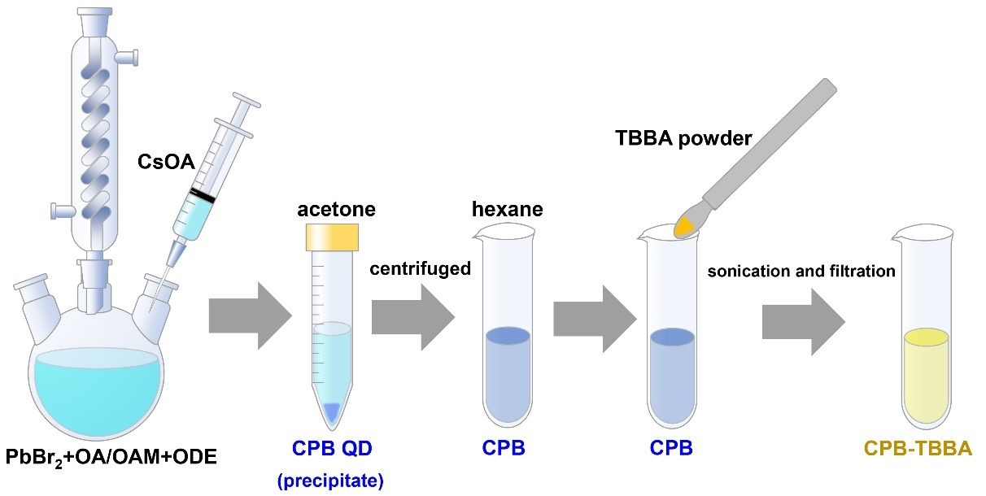
Supplementary Figure 1. Synthetic route of CPB-TBBA hybrid material.
CPB QDs were synthesized by a hot injection method. The CPB-TBBA is prepared by adding TBBA powder into the CPB solution followed by sonication and filtration.

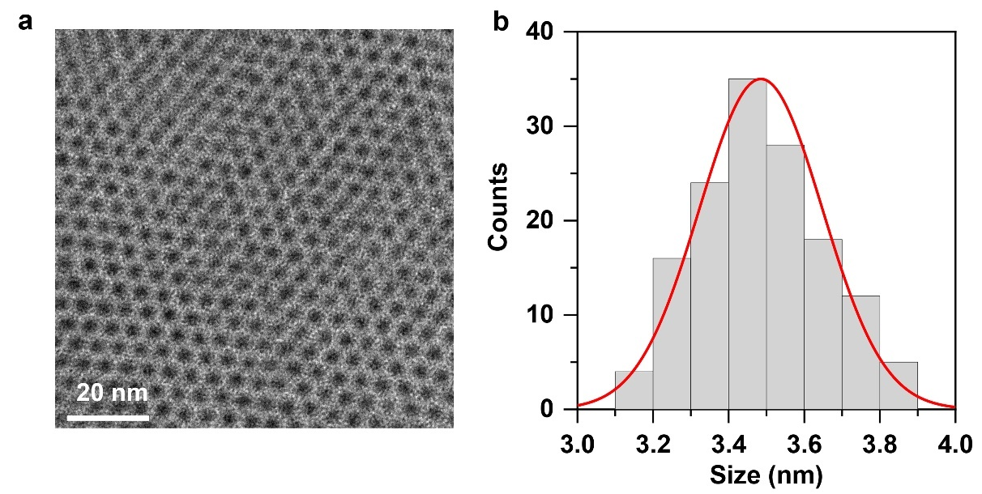
Supplementary Figure 2. TEM images of CPB.
(a) TEM images and (b) size distribution histograms of CPB

Supplementary Figure 3. TBBA synthetic route.
The TBBA is synthesized by one-pot reaction following the treatment of LiOH (EtOH/H₂O).

Supplementary Figure 4. ¹H NMR spectrum of compound 1.
¹H NMR spectrum (CDCl₃, 400 MHz, 298 K) of compound 1.

Supplementary Figure 5. ¹³C NMR spectrum of compound 1.
¹³C NMR spectrum (CDCl₃, 101 MHz, 298 K) of compound 1.

Supplementary Figure 6. ¹H NMR spectrum of TBBA.
¹H NMR spectrum (DMSO, 400 MHz, 298 K) of TBBA.

Supplementary Figure 7. ¹³C NMR spectrum of TBBA.
¹³C NMR spectrum (DMSO, 101 MHz, 298 K) of TBBA.
Supplementary Figure 8. MALDI-TOF mass spectrum of TBBA.
MALDI-TOF mass spectrum of TBBA.

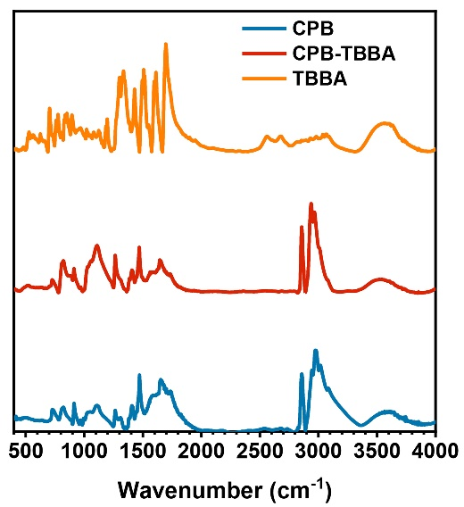
Supplementary Figure 9. FTIR spectra of CPB, TBBA, and CPB-TBBA
FTIR spectra of CPB (blue), TBBA (orange) and CPB-TBBA (red). The broad feature in the range of 2500-3500cm⁻¹ corresponding to the vibration of the -OH group^{1,2} can be clearly detected in free TBBA but not in CPB-TBBA, indicating that the TBBA ligands are deprotonated and very likely bound onto the QD surfaces.

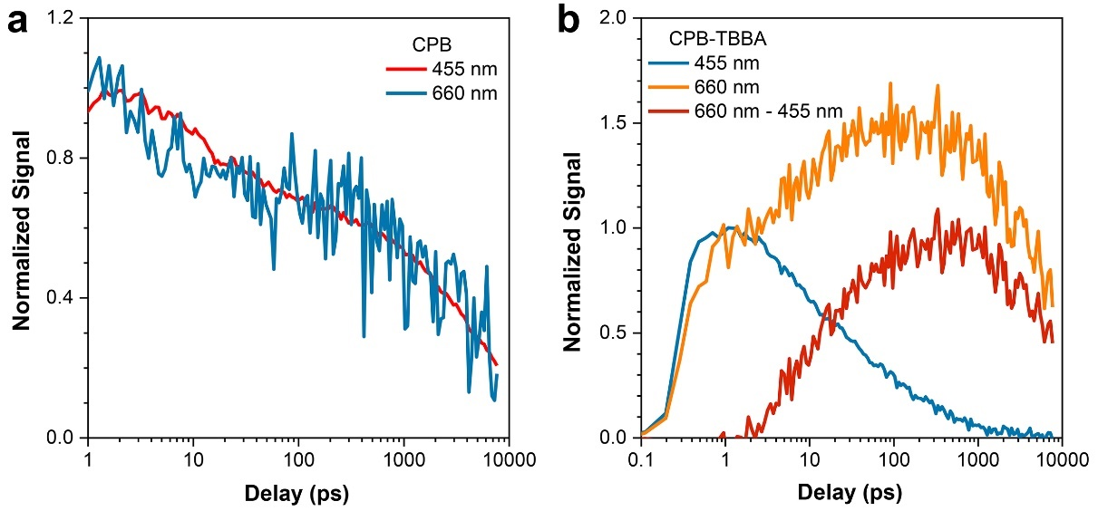
Supplementary Figure 10. Extraction of TBBA singlet kinetics in CPB-TBBA.
(a) Normalized TA kinetics of CPB probed at 455 nm (red) and 660 nm (blue). The kinetics at 455 nm results from exciton bleaching (XB) due to state-filling effects^{3,4}. The kinetics at 660 nm results from photo induced absorption (PIA) duo to the electron absorption in conduction band⁴. The XB and PIA kinetics of CPB agrees with each other. (b) Normalized TA kinetics of CPB-TBBA probed at 455 nm (blue) and 660 nm (orange). Because the PIA of CPB* and excited-state absorption (ESA) of TBBA* are overlapped at 660 nm, the TBBA* kinetics are extracted by subtracting normalized TA kinetics at 455 nm by that at 660 nm.

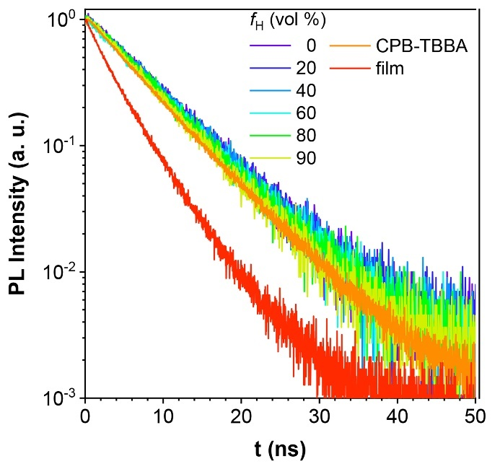
Supplementary Figure 11. Time-resolved PL kinetics.
Time-resolved PL kinetics of TBBA in the hexane/THF mixtures with different fractions (f_{H}). And time-resolved PL kinetics of CPB-TBBA in hexane and TBBA film are also plotted for comparison (λ_{ex} = 405 nm).

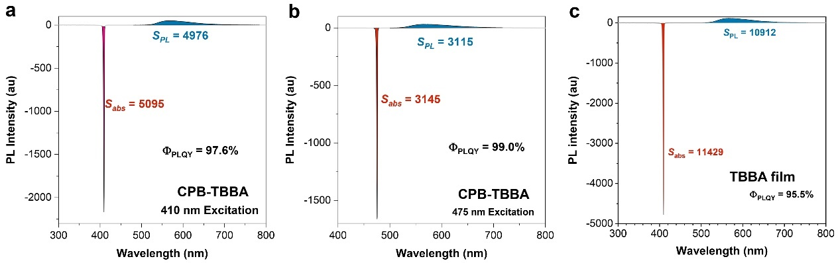
Supplementary Figure 12. PLQYs of CPB-TBBA and TBBA film determined by an integrating sphere.
PLQYs of (a) CPB-TBBA with a 410 nm excitation laser, (b) CPB-TBBA with a 475 nm excitation laser and (c) TBBA film with a 410 nm excitation laser determined by an integrating sphere.

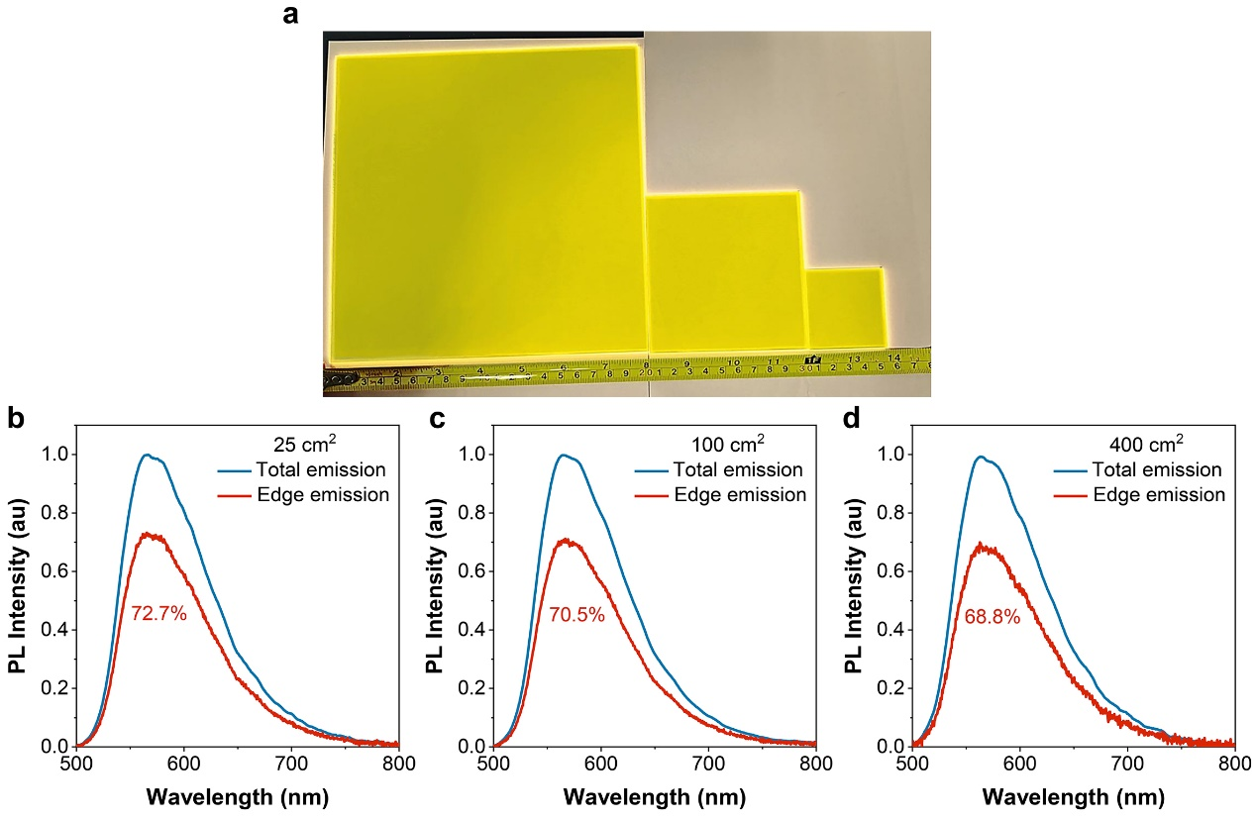
Supplementary Figure 13. internal optical efficiency ($η_{int}$) determined by an integrating sphere
(a) Photographs of LSC made of CPB-TBBA with different sizes. The total (blue) and edge (red) emission spectra of LSC areas of (a) 25 cm², (b) 100 cm² and (c) 400 cm².

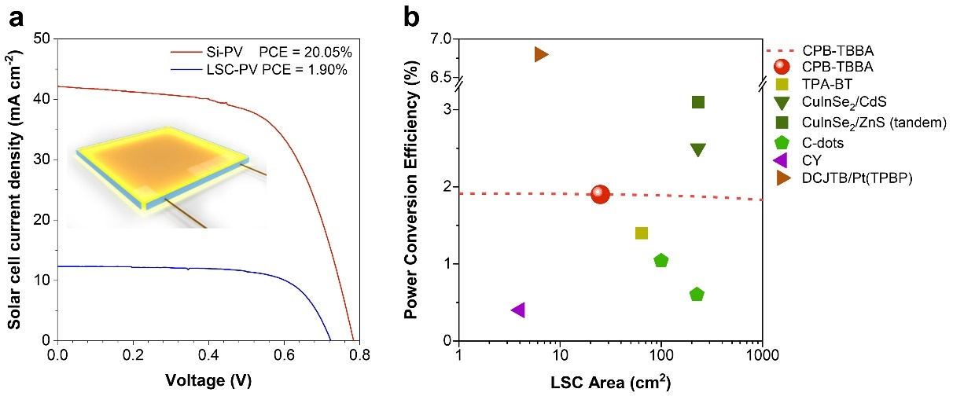
Supplementary Figure 14. Photovoltaic performance of CPB-TBBA LSC.
(a) J-V curve of a commercial Si solar cell (red) and the same cell attached to the edge of our CPB-TBBA LSC measured under AM 1.5G solar spectrum. The power conversion efficiencies are shown on the top. (b) Power conversion efficiency of CPB-TBBA LSC (red circle) and those for literatures are also listed for comparison⁵⁻⁹.

Supplementary Table 1. Lifetimes of CPB* of free CPB and CPB-TBBA. The energy transfer rate and efficiency are also listed.
 | τ₁ (ps) | a₁ | τ₂ (ps) | a₂ | τ_{ave} (ps) | k_{ET} (10¹⁰ s⁻¹) | Ф_{ET} (%)
CPB* | 25.5 | 0.32 | 5570.4 | 0.66 | 3759.8
CPB*-TBBA | 7.55 | 0.46 | 79.3 | 0.44 | 42.6 | 2.32 | 98.9

Supplementary Table 2. PLQYs, lifetimes, radiative and non-radiative rates of TBBA under different f_{H} in the THF solution, CPB-TBBA in hexane and TBBA film.
f_{H} (%) | 0 | 20 | 40 | 60 | 80 | 90 | CPB-TBBA | TBBA (film)
PLQY (%) | 30.6 | 36.7 | 43.6 | 55.3 | 71.2 | 86.3 | 98.3 | 95.4
τ (ns) | 7.2 | 7.3 | 7.2 | 7.1 | 6.9 | 6.5 | 6.3 | 3.7
k_{r} (10⁸ s⁻¹) | 0.43 | 0.50 | 0.61 | 0.78 | 1.03 | 1.33 | 1.56 | 2.58
k_{nr} (10⁸ s⁻¹) | 0.96 | 0.87 | 0.78 | 0.63 | 0.42 | 0.21 | 0.03 | 0.12

Supplementary Table 3. LSC performance of CPB-TBBA and previous reported in literatures.
 | Luminescent material | PLQY (%) | LSC area (cm²) | η_{ext} (%) | PCE (%)
Adv. Energy Mater.¹⁰ | PbS/CdS | 50 | 15 | 1 | NA
J. Phys. Chem. Lett.⁵ | TPA-BT | 88 | 64 | 3.7 | 1.4
Nat. Photon.⁶ | CuInSe₂/ZnS | 72 | 231 | 5.5 | 2.5
Energy Environ. Sci.¹¹ | C-dots | 65 | 25, 100, 225 | 3.0, 2.7, 2.2 | NA, 1.04, 0.6
Nat. Photon.⁷ | Si-QD | 50 | 144 | 2.85 | NA
Nat. Photon.¹² | CdSe/CdS | 45 | 29 | 0.6 | NA
Adv. Opt. Mater.⁸ | Cy7 | 20 | 4 | NA | 0.4
Science⁹ | DCJTB/Pt(TPBP) | 70/50 | 6.3 | NA | 6.8
Present work | CPB-TBBA | 98 | 25, 100, 400 | 5.8, 5.6, 5.5 | 1.9

Supplementary Note 1. Kinetics fitting models
The TA kinetic curves were fitted by a bi-exponential function. The average lifetime $τ_{ave}$ was calculated by equation S1,
$τ_{ave}=\frac{A_{1}τ_{1}+A_{2}τ_{2}}{A_{1}+A_{2}}$ (S1),
where $τ_{i}$ and $A_{i}$ are the lifetime and amplitude of the i-th exponential component, respectively. The decay rates of CPB and CPB-TBBA were $\frac{1}{τ_{CPB}}$ and $\frac{1}{τ_{CPB-TBBA}}$, respectively. Thereby, the k_{ET} and Ф_{ET} were determined by $\frac{1}{τ_{CPB-TBBA}}-\frac{1}{τ_{CPB}}$ and $1-\frac{τ_{CPB-TBBA}}{τ_{CPB}}$, respectively. All the calculation results were listed in Supplementary Table 1.

Supplementary Note 2. Calculation model of radiative and non-radiative rates of TBBA
The TBBA* has two relaxation channels: radiation, non-radiation (the non-radiative decay includes intersystem crossing). The rate equation of TBBA* can be described as equation S2.
$\frac{d{TBBA}^{*}}{dt}=-\left(k_{r}+k_{nr}\right)dt$ (S2)
According to above equation, it is easy to deduce equation S3.
${TBBA}^{*}=e^{-\left(k_{r}+k_{nr}\right)t}$ (S3)
The time-resolved PL kinetics were plotted in Supplementary Fig. 11 and fitted by 1-exponential decay function as shown in equation S3. The fitted rates are $k_{f}=k_{r}+k_{nr}$. And PLQY can be depicted as $Ф_{PLQY}=\frac{k_{r}}{k_{r}+k_{nr}}$. Combining the fitting results from Supplementary Fig. 11 and the measured PLQYs, the $k_{r}$ and $k_{nr}$ can be deduced and listed in Supplementary Table 2.

Supplementary Note 3. Calculation model of quantum efficiencies of LSC
According to the calculation model develop in ref. 6 and ignoring the scattering effect, the internal quantum efficiency ($η_{int}$) can be illuminated by equation S4.
$η_{int}=\frac{η_{PL}η_{trap}}{1+βα_{2}L(1-η_{PL}η_{trap})}$ (S4)
where $η_{PL}$ represents the PLQY of the luminescent material. $η_{trap}$​ is the total internal reflection efficiency of the polymer, which is related to the refractive index of the polymer and is generally around 75%. 𝛽 is an empirical value, typically 1.4. L is the size of the LSC. 𝛼₂​ is the reabsorption coefficient. And the parameter is calculated by equation S5.
$〈α_{2}〉=\frac{\int{S_{PL}(λ)α(λ)dλ}}{\int{S_{PL}(λ)dλ}}$ (S5)
where $S_{PL}(λ)$ and $α(λ)$ are PL and absorption spectra, respectively.
The external quantum efficiency can be deduced by $η_{ext}=η_{int}η_{abs}$. Here $η_{abs}$ is the LSC absorbance for solar spectrum, which can be calculated by equation S6.
$η_{abs}=\frac{\int{\left[1-R\left(λ\right)\right]×[1-{10}^{-OD\left(λ\right)}]×S(λ)dλ}}{S(λ)dλ}$ (S6)
where $R\left(λ\right)$ is the reflectance of a glass window. $OD\left(λ\right)$ is the absorption spectrum of LSC. $S(λ)$ is the solar spectrum.

Supplementary Note 4. Calculations of transmittance
The weighted average transmittance of an LSC is calculated by equation S7⁶.
$Transmittance=\frac{\int{T(λ)P(λ)S(λ)dλ}}{\int{P(λ)S(λ)dλ}}$ (S7)
where $T(λ)$ is the transmittance of the LSC. $P(λ)$ is the photopic vision function of human eye. $S(λ)$ is the solar spectrum. $T\left(λ\right)$ of LSC can be determined by $T\left(λ\right)=\left(1-R\right){10}^{-OD(λ)}$. The R value is typically 4%.

1. He, S., et al. Thermally Activated Delayed Near‐Infrared Photoluminescence from Functionalized Lead‐Free Nanocrystals. Angew. Chem., Int. Ed. 135, e202217287 (2023).
2. Wheeler, L.M., et al. Targeted ligand-exchange chemistry on cesium lead halide perovskite quantum dots for high-efficiency photovoltaics. J. Am. Chem. Soc. 140, 10504-10513 (2018).
3. Luo, X., et al. Triplet energy transfer from CsPbBr3 nanocrystals enabled by quantum confinement. J. Am. Chem. Soc. 141, 4186-4190 (2019).
4. Wu, K., et al. Ultrafast interfacial electron and hole transfer from CsPbBr3 perovskite quantum dots. J. Am. Chem. Soc. 137, 12792-12795 (2015).
5. Li, X., et al. Low-Loss, High-Transparency Luminescent Solar Concentrators with a Bioinspired Self-Cleaning Surface. J. Phys. Chem. Lett. 13, 9177-9185 (2022).
6. Wu, K.F., Li, H.B. & Klimov, V.I. Tandem luminescent solar concentrators based on engineered quantum dots. Nature Photon. 12, 105-+ (2018).
7. Meinardi, F., et al. Highly efficient luminescent solar concentrators based on earth-abundant indirect-bandgap silicon quantum dots. Nature Photon. 11, 177-185 (2017).
8. Zhao, Y., Meek, G.A., Levine, B.G. & Lunt, R.R. Near‐infrared harvesting transparent luminescent solar concentrators. Adv. Opt. Mater. 2, 606-611 (2014).
9. Currie, M.J., Mapel, J.K., Heidel, T.D., Goffri, S. & Baldo, M.A. High-efficiency organic solar concentrators for photovoltaics. Science 321, 226-228 (2008).
10. Zhou, Y., et al. Near infrared, highly efficient luminescent solar concentrators. Adv. Energy Mater. 6, 1501913 (2016).
11. Zhao, H., et al. Gram-scale synthesis of carbon quantum dots with a large Stokes shift for the fabrication of eco-friendly and high-efficiency luminescent solar concentrators. Energy Environ. Sci. 14, 396-406 (2021).
12. Meinardi, F., et al. Large-area luminescent solar concentrators based on ‘Stokes-shift-engineered’nanocrystals in a mass-polymerized PMMA matrix. Nature Photon. 8, 392-399 (2014).

