Supplementary Information
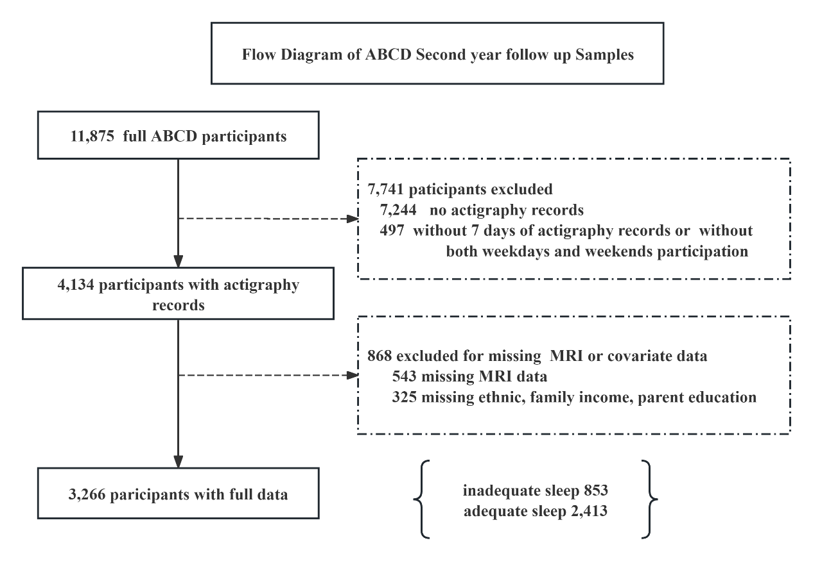
Fig. S1 Participant inclusion flowchart of the ABCD study.
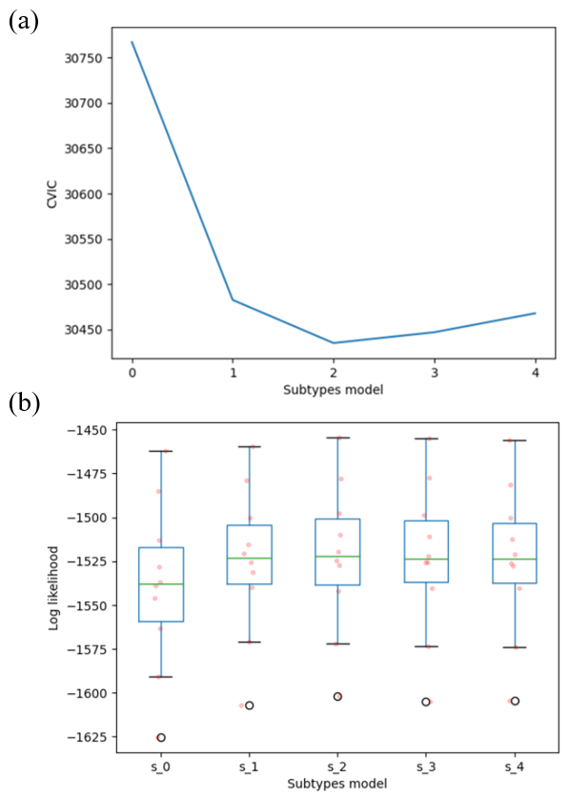
Fig. S2 The optimum number of insufficient sleep subtypes. (a) cross-validation information criterion (CVIC), 8 hours insufficient sleep cutoff. (b) Log-likelihood based on independent individuals with insufficient sleep (n = 853). The box ranges from 25% to 75% quartile values, with a line at the median. The whiskers of the boxes show the range of the data. Data points exceeding these limits are classified as outliers and marked as dots.

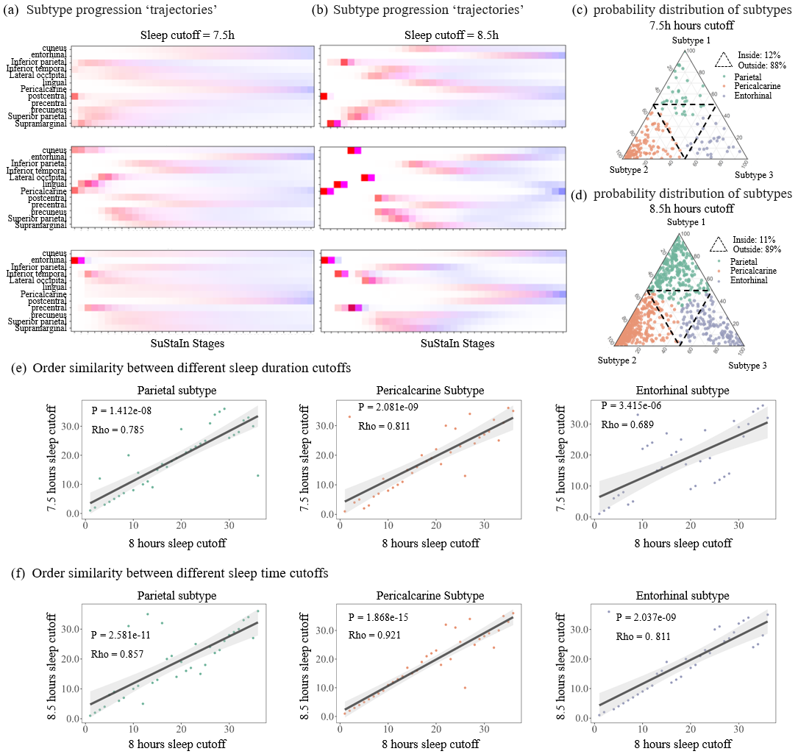
Fig. S3 Robustness of insufficient sleep subtypes. We used different sleep duration cutoffs (7.5 hours and 8.5 hours) as validation. (a), Three sleep subtype morphological ‘trajectories’ with 7.5 hours cutoff. (b), Three sleep subtype morphological ‘trajectories’ with 8.5 hours cutoff. (c-d), Probability-based distribution of three post-effected (i.e., parietal, pericalcarine, and entorhinal) subtypes (c, 7.5 hours cutoff; d, 8.5 hours cutoff). (e), Order similarity of atrophy ‘trajectory’ between the discovery sleep duration (8 hours) and 7.5 hours. Spearman’s rank correlation test (one-tailed P value, FDR corrected) was used. (f), Order similarity of atrophy ‘trajectory’ between the discovery sleep duration (8 hours) and 8.5 hours. Spearman’s rank correlation test (one-tailed P value, FDR corrected) was used

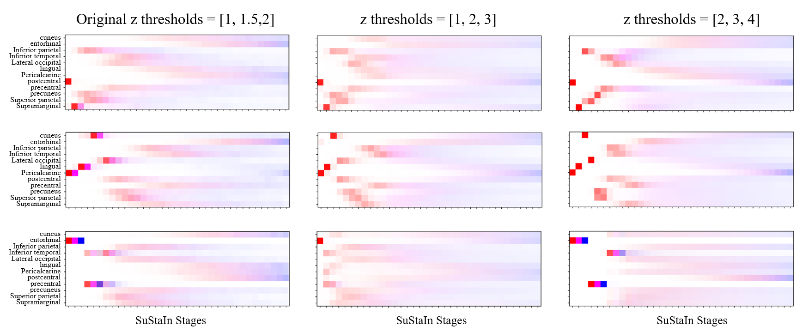
Fig. S4 SulsaIn model with different z score cutoffs

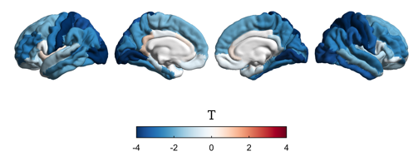
Fig. S5 ROI-based group differences between insufficient and sufficient sleep adolescents measured with subjective sleep duration cutoff of 8 hours.

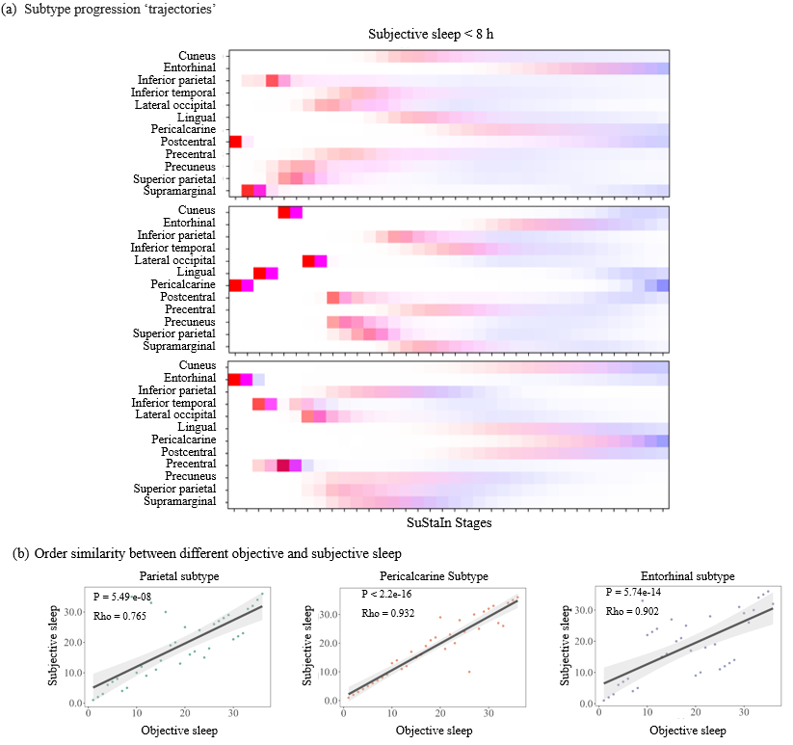
Fig. S6 Robustness of insufficient sleep subtypes replicated with subjective sleep duration measurement. We used sleep duration measured with the Sleep Disturbance Scale for Children as cutoff (subjective sleep less than 8 hours). (a), Three sleep subtype morphological ‘trajectories’ with subjective sleep cutoff. (b), Order similarity of atrophy ‘trajectory’ between the discovery objective sleep duration (8 hours) and subjective sleep duration (8 hours). Spearman’s rank correlation test (one-tailed P value, FDR corrected) was used.

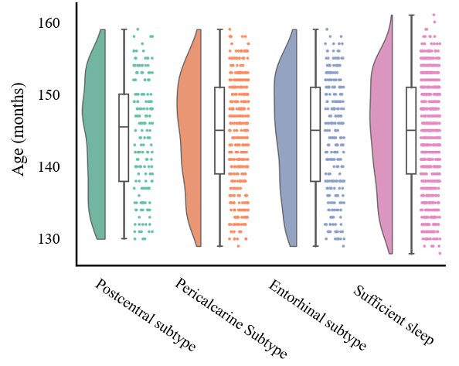
Fig. S7 Biological age differences between insufficient sleep subtypes. The biological age of the three insufficient sleep subtypes was no difference compared with the sufficient sleep group.

Supplementary Table S1. ABCD study second-year follow-up sample characteristics
 | Sufficient sleep  N = 2,413 | Insufficient sleep  N = 853
Demographic Characteristics
Age (years), mean (SD) | 11.87 ± 0.64 | 12.03 ± 0.63
Sex (male%) | 50.6 | 56.5
Race (White%/ Black%/Asian%/Other%) | 87.9/5.3/2.0/4.8 | 69.5/21.2/2.8/6.5
Ethnic (Hispanic/ Latino%) | 21.6 | 29.0
Parental Characteristics
Maternal Birth age (years) | 30.5 ± 5.6 | 29.4 ± 6.4
Parental Education (college or more%) | 91 | 86
Household income
< $11999 (%) | 1.1 | 3.4
$12 000 – $24999 (%) | 2.7 | 4.0
$25 000 – $49999 (%) | 8.5 | 17.1
$50 000 – $99999 (%) | 28.6 | 29.4
>$100 000 (%) | 59.1 | 46.1
Continuous variables are shown as mean (standard deviation; SD) and categorical variables as percentage (%).

Supplementary Table S2 Statistical comparison of three layers of socio-ecological factors (pediatric sleep, individual child factors, and neighborhood environments) between the neuroimaging-based subtypes for the ABCD dataset. Data were presented as p-value / Cohen’s d (Rho). Only the significant results were listed.
 | Postcentral vs sufficient sleep | Pericalcarine vs sufficient sleep | Entorhinal vs sufficient sleep
Sleep disturbance (p-value / Cohen’s d)
DIMS | 0.256 / 0.08 | 0.009 / 0.20 | <0.001 / 0.33
SBD | 0.820 / -0.06 | 0.208 / 0.11 | 0.704 / 0.05
DA | 0.704 / -0.03 | 0.256 / -0.07 | 0.704 / -0.05
SWTD | 0.099 / -0.13 | 0.009 / -0.16 | 0.704 / -0.05
DOES | 0.878 / -0.02 | 0.339 / 0.08 | 0.647 / 0.05
SHY | 0.767/ 0.07 | 0.704 / -0.04 | 0.704 / -0.02
Weekly sleep loss | 0.397 / 0.12 | <0.001 / 0.31 | 0.018 / 0.19
Physical (p-value / Cohen’s d) and mental factors (p-value / Rho)
Physical activities | 0.984 / -0.002 | 0.041 / -0.167 | 0.148 / -0.261
Externalizing disorders | 0.951 / 0.001 | 0.375 / 0.095 | 0.008 / 0.394
Internalizing disorders | 0.849 / -0.029 | 0.227 / 0.128 | 0.032 / 0.319
Overall disorders | 1 / <0.001 | 0.055 / 0.206 | 0.045/ 0.30
Neighborhood environment (p-value / Cohen’s d)
Night light | 0.758 / 0.01 | 0.002 / 0.21 | 0.311 / 0.08
Adult insufficient sleep | 0.124 / 0.15 | <0.001 / 0.32 | <0.001 /0.25
Income | 0.717 / -0.08 | <0.001 / 0.28 | 0.068 / 0.17
Education | 0.478 / -0.01 | <0.001 / 0.19 | 0.246 / 0.06
NH disadvantage | 0.281 / 0.16 | <0.001 / 0.26 | 0.068 / 0.17
Night noise | 0.776 / <0.01 | 0.002 / 0.21 | 0.112 / 0.16
*NH abbreviates for neighborhood. Significant numbers of P_{FDR} < 0.05 were shown in bold, Bonferroni corrected. DIMS abbreviates for disorders of initiating and maintaining sleep; SBD abbreviates for sleep breathing disorders; DA abbreviates for disorder of arousal nightmares; SWTD abbreviates for sleep wake transition disorders; DOES abbreviates for disorder of excessive somnolence; SHY abbreviates for sleep hyperhidrosis.

Supplementary Table S3 Statistical comparison of pediatric sleep between the neuroimaging-based subtypes for the Shanghai dataset. Data were presented as p-value / Cohen’s d. Only the significant results were listed.
 | Postcentral vs sufficient sleep | Pericalcarine vs sufficient sleep | Entorhinal vs sufficient sleep
Pediatric sleep
Bedtime resistance | 0.718 / 0.02 | 0.457 / 0.12 | 0.450/ 0.19
Sleep onset delay | 0.752 / 0.16 | 0.403 / 0.21 | 0.116 / 0.34
Sleep duration | 0.22 / 0.27 | 0.049 / 0.57 | 0.002 / 0.68
Sleep anxiety | 0.973 / 0.07 | 0.066 /0.49 | 0.023 / 0.64
Night wakings | 0.161 / -0.37 | 0.143 / 0.29 | 0.149 / 0.52
Parasomnias | 0.186 / -0.34 | 0.634 / -0.22 | 0.759 / <0.01
Sleep disordered breathing | 0.171 / 0.36 | 0.467 / 0.23 | 0.69 / >-0.01
Daytime sleepiness | 0.339 / -0.22 | 0.714 / 0.13 | 0.955 / <0.01
* Significant numbers of P_{FDR} < 0.05 were shown in bold, Bonferroni corrected.

