Table S1 Demographic characteristics of the study participants in UKB
Characteristic | Total | METS-VF |  |  |  | P
Characteristic | Total | Q1 (<6.916) | Q2 (6.916-7.207) | Q3 (7.207-7.449) | Q4 (>7.449) | P
Participants | n=101292 | n=25323 | n=25323 | n=25323 | n=25323
Age, years | 57.826±7.684 | 56.615±7.856 | 57.346±7.856 | 57.801±7.593 | 59.543±6.916 | <0.001
Gender, male, n (%) | 50469 (49.83) | 5356 (21.15) | 9482 (37.44) | 15297 (60.41) | 20334 (80.30) | <0.001
BMI, kg/m2 | 31.069±4.855 | 26.956±2.888 | 29.967±3.052 | 31.931±3.673 | 35.421±5.033 | <0.001
Height, cm | 168.708±9.578 | 166.34±8.443 | 167.294±10.196 | 169.986±10.05 | 171.214±8.673 | <0.001
WC, cm | 100.799±11.77 | 87.673±6.309 | 96.993±5.068 | 104.199±5.201 | 114.33±8.955 | <0.001
SBP, mmHg | 149.1±18.224 | 147.677±18.7 | 148.237±18.206 | 149.54±17.818 | 150.963±17.983 | <0.001
DBP, mmHg | 89.011±9.769 | 87.836±9.635 | 88.693±9.634 | 89.689±9.626 | 89.834±10.041 | <0.001
HbA1c, (%) | 5.537 (5.281-5.857) | 5.464 (5.226-5.729) | 5.509 (5.271-5.802) | 5.537 (5.281-5.857) | 5.656 (5.363-6.141) | <0.001
Hypertention, n (%) | 70417 (69.52) | 16282 (64.30) | 16784 (66.28) | 17996 (71.07) | 19355 (76.43) | <0.001
Education level, n (%) |  |  |  |  |  | <0.001
College or above | 26615 (26.28) | 7489 (29.57) | 6781 (26.78) | 6547 (25.85) | 5798 (22.90)
others | 74677 (73.72) | 17834 (70.43) | 18542 (73.22) | 18776 (74.15) | 19525 (77.10)
Race |  |  |  |  |  | <0.001
White | 95017 (93.81) | 23563 (93.05) | 23552 (93.01) | 23715 (93.65) | 24187 (95.51)
Latin | 524 (0.52) | 150 (0.59) | 124 (0.49) | 133 (0.53) | 117 (0.46)
Black | 4077 (4.02) | 1213 (4.79) | 1153 (4.55) | 1015 (4.01) | 696 (2.75)
Asian | 1674 (1.65) | 397 (1.57) | 494 (1.95) | 460 (1.82) | 323 (1.28)
Smoking status, n (%)) |  |  |  |  |  | <0.001
Never | 51616 (50.96) | 14462 (57.11) | 13749 (54.29) | 12517 (49.43) | 10888 (43.00)
Former | 38374 (37.88) | 7907 (31.22) | 8820 (34.83) | 9974 (39.39) | 11673 (46.10)
Now | 11302 (11.16) | 2954 (11.67) | 2754 (10.88) | 2832 (11.18) | 2762 (10.91)
Alcohol consumption status, n (%) |  |  |  |  |  | <0.001
Never | 5708 (5.64) | 1520 (6.00) | 1629 (6.43) | 1410 (5.57) | 1149 (4.54)
Former | 4339 (4.28) | 965 (3.81) | 1031 (4.07) | 1065 (4.21) | 1278 (5.05)
Now | 91245 (90.08) | 22838 (90.19) | 22663 (89.50) | 22848 (90.23) | 22896 (90.42)
Frequency of moderated physical activity, n (%) |  |  |  |  |  | <0.001
Never | 16515 (16.30) | 3333 (13.16) | 3884 (15.34) | 4275 (16.88) | 5023 (19.84)
<3 | 38934 (38.44) | 9796 (38.68) | 9885 (39.04) | 9775 (38.60) | 9478 (37.43)
>3 | 45843 (45.26) | 12194 (48.15) | 11554 (45.63) | 11273 (44.52) | 10822 (42.74)
Lipid-lowing medication, n (%) | 34413 (33.97) | 7745 (30.58) | 8199 (32.38) | 8541 (33.73) | 9928 (39.21) | <0.001
Blood pressure medication, n (%) | 39439 (38.94) | 8280 (32.70) | 9027 (35.65) | 9921 (39.18) | 12211 (48.22) | <0.001
Aspirin, n (%) | 18017 (17.79) | 3424 (13.52) | 3873 (15.29) | 4542 (17.94) | 6178 (24.40) | <0.001
Insulin, n (%) | 2398 (2.37) | 525 (2.07) | 453 (1.79) | 501 (1.98) | 919 (3.63) | <0.001
Anticoagulant | 130 (0.13) | 28 (0.11) | 20 (0.08) | 32 (0.13) | 50 (0.20) | 0.002
Laboratory assessments
Scr, umol/L | 71.6 (62.1-82.3) | 65.9 (58.5-75.2) | 69.3 (60.5-79.9) | 74.3 (64.3-84.4) | 77.2 (67.9-87.1) | <0.001
eGFR, ml/min | 86.964 (77.129-96.338) | 90.003 (80.235-99.334) | 87.588 (77.735-96.96) | 86.514 (76.784-95.58) | 83.727 (74.192-92.628) | <0.001
Ua, umol/L | 337.5 (285.8-393.3) | 296.2  (252.8-344) | 327.2 (280.3-378.05) | 354.1 (306.3-405.3) | 374.2 (323.6-426.8) | <0.001
Cys-C | 0.935 (0.849-1.035) | 0.882 (0.803-0.973) | 0.919 (0.84-1.013) | 0.947 (0.867-1.043) | 0.993 (0.905-1.099) | <0.001
TC, mmol/L | 5.569 (4.763-6.437) | 5.748 (4.976-6.608) | 5.697  (4.892-6.57) | 5.564 (4.773-6.421) | 5.246 (4.432-6.102) | <0.001
TG, mg/dL | 196.736 (156.645-261.872) | 186.292 (154.167-240.499) | 193.284 (155.672-255.234) | 201.869 (158.327-270.368) | 209.037 (160.274-283.51) | <0.001
LDL-C, mmol/L | 3.532 (2.893-4.194) | 3.645 (3.008-4.3) | 3.623 (2.983-4.287) | 3.535 (2.912-4.196) | 3.326 (2.692-3.976) | <0.001
HDL-C, mg/dL | 46.056 (39.25-53.519) | 48.956 (43.117-58.198) | 47.525 (40.758-55.491) | 45.399 (38.902-52.398) | 41.996 (36.504-48.415) | <0.001
GLU, mg/dL | 93.15 (85.338-105.084) | 93.438 (85.446-105.03) | 92.394 (85.05-103.662) | 92.43 (84.978-103.77) | 94.446 (86.004-109.386) | <0.001
METS-VF | 7.158±0.420 | 6.602±0.319 | 7.069±0.083 | 7.328±0.069 | 7.634±0.145 | <0.001
The chi-square test was used for the comparison of categorical variables; the t-test was employed to compare variates with normal distribution, and the rank-sum test was conducted for variates with skewed distribution. Abbreviations: METS-VF; BMI: body mass index; WC: waist circumference; SBP: systolic blood pressure; DBP: diastolic blood pressure; eGFR: estimated glomerular filtration rate; Ua: uric acid ; BUN: blood urea nitrogen; TC: total cholesterol; TG: HDL-C: high-density lipoprotein cholesterol; LDL-C:low-density lipoprotein cholesterol; GLU: glucose; Scr: serum creatinine; Cys-C:Cystatin C.

Table S2 Demographic characteristics of the study participants in CHARLS
Characteristic | Total | METS-VF |  |  |  | P
Characteristic | Total | Q1 (<6.800) | Q2 (6.800-7.011) | Q3 (7.011-7.192) | Q4 (>7.192) | P
Participants | n=1680 | n=420 | n=420 | n=420 | n=420
Age, years | 59 (52-65) | 55 (49-61) | 58 (52-64) | 60 (54-66) | 63 (57-70) | <0.001
Gender, male, n (%) | 445 (26.49) | 80 (19.05) | 68 (16.19) | 99 (23.57) | 198 (47.14) | <0.001
BMI, kg/m2 | 26.212 (23.825-28.463) | 23.368 (21.476-25.333) | 25.506 (23.606-27.439) | 26.908 (25.116-28.644) | 28.846 (26.829-30.863) | <0.001
Height, cm | 156.358±9.141 | 157.161±10.489 | 155.488±7.168 | 155.452±8.28 | 157.331±10.084 | 0.001
WC, cm | 92.83±10.533 | 82.514±10.533 | 91.389±4.496 | 95.742±4.698 | 101.676±9.78 | <0.001
SBP, mmHg | 140.667 (125.667-153.333) | 138 (122.167-151.5) | 138.667 (124.667-151) | 141.333 (128.667-154.083) | 142.167 (129.417-158.75) | <0.001
DBP, mmHg | 80.667 (72.333-89) | 80.167 (71.667-90) | 80.333 (73-88) | 80.833 (73-89.25) | 80.667 (72.333-89.333) | 0.902
HbA1c, (%) | 5.3 (5-5.7) | 5.2 (4.9-5.6) | 5.2 (4.9-5.625) | 5.3 (5-5.8) | 5.4 (5.1-5.9) | 0.077
Hypertention, n (%) | 1243 (73.99) | 292 (69.52) | 286 (68.10) | 314 (74.76) | 351 (83.57) | <0.001
Dyslipidemia (%) | 284 (17.38) | 63 (15.52) | 55 (13.38) | 60 (14.71) | 106 (25.92) | <0.001
Diabetes (%) | 727 (43.27) | 198 (47.14) | 165 (39.29) | 167 (39.76) | 197 (46.90) | 0.022
Education level, n (%) |  |  |  |  |  | <0.001
Senior high school or above | 1470 (87.50) | 366 (87.14) | 359 (85.48) | 370 (88.10) | 375 (89.29) | 0.394
others | 210 (12.50) | 54 (12.86) | 61 (14.52) | 50 (11.90) | 45 (10.71)
Smoking status, n (%)) |  |  |  |  |  | <0.001
Never or former | 1269 (75.63) | 340 (81.15) | 344 (81.90) | 317 (75.48) | 268 (63.96)
Now | 409 (24.37) | 79 (18.85) | 76 (18.10) | 103 (24.52) | 151 (36.04)
Alcohol consumption status, n (%) |  |  |  |  |  | 0.005
Never or former | 355 (21.13) | 86 (20.48) | 75 (17.86) | 80 (19.05) | 114 (27.14)
Now | 1325 (78.87) | 334 (79.52) | 345 (82.14) | 340 (80.95) | 306 (72.86)
Lipid-lowing medication, n (%) | 170 (10.12) | 36 (8.57) | 34 (8.10) | 33 (7.86) | 67 (15.95) | <0.001
Blood pressure medication, n (%) | 644 (38.33) | 117 (27.86) | 147 (35.00) | 160 (38.10) | 220 (52.38) | <0.001
Medicine for diabetes (%) | 160 (9.52) | 27 (6.43) | 40 (9.52) | 39 (9.29) | 54 (12.86) | 0.018
Laboratory assessments
Scr, umol/L | 0.735 (0.644-0.859) | 0.712 (0.61-0.802) | 0.723 (0.644-0.831) | 0.74 (0.641-0.87) | 0.78 (0.655-0.927) | <0.001
eGFR, ml/min | 84.913 (71.577-99.073) | 94.294 (81.154-104.346) | 86.06 (73.207-98.782) | 84.596 (71.027-96.455) | 74.905 (63.41-89.472) | <0.001
Ua, umol/L | 4.501 (3.708-5.384) | 4.14 (3.499-5.032) | 4.423 (3.641-5.192) | 4.655 (3.72-5.316) | 4.927 (4.119-5.952) | <0.001
Cys-C, mmol/L | 0.95 (0.81-1.098) | 0.86 (0.75-0.99) | 0.92 (0.81-1.05) | 0.96 (0.83-1.1) | 1.03 (0.903-1.19) | <0.001
TC, mg/dL | 199.486 (173.97-228.094) | 196.2 (174.26-225.774) | 198.326 (171.264-226.548) | 203.738 (177.063-230.51) | 199.486 (172.617-225.388) | 0.615
TG, mg/dL | 188.505 (146.025-259.526) | 196.912 (160.185-260.411) | 183.195  (136.069-248.685) | 184.08 (136.29-258.862) | 189.39 (141.821-265.942) | 0.089
LDL-C, mg/dL | 39.047 (33.248-45.619) | 39.82 (34.021-44.846) | 39.82 (34.407-46.779) | 39.047 (33.248-46.102) | 37.114 (30.928-43.686) | <0.001
HDL-C, mg/dL | 114.434 (90.464-141.012) | 111.341 (89.305-137.243) | 115.98 (89.498-143.042) | 117.526 (92.784-143.429) | 114.047 (86.598-138.016) | 0.056
GLU, mg/dL | 113.04 (101.16-139.14) | 114.48 (100.98-139.59) | 110.07 (100.08-135.945) | 111.96 (100.62-138.96) | 117.09 (103.32-144.18) | 0.555
METS-VF | 6.966±0.382 | 6.478±0.363 | 6.919±0.06 | 7.102±0.054 | 7.364±0.17 | <0.001
The chi-square test was used for the comparison of categorical variables; the t-test was employed to compare variates with normal distribution, and the rank-sum test was conducted for variates with skewed distribution. Abbreviations: METS-VF: metabolism score for visceral; BMI: body mass index; WC: waist circumference; SBP: systolic blood pressure; DBP: diastolic blood pressure; Ua: uric acid ; TC: total cholesterol; TG: HDL-C: high-density lipoprotein cholesterol; LDL-C:low-density lipoprotein cholesterol; GLU: glucose; Scr: serum creatinine;eGFR: Cys-C:Cystatin C.

Table S3 Associations of METS-VF with IHD, Angina, MI, stroke, ISS, hemorrhagic stroke, AF and HF in UK Biobank
Variable | Characteristics | Cases/Total(%) | HR (95%CI) | P value | P for trend
IHD
Model1 | Per 1 SD | 11019/101292 (10.88) | 2.28 (2.17-240) | <0.001
 | Q1 | 1859/25323 (7.34) | Ref |  | <0.001
 | Q2 | 2312/25323 (9.13) | 1.26 (1.19-1.34) | <0.001
 | Q3 | 2868/25323 (11.33) | 1.59 (1.50-1.69) | <0.001
 | Q4 | 3980/25323 (15.72) | 2.31 (1.19-2.44) | <0.001
Model2 | Per 1 SD | 11019/101292 (10.88) | 1.66 (1.57-1.76)
 | Q1 | 1859/25323 (7.34) | Ref |  | <0.001
 | Q2 | 2312/25323 (9.13) | 1.14 (1.07-1.22) | <0.001
 | Q3 | 2868/25323 (11.33) | 1.27 (1.20-1.36) | <0.001
 | Q4 | 3980/25323 (15.72) | 1.67 (1.57-1.77) | <0.001
Model3 | Per 1 SD | 11019/101292 (10.88) | 1.44 (1.36-1.52) | <0.001
 | Q1 | 1859/25323 (7.34) | Ref |  | <0.001
 | Q2 | 2312/25323 (9.13) | 1.10 (1.04-1.17) | 0.002
 | Q3 | 2868/25323 (11.33) | 1.19 (1.12-1.27) | <0.001
 | Q4 | 3980/25323 (15.72) | 1.45 (1.36-1.55) | <0.001
Angina
Model1 | Per 1 SD |  | 1.85 (1.73-1.98) | <0.001
 | Q1 | 5673/101292 (5.60) | Ref |  | <0.001
 | Q2 | 1038/25323 (4.10) | 1.21 (1.11-1.31) | <0.001
 | Q3 | 1243/25323 (4.91) | 1.46 (1.36-1.59) | <0.001
 | Q4 | 1494/25323 (5.90) | 1.92 (1.78-2.07) | <0.001
Model2 | Per 1 SD | 1898/25323 (7.50) | 1.53 (1.42-1.65) | <0.001
 | Q1 | 5673/101292 (5.60) | Ref |  | <0.001
 | Q2 | 1038/25323 (4.10) | 1.14 (1.05-1.24) | 0.002
 | Q3 | 1243/25323 (4.91) | 1.29 (1.19-1.41) | <0.001
 | Q4 | 1494/25323 (5.90) | 1.59 (1.45-1.72) | <0.001
Model3 | Per 1 SD | 1898/25323 (7.50) | 1.38 (1.28-1.49) | <0.001
 | Q1 | 5673/101292 (5.60) | Ref |  | <0.001
 | Q2 | 1038/25323 (4.10) | 1.11 (1.02-1.21) | 0.012
 | Q3 | 1243/25323 (4.91) | 1.23 (1.13-1.34) | <0.001
 | Q4 | 1494/25323 (5.90) | 1.43 (1.32-1.56) | <0.001
MI
Model1 | Per 1 SD | 3860/101292 (3.81) | 2.03 (1.87-2.21) | <0.001
 | Q1 | 668/25323 (2.64) | Ref |  | <0.001
 | Q2 | 839/25323 (3.31) | 1.27 (1.14-1.40) | <0.001
 | Q3 | 1041/25323 (4.11) | 1.59 (1.44-1.75) | <0.001
 | Q4 | 1312/25323 (5.18) | 2.06 (1.88-2.26) | <0.001
Model2 | Per 1 SD | 3860/101292 (3.81) | 1.35 (1.23-1.48) | <0.001
 | Q1 | 668/25323 (2.64) | Ref
 | Q2 | 839/25323 (3.31) | 1.11 (1.00-1.23) | 0.049 | <0.001
 | Q3 | 1041/25323 (4.11) | 1.18 (1.07-1.31) | 0.001
 | Q4 | 1312/25323 (5.18) | 1.34 (1.21-1.49) | <0.001
Model3 | Per 1 SD | 3860/101292 (3.81) | 1.20 (1.09-1.32) | <0.001
 | Q1 | 668/25323 (2.64) | Ref |  | <0.001
 | Q2 | 839/25323 (3.31) | 1.07 (0.96-1.18) | 0.218
 | Q3 | 1041/25323 (4.11) | 1.11 (1.00-1.23) | 0.056
 | Q4 | 1312/25323 (5.18) | 1.20 (1.08-1.33) | 0.001
Stroke
Model1 | Per 1 SD | 3093/101292 (3.05) | 1.84 (1.67-2.01) | <0.001
 | Q1 | 589/25323 (2.33) | Ref |  | <0.001
 | Q2 | 716/25323 (2.83) | 1.22 (1.10-1.37) | <0.001
 | Q3 | 751/25323 (2.97) | 1.30 (1.16-1.44) | <0.001
 | Q4 | 1037/25323 (4.10) | 1.85 (1.67-2.04) | <0.001
Model2 | Per 1 SD | 3093/101292 (3.05) | 1.66 (1.50-1.84) | <0.001
 | Q1 | 589/25323 (2.33) | Ref |  | <0.001
 | Q2 | 716/25323 (2.83) | 1.19 (1.06-1.33) | 0.002
 | Q3 | 751/25323 (2.97) | 1.20 (1.07-1.34) | 0.002
 | Q4 | 1037/25323 (4.10) | 1.64 (1.46-1.83) | <0.001
Model3 | Per 1 SD | 3093/101292 (3.05) | 1.42 (1.28-1.58) | <0.001
 | Q1 | 589/25323 (2.33) | Ref |  | <0.001
 | Q2 | 716/25323 (2.83) | 1.15 (1.03-1.29) | 0.012
 | Q3 | 751/25323 (2.97) | 1.12 (1.00-1.25) | 0.057
 | Q4 | 1037/25323 (4.10) | 1.41 (1.25-1.58) | <0.001
ISS
Model1 | Per 1 SD | 2591/101292 (2.56) | 1.99 (1.80-2.21) | <0.001
 | Q1 | 482/25323 (1.90) | Ref |  | <0.001
 | Q2 | 575/25323 (2.27) | 1.20 (1.06-1.36) | 0.003
 | Q3 | 637/25323 (2.52) | 1.34 (1.19-1.51) | <0.001
 | Q4 | 897/25323 (3.54) | 1.95 (1.75-2.18) | <0.001
Model2 | Per 1 SD | 2591/101292 (2.56) | 1.75 (1.56-1.97) | <0.001
 | Q1 | 482/25323 (1.90) | Ref |  | <0.001
 | Q2 | 575/25323 (2.27) | 1.15 (1.02-1.30) | 0.022
 | Q3 | 637/25323 (2.52) | 1.22 (1.08-1.38) | 0.002
 | Q4 | 897/25323 (3.54) | 1.68 (1.49-1.90) | <0.001
Model3 | Per 1 SD | 2591/101292 (2.56) | 1.49 (1.32-1.67) | <0.001
 | Q1 | 482/25323 (1.90) | Ref |  | <0.001
 | Q2 | 575/25323 (2.27) | 1.12 (0.99-1.26) | 0.076
 | Q3 | 637/25323 (2.52) | 1.13 (1.00-1.29) | 0.050
 | Q4 | 897/25323 (3.54) | 1.43 (1.26-1.63) | <0.001
hemorrhagic stroke
Model1 | Per 1 SD | 651/101292 (0.64) | 1.15 (1.16-1.24) | 0.001
 | Q1 | 139/25323 (0.55) | Ref |  | 0.002
 | Q2 | 168/25323 (0.66) | 1.33 (1.20-1.47) | <0.001
 | Q3 | 146/25323 (0.58) | 1.82 (1.65-2.00) | <0.001
 | Q4 | 198/25323 (0.78) | 3.44 (3.16-3.76) | <0.001
Model2 | Per 1 SD | 651/101292 (0.64) | 1.17 (1.07-1.28) | <0.001
 | Q1 | 139/25323 (0.55) | Ref |  | 0.003
 | Q2 | 168/25323 (0.66) | 1.23 (0.98-1.55) | 0.069
 | Q3 | 146/25323 (0.58) | 1.09 (0.86-1.39) | 0.477
 | Q4 | 198/25323 (0.78) | 1.52 (1.19-1.94) | 0.001
Model3 | Per 1 SD | 651/101292 (0.64) | 1.11 (1.01-1.22) | 0.027
 | Q1 | 139/25323 (0.55) | Ref |  | 0.075
 | Q2 | 168/25323 (0.66) | 1.22 (1.16-1.24) | 0.088
 | Q3 | 146/25323 (0.58) | 1.06 (0.97-1.52) | 0.605
 | Q4 | 198/25323 (0.78) | 1.48 (1.19-1.83) | <0.001
AF
Model1 | Per 1 SD | 8999/101292 (8.88) | 2.92 (2.76-3.10) | <0.001
 | Q1 | 1370/25323 (5.41) | Ref |  | <0.001
 | Q2 | 1780/25323 (7.03) | 1.31 (1.22-1.41) | <0.001
 | Q3 | 2254/25323 (8.90) | 1.68 (1.57-1.79) | <0.001
 | Q4 | 3595/25323 (14.20) | 2.76 (2.59-2.94) | <0.001
Model2 | Per 1 SD | 8999/101292 (8.88) | 2.54 (2.38-2.71) | <0.001
 | Q1 | 1370/25323 (5.41) | Ref |  | <0.001
 | Q2 | 1780/25323 (7.03) | 1.26 (1.17-1.35) | <0.001
 | Q3 | 2254/25323 (8.90) | 1.52 (1.42-1.63) | <0.001
 | Q4 | 3595/25323 (14.20) | 2.35 (2.19-2.52) | <0.001
Model3 | Per 1 SD | 8999/101292 (8.88) | 2.18 (2.05-2.33) | <0.001
 | Q1 | 1370/25323 (5.41) | Ref |  | <0.001
 | Q2 | 1780/25323 (7.03) | 1.21 (1.13-1.30) | <0.001
 | Q3 | 2254/25323 (8.90) | 1.41 (1.31-1.51) | <0.001
 | Q4 | 3595/25323 (14.20) | 2.03 (1.89-2.18) | <0.001
HF
Model1 | Per 1 SD | 4790/101292 (4.73) | 3.98 (3.67-4.32) | <0.001
 | Q1 | 655/25323 (2.59) | Ref |  | <0.001
 | Q2 | 860/25323 (3.40) | 1.33 (1.20-1.47) | <0.001
 | Q3 | 1167/25323 (4.61) | 1.82 (1.65-2.00) | <0.001
 | Q4 | 2108/25323 (8.32) | 3.44 (3.16-3.76) | <0.001
Model2 | Per 1 SD | 4790/101292 (4.73) | 3.91 (3.56-4.29) | <0.001
 | Q1 | 655/25323 (2.59) | Ref |  | <0.001
 | Q2 | 860/25323 (3.40) | 1.30 (1.18-1.44) | <0.001
 | Q3 | 1167/25323 (4.61) | 1.77 (1.60-1.95) | <0.001
 | Q4 | 2108/25323 (8.32) | 3.26 (2.96-3.59) | <0.001
Model3 | Per 1 SD | 4790/101292 (4.73) | 2.80 (2.55-3.08) | <0.001
 | Q1 | 655/25323 (2.59) | Ref |  | <0.001
 | Q2 | 860/25323 (3.40) | 1.21 (1.10-1.34) | <0.001
 | Q3 | 1167/25323 (4.61) | 1.52 (1.37-1.68) | <0.001
 | Q4 | 2108/25323 (8.32) | 2.45 (2.22-2.70) | <0.001
Per increased in 1-SD of METS-VF was 0.436 for UK Biobank
Model 1: Unadjusted
Model 2: Adjusted for age, gender, race, education, smoking, alcohol consumption, and Moderated physical activity
Model 3: included all variables from Model 2, and further adjusted for hypertention, diabetes, LDL, Ua and HbA1c.
Abbreviations: METS-VF: metabolism score for visceral; HR:Hazard ratios; CI: confidence interval; Ref: reference; IHD: ischemic heart disease; MI: myocardial infarction; ISS: ischaemic stroke; AF: atrial fibrillation; HF: heart failure; LDL-C: low-density lipoprotein cholesterol; Ua: uric acid.

Table S4 Associations of METS-VF with heart disease and stroke in CHARLS
Variable | Characteristics | Cases/Total(%) | HR (95%CI) | P value | P for trend
Heart disease
Model1 | Per 1 SD | 361/1680 (21.49) | 3.80 (2.49-5.82) | <0.001
 | Q1 | 65/420 (15.48) | Ref |  | <0.001
 | Q2 | 70/420 (16.67) | 1.20 (0.80-1.79) | 0.388
 | Q3 | 101/420 (24.05) | 1.82 (1.25-2.65) | 0.002
 | Q4 | 125/420 (29.76) | 2.35 (1.64-3.38) | <0.001
Model2 | Per 1 SD | 361/1680 (21.49) | 3.52 (2.49-5.82) | <0.001
 | Q1 | 65/420 (15.48) | Ref |  | <0.001
 | Q2 | 70/420 (16.67) | 1.18 (0.79-1.78) | 0.417
 | Q3 | 101/420 (24.05) | 1.86 (1.27-2.72) | 0.001
 | Q4 | 125/420 (29.76) | 2.52 (1.70-3.73) | <0.001
Model3 | Per 1 SD | 361/1680 (21.49) | 2.51 (1.61-3.78) | <0.001
 | Q1 | 65/420 (15.48) | Ref |  | <0.001
 | Q2 | 70/420 (16.67) | 1.21 (0.82-1.83) | 0.361
 | Q3 | 101/420 (24.05) | 1.91 (1.30-2.80) | 0.001
 | Q4 | 125/420 (29.76) | 2.58 (1.73-2.84) | <0.001
Stroke
Model1 | Per 1 SD | 159/1680 (9.46) | 2.25 (1.41-3.60) | 0.001
 | Q1 | 30/420 (7.14) | Ref |  | <0.001
 | Q2 | 35/420 (8.33) | 0.84 (0.52-1.38) | 0.508
 | Q3 | 35/420 (8.33) | 0.99 (0.62-1.59) | 0.975
 | Q4 | 59/420 (14.05) | 1.73 (1.14-2.63) | 0.01
Model2 | Per 1 SD | 159/1680 (9.46) | 1.72 (1.05-2.81) | 0.031
 | Q1 | 30/420 (7.14) | Ref |  | <0.001
 | Q2 | 35/420 (8.33) | 0.84 (0.52-1.38) | 0.494
 | Q3 | 35/420 (8.33) | 0.99 (0.62-1.58) | 0.954
 | Q4 | 59/420 (14.05) | 1.67 (1.08-2.57) | 0.02
Model3 | Per 1 SD | 159/1680 (9.46) | 1.82 (1.11-3.01) | 0.018
 | Q1 | 30/420 (7.14) | Ref |  | <0.001
 | Q2 | 35/420 (8.33) | 0.88 (0.54-1.43) | 0.596
 | Q3 | 35/420 (8.33) | 0.99 (0.62-1.59) | 0.964
 | Q4 | 59/420 (14.05) | 1.63 (105-2.53) | 0.031
Per increased in 1-SD of METS-VF was 0.384 for CHARLS
Model 1: Unadjusted
Model 2: Adjusted for age, gender, education, smoking, and alcohol consumption
Model 3: included all variables from Model 2, and further adjusted for hypertention, diabetes, LDL, Ua and HbA1c.
Abbreviations:METS-VF: metabolism score for visceral; HR:Hazard ratios; CI: confidence interval; Ref: reference; LDL-C: low-density lipoprotein cholesterol; Ua: uric acid.
Table. S5 Threshold effect analysis of METS-VF for new-onset CVD in UKB
Variables | Adjusted HR (95% CI), P value
CVD
Model1 Standard Line regression | 1.64 (1.58-1.71) , P<0.001
Model2 Two-piece wise linear regression
Infection point | 7.285
METS-VF<7.285 | 1.30 (1.23-2.25) , P<0.001
METS-VF≥7.285 | 2.45 (2.26-2.67) , P<0.001
Log-likelihood ratio test | P<0.001
IHD
Model1 Standard Line regression | 1.44 (1.36-1.52) , P<0.001
Model2 Two-piece wise linear regression
Infection point | 7.224
METS-VF<7.224 | 1.19 (1.09-1.29) , P<0.001
METS-VF≥7.224 | 1.87 (1.69-2.09) , P<0.001
Log-likelihood ratio test | P<0.001
Angina
Model1 Standard Line regression | 1.42 (1.32-1.54) , P<0.001
Model2 Two-piece wise linear regression
Infection point | 7.193
METS-VF<7.193 | 1.24 (1.10-1.40) , P<0.001
METS-VF≥7.193 | 1.71 (1.48-1.97) , P<0.001
Log-likelihood ratio test | P=0.003
Stroke
Model1 Standard Line regression | 1.42 (1.28-1.58) , P<0.001
Model2 Two-piece wise linear regression
Infection point | 7.213
METS-VF<0.652 | 1.21 (1.04-1.42) , P=0.015
METS-VF≥0.652 | 1.79 (1.46-2.19) , P<0.001
Log-likelihood ratio test | P=0.009
ISS
Model1 Standard Line regression | 1.42 (1.32-1.67) , P<0.001
Model2 Two-piece wise linear regression
Infection point | 7.225
METS-VF<7.225 | 1.24 (1.05-1.48) , P=0.012
METS-VF≥7.225 | 1.91 (1.54-2.38) , P<0.001
Log-likelihood ratio test | P=0.009
hemorrhagic stroke
Model1 Standard Line regression | 1.21 (0.97-1.51) , P=0.088
Model2 Two-piece wise linear regression
Infection point | 6.928
METS-VF<6.928 | 0.85 (0.57-1.26) , P=0.413
METS-VF≥6.928 | 1.56 (1.12-2.17) , P=0.009
Log-likelihood ratio test | P=0.049
AF
Model1 Standard Line regression | 2.18 (2.04-2.33) , P<0.001
Model2 Two-piece wise linear regression
Infection point | 7.361
METS-VF<7.361 | 1.60 (1.46-1.74) , P<0.001
METS-VF≥7.361 | 3.99 (3.48-4.58) , P<0.001
Log-likelihood ratio test | P<0.001
HF
Model1 Standard Line regression | 2.80 (2.55-3.08) , P<0.001
Model2 Two-piece wise linear regression
Infection point | 7.440
METS-VF<7.440 | 1.89 (1.68-2.13) , P<0.001
METS-VF≥7.440 | 6.99 (5.69-8.57) , P<0.001
Log-likelihood ratio test | P<0.001
Abbreviations: METS-VF: metabolism score for visceral; HR:Hazard ratios; CI: confidence interval; Ref: reference; LDL-C: low-density lipoprotein cholesterol; Ua: uric acid.

Table S6 Threshold effect analysis of METS-VF for new-onset CVD in CHARLS
Variables | Adjusted HR (95% CI), P value
Stroke
Model1 Standard Line regression | 2.11 (1.29-3.46) , P=0.002
Model2 Two-piece wise linear regression
Infection point | 7.068
METS-VF<7.068 | 1.14 (0.63-2.07) , P=0.653
METS-VF≥7.068 | 5.54 (2.51-12.22) , P<0.001
Log-likelihood ratio test | P=0.009
Abbreviations: METS-VF: metabolism score for visceral; CVD: cardiovascular disease; HR:Hazard ratios; CI: confidence interval. IHD: ischemic heart disease; MI: myocardial infarction; ISS: ischaemic stroke; AF: atrial fibrillation; HF: heart failure

Table S7 Joint association of METS-VF and PRS with new on-set CVD in UKB
Variables | Genetic risk | METS-VF | HR (95%CI) | P value
CVD | Low | Q1 | Ref
 | Low | Q2 | 1.10 (0.98-1.23) | 0.108
 | Low | Q3 | 1.25 (1.12-1.39) | <0.001
 | Low | Q4 | 1.78 (1.61-1.97) | <0.001
 | Intermediate | Q1 | 1.20 (1.09-1.32) | <0.001
 | Intermediate | Q2 | 1.37 (1.25-1.51) | <0.001
 | Intermediate | Q3 | 1.58 (1.44-1.73) | <0.001
 | Intermediate | Q4 | 1.99 (1.82-2.18) | <0.001
 | High | Q1 | 1.52 (1.37-1.69) | <0.001
 | High | Q2 | 1.87 (1.69-2.07) | <0.001
 | High | Q3 | 1.89 (1.70-2.09) | <0.001
 | High | Q4 | 2.36 (2.14-2.61) | <0.001
IHD | Low | Q1 | Ref
 | Low | Q2 | 1.00 (0.84-1.19) | 0.979
 | Low | Q3 | 1.13 (0.96-1.34) | 0.142
 | Low | Q4 | 1.62 (1.39-1.89) | <0.001
 | Intermediate | Q1 | 1.40 (1.21-1.62) | <0.001
 | Intermediate | Q2 | 1.60 (1.39-2.06) | <0.001
 | Intermediate | Q3 | 1.79 (1.55-2.61) | <0.001
 | Intermediate | Q4 | 2.16 (1.88-2.48) | <0.001
 | High | Q1 | 2.32 (1.99-2.70) | <0.001
 | High | Q2 | 2.56 (2.20-2.97) | <0.001
 | High | Q3 | 2.66 (2.29-3.09) | <0.001
 | High | Q4 | 3.05 (2.63-3.53) | <0.001
Angina | Low | Q1 | Ref
 | Low | Q2 | 1.07 (0.84-1.36) | 0.574
 | Low | Q3 | 1.11 (0.88-1.39) | 0.389
 | Low | Q4 | 1.42 (1.14-1.77) | 0.002
 | Intermediate | Q1 | 1.40 (1.16-1.70) | 0.001
 | Intermediate | Q2 | 1.56 (1.29-1.89) | <0.001
 | Intermediate | Q3 | 1.85 (1.53-2.24) | <0.001
 | Intermediate | Q4 | 2.14 (1.77-2.59) | <0.001
 | High | Q1 | 2.26 (1.84-2.78) | <0.001
 | High | Q2 | 2.60 (2.13-3.19) | <0.001
 | High | Q3 | 2.71 (2.21-3.31) | <0.001
 | High | Q4 | 3.04 (2.49-3.72) | <0.001
MI | Low | Q1 | Ref
 | Low | Q2 | 1.31 (0.95-1.81) | 0.097
 | Low | Q3 | 1.31 (0.96-1.79) | 0.094
 | Low | Q4 | 1.62 (1.20-2.19) | 0.002
 | Intermediate | Q1 | 1.76 (1.35-2.30) | <0.001
 | Intermediate | Q2 | 2.03 (1.56-2.65) | <0.001
 | Intermediate | Q3 | 2.52 (1.94-3.27) | <0.001
 | Intermediate | Q4 | 3.20 (2.47-4.15) | <0.001
 | High | Q1 | 3.06 (2.32-4.04) | <0.001
 | High | Q2 | 3.73 (2.84-4.90) | <0.001
 | High | Q3 | 4.32 (3.29-5.67) | <0.001
 | High | Q4 | 4.43 (3.38-5.82) | <0.001
ISS | Low | Q1 | Ref
 | Low | Q2 | 1.04 (0.75-1.43)
 | Low | Q3 | 0.92 (0.66-1.27) | 0.832
 | Low | Q4 | 1.53 (1.14-2.05) | 0.611
 | Intermediate | Q1 | 1.25 (0.96-1.63) | 0.005
 | Intermediate | Q2 | 1.43 (1.11-1.85) | 0.096
 | Intermediate | Q3 | 1.46 (1.13-1.89) | 0.007
 | Intermediate | Q4 | 1.78 (1.38-2.31) | 0.004
 | High | Q1 | 1.77 (1.32-2.36) | <0.001
 | High | Q2 | 1.90 (1.43-2.52) | <0.001
 | High | Q3 | 2.07 (1.56-2.73) | <0.001
 | High | Q4 | 2.34 (1.77-3.07) | <0.001
AF | Low | Q1 | Ref
 | Low | Q2 | 1.27 (1.01-1.59) | 0.039
 | Low | Q3 | 1.41 (1.14-1.75) | 0.002
 | Low | Q4 | 2.34 (1.92-2.85) | <0.001
 | Intermediate | Q1 | 1.88 (1.56-2.26) | <0.001
 | Intermediate | Q2 | 2.27 (1.89-2.72) | <0.001
 | Intermediate | Q3 | 2.58 (2.15-3.09) | <0.001
 | Intermediate | Q4 | 3.81 (3.18-4.56) | <0.001
 | High | Q1 | 3.41 (2.81-4.14) | <0.001
 | High | Q2 | 4.16 (3.44-5.03) | <0.001
 | High | Q3 | 5.06 (4.20-6.09) | <0.001
 | High | Q4 | 6.72 (5.59-8.07) | <0.001
Adjusted for age, gender, race, education, smoking, alcohol consumption, moderated physical activity, hypertention, diabetes, LDL, Ua and HbA1c. Abbreviations: METS-VF: metabolism score for visceral; CVD: cardiovascular disease; PRS: polygenic risk score; HR: Hazard ratios; CI: confidence interval; Ref: reference; IHD: ischemic heart disease; MI: myocardial infarction; ISS: ischaemic stroke; AF: atrial fibrillation.

Table S8 The predictive ability of METS-VF for the risk of new-onset CVD
Variables | NRI (95% CI) | P value | IDI (95% CI) | P value
UK biobank
METS-VF VS METS-IR（3 years） | 0.165 (0.075-0.177) | <0.001 | 0.003 (0.001-0.004) | <0.001
METS-VF VS BMI（3 years） | 0.164 (0.041-0.178) | <0.001 | 0.004 (0.001-0.004) | <0.001
METS-VF VS TyG（3 years） | 0.137 (0.033-0.152) | <0.001 | 0.004 (0.001-0.004) | <0.001
METS-VF VS VAI（3 years） | 0.138 (0.007-0.148) | <0.001 | 0.004 (0-0.004) | <0.001
METS-VF VS METS-IR（5 years） | 0.170 (0.041-0.180) | <0.001 | 0.006 (0.001-0.007) | <0.001
METS-VF VS BMI（5 years） | 0.167 (0.004-0.176) | <0.001 | 0.007 (0.002-0.007) | <0.001
METS-VF VS TyG（5 years） | 0.142 (0.034-0.154) | <0.001 | 0.007 (0.002-0.008) | <0.001
METS-VF VS VAI（5 years） | 0.140 (0.007-0.140) | <0.001 | 0.007 (0-0.007) | <0.001
METS-VF VS METS-IR（8 years） | 0.168 (0.041-0.174) | <0.001 | 0.011 (0.003-0.011) | <0.001
METS-VF VS BMI（8 years） | 0.165 (0.041-0.168) | <0.001 | 0.011 (0.003-0.012) | <0.001
METS-VF VS TyG（8 years） | 0.142 (0.035-0.146) | <0.001 | 0.012 (0.003-0.013) | <0.001
METS-VF VS VAI（8 years） | 0.141 (0.007-0.142) | <0.001 | 0.012 (0.001-0.012) | <0.001
CHARLS
METS-VF VS METS-IR（3 years） | 0.173 (0.013-0.335) | <0.001 | 0.006 (0.001-0.011) | <0.001
METS-VF VS BMI（3 years） | 0.174 (0.013-0.335) | <0.001 | 0.006 (0.001-0.011) | <0.001
METS-VF VS TyG（3 years） | 0.257 (0.017-0.339) | <0.001 | 0.006 (0-0.01) | <0.001
METS-VF VS VAI（3 years） | 0.174 (0.009-0.289) | <0.001 | 0.005 (0-0.008) | <0.001
METS-VF VS METS-IR（5 years） | 0.150(0.019-0.258) | <0.001 | 0.005 (0-0.011) | <0.001
METS-VF VS BMI（5 years） | 0.150(0.019-0.258) | <0.001 | 0.005 (0-0.011) | <0.001
METS-VF VS TyG（5 years） | 0.169 (0.025-0.225) | <0.001 | 0.005 (0-0.01) | <0.001
METS-VF VS VAI（5 years） | 0.125 (0.008-0.213) | <0.001 | 0.004 (0-0.008) | <0.001
METS-VF VS METS-IR（8 years） | 0.147 (0.034-0.199) | <0.001 | 0.022 (0.004-0.03) | <0.001
METS-VF VS BMI（8 years） | 0.147 (0.034-0.199) | <0.001 | 0.022 (0.004-0.03) | <0.001
METS-VF VS TyG（8 years） | 0.163 (0.028-0.172) | <0.001 | 0.022 (0.003-0.029) | <0.001
METS-VF VS VAI（8 years） | 0.146 (0.001-0.158) | <0.001 | 0.02 (0.01-0.022) | <0.001
Abbreviations: CI: confidence interval, IDI: integrated discrimination improvement, NRI: net reclassification improvement, CVD: Cardiovascular disease. METS-VF: Metabolic score for visceral fat, METS‐IR: Metabolic score for insulin resistance, BMI: Body mass index (BMI), TyG: Triglyceride-glucose index, VAI: Visceral adiposity index.

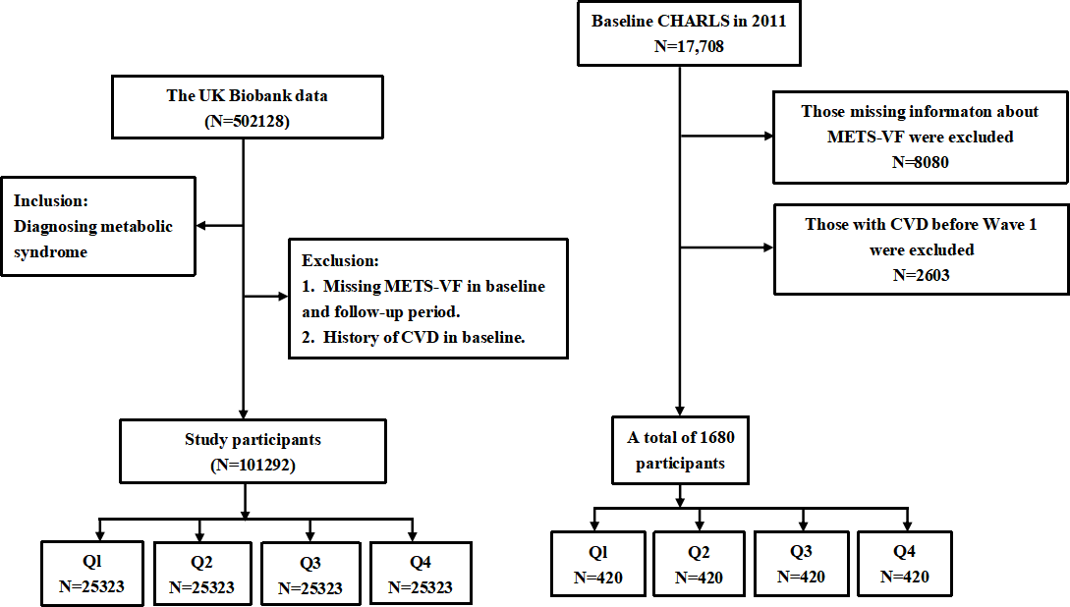
Fig S1. Study workflow in UK Biobank and CHARLS

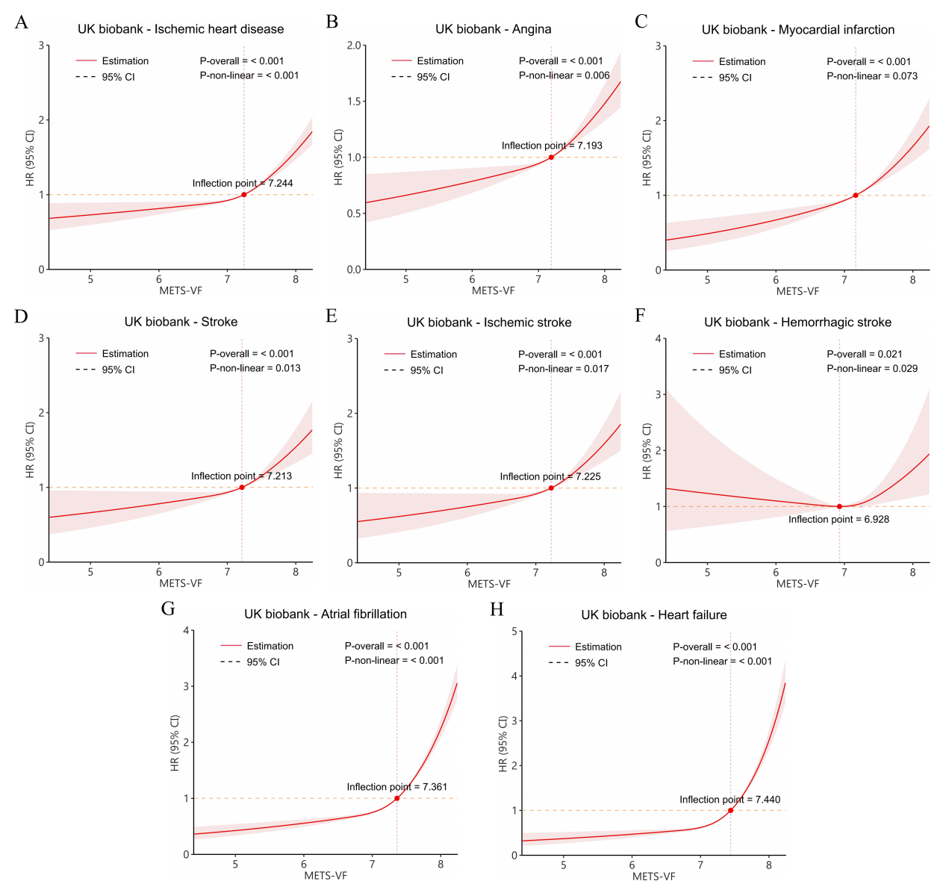
Fig. S2 Analysis of restricted cubic spline regression in UK biobank. (A) Non-linear relationship between the METS-VF with IHD. (B) Non-linear relationship between the METS-VF with angina. (C) Positive linear relationship between the METS-VF with MI. (D) (F) Non-linear relationship between the METS-VF with stroke. (E) Non-linear relationship between the METS-VF with ISS (F) Non-linear relationship between the METS-VF with Hemorrhagic stroke. (G) Non-linear relationship between the METS-VF with AF. (H) Non-linear relationship between the METS-VF with HF. Adjusted for age, gender, race, education level, smoking status, alcohol consumption status, physical activity, hypertention, diabetes, LDL, Ua and HbA1c. Abbreviations: HR: Hazard ratios, CI: Confidence interval, METS-VF: Metabolic score for visceral fat, LDL-C: Low-density lipoprotein cholesterol; Ua: Uric acid, MI: Myocardial infarction; ISS: Ischaemic stroke, AF: Atrial fibrillation; HF: Heart failure.

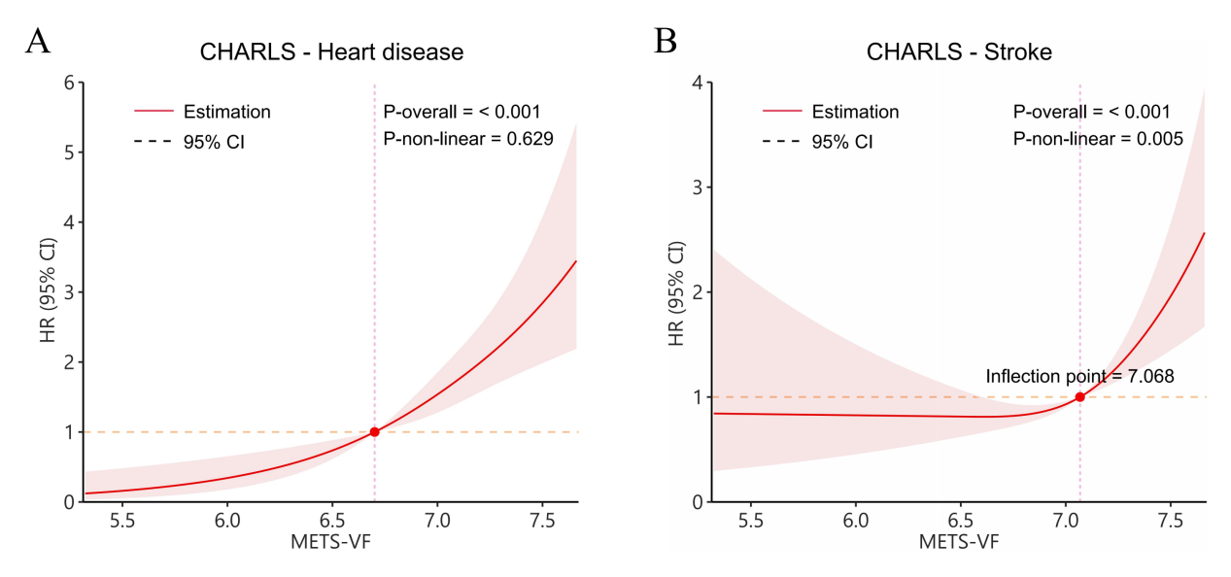
Fig. S3 Analysis of restricted cubic spline regression in CHARLS. (A) Positive linear relationship between the METS-VF with Heart disease. (B) Non-linear relationship between the METS-VF with stroke. Adjusted for age, gender, race, education level, smoking status, alcohol consumption status, physical activity, hypertention, diabetes, LDL, Ua and HbA1c. Abbreviations: HR: Hazard ratios, CI: Confidence interval, METS-VF: Metabolic score for visceral fat. AF: Atrial fibrillation; LDL-C: Low-density lipoprotein cholesterol; Ua: Uric acid.

