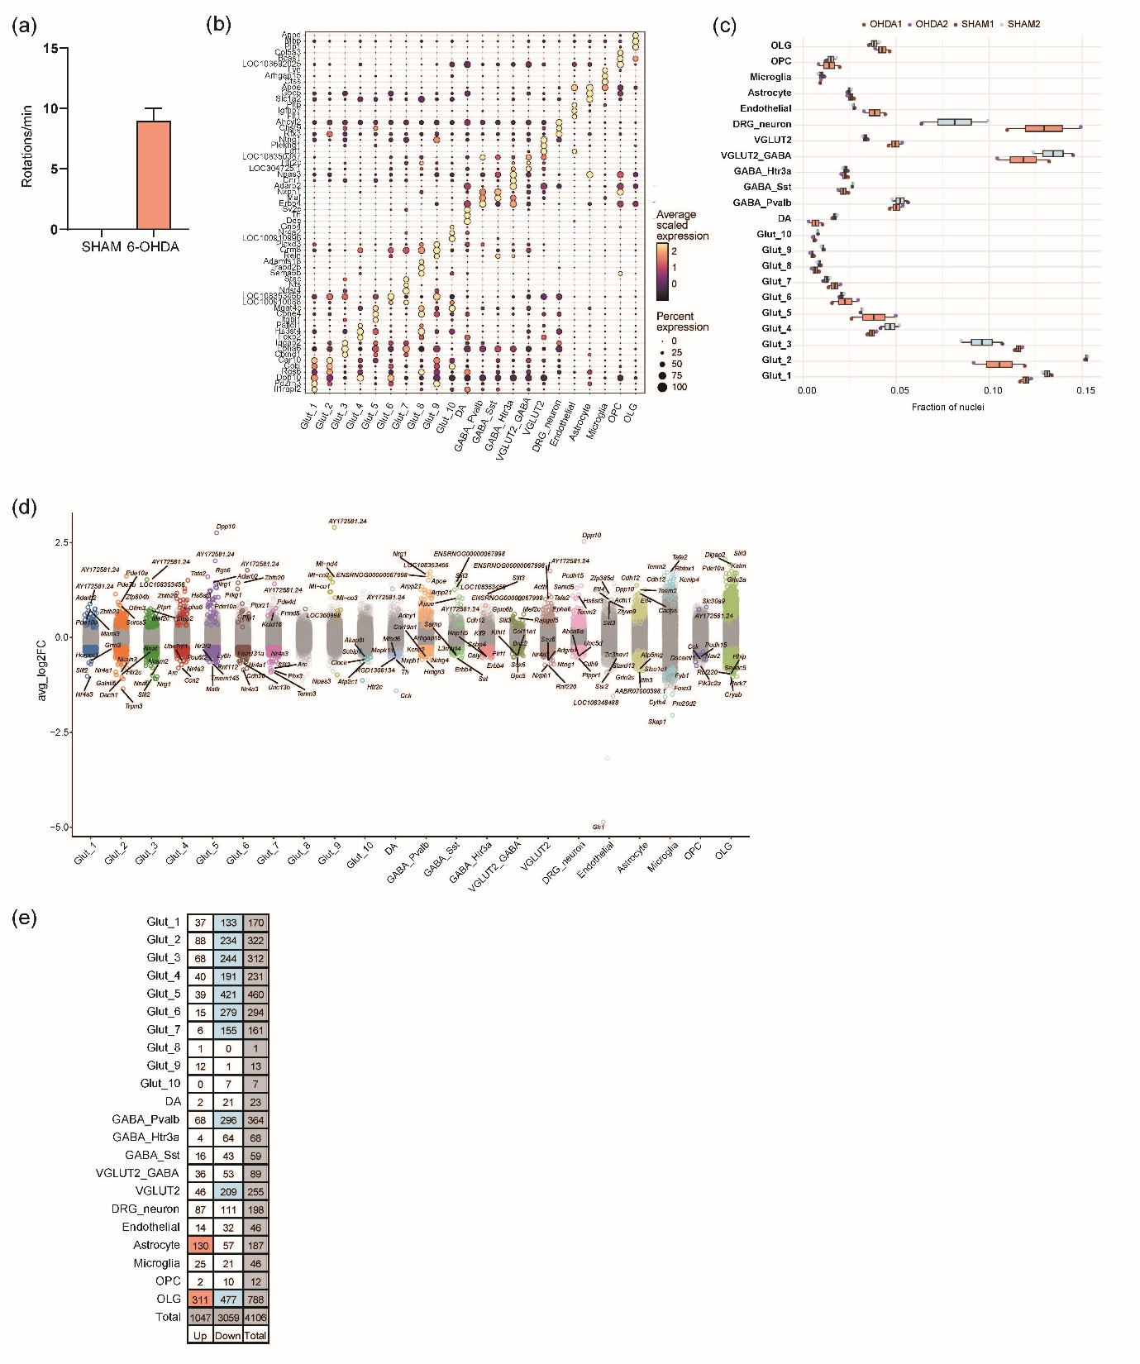Supplementary Figure 1. Behavioral and cell type–level transcriptional validation of 6-OHDA–induced DA lesioning. (a) Rotational behavior assay showing a greater increase in ipsilateral rotations per minute in 6-OHDA–lesioned rats than in SHAM controls, confirming successful induction of DA dysfunction and unilateral motor impairment. (b) Dot plot illustrating the expression of canonical marker genes across the 22 identified midbrain cell populations, including Glut neurons (Glut_1–Glut_10), DA, GABAergic neurons (GABA_Pvalb, GABA_Sst, and GABA_Htr3a), DRG_neuron, VGLUT2_GABA, VGLUT2, OLG, ASTs, MG, endothelial cells, and OPC. Dot size represents the proportion of expressing nuclei within each cluster, while color intensity reflects the average expression level. (c) Boxplots depicting the distribution of nuclei fraction per cell type between the SHAM and 6-OHDA–treated groups. (d) Volcano plot summarizing differential gene expression across all cell types. Average log2 fold change (avg_log2FC) values highlight the five most significantly upregulated and downregulated genes per cell type, revealing cell-type-specific transcriptional remodeling following 6-OHDA–induced injury. (e) Summary table quantifying the number of significantly upregulated, downregulated, and total DEGs for each cell type. Glut neurons exhibit the highest number of transcriptional alterations, consistent with their prominent role in post-lesional plasticity and compensation. Abbreviations: 6-OHDA, 6-hydroxydopamine; DA, dopaminergic; SHAM, vehicle-treated; Glut, glutamatergic neurons; GABA, gamma-aminobutyric acid; DRG, dorsal root ganglia; VGLUT2, vesicular glutamate transporter 2; OLG, oligodendrocytes; OPC, oligodendrocyte precursor cells.

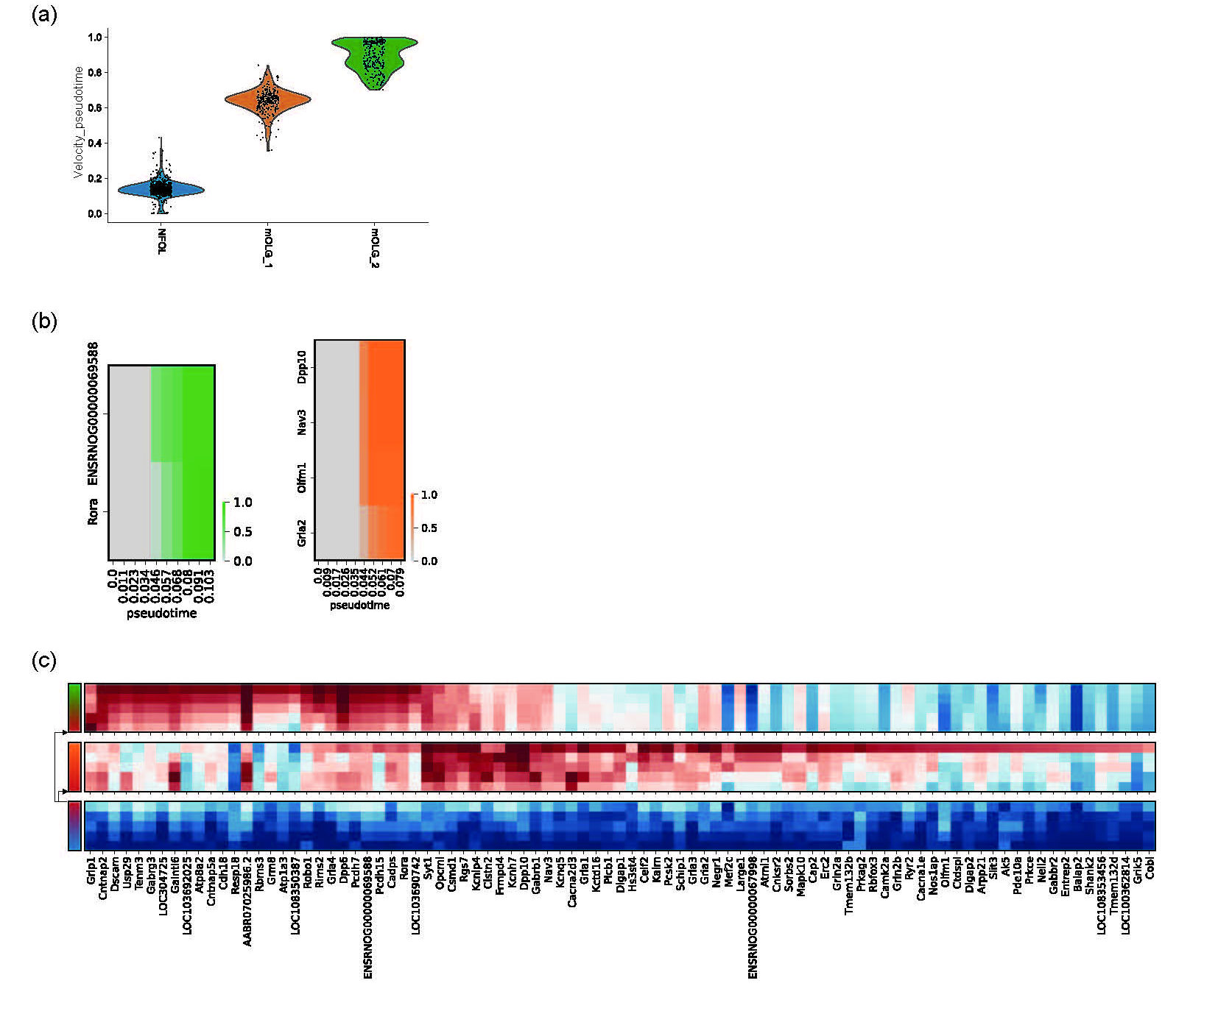Supplementary Figure 2. Pseudotime and bifurcation-resolved transcriptional programs underlying OLG fate commitment. (a) Violin plots visualizing the distribution of velocity-derived pseudotime values for cells assigned to the mOLG_1 and mOLG_2 fates. Cells were stratified based on fate probability inferred by CellRank, revealing distinct temporal progression patterns toward the respective terminal states. (b) Fate-specific gene module analysis using scFates. Gene modules associated with the mOLG_1 (left) and mOLG_2 (right) lineages were identified based on their expression dynamics along pseudotime prior to the bifurcation, highlighting lineage-specific regulatory programs. (c) Branch-specific differential gene expression analysis performed across all branches using scFates. Differential testing was conducted with rescaling, allowing comparison across full branch populations independent of pseudotime progression. Abbreviations: OLG, oligodendrocytes; mOLG_1, mature oligodendrocyte lineage 1; mOLG_2, mature oligodendrocyte lineage 2; CellRank, computational tool for pseudotime and fate inference; scFates, single-cell fate prediction analysis.

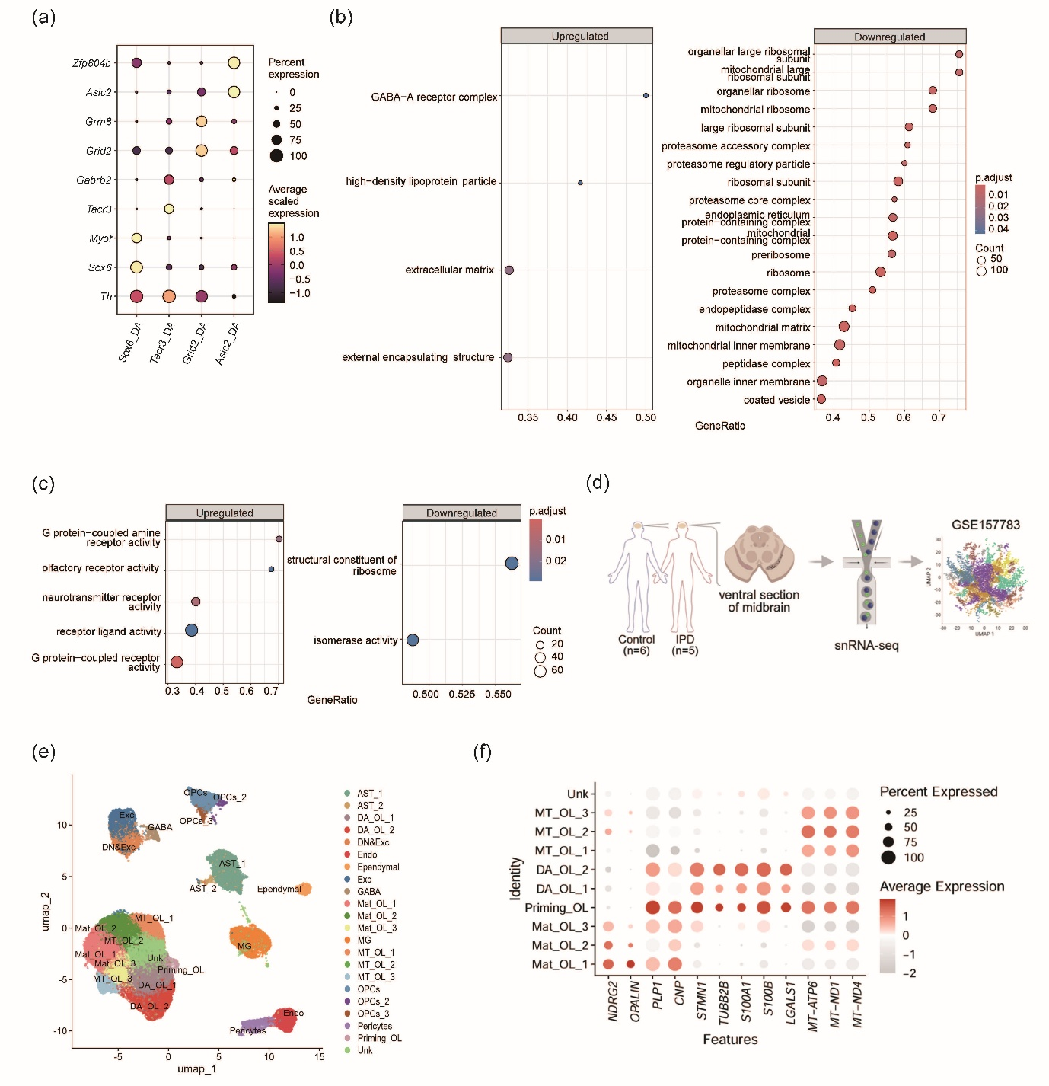Supplementary Figure 3. Transcriptional and functional signatures of Asic2⁺ DA neurons. (a) Dot plot showing the expression patterns of representative marker genes across DA neuron subtypes. Genes include classical DA markers (TH, Sox6), subtype-specific modulators (Tacr3, Asic2), and neurotransmitter-related genes (Gabra2, Grik2, and Gpr88). Dot size represents the proportion of nuclei expressing each gene, while color intensity reflects the average scaled expression. (b) GO enrichment analysis of DEGs in the Asic2+ DA neuron population, categorized under the Cellular Component ontology. Upregulated genes (left) are enriched in terms related to the extracellular matrix and GABA-A receptor complex, while downregulated genes (right) show significant enrichment in mitochondrial and ribosomal compartments, suggesting structural and metabolic alterations. (c) GO enrichment analysis of the same gene set under the Molecular Function ontology. Upregulated genes (left) are enriched for neurotransmitter receptor activity and G protein-coupled receptor signaling, while downregulated genes (right) are associated with ribosomal structural constituents and isomerase activity, indicating suppressed biosynthetic activity in Asic2⁺ DA neurons. (d) Schematic representation of the human PD snRNA-seq dataset. Postmortem midbrain tissues from patients with idiopathic PD (n = 5) and age-matched controls (n = 6) were analyzed. Data were obtained from the publicly available dataset GSE157783. (e) UMAP plot showing the overall distribution of subclusters identified in the dataset. Subclusters include AST_1, AST_2, DA_OL_1, DA_OL_2, DN&Exc, Endo, Ependymal, Exc, GABA, Mat_OL_1, Mat_OL_2, Mat_OL_3, MG, MT_OL_1, MT_OL_2, and MT_OL_3, OPCs, OPCs_2, OPCs_3, Pericytes, Priming_OL, and Unk. (f) Dot plots visualizing the expression of established marker genes across clusters for lineage identification. Abbreviations: 6-OHDA, 6-hydroxydopamine; DA, dopaminergic; TH, tyrosine hydroxylase; Sox6, SRY-box transcription factor 6; Tacr3, tachykinin receptor 3; Asic2, acid-sensing ion channel 2; Gabra2, GABA receptor subunit alpha-2; Grik2, glutamate receptor, ionotropic, kainate 2; Gpr88, G-protein coupled receptor 88; GO, Gene Ontology; DEGs, differentially expressed genes; GABA-A, gamma-aminobutyric acid type A; PD, Parkinson's disease; snRNA-seq, single-nucleus RNA sequencing; AST, astrocytes; DA_OL, damage-associated oligodendrocytes; DN&Exc, dopaminergic and excitatory neurons; Endo, endothelial cells; Exc, excitatory neurons; GABA, GABAergic neurons; Mat_OL, mature oligodendrocytes; MG, microglia; MT_OL, mitochondria-high oligodendrocytes; OPCs, oligodendrocyte precursor cells; Unk, unknown.

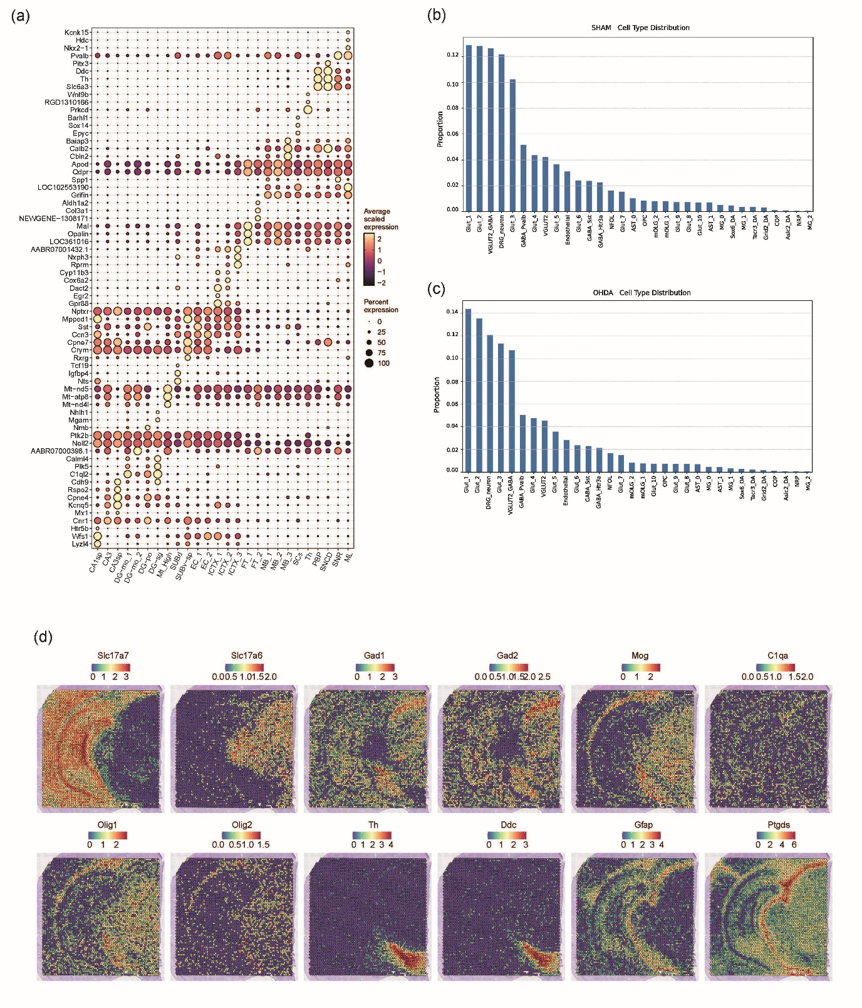Supplementary Figure 4. Regional gene expression patterns and group-wise cell type distribution across the midbrain spatial transcriptome. (a) Dot plot showing the expression of representative marker genes across spatially annotated regions, including the cortex, hippocampus, and thalamus. Selected genes highlight key populations: neuronal markers (Slc17a7, Slc17a6, Gad1, and Gad2), OLGs (Mog, Olig1, and Olig2), DA (TH, Ddc), ASTs (Gfap, Ptgds), and MG (C1qa) populations. This plot validates regional annotation based on transcriptional profiles. Dot size represents the proportion of expressing spots, while color intensity reflects the average expression level. (b) Bar plots comparing the relative proportions of predicted cell types in the SHAM and 6-OHDA groups, based on Tangram-based deconvolution across spatial transcriptomic spots. For each group, the cell type composition was calculated by summing the deconvolution-derived cell probabilities across all spots and normalizing them to the total. Notably, alterations in the proportion of excitatory neurons, DA subtypes, and glial cell populations were observed between conditions, reflecting region- and cell-type-specific remodeling following DA neurodegeneration. (c) Spatial feature plots visualizing the expression of representative marker genes across the midbrain tissue section from the Visium spatial transcriptomic dataset. The shown genes correspond to excitatory neurons (Slc17a7 and Slc17a6), inhibitory neurons (Gad1 and Gad2), OLGs (Mog, Olig1, and Olig2), MG (C1qa), DA neurons (TH and Ddc), and ASTs (Gfap and Ptgds). Each panel depicts transcript abundance overlaid on tissue coordinates, highlighting region-specific localization patterns and validating the anatomical segmentation used for downstream analysis. Abbreviations: 6-OHDA, 6-hydroxydopamine; SHAM, vehicle-treated; Th, tyrosine hydroxylase; Ddc, Dopa decarboxylase; Slc17a7, solute carrier family 17 member 7 (also known as Vglut1); Slc17a6, solute carrier family 17 member 6 (also known as Vglut2); Gad1, glutamate decarboxylase 1 (GAD65); Gad2, glutamate decarboxylase 2 (GAD67); Mog, myelin oligodendrocyte glycoprotein; Olig1, oligodendrocyte transcription factor 1; Olig2, oligodendrocyte transcription factor 2; Gfap, glial fibrillary acidic protein; Ptgds, prostaglandin D2 synthase; C1qa, complement component 1, q subcomponent, A chain; Tangram, spatial deconvolution method; Visium, spatial transcriptomics platform.

(a) SHAM
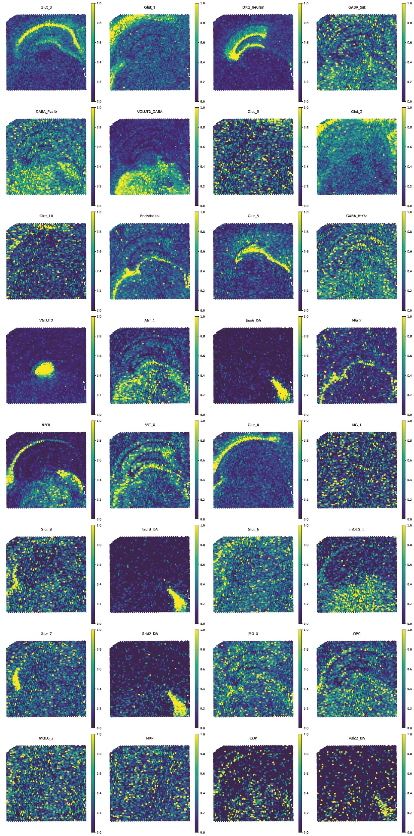
(b) 6-OHDA
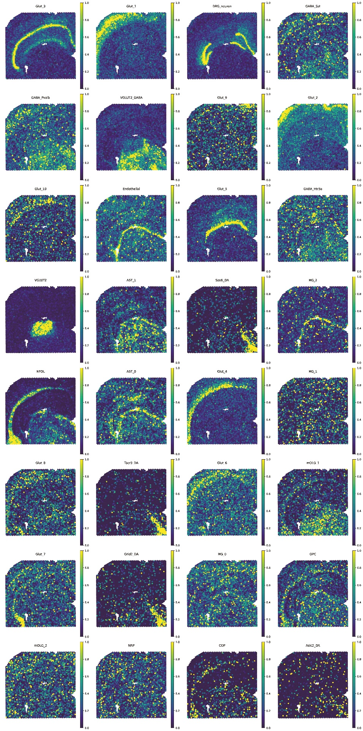
Supplementary Figure 5. Spatial distribution of major cell types predicted by Tangram mapping in SHAM and 6-OHDA-treated midbrain sections. (a) Predicted spatial distribution of 32 major cell types in SHAM midbrain sections, generated by mapping snRNA-seq-derived annotations onto spatial transcriptomics data using the Tangram algorithm. Each plot represents the probability of a specific cell type being assigned to each spatial spot. Notable cell populations include Glut neuron subtypes (e.g., Glut_1, Glut_3, Glut_4, Glut_5, and Glut_6), GABAergic neurons (e.g., GABA_Pvalb, GABA_Sst, and GABA_Htr3a), DA neurons (Sox6_DA, Tacr3_DA, Grid2_DA, and Asic2_DA), OLGs (mOLG_1 and mOLG_2), ASTs (AST_0 and AST_1), MG (MG_0, MG_1, and MG_2), and endothelial cells. (b) Predicted spatial distribution of the same 32 cell types in midbrain sections from 6-OHDA-lesioned rats. Comparative visualization reveals region-specific alterations in the abundance and localization of neuronal and glial populations following DA degeneration. Color intensity reflects the normalized probability of each cell type at a given spatial location (yellow = high probability; purple = low probability). Spatial mapping was performed using the Tangram in probabilistic optimization mode with spot-level cell-type prediction. Abbreviations: 6-OHDA, 6-hydroxydopamine; SHAM, vehicle-treated; Tangram, spatial mapping algorithm; snRNA-seq, single-nucleus RNA sequencing; Glut, glutamatergic neurons; GABA, gamma-aminobutyric acid; DA, dopaminergic; OLG, oligodendrocytes; mOLG, mature oligodendrocytes; AST, astrocytes; MG, microglia.

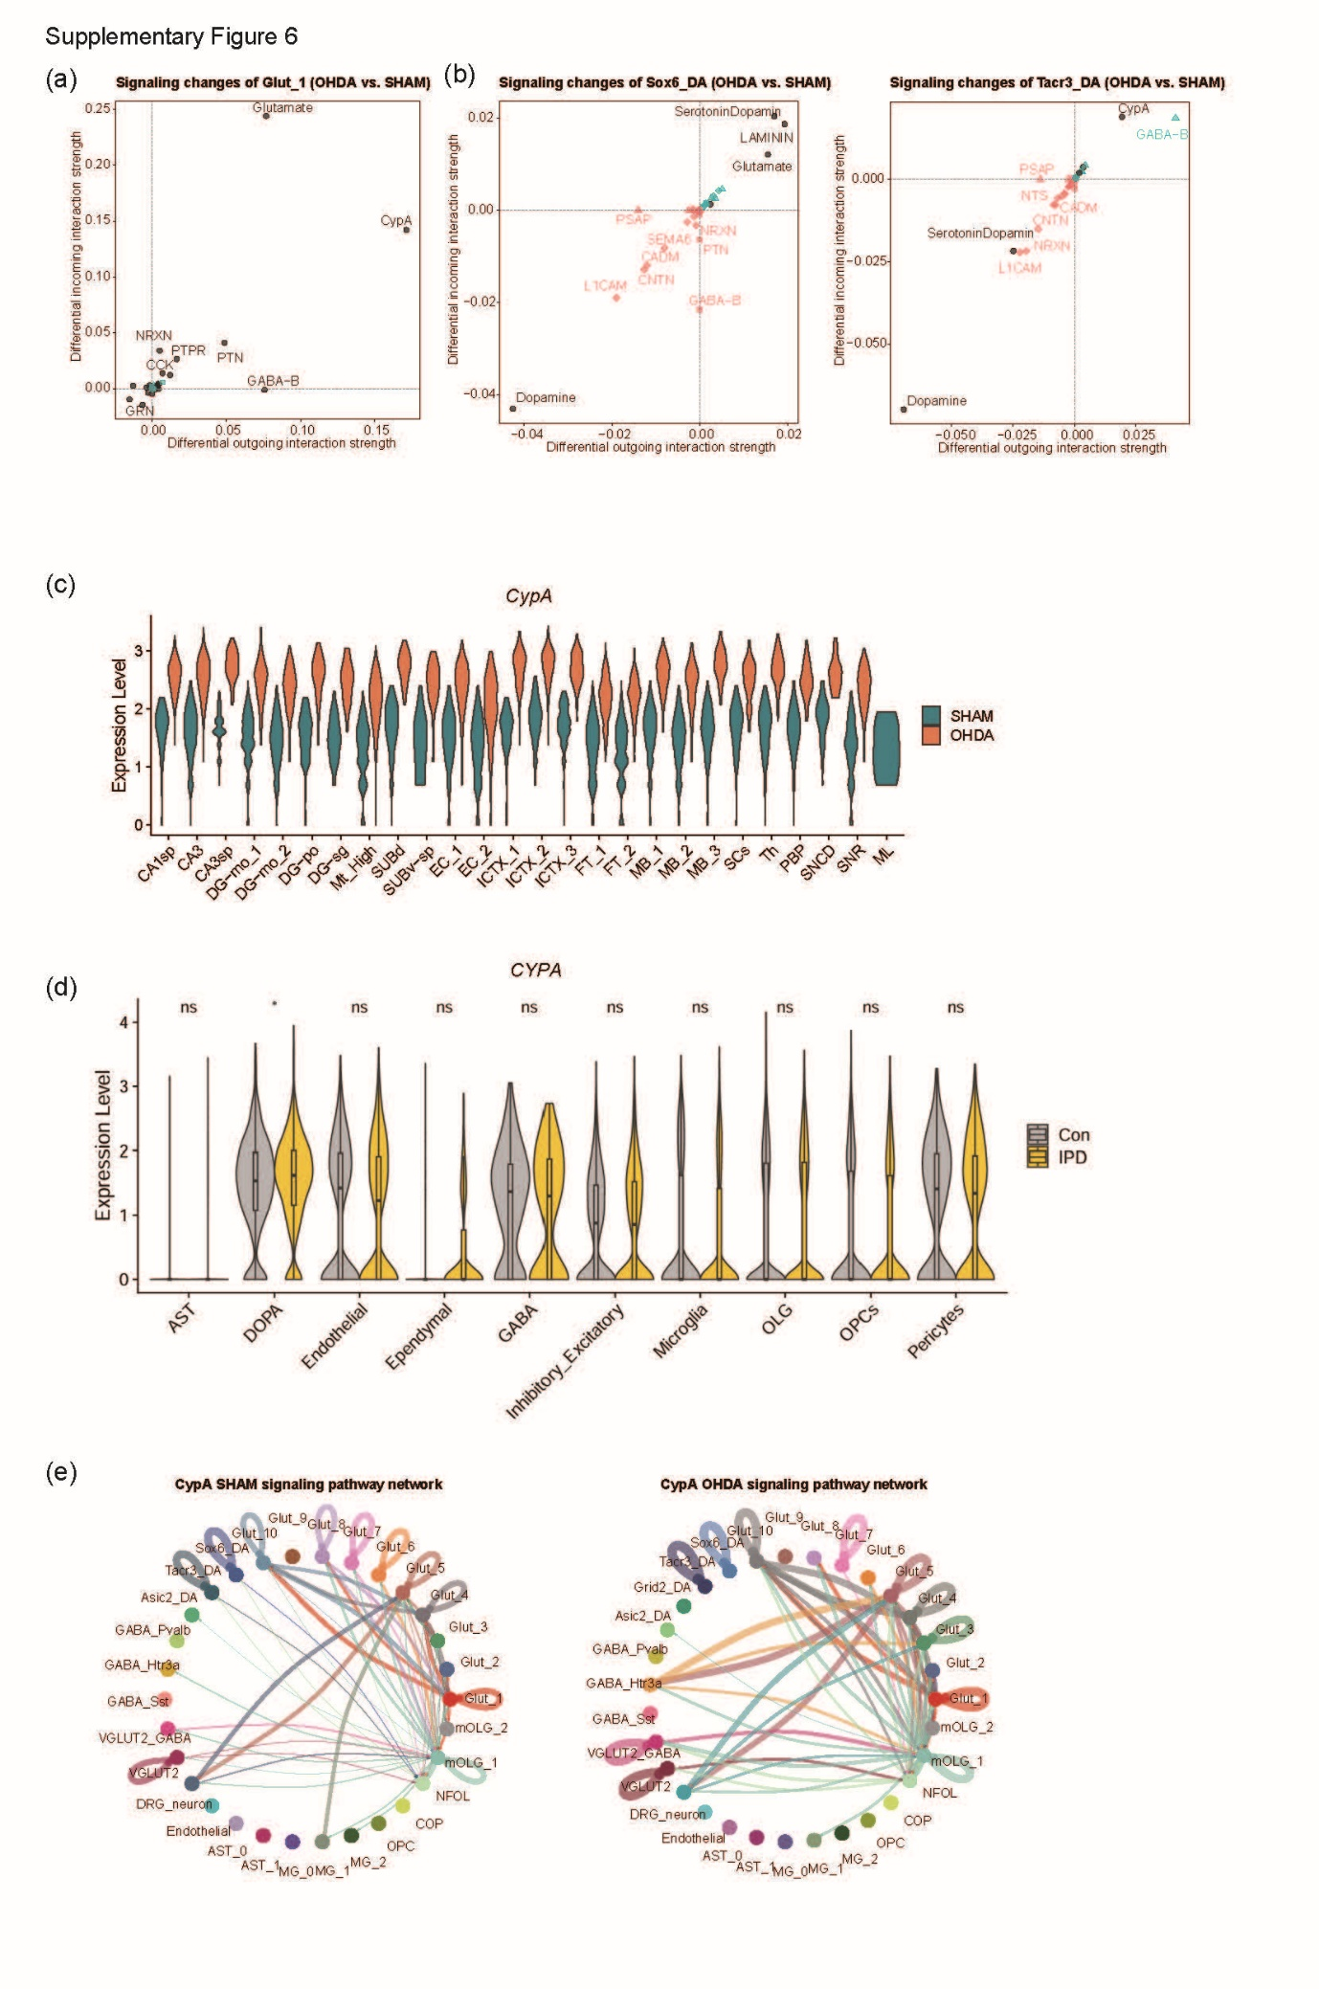Supplementary Figure 6. Differential analysis of ligand-receptor signaling dynamics in selected neuronal subtypes between 6-OHDA and SHAM conditions. (a) Differential signaling landscape of Glut_1 neuron comparing 6-OHDA and SHAM. Scatter plot illustrating changes in incoming and outgoing interaction strengths for the Glut_1 population. Each point represents a signaling pathway, colored by specificity (black: shared; red: SHAM-specific; blue: OHDA-specific), and shaped by the mode of specificity (circle: shared; triangle: specific to incoming or outgoing; diamond: specific to both). Glutamate and CypA signaling show marked increases in both incoming and outgoing interactions in the 6-OHDA group. (b) Differential signaling landscapes of Sox6_DA neurons (left) and Tacr3_DA (right) comparing the 6-OHDA and SHAM groups. In both subtypes, several neurodevelopment- and adhesion-related pathways (e.g., SEMA6, NRXN, PTN, and L1CAM) are enriched under SHAM conditions. Notably, dopamine signaling is substantially reduced following OHDA lesioning. (c) Violin plot illustrating the regional distribution of CypA expression levels across anatomical regions of the midbrain in the SHAM and OHDA groups. Each violin represents the distribution of normalized CypA transcript levels within a specific region, stratified by experimental conditions. A widespread upregulation of CypA expression is observed across midbrain and cortical regions following 6-OHDA treatment, consistent with stress-induced gene activation. (d) Violin plots depicting ASIC2 expression levels in postmortem midbrain tissue from controls and patients with idiopathic PD. Horizontal lines represent the median and IQR. Statistical significance between groups was determined using a two-sided Wilcoxon rank-sum test. Statistical significance levels are indicated as p < 0.05 (*), p < 0.001 (**), or p < 0.0001 (***). (e) Circle plots depicting CypA-mediated intercellular communication networks inferred by CellChat in SHAM (left) and 6-OHDA (right) midbrain samples. Nodes represent distinct cell populations, while edges denote significant ligand-receptor interactions involving CypA. Edge thickness reflects interaction strength. This comparative visualization reveals enhanced CypA-associated signaling following DA injury. Abbreviations: 6-OHDA, 6-hydroxydopamine; SHAM, vehicle-treated control; DA, dopaminergic; Glut, glutamatergic neuron; CypA, cyclophilin A (PPIA); ASIC2, acid-sensing ion channel 2; PD, Parkinson’s disease; SEMA6, semaphorin 6; NRXN, neurexin; PTN, pleiotrophin; L1CAM, L1 cell adhesion molecule.

