Supporting Information
Novel Synthetic Strategy for Aromatic Ether Coumarin Derivatives and Evaluation of Anti-allergic Potential
Xiaoyue Liu, Xiaoxia Mao#, Yuying Zhang, Dejun Zhou*
（The key laboratory of Chinese medicine research and development in HeBei province, Institute of Chinese Medicine in Chengde Medical University, Chengde, Hebei, China）

Contents:
1. General Information 2
1.1. General experimental Procedures 2
1.2. Experimental material 2
1.3. Instrumentation 2
2. Experimental manipulation of biological activity 3
2.1. β -Aminohexosidase release in RBL - 2H3 cells 3
2.2. Antigen-induced degranulation assay 3
3. Experimental Procedures 4
3.1 Synthesis of ethyl 7-hydroxy-3-carboxylate coumarin (1) 4
3.2 Synthesis of coumarin 2 7-hydroxy-3-carboxylic acid (2) 5
3.3 Synthesis of 7-hydroxy-3-methyl ketocoumarin (3) 5
3.4 Synthesis of 7-phenylether-3-carboxylic acid ethyl ester coumarin intermediate (4') 6
3.5 Synthesis of ethyl 7-phenylether-3-carboxylate coumarin (4) 7
3.6 Synthesis of coumarin 5 from 7-phenylether-3-carboxylic acid (5) 8
3.7 Synthesis of 7-phenylether-3-methyl ketocoumarin (6') 9
3.8 Synthesis of 7-phenylether-3-methylketone coumarin (6) 9
3.9 Synthesis of 4-phenylether coumarin intermediate (7') 10
3.10 Synthesis of 4-phenylether coumarin (7) 11
4. ¹H NMR, ¹³C NMR, IR & HRMS Spectra of compounds (1-7) 13

1. General Information

1.1. General experimental Procedures
Unless otherwise stated, all reactions involved were carried out using dry round-bottomed flasks under a nitrogen atmosphere. Air and moisture sensitive liquids were transferred by syringe. Organic solutions were concentrated by rotary evaporation at not more than 40 ℃. Anhydrous solvents were obtained by standard procedures. Reactions were detected by UV fluorescence (254 nm) using a GF254 prefabricated thin-layer chromatography plate (Qingdao Ocean Chemistry Co., Ltd.). Separation and purification were operated using silica gel column chromatography with specifications of 200~300 mesh, the unfolding agent was petroleum ether/ethyl acetate (3:1, v/v), and the eluents were petroleum ether, ethyl acetate and methanol. All the steps of cell culture were done in a biological safety cabinet, and all the materials used in the experiment were sterile.

1.2. Experimental material
Unless otherwise stated, commercially available chemical reagents were purchased from commercial suppliers (Aladdin, Macklin, Energy Chemical, Sinopharm Chemical Reagent Co., Ltd.) and used directly without further purification. Dimethyl sulfoxide (Item No. ST038-100 ml) was purchased from Beyotime Biotechnology Co. MEM basal medium (Item No. G4550-500 ml) was purchased from Wuhan Saier Biotechnology Co. Fetal bovine serum (Item No. 164210-50) was purchased from Wuhan Priority Biotechnology Co. Cell counting kit-8 (Item No. C6005) was purchased from China New Cell & Molecular Biotechnology Co. Rat basophilic leukemia cells ( RBL-2H3 ) were purchased from Wuhan Punosai Life Science and Technology Co.

1.3. Instrumentation
Nuclear magnetic resonance (NMR) spectral data were obtained on Bruker 400 NMR and BRUKER AVANCE NEO 600 MHZ instrument at 23 °C. Deuterated solvents used were deuterated chloroform and dimethyl sulfoxide (CDCl₃: ¹H NMR δ 7.26, ¹³C NMR δ 77.16; DMSO-d₆: ¹H NMR δ 2.50, ¹³C NMR δ 39.60). Infrared (IR) spectral data were tested and recorded using an IRAffinity-1s infrared spectrometer. Mass spectra （Ms）were tested and recorded using a Micro Q-TOF mass spectrometer. Melting points were tested and recorded using a STUART SMP40 micro melting point meter, uncorrected.

2. Experimental manipulation of biological activity

2.1. β -Aminohexosidase release in RBL - 2H3 cells
The extent of degranulation was assessed by measuring the secretion of β-hexosaminidase.RBL-2H3 was suspended at a density of 2×105 cells/ml and sensitized with 1.5 μg/ml DNP-IgE at 37 ℃ for 6 h. The sensitized cells were washed with Tyrodeˊs buffer, and 0 nM, 10 nM, 100 nM, and 1 μM bis-coumarin compounds were added, and incubated for 37 ℃ for 30 min. The cells were incubated for 30 min. followed by stimulation with 100 ng/ml DNP- BSA for 1 h. The cell supernatant was centrifuged and collected, and the cell pellet was lysed with Tyrodeˊs buffer containing 0.5% Triton x-100. After incubation with substrate at 37 ℃ for 1 h, the reaction was terminated by the addition of 0.2 M sodium hydroxide and 0.2 M glycine, and the OD values of the supernatant and cell lysates at 405 nm were determined using an enzyme marker. β-Hexosaminidase (%) = (supernatant OD - blank OD)/(supernatant OD+cell OD - blank OD).

2.2. Antigen-induced degranulation assay
The extent of degranulation was assessed by measuring the secretion of β-hexosaminidase. mBMMCs were suspended at a density of 2 × 105/ml and sensitized with 1.5 μg/ml DNP-IgE for 6 h at 37 °C. Sensitized cells were washed with Tyrodeˊs buffer, 1 μM bicoumarin compound was added, and the cells were incubated for 30 min at 37 °C. The cells were subsequently stimulated with 100 ng/ml DNP- BSA for 1 h. The cell supernatants were centrifuged and collected. ml DNP- BSA was stimulated for 1 h. The cell supernatant was centrifuged and collected, and the cell pellet was lysed with Tyrodeˊs buffer containing 0.5% Triton X-100. After incubation with substrate at 37 ℃ for 1 h, the reaction was terminated by the addition of 0.2 M sodium hydroxide and 0.2 M glycine, and the OD values of the supernatant and cell lysates at 405 nm were determined using an enzyme marker. β-Hexosaminidase (%) = (supernatant OD - blank OD)/(supernatant OD+cell OD - blank OD).

3. Experimental Procedures

3.1 Synthesis of ethyl 7-hydroxy-3-carboxylate coumarin (1)
The raw material 2,4-dihydroxybenzaldehyde (S₁) (2.0 g, 1 eq) was dissolved in 40 ml of anhydrous ethanol, and diethyl malonate (6.56 ml, 3 eq) was added to the reaction system at room temperature with stirring, followed by the addition of diethylamine (8.95 ml, 6 eq), and then the reaction was carried out at 90 ℃ for 2-3 h. The extent of the reaction was monitored by TLC, and was stopped after the raw material was consumed or the reaction was no longer in progress. The reaction was stopped when the raw material was consumed or the reaction was no longer proceeding. When the reaction system returned to room temperature, 10% hydrochloric acid was added to adjust the pH to 1-2, and the solid was precipitated by stirring in an ice bath for 15 min, the dark brown solid was obtained by filtration, and the light brown solid (1) was obtained by recrystallization from 50% ethanol (3.37 g), with a yield of 98%. The unfolding agent was petroleum ether:ethyl acetate=3:1 Brown solid, m.p. 167-169 °C, yield 98 %.
¹H NMR (400 MHz, DMSO-d₆) δ 8.67 (s, 1H), 7.76 (d, J = 8.6 Hz, 1 H), 6.84 (dd, J = 8.6, 2.1 Hz, 1 H), 6.73 (d, J = 2.1 Hz, 1 H), 4.26 (q, J = 7.1 Hz, 2 H), 1.29 (t, J = 7.1 Hz, 3 H). ¹³C NMR (100 MHz, DMSO-d₆) δ 164.54, 163.43, 157.59, 156.88, 149.92, 132.59, 114.48, 112.57, 110.90, 102.27, 61.28, 14.60. HRMS-ESI (m/z): [M+ Na]+ Calcd for C₁₂H₁₀O₅Na 257.0426, Found: 257.0421. IR (KBr, cm⁻¹): 3217.27, 1699.29, 1591.27, 1215.15, 1118.71, 827.46, 794.67, 640.37.

3.2 Synthesis of coumarin 2 7-hydroxy-3-carboxylic acid (2)
Compound (1) (2.0 g,1 eq) was dissolved in 10 ml of ethanol and 5 ml of water, stirred at room temperature, NaOH (1.37 g,4 eq) was added to the reaction system, and the reaction was heated up to 80 ℃ for 15 min, and the extent of the reaction was monitored by TLC, and the reaction was stopped after the raw materials were consumed or the reaction was no longer proceeding. When the reaction system returned to room temperature, 10% hydrochloric acid was added to adjust the pH to 1-2, and the solid was precipitated by stirring in an ice bath for 15 min, and the white solid (2) was obtained by filtration (1.72 g) in 98% yield. Expanding agent for petroleum ether: ethyl acetate = 3: 1. White solid, m.p. 255-257 ℃, yield 98 %.
¹H NMR (600 MHz, DMSO-d₆) δ 8.67 (s, 1 H), 7.74 (d, J = 8.6 Hz, 1 H), 6.83 (dd, J = 8.6, 2.2 Hz, 1H), 6.72 (d, J = 2.2 Hz, 1H). ¹³C NMR (150 MHz, DMSO-d₆) δ 164.81, 158.22, 132.48, 114.70. HRMS-ESI (m/z): [M+Na]+ Calcd for C₁₀H₆O₅Na 229.0109, Found: 229.0107. IR (KBr, cm⁻¹): 3136.25, 1712.76, 1683.86, 1618.28, 1220.94, 1136.07, 819.75, 796.60, 750.31, 644.22.

3.3 Synthesis of 7-hydroxy-3-methyl ketocoumarin (3)
The raw material 2,4-dihydroxybenzaldehyde (S) (1.0 g,1 eq) was dissolved in 20 ml of anhydrous ethanol, stirred at room temperature, ethyl acetoacetate (2.84 ml,3 eq) was added to the reaction system, followed by the addition of diethylamine (4.48 ml,6 eq), and then the reaction was carried out at a temperature of 90 ℃ for 2-3 h. The extent of the reaction was monitored by TLC, and was stopped when the raw material was consumed or the reaction was no longer in progress. The reaction was stopped when the raw material was consumed or the reaction was no longer proceeding. When the reaction system returned to room temperature, 10% hydrochloric acid was added to adjust the pH to 1-2, and the solid was precipitated by stirring in an ice bath for 15 min, and the dark yellow solid was obtained by filtration, and then 1.48 g of light yellow solid (3) was obtained by recrystallization from 50% ethanol, with 98% yield. The unfolding agent was petroleum ether: ethyl acetate=1:1. Yellow solid, m.p. 243-245 ℃, yield 98%;
¹H NMR (600 MHz, DMSO-d₆) δ 11.28(s, 1H), 8.59 (s, 1 H), 7.79 (d, J = 8.6 Hz, 1 H), 6.85 (dd, J = 8.6, 2.0 Hz, 1 H), 6.75 (d, J = 2.0 Hz, 1 H), 2.55 (s, 3 H). ¹³C NMR (150 MHz, DMSO-d₆) δ 195.17, 164.67, 159.53, 157.73, 148.37, 133.18, 119.72, 114.70, 111.27, 102.24, 30.55. HRMS-ESI (m/z): [M+H]+ Calcd for C₁₁H₉O₄ 205.0501, Found: 205.0492. IR (KBr, cm⁻¹): 3215.34, 3057.17, 1705.07, 1681.93, 1625.99, 1614.42, 1213.23, 1134.14, 825.53, 644.22.

3.4 Synthesis of 7-phenylether-3-carboxylic acid ethyl ester coumarin intermediate (4')
Compound 1 (0.2 g,1 eq) was dissolved in 25 ml of anhydrous methanol and stirred at room temperature, iodobenzene diacetic acid (1.38 g,5 eq) was added to the reaction system, the reaction was carried out at 25 ℃ for 3-4 h. The extent of the reaction was monitored by TLC, and the reaction was stopped after the raw material was consumed or the reaction was no longer proceeding. Post-treatment: the solvent was removed by rotary evaporation, followed by further separation and purification of the product by column chromatography, dry sampling, the eluent was eluted in the order of ethyl acetate:methanol=20:1 to 5:1, and tracked by TLC plate spotting, with UV appearing at 10:1, and no UV on the plate spotting at 5:1, which indicated that the elution was complete. The obtained liquid was rotary evaporated to remove petroleum ether and ethyl acetate. Finally oil pumping to dryness yielded 0.29 g of white solid (4') in 78% yield. The unfolding agent was ethyl acetate: methanol = 10:1. White solid, m.p. 197-199 ℃, yield 78%;
¹H NMR (600 MHz, DMSO-d₆) δ 8.41 (s, 1H), 7.92 (brd, J = 7.9 Hz, 2 H), 7.56 (brt, J = 7.4 Hz, 1 H), 7.44 (m, 3 H), 6.38 (d, J = 9.1 Hz, 1 H), 4.20 (q, J = 7.1 Hz, 2 H), 1.26 (t, J = 7.1 Hz, 3 H). ¹³C NMR (150 MHz, DMSO-d₆) δ 174.44, 164.07, 160.54, 157.00, 149.44, 134.58, 134.58, 131.79, 131.79, 130.92, 120.46, 119.93, 115.46, 104.59, 101.22, 97.69, 60.39, 14.78.

3.5 Synthesis of ethyl 7-phenylether-3-carboxylate coumarin (4)
Compound 1 (0.2 g,1 eq) was dissolved in 25 ml of anhydrous methanol and stirred at room temperature, iodobenzene diacetic acid (1.38 g,5 eq) was added to the reaction system, and the reaction was heated up to 60 ℃ for 3-4 h. The extent of the reaction was monitored by TLC, and the reaction was stopped when the raw materials were consumed or the reaction was no longer proceeding. Post-treatment: the solvent was removed by rotary evaporation, followed by further separation and purification of the product by column chromatography, dry sampling, the eluent was eluted in the order of petroleum ether:ethyl acetate=20:1 to 3:1, and tracked by TLC spot plate, the UV appeared after concentration at 8:1, the main spot appeared at 6:1, and no UV was found in the spot plate at 3:1, which indicated that the elution was complete. The obtained liquid was rotary evaporated to remove petroleum ether and ethyl acetate. Finally oil pumping to dryness gives 0.31 g of white solid (4) in 85% yield. The unfolding agent was petroleum ether: ethyl acetate = 3:1. White solid, m.p. 204-206 ℃, yield 85%;
¹H NMR (600 MHz, DMSO-d₆) δ 8.74 (s, 1 H), 7.90 (d, J = 8.6 Hz, 1 H), 7.48(t, J = 7.4 Hz, 2 H), 7.28 (tt, J = 7.4, 1.1 Hz, 1 H), 7.13 (brd, J = 7.4 Hz, 2 H), 6.82 (d, J = 8.6 Hz, 1 H), 4.30 (q, J = 7.1 Hz, 2 H), 1.32 (t, J = 7.1 Hz, 3 H). ¹³C NMR (150 MHz, DMSO-d₆) δ 162.87, 162.28, 156.69, 156.33, 155.56, 149.25, 132.40, 130.95, 125.53, 119.97, 116.02, 114.75, 114.56, 78.80, 61.68, 14.56. HRMS-ESI (m/z): [M+H]+ Calcd for C₁₈H₁₄IO₅ 436.9886, Found: 436.9882. IR (KBr, cm⁻¹): 3055.24, 3003.17, 1714.72, 1490.97, 1369.46, 1280.73, 1195.87, 808.17.

3.6 Synthesis of coumarin 5 from 7-phenylether-3-carboxylic acid (5)
Compound 2 (0.2 g,1 eq) was dissolved in 25 ml of anhydrous methanol and stirred at room temperature, iodobenzene diacetic acid (1.56 g,5 eq) was added to the reaction system, and the reaction was heated up to 60 ℃ for 3-4 h. The extent of the reaction was monitored by TLC, and the reaction was stopped when the raw materials were consumed or the reaction was no longer proceeding. Post-treatment: the solvent was removed by rotary evaporation, followed by further separation and purification of the product by column chromatography, dry sampling, the eluent was eluted in the order of petroleum ether:ethyl acetate=20:1 to 3:1, and tracked by TLC spot plate, the UV appeared after concentration at 8:1, the main spot appeared at 6:1, and no UV was found in the spot plate at 3:1, which indicated that the elution was complete. The obtained liquid was rotary evaporated to remove petroleum ether and ethyl acetate. Finally oil pumping to dryness gives 0.32 g of white solid (5) in 81% yield. The unfolding agent was petroleum ether: ethyl acetate = 3:1. White solid, m.p. 242-244 ℃, yield 81 %;
¹H NMR (600 MHz, CDCl₃) δ12.03 (s, 1 H), 8.81 (s, 1 H), 7.59 (d, J = 8.7 Hz, 1 H), 7.48 (t, J = 7.5 Hz, 2 H), 7.32 (brt, J = 7.4 Hz, 1 H), 7.13 (brd, J = 8.0 Hz, 2 H), 6.79 (d, J = 8.7 Hz, 1 H). ¹³C NMR (151 MHz, CDCl₃) δ 164.40, 163.92, 162.41, 154.39, 150.85, 131.60, 130.54, 126.13, 120.60, 114.21, 114.01, 112.67. ESI-MS (m/z): [M-H]⁻: 407.19.
IR (KBr, cm⁻¹): 3053.32, 1734.01, 1689.64, 1610.56, 1585.49, 1224.80, 1197.79, 798.53, 692.44.

3.7 Synthesis of 7-phenylether-3-methyl ketocoumarin (6')
Compound 3 (0.2 g,1 eq) was dissolved in 25 ml of anhydrous methanol and stirred at room temperature, iodobenzene diacetic acid (1.58 g,5 eq) was added to the reaction system, the reaction was carried out at 25 ℃ for 3-4 h. The extent of the reaction was monitored by TLC, and the reaction was stopped after the raw material was consumed or the reaction was no longer proceeding. Post-treatment: the solvent was removed by rotary evaporation, followed by further separation and purification of the product by column chromatography, dry sampling, the eluent was eluted in the order of ethyl acetate:methanol=20:1 to 5:1, and tracked by TLC plate spotting, with UV appearing at 10:1, and no UV on the plate spotting at 5:1, which indicated that the elution was complete. The obtained liquid was rotary evaporated to remove petroleum ether and ethyl acetate. Finally oil pumping to dryness yielded 0.32 g of yellow solid (6') in 81% yield. The unfolding agent was ethyl acetate: methanol = 10:1. Yellow solid, m.p. 155-158 ℃, yield 81%;
¹H NMR (600 MHz, DMSO-d₆) δ 8.39 (s, 1 H), 7.96 – 7.92 (m, 2H), 7.60 – 7.55 (m, 1 H), 7.50 (d, J = 9.2 Hz, 1 H), 7.45 (t, J = 7.8 Hz, 2 H), 6.41 (d, J = 9.1 Hz, 1 H), 2.48 (s, 3 H). ¹³C NMR (150 MHz, DMSO-d₆) δ 193.93, 160.80, 147.86, 135.29, 134.63, 131.76, 130.96, 120.86, 119.92, 115.50, 105.44, 97.95, 30.51.

3.8 Synthesis of 7-phenylether-3-methylketone coumarin 6
Compound 3 (0.2 g,1 eq) was dissolved in 25 ml of anhydrous methanol and stirred at room temperature, iodobenzene diacetic acid (1.58 g,5 eq) was added to the reaction system, and the reaction was heated up to 60 ℃ for 3-4 h. The extent of the reaction was monitored by TLC, and the reaction was stopped when the raw materials were consumed or the reaction was no longer proceeding. Post-treatment: the solvent was removed by rotary evaporation, followed by further separation and purification of the product by column chromatography, dry sampling, the eluent was eluted in the order of petroleum ether:ethyl acetate=20:1 to 3:1, and tracked by TLC spot plate, the UV appeared after concentration at 8:1, the main spot appeared at 6:1, and no UV was found in the spot plate at 3:1, which indicated that the elution was complete. The obtained liquid was rotary evaporated to remove petroleum ether and ethyl acetate. The final oil pumping resulted in 0.34 g of yellow solid (6) in 85% yield. The unfolding agent was petroleum ether: ethyl acetate = 3:1. Yellow solid, m.p. 185-187 ℃, yield 85%;
¹H NMR (600 MHz, DMSO-d₆) δ 8.63 (s, 1 H), 7.93 (d, J = 8.6 Hz, 1 H), 7.49 (t, J = 7.8 Hz, 2 H), 7.29 (t, J = 7.4 Hz, 1 H), 7.13 (d, J = 8.0 Hz, 2 H), 6.84 (d, J = 8.6 Hz, 1 H), 2.51 (s, 3 H). ¹³C NMR (150 MHz, DMSO-d₆) δ 195.15, 162.24, 158.83, 155.60, 147.47, 132.87, 130.95, 125.51, 119.91, 115.10, 114.76, 79.16, 40.56, 30.48. HRMS-ESI (m/z): [M+H]+ Calcd for C₁₇H₁₂IO₄ 406.9780, Found: 406.9775. IR (KBr, cm⁻¹): 3228.84, 2978.09, 1681.93, 1622.13, 1598.99, 1273.02, 1136.07, 839.03, 704.02.

3.9 Synthesis of 4-phenylether coumarin intermediate (7')
The raw material (S₂) (0.2 g,1 eq) was dissolved in 4 ml of ethylene glycol dimethyl ether and 1 ml of distilled water, stirred at room temperature, iodobenzene diacetic acid (1.19 g,3 eq) was added to the reaction system, followed by the addition of anhydrous sodium carbonate (0.39 g,3 eq), and the reaction was conducted at room temperature for 3-4 h. The extent of the reaction was monitored by TLC, and was stopped after the raw material had been consumed or the reaction was no longer proceeding. The reaction was stopped when the raw material was consumed or the reaction was no longer proceeding. Post-treatment: the solvent was removed by rotary evaporation, ethyl acetate was added, water was extracted three times, and 0.36 g of yellow solid (7') was obtained by rotary evaporation in 80% yield. The unfolding agent was ethyl acetate. Yellow solid, m.p. 142-145 ℃, yield 80%;
¹H NMR (600 MHz, DMSO-d₆) δ 7.90 (dd, J = 7.8, 1.6 Hz, 1 H), 7.85 (dd, J = 8.3, 1.0 Hz, 2 H), 7.61 – 7.49 (m, 2 H), 7.42 (t, J = 7.6 Hz, 2 H), 7.31 – 7.20 (m, 2 H). ³C NMR (150 MHz, DMSO-d₆) δ 173.02, 161.43, 154.42, 133.56, 133.31, 131.60, 131.18, 126.14, 123.91, 120.35, 116.73, 115.48, 82.43.

3.10 Synthesis of 4-phenylether coumarin (7)
The raw material (S₂) (0.5 g,1 eq) was dissolved in 10 ml of ethylene glycol dimethyl ether and 2.5 ml of distilled water, stirred at room temperature, iodobenzene diacetic acid (2.98 g,3 eq) was added to the reaction system, followed by the addition of anhydrous sodium carbonate (0.98 g,3 eq), and then the reaction was carried out at 80 ℃ for 3-4 h. The extent of the reaction was monitored by TLC, and was stopped when the raw materials were consumed or the reaction was no longer in progress. The reaction was stopped when the raw material was consumed or the reaction was no longer proceeding. Post-treatment: the solvent was removed by rotary evaporation, 30 ml of ethanol was added to dissolve the solvent, then water was added to produce flocculent, the solid was precipitated by stirring for 30 min, and 0.39 g of yellow solid (7) was obtained by filtration in 87 % yield. Expanding agent is ethyl acetate. Yellow solid, m.p. 188-190 ℃, yield 87%;
¹H NMR (600 MHz, DMSO-d₆) δ 7.69 (t, J = 7.9 Hz, 1 H), 7.54 (brd, J = 8.3 Hz, 1 H), 7.43 (brd, J = 8.0 Hz, 1 H), 7.38 (t, J = 7.7 Hz, 2 H), 7.29 (brt, J = 7.6 Hz, 1 H), 7.13 (m, 3 H). ¹³C NMR (150 MHz, DMSO-d₆) δ 164.20, 159.86, 155.95, 153.61, 133.57, 130.69, 125.14, 123.91, 123.76, 117.18, 116.33, 116.23, 84.01. HRMS-ESI (m/z): [M+H]+ Calcd for C₁₅H₁₀IO₃ 364.9675, Found: 364.9668. IR (KBr, cm⁻¹): 1734.01, 1591.27, 1556.55, 1481.33, 1336.67, 1271.09, 1161.15, 891.11, 758.02, 684.73.

4. NMR、IR & HRMS Spectra of compounds 1-7
4.1. ¹H NMR spectra of crude compound (1)
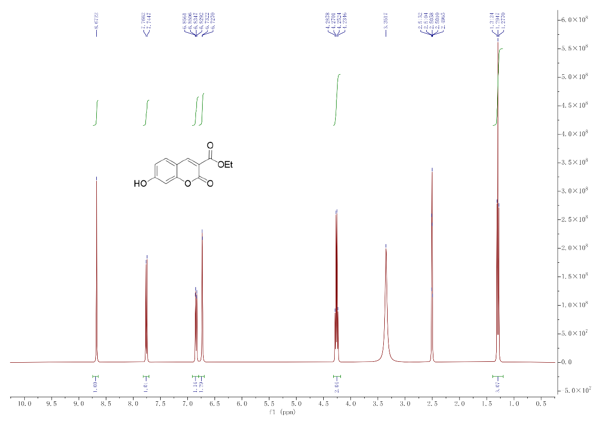
4.2. ¹³C NMR spectra of crude compound (1)
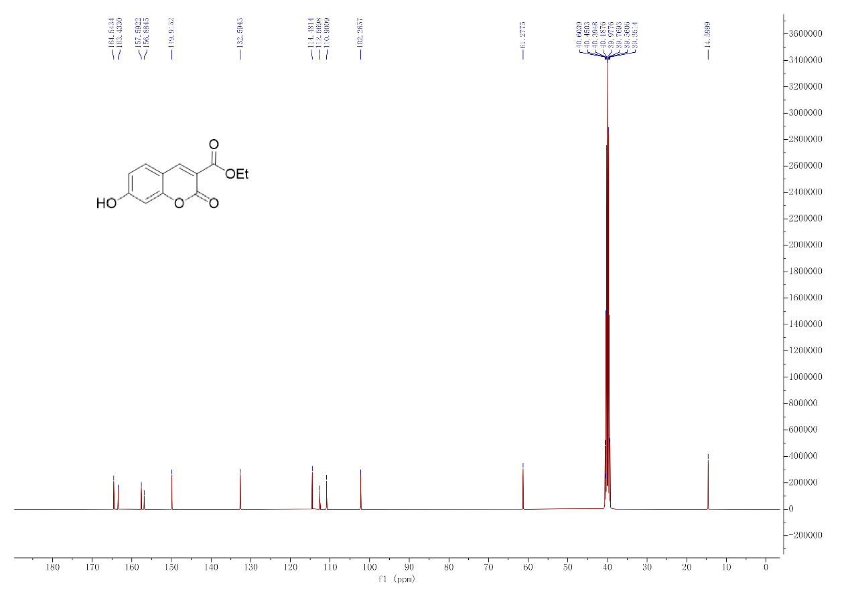
4.3. HRMS spectra of compound (1)
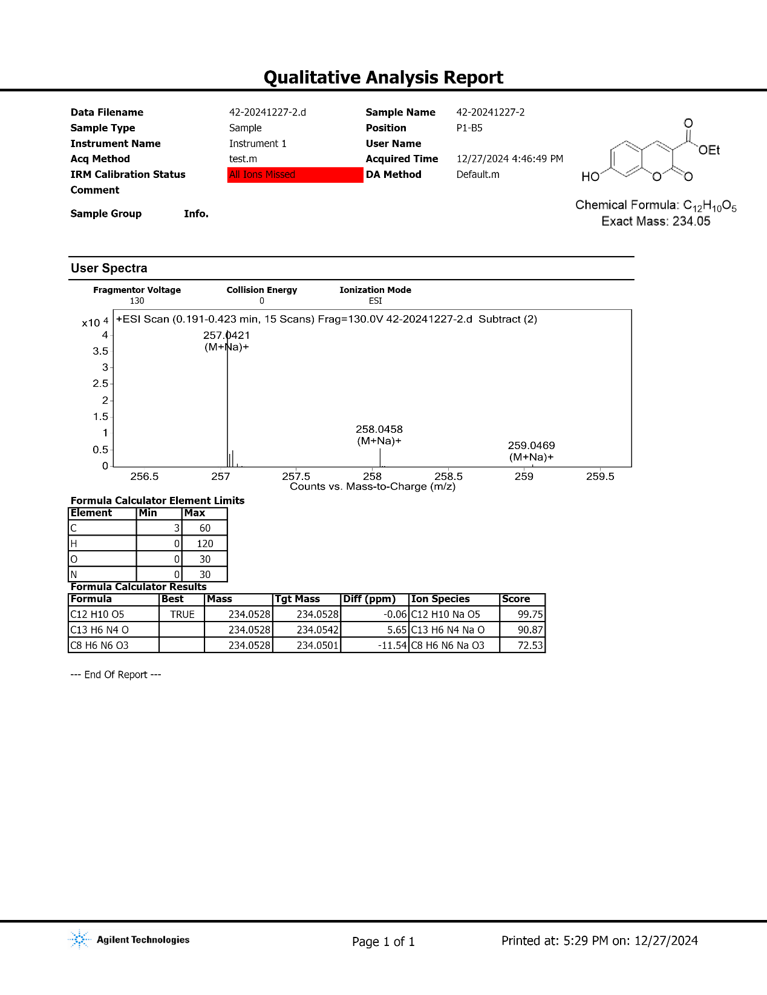4.4. IR spectra of compound(1)
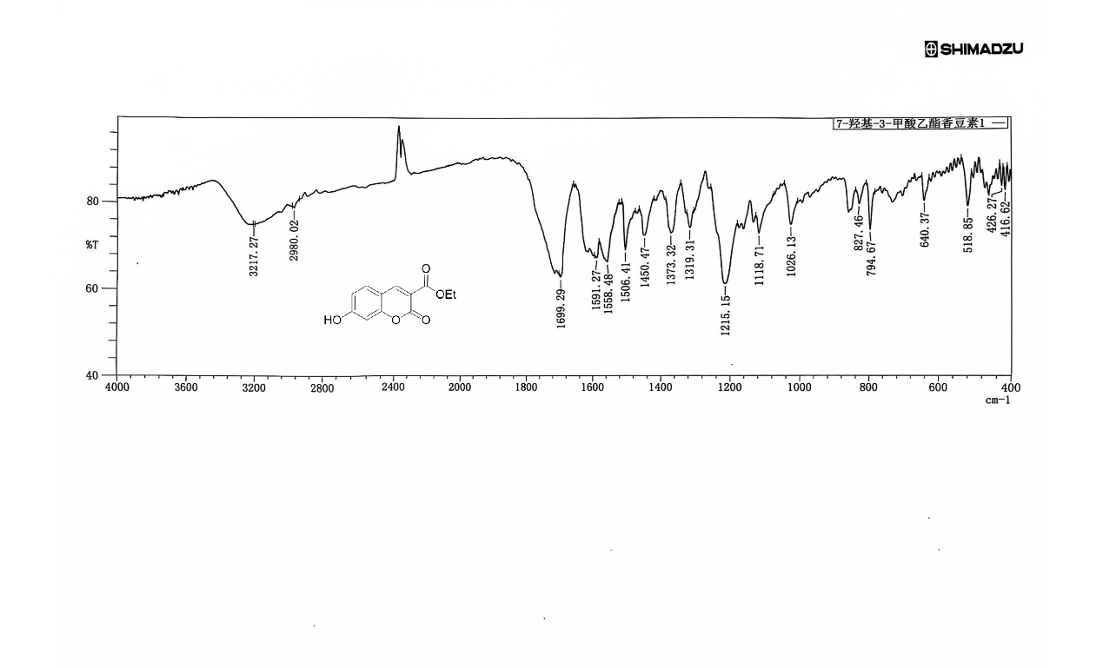
4.5. ¹H NMR spectra of crude compound (2)

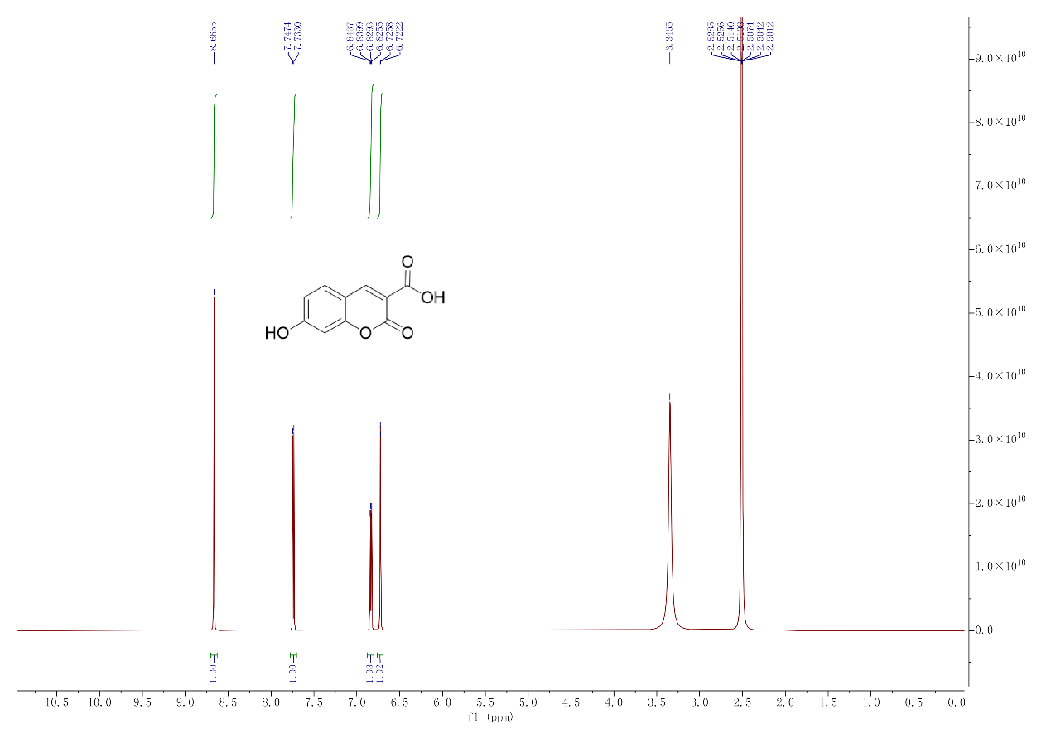
4.6. ¹³C NMR spectra of crude compound (2)
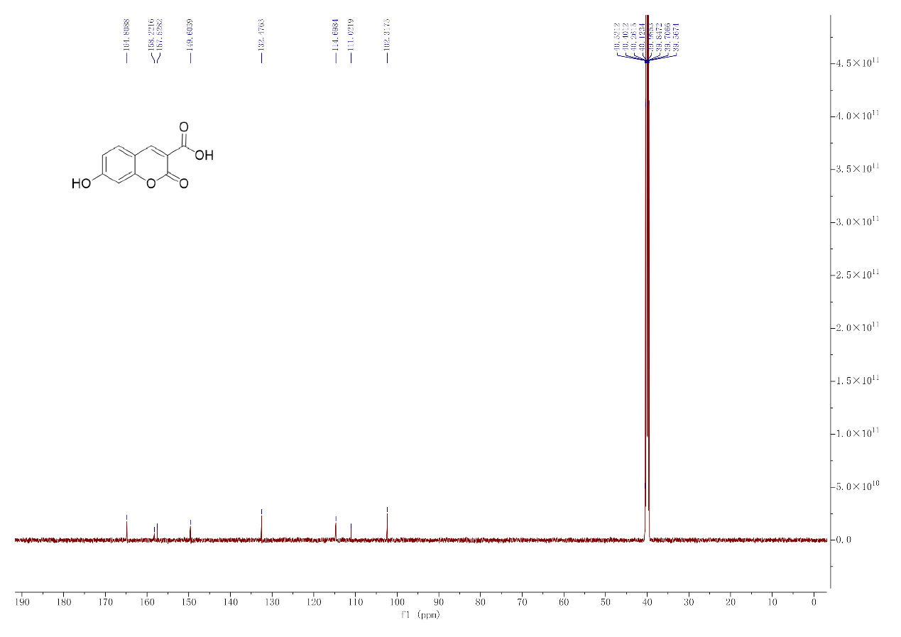
4.7. HRMS spectra of compound (2)
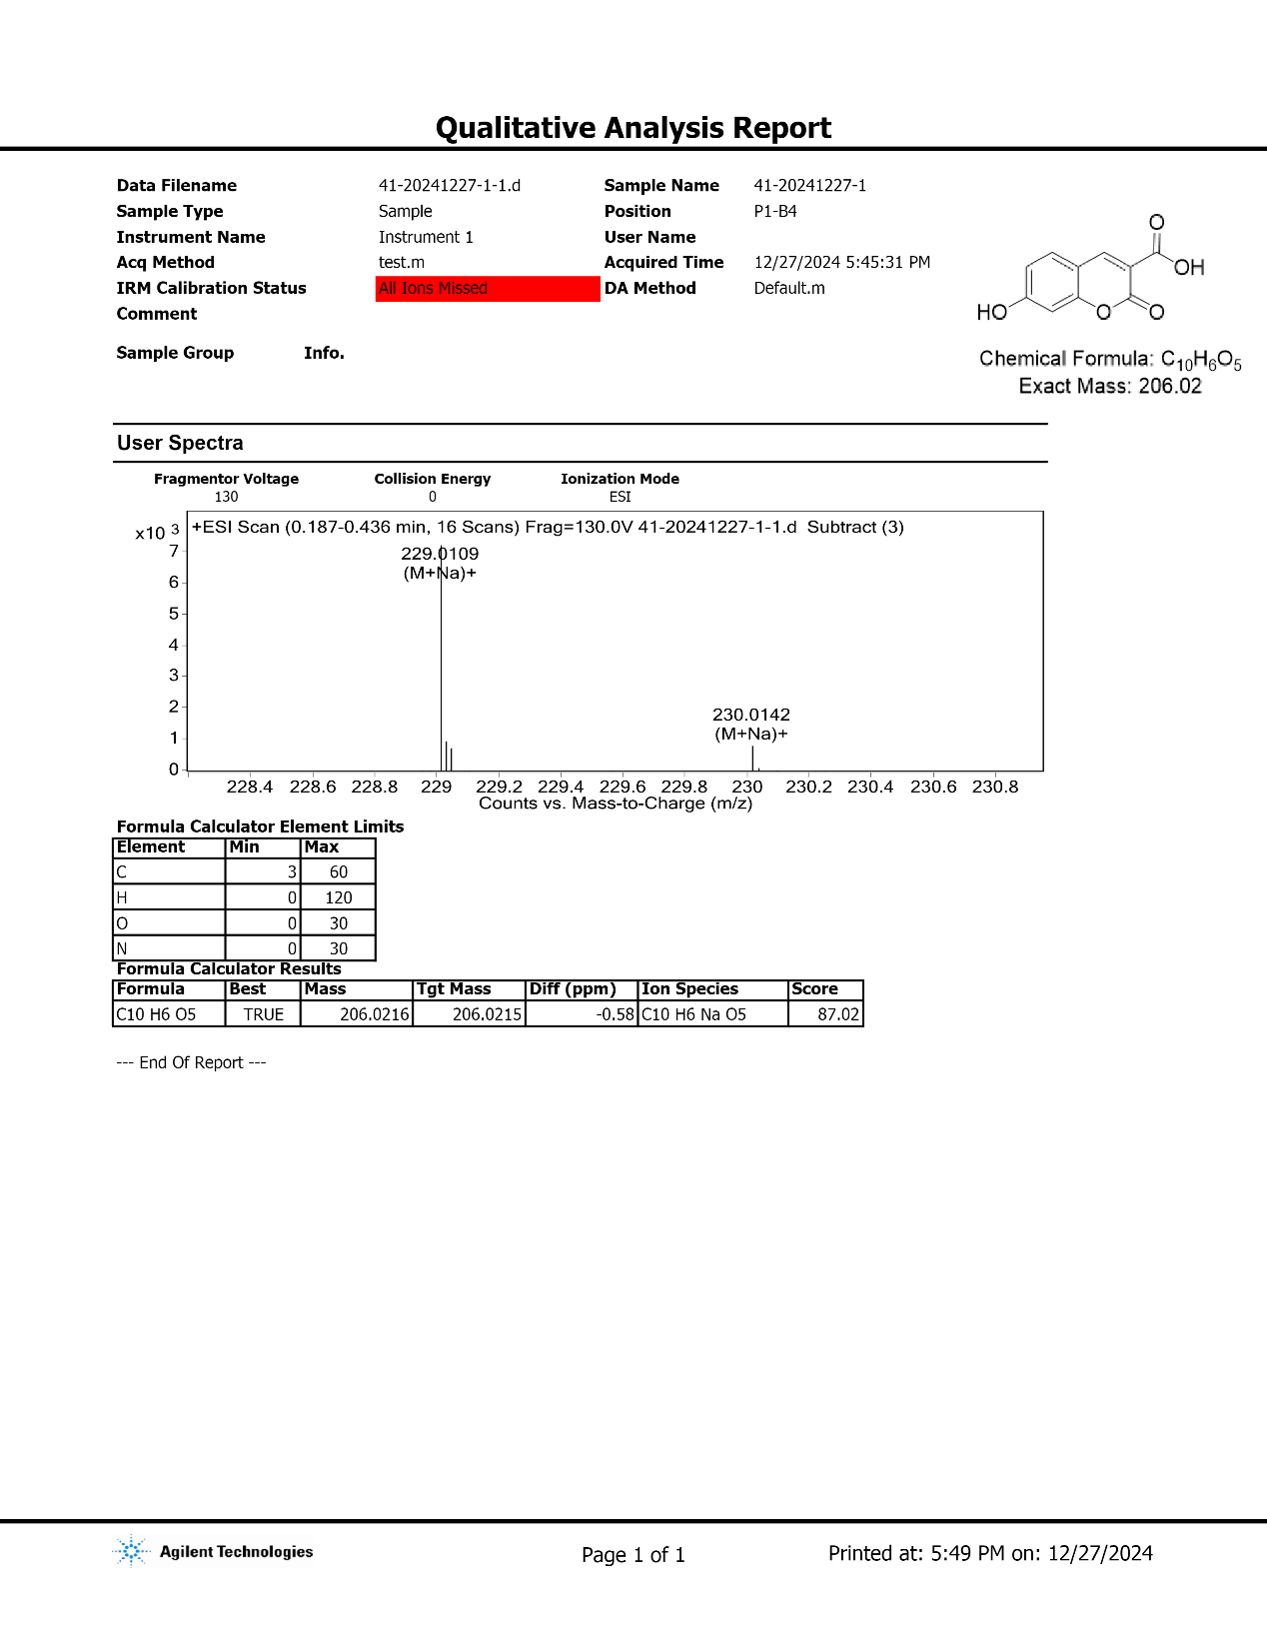
4.8. IR spectra of compound (2)
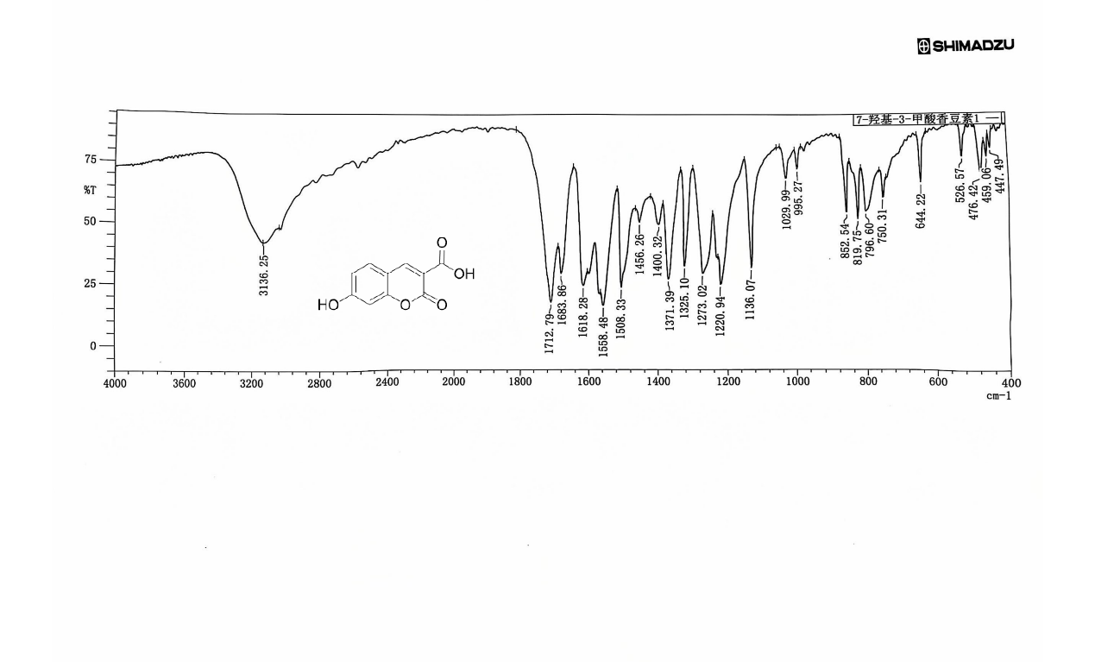
4.9. ¹H NMR spectra of crude compound (3)
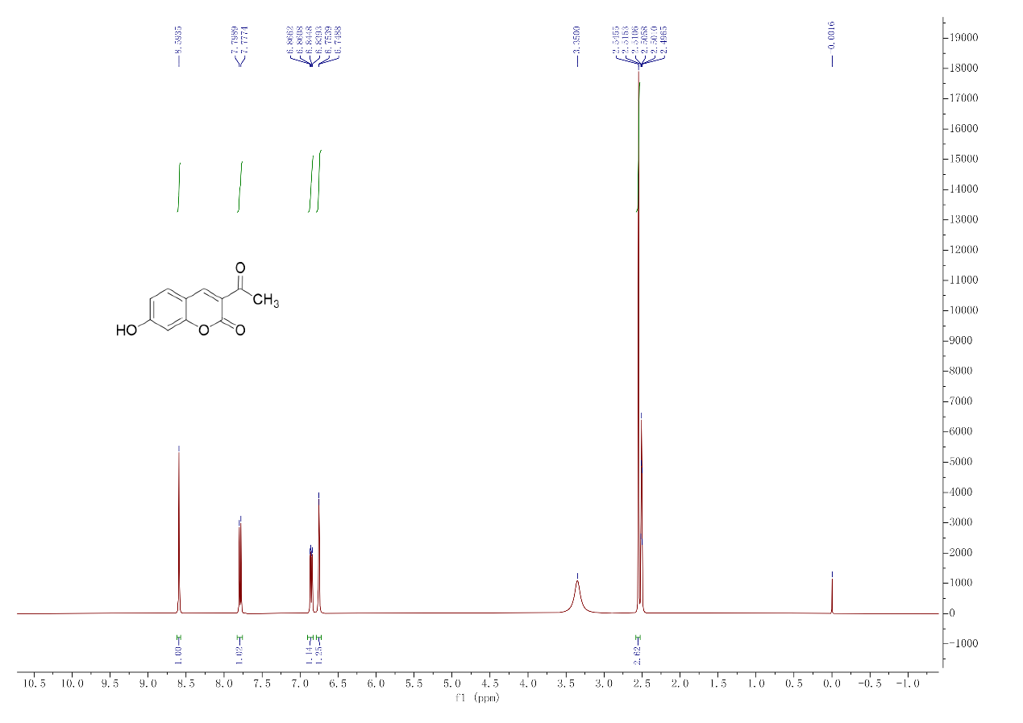
4.10. ¹³C NMR spectra of crude compound(3)
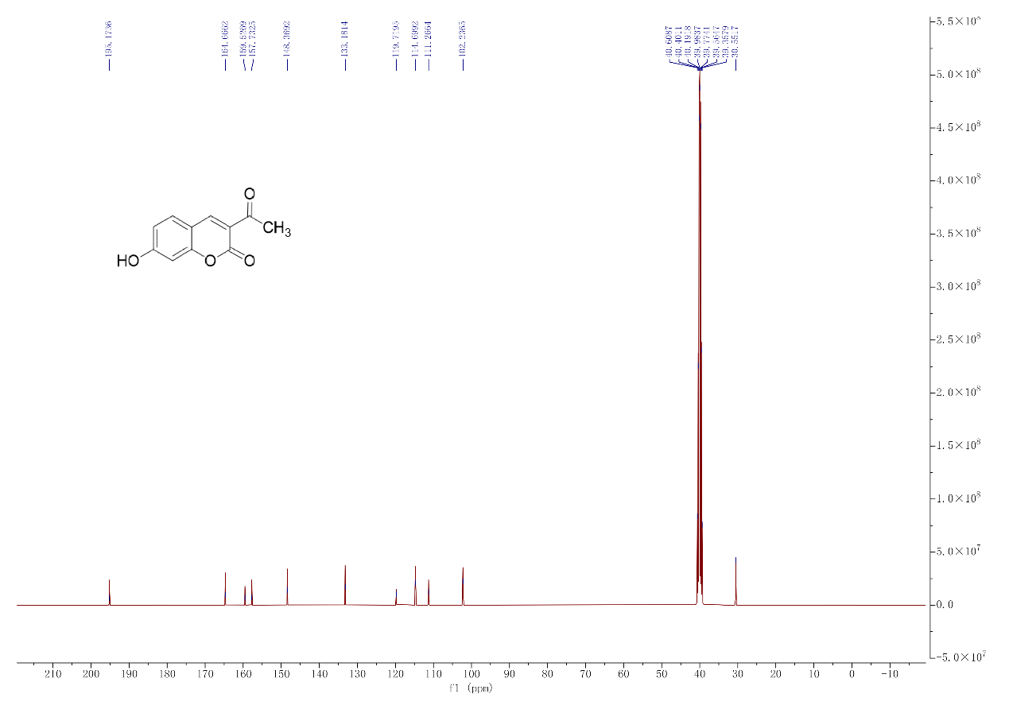
4.11. HRMS spectra of compound (3)
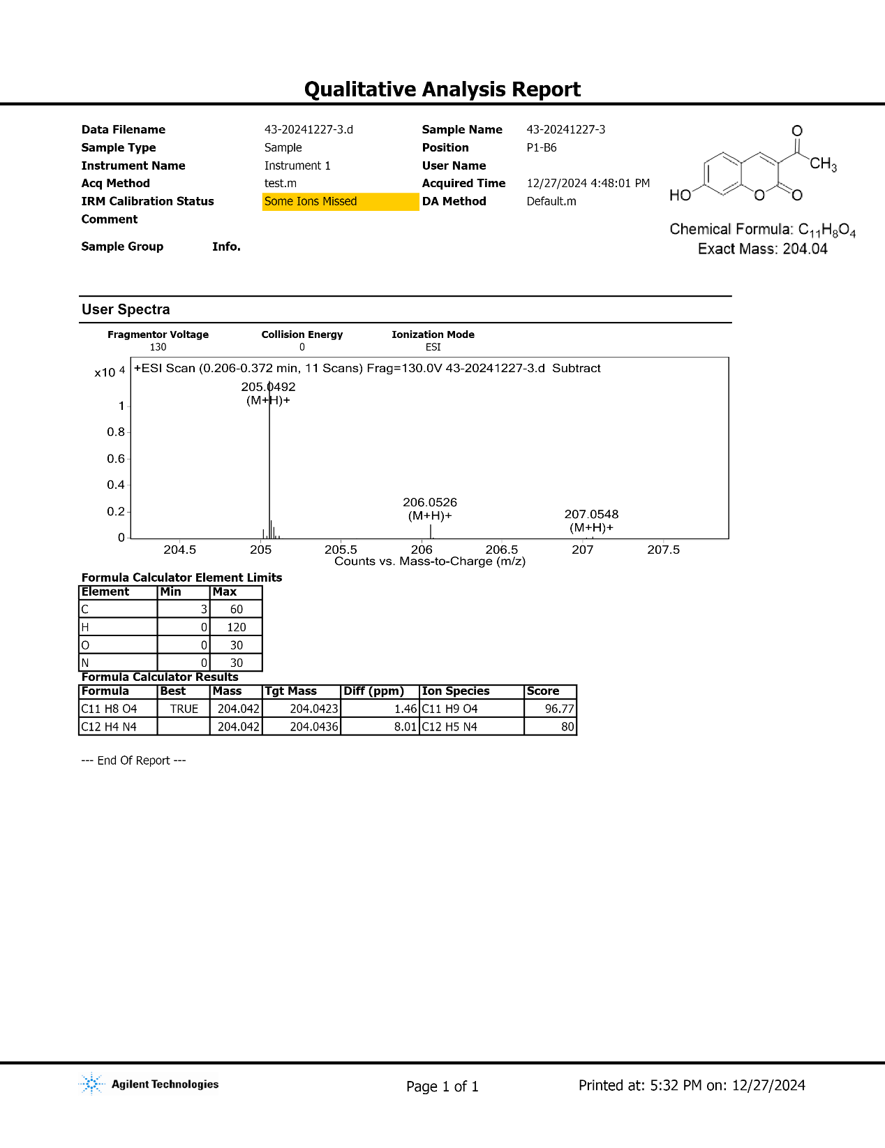
4.12. IR spectra of compound(3)
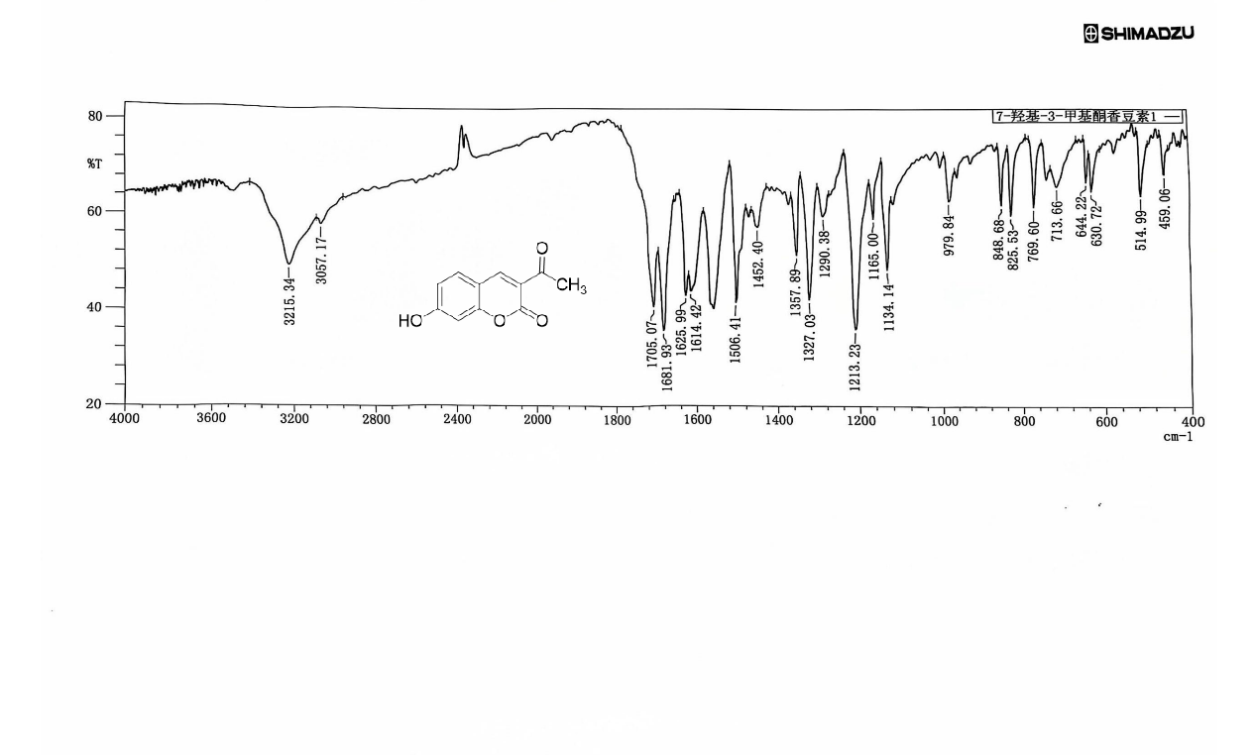
4.13. ¹H NMR spectra of crude compound (4’)
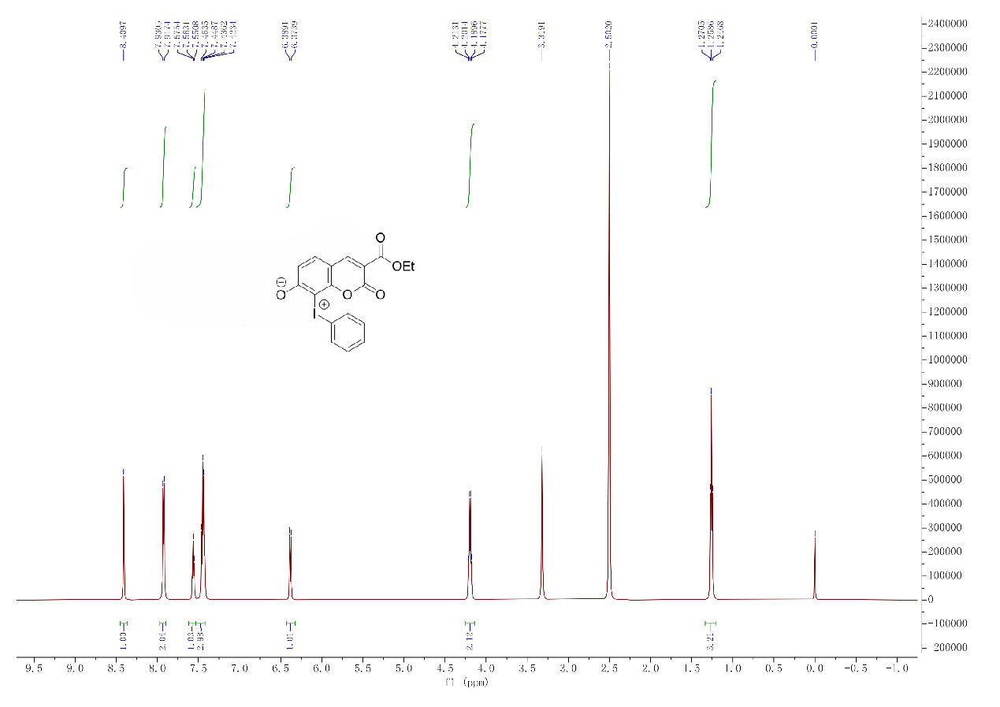
4.14. ¹³C NMR spectra of crude compound (4’)
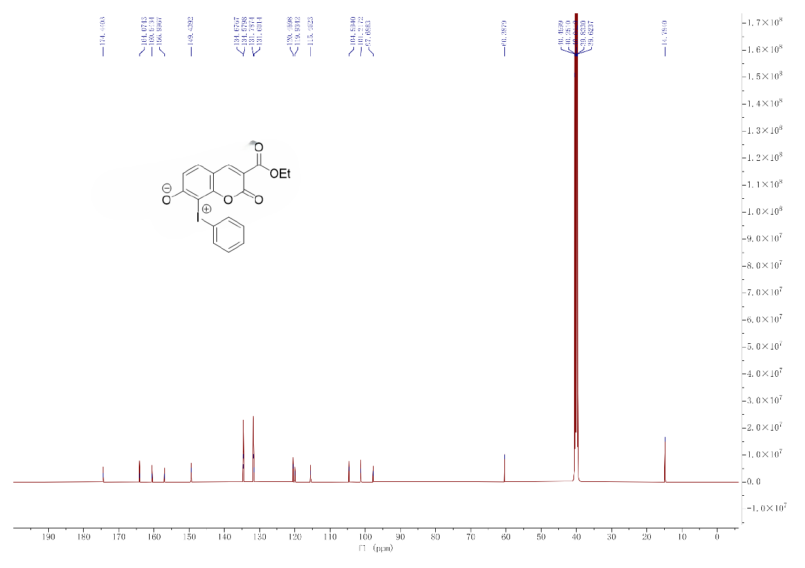
4.15. ¹H NMR spectra of crude compound(4)
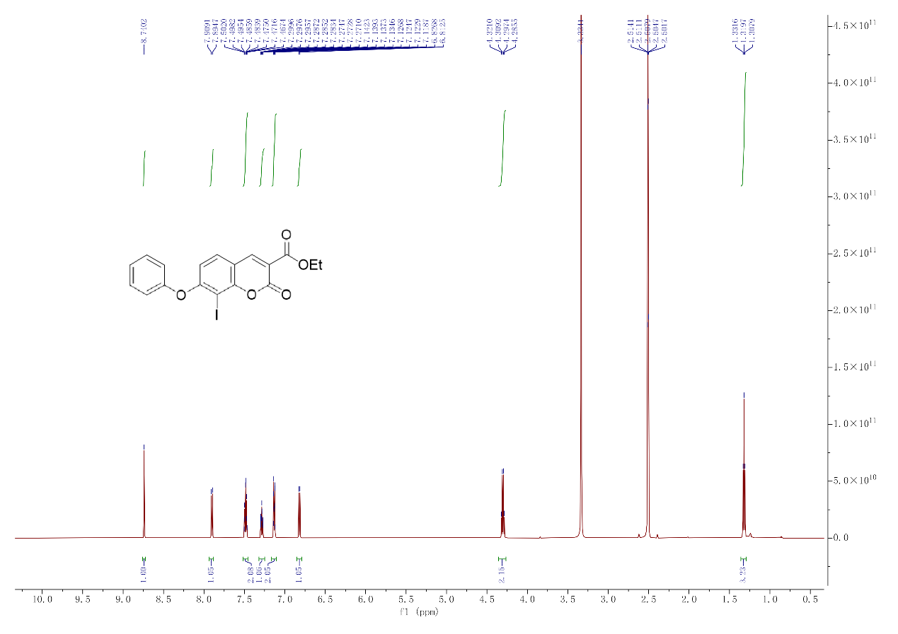
4.16. ¹³C NMR spectra of crude compound (4)
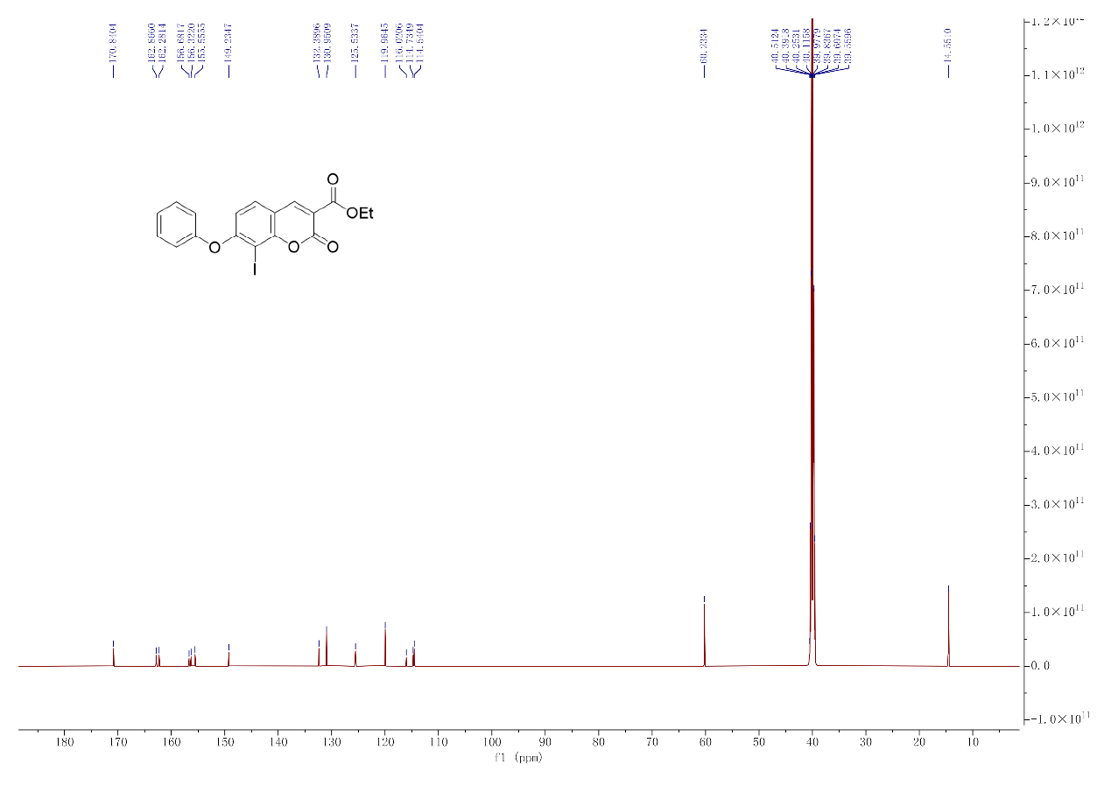
4.17. RMS spectra of compound (4)
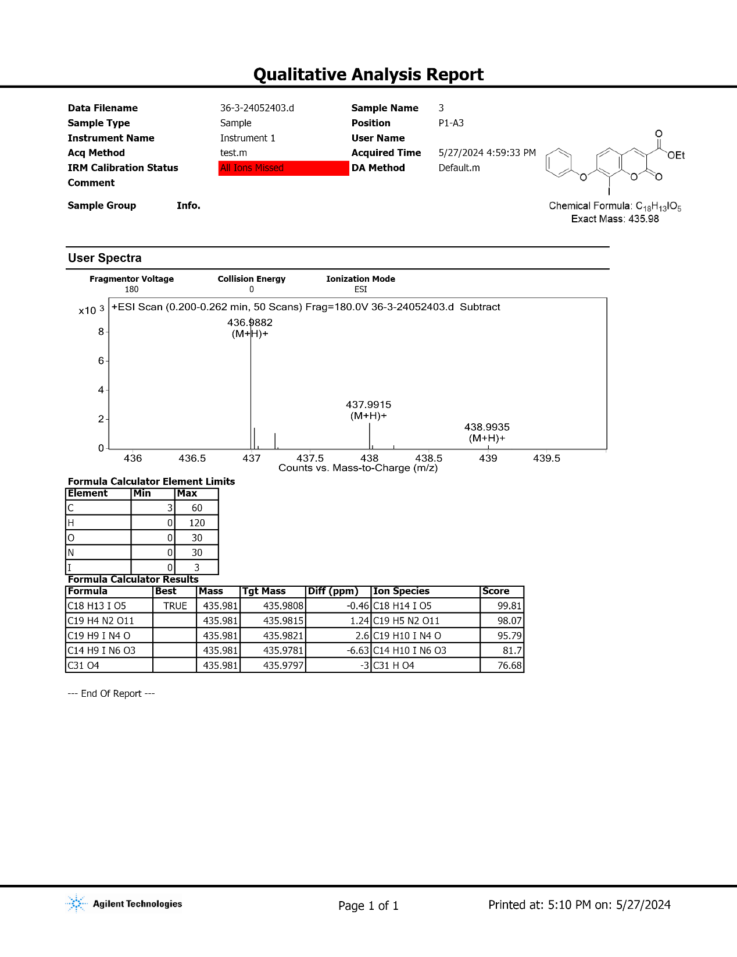
4.18. IR spectra of compound (4)
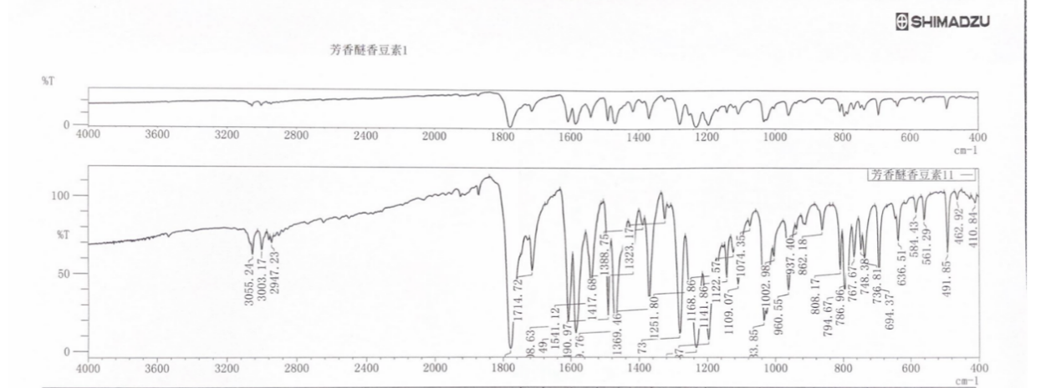

4.19. ¹H NMR spectra of compound (5)
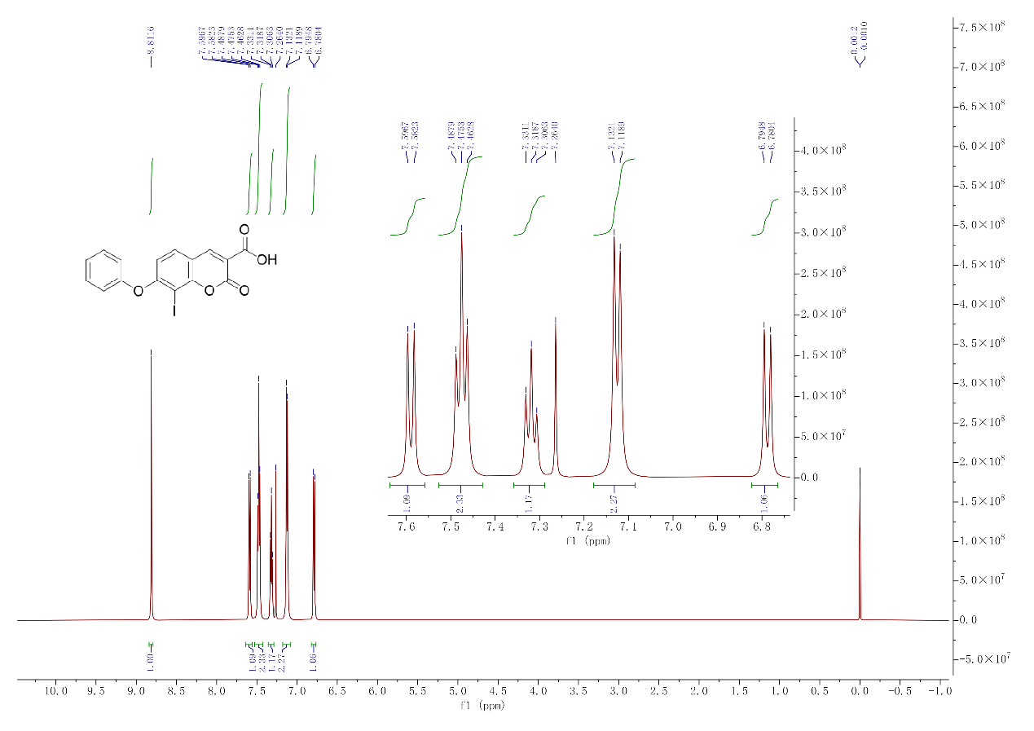

4.20. ¹³C NMR spectra of compound (5)
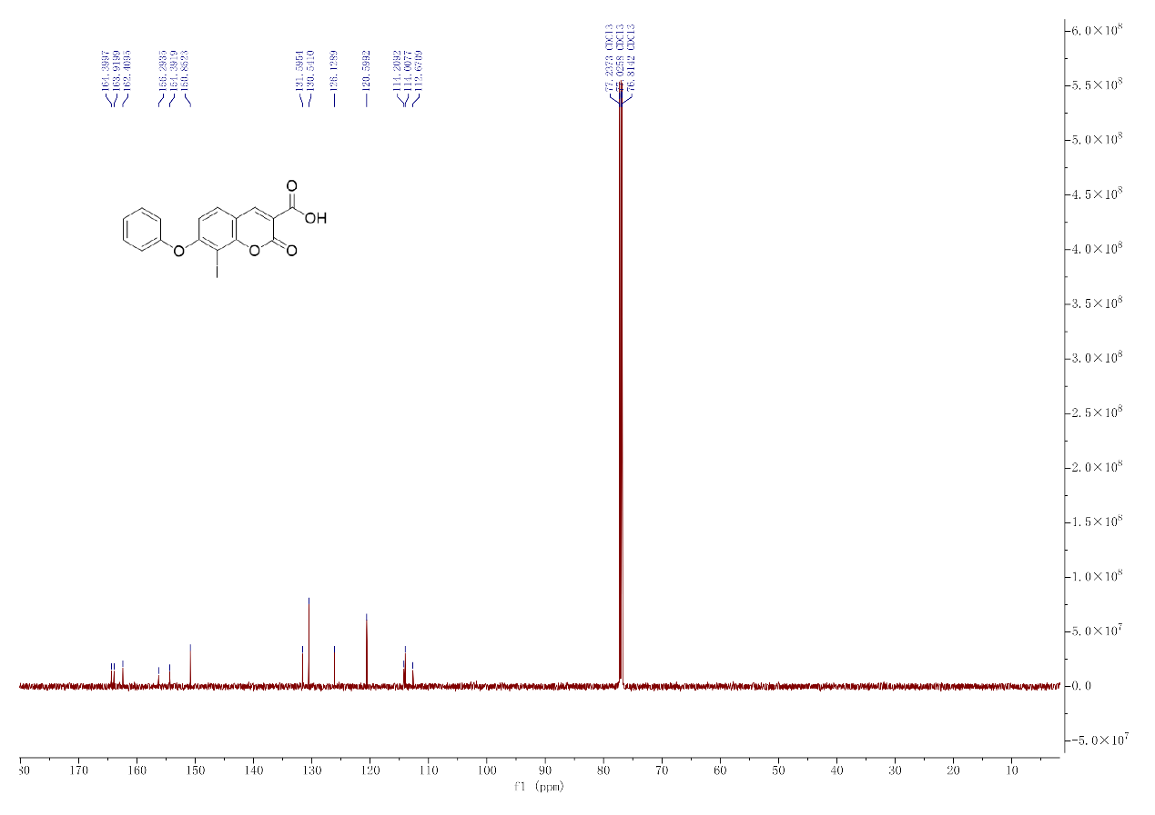

4.21. HRMS spectra of compound(5)
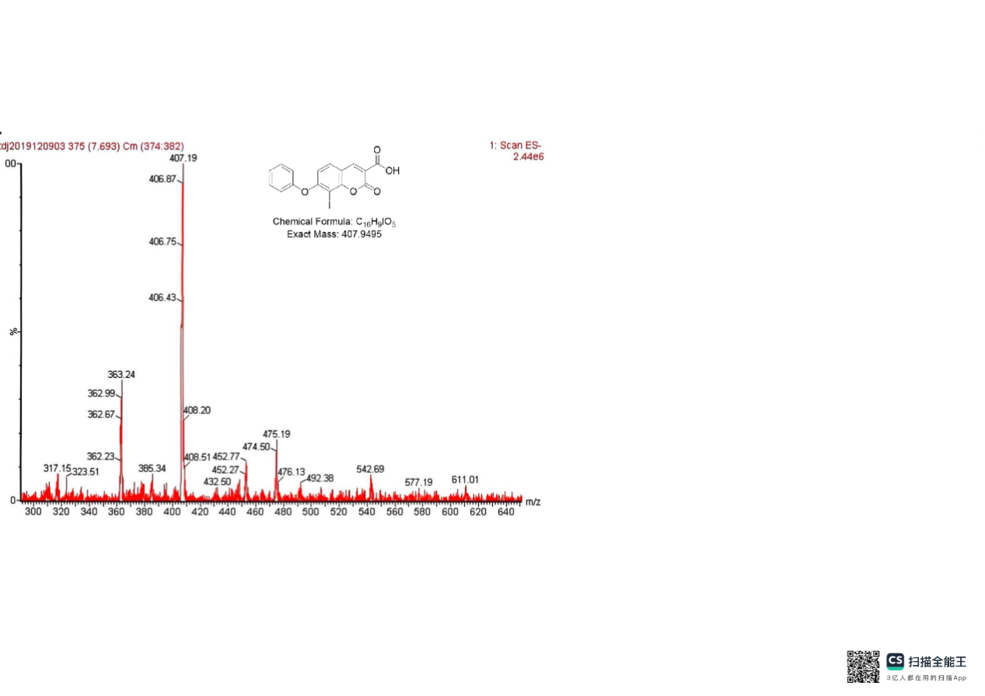

4.22. IR spectra of compound (5)
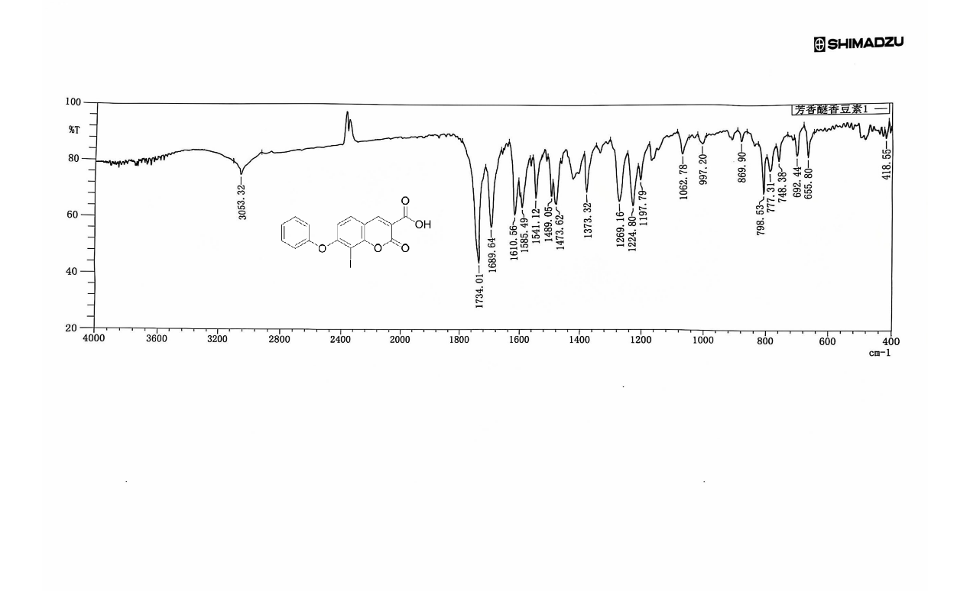

4.23. ¹H NMR spectra of compound (6’)
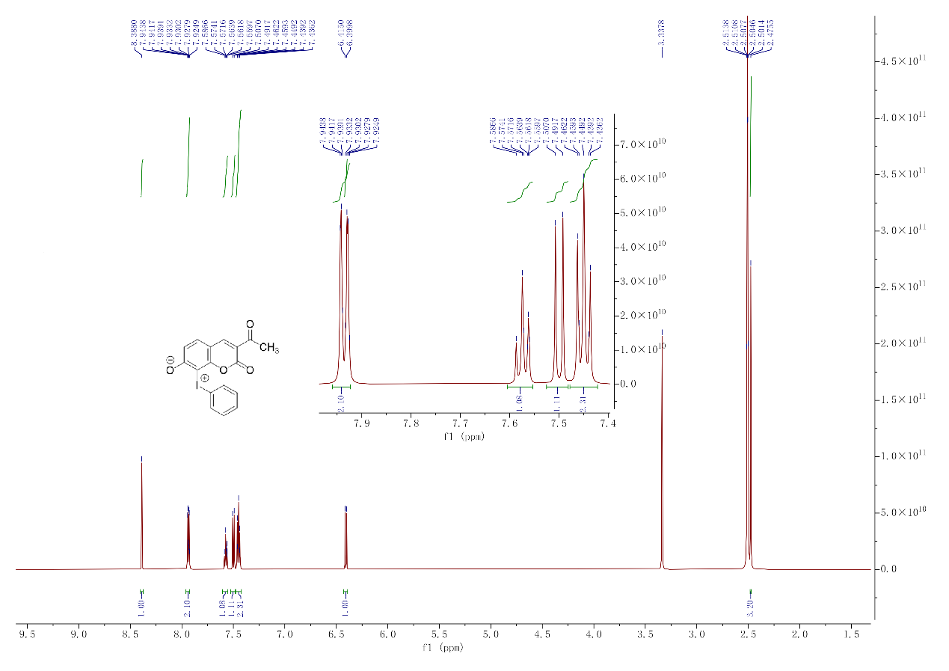
4.24. ¹³C NMR spectra of compound (6’)
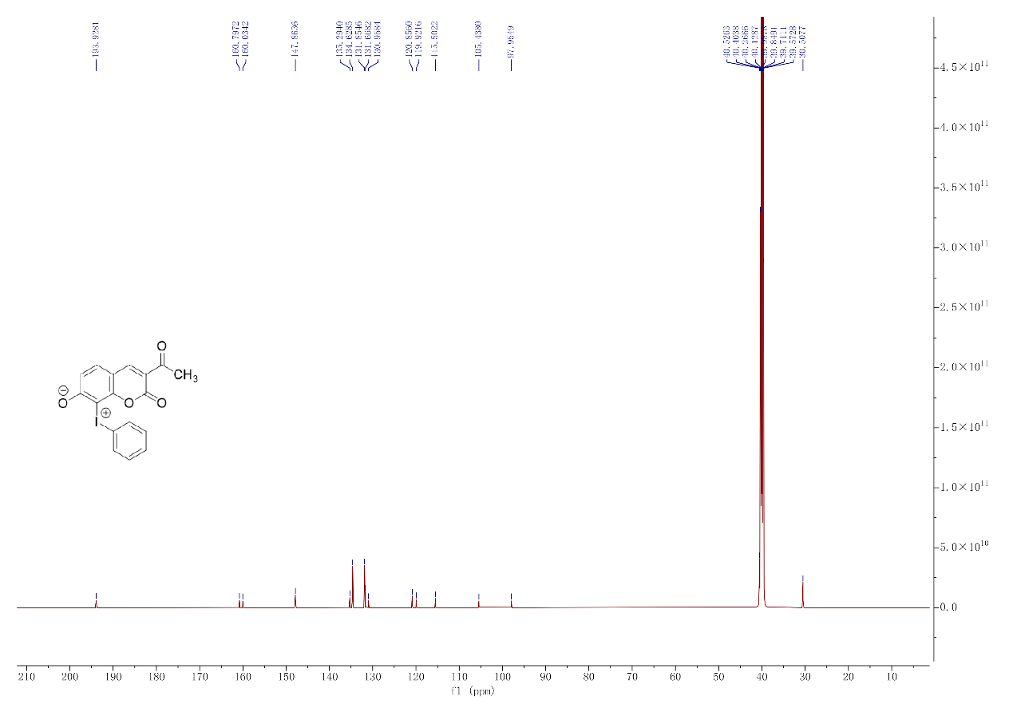
4.25. ¹H NMR spectra of compound (6)
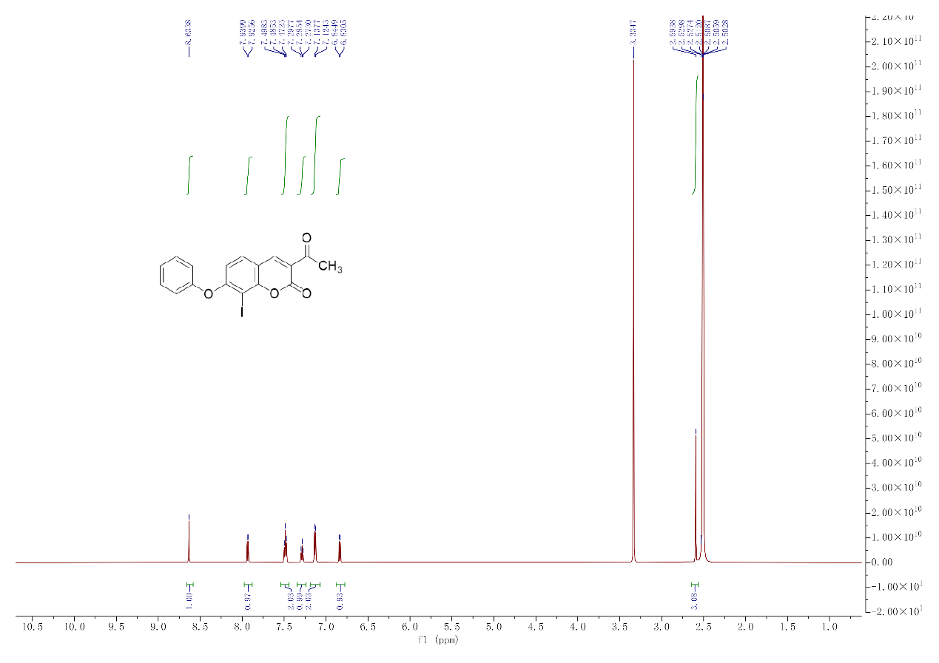
4.26. ¹³C NMR spectra of compound(6)
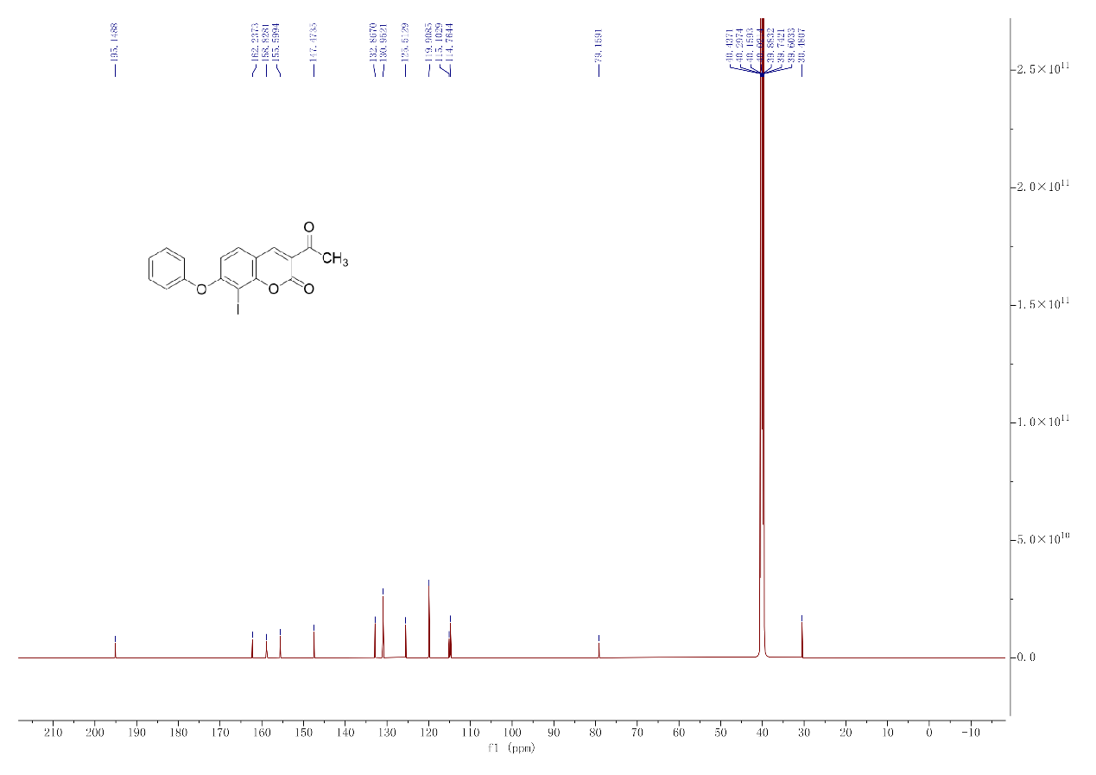
4.27. HRMS spectra of compound (6)
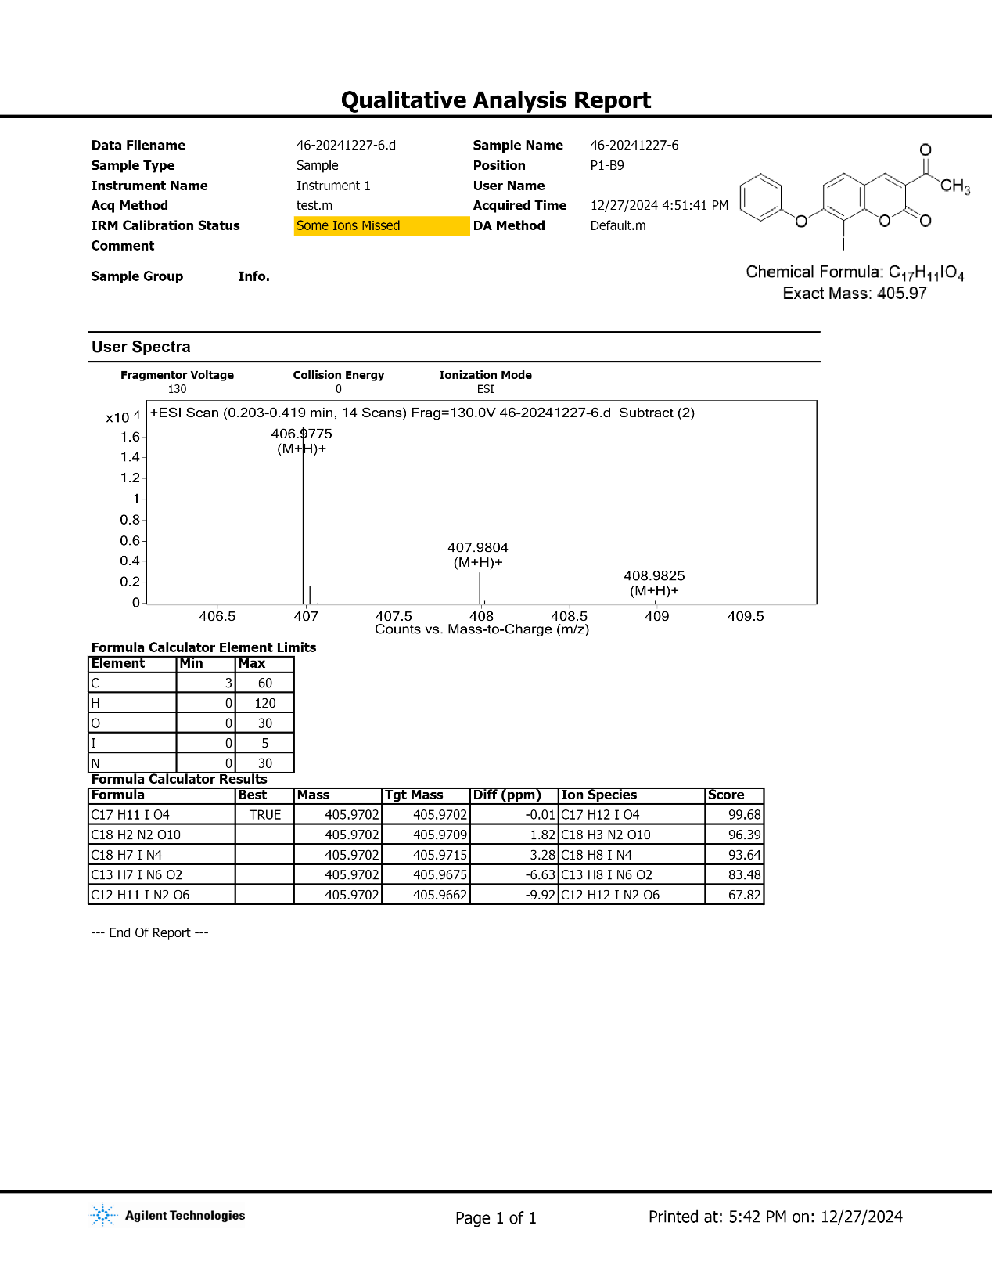
4.28. IR spectra of compound (6)
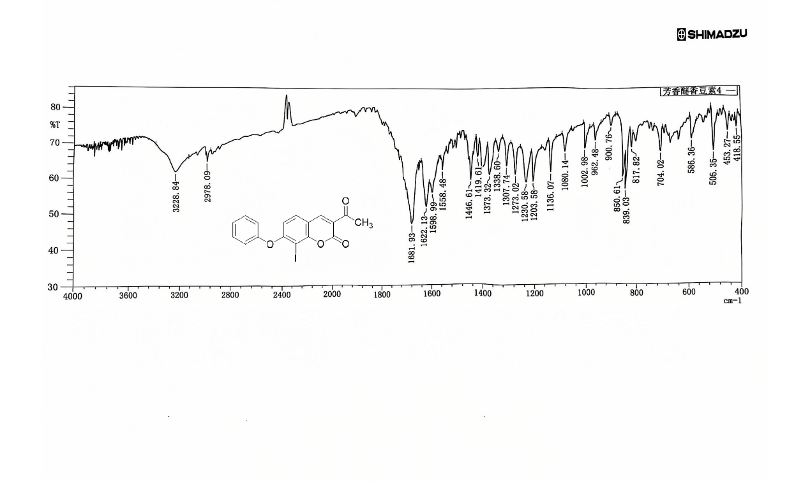
4.29. ¹H NMR spectra of compound(7’)
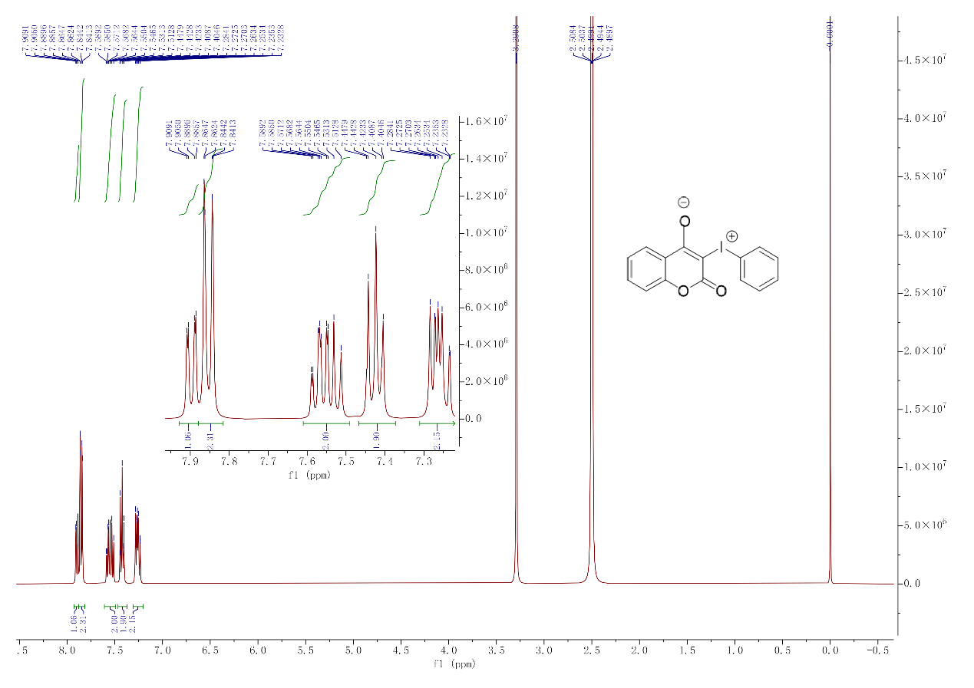
4.30. ¹³C NMR spectra of compound (7’)
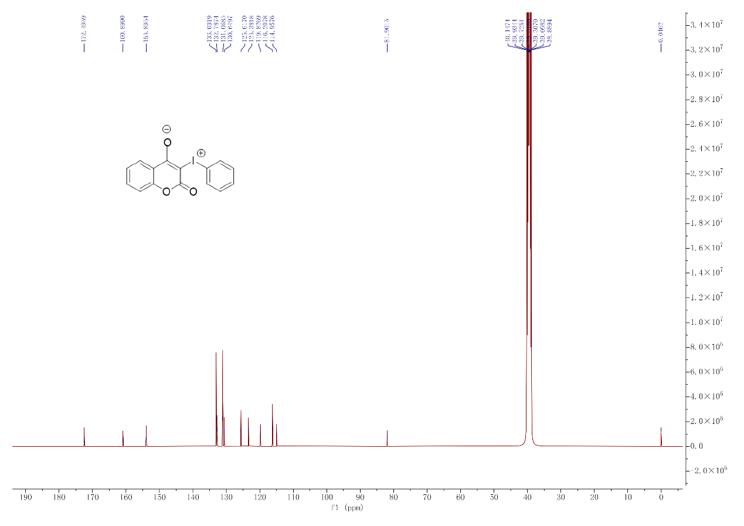
4.31. ¹H NMR spectra of compound (7)
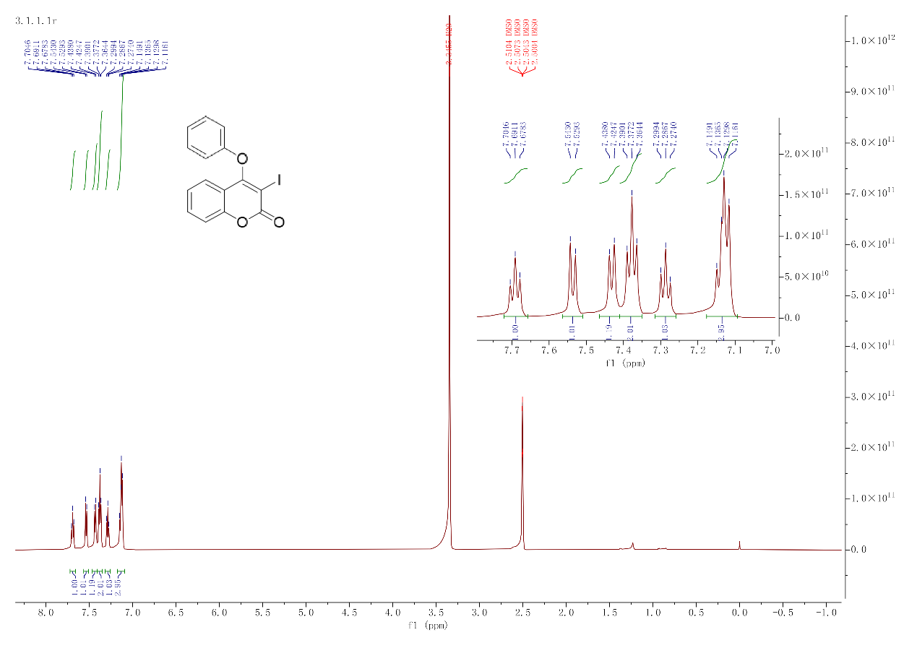
4.32. ¹³C NMR spectra of compound (7)
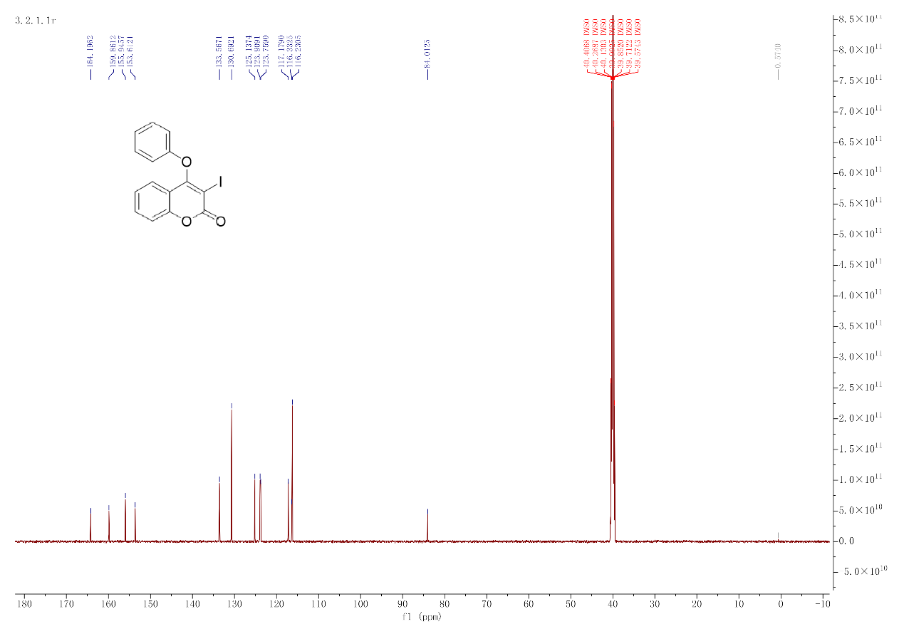
4.33. HRMS spectra of compound (7)
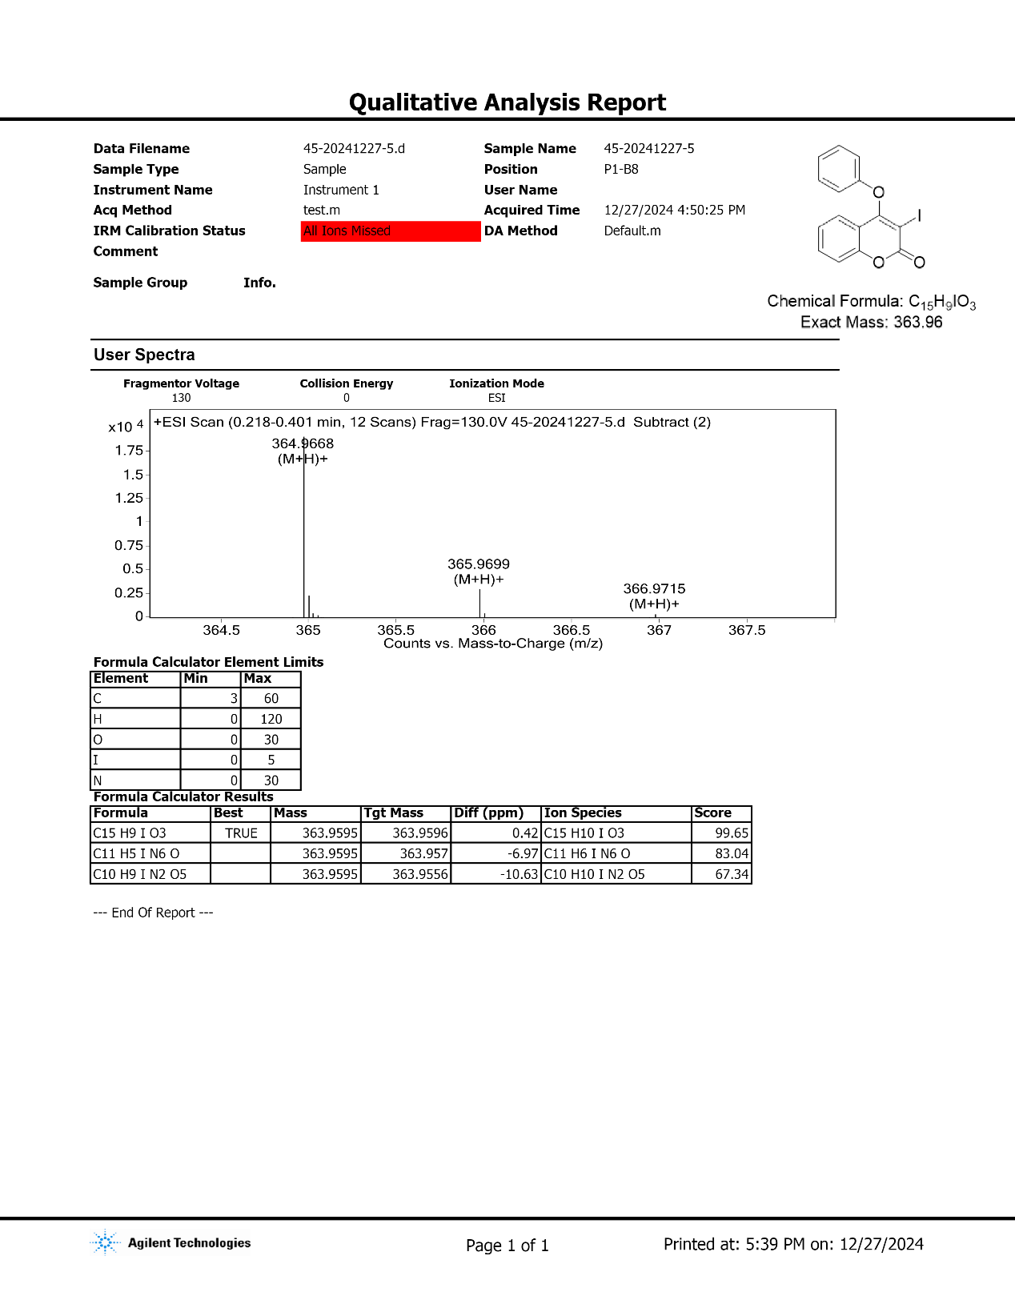
4.34. IR spectra of compound (7)
