Supplementary for
Pathways towards climate and health co-benefits in global ruminant sector
Shuai Ren¹*, Yingfang Cao², Qing Hu³, Robert S. Powell⁴, Michael G. Windisch⁵, Yi Xi⁶, Xuejun Liu⁷, Adam F. A. Pellegrini⁴, César Terrer¹
¹Department of Civil and Environmental Engineering, Massachusetts Institute of Technology,
Cambridge, MA, USA
²Qinghai Provincial Key Laboratory of Restoration Ecology for Cold Region, Northwest Institute of Plateau Biology, Chinese Academy of Sciences, Xining, China
³Beijing Municipal Ecological and Environmental Monitoring Center, Beijing, China
⁴Department of Plant Sciences, University of Cambridge, Cambridge, UK
⁵Institute for Atmospheric and Climate Science, Department of Environmental Systems Science, ETH Zurich, Zurich, Switzerland
⁶Laboratoire des Sciences du Climat et de l’Environnement, LSCE/IPSL, CEA-CNRS-UVSQ, Université Paris-Saclay, Gif-sur-Yvette, France
⁷State Laboratory of Nutrient Use and Management, College of Resources and Environmental Sciences, China Agricultural University, Beijing, China

*Correspondence to shuairen707@gmail.com

Table of Contents
- Supplementary Text
- Figures S1-S32
- Tables S1-S7
- References

Supplementary Text
- Global GI estimates
Here we calculated global grid-level grazing intensity (GI) as the ratio of grazed biomass to aboveground net primary production (ANPP) available to livestock (Eq.1).
$$GI (\%)=\frac{TLU×FI}{GA×ANPP} × 100 (1)$$
where TLU denotes Tropical Livestock Units (1 TLU = 250 kg live weight), derived from livestock numbers (e.g., sheep and cattle) and species-specific conversion factors. GA represents grazing area per grid cell, while FI refers to grass feed intake, defined as the amount of biomass consumed annually per TLU. In this study, FI values were obtained from Fetzel et al.(1), which is available at a regional scale and accounts only for forage from grazing land. All parameters used in the calculation exhibit temporal dynamics over 1961-2100 except FI.
The extent of grazing land over the study period was obtained from the LUHv2. ANPP was estimated by subtracting the fraction allocated to the belowground (f_{BNPP}) from the NPP. NPP data for the historical period were sourced from the GIMMS3g NPP dataset (2), which covers the years 1982 to the present. For years prior to 1982, NPP values were assumed to be equivalent to those in 1982 due to data limitations. Future NPP projections were derived from 10 CMIP6 models under the SSP2 scenario, and bias correction was applied to generate consistent NPP estimates over the studied period. The global spatial distribution of present-day f_{BNPP} was estimated as the ratio of belowground NPP (BNPP, (3)) to total NPP, while its temporal dynamics under grazing were modeled using a relationship derived from 237 field observations (Eq.2; R² = 0.22).
$$∆f_{BNPP}=-0.056+GI×1.52×{10}^{-3}+MAT×6.73×{10}^{-4}+MAP×6.91×{10}^{-5} (2)$$
where ∆f_{BNPP} represents grazing-induced f_{BNPP} changes, GI is grazing intensity in the unit of %. MAT and MAP represent mean annual temperature (°C) and precipitation (mm), respectively.
To ensure consistency, we estimated global gridded livestock distributions for the entire period of 1961–2100 (Fig. S25). For each country, national live animal populations were obtained from the FAO production database for the historical period (1961–2019), and projected for 2020–2100 based on country-specific historical relationships between domestic ruminant production and livestock numbers (see Method). The national animal population data were then downscaled to a grid level for 1961-2019, assuming that the current share of livestock numbers in each grid relative to the national total remained constant over time; current global livestock distribution was derived from GLWv4 for 2020 (4). We acknowledge that this static spatial assumption may introduce bias in regions that would experience major land use or population shifts in the future, future efforts would benefit from more temporally explicit datasets to further improve spatial accuracy.
Due to data limitations, we assumed that the uncertainty of historical GI estimates is equivalent to that of current estimates, as reported by (5), which shows an average global variation of about 10%. For future GI estimates, uncertainty was quantified based on 40 combinations derived from 10 CMIP6 NPP datasets and 4 different animal population projections (see Methods).

- Uncertainty and sensitivity analysis
It is important to recognize two major sources of uncertainty in our analysis for meat reduction scenario. First, reducing meat consumption would likely free up grazing land, creating substantial opportunities for carbon sequestration (6). However, due to methodological challenges, such as limited constraints on land-use change, we only considered changes in livestock populations alongside meat reduction, while assuming that the extent of grazing land remained constant. Second, uncertainties also arise from the method used to estimate health impacts. Specifically, we assessed the mortality risks associated with the three body weight categories based on the relationship between their prevalence and per capital food consumption across countries (Table S6; see Methods). Although informative, this method lacks direct experimental validation and may introduce some uncertainty.
To strength the robustness of our conclusions, we further evaluated two unique dietary scenarios, that is a global shift from current dietary patterns to the planetary health diet and a vegan diet (Fig. 2). Although the finding that climate and health co-benefits under the vegan diet are limited supports our overall conclusions, uncertainties remain—particularly regarding the method of converting meat production to livestock numbers, changes in emissions from non-ruminant foods, and the use of global parameters.
To further assess the robustness of our results, we conducted four independent sensitivity analyses (SA) (Fig. S15). First, in SA 1 and 2, we applied two alternative approaches (empirical and proportional approaches; see Methods) to estimate livestock numbers based on ruminant meat production. Second, while a global shift from BAU to the EAT–Lancet healthy diet generally reduces emissions from non-ruminant foods, a transition to the vegan diet increases these emissions (Fig. S32), as per capita energy intake remains constant. In sensitivity analysis 3, we accounted for changes in emissions from non-ruminant foods when estimating climate impacts. Finally, in assessing the economic implications, due to data constraints, we applied a global social cost of carbon for CO₂, whereas country-specific values were used for the value of statistical life (VSL) in health assessments (see method). To evaluate the impact of this mismatch, we conducted SA4 using a global VSL. These sensitivity tests collectively confirmed the robustness of our conclusions (Fig. S15). It is worth noting that the findings presented in this section are derived at a global level and their applicability may vary in regions with different contexts. Further region-specific research is warranted to enhance the contextual relevance and policy guidance of these findings.
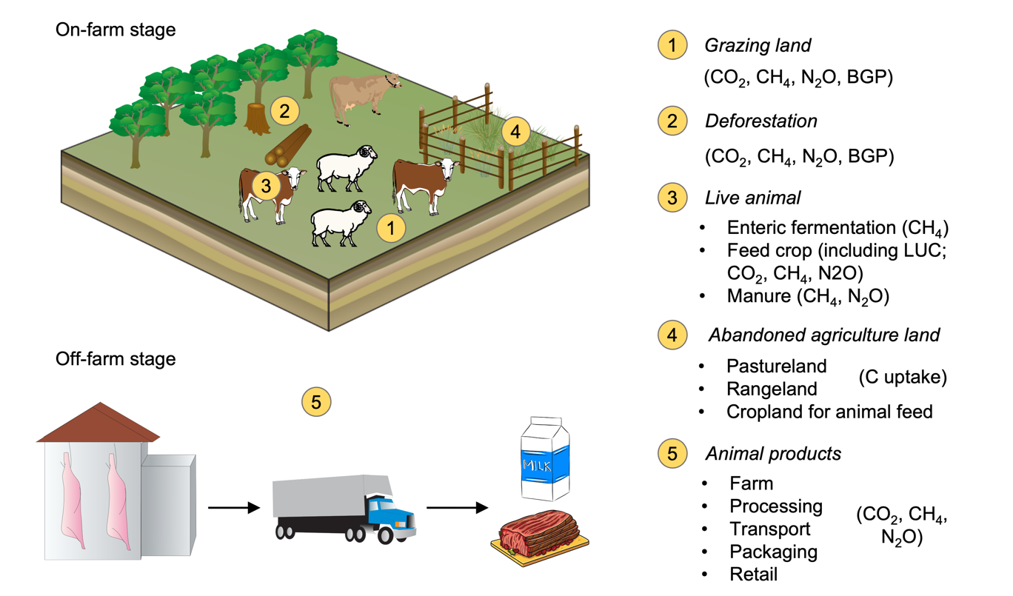
Figure S1. GHG emissions and sinks from on-farm and off-farm stages of the ruminant sector. BGP, biogeophysical impacts; LUC, land use change. See Methods for details.
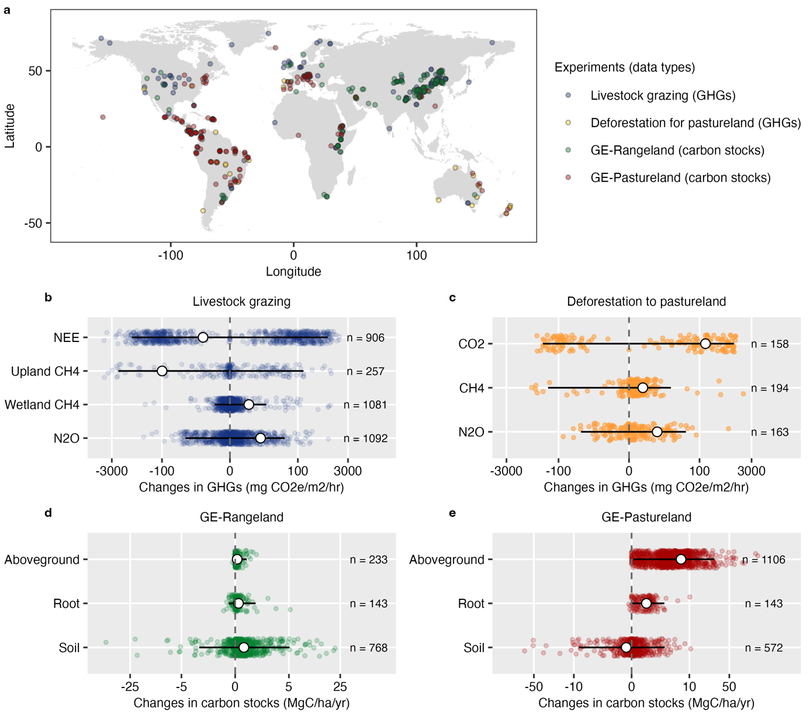
Figure S2. Spatial distribution of sample sites in this synthesis. In this study, we compiled seasonal GHG flux data for CO₂, CH₄ and N₂O associated with grazing (n = 3,336 pairs) and deforestation (n = 515 pairs). In addition, we also collected 2,965 paired carbon observation of aboveground, root and soil from grazing exclusion studies. Error bars represent 95% confidence intervals.
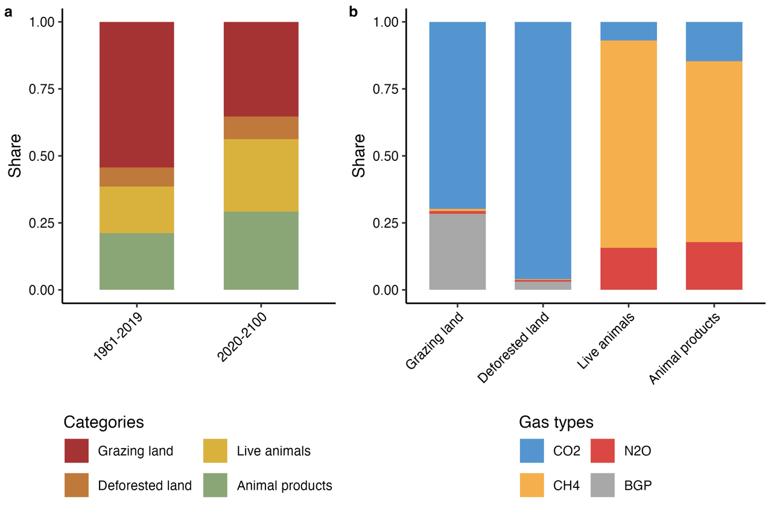
Figure S3. Relative contributions of GHG emissions across different source categories and gas types. BGP, biogeophysical impacts.
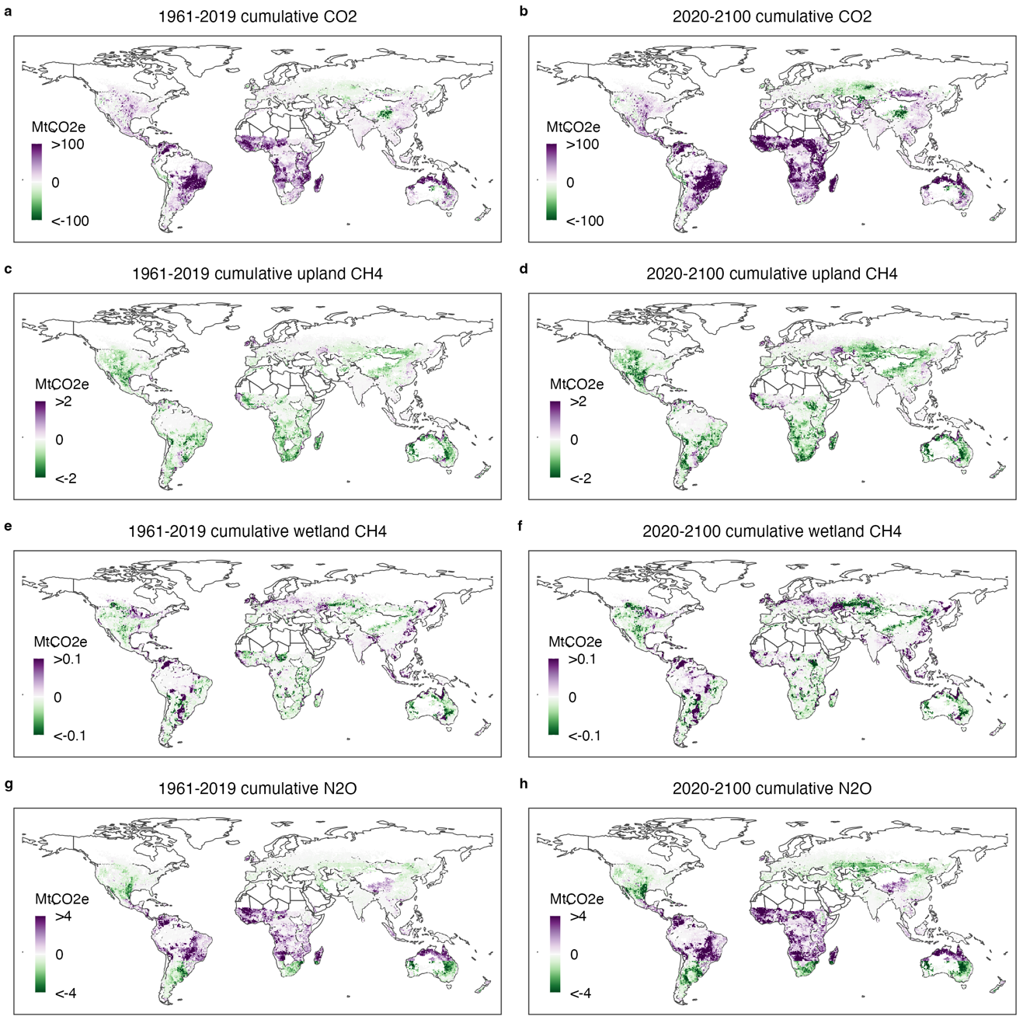
Figure S4. Spatial distribution of grazing-driven cumulative emissions of each GHG type for the periods 1961–2019 and 2020–2100 under the business-as-usual scenario.
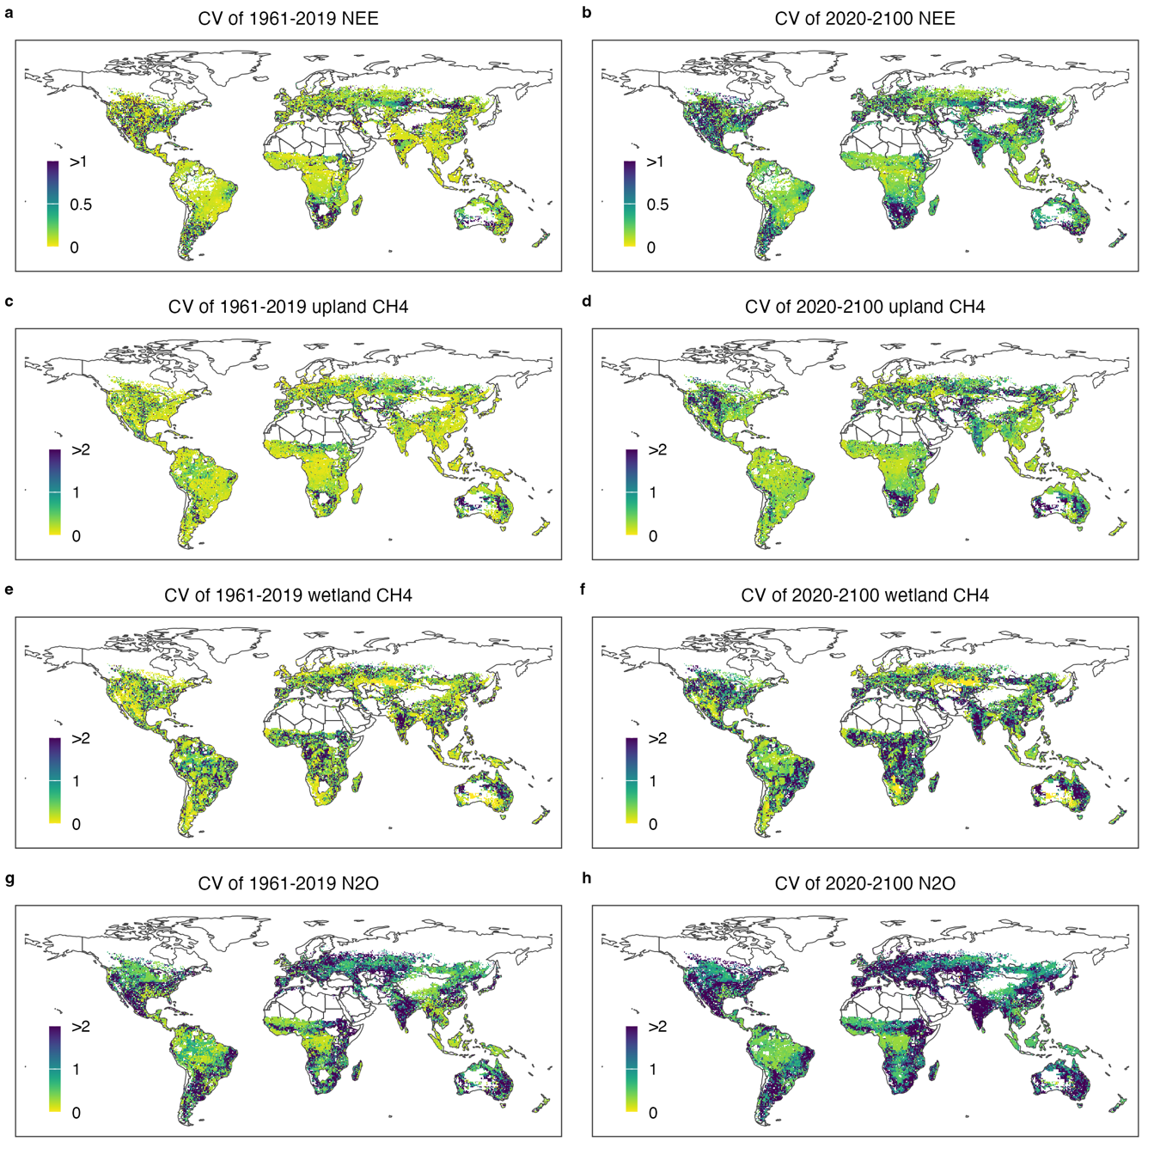
Figure S5. Uncertainty associated with grazing-driven GHG emissions. The coefficient of variation (CV) was estimated based on 10,000 bootstrap predictions (see Methods).
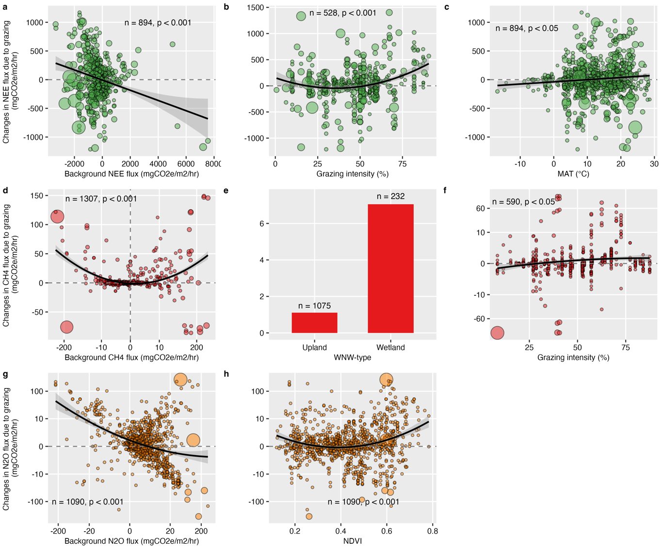
Figure S6. Relationships between grazing-induced flux changes of CO₂ (a-c), CH₄ (d-f), and N₂O (g, h) and their key drivers identified by random forest models (Table S3). Dot sizes represent the magnitude of variation. In this study, changes in aboveground biomass were used as an indicator of grazing intensity. WNW refers to wetland and non-wetland types. The shaded area indicates the 95% confidence interval.
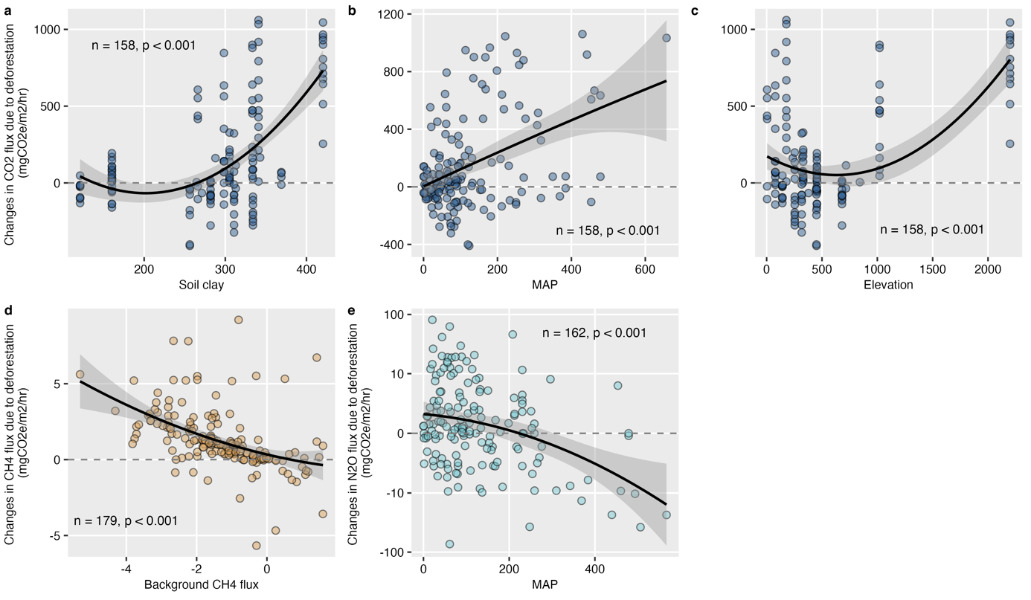
Figure S7. Relationships between deforestation-induced flux changes of CO₂ (a-c), CH₄ (d), and N₂O (e) and their key drivers identified by random forest models (Table S4). Dot sizes represent the magnitude of variation. The shaded area indicates the 95% confidence interval.
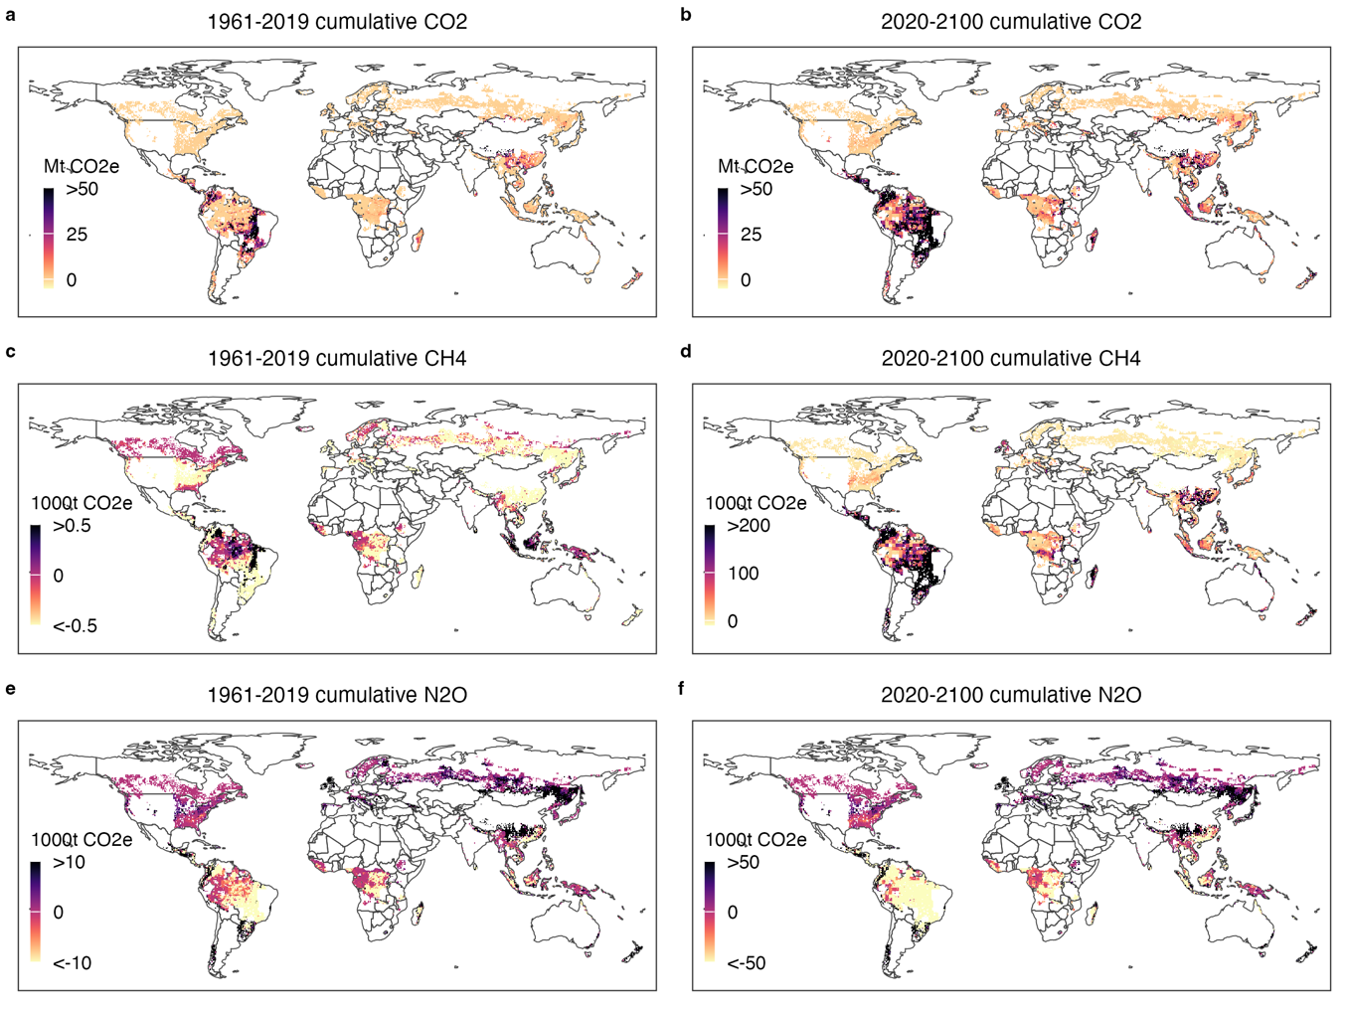
Figure S8. Spatial distribution of deforestation-driven cumulative emissions of each GHG type from deforestation for the periods 1961–2019 and 2020–2100 under the business-as-usual scenario.
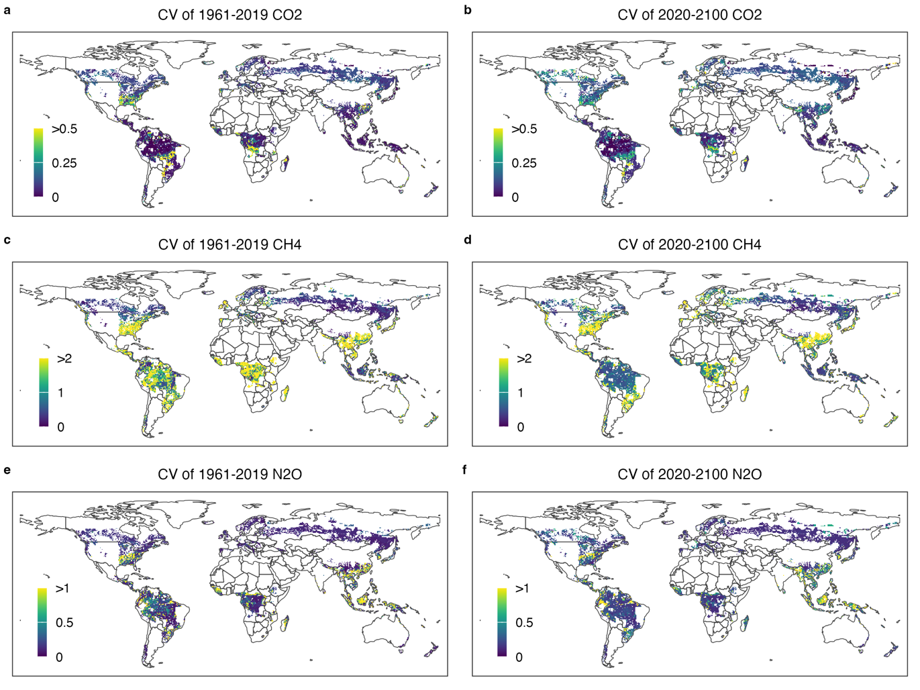
Figure S9. Uncertainty associated with deforestation-driven GHG emissions. The coefficient of variation (CV) was estimated based on 10,000 bootstrap predictions (see Methods).
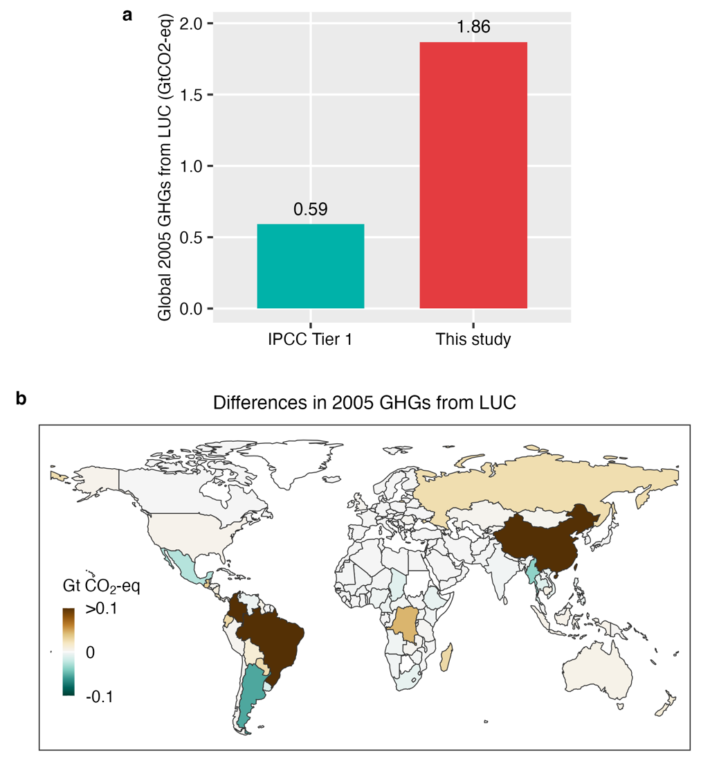
Figure S10. Comparison of our data-driven estimates of deforestation-induced GHG emissions in 2005 with those derived from the IPCC Tier 1 method. (a) Global total emissions; (b) Spatial differences between our estimates and the IPCC Tier 1 results.
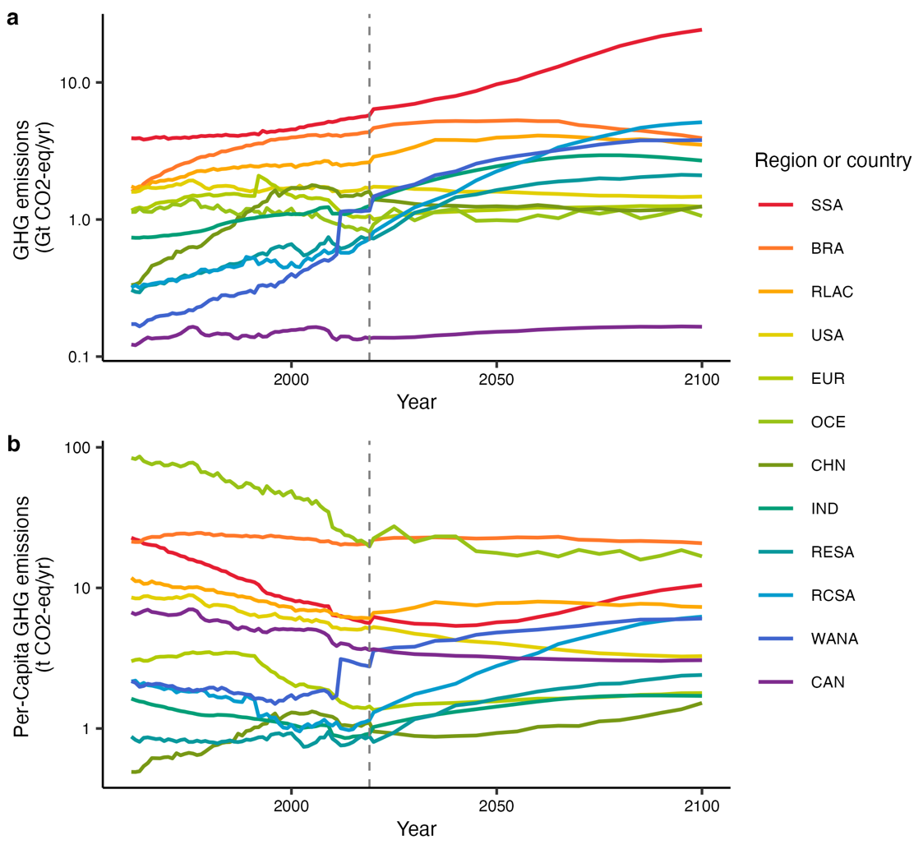
Figure S11. Annual GHG emissions from the ruminant sector and per capita emissions by region and country. SSA, Sub-Saharan Africa; BRA, Brazil; RLAC, Rest of Latin America and the Caribbean; USA, United States; EUR, Europe; OCE, Oceania; CHN, China; IND, India; RESA, Rest of Eastern and South-eastern Asia; RCSA, rest of Central and Southern Asia; WANA, Western Asia and Northern Africa; CAN, Canada.
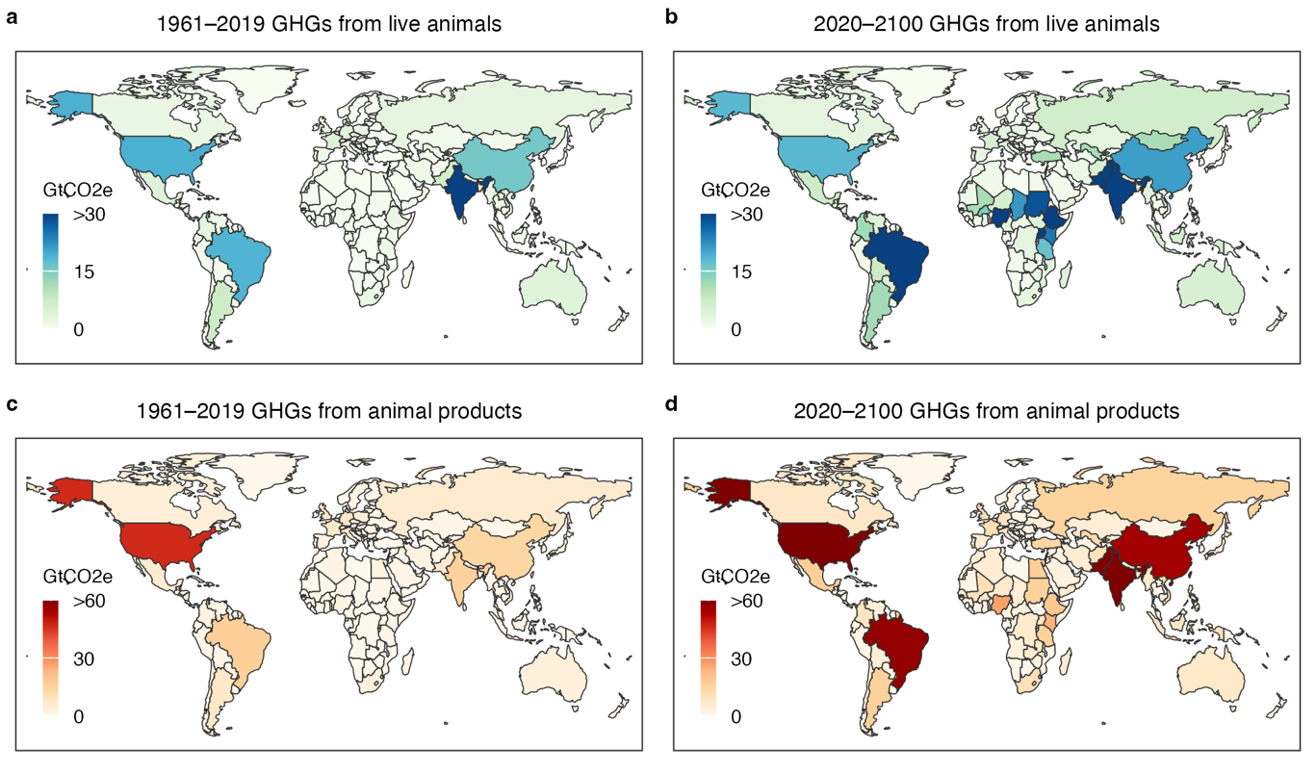
Figure S12. Spatial distribution of cumulative GHG emissions from live animals and products for the periods 1961–2019 and 2020–2100 under the business-as-usual scenario.
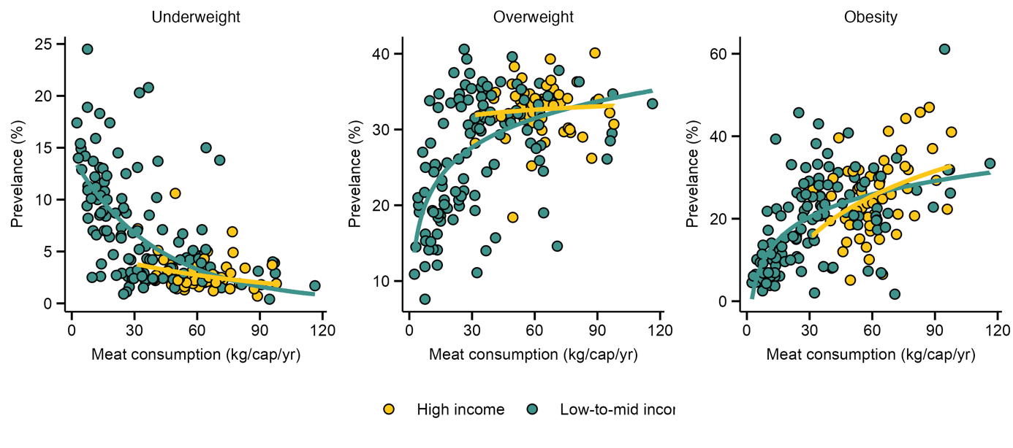
Figure S13. Relationships between per capita meat consumption (excluding food loss and waste) and the prevalence of the three body weight categories across low- to middle- and high-income countries.
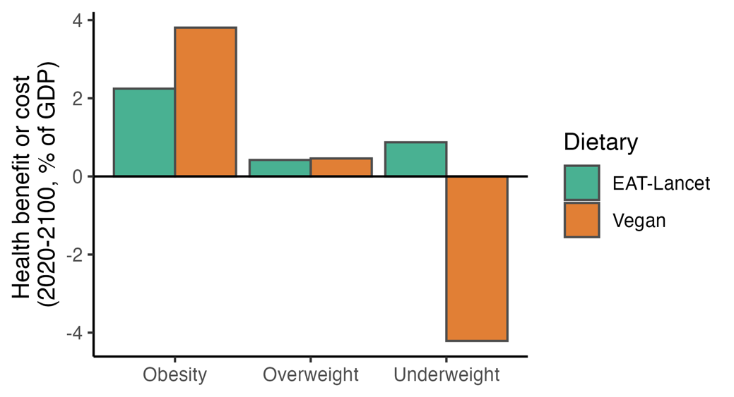
Figure S14. Global health impacts of dietary shifts toward the EAT-Lancet healthy diet and a vegan diet. In this study, human mortality risk was used as an indicator of health (see Methods).
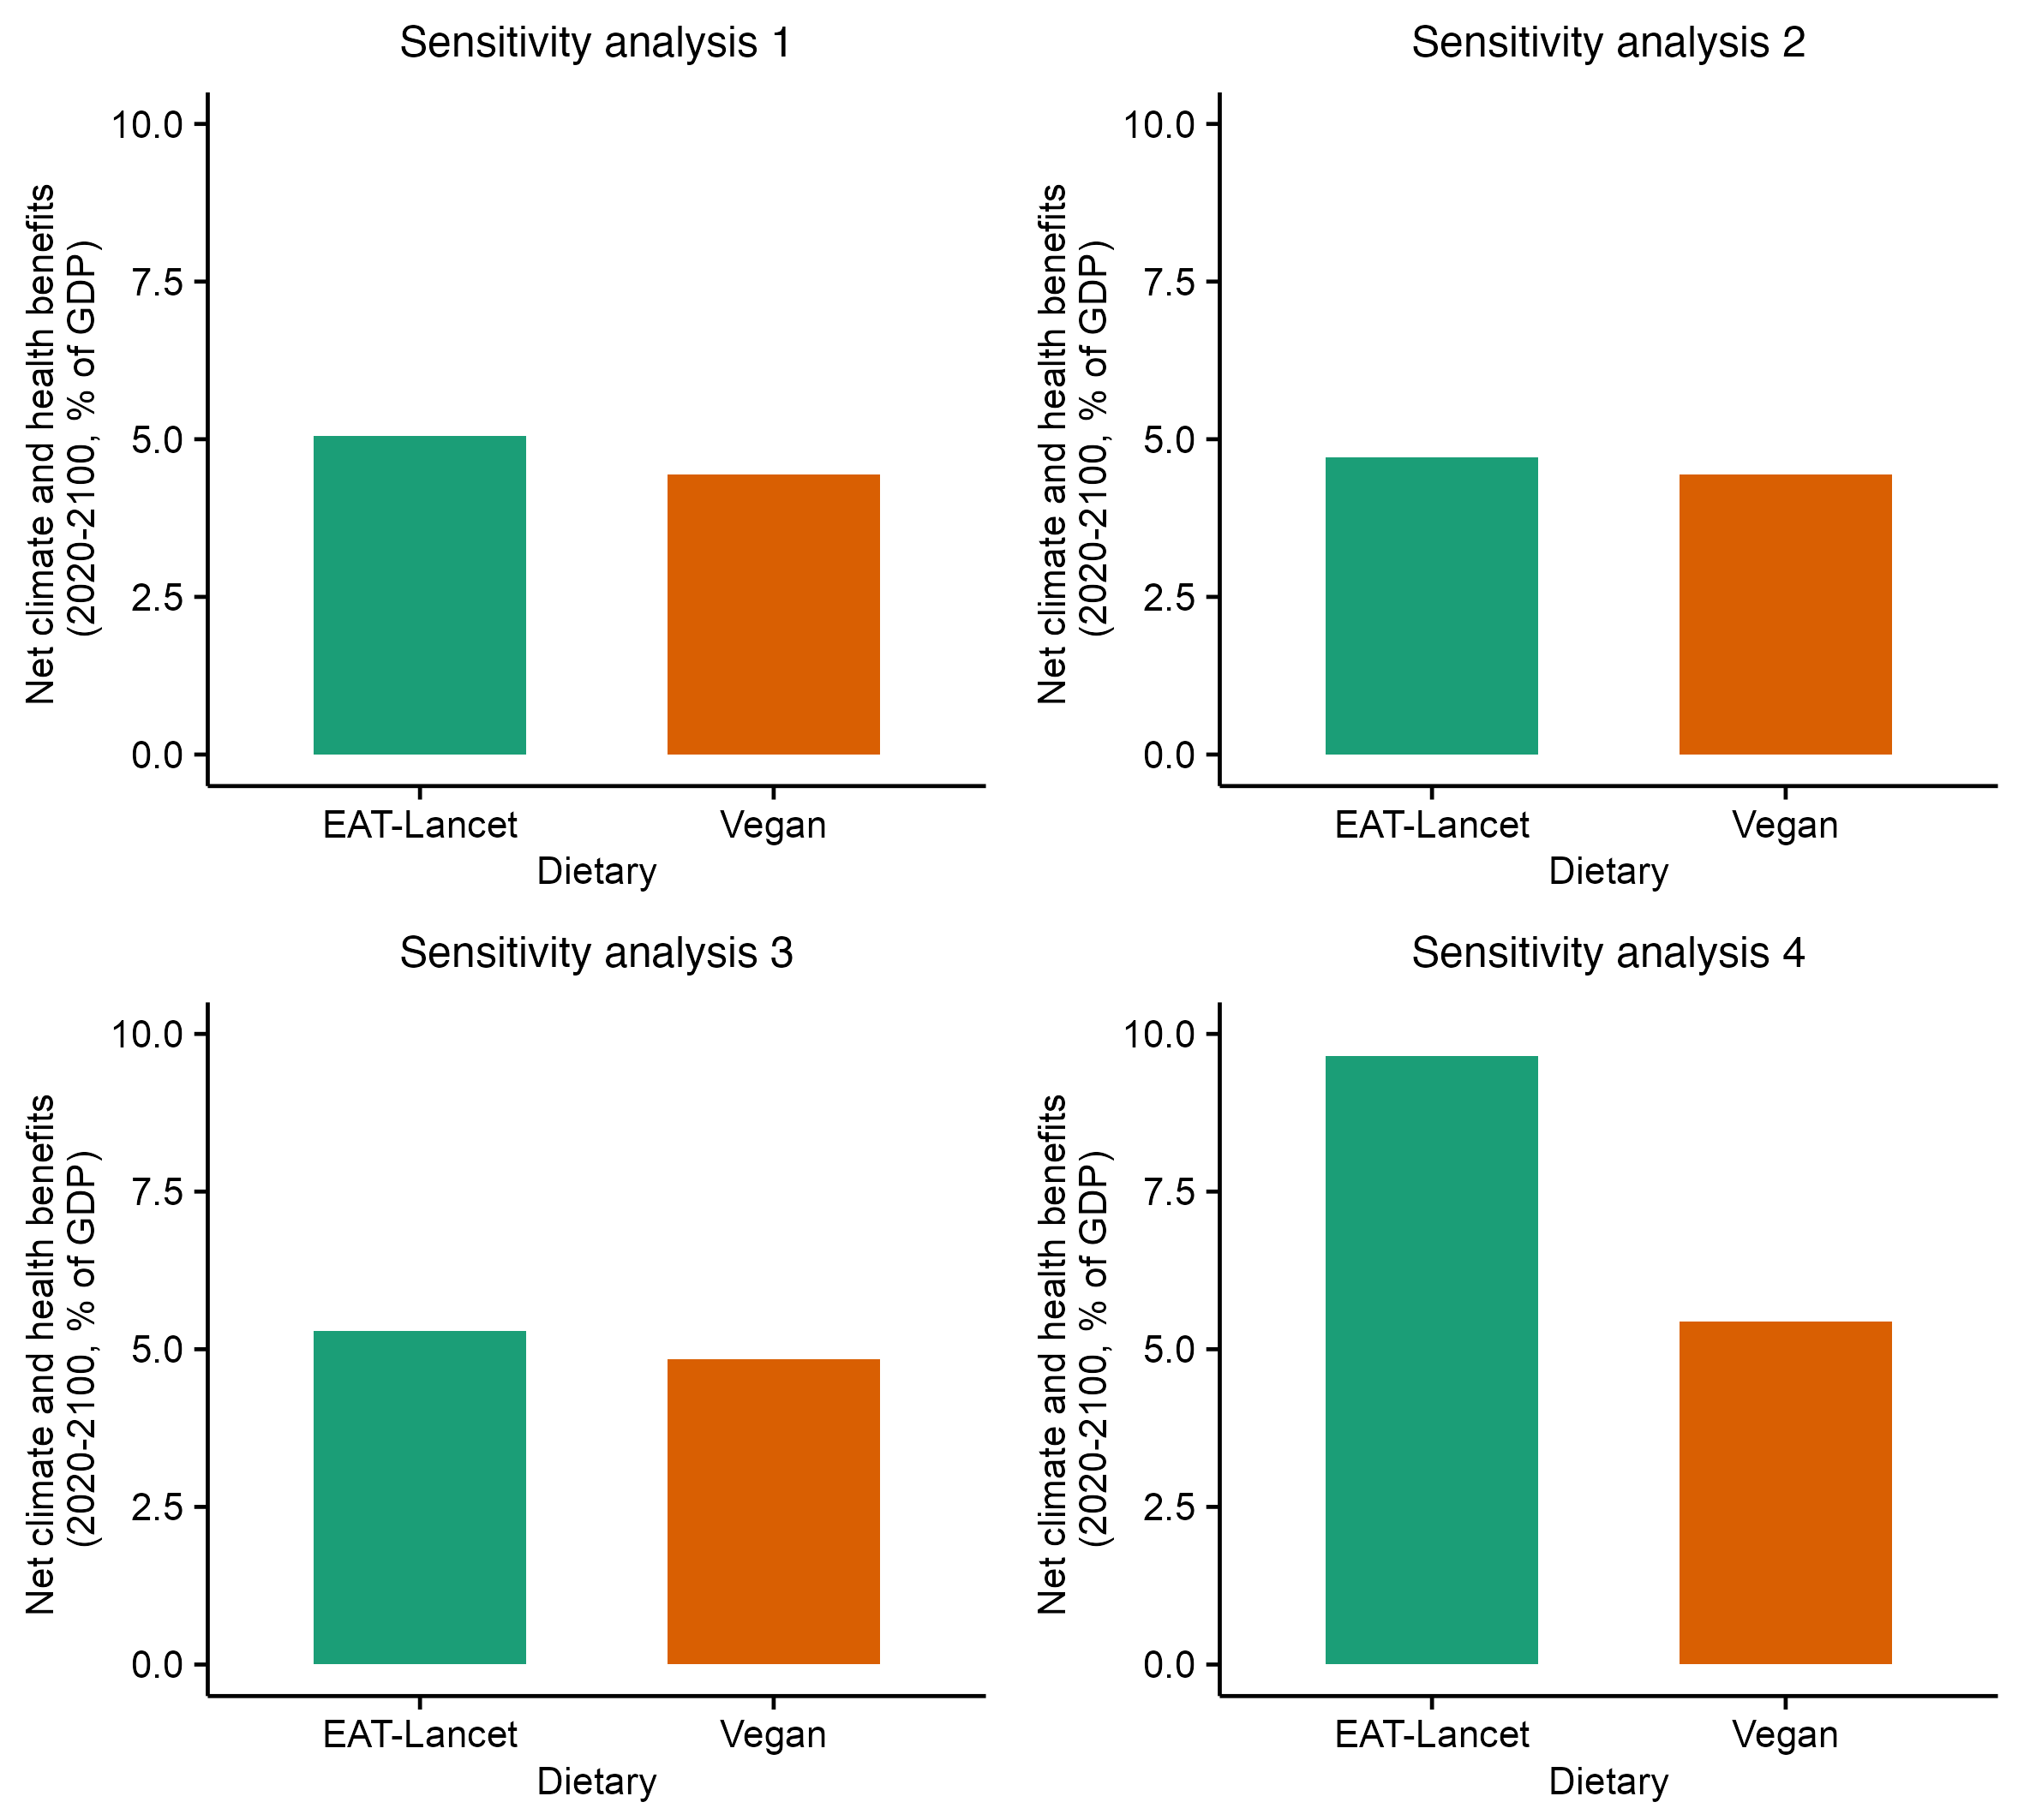
Figure S15. Sensitivity analysis of the impacts of dietary shifts toward the EAT-Lancet healthy diet and a vegan diet. See Supplementary Text for details.
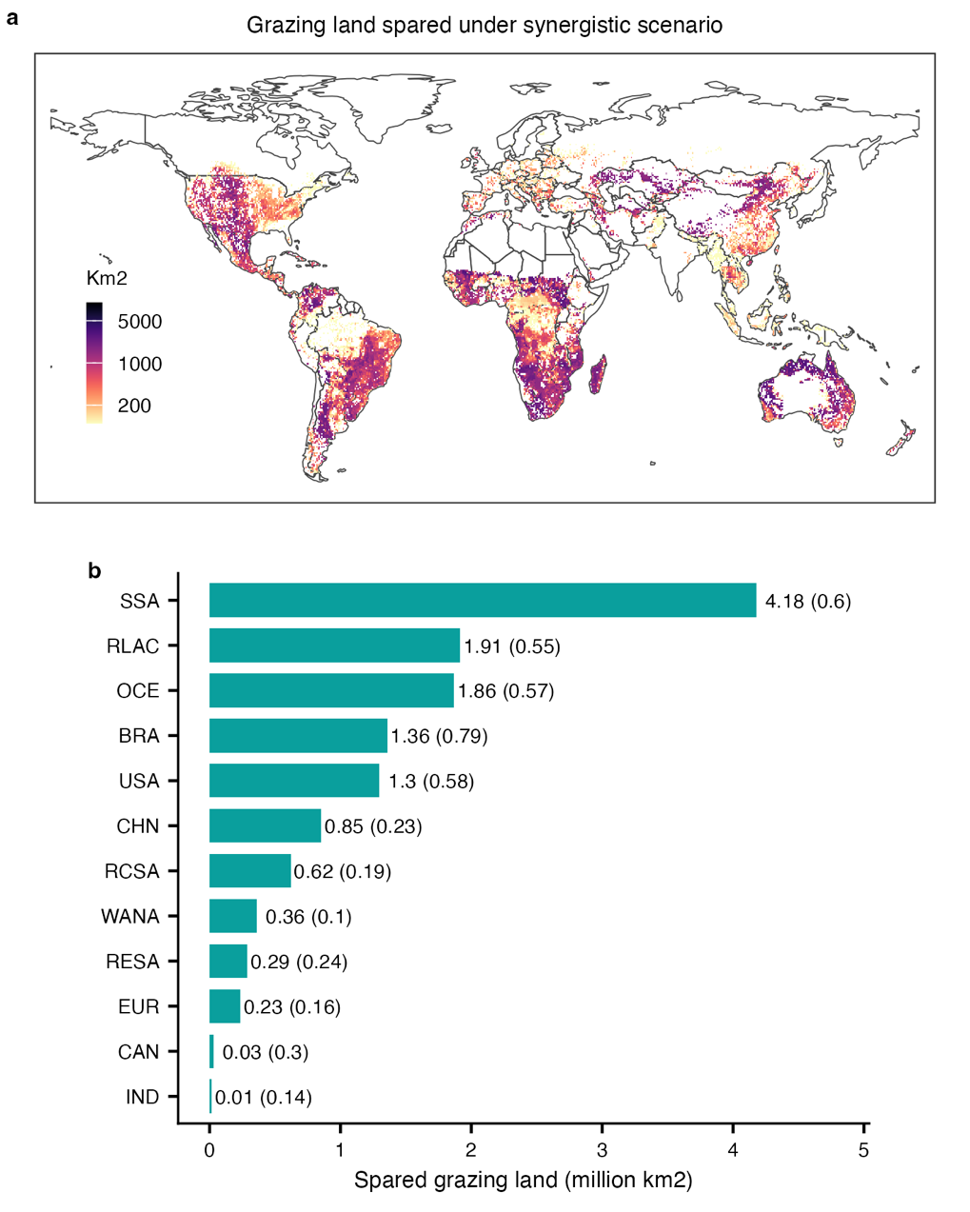
Figure S16. Global grazing land spared under the synergistic scenario. (a) Spatial distribution of spared grazing land. (b) Spared land by region, with values in brackets indicating the proportion of spared area relative to the total grazing land in each region. SSA, Sub-Saharan Africa; BRA, Brazil; RLAC, Rest of Latin America and the Caribbean; USA, United States; EUR, Europe; OCE, Oceania; CHN, China; IND, India; RESA, Rest of Eastern and South-eastern Asia; RCSA, rest of Central and Southern Asia; WANA, Western Asia and Northern Africa; CAN, Canada.
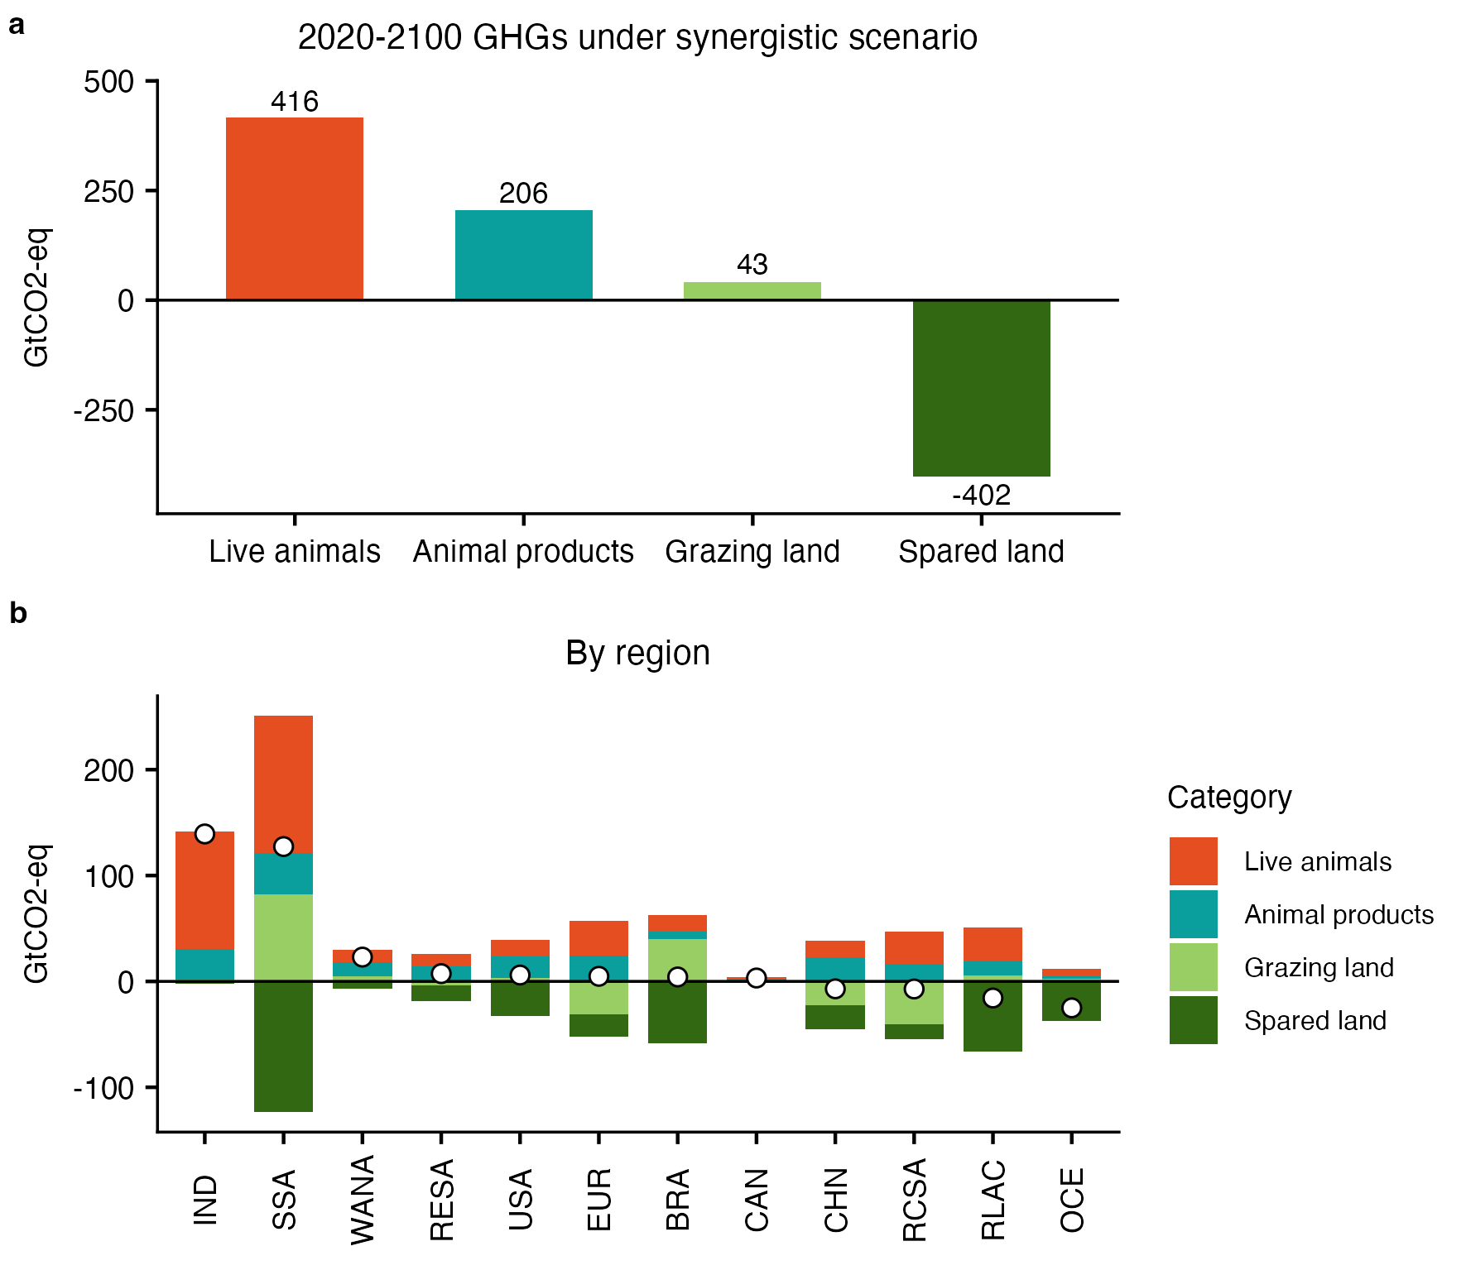
Figure S17. Global and regional GHG emissions from ruminant sector over 2020 to 2100 under the synergistic strategy scenario. In b, the points represent the net total emissions. Regional abbreviation definitions are consistent with those used in Figure S16.
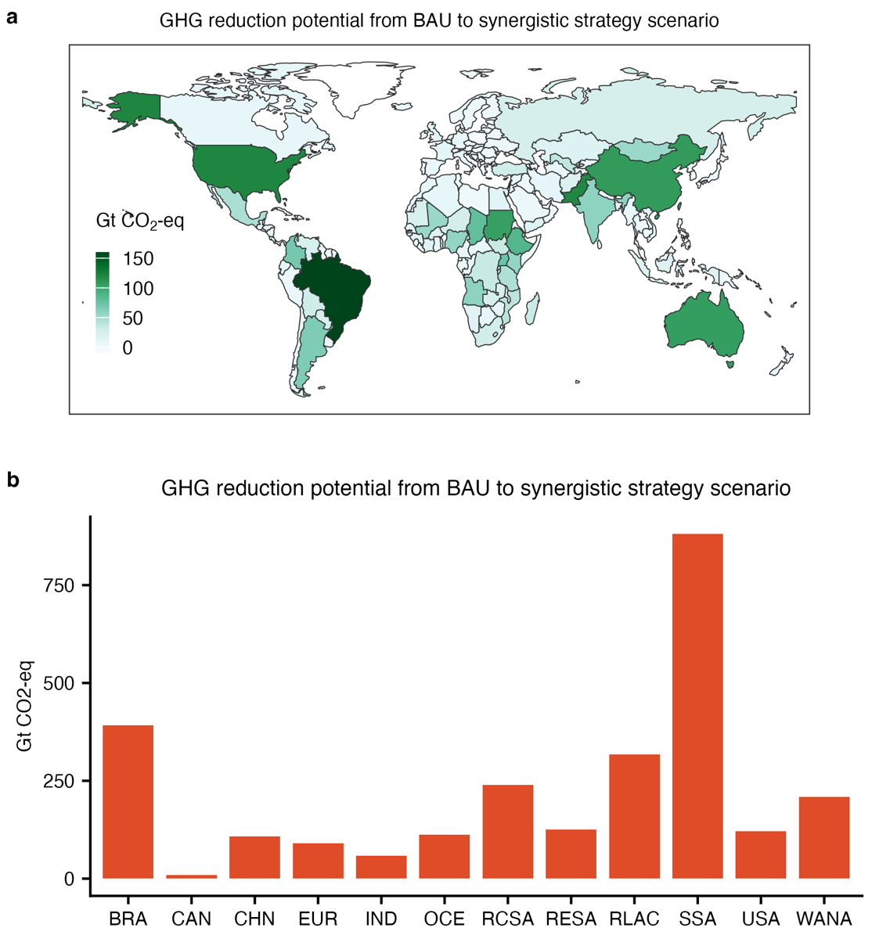
Figure S18. Global and regional ruminant GHG reduction potential under the synergistic scenario compared to the BAU scenario. Regional abbreviation definitions are consistent with those in Figure S16.
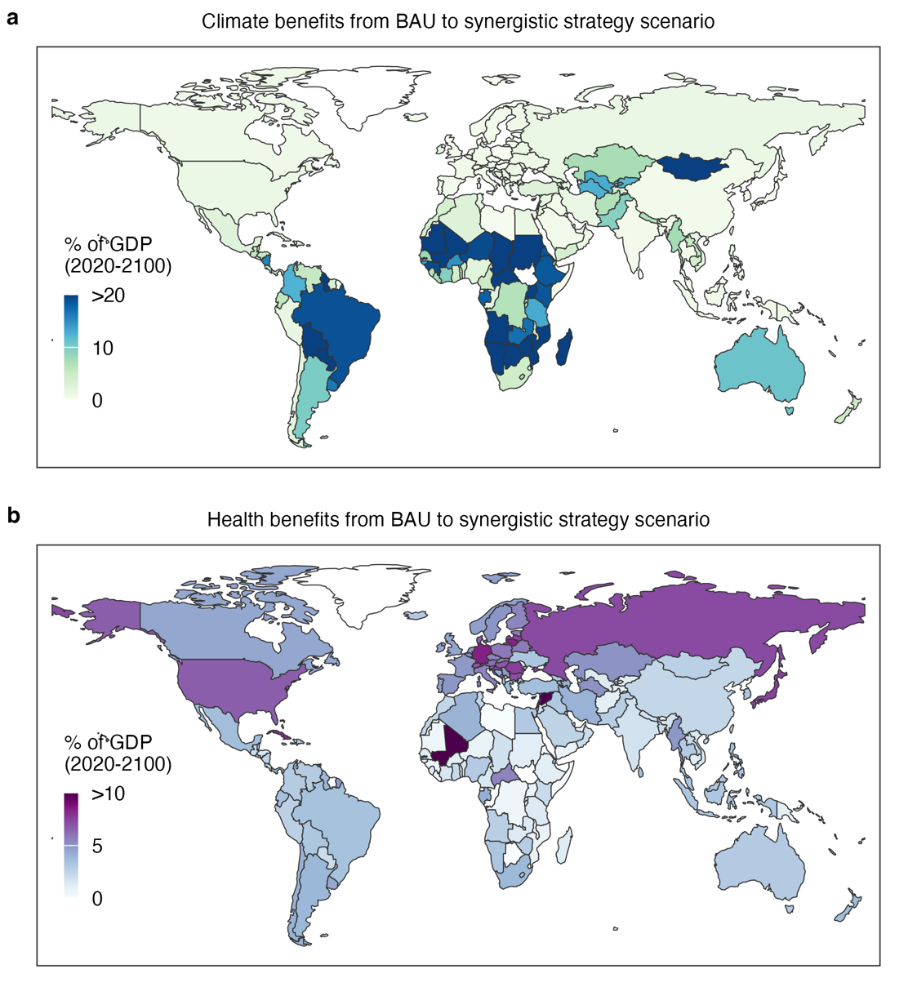
Figure S19. Economic benefits from avoided climate and health damages from BAU to synergistic scenario.
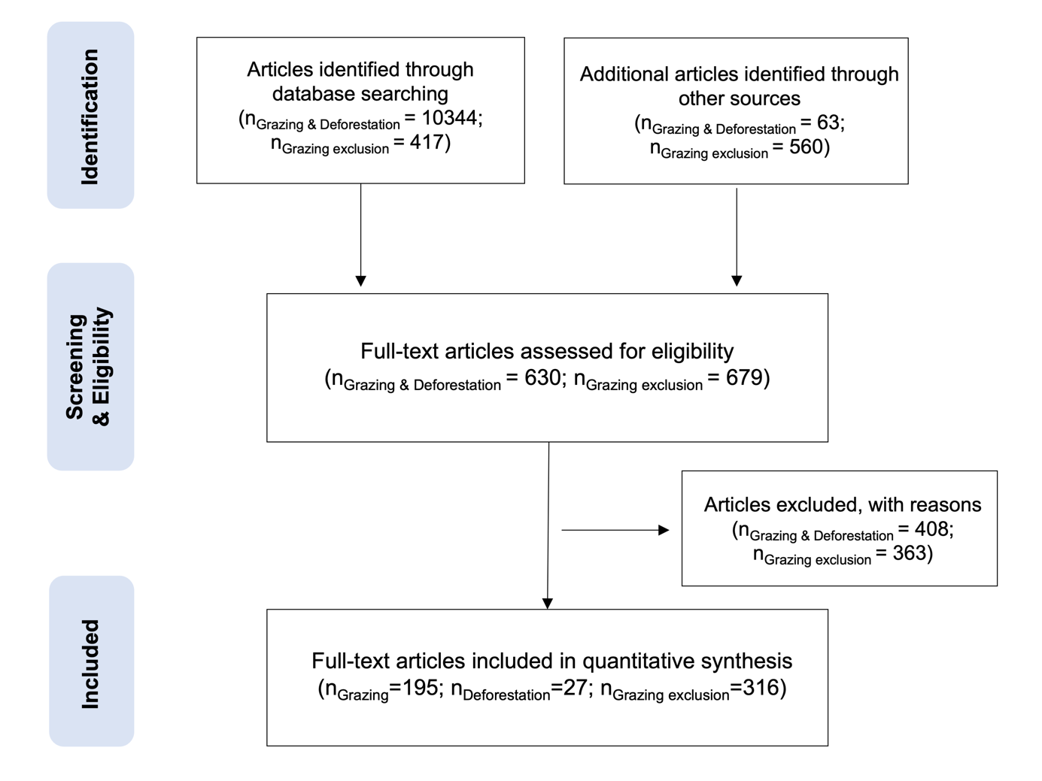
Figure S20. PRISMA flow diagram showing the procedure of selecting studies for this synthesis.
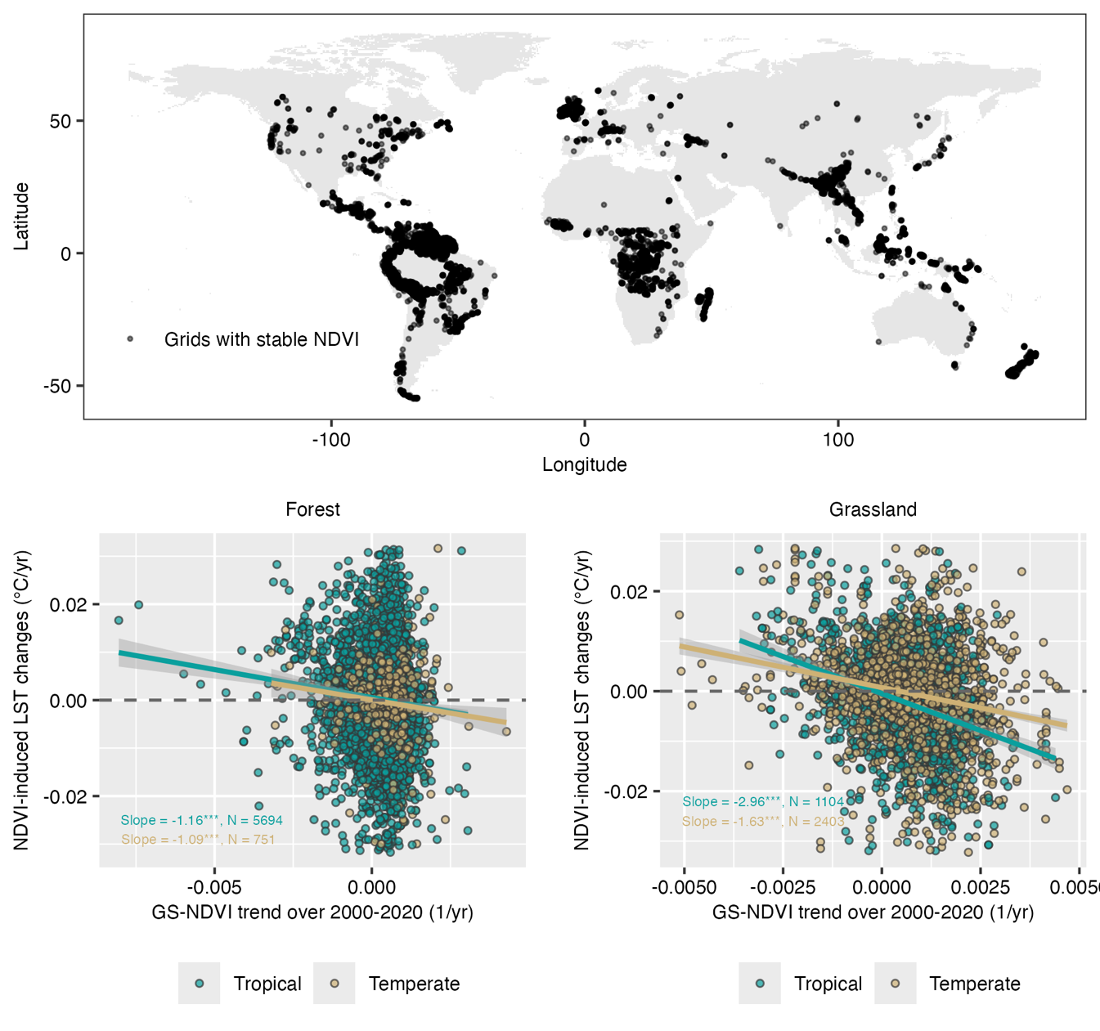
Figure S21. Spatial distribution of grid cells with stable NDVI from 2000 to 2020. The scatter plots show biome-specific relationships between changes in NDVI and associated changes in land surface temperature across these stable grid cells. The shaded area indicates the 95% confidence interval. See Methods for details. GS, growing season.
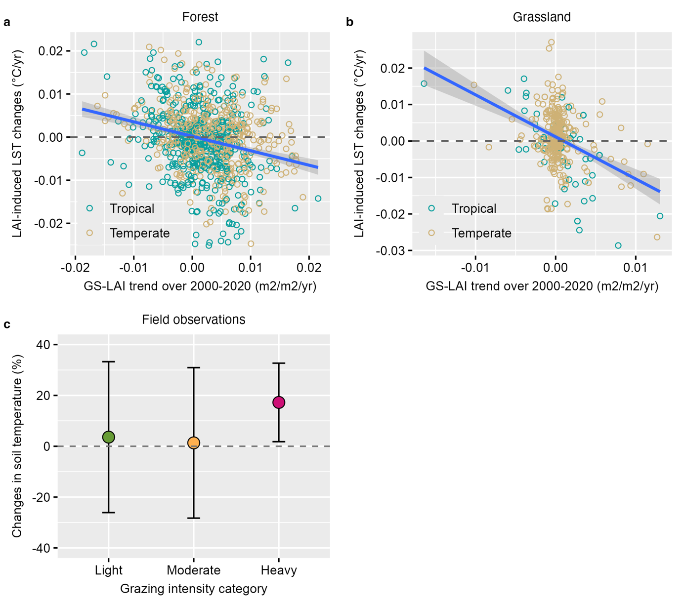
Figure S22. Relationships between changes in LAI and associated changes in land surface temperature across stable grid cells. Panel c shows the effects of grazing intensity on soil temperature based on field observations from Ref(7). The shaded area and error bars indicate the 95% confidence intervals. GS, growing season.
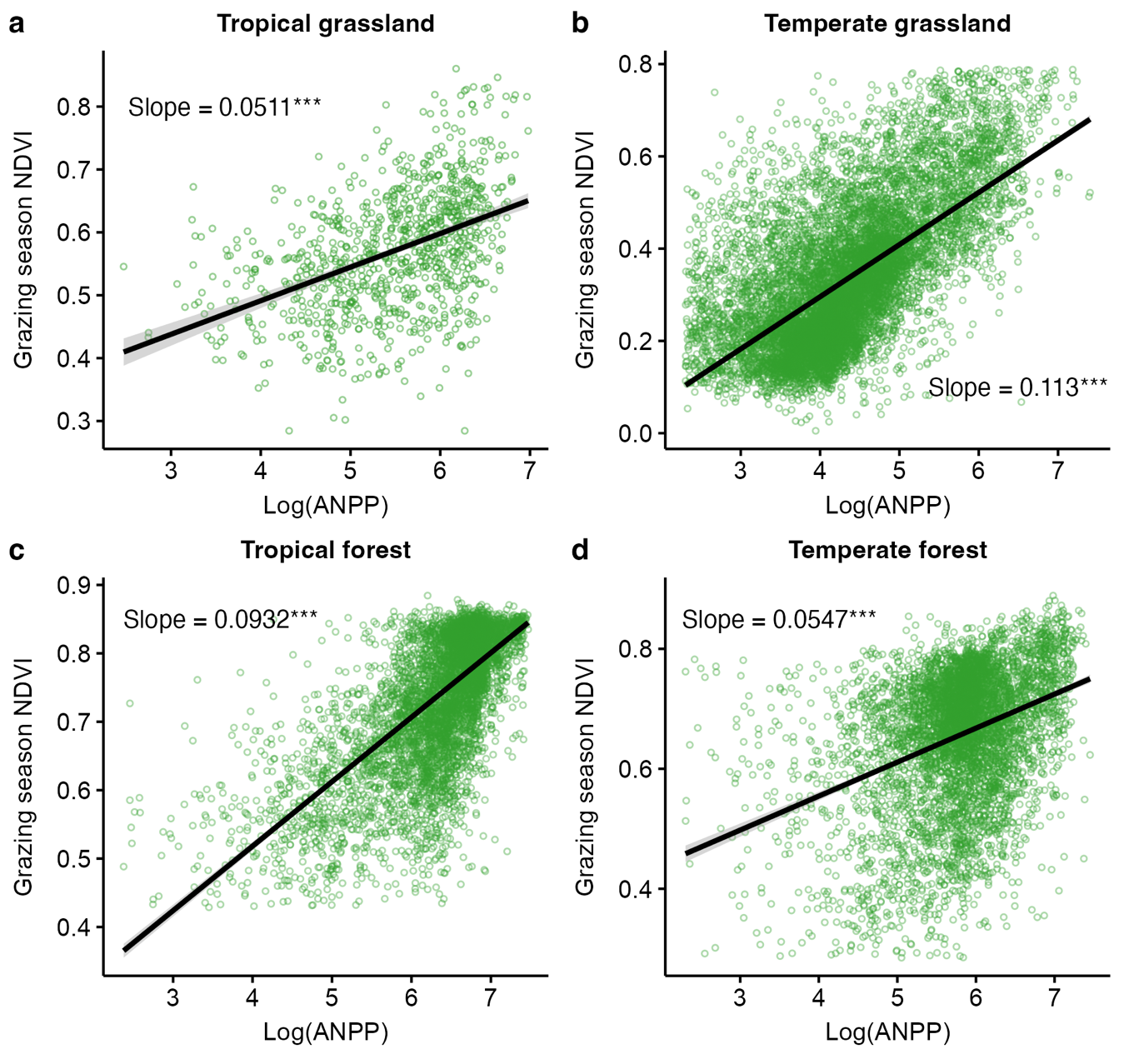
Figure S23. Relationships between aboveground net primary productivity (ANPP) and growing season NDVI based on global datasets across different ecosystems.
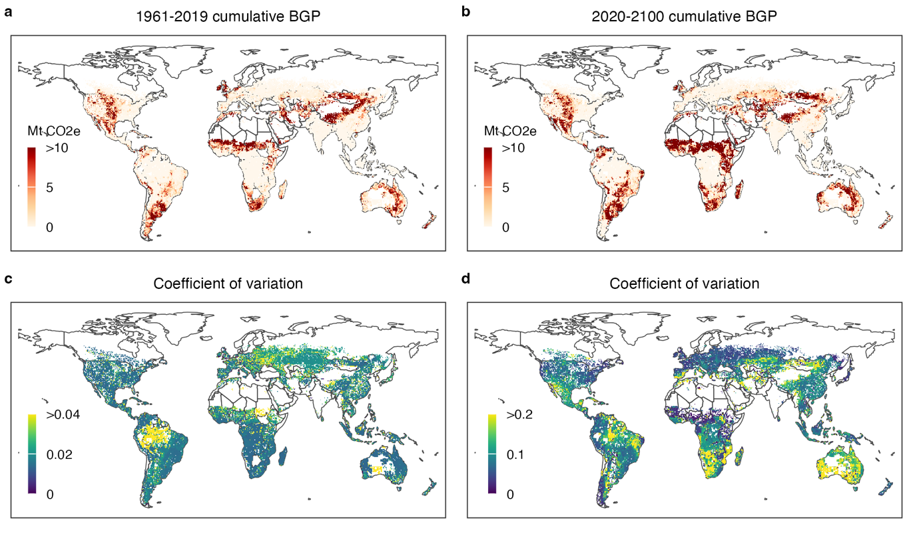
Figure S24. Spatial distribution of the biophysical impacts of grazing activities and their uncertainties for the periods 1961–2019 and 2020–2100 under the business-as-usual scenario.
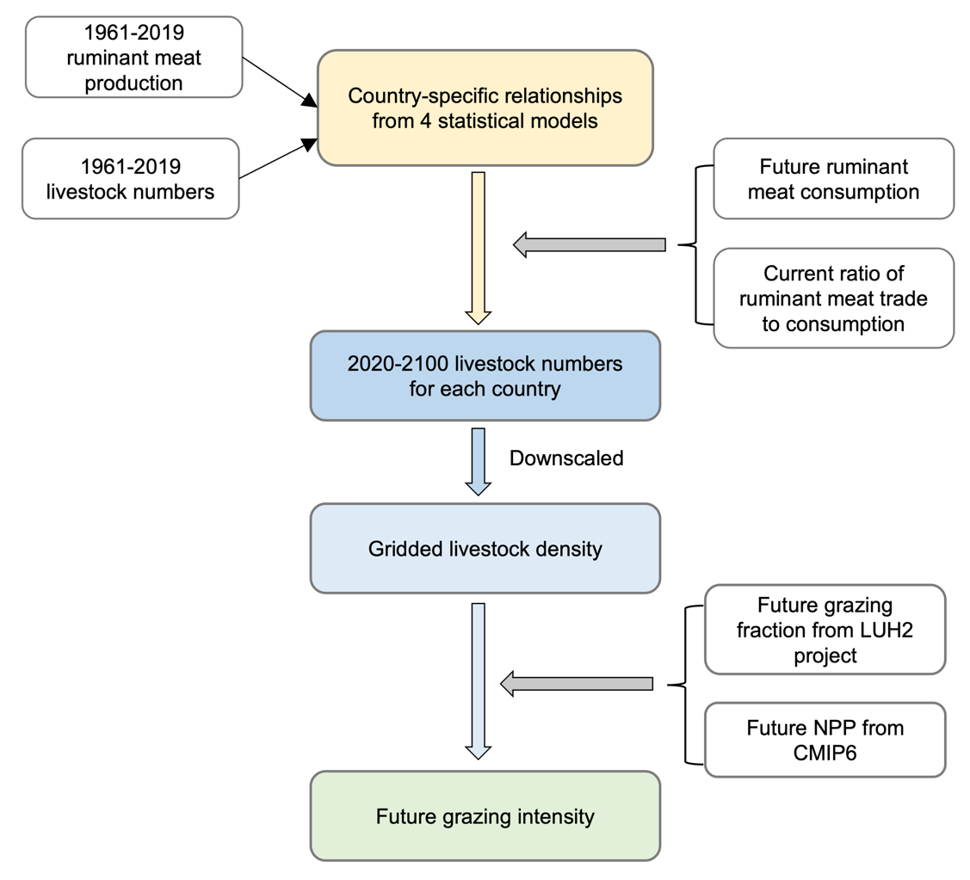
Figure S25. Flowchart illustrating the procedure for forecasting future livestock numbers and associated grazing intensity. See Method for details.
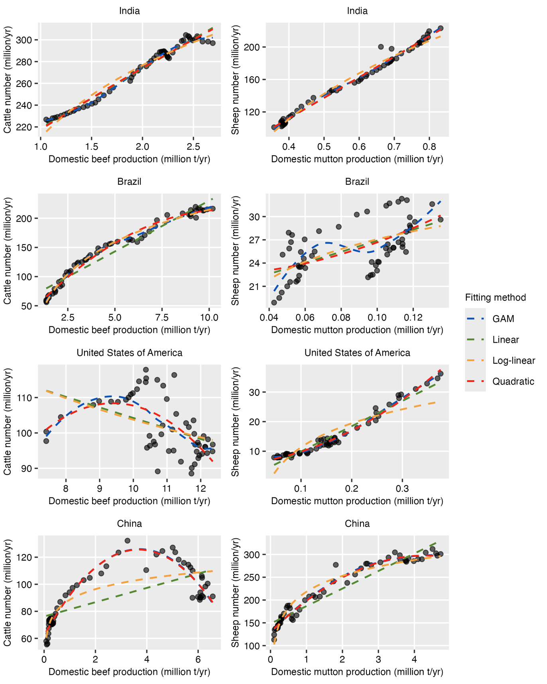
Figure S26. Historical (1961-2019) relationships between livestock numbers and domestic ruminant meat production (accounting for trade, and food loss and waste) in the four countries with the highest livestock populations. GAM, generalized additive models.
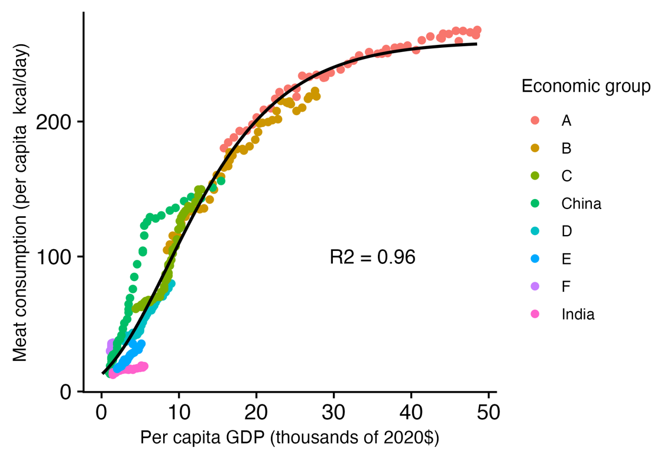
Figure S27. Relationship between per capita meat consumption and per capita GDP across eight economic groups, as defined in Ref(8). See Ref(8) for the definitions of economic groups.
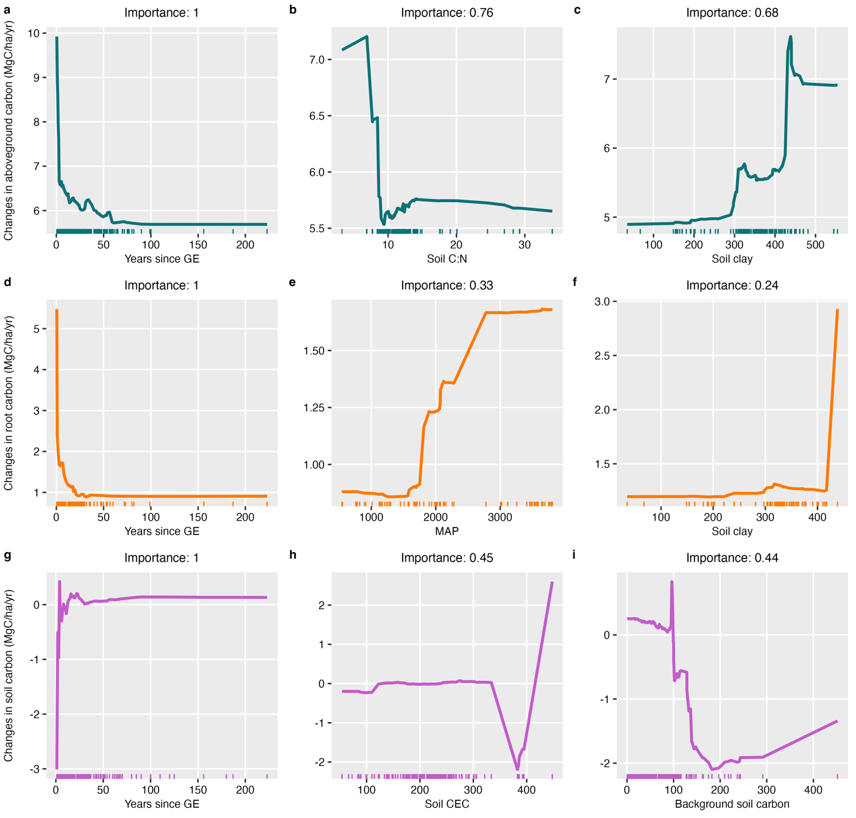
Figure S28. Partial dependence plots of key predictors influencing carbon changes in aboveground biomass, roots, and soil in pasturelands.
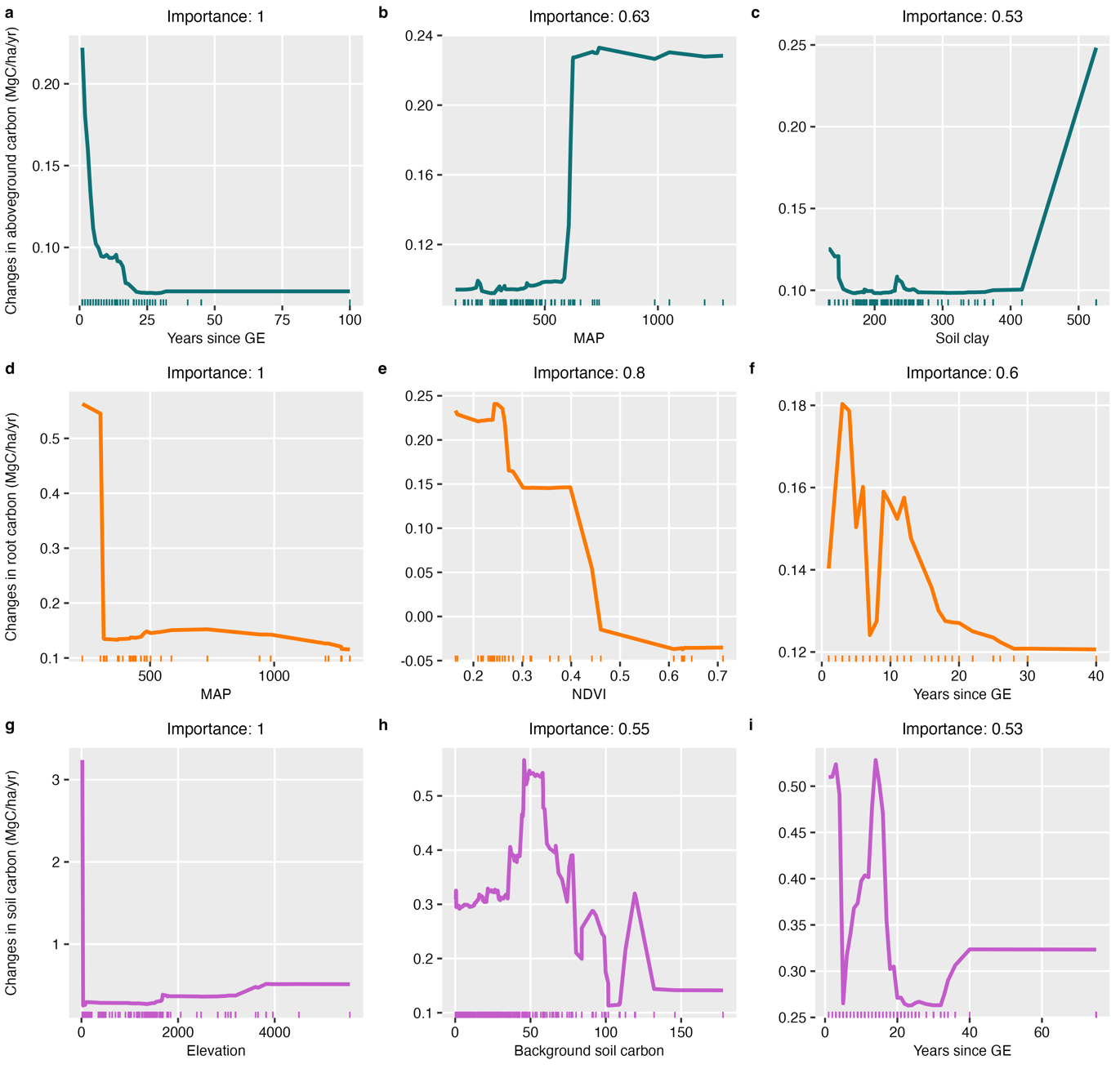
Figure S29. Partial dependence plots of key predictors influencing carbon changes in aboveground biomass, roots, and soil in rangelands.
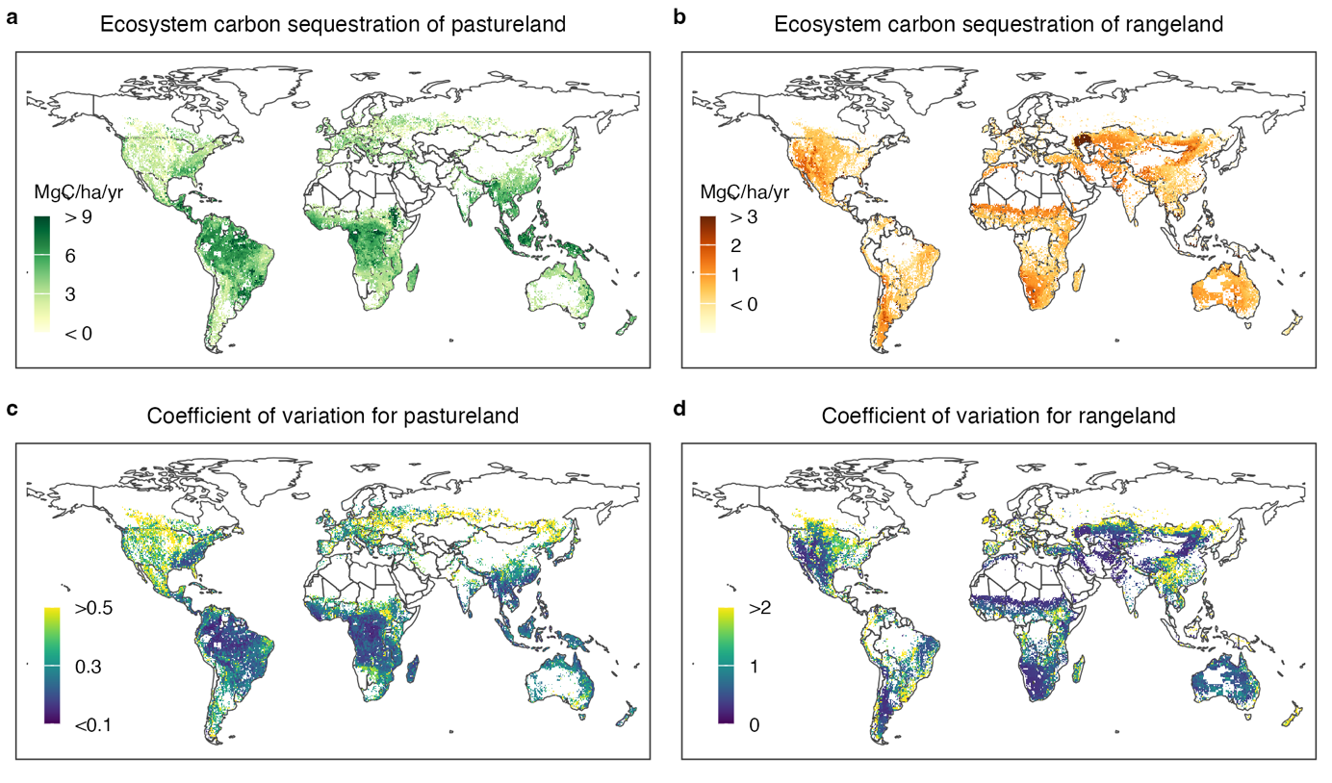
Figure S30. Spatial distribution of data-driven ecosystem carbon sequestration rates—including aboveground biomass, roots, and 1-meter soils—and associated uncertainties for pastureland in potential forest areas and rangeland in potential grassland areas over the next eighty years. See Table S2 for a global summary.
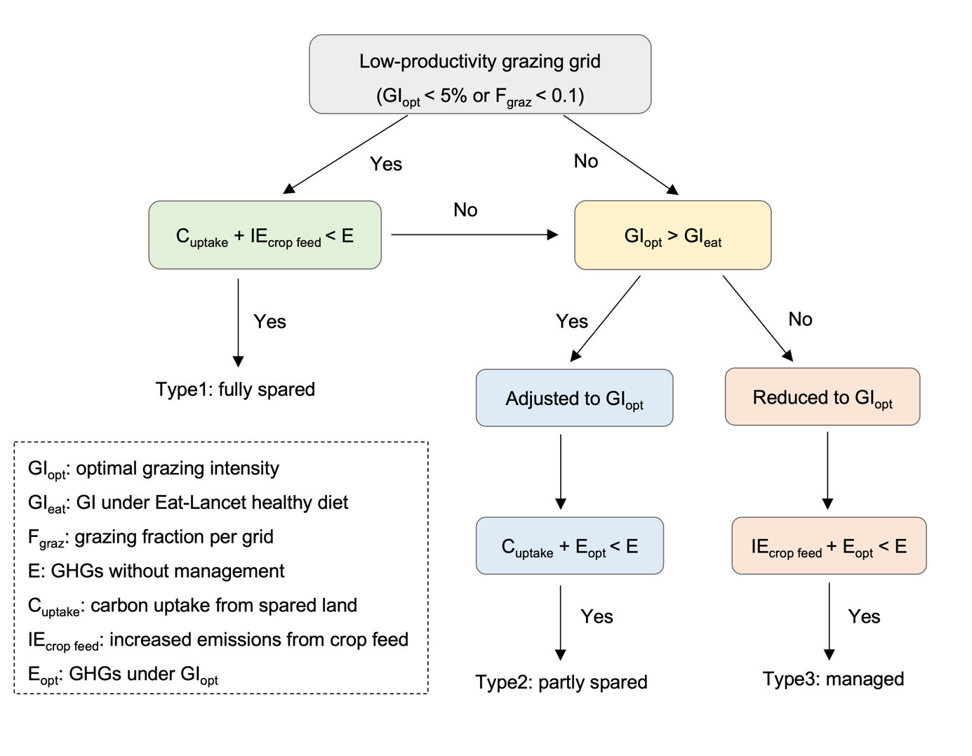
Figure S31. Flowchart illustrating the methodology for estimating spared grazing land under the synergistic strategy scenarios. See Method for details.
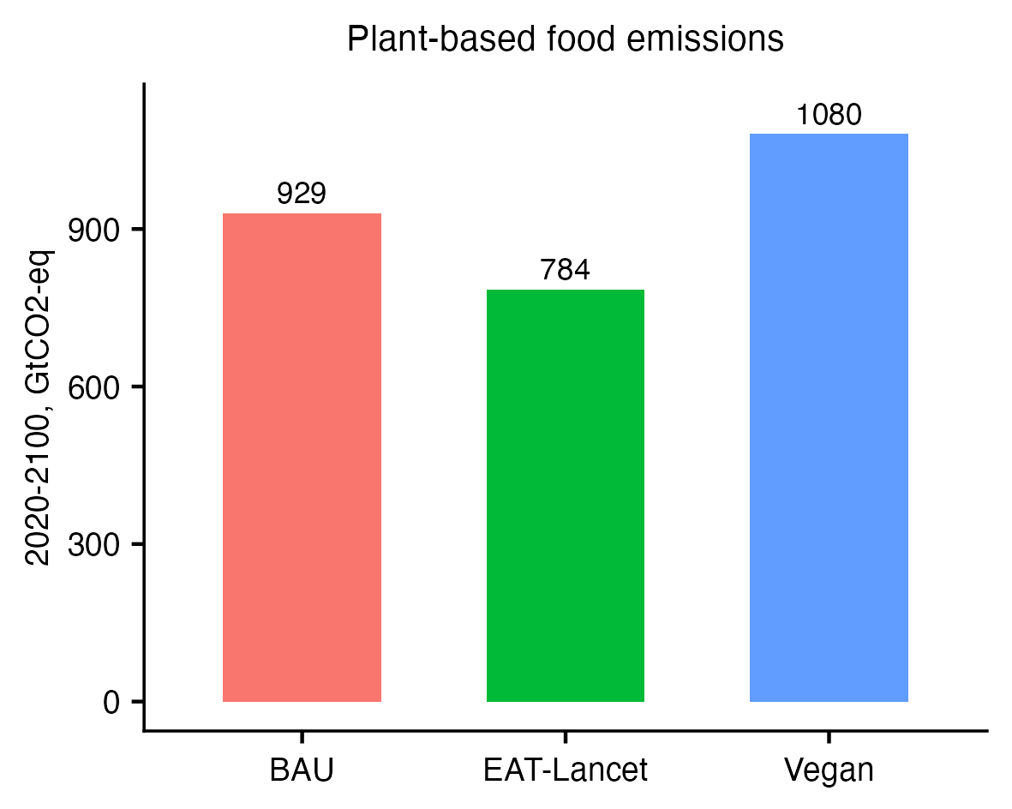
Figure S32. GHG emissions from plant-based food consumption from 2020 to 2100 under three dietary scenarios.
Table S1. Global cumulative GHG emissions by source and gas type for the periods 1961–2019 and 2020–2100.
Categories | Sources/Gas types | 1961-2019 GHG emissions (Gt CO2-eq; mean ± sd) | 2020-2100 GHG emissions (Gt CO2-eq; mean ± sd)
Grazing land | CO2 | 461 ± 872 | 736 ± 1454
Grazing land | Wetland CH4 | 0.29 ± 2.54 | 0.51 ± 4.07
Grazing land | Upland CH4 | -7.02 ± 31.4 | -8.75 ± 46.1
Grazing land | N2O | 7.64 ± 152 | 10.4 ± 238
Grazing land | Biogeophysical | 132 ± 14 | 355 ± 52
Deforested land | CO2 | 75 ± 99 | 256 ± 157
Deforested land | CH4 | -0.15 ± 1.15 | 1.32 ± 9.38
Deforested land | N2O | -0.4 ± 1.38 | -1.77 ± 4.08
Deforested land | Biogeophysical | 2.84 ± 1.37 | 7.75 ± 3.73
Abandoned land | Pastureland (carbon uptake) | -15.3 ± 5.36 | -82.5 ± 29
Abandoned land | Pastureland (Biogeophysical) | -0.51 ± 0.24 | -3.27 ± 1.58
Abandoned land | Rangeland (carbon uptake) | -14.7 ± 26 | -42.6 ± 75
Abandoned land | Croplandª (carbon uptake) | -1.37 ± 0.14 | -6.16 ± 0.61
Abandoned land | Croplandª (Biogeophysical) | -0.24 ± 0.11 | -1.1 ± 0.53
Live animals-cattle | Enteric fermentation (CH4) | 118 ± 11.8 | 478 ± 48
Live animals-cattle | Feed (CO2)^{b} | 15 ± 3.03 | 46.6 ± 9.32
Live animals-cattle | Feed (N2O) | 18.3 ± 3.65 | 65 ± 13
Live animals-cattle | Manure (CH4) | 9.04 ± 1.81 | 20.6 ± 4.12
Live animals-cattle | Manure (N2O) | 11.2 ± 2.24 | 40.5 ± 8.1
Live animals-sheep | Enteric fermentation (CH4) | 13.6 ± 1.36 | 149 ± 15
Live animals-sheep | Feed (CO2)^{b} | 0.98 ± 0.19 | 8.58 ± 1.71
Live animals-sheep | Feed (N2O) | 1.66 ± 0.33 | 16.4 ± 3.28
Live animals-sheep | Manure (CH4) | 0.38 ± 0.07 | 4.11 ± 0.82
Live animals-sheep | Manure (N2O) | 0.79 ± 0.16 | 6.95 ± 1.39
Animal products-ruminant meat^{c} | CO2 | 16.6 ± 8.74 | 78.8 ± 40.2
Animal products-ruminant meat^{c} | CH4 | 105 ± 55 | 474 ± 238
Animal products-ruminant meat^{c} | N2O | 25 ± 13 | 117 ± 59
Animal products-dairy^{c} | CO2 | 19 ± 5.7 | 52.6 ± 16
Animal products-dairy^{c} | CH4 | 50 ± 15 | 138 ± 42
Animal products-dairy^{c} | N2O | 16 ± 5 | 45 ± 14
Overall |  | 1,060 ± 894 | 2,961 ± 1,508
ªcropland used for growing feeding crops; ^{b}including emissions from land use change; ^{c}excluding emissions from land use change

Table S2. Carbon sequestration potential of aboveground biomass, root biomass, and soils over the next 80 years from grazing exclusion. See Method for more details.
Components | Pastureland (Gt CO2-eq) | Rangeland (Gt CO2-eq) | Croplandª (Gt CO2-eq)
Aboveground | 411 ± 90 | 44 ± 14 | -
Root | 93 ± 34 | 167 ± 182 | -
1-m Soil | 13 ± 26 | 157 ± 325 | -
Ecosystem | 517 ± 100 | 368 ± 373 | 62.3
Biogeophysical | 27.5
Total | 975 ± 385
ªcropland used for growing feeding crops

Table S3. Variable importance for grazing-induced GHG changes as identified by random forest models.
Fluxes | All evaluated factors | Selected important factors (relative importance value) | R2 (RMSE) of final model
NEE | Background GHG flux  Grazing intensity  MAT  MAP  Elevation  Aridity  NDVI  Soil CEC  Soil N  Soil clay  Soil pH  Soil organic carbon  Soil C:N  WNW types  Biomes  Experimental duration  Grazing season | Background NEE flux (1)  Grazing intensity (0.8)  MAT (0.48)  MAP (0.43)  NDVI (0.37)  Elevation (0.31)  Soil CEC (0.3)  Soil clay (0.24)  Soil organic carbon (0.18)  Soil C:N (0.17)  Soil pH (0.15)  Soil N (0.15)  Aridity (0.1)  Biomes (0.046) | 0.54 (189)
CH₄ |  | Background CH4 flux (1)  Grazing intensity (0.34)  MAT (0.29)  Soil N (0.25)  NDVI (0.24)  MAP (0.23)  Elevation (0.2)  Soil organic carbon (0.066)  Soil clay (0.057)  Soil C:N (0.05)  Aridity (0.048)  Wetland and non-wetland types (0.026)  Soil pH (0.023)  Soil CEC (0.012) | 0.43 (3.55)
N₂O |  | Background N2O flux (1)  NDVI (0.21)  MAT (0.15)  MAP (0.13)  Biome (0.09)  Soil CEC (0.07)  Grazing intensity (0.069)  Aridity (0.048)  Soil pH (0.033)  Soil clay (0.019)  Elevation (0.018)  Soil N (0.015)  Soil organic carbon (0.0067)  Soil C:N (0.0065) | 0.53 (7.93)

Table S4. Variable importance for deforestation-induced GHG changes as identified by random forest models.
Fluxes | Relative importance of selected variables | R2 (RMSE) of final model
CO₂ | Soil clay (1)  MAP (0.606)  Elevation (0.569)  Aridity (0.28)  MAT (0.2)  Soil pH (0.17)  Forest age (0.15)  Soil N (0.12)  Soil CEC (0.11)  Time since deforestation (0.043)  Soil organic carbon (0.01) | 0.81 (160)
CH₄ | Background CH4 flux (1)  MAT (0.45)  MAP (0.24)  Aridity (0.07)  Soil pH (0.043)  Time since deforestation (0.024)  Soil organic carbon (0.018)  Soil clay (0.015)  Soil CEC (0.015)  Elevation (0.0065)  Forest age (0.0063)  Soil N (0.00) | 0.3 (1.9)
N₂O | MAP (1)  Soil CEC (0.65)  MAT (0.58)  Aridity (0.24)  Elevation (0.19)  Soil N (0.17)  Soil pH (0.16)  Soil clay (0.15)  Soil organic carbon (0.12)  Forest age (0.00) | 0.45 (7.86)

Table S5. Information on global datasets used in this study.
Name | Source | Time | Temporal resolution | Usage | Reference
Background NEE flux | FluxCom | Present-day | Monthly | 1 | https://www.fluxcom.org/
Background CH4 flux of wetland | WETCHIMPª | Present-day | Monthly | 1 | https://doi.pangaea.de/10.1594/PANGAEA.887208
Background CH4 flux of upland | LPJ-Bern | Present-day | Monthly | 1,2 | https://doi.pangaea.de/10.1594/PANGAEA.887208
Background CH4 flux of upland | VISIT | 1901-2020 | Monthly | 1,2 | https://www.nies.go.jp/doi/10.17595/20210521.001-e.html
Background CH4 flux of upland | MeMo v1.0 | 1990-2009 | Monthly | 1,2 | https://gmd.copernicus.org/articles/11/2009/2018/
Background N2O flux | VISIT | 1901-2020 | Monthly | 1 | https://www.nies.go.jp/doi/10.17595/20210521.001-e.html
Background N2O flux | ISIMIP3a^{b} | 1901-2020 | Monthly | 1 | https://www.isimip.org/
Grazing intensity | This study | 1961-2100 | Yearly | 1,3 | -
MAT | CRUv4.05 | 1901-2020 | Monthly | 1,2 | https://crudata.uea.ac.uk/cru/data/hrg/cru_ts_4.05/
MAT | CMIP6^{c} | 2015-2100 | Monthly | 1,2,3 | https://pcmdi.llnl.gov/CMIP6/
MAP | CRUv4.05 | 1901-2020 | Monthly | 1,2 | https://crudata.uea.ac.uk/cru/data/hrg/cru_ts_4.05/
MAP | CMIP6^{d} | 2015-2100 | Monthly | 1,2,3 | https://pcmdi.llnl.gov/CMIP6/
NDVI | MODIS | 2000-2020 | Monthly | 1,3 | https://neo.gsfc.nasa.gov/view.php?datasetId=MOD_NDVI_M
Elevation | SRTM | Present-day | - | 1,2,3 | https://www.usgs.gov/centers/eros/science/usgs-eros-archive-digital-elevation-shuttle-radar-topography-mission-srtm-1
Soil CEC | SoilGridsv2 | Present-day | - | 1,2,3 | https://soilgrids.org/
Soil clay | SoilGridsv2 | Present-day | - | 1,2,3 | https://soilgrids.org/
Soil organic carbon | SoilGridsv2 | Present-day | - | 1,2,3 | https://soilgrids.org/
Soil C:N | SoilGridsv2 | Present-day | - | 1,2,3 | https://soilgrids.org/
Soil pH | SoilGridsv2 | Present-day | - | 1,2,3 | https://soilgrids.org/
Soil N | SoilGridsv2 | Present-day | - | 1,2,3 | https://soilgrids.org/
Aridity | Global_AI_PET | 1970-2000 | Yearly | 1,2,3 | https://cgiarcsi.community/2019/01/24/global-aridity-index-and-potential-evapotranspiration-climate-database-v3/
Biomes | MODIS IGBP | Present-day | - | 1 | https://modis.gsfc.nasa.gov/data/dataprod/mod12.php
Wetland | Global wetland reconstruction | 1700-2020 | Yearly | 1 | https://zenodo.org/records/7293597
Forest age | Global 1km forest age datasets | 2010 | - | 2 | https://www.bgc-jena.mpg.de/geodb/projects/FileDetails.php
1 is for quantifying GHG changes induced by grazing; 2 is for quantifying GHG changes induced by deforestation; 3 is for estimating carbon sequestration potentials from grazing exclusion.
a including Bern, LPJ-WHyMe, Orchidee, SDGVM, LPJ-WSL models
b including classic, dlem, elm-eca models
c including ACCESS-CM2, ACCESS-ESM1-5, BCC-CSM2-MR, CanESM5, CESM2-WACCM, CMCC-CM2-SR5, FIO-ESM-2-0, MIROC6, MRI-ESM2-0, NorESM2-LM, TaiESM1
d including ACCESS-CM2, ACCESS-ESM1-5, BCC-CSM2-MR, CanESM5, CanESM5-1, CESM2-WACCM, CMCC-CM2-SR5, CMCC-ESM2, MIROC6, MPI-ESM1-2-LR, MRI-ESM2-0, NorESM2-LM, TaiESM1

Table S6. Coefficients from regularized regression models between the prevalence of body weight categories and major food groups (log-transformed).
Country groups | Variables | Underweight | Overweight | Obesity
High income | Intercept | 3.628 | 3.476 | 2.905
High income | Grain | 0.091 | 2.649e-5 | -0.112
High income | Vegetable and fruit | 0.123 | 1.032e-4 | 0.026
High income | Meat | -0.517 | 1.758e-4 | 0.412
High income | Seafood | 0.108 | -1.9e-4 | -0.188
High income | Dairy | -0.185 | 2.205e-4 | -0.133
High income | Others | -0.217 | 1.896e-4 | -0.015
High income | R2 | 0.36 | 0.12 | 0.28
Low to middle income | Intercept | 4.729 | 1.628 | 1.162
Low to middle income | Grain | 0.033 | 0.0745 | -1.02
Low to middle income | Vegetable and fruit | -0.131 | 0.0433 | -0.012
Low to middle income | Meat | -0.277 | 0.116 | 0.246
Low to middle income | Seafood | -0.0104 | 0.0173 | -0.012
Low to middle income | Dairy | -0.168 | 0.0919 | 0.148
Low to middle income | Others | -0.238 | 0.0689 | 0.208
Low to middle income | R2 | 0.47 | 0.48 | 0.45

Table S7. Variable importance for changes of different carbon components from grazing exclusion as identified by random forest models.
Land types | Carbon components | Relative importance of selected variables | R2 (RMSE) of final model
Pastureland | Aboveground | Time since grazing exclusion (1)  Soil C:N (0.76)  Soil clay (0.68)  MAP (0.41)  NDVI (0.37)  Soil organic carbon (0.27)  Soil N (0.21)  Soil pH (0.16)  Aridity (0.13)  Soil CEC (0.13)  Elevation (0.003)  MAT (0.00) | 0.4 (4.34)
Pastureland | Root | Time since grazing exclusion (1)  MAP (0.33)  Soil clay (0.24)  NDVI (0.028)  MAT (0.02)  Soil CEC (0.014)  Soil N (0.013)  Elevation (0.0078)  Soil organic carbon (0.0053)  Aridity (0.0012)  Soil C:N (0.001)  Soil pH (0.000) | 0.55 (0.77)
Pastureland | Soil | Time since grazing exclusion (1)  Soil CEC (0.45)  Soil organic carbon (0.44)  Aridity (0.27)  MAT (0.14)  Soil C:N (0.11)  Soil clay (0.074)  Soil depth (0.055)  Soil N (0.032)  MAP (0.03)  Elevation (0.015)  NDVI (0.0143)  Soil pH (0.00) | 0.48 (1.42)
Rangeland | Aboveground | Time since grazing exclusion (1)  MAP (0.63)  Soil clay (0.53)  NDVI (0.47)  Soil CEC (0.42)  Aridity (0.19)  Elevation (0.097)  MAT (0.074)  Soil N (0.056)  Soil C:N (0.045)  Soil pH (0.039)  Soil organic carbon (0.00) | 0.6 (0.09)
Rangeland | Root | MAP (1)  NDVI (0.8)  Time since grazing exclusion (0.6)  Aridity (0.44)  Grazing intensity (0.3)  Elevation (0.19)  Soil clay (0.15)  Soil C:N (0.12)  Soil pH (0.099)  Soil CEC (0.089)  Soil N (0.047)  Soil organic carbon (0.00) | 0.52(0.23)
Rangeland | Soil | Elevation (1)  Soil organic carbon (0.55)  Time since grazing exclusion (0.53)  Soil CEC (0.46)  Soil N (0.17)  Soil clay (0.15)  MAT (0.14)  NDVI (0.13)  Soil C:N (0.13)  Soil depth (0.12)  Aridity (0.1)  Soil pH (0.086)  MAP (0.05)  Grazing intensity (0.00) | 0.59 (0.51)

References
1. T. Fetzel et al., Quantification of uncertainties in global grazing systems assessment. Global Biogeochemical Cycles 31, 1089-1102 (2017).
2. W. Kolby Smith et al., Large divergence of satellite and Earth system model estimates of global terrestrial CO2 fertilization. Nature climate change 6, 306-310 (2016).
3. L. Xiao et al., Global depth distribution of belowground net primary productivity and its drivers. Global Ecology and Biogeography 32, 1435-1451 (2023).
4. M. Gilbert et al., Global distribution data for cattle, buffaloes, horses, sheep, goats, pigs, chickens and ducks in 2010. Scientific data 5, 1-11 (2018).
5. S. Ren et al., Historical impacts of grazing on carbon stocks and climate mitigation opportunities. Nature Climate Change 14, 380-386 (2024).
6. Z. Sun, L. Scherer, Q. Zhang, P. Behrens, Adoption of plant-based diets across Europe can improve food resilience against the Russia–Ukraine conflict. Nature Food 3, 905-910 (2022).
7. S. Tang et al., Heavy grazing reduces grassland soil greenhouse gas fluxes: A global meta-analysis. Science of the Total Environment 654, 1218-1224 (2019).
8. D. Tilman, M. Clark, Global diets link environmental sustainability and human health. Nature 515, 518-522 (2014).

