Modular supramolecular polycations enable efficient delivery of RNA therapeutics and vaccines
Rafał J. Kopiasz,^{a,b†} Hadijatou J. Sallah,^{c†} Robert J. Cavanagh,^{a†} Sal Jones,ª Cara Moloney,^{a,g} Lewis O’Shaughnessy,ª Phoebe McCrorie,^{g} Ala’ Salem,^{d} Hulya Bayraktutan,ª Luke A. Granger,^{c} Francois Hallac,^{e.f}, Alison A. Ritchie,^{g} Shreeya Parmar,^{g} Anna M. Grabowska,^{g} Poulam Patel, ^{g} Srinivasan Madhusadan,^{g} Ruman Rahman,^{g} Alan McIntyre,^{g} Robin J. Shattock,^{c} Charalampos Makatsoris ^{e,f} Roger Coulston,^{d} Andrew M. Howe,^{d} Pratik Gurnani,^{h} Snjezana Stolnik,ª John Tregoning^{c*} and Cameron Alexander^{a*}
ª University of Nottingham, School of Pharmacy, NG7 2RD, UK.
^{b} Institut Galien Paris-Saclay, CNRS UMR 8612, Université Paris-Saclay, 17, Avenue des Sciences,91400 Orsay, France.
^{c} Imperial College London, Department of Infectious Disease - Faculty of Medicine, St Mary's Campus, London W2 1PG, UK.
^{d} Aqdot Ltd, Cambridge, CB22 3EG, UK
^{e} King’s College London, Department of Engineering, Strand Building, Strand, London, WC2R 2LS, UK.
^{f} Centillion Ltd, Unit 152/153 Science Park, Milton Road, Cambridge, CB4 0GN, UK.
^{g} University of Nottingham, Biodiscovery Institute, School of Medicine, NG7 2RD, UK
^{h} UCL School of Pharmacy, University College London, Bloomsbury, London, WC1N 1AX, UK.

Supporting Information
Details of experimental methods, materials and biological characterisation and in vivo studies.

Table of Contents
Experimental section 2
Materials 2
Chemical characterization methods 2
Synthesis of monomers for supramolecular assembly 2
Preparation and characterisation of supramolecular polyelectrolyte complexes (suprapolyplexes) 7
Formulation stability studies 8
Cell Culture and In Vitro Assays 8
Transfection and Metabolic Activity Assays 8
Assays to evaluate knockdown with siRNA 9
Culture of 3D breast cancer spheroids 9
In vitro saRNA transfections 10
In vivo assays 11
Supporting Schemes and Figures 14
Supplementary Table 26
Characterisation data for supramolecular monomers 27

Experimental section

Materials
All chemicals were bought from commercial suppliers and used without purification. For biological assays, high glucose DMEM, trypsin-EDTA, foetal bovine serum, L-glutamine and DMSO were purchased from Sigma-Aldrich. Hoechst and PrestoBlue were from Invitrogen. Unless otherwise stated, cell lines were acquired from the European Collection of Authenticated Cell Cultures (ECACC).

Chemical characterization methods
¹H, ¹³C, COSY (Homonuclear COrrelation SpectroscopY), HMBC (Heteronuclear Multiple Bond Correlation), HSQCM (Heteronuclear Single Quantum Coherence), and DOSY (Diffusion Ordered SpectroscopY) NMR spectra were recorded at 25 °C on a Bruker Advance III 400 MHz spectrometer. All chemical shifts are reported in ppm (δ) referenced to the chemical shifts of residual solvents resonances of DMSO-d₆ (2.50 ppm for ¹H and 39.52 ppm for ¹³C NMR spectra), CDCl₃ (7.26 ppm for ¹H and 77.16 ppm for ¹³C NMR spectra), and D₂O (4.79 ppm for ¹H NMR spectra). High-resolution mass-spectrometry (HR-MS) measurements were performed using ESI-TOF MicroTOF II system; samples were injected in MeOH at a concentration of ca. 0.1 mg/mL.

Synthesis of monomers for supramolecular assembly

Tert-butyl (1-((2-acrylamidoethyl)amino)-1-oxo-3-phenylpropan-2-yl)carbamate (L1-acryl)
To a solution of BocPheOMe (5 g, 17.9 mmol) in 100 mL of CHCl₃/MeOH 1/1, 1,2-diaminoethylene (10.7 g, 11.9 mL, 179 mmol) was added, and the mixture was stirred for 4 days at 40°C. Following this, the mixture was concentrated using a rotary evaporator and the remaining residue was redissolved in ethyl acetate (200 mL) and washed with saturated Na₂CO₃ solution (1 x 150 mL) and brine (4 x 150 mL). Subsequently, the organic phase was dried over MgSO₄ and concentrated to obtain the crude product L1-amine (4.0 g, 72%). which was used in the next step without further purification.
Acryloyl chloride (952 mg, 0.85 mL, 10.5 mmol) in anhydrous DCM (15 mL) was added dropwise to a solution of L1-amine (2 g, 6.5 mmol) and TEA (2.63 g, 3.6 mL, 26 mmol) in anhydrous DCM (65mL) cooled down in an ice bath keeping temperature below 10 °C (around 1.5 h). The cooling bath was removed, and the mixture was stirred at ambient temperature overnight, before cooling the reaction in an ice bath and quenching by addition of few drops of water and stirring for 20 min. Following this, the cooling bath was removed, and more water was added (100 mL). Phases were separated and the water phase was extracted with DCM (2 x 100 mL). Combined organic phases were washed with 1.2 M HCl_{(aq)} (2 x 100 mL), saturated NaHCO_{3(aq)} (3 x 100 mL) and brine (2 x 100 mL), and dried over MgSO₄ and concentrated. The obtained solid was recrystalized from ethyl acetate (60 mL) yielding 1.52 g (65%) of white fine crystals. ¹H NMR (400 MHz, CDCl₃) δ 7.35 – 7.16 (m, 5H, Ph-CH₂), 6.69 (bs, 1H, C(O)-NH-CH₂), 6.52 (bs, 1H, C(O)-NH-CH₂), 6.26 (dd, J = 17.0, 1.5 Hz, 1H, -CH=C(H_{cis})-H), 6.09 (dd, J = 17.0, 10.2 Hz, 1H, -CH=CH₂), 5.64 (dd, J = 10.2, 1.5 Hz, 1H, -CH=C(H_{trans})-H), 5.21 (d, J = 7.7 Hz, 1H, NH-CH-C(O)), 4.32 (m, 1H, NH-CH-C(O)), 3.35 (s, 4H, NH-(CH₂)₂-NH), 3.10 – 2.97 (m, 2H, Ph-CH₂-CH), 1.40 (s, 9H, C-(CH₃)₃); ¹³C NMR (400 MHz, CDCl₃) δ 172.71, 166.33, 136.76, 130.87, 129.40, 128.75, 127.08, 126.59, 80.37, 76.84, 56.21, 39.90, 39.52, 38.82, 28.40; HRMS (ESI): m/z [M + Na]⁺ calculated for C₁₉H₂₇N₃NaO₄: 384.1894, found: 384.1898

N-Hydroxysuccinimide (tert-butoxycarbonyl)phenylalanylglycylglycinate ester (BocPheGlyGlyOSu)
To a solution of BocPheGlyGlyOH (3 g, 7.8 mmol) in anhydrous DMF (100 mL) solid EDC (2.09 g, 10.9 mmol) and solid NHS (1.26 g, 10.9 mmol) were added. The mixture was stirred overnight at room temperature and concentrated on a rotary evaporator. Obtained oil was dissolved in ethyl acetate (90 mL) and water (90 mL). After phase separation, the aqueous layer was extracted with ethyl acetate (2 x 90 mL), and combined organic phases were washed briefly with 1.2 M HCl_{aq} (2 x 90 mL), brine (2 x 90 mL) and saturated NaHCO₃ (2 x 90 mL), dried over MgSO₄, and concentrated yielding 3.24 g of solid. According to analysis of ¹H NMR spectra the solid contain 83% of desired compound and 17% of ethyl acetate. Overall yield was 72%. ¹H NMR (400 MHz, CHCl₃) δ 8.44 (t, J = 6.0 Hz, 1H, C(O)-NH-CH₂), 8.29 (t, J = 5.7 Hz, 1H, C(O)-NH-CH₂), 7.32-7.15 (m, 5H, Ph-CH₂), 6.97 (d, J = 8.4 Hz, 1H, C(O)-NH-CH₂), 4.30 (t, z 2H, NH-CH₂-C(O)), 4.28 – 4.16 (m, 1H, NH-CH-C(O)), 3.80 (d, J = 5.7 Hz, 2H, NH-CH₂-C(O)), 3.03 (dd, J = 13.8, 4.3 Hz, 1H, Ph-CH₂-CH), 2.82 (s, 4H, C(O)-CH₂-CH₂-C(O)), 2.74 (dd, J = 13.9, 10.5 Hz, 1H, Ph-CH₂-CH), 1.30 (s, 9H, C-(CH₃)₃); ¹³C NMR (400 MHz, CHCl₃) δ 172.34, 169.72, 168.97, 165.53, 136.48, 129.26, 128.71, 127.05, 80.62, 56.25, 42.85, 38.92, 38.07, 28.27, 25.59; HRMS (ESI): m/z [M + H]⁺ calculated for C₂₂H₂₈N₄O₈: 477.1980, found: 477.1980. m/z [M + Na]⁺ calculated for C₂₂H₂₈N₄O₈: 499.1799, found: 499.1796. m/z [M + NH₄]⁺ calculated for C₂₂H₂₈N₄O₈: 494.2245, found: 494.2246.

N-Hydroxysuccinimide (tert-butoxycarbonyl)phenylate ester (BocPheOSu)
To a solution of BocPheOH (5 g, 18.9 mmol) in DMF (100 mL) solid EDC (4.35 g, 22.7 mmol) and solid NHS (2.61 g, 22.7 mmol) were added. The mixture was stirred overnight at room temperature and concentrated on a rotary evaporator. The obtained oil was dissolved in ethyl acetate (80 mL) and water (100 mL). After phase separation, the aqueous layer was extracted with ethyl acetate (2 x 80 mL), and combined organic phases were washed briefly with 1.2 M HCl_{aq} (1 x 80 mL), brine (2 x 80 mL) and saturated NaHCO₃ (2 x 80 mL), dried over MgSO₄, and concentrated yielding 6.3 g (93%) of pale yellow solid. ¹H NMR (400 MHz, CDCl₃) δ 7.30 (m, 5H, Ph-CH₂), 4.66 – 4.91 (m, 2H, Boc-NH-CH-C(O)), 3.28 (dd, J = 14.3, 5.2 Hz, 1H, Ph-CH₂-CH), 3.15 (dd, J = 14.2, 5.5 Hz, 1H, Ph-CH₂-CH), 2.81 (s, 4H, C(O)-CH₂-CH₂-C(O)), 1.38 (s, 9H, C-(CH₃)₃). ¹³C NMR (400 MHz, CHCl₃) δ 174.60, 172.10, 168.78, 167.76, 155.36, 154.70, 134.76, 129.69, 129.48, 128.70, 128.53, 127.37, 80.60, 54.37, 52.65, 38.10, 28.23, 25.61. HRMS (ESI): m/z [M + Na]⁺ calculated for C₁₈H₂₂N₂O₆: 385.1370, found: 385.1375. m/z [M + NH₄]⁺ calculated for C₁₈H₂₂N₂O₆: 380.1816, found: 380.1801.

TETA-2Phe-Boc
To a solution of TETA (38.3 mg, 0.26 mmol) in DMSO (0.5 mL) a solution of BocPheOSu (190.1 mg, 0.52 mmol) in DMSO (1 mL) was added, and the mixture was stirred at ambient temperature for 24 h. The mixture was then poured into water (15 mL), saturated K₂CO_{3(aq)} solution was added (1 mL), and the water phase was extracted with ethyl acetate (4 x 15 mL). Combined organic phases were washed with brine with the addition of saturated K₂CO_{3(aq)} solution (3 x 30 mL), dried over MgSO₄, and concentrated yielding 119 mg (72%) of a white solid. ¹H NMR (400 MHz, DMSO) δ 7.78 (t, J=5.6, 2H), 7.18 (m, 10H), 6.83 (d, J=8.4, 2H), 4.06 (m, 2H), 3.06 (m, 4H), 2.86 (dd, J=13.6, 5.1, 2H), 2.68 (dd, J=13.6, 9.7, 2H), 2.47 (m, 4H + 4H), 1.24 (s, 18H); ¹³C NMR (400 MHz, DMSO-d₆) δ 171.98, 155.65, 138.64, 129.65, 128.45, 126.61, 78.44, 56.28, 48.94, 48.80, 39.05, 38.13, 28.61; HRMS (ESI): m/z [M + H]⁺ calculated for C₃₄H₅₃N₆O₆: 641.4021, found: 641.4027. For peaks assignment see Figure S12.

TETA-2Phe
An aliquot (2 mL) of 1.2 M HCl_{aq} was added to TETA-2Phe (70 mg; 0.11 mmol) and the suspension was stirred for 2 h at 50 °C until clear. Subsequently, the solution was freeze-dried yielding 65 mg (94%) of a yellowish solid. ¹H NMR (400 MHz, D₂O) δ 7.47 – 7.31 (m, 10H), 4.27 (t, J = 7.4 Hz, 2H), 3.62 (m, 2H), 3.49 (s, 4H), 3.45 (m, 2H), 3.26 – 3.12 (m, 8H); ¹³C NMR (400 MHz, D₂O) δ 170.01, 133.78, 129.41, 129.21, 128.07, 54.61, 47.12, 43.17, 36.72, 35.67. HRMS (ESI): m/z [M + H]⁺ calculated for C₂₄H₃₆N₆O₂: 441.2973, found: 441.2975. For peaks assignment see Figure S13.

TETA-2L2-Boc
To a solution of TETA (153 mg, 1.05 mmol) in DMSO (2 mL) a solution of BocPheGlyGlyOSu (1000 mg, 2.10 mmol) in DMSO (4 mL) was added, and the mixture was stirred at ambient temperature for 24 h. The mixture was then poured into water (80 mL), saturated K₂CO_{3(aq)} solution was added (15 mL), and the water phase was extracted with ethyl acetate (4 x 40 mL). Combined organic phases were washed with brine with the addition of saturated K₂CO_{3(aq)} solution (3 x 150 mL), dried over MgSO₄, and concentrated yielding 685 mg (87%) of a white solid. ¹H NMR (400 MHz, DMSO) δ 8.33 (t, J = 5.9, 2H), 8.12 (t, J=6.1, 2H), 7.96 (t, J=5.6, 2H), 7.23 (m, 10H), 7.03 (d, J=8.1, 2H), 4.21 (m, 2H), 3.78 – 3.71 (m, 8H), 3.24 (m, 4H), 3.04 (dd, J=13.8, 4.3, 2H), 2.76 (s, 4H), 2.71 (m, 2H + 4H), 1.29 (s, 18H); ¹³C NMR (400 MHz, DMSO-d₆) δ 172.71, 169.57, 169.33, 155.85, 138.67, 129.68, 128.46, 126.61, 78.61, 56.24, 48.05, 47.12, 42.75, 42.59, 38.00, 37.76, 28.60, 28.21, 14.56; HRMS (ESI): m/z [M + H]⁺ calculated for C₄₂H₆₅N₁₀O₁₀: 869.4880, found: 869.4877. For peaks assignment see Figure S14 and Figure S15.

TETA-2L2
An aliquot (2 mL) of 1.2 M HCl_{aq} was added to TETA-2L2-Boc (70 mg; 0.08 mmol) and the suspension was stirred for 2 h at 50 °C until clear. Subsequently, the solution was freeze-dried yielding 59 mg (89%) of a yellowish solid. ¹H NMR (400 MHz, D₂O) δ 7.39 – 7.13 (m, 10H), 4.25 (t, J = 7.3 Hz, 2H), 4.00 – 3.77 (m, 14H), 3.49 (t, J = 5.7 Hz, 4H), 3.40 (s, 4H), 3.20 (t, J = 5.8 Hz, 4H), 3.15 (t, J = 6.8 Hz, 4H); ¹³C NMR (400 MHz, D₂O) δ 172.35, 171.57, 169.88, 133.70, 129.41, 129.17, 128.03, 54.46, 47.92, 43.20, 42.46, 42.34, 36.72, 35.80. HRMS (ESI): m/z [M + H]⁺ calculated for C₃₂H₄₈N₁₀O₆: 669.3831, found: 669.3847. m/z [M + Na]⁺ calculated for C₃₂H₄₈N₁₀O₆: 691.3651, found: 691.3637 For peaks assignment see Figure S16.

TETA-3L2-Boc
To a solution of TETA (30.6 mg, 0.21 mmol) in DMSO (0.4 mL) a solution of BocPheGlyGlyOSu (300 mg, 0.63 mmol) in DMSO (0.4 mL) was added, and the mixture was stirred at ambient temperature for 24 h. The mixture was then poured into water (20 mL), saturated K₂CO_{3(aq)} solution was added (2 mL), and the water phase was extracted with ethyl acetate (3 x 15 mL). Combined organic phases were washed with brine with the addition of saturated K₂CO_{3(aq)} (3 x 30 mL), dried over MgSO₄, and concentrated yielding 242.6 mg (94%) of a white solid. ¹H NMR (400 MHz, DMSO) δ 8.32 – 8.22 (m, 3H), 8.16 – 8.04 (m, 3H), 7.97 – 7.90 (m, 3H), 7.32 – 7.14 (m, 15H), 7.06 – 6.94 (m, 3H), 4.26 – 4.13 (m, 3H), 4.10 – 3.68 (m, 12H), 3.46 – 3.16 (m, 5 x 2H), 3.03 (dd, J = 13.8, 4.2, 11H), 2.80 – 2.62 (m, 3H + 2H), 1.29 (s, 27H); ¹³C NMR (400 MHz, DMSO) δ 172.69, 172.52, 169.57, 169.32, 169.17, 168.90, 155.85, 155.75, 154.76, 138.74, 138.67, 129.68, 128.46, 126.61, 79.68, 78.62, 78.51, 60.22, 56.23, 42.71, 42.52, 37.92, 37.77, 37.07, 28.60, 28.22, 21.23, 14.56; HRMS (ESI): m/z [M + H]⁺ calculated for C₆₀H₈₈N₁₃O₁₅: 1230.6517, found: 1230.6447. For peaks assignment see Figure S17 and Figure S18.

TETA-3L2
An aliquot (3 mL) of 1.2 M HCl_{aq} was added to TETA-3L2-Boc (207 mg; 0.17 mmol) and the suspension was stirred for 2 h at 50 °C until clear. Subsequently, the solution was freeze-dried yielding 164 mg (91%) of a yellowish solid. ¹H NMR (400 MHz, D₂O) δ 7.41 – 7.17 (m, 15H), 4.25 (m, 3H), 4.14 – 3.08 (m, 30H). ¹³C NMR (400 MHz, D₂O) δ 172.25, 171.77, 171.65, 171.49, 171.32, 171.10, 169.87, 133.72, 129.41, 129.18, 128.04, 54.44, 47.58, 42.39, 41.02, 36.74, 35.82. For peaks assignment see Figure S19. HRMS (ESI): m/z [M + H]⁺ calculated for C₄₅H₆₃N₁₃O₉: 930.4944, found: 930.4970

TEPA-2L2-Boc
To a solution of TEPA (19.8 mg, 0.105 mmol) in DMSO (0.2 mL) a solution of BocPheGlyGlyOSu (100 mg, 0.21 mmol) in DMSO (0.4 mL) was added, and the mixture was stirred at ambient temperature for 24 h. The mixture was then poured into water (10 mL), saturated K₂CO_{3(aq)} solution was added (3 mL), and the water phase was extracted with ethyl acetate (3 x 15 mL). Combined organic phases were washed with brine with the addition of saturated K₂CO_{3(aq)} solution (2 x 25 mL), dried over MgSO₄, and concentrated yielding 38.7 mg (40%) of a white solid. ¹H NMR (400 MHz, DMSO) δ 8.38 – 8.23 (m, 2H), 8.19 – 8.02 (m, 2H), 8.00 – 7.89 (m, 2H), 7.35 – 7.14 (m, 10H), 7.02 (d, J = 8.3 Hz, 2H), 4.25 – 4.13 (m, 2H), 3.80 – 3.62 (m, 8H), 3.30 – 3.09 (m, 4H), 3.03 (dd, J = 13.9, 4.2 Hz, 2H), 2.94 – 2.59 (m, 10H), 2.47 – 2.24 (m, 4H), 1.29 (s, 18H); ¹³C NMR (101 MHz, DMSO) δ 172.69, 169.61, 169.21, 155.85, 138.67, 129.68, 128.47, 126.62, 79.67, 78.62, 56.23, 47.92, 42.75, 42.59, 37.76, 37.38, 28.60, 28.22; HRMS (ESI): m/z [M + H]⁺ calculated for C₄₄H₇₀N₁₁O₁₀: 912.5302, found: 912.5318. For peaks assignment see Figure S20 and Figure S21.

TEPA-2L2
An aliquot (3 mL) of 1.2 M HCl_{aq} was added to TEPA-2L2-Boc (28.7 mg; 0.03 mmol) and the suspension was stirred for 2 h at 50 °C until clear. Subsequently, the solution was freeze-dried yielding 24 mg (90%) of a yellowish solid. ¹H NMR (400 MHz, D₂O) δ 7.44 – 7.09 (m, 10H), 4.25 (t, J = 7.3, 2H), 4.00 – 3.75 (m, 8H), 3.74 – 2.80 (m, 20H). ¹³C NMR (400 MHz, D₂O) 172.65, 172.41, 171.59, 169.89, 133.71, 129.42, 129.18, 128.03, 54.45, 47.99, 43.47, 43.01, 42.47, 42.34, 36.73, 35.79 For peaks assignment see Figure S22. HRMS (ESI): m/z [M + H]⁺ calculated for C₃₄H₅₃N₁₁O₆: 712.4253, found: 712.4265.

TEPA-3L2-Boc
To a solution of TEPA (19.8 mg, 0.105 mmol) in DMSO (0.2 mL) a solution of BocPheGlyGlyOSu (150 mg, 0.315 mmol) in DMSO (0.4 mL) was added, and the mixture was stirred at ambient temperature for 24 h. The mixture was then poured into water (10 mL), saturated K₂CO_{3(aq)} solution was added (3 mL), and the water phase was extracted with ethyl acetate (3 x 15 mL). Combined organic phases were washed with brine with the addition of saturated K₂CO_{3(aq)} solution (2 x 25 mL), dried over MgSO₄, and concentrated yielding 96.4 mg (40%) of a white solid. ¹H NMR (400 MHz, DMSO) δ 8.28 (s, 8H), 7.27 (s, 15H), 7.02 (s, 3H), 4.21 (s, 3H), 3.79 (s, 12H), 3.50 – 3.11 (m, 10H), 3.04 (d, J = 13.9 Hz, 3H), 2.75 (s, 6H), 2.47 – 2.18 (m, 3H), 1.29 (s, 27H). ¹³C NMR (400 MHz, DMSO) δ 172.67, 172.51, 169.57, 169.25, 155.85, 155.76, 138.74, 138.67, 129.68, 128.46, 126.61, 78.61, 78.51, 56.23, 55.39, 42.71, 42.52, 37.91, 37.77, 28.60. HRMS (ESI): m/z [M + H]⁺ calculated for C₆₂H₉₃N₁₄O₁₅: 1273.6939, found: 1273.6940. For NMR spectra and peaks assignment see Figure S23 and Figure S24.

TEPA-3L2
An aliquot (3 mL) of 1.2 M HCl_{aq} was added to TEPA-3L2-Boc (114.1 mg; 0.09 mmol) and the suspension was stirred for 2 h at 50 °C until clear. Subsequently, the solution was freeze-dried yielding 96.4 mg (100%) of a yellowish solid. ¹H NMR (400 MHz, D₂O) δ 7.51 – 7.25 (m, 15H), 4.34 (t, J = 7.3 Hz, 3H), 4.27 – 3.12 (m, 34H). ¹³C NMR (400 MHz, D₂O) δ 172.65, 172.41, 172.35, 171.59, 171.50, 169.89, 169.87, 133.71, 129.45, 129.42, 129.18, 129.13, 128.03, 128.00, 54.45, 53.68, 51.86, 51.25, 49.17, 48.43, 47.99, 47.36, 43.47, 43.01, 42.47, 42.34, 41.33, 41.03, 36.73, 35.79, 34.35, 33.98. For peaks assignment see Figure S25. HRMS (ESI): m/z [M + H]⁺ calculated for C₄₇H₆₈N₁₄O₉: 973.5366, found: 973.5366.

T2AEA-3L2-Boc
To a solution of tris-(2-aminoethyl)amine (10.2 mg, 0.07 mmol) in DMSO (0.2 mL) a solution of BocPheGlyGlyOSu (100 mg, 0.21 mmol) in DMSO (0.4 mL) was added, and the mixture was stirred at ambient temperature for 24 h. The mixture was then poured into water (10 mL), saturated K₂CO_{3(aq)} solution was added (1 mL), and the water phase was extracted with ethyl acetate (3 x 10 mL). Combined organic phases were washed with brine with the addition of saturated K₂CO_{3(aq)} solution (3 x 20 mL), dried over MgSO₄, and concentrated yielding 74.4 mg (86%) of a white solid. ¹H NMR (400 MHz, DMSO-d₆) δ 8.25 (t, J=5.6, 3H), 8.04 (t, J=5.9, 3H), 7.72 (t, J=5.7, 3H), 7.22 (dd, J=30.1, 4.4, 15H), 7.01 (d, J=8.2, 3H), 4.24 – 4.15 (m, 3H), 3.77 (d, J=5.6, 6H), 3.71 (d, J=6.6, 6H), 3.13 (d, J=6.4, 6H), 3.02 (dd, J=13.8, 4.2, 3H), 2.75 (dd, J=13.8, 10.3, 3H), 2.51 (m, 6H), 1.29 (s, 27H); ¹³C NMR (400 MHz, DMSO-d₆) δ 172.70, 169.57, 169.07, 155.86, 138.65, 129.67, 128.48, 126.62, 78.63, 56.21, 53.73, 42.70, 42.52, 37.77, 37.51, 28.59; HRMS (ESI): m/z [M + H]⁺ calculated for C₆₀H₈₈N₁₃O₁₅: 1230.6518, found: 1230.6312. For peaks assignment see Figure S26 and Figure S27.

T2AEA-3L2
An aliquot (3 mL) of 1.2 M HCl_{aq} was added to T2AEA-3L2-Boc (62.2 mg; 0.05 mmol) and the suspension was stirred for 2 h at 50 °C until clear. Subsequently, the solution was freeze-dried yielding 49.0 mg (91%) of a yellowish solid. ¹H NMR (400 MHz, D₂O) δ 7.49 – 7.12 (m, 15H), 4.25 (t, J = 7.0 Hz, 3H), 3.98 – 3.75 (m, 12H), 3.66 – 3.50 (m, 6H), 3.47 – 3.33 (m, 6H), 3.23 – 3.08 (m, 6H); ¹³C NMR (101 MHz, D₂O) δ 172.79, 172.52, 172.41, 171.48, 171.42, 171.16, 169.90, 169.86, 169.72, 169.59, 133.71, 129.41, 129.18, 128.04, 54.44, 53.24, 42.45, 42.33, 42.14, 41.06, 40.50, 36.74, 34.38. HRMS (ESI): m/z [M + H]⁺ calculated for C₄₅H₆₃N₁₃O₉: 930.4944, found: 930.4981 For peaks assignment see Figure S28.

B3APP-2L2-Boc
To a solution of bis-(3-aminopropyl)piperazine (21.0 mg, 0.105 mmol) in DMSO (0.2 mL) a solution of BocPheGlyGlyOSu (100 mg, 0.21 mmol) in DMSO (0.4 mL) was added, and the mixture was stirred at ambient temperature for 24 h. The mixture was poured then into water (10 mL), saturated K₂CO_{3(aq)} solution was added (1 mL), and the water phase was extracted with ethyl acetate (3 x 10 mL). Combined organic phases were washed with brine with the addition of saturated K₂CO_{3(aq)} solution (3 x 20 mL), dried over MgSO₄, and concentrated yielding 82 mg (86%) of a white solid. ¹H NMR (400 MHz, DMSO-d₆) δ 8.27 (t, J=5.7, 2H), 8.03 (t, J=5.9, 2H), 7.72 (t, J=5.5, 2H), 7.33 – 7.14 (m, 10H), 7.03 (d, J=8.2, 2H), 4.24 – 4.12 (m, 2H), 3.74 (d, J=5.6, 4H), 3.67 (d, J=5.8, 4H), 3.09 – 2.98 (m, 6H), 2.75 (dd, J=13.8, 10.2, 2H), 2.45 – 2.23 (m, 12H), 1.55 (p, J=7.1, 4H), 1.29 (s, 18H); ¹³C NMR (400 MHz, DMSO-d₆) δ 172.76, 169.47, 168.85, 155.87, 138.63, 129.66, 128.48, 126.63, 78.64, 56.22, 55.74, 53.17, 42.79, 42.51, 37.74, 37.40, 28.60, 28.22, 26.77; HRMS (ESI): m/z [M + H]⁺ calculated for C₄₆H₇₁N₁₀O₁₀: 923.5350, found: 923.5358. For peaks assignment see Figure S29 and Figure S30.

B3APP-2L2
An aliquot (3 mL) of 1.2 M HCl_{aq} was added to B3APP-2L2-Boc (62 mg; 0.07 mmol) and the suspension was stirred for 2 h at 50 °C until clear. Subsequently, the solution was freeze-dried yielding 43 mg (70%) of a yellowish solid. ¹H NMR (400 MHz, D₂O) δ 7.41 – 7.19 (m, 10H), 4.25 (t, J = 7.3 Hz, 2H), 3.98 – 3.78 (m, 8H), 3.63 (s, 8H), 3.31 – 3.20 (m, 8H), 3.19 – 3.14 (m, 4H), 1.96 – 1.88 (m, 4H); ¹³C NMR (101 MHz, D₂O) δ 171.64, 171.48, 169.89, 133.72, 129.40, 129.18, 128.04, 54.45, 48.66, 42.50, 42.34, 41.03, 40.40, 36.73, 36.16, 35.95, 23.50. HRMS (ESI): m/z [M + H]⁺ calculated for C₃₆H₅₄N₁₀O₆: 723.4301, found: 723.4284. m/z [M + Na]⁺ calculated for C₃₆H₅₄N₁₀O₆: 745.4103, found: 745.4120. For peaks assignment see Figure S31.

TETA-2C4-2L2-Boc
To a solution of TETA-2L2-Boc (100 mg, 0.115 mmol) in ACN (0.5 mL), solid K₂CO₃ (96 mg, 0.7 mmol) was added followed by a solution of n-bromobutane (31.5 mg, 0.23 mmol) in ACN (1.5 mL). The mixture was stirred at 60°C for 2 days, conversion of bromide was monitored with ¹H NMR. After cooling to ambient temperature, inorganic salts were filtered off and the obtained clear solution was concentrated on a rotary evaporator yielding 100 mg of a yellowish solid. Obtained product consisted both mono- and di-substituted TETA-2L2-Boc, where molar ration between mono/di is 1.33/1.00 (calculated from ¹H NMR spectrum). ¹H NMR (400 MHz, DMSO) δ 8.42 – 8.18 (m, 2H), 8.03 (t, J = 5.8 Hz, 2H), 7.95 – 7.61 (m, 2H), 7.35 – 7.11 (m, 10H), 7.01 (d, J = 8.2 Hz, 2H), 4.50 – 4.09 (m, 2H), 4.06 – 3.53 (m, 8H), 3.11 (d, J = 7.0 Hz, 4H), 3.06 – 2.96 (m, 2H), 2.75 (dd, J = 13.8, 10.2 Hz, 2H), 2.51 – 2.32 (m, 8H), 1.29 (s, 22H), 0.86 (t, J = 7.1 Hz, 4H). ¹³C NMR (400 MHz, DMSO) δ 172.66, 169.47, 168.87, 155.85, 138.64, 129.66, 128.47, 127.17, 126.62, 78.63, 56.21, 54.38, 53.61, 52.63, 42.71, 42.50, 37.75, 37.50, 29.52, 28.60, 20.45, 20.43, 14.42. For peaks assignment see Figure S32 and Figure S33. HRMS (ESI): m/z [M + H]⁺ calculated for C₅₀H₈₀N₁₀O₁₀: 981.6132, found: 981.6161.

TETA-2C4-2L2
An aliquot (3 mL) of 1.2 M HCl_{aq} was added to TETA-2C4-2L2-Boc (82 mg) and the suspension was stirred for 2 h at 50 °C until clear. Subsequently, the solution was freeze-dried yielding 77.5 mg of a yellowish solid. ¹H NMR (400 MHz, D₂O) δ 7.49 – 7.05 (m, 10H), 4.60 – 4.17 (m, 2H), 4.15 – 3.76 (m, 8H), 3.74 – 3.45 (m, 7H), 3.37 (t, J = 6.4 Hz, 4H), 3.28 – 3.20 (m, 3H), 3.16 (q, J = 6.5 Hz, 4H), 1.76 – 1.52 (m, 3H), 1.32 (q, J = 7.3 Hz, 3H), 0.96 – 0.77 (m, 4H). ¹³C NMR (400 MHz, D₂O) δ 172.83, 172.45, 171.53, 169.87, 169.58, 168.16, 133.72, 129.42, 129.18, 129.14, 128.66, 128.04, 54.46, 53.94, 52.81, 46.67, 42.50, 42.34, 41.09, 40.50, 36.74, 34.23, 24.87, 19.14, 12.78. For peaks assignment see Figure S34. m/z [M + H]⁺ calculated for C₄₀H₆₄N₁₀O₆: 781.5083, found: 781.5120.

TETA-2L2-2Ac-Boc
To a solution of TETA-2L2 (100 mg, 0.115 mmol) in MeOH (1 mL), methyl acrylate (100 µL, 99.0 mg, 1.15 mmol) was added and the mixture was stirred at 60°C for 4 days. Then, the mixture was concentrated using a rotary evaporator and dried in a vacuum oven to remove unreacted acrylate. The ratio between mono- and di-functionalized product was determined from 1H NMR as 0.45/0.55 mol/mol. ¹H NMR (400 MHz, D2O) δ 8.31 – 7.70 (m, 6H), 7.27 – 7.19 (m, 10H), 7.01 (d, J = 8.3 Hz), 4.21 (m, 2H), 3.77 – 3.68 (m, 8H), 3.59 (s, 4.6H / mixture of products), 3.45 (m, 1H / mixture of products), 3.30 – 2.92 (m, 8.2H / mixture of products), 2.83 – 2.60 (m, 5.1H / mixture of products), 2.50 – 2.33 (m, 6.2H / mixture of products), 1.29 (s, 18H); HRMS (ESI) for mono-substituted product: m/z [M + H]⁺ calculated for C₄₆H₇₁N₁₀O₁₂: 955.5247, found: 955.5283; for di-substituted product: m/z [M + H]⁺ calculated for C₅₀H₇₇N₁₀O₁₄: 1041.5615, found: 1041.5655. For peaks assignment see Figure S35 and Figure S36.

TETA-2L2-2Ac
An aliquot (3 mL) of 1.2 M HCl_{aq} was added to TETA-2L2-2Ac-Boc and the suspension was stirred for 5 h at 60 °C. Subsequently, the solution was freeze-dried yielding a yellowish solid. HRMS (ESI): m/z [M - H]⁻ calculated for C₃₈H₅₆N₁₀O₁₀: 811.4108, found: 811.4122. ¹H NMR (400 MHz, D2O) δ 7.32 – 7.22 (m, 10H), 4.24 (t, J = 7.3 Hz, 2H), 4.01 – 3.72 (m, 10H), 3.67 (s, 1H), 3.65 – 3.47 (m, 7H), 3.41 (s, 4H), 3.15 (s, 4H), 2.87 (s, 3H).
For peaks assignment see Figure S37.

TETA-2PEG-2L2
To a solution of TETA-2L2-Boc (150 mg, 0.173 mmol) in methanol (1 mL), PEG methacrylate [M_{n} 500] (346 mg) was added, and the reaction mix was stirred at room temperature for 2 days. The mixture was then diluted with water and dialysed against ultrapure water using (MWCO 500-1000) for 24 hours. The product was freeze dried to remove excess water and then redissolved in 1.2M HCl_{aq} (10mL) and stirred at 60°C for 2 hours. The reaction mixture was washed with ethyl acetate (20 mL) and DCM (2 x 10 mL), before the aqueous phase was again freeze dried. The product was recovered as a viscous, pale-yellow oil. 82.7 mg (29%) ¹H NMR (400 MHz, D₂O) δ 7.44 – 7.10 (m, 10H), 4.23 (q, J = 7.1 Hz, 3H), 4.00 – 3.66 (m, 11H), 3.61 (d, J = 1.5 Hz, 60H), 3.56 – 3.28 (m, 15H), 3.26 – 3.01 (m, 7H). ¹³C NMR (400 MHz, D₂O) δ 169.88, 133.70, 129.40, 129.16, 128.02, 71.69, 69.64, 69.55, 69.42, 60.35, 54.46, 42.43, 36.73, 35.79. For peaks assignment, see Figure S38.

TETA-2L1 and TETA-3L1
To a solution of TETA (36.2 mg, 0.248 mmol) in MeOH (0.5 mL), a solution of L1-acryl (179.1 mg, 0.496 mmol or 268.6 mg, 0.744 mmol) in MeOH (3 mL) was added, and the mixture was stirred at 50 °C for 7 days. Then, the mixture was concentrated on a rotary evaporator, and a received sticky solid was dissolved in 1.2 M HCl_{aq} at 50 °C and further stirred at room temperature for 2 h. The final product was isolated by freeze-drying. The final average amount of Phe-residues per one TETA molecule was determined from ¹H NMR spectra as 1.87 for TETA-2L1 and 2.82 for TETA-3L1 (Figure S39 and Figure S40).

Preparation and characterisation of supramolecular polyelectrolyte complexes (suprapolyplexes)

Preparation of supramolecular polymers for NMR experiments
The desired mass of supramolecular monomer in its hydrochloride salt form was dissolved in D₂O (1 mL) at 12 mM. The solution was added to solid CB[8] at such a quantity to reach 1:2 stoichiometry between CB[8] and Phe residues, and the formed suspension was sonicated at 30-40°C until clear (~5 h). These samples were analysed by ¹H and DOSY NMR. Samples with lower concentration of supramolecular polymers were obtained by diluting the 12 mM solutions with D₂O. Samples with lower than 0.5 eq. of CB[8] per Phe residues were obtained by mixing the solutions containing 0.5 eq. of CB[8] with solutions of monomers in D₂O at the concentration of 12 mM without CB[8] at desired ratios.

Characterization of polyplexes and suprapolyplexes with mRNA

Preparation of supramolecular polymers
A monomer in its hydrochloric form (10 mg) was dissolved in water (2 mL) and the solution was added to solid CB[8] at such a quantity to reach 1:2 stoichiometry between CB[8] and Phe residues. The formed suspension was sonicated at 30-40°C until clear (~5 h). These stock samples of supramolecular polymers were stored at a fridge.

Formation of complexes with mRNA for characterisation
A volume of a solution of non-capped fLuc mRNA at the concentration of 60 μg/mL in 50 mM sodium acetate buffer pH 5.5 was quickly mixed using a pipette with the same volume of 2-times concentrated solution of a supramolecular monomer in water to reach the desired N/P ratio. Polyplexes with supramolecular monomers without CB[8] were prepared in in the same way.

Particle sizes and zeta-potential of suprapolyplex formulations
To minimize sample changes during data recording, the DLS measurements of the complexes were performed after 2 h at room temperature. The hydrodynamic diameter (D_{z}) and zeta potential (ζ-potential) of complexes were measured by dynamic light scattering using the Zetasizer Ultra (Malvern Instruments, Malvern, UK) at 25°C in MilliQ water or 50 mM sodium acetate buffer pH 5.5. Both D_{z} and ζ-potential were calculated using the software provided by Malvern with the apparatus. Dynamic light scattering was measured at a scattering angle of 173°. ζ-potential was calculated from measured electrophoretic mobility by applying Smoluchowski's equation. All samples were measured in triplicate.

Analysis of encapsulation of RNA
To detect un-encapsulated mRNA after complexation, a fluorescence-based Quant-iT RiboGreen assay kit (ThermoFisher, UK) was used. All samples were diluted in TE buffer (1/1 v/v) and the assay was performed according to the manufacturer's protocol, including a calibration curve prepared with the same mRNA as used in complexes. Samples were then loaded on a black 96-well plate, and the fluorescence intensity at 528 nm was measured upon excitation at 485 nm. The concentration of free mRNA was calculated based on the calibration curve and served to calculate the encapsulation efficiency as a fraction of mRNA entrapped in the complexes.

Formulation stability studies
The physical stability of formulations was assessed via dynamic light scattering measurements with a Malvern Zetasizer Ultra. Backscattering measurements from samples in a ZEN2112 quartz cuvette at 20°C were used to determine the z-average hydrodynamic diameter (D_{z}), the polydispersity index (PI) and the derived mean count rate (DCR). In this arrangement, the focal position of the laser in the cell is fixed. The measurement procedure involved an initial delay of 120 s for thermal equilibration, then three measurements (with the number of sub-runs set to automatic to allow extra sub-runs if required for optimal signal/noise) and results calculated using the “General Purpose Analysis” function on the Ultra instrument. The automatic size average option was used to combine the data from the three measurements and the average size was reported. When prepared under controlled-flow conditions (e.g. controlled volumetric flow rate and mixing via T-piece,), size distributions were found to be reproducible (typically ±10%) distributions monomodal and with PI ≤ 0.2.

Cell Culture and In Vitro Assays
Cell lines - A549, HEK293T, MDA-MB-231 and MDA-MB-468 cells were grown in complete Dulbecco’s Modified Eagle Medium (DMEM, Sigma D6429) with 10% FBS (Sigma F7524) and 1% L-glutamine (G7513)), kept at 37°C and 5% CO₂..

Transfection and Metabolic Activity Assays
In a 96-well plate, 7x10³ cells/well A549 cells, 1x10⁴ cells/well MDA-MB-231, 1x10⁴ cells/well MDA-MB-468 or 2.5x10⁴ cells/well HEK293T cells were seeded in 200 µL media and incubated at 37°C and 5% CO₂ for 24 h to allow attachment to the bottom of the wells. Medium was then replaced with treatments, formulated in 25 mM sodium acetate, diluted tenfold in OptiMEM (Gibco #31985070) to a final fLuc mRNA (Trilink/Tebubio #L-7202) concentration of 500 ng/mL. Controls formulated at the point of treatment were Lipofectamine MessengerMAX (Invitrogen # LMRNA003) made up with incubation times and quantities according to manufacturer’s instructions, but replacing culture medium with OptiMEM to match other formulations (‘Lipofectamine’), and 1% w/v Triton-X-100 (SigmaAldrich #X100) (‘Killed’). Where transfection and metabolic activity assays were both performed, duplicate plates were seeded, treated and assayed simultaneously. Following treatment, plates were incubated at 37°C and 5% CO₂ for 24 h.
Metabolic activity was measured using PrestoBlue™ assay. Treated medium was replaced with 100 µl PrestoBlue (Invitrogen # A13261) diluted tenfold in PBS. The plate was incubated for 45 minutes before reading fluorescence on TECAN Spark 10M (excitation 535 nm, emission 615 nm). Results were normalised against Triton-X-100 killed control (0%) and medium control (100%) in Microsoft Excel and plotted as percentages in Graphpad Prism.
Transfection assays were performed using ONE-glo reagent (Promega #E6120) according to the manufacturer’s instructions. To avoid luminescence bleed-through between wells, well contents were moved to an opaque white plate (Greiner #655083) following reagent incubation with cells. The plate was then read for luminescence on TECAN Spark 10M and data plotted in Graphpad Prism.

LDH release assay
As above, cells were seeded in 96-well plates and incubated with treatments. To assess for potential cellular plasma membrane damage following treatment, 50 µL samples of well supernatant was collected for detection of extracellularly released lactate dehydrogenase (LDH) enzyme. LDH detection reagent (Sigma-Aldrich, #TOX7) was prepared according to manufacturers instructions, and 100 µL reagent added per 50 µL supernatant sample in a fresh 96 well plate. Resulting solutions were then incubated for 25 minutes at room temperature shielded from light. Absorbance was then measured at 492 nm on a TECAN Spark 10M plate reader. Relative LDH release was calculated with media control set at 0% and values resulting from Triton-X-100 killed control, assumed to cause total cell lysis, as 100%.

Assays to evaluate knockdown with siRNA
MDA-MB-231 cells expressing firefly luciferase (MDA-MB-231-fLuc) were a gift from Dr Anna Grawboska (University of Nottingham) and used as a reporter line for assessment of the activity of siRNA against fLuc (CCGCAAGAUCCGCGAGAUU) acquired from Eurogentec. MDA-MB-231-fLuc cells were seeded in white 96 well plates at a density of 8x10³ cells/well and cultured for 24 hours, followed by the addition of 40 nM fLuc siRNA containing treatments. Formulations were applied in OptiMEM, incubated with cells for 4 hours followed by their removal and application of complete culture medium for 44 hours. The resulting effects on luciferase expression and metabolic activity were probed with ONE-glo reagent and PrestoBlue™ assay, respectively, as described above.
Investigating the activity of siRNA delivery against a therapeutic target was performed with siRNA targeted to cyclin-dependent kinase 1 (CDK-1 siRNA; purchased from Horizon / Dharmacon™, ON-TARGETplus Human CDK1 (983) siRNA, #J-003224-13). In addition, a control of scrambled siRNA (Eurogentec, #SR-CL000-005) was used in formulations for comparison. MDA-MB-231 cells were seeded at 8x10³ cell/well in 96 well plates, cultured for 24 hours prior to assaying and CDK-1 and scrambled siRNA formulations at an siRNA concentration of 6-50 nM applied in 2.5% FBS:OptiMEM for 48 hours. Metabolic activity of cells was then probed using the PrestoBlue™ assay as described above.

Culture of 3D breast cancer spheroids
Spheroids were generated using ultra-low attachment plates (Corning 7007). MDA-MB-231 and MDA-MB-468 cells were seeded at 2x10³ cells per well in the presence of 100 µg/mL Cultrex basement membrane extract (Culturex-BME; Bio-Techne). The plates were centrifuged for 5 minutes at 300 RCF and cultured for 3 days until spheroid formation was confirmed microscopically. Transfection and cytotoxicity via metabolic activity assessment were performed as described above.

Timelapse Imaging of mCherry-Gal9 HEK239T Cells
HEK293T cells were modified to stably and constitutively express mCherry-tagged Galectin 9 (Gal9) using Addgene plasmid # 166689 (mCherry-Gal9, a gift from Alan Sabirsh (http://n2t.net/addgene:166689; RRID:Addgene_166689) and pCMV-ZFN-AAVS1, a gift from Dmitriy Mazurov (Addgene plasmid # 89707 ; http://n2t.net/addgene:89707; RRID:Addgene_89707), following a published method. Successful incorporation of the gene was validated by observation of puncta formation on treatment with chloroquine – addition of chloroquine, known to cause endosomal damage, caused many puncta to form in transfected cells compared to very sparse puncta in transfected cells in medium without chloroquine.
The resulting mCherry-Gal9 HEK293T cells were seeded at 2.5x10⁴ cells per well in a 96-well glass-bottomed black-walled cell culture plate (Greiner 655891) in DMEM with 10% FBS and 1% L-Glutamine. After 24 hours incubation at 37°C, 5% CO2, culture medium was removed and replaced with triplicate treatments or controls in OptiMEM (Gibco 11058021), including Lipofectamine MessengerMax (Invitrogen LMRNA003) formulated according to manufacturer’s instructions. Hoechst 33342 was applied to cells at a concentration of 1 to 5 µg/ml for nuclear staining. Zeiss CellDiscoverer 7 was used to image each well in 1 to 3 consistent positions at set intervals overnight. Custom macros in FIJI were used for quantification (doi:10.1038/nmeth.2019). Imaging wavelengths: Hoechst 33342 laser 405 nm, detection 410-600 nm; eGFP laser 488 nm, detection 400-570 nm; mCherry laser 561 nm, detection 580-700 nm.

Formulations for saRNA vaccine assays
The following lipids were prepared in stock solutions in absolute ethanol: C12-200 ionizable lipid (Corden Pharma, Switzerland), helper lipid, 1,2-distearoyl-sn-glycero-3-phosphocholine (DSPC) (Avanti® Polar Lipids, US), cholesterol (plant derived) (Avanti® Polar Lipids, US) and dimyristoyl-sn-glycero-3-phosphoethanolamine-N-[methoxy(polyethylene glycol)-2000]) (DMPE-200 PEG) (Avanti® Polar Lipids, US).
C12-200 saRNA LNP formulations were prepared in absolute ethanol using C12-200 (ionizable lipid), DSPC (helper lipid), cholesterol and DMPE-PEG 2000 at a molar ratio of 35:16:46.5:2.5, respectively.
fLuc saRNA was diluted in 50 mM sodium acetate (Sigma®, US) and 100 mM sodium chloride buffer (Sigma®, US) at pH = 5.5. To generate LNPs, lipids in ethanol and saRNA in buffer were mixed using NanoAssemblr® Ignite™ at N/P 8, a flow rate ratio of 3:1 (RNA to lipids). For buffer exchange and concentration, LNP formulations were diluted in 10% sucrose PBS (Ca²⁻ and Mg²⁻) and centrifuged at 4000 g for 30 min at 18°C using an Amicon ULTRA-15 10,000 MWCO centrifugal filter (Millipore, UK).
Encapsulation of saRNA in LNPs was determined by Quant-iT RiboGreen assay (ThermoFisher, UK) as per the Precision Nanosystems protocol. Briefly, LNP formulations were diluted to ~5μg/mL and incubated with 1:1 (v/v) of 1X TE buffer or 1X Triton buffer (2% Triton X-100 in 1X TE buffer) in black, flat bottom, 96-well Costar® plate (ThermoFisher, UK) at 37°C for 10 min to lyse LNPs. Plates were placed at RT for 5 mins before adding 100µl RiboGreen reagent diluted 1:100 in 1X TE buffer. RNA standards were prepared as per protocol. Plates were read immediately using a FLUOstar Omega™ plate reader (BMG LABTECH, UK) at an excitation of 485 nm and emission of 528 nm.
The following equation was used to calculate encapsulation efficiency (EE):
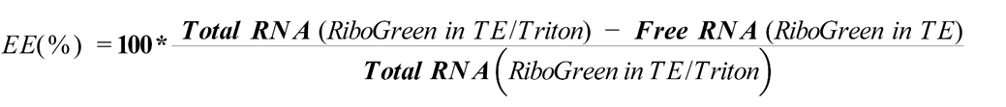

In vitro saRNA transfections
All cell lines were maintained at 37°C with 5% CO2, using established culture conditions.

Adherent cell culture
HEK 293T/17 and HeLa cells were cultured in Dulbecco's Modified Eagle Medium (DMEM) (Gibco, Thermo Fisher, UK) supplemented with 10% foetal bovine serum (FBS) (v/v), 1% l-glutamine (v/v), and 1% penicillin/streptomycin (v/v) (Thermo Fisher, UK). Cells were routinely passaged by washing with DPBS, detachment with trypsin (TrypLE Express 1×) (Gibco, UK), and re-seeding in fresh complete medium.
hSkMCs were cultured in Skeletal Muscle Cell Growth Medium (PromoCell, Germany) supplemented with SupplementMix (PromoCell, Germany). Cells were passaged by washing with DPBS, trypsinisation, and trypsin neutralisation with a 10% FBS solution in DPBS. Cells were centrifuged and resuspended in fresh medium.

Suspension cell culture
THP-1 cells were cultured in RPMI-1640 medium (Sigma, UK) supplemented with supplemented with (Gibco, Thermo Fisher, UK) supplemented with 10% foetal bovine serum (FBS) (v/v), 1% l-glutamine (v/v), and 1% penicillin/streptomycin (v/v) (Thermo Fisher, UK). For passaging, cell suspensions were collected, centrifuged, and the pellet resuspended in fresh medium.
In a 96-well plate, 50x10⁴ cells/well HEK293T cells, 4x10⁴ cells/well HeLa, 1x10⁴ cells/well hSkMC or 1x10⁶ cells/well THP-1 cells were seeded in 100 µL media and incubated at 37°C and 5% CO₂ for 24 h to allow attachment to the bottom of the wells.
For the transfection, media were completely removed and replaced with pre-warmed transfection medium (DMEM with 1% l-glutamine). saRNA formulations (100ng saRNA equivalent) were added to each well and allowed to incubate for 24h. For THP-1, cells were centrifuged after 24 h for 2 min at 500 g and 100μL of supernatant removed and stored at -80°C for cytokine analysis. Remaining transfection samples were assessed by luciferase assays. To assess transfection efficiencies of fLuc suprapolyplexes in cells, 1:1 (v/v) Bright-Glo™ luciferin substrate (Promega, UK) was added to wells. After 5 min, the treated samples were transferred to white 96-well plates (Falcon®, US), and luminescence intensities were recorded using a FLUOstar Omega plate reader (BMG LABTECH, UK).

In vivo assays

mRNA biomarker expression assay in orthotopic Triple Negative Breast Cancer model
Experiments were conducted under the UK Home Office Licence number PPL P435A9CF8. LASA good practice guidelines, FELASA working group on pain and distress guidelines and ARRIVE reporting guidelines were also followed. For the biomarker expression experiments, 6-7 week-old female immunodeficient CD-1 NuNu mice were purchased from Charles River UK. Mice were maintained in individually ventilated cages (Tecniplast UK) within a barriered unit, illuminated by fluorescent lights set to give a 12-hour light-dark cycle (on 07.00, off 19.00), as recommended in the guidelines to the Home Office Animals (Scientific Procedures) Act 1986 (UK). The room was air-conditioned by a system designed to maintain an air temperature range of 21 ± 2 °C and a humidity of 55 ± 10 %. Mice were housed in social groups, 3 per cage, during the study, with irradiated bedding and autoclaved nesting materials and environmental enrichment (Datesand UK). Sterile irradiated 5V5R rodent diet (IPS Ltd, UK) and irradiated water (SLS, UK) were offered ad libitum. The condition of the animals was monitored throughout the study by an experienced animal technician. After a week’s acclimatisation, the mice were split into 2 groups of 3 mice per group and initiated with tumours with either MDA-MB2321fluc or MDA-MB231 wt cells as below:
The cells were maintained in vitro in RPMI culture medium (Sigma, UK) containing 10 % (v/v) heat inactivated fetal bovine serum (Sigma, Poole, UK) and 2 mM L-glutamine (Sigma, UK) at 37 °C in 5 % CO₂ and humidified conditions. Cells from sub-confluent monolayers were harvested with 0.025 % EDTA, washed in culture medium and counted. Cells with viability of > 90 % were re-suspended and seeded at 2x10⁶ cells per T150 flask and incubated for 48 hours. On day of initiation, cells were harvested from semi-confluent monolayers with 0.025 % EDTA, washed twice in the culture medium and counted 3 times. Cells with viability of > 90 % were re-suspended for in vivo administration in growth-factor reduced matrigel at 2 x 10⁶ cells/mL for injection of 100 μL into the left mammary fat pad just inferior to the nipple. Tumour establishment and growth was monitored during the experiment by 2D optical imaging, carried out under anaesthesia in an IVIS Spectrum weekly, and were also measured by Vernier callipers (Camlab) twice weekly and animals weighed weekly. The tumour volumes were calculated using a standard volume formula as previously reported (tumour volume = ½ (length × width²). Dosing (20 μL, intratumourally) commenced on day 26 when the tumours had reached a suitable size as established by calliper measurement and bioluminescent imaging, average diameters around 6 mm. Expression of mRNA was monitored via optical imaging prior to injection, then at 24, 72 and 1 week post-administration at an excitation wavelength of 542 – 582nm and an emission wavelength of 603-678, with study termination 1-2 weeks post-injection, depending on tumour size and condition. For all mice, tumours were excised and imaged ex vivo, then collected as snap-frozen and formalin fixed (half each).

In vivo saRNA studies
Female, 6-8 week old, C57BL/6J or BALB/c specific-pathogen-free (SPF) mice were purchased from Charles River Laboratories (UK) and maintained according to institutional and United Kingdom Home Office guidelines. All experiments were performed in the SPF room in the animal facility on a 12-h light/dark cycle (on 07.00, off 19.00) at 20-24°C with 55% ± 10% humidity. All work was approved by the Animal Welfare and Ethical Review Board at Imperial College London, and studies were in accordance with the Animal Research: Reporting of In vivo Experiments (ARRIVE) guidelines. Mice were housed in social groups, 5 per cage (unless otherwise stated) in fully ventilated cages with heat treated Apsen Chip 2 bedding (Datesand, UK) and autoclaved nesting materials (LBS, UK) and environmental enrichment (Datesand UK). Sterile irradiated Teklad Global rodent maintenance diet (Envigo/Inotive) and RO water were offered ad libitum. The condition of the animals was monitored throughout the study by an experienced animal technician. All studies were performed following an acclimatisation period of one week. Experiments were conducted under the UK Home Office Licence number PPL PP5168779.

In vivo gene expression studies
C57BL/6J mice were injected intramuscularly with TETA-3L2-CB[8] or C12-200 formulations containing 1.5µg fLuc saRNA in 50 µL volumes: naïve mice received 50 µL PBS. Mice were weighed over 72 h to monitor reactogenicity to formulations. At each imaging timepoint (d1 and d2) mice were dosed via intraperitoneal (i.p.) injection with 100 µL IVISbrite D-Luciferin bioluminescent substrate (Revvity, UK). After 10 minutes mice were anaesthetised with vaporised isoflurane and placed in an Ami HT spectral imager (Spectral Instruments Imaging) and bioluminescence was recorded.

Multiplex cytokine analysis
Cytokines from serum were assessed using a custom 10-spot U-Plex mouse kit from Meso Scale Discovery (MSD). The concentrations of 9 analytes (IFN-α, IFN-β, IFN- γ, IL-5, IL-6, KC/GRO, MCP-1, CXCL10 and TNF) were assessed.

In vivo immunisation studies
BALB/c mice were i.m. injected in the right anterior tibialis with TETA-3L2-CB[8] formulations containing HA saRNA (50 µL, 200μg.mL⁻¹ = 1 μg saRNA) or sterile PBS (50 µL) in a prime-boost regimen with a 4-week interval between immunisations.

Infection Challenge
At a time-point of 4-weeks after boost immunisation, mice were challenged with 2.5 x 10⁵ pfu of H1N1 A/California/07/2009 influenza virus resuspended in 100µL of PBS. Virus solution was placed onto their noses which was then inhaled. This was performed on unconscious mice after being anaesthetised with vaporised isoflurane. Mice were weighed at the time of challenge and each day thereafter. Mice were regularly monitored and were culled (non-schedule 1) via overdose, by intraperitoneal administration of pentobarbital to ensure they did not surpass the severity limit of the experiment, and cull-confirmed by terminal bleed.

Tissue dissection and sample collection
Blood samples were collected 4 weeks after each dose was administered, serum was extracted and stored at -80ºC for ELISA analysis. The right lung lobe was harvested and stored and stored at -80°C for qPCR analysis. The left lung lobe was harvested and processed immediately for flow-cytometry analysis. Briefly, lungs were manually homogenised then passed through 100 μm cell strainers. Lung cells were then centrifuged at 500 x g for 5 min and supernatants removed before treatment with red blood cell lysis buffer (ACK; 0.15 M ammonium chloride, 1 M potassium hydrogen carbonate, and 0.01 mM EDTA, pH 7.2) (Gibco, UK). To remove lysis buffer, cells were washed with RPMI-1640 and centrifuged at 200 x g for 5 min before final resuspension in complete RPMI-1640. Cell concentrations and viability were determined by trypan blue exclusion.

Anti-HA specific IgG ELISA
A semiquantitative immunoglobulin ELISA was conducted by coating 96-well ELISA microplates (Nunc, Rochester, NY) with 1 µg/mL H1N1 Cal/09 influenza A capture antigen (Sino Biological) and anti-mouse Kappa (1:1000) and Lambda (1:1000) capture antibodies (standards) (Novus Biologicals) diluted in PBS and incubated overnight at 4°C. Plates were washed with PBS and Tween-20, then blocked with an assay buffer containing 1% (w/v) BSA and 0.05% (v/v) Tween-20 in PBS for 1 hour at 37°C, followed by another wash. Diluted serum samples and 5-fold serial dilutions of purified anti-mouse IgG standard (Southern Biotech), starting at 1000 ng/mL, were added to the wells and incubated at 37°C for 2 hours, then washed again. The bound antibodies were detected using a 1:5000 dilution of anti-mouse IgG-HRP, incubated at 37°C for 1 hour, and washed once more. The plates were developed using TMB, and the reaction was stopped after 5 minutes with H₂SO₄. (50 μL, 1M) Absorbance was measured using a VersaMax spectrophotometer (Molecular Devices) and analysed with SoftMax Pro GxP v5 software.

T cell phenotyping
Lung cells were plated in a U-bottom 96-well plate and centrifuged at 500 x g for 2 minutes at 4°C. Cells were stained with 100 μL of Live/Dead violet dye (BioLegend, Catalog: 423113) and incubated for 20 min at 4°C in the dark. After centrifugation at 500 x g for 2 minutes, supernatants were removed. Cells were resuspended in Fc block (Anti-CD16, BD, Catalog: 6266549) in PBS with 1% BSA for 20 minutes, followed by staining with surface antibodies: CD3 (Biolegend Catalog: 100204), CD4 (BD, Catalog: Invitrogen 45-0042-82), CD8 (BD, Catalog: 560182) for 1 hour at room temperature in the dark. Excess antibodies were washed off with 1% BSA in PBS, and the cells were filtered through fluorescence-activated cell sorting tubes. Flow cytometry was performed on an LSR Fortessa (BD), and data analysis was conducted using FlowJo software. Fluorescence minus one (FMO) controls were used for surface staining analysis.

qRT-PCR
Lung tissue was homogenized in Trizol using a TissueLyzer (Qiagen, Manchester, UK) instrument at 50 oscillation for 4 minutes. RNA was extracted from homogenates using Trizol/chloroform extraction. Total RNA concentrations and purity were determined using a NanoDrop One (ThermoFisher, UK) spectrophotometer. All RNA samples were normalised to 200 ng/µL and converted into cDNA using a GoScript reverse transcription system (Promega, UK). qRT-PCR was performed for the influenza M gene on a Stratagene Mx 3005p (Agilent technologies, Santa Clara, CA, USA) instrument, using primers 5′- AAGACAAGACCAATYCTGTCACCTCT-3′ and 5′- TCTACGYTGCAGTCCYCGCT -3′ and probe 5′-FAM-TYACGCTCACCGTGCCCAGTG-TAMRA-3’. M gene-specific RNA copy number was determined against an Influenza M gene standard.

Supporting Schemes and Figures
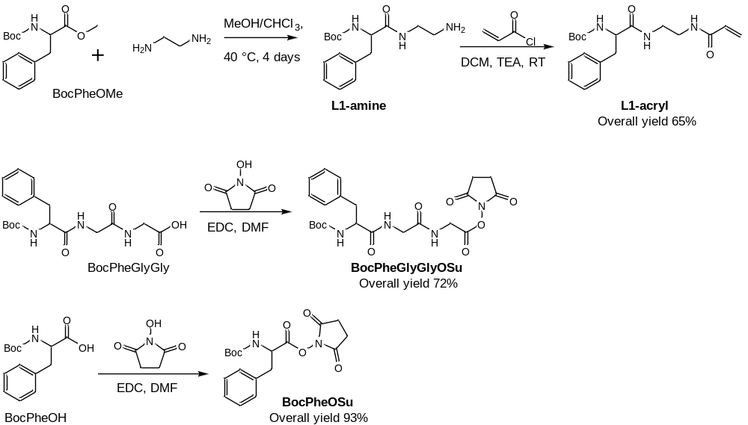
Scheme S1. Synthesis of precursors to supramolecular monomers

.
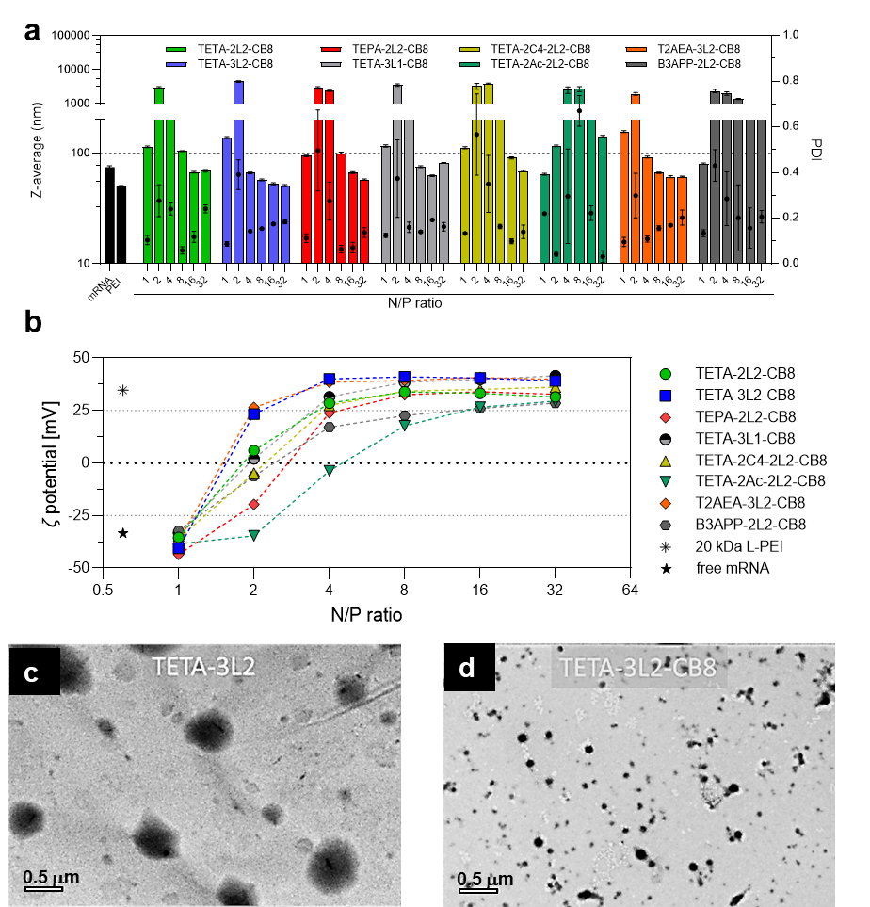
Figure S 1. (a) Characterisation of mRNA polyplex nanoparticles formed with non-capped fLuc mRNA (30 μg/mL) and synthesised monomers in the presence of 0.5 eq of CB[8] in 25 mM sodium acetate buffer pH 5.5 at different N/P ratio; (a) Z-average diameter (bars) and PDI (dots), (b) ζ-potential in 25 mM NaOAc pH 5.5. (c,d) TEM images of the nanoparticles formed with fLuc mRNA (30 μg/mL), and (c) the monomer TETA-3L2 or (d) the supramolecular polymer TETA-3L2-CB[8] in 25 mM sodium acetate pH 5.5 at N/P = 4 (scale bar: 500 nm).

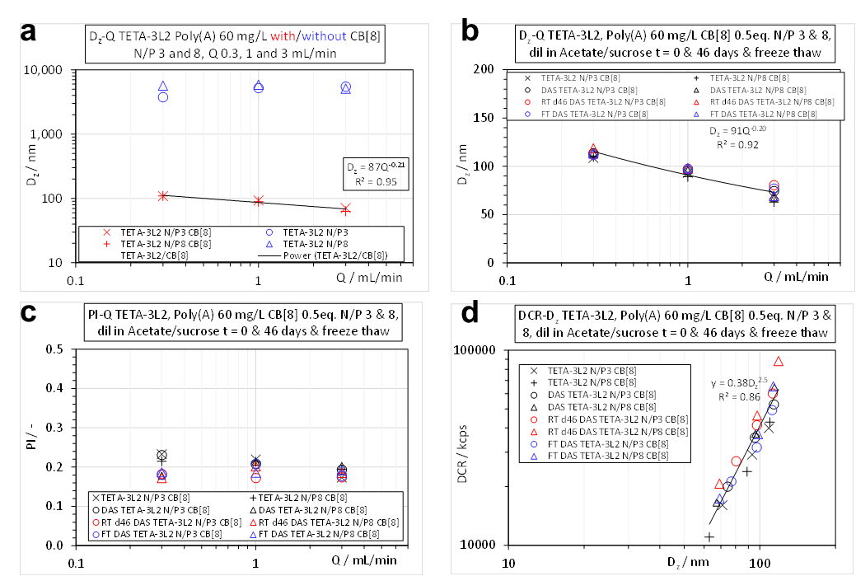
Figure S 2. (a) Particle sizes determined by DLS of TETA-3L2 formulations with polyA as mRNA analogue, prepared with and without CB[8] at different volumetric flow rate, Q. (b-d) Critical quality attributes, for TETA-3L2/Poly(A) suprapolyplexes, parent and after 1:1 v:v dilution with 20 mM acetate buffer pH 5.5 and 10% sucrose: (b) z-average diameter (D_{z}), (c) polydispersity index (PI) and (d) derived count rate (DCR) at 30 mg/L Poly(A) equivalent. Lines in (b) and (d) are power-law fits to all data plotted. Measurements after 46 days at room T (RT, ~20°C) or following freeze-thaw (FT).

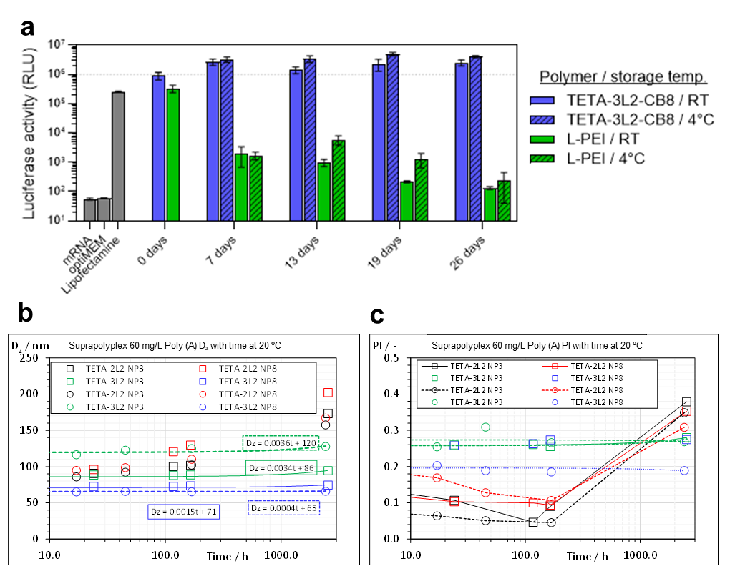
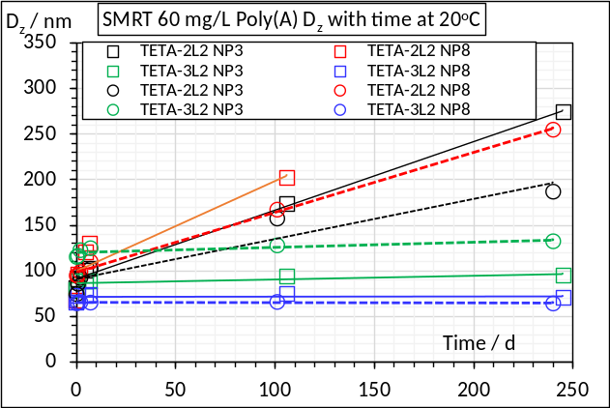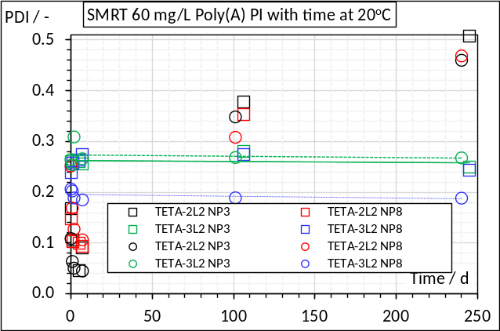
Figure S 3. (a) Functional stability of suprapolyplexes formed with fLuc mRNA and TETA-3L2-CB[8] at N/P = 4 demonstrated via successful luciferase expression in HEK293T cell line after storage at 4°C or room temperature for 26 days, in contrast to polymer comparator L-PEI. In (b, c), the physical properties of supramolecular polyplexes prepared at 60 mg/L with poly(A) and stored for different times are shown (squares and circles, corresponding to preparations made at different times). TETA-2L2 N/P 3 (black) and N/P 8 (red), and TETA-3L2 N/P 3 (green) and N/P 8 (blue) to 240 days at room temperature (~20°C). (b), z-average diameter, D_{z}, with linear fits to the TETA-3L2 data (c) - Polydispersity index, PDI, with linear fits to the TETA-3L2 data.

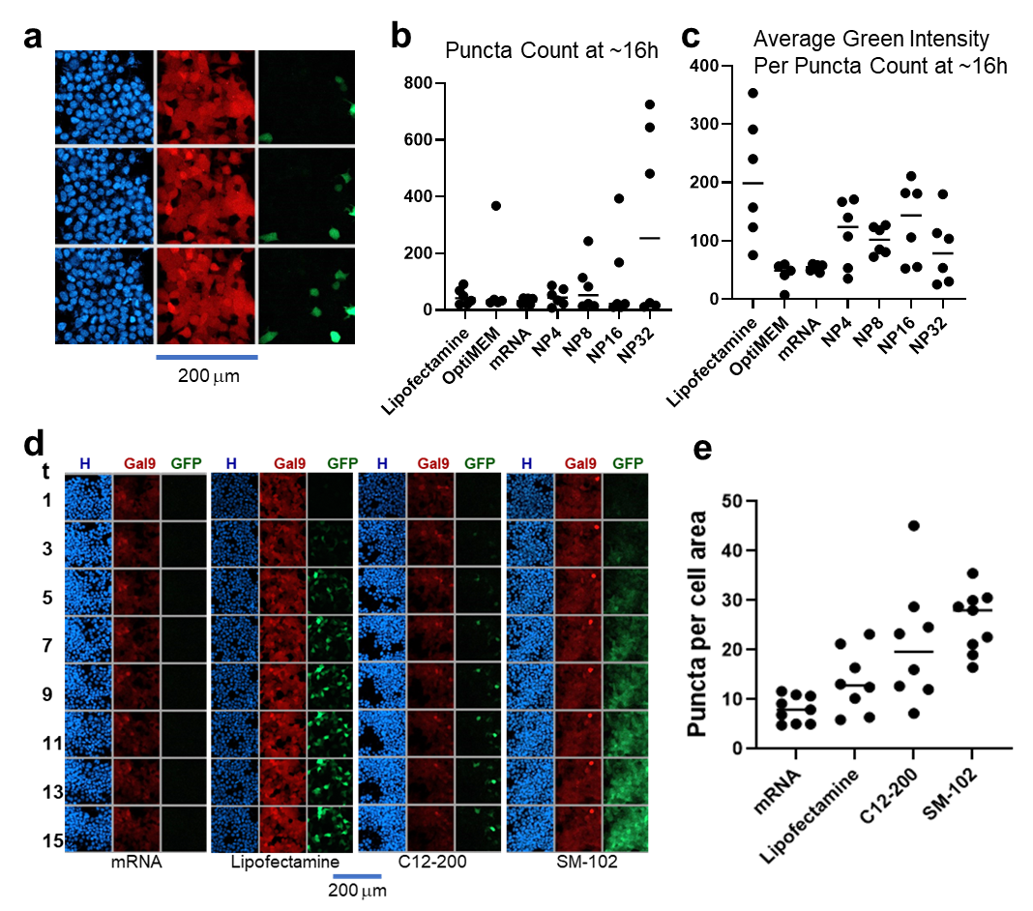
Figure S 4. (a) Representative fluorescence micrographs of mCherryGal 9 HEK293T cells treated with supra-polyplex formulations of TETA-3L2-CB[8] and eGFP mRNA. In (b) the total number of localised Gal-9 puncta, indicative of endosomal membrane damage, is given for cells treated with Lipofectamine, Opti-MEM and mRNA controls, and TETA-3L2-CB[8]-eGFP mRNA at 16 hr, while in (c) is shown the average intensity from the green channel (eGFP signal) per puncta, as a measure of Gal-9 endosomal recruitment and transfection for the same formulations at the same timepoint. In (d) fluorescence micrographs of mCherryGal 9 HEK293T cells treated with comparator delivery agents (lipofectamine, C12-200 and SM102 ionisable lipids), indicate transfection was most rapid and to a greater extent in SM102 formulations, but again with no definitive trend of increased transfection with endosomal damage. In (e) average number of puncta per cell area at the same timepoint as in (b-d). Key for micrographs: H = Hoechst, Gal9 = mCherry Gal9 and GFP = expressed eGFP. Scale bars 200 mm
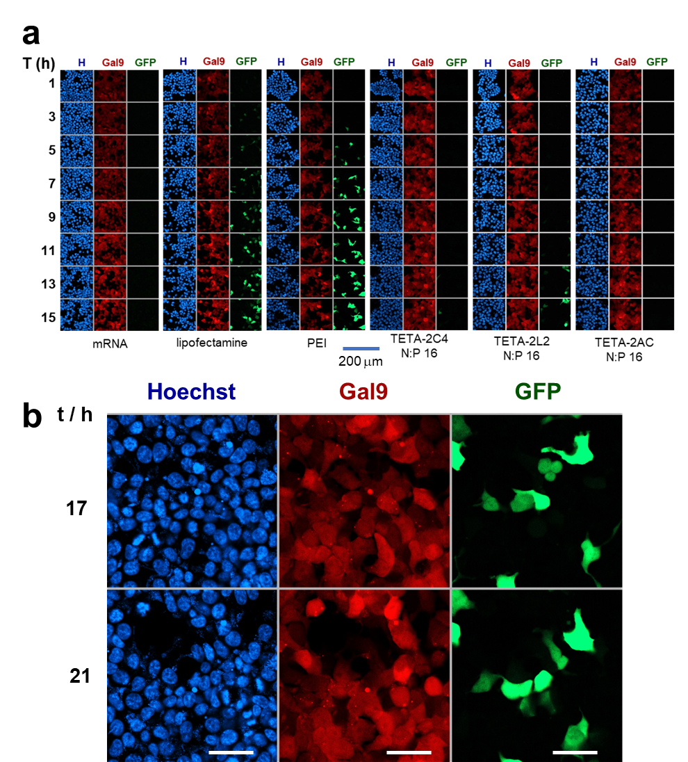
Figure S 5. Fluorescence micrographs of mCherryGal 9 HEK293T cells treated with formulations of eGFP mRNA with TETA-2L2-CB[8], TETA-2Ac-2L2-CB[8], TETA-2C4-2L2-CB[8] and comparator lipid and polycation formulations over time. In (b) are shown higher magnification fluorescence micrographs of mCherryGal 9 HEK293T cells treated with supra-polyplex formulations of TETA-3L2-CB[8] and eGFP mRNA formulations after 17 and 21 hours. Scale bar = 50 mm.
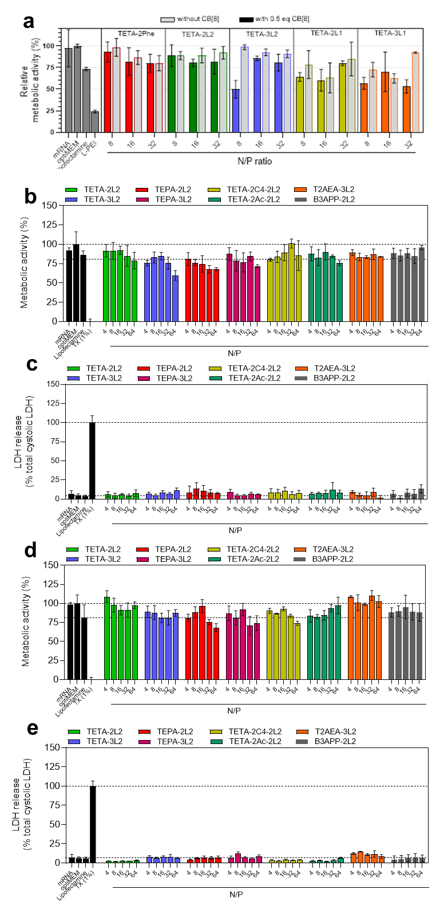
Figure S 6. Metabolic activity as measured by Presto Blue assays for suprapolyplexes from supramolecular monomer shown + CB[8] in (a) HEK 293T b) MDA-MB-231 and d) MDA-MB-468 cells. Membrane damage assays as measured by LDH release are shown for (c) MDA-MB-231, and (e) MDA-MB-468 cells.
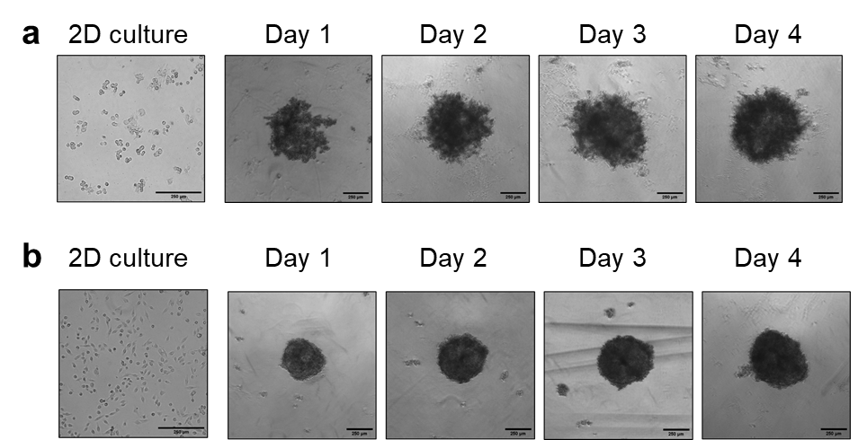
Figure S 7. Phase contrast microscopy of (a) MDA-MB-231 cells in 2D culture and spheroid growth for 4 days, and (b) MDA-MB-468 cells in 2D culture and spheroid growth for 4 days, Scale bars = 250 mm

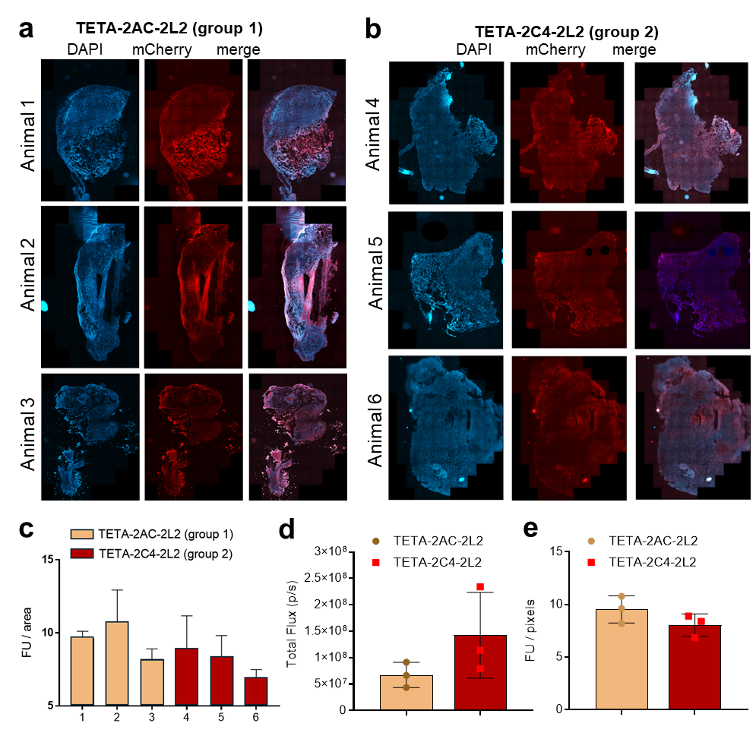
Figure S 8. (a,b) Images of tumour sectioning. Quantification of intratumoural mCherry signal (mRNA transfection) for (c) individual animals, (d) the total flux and (e) averaged values for treatments. Tumours sectioned at 4 points within tumour, mounted and stained with DAPI (Blue). Sections imaged using SlideScanner for mRNA transfection (mCherry, Red) at x25 magnification.

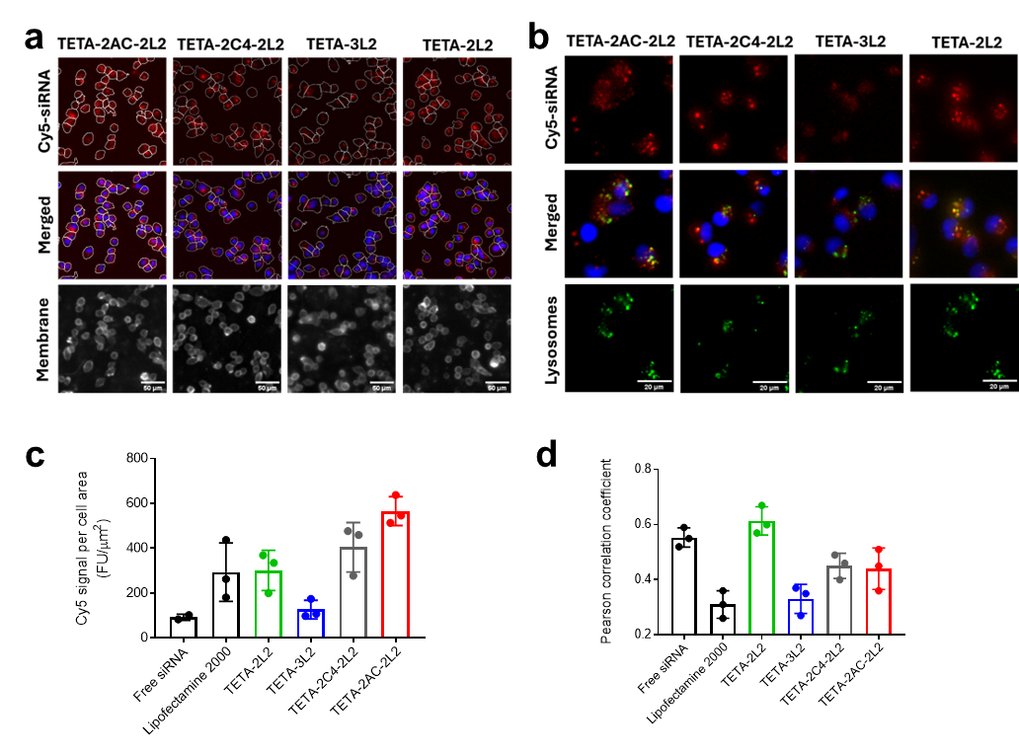
Figure S 9. In (a, b) are shown siRNA uptake studies performed in MDA-MB-231 cells. Formulations dosed for 24 hours with 40 nM siRNA; 20% Cy5-tagged scrambled siRNa, 80% fLuc siRNA. Cells stained with Hoechst 33342 for nuclei, CellMask Orange for plasma membrane staining and Lysotracker Green for lysosomes. Bar chart represents triplicate values from same experiment. In (c,d) are bar chart representations of total RNA (as measured by Cy5 signal) per cell and Pearson correlation coefficients for the Cy5 and Lysosomal channels (triplicate values from the same experiments). Scale bar a) 50 μm and b) 20 μm.

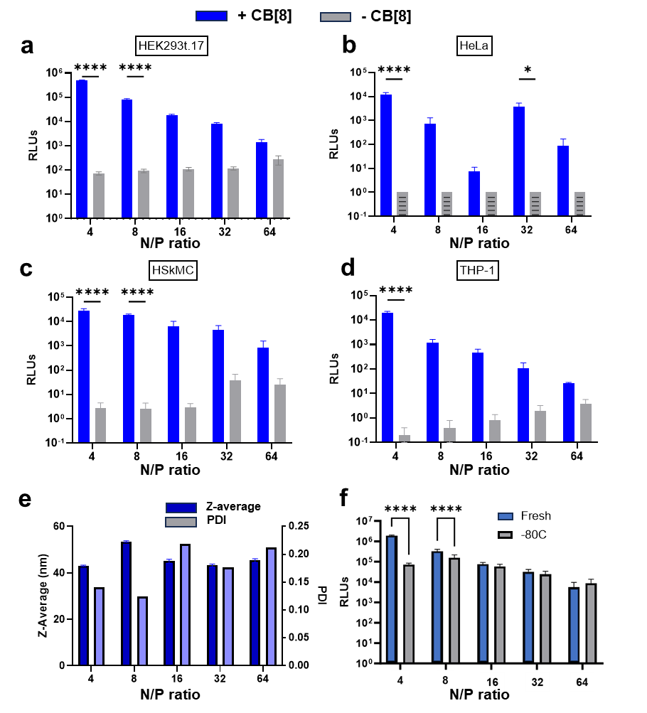
Figure S 10. TETA-3L2 CB[8] saRNA CB[8] suprapolyplexes transfect different cell lines. Transfection assays with 100 ng saRNA TETA-3L2 CB[8] formulations with firefly luciferase (fLuc) encoding saRNA +/- CB[8] at N/P ratios ranging from 4 to 64 for 24h and gene expression measured by luciferase assay. Transfection of HEK293T.17 (a), HeLa (b, patterned grey bars indicate no measurable gene expression), HSkMC (c) and THP-1 cells (d). Bars represent mean ± SEM (n = 5). Statistical significance was calculated by Two-way ANOVA with Šídák's multiple comparisons test (*p<0.05, ****p<0.0001). Particle size and polydispersity index of TETA-3L2 CB[8] saRNA CB[8] suprapolyplexes meet critical quality attributes for RNA nanoparticle formulations (e), and with no loss of transfection efficacy at N:P > 8 after storage at -80 °C (f).

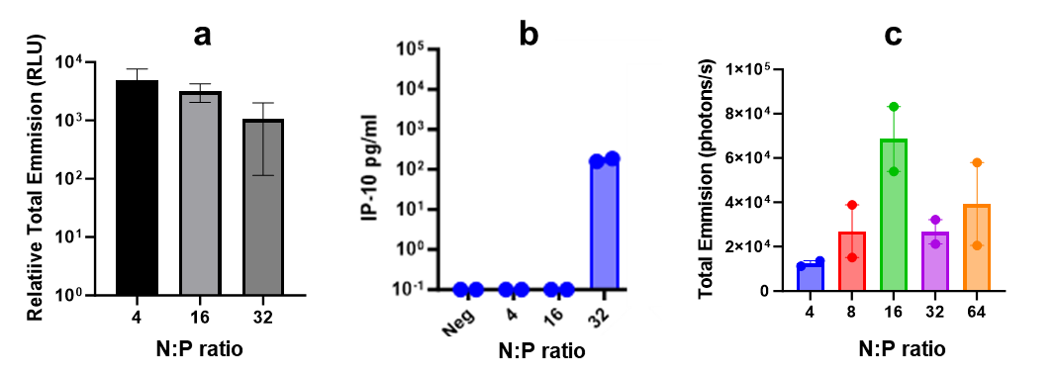
Figure S 11. (a) TETA-3L2 CB[8] suprapolyplexes with fLuc saRNA (freeze-thawed) transfect THP-1 cells at N/P 4, 16, 32. Following transfection with 1μg saRNA for 48 hours, supernatant collected for IP-10 ELISA (inflammation) quantified in (b). Luminescence from skin tissue after TETA-3L2 CB[8] suprapolyplexes with fLuc saRNA (freeze-thawed) at N/P 4, 16, 32, 64 at 20μg/mL saRNA were formulated in water and 10% sucrose, 10mM HEPES and injected into skin (1mg of saRNA) in serum-free media (c).

Supplementary Table
Table S1: CQA of preparations of three oligomers and mixtures thereof at 60 mg/L Poly(A) and N/P 3 and 8. Top, initial characteristics and Bottom, changes after 14 days held at 4°C.
 | N/P 3 |  |  | N/P 8
Oligomer | D_{z} / nm | PI | DCR / kcps | D_{z} / nm | PI | DCR / kcps
A TETA-2L2 | 79 | 0.09 | 1.1E+05 | 89 | 0.08 | 8.9E+04
B TETA-3L2 | 48 | 0.18 | 3.2E+04 | 41 | 0.22 | 1.9E+04
C TETA-2C4-2L2 | 66 | 0.10 | 8.7E+04 | 59 | 0.17 | 4.4E+04
AB TETA-2L2,3L2 | 54 | 0.15 | 4.4E+04 | 37 | 0.17 | 1.5E+04
BC TETA-3L2, TETA-2C4-2L2 | 53 | 0.19 | 3.8E+04 | 42 | 0.19 | 1.9E+04
AC TETA-2L2, TETA-2C4-2L2 | 59 | 0.08 | 6.1E+04 | 48 | 0.11 | 2.8E+04
ABC TETA-2L2, TETA-3L2, TETA-2C4-2L2 | 51 | 0.17 | 3.4E+04 | 44 | 0.15 | 2.3E+04

 | N/P 3 |  |  | N/P 8
Oligomer | D_{z,14}/D₀ | PI₁₄-PI₀ | DCR₁₄/DCR₀ | D_{z,14}/D₀ | PI₁₄-PI₀ | DCR₁₄/DCR₀
A | 1.4 | 0.03 | 1.5 | 1.5 | 0.01 | 1.5
B | 1.1 | 0.02 | 1.0 | 1.0 | 0.04 | 1.0
C | 1.1 | 0.02 | 1.0 | 1.0 | -0.01 | 1.0
AB | 1.1 | 0.01 | 1.0 | 1.0 | -0.01 | 1.0
BC | 1.1 | 0.05 | 1.0 | 1.0 | 0.01 | 1.0
AC | 1.1 | -0.03 | 1.4 | 1.4 | 0.01 | 1.4
ABC | 1.1 | 0.00 | 1.1 | 1.1 | 1.1 | 1.1

Individual, 1:1 and 1:1:1 (molar) mixtures of TETA-2L2, TETA-3L2 and TETA-2C4-2L2 (mole ratio of CB[8] to L2 of 0.5) were prepared and mixed with Poly(A) solutions by micropipette to give formulations at 60 mg/L Poly(A) with N/P 3 and 8. The sizes were 35-100 nm, with PI < 0.25 and small particles with low polydispersity (MQA PI < 0.3) and a light-scattering intensity (DCR, direct count rate) that scaled with D_{z}²⁻⁸, consistent with self-similar structures.

Characterisation data for supramolecular monomers
Figure S 12. ¹H and ¹³C NMR (400 MHz, DMSO-d₆) spectrum of TETA-2Phe-Boc (peaks assigned based on NMR COSY, and HSQC spectra).
Figure S 13. ¹H and ¹³C NMR (400 MHz, D₂O) spectrum of TETA-2Phe (peaks assigned based on NMR COSY, and HSQC spectra).

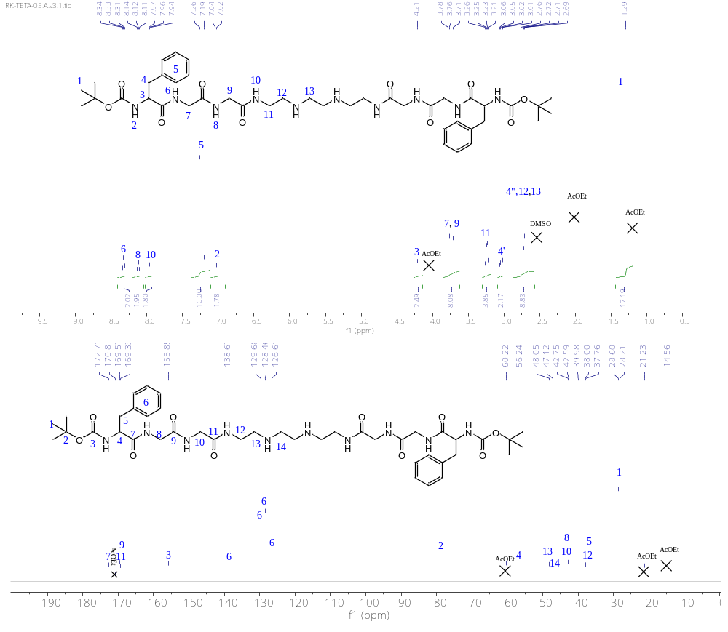
Figure S 14. ¹H and ¹³C NMR (400 MHz, DMSO-d₆) spectrum of TETA-2L2-Boc (peaks assigned based on NMR COSY, HMBC and HSQC spectra).

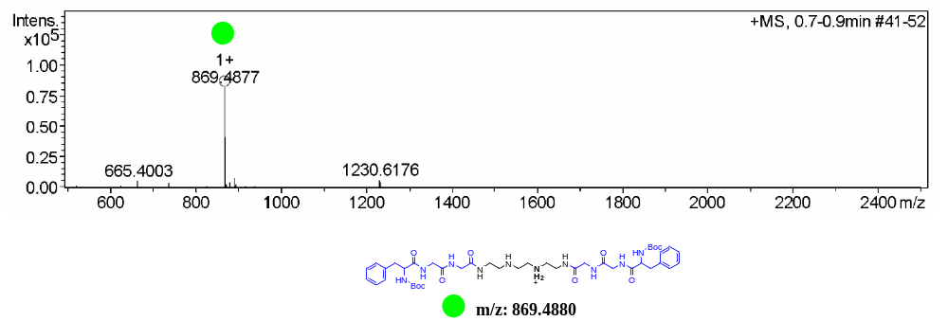
Figure S 15.. HR-MS ESI spectra of TETA-2L2-Boc.

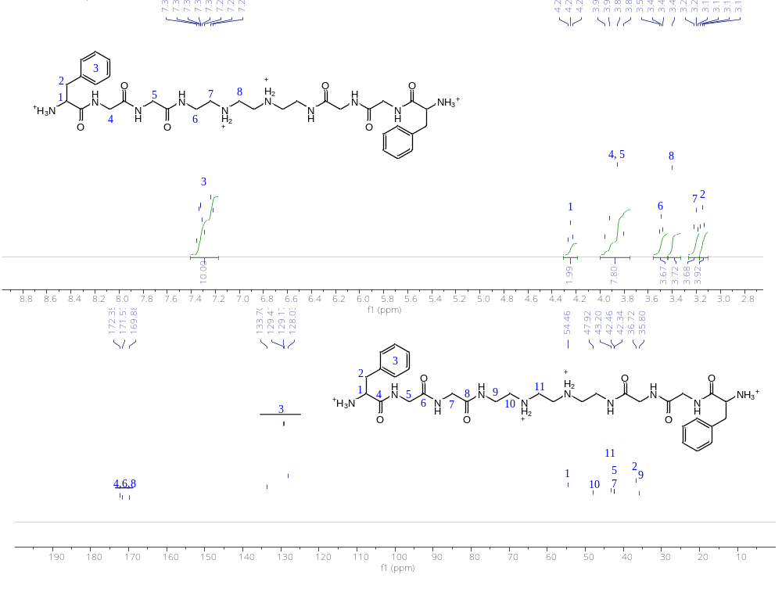
Figure S 16. ¹H and ¹³C NMR (400 MHz, D₂O) spectrum of TETA-2L2 (peaks assigned based on NMR COSY, HMBC and HSQC spectra).
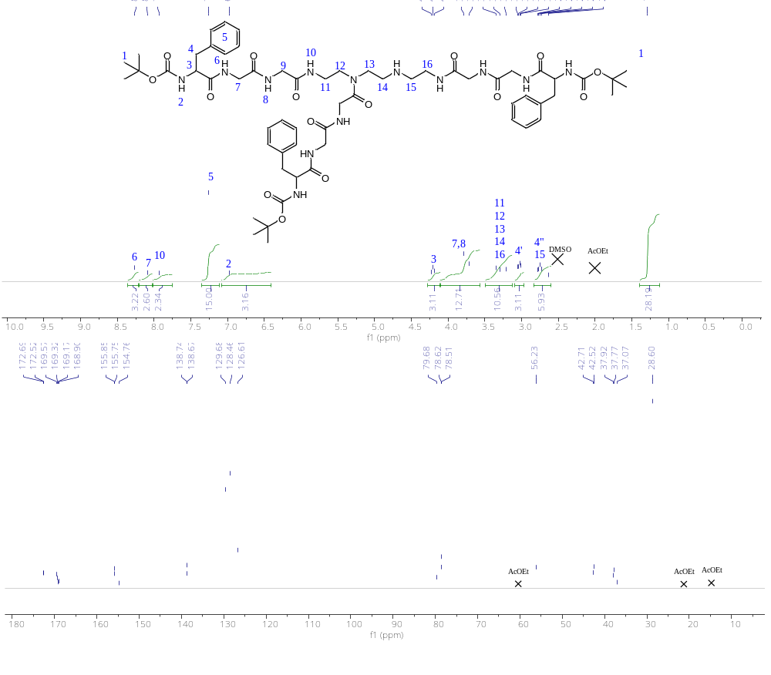
Figure S 17. ¹H and ¹³C NMR (400 MHz, DMSO-d₆) spectrum of TETA-3L2-Boc (peaks assigned based on NMR COSY spectrum).

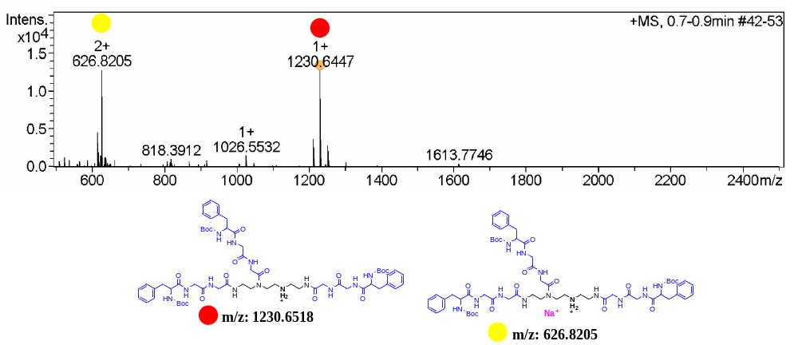
Figure S 18. HR-MS ESI spectra of TETA-3L2-Boc.
Figure S 19. ¹H and ¹³C NMR (400 MHz, D₂O) spectrum of TETA-3L2.

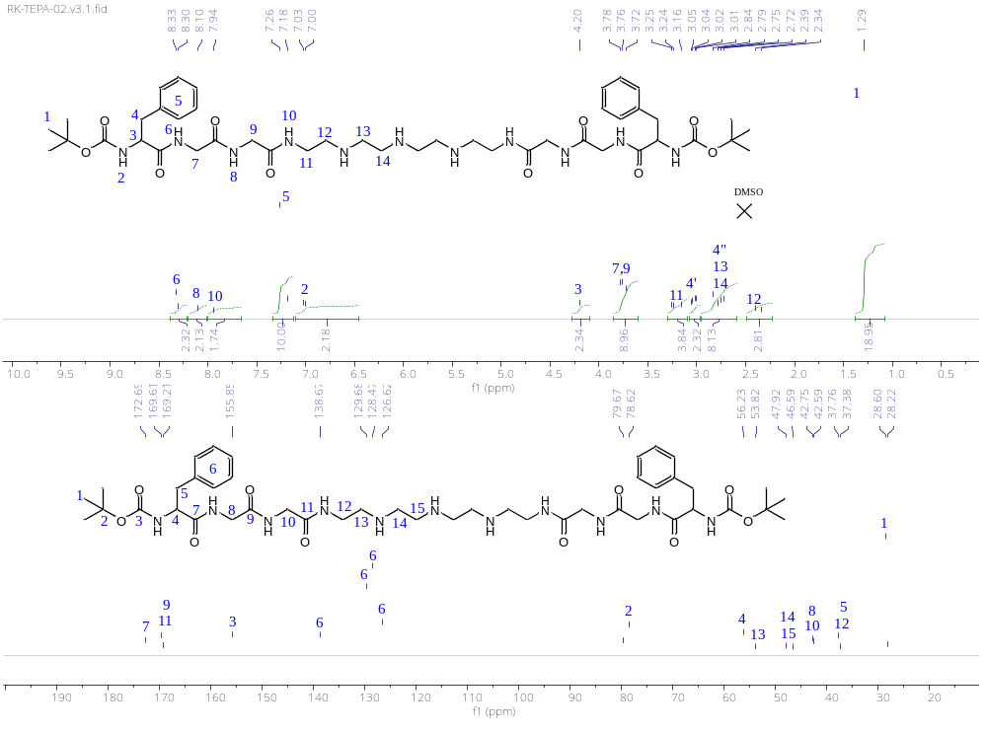
Figure S 20. ¹H and ¹³C NMR (400 MHz, DMSO-d₆) spectrum of TEPA-2L2-Boc (peaks assigned based on NMR COSY, HMBC, and HSQC spectra spectra).

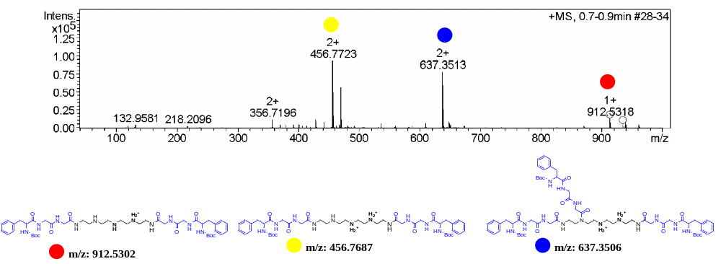
Figure S 21. HR-MS ESI spectra of TEPA-2L2-Boc.
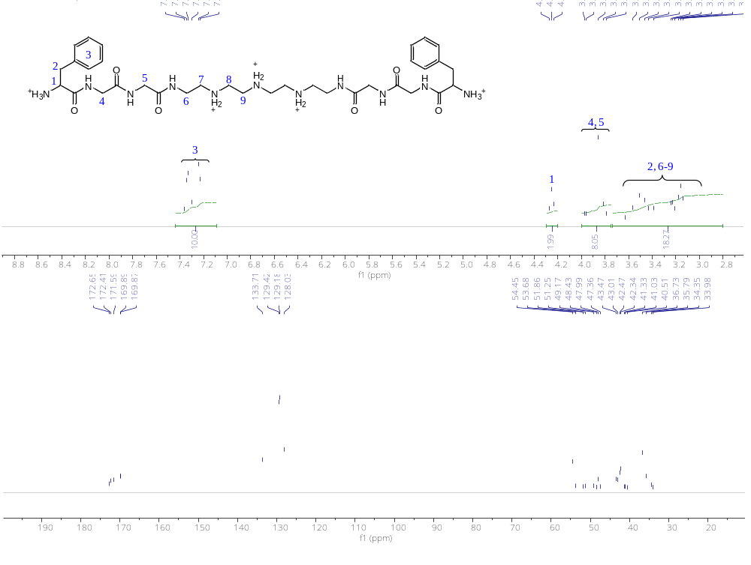
Figure S 22. ¹H and ¹³C NMR (400 MHz, D₂O) spectrum of TEPA-2L2.

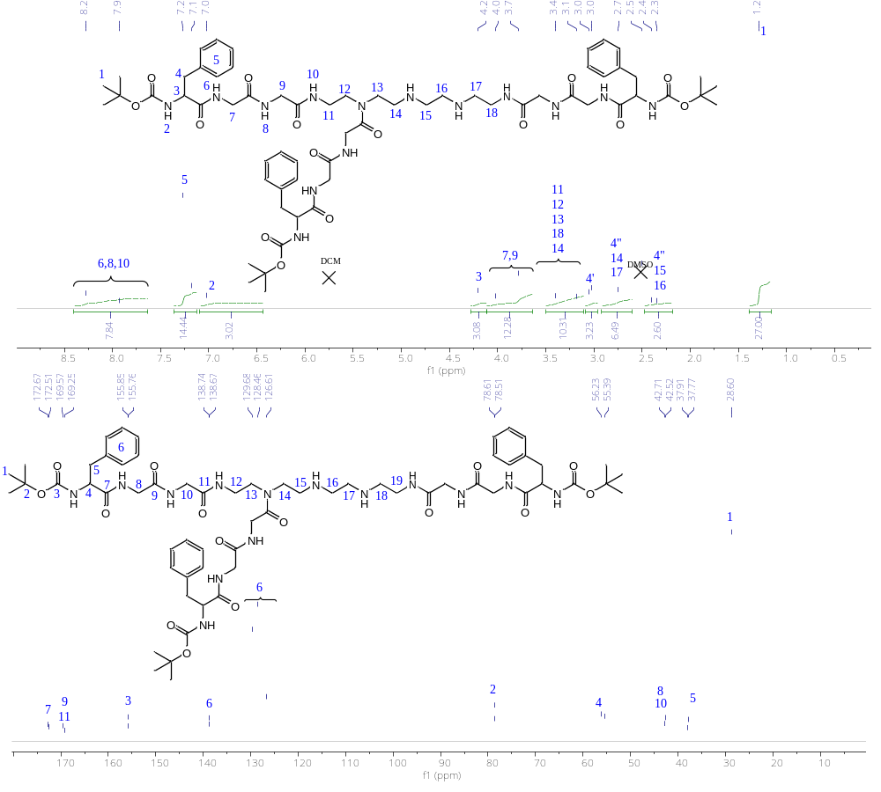
Figure S 23. ¹H and ¹³C NMR (400 MHz, D₂O) spectrum of TEPA-3L2-Boc.

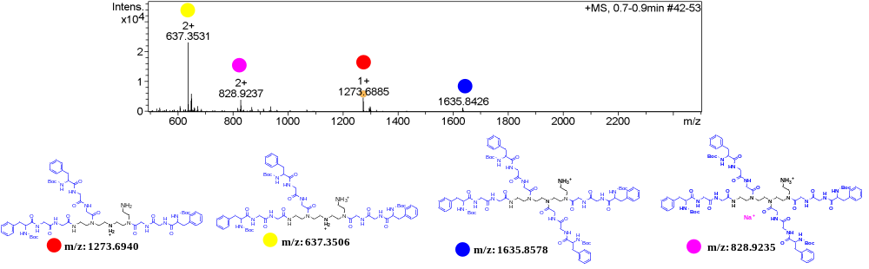
Figure S 24. HR-MS ESI spectra of TEPA-3L2-Boc.

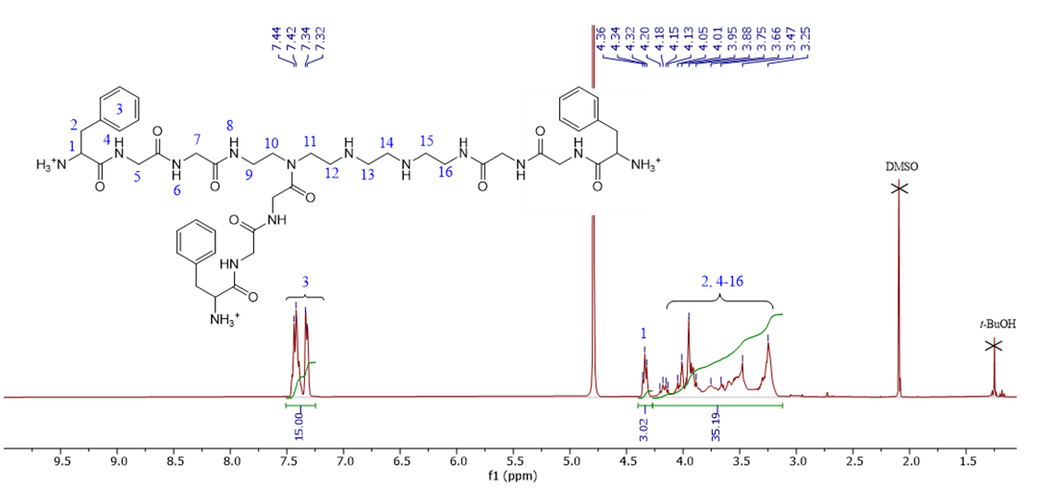
Figure S 25. ¹H and ¹³C NMR (400 MHz, D₂O) spectrum of TEPA-3L2.

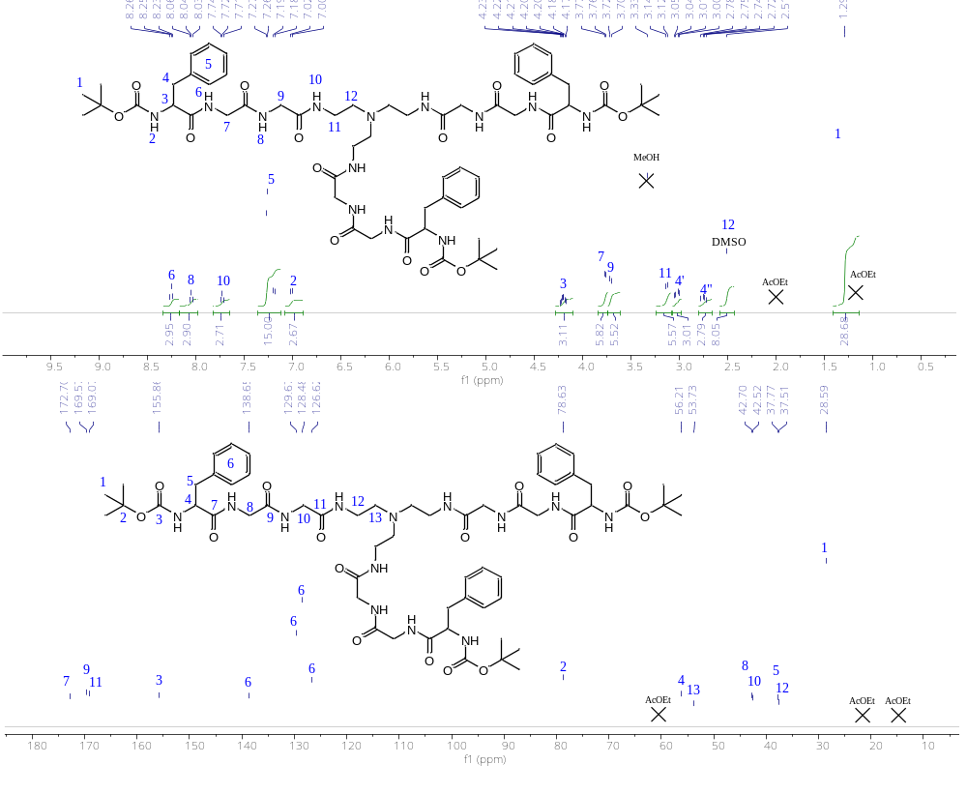
Figure S 26. ¹H and ¹³C NMR (400 MHz, DMSO-d₆) spectrum of T2AEA-3L2-Boc (peaks assigned based on NMR COSY, HMBC and HSQC spectra).

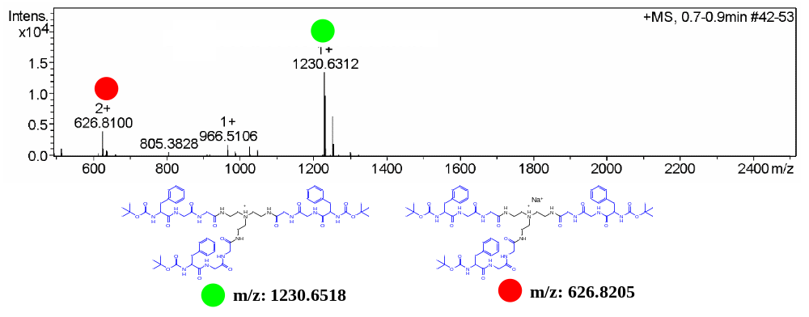
Figure S 27. HR-MS ESI spectra of T2AEA-3L2-Boc.

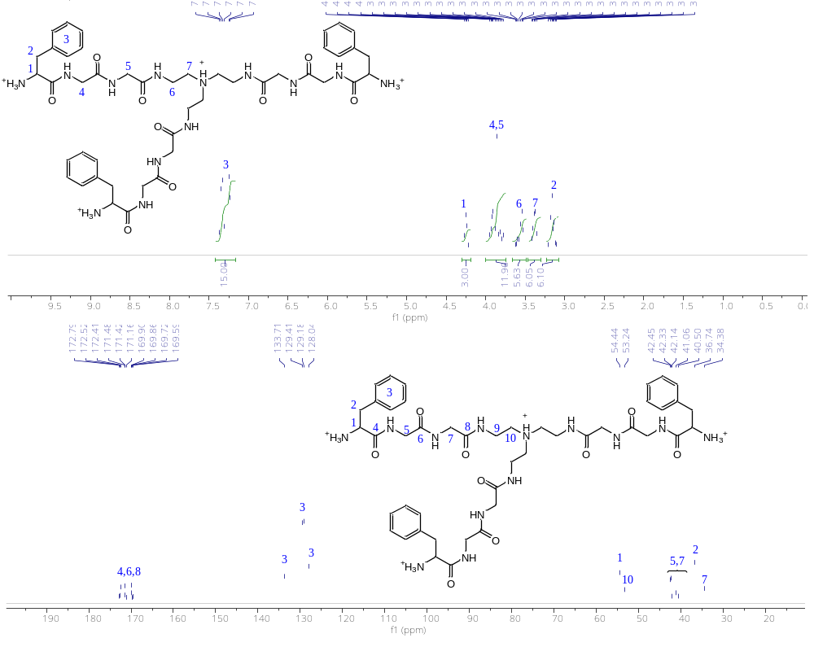
Figure S 28. ¹H and ¹³C NMR (400 MHz, D₂O) spectrum of T2AEA-3L2 (peaks assigned based on NMR COSY, HMBC and HSQC spectra).

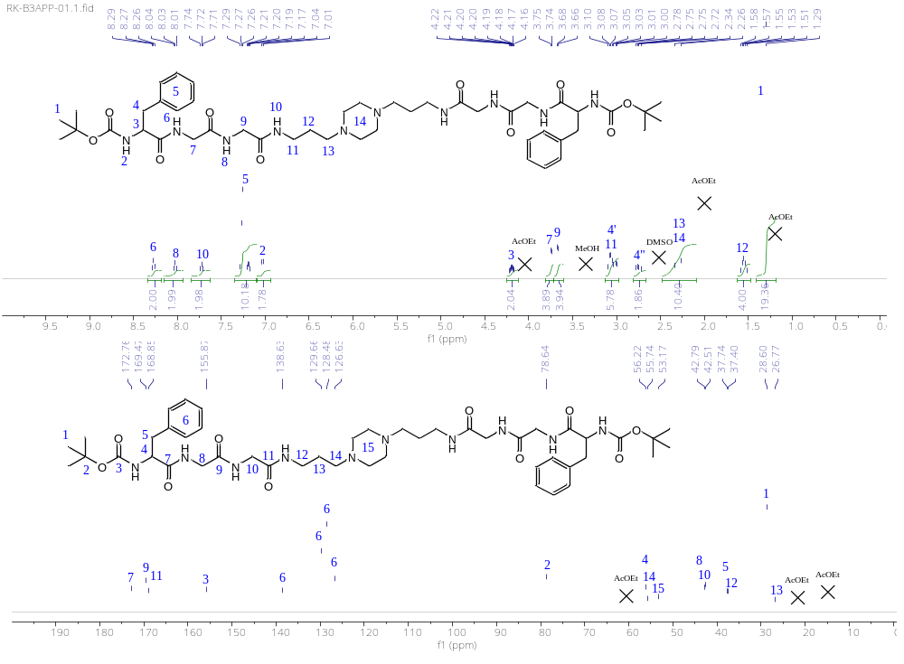
Figure S 29. ¹H and ¹³C NMR (400 MHz, DMSO-d₆) spectrum of B3APP-2L2-Boc (peaks assigned based on NMR COSY, HMBC and HSQC spectra).

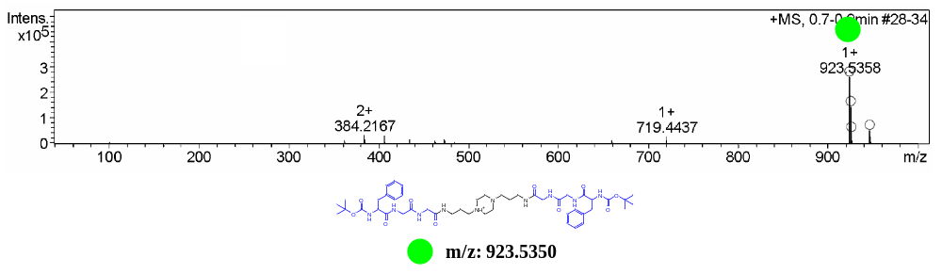
Figure S 30. HR-MS ESI spectra of B3APP-2L2-Boc.

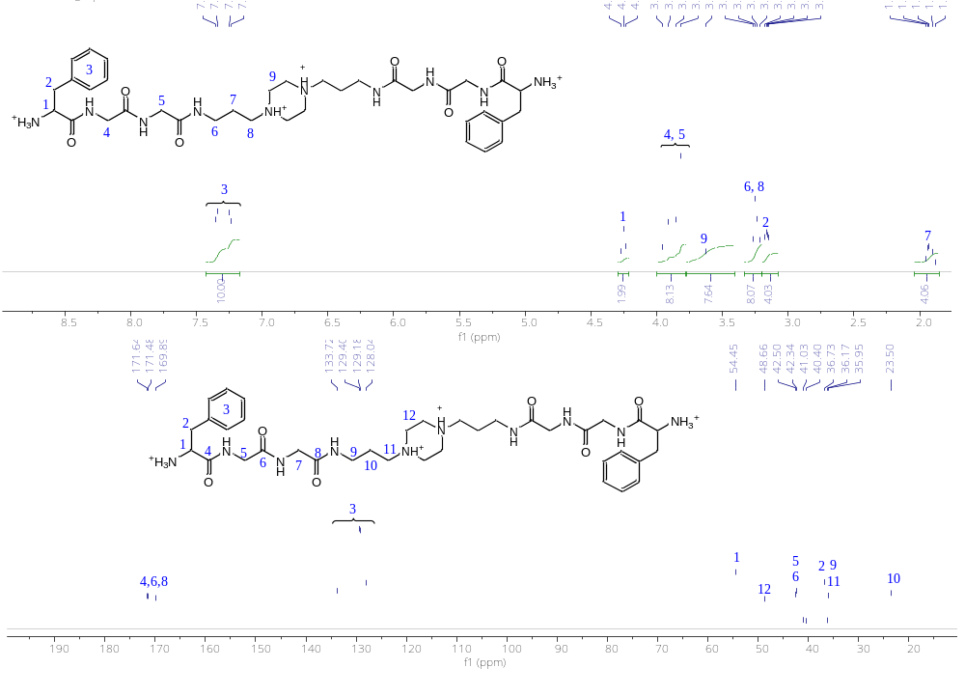
Figure S 31. ¹H and ¹³C NMR (400 MHz, D₂O) spectrum of B3APP-2L2 (peaks assigned based on NMR COSY, HMBC and HSQC spectra).

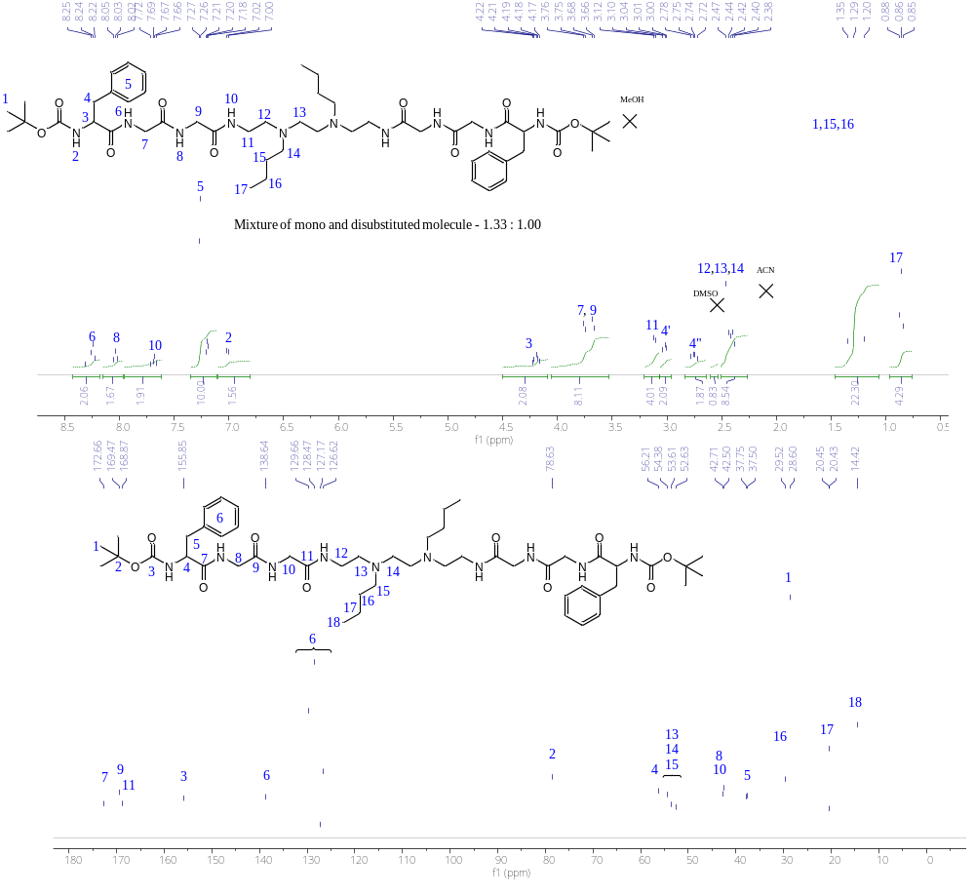
Figure S 32. ¹H and ¹³C NMR (400 MHz, DMSO-d₆) spectrum of TETA-2C4-2L2-Boc (peaks assigned based on NMR COSY, and HSQC spectra).
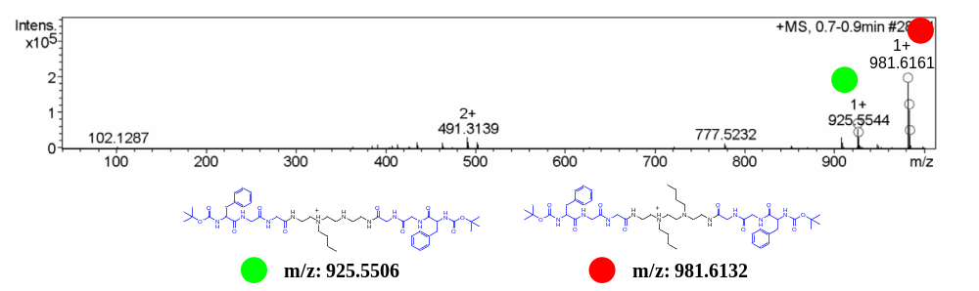
Figure S 33. HR-MS ESI spectra of TETA-2C4-2L2-Boc.

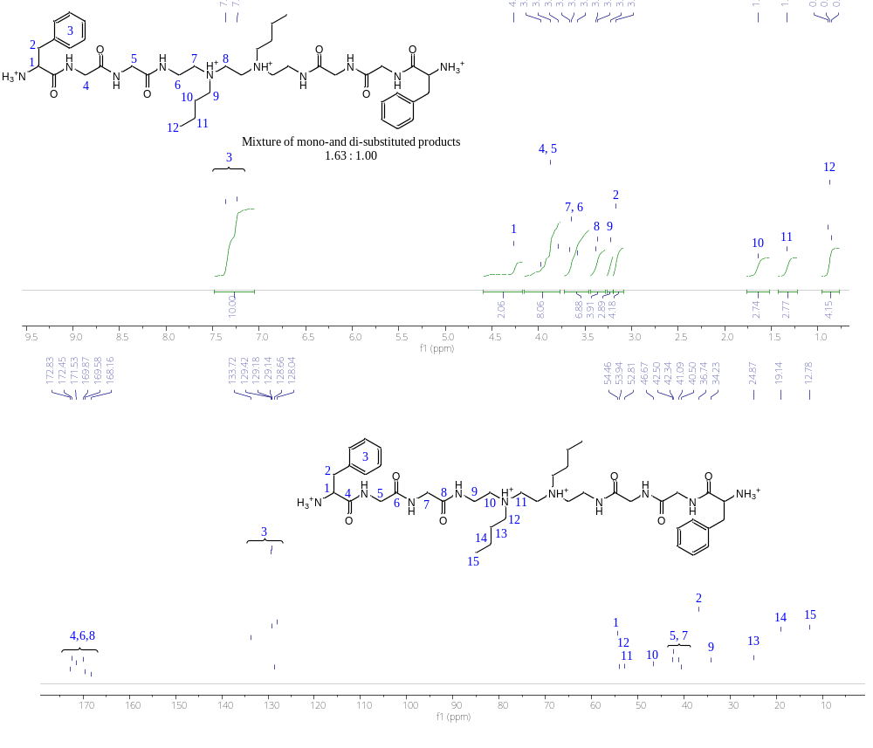
Figure S 34. ¹H and ¹³C NMR (400 MHz, D₂O) spectrum of TETA-2C4-2L2 (peaks assigned based on NMR COSY, and HSQC spectra).

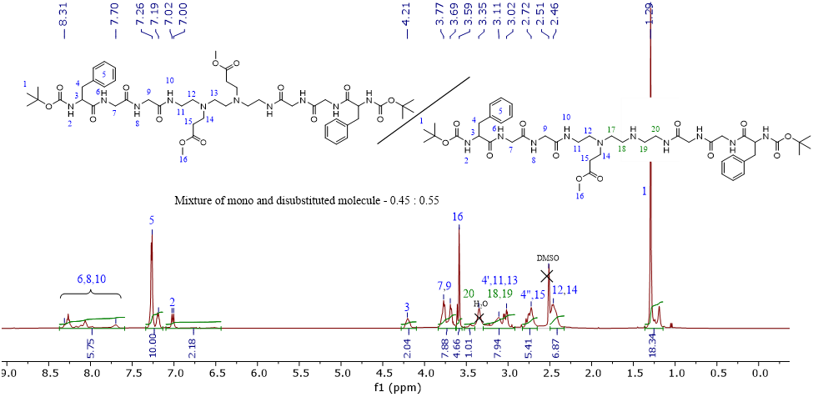
Figure S 35. ¹H NMR (440 MHz, DMSO-d₆) spectrum of TETA-2L2-2Ac-Boc (peaks assigned based on NMR COSY, HMBC and HSQC spectra).

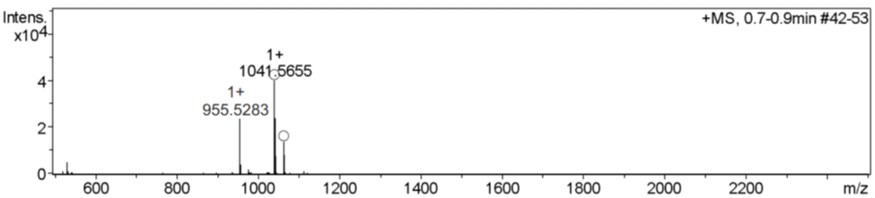
Figure S 36. HR-MS ESI spectra of TETA-2L2-2Ac-Boc.

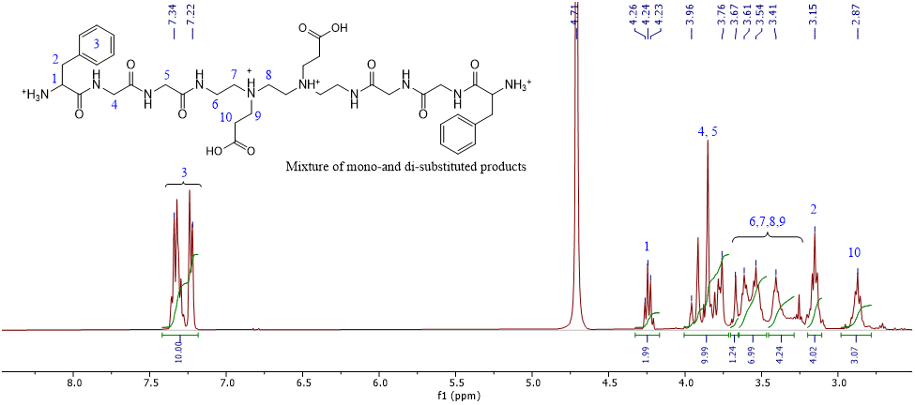
Figure S 37. ¹H NMR (400 MHz, DMSO-d₆) spectrum of TETA-2L2-2Ac (peaks assigned based on NMR COSY, HMBC and HSQC spectra).

Figure S 38. ¹H and ¹³C NMR (400 MHz, D₂O) spectrum of TETA-2PEG-2L2 (peaks assigned based on NMR COSY, and HSQC spectra).

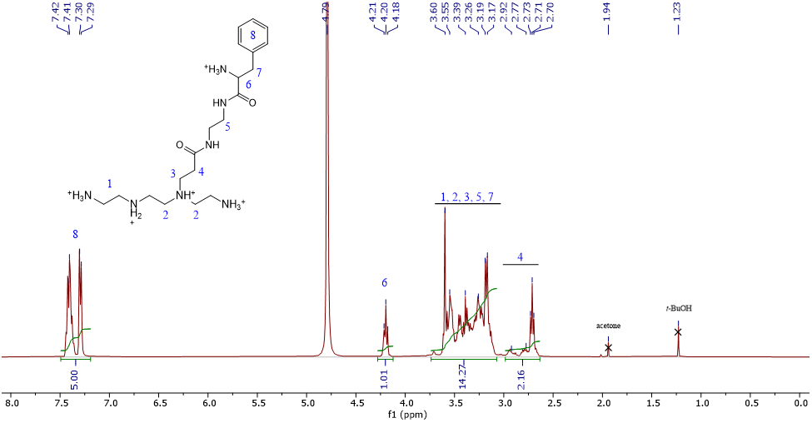
Figure S39. ¹H NMR (400 MHz, D₂O) spectrum of TETA-2L1. The presented structure is only a representation of TETA-L1 derivatives, the final product contains a mixture of mono- and di-functionalized TETA molecules.

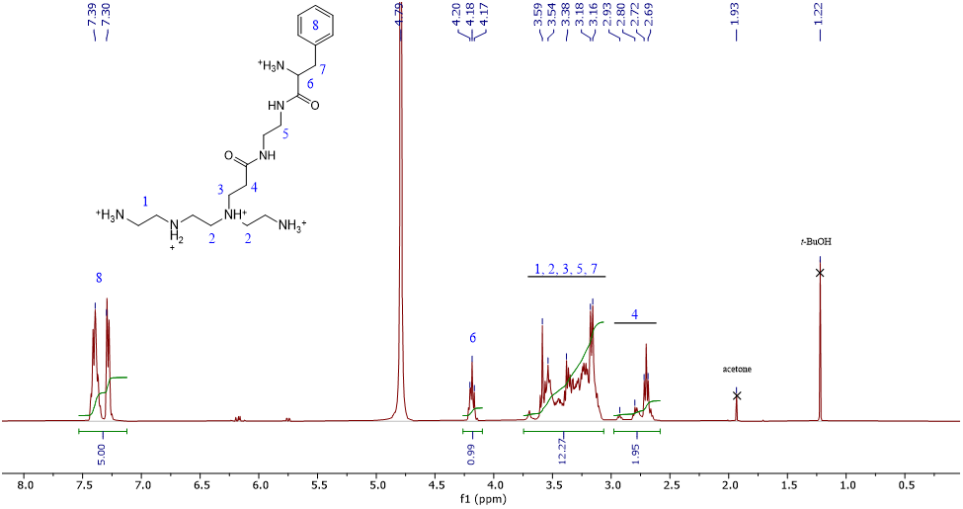
Figure S40. ¹H NMR (400 MHz, D₂O) spectrum of TETA-3L1. The presented structure is only a representation of TETA-L1 derivatives, the final product contains a mixture of mono- and di-functionalized TETA molecules.

DCR is a measure of the average light scattering intensity from the sample. A log-log plot of DCR vs D_{z} can detect outlier preparations. Typically, at a given concentration, DCR~D_{z}²⁻³, while “unstable” samples can be recognised by a DCR much (>100x) lower than expected for the size, even if the polydispersity index is consistent with narrow size distribution.
Munson, M.J., O’Driscoll, G., Silva, A.M et al. A high-throughput Galectin-9 imaging assay for quantifying nanoparticle uptake, endosomal escape and functional RNA delivery. Commun Biol, 2021, 4, 211.

