Supplementary Information
Crystalline Layered Fullerene Network with Exceptionally High Density of Intercalated Alkali Ions
Hao Mei^{1,#}, Mingming Gao^{2,#}, Wentao Fan¹, Yuyu Wang³, Shitao Wu⁴, Yuxuan Zhang¹, Hui Yu¹, Qixing Wang⁵, Antonio Gaetano Ricciardulli⁶, Xing Lu², Panpan Zhang^{2,7,*}, Yiyong Mai¹, Paolo Samorì^{6,*}, Sheng Yang^{1,*}

¹ State Key Laboratory of Synergistic Chem-Bio Synthesis, Frontiers Science Center for Transformative Molecules, School of Chemistry and Chemical Engineering, Shanghai Jiao Tong University, 200240 Shanghai, China
² State Key Laboratory of Material Processing and Die & Mould Technology, School of Materials Science and Engineering, Huazhong University of Science and Technology, 430074 Wuhan, China
³ College of Energy Storage Technology, Shandong Key Laboratory of Advanced Electrochemical Energy Storage Technologies, Shandong University of Science and Technology, 266590 Qingdao, China
⁴ Shanghai Key Laboratory of High-Resolution Electron Microscopy, Shanghai Tech University, 201210 Shanghai, China
⁵ Department of Physics, College of Physical Science and Technology, Xiamen University, 361005 Xiamen, China
⁶ University of Strasbourg, CNRS, ISIS UMR 7006, 8 allée Gaspard Monge, F-67000 Strasbourg, France
⁷ Key Laboratory of Advanced Energy Materials Chemistry (Ministry of Education), Nankai University, 300071 Tianjin, China
# H.M. and M.G. contributed equally to this work.
* Email: ppzhang@hust.edu.cn; samori@unistra.fr; sheng.yang@sjtu.edu.cn

1. Supplementary Methods

Experimental details
Chemicals
C₆₀ powder (99.9 at%; Suzhou Dade Carbon Nano Technology Co., Ltd, China), Mg foil (99.95% at%, 0.05 mm thickness ×10 cm width ×10 cm length, SCI Materials Hub Co., Ltd, China), all acids (HNO₃, H₂SO₄, HCl, CF₃COOH) and organic solvents (N,N-dimethylformamide, N-methylformamide, N-methylpyrrolidone) were used without any additional treatment.
CVT synthesis of Mg₄C₆₀ crystal
Mg₄C₆₀ crystals were prepared by a two-zone chemical vapor transport method, in which Mg foil was used as Mg supplier and the growth substrate. In prior to use, Mg foil was immersed into 0.1 M HCl for 5 s to remove the surface oxides. Then, a piece of Mg foil (1 cm×2 cm) and 150 mg C₆₀ powder were placed into two terminals of quartz tube with a separate distance of 25 cm. After that, the quartz tube was vacuumed and transferred into two-temperature zone tube furnace with temperature gradient of 510-600 °C for 20 h. At the end, micrometer-scale Mg₄C₆₀ crystals were collected from the quartz tube.
Synthesis of Layered C₆₀ network (LCNW)
The LCNW was produced by de-intercalation of Mg ions from Mg₄C₆₀. Firstly, 1.0 g Mg₄C₆₀ crystals were immersed in 100 ml 2M HCl (or 2M HNO₃, 1M H₂SO₄, pure CF₃COOH) for 6 h. In this process, a large amount of bubbles were observed on the surface of crystals. The samples were further washed with deionized water and ethanol for 3 times respectively, and dried at 60 °C in a vacuum oven. A solvothermal process was further applied to totally remove the residual Mg from acid-treated Mg_{0.5}C₆₀. Generally, the obtained Mg_{0.5}C₆₀ (100 mg) were added into 10 mL N,N-dimethylformamide containing 1.0 g salicylic acid, transferred into a polytetrafluoroethylene autoclave and kept at 80 ºC for 6 h. After reaction, the obtained LCNW samples were washed carefully with deionized water and ethanol for 3 times, and dried at 60 °C in a vacuum oven.
Theoretical calculations
Density functional theory (DFT) calculations were performed using the Vienna ab initio Simulation Package (VASP). The projected augmented wave (PAW) method and Perdew-Burke-Ernzerhof (PBE) functional were used to describe the interaction between the ion-core and valence electron and the exchange-correlation interaction, respectively. To obtain a reasonable fullerene arrangement, the structural reconstruction was carried out by using the periodic rule of the crystal, i.e. orthorhombic phase. The Brillouin zone was sampled at the Γ-point, and a cut-off energy of 450 eV was applied for the plane-wave basis set. Convergence was considered achieved when the total energy and Hellmann-Feynman force reached thresholds of 10⁻⁵ eV and 0.02 eV/Å, respectively. The van der Waals interaction treated using the DFT-D3 method.
Electrochemical measurement
The active materials, conductive acetylene black, and poly(vinyl difluoride) (PVDF) were blended at a mass ratio of 6:3:1 with the help of N-methyl-2-pyrrolidinone (NMP). Subsequently, the slurry was coated onto a copper foil and then vacuum-dried at 80°C overnight. The lithium-ion storage mechanism was adopted in coin-cells (CR2032 type). The raw C₆₀, graphite, and LCNW electrodes were utilized as the working electrode respectively, lithium foil was employed as the counter electrode, and the polypropylene film was used as the separator. For Li/Na/K based half-cell, 1 M LiPF₆, 1 M NaPF₆, or 0.8 M KPF₆ in a mixture of ethylene carbonate (EC) and diethyl carbonate (DEC) at a volume ratio (1:1) was served as the electrolyte, respectively. The full cell was assembled with LCNW anode and a commercial LiFePO₄ cathode. The mass ratio of the cathode and anode was calculated to be 5.5. The cyclic voltammetry (CV), galvanostatic charge-discharge (GCD), and galvanostatic intermittent titration technique (GITT) were measured with a Land CT2001A test system. Electrochemical impedance spectroscopy (EIS) was carried out using a CHI 660E workstation. The GITT curve obtained at 0.2 A g^{–1} provides insights into the diffusion coefficient of Li⁺ (D_{Li}) in the LCNW electrode. The D_{Li} value can be determined using the following formula:¹
$$D_{Li}=\frac{4}{πτ}({\frac{n_{B}V_{M}}{S})}^{2}({\frac{∆E_{s}}{∆E_{t}})}^{2}$$
where $τ$ represents relaxation time (1800 seconds), $n_{B}$ denotes the number of moles, $V_{M}$ is the molar volume, $S$ indicates the contact area between electrode and electrolyte, while $∆E_{s}$ and $∆E_{t}$ refer to voltage variations induced by pulses and during constant current charging/discharging, respectively.

Material characterization
Scanning electron microscopy (SEM) analyses were conducted using a ZEISS Gemini SEM 300 field emission microscope operating at 5 kV. X-ray diffraction (XRD) was used to analyze the phase structure and crystallinity (Thermelfeld ARL Equinox 3500, Cu K_{α}, 0.154 nm). Raman spectra of the original C₆₀ molecule, Mg₄C₆₀, and the LCNW were obtained by Labram Soleil confocal micro-Raman spectrometer (excitation wavelength of 532 nm). Fourier transform infrared (FTIR) spectra ranging from 400 to 4000 cm⁻¹ were obtained using a Nicolet 6700 spectrometer (Thermo Fisher, USA) by KBr squashing method. Transmission electron microscopy (TEM) images were captured from a field emission transmission electron microscope (Thermofisher, TALOS F200X, 200 kV). X-ray photoelectron spectroscopy (XPS) was conducted to investigate the surface chemical states and performed with Al K_{α} radiation (hν = 1486.6 eV, Thermo Scientific, ESXCALAB Xi).

2. Supplementary Figures
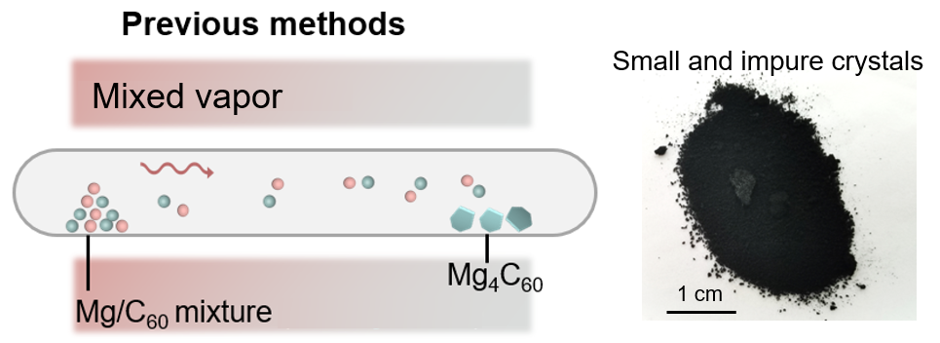
Figure S1. Previous method for preparing Mg₄C₆₀ crystals.²⁻⁵ They directly evaporate magnesium (Mg) and C₆₀ powder mixture at high-temperature region to enable growth of Mg₄C₆₀ at low-temperature region. Under such circumstances, most C₆₀ raw materials were consumed through side reactions with Mg powder, resulting in limited utilization of C₆₀ and low yield of Mg₄C₆₀.

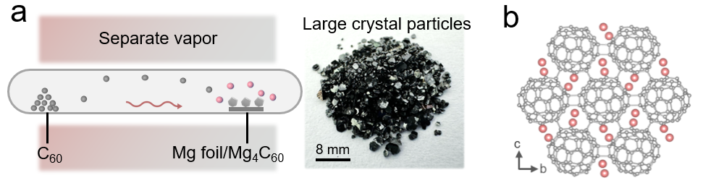
Figure S2. (a) The CVT synthesis of Mg₄C₆₀ crystal in this work. The experimental setup positioned Mg and molecular C₆₀ powder at separate ends of a vacuum quartz tube to initiate controlled volatilization. To minimize interference of characteristics from Mg source (including particle size and surface oxides) on volatilization behavior, pre-treated Mg foil was employed as the feedstock. (b) Crystal structure of Mg₄C₆₀.

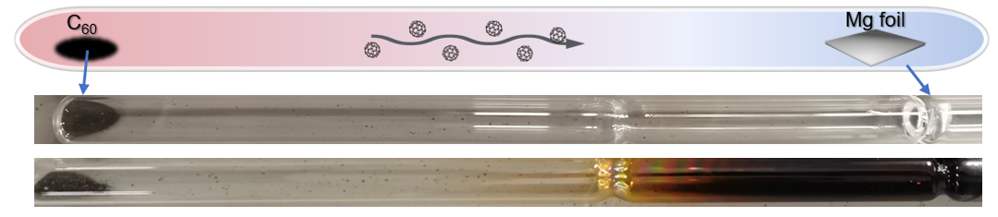
Figure S3. The CVT growth of Mg₄C₆₀ crystal on a Mg foil. The transparent quartz tube turns black, caused by the side reaction between Mg vapor and SiO₂.

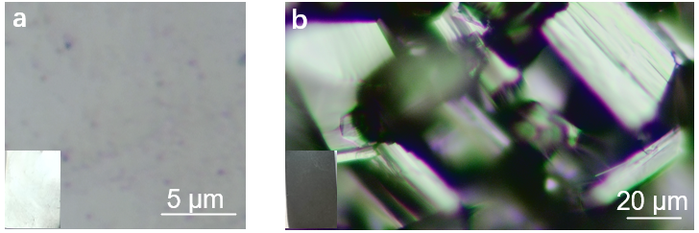
Figure S4. Optical images of (a) pristine Mg foil and (b) prepared Mg₄C₆₀ crystals with clearly layered structure. The pristine Mg foil displays metallic luster with a smooth surface morphology, whereas CVT reaction induces the formation of black crystalline Mg₄C₆₀ particulates.

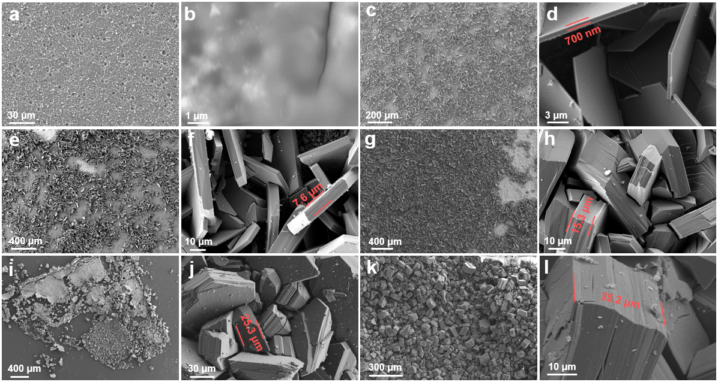
Figure S5. The evolution of Mg₄C₆₀ interface growth on a Mg foil at different reaction times: SEM images of (a,b) pristine Mg foil; (c,d) 3 h; (e,f) 5 h; (g,h) 8 h; (i,j) 13 h; (k,l) 17 h. The thickness of Mg₄C₆₀ increases with the extension of reaction time. When the Mg foil was fully reacted, the large Mg₄C₆₀ crystals can easily fall off from the substrate.

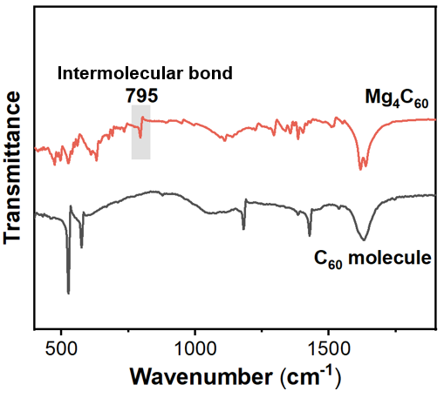
Figure S6. The infrared spectroscopy of Mg₄C₆₀ and C₆₀ molecule. The marked peak located at 795 cm^{–1} of Mg₄C₆₀ is attributed to the intermolecular bonding of C₆₀.

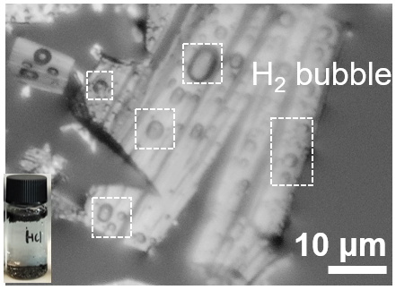
Figure S7. The optical image of a Mg₄C₆₀ crystal immersed into a 2M HCl solution. Distinct bubbles were observed on the surface of the crystal, caused by electron transport from electronegative C₆₀ network to H⁺.

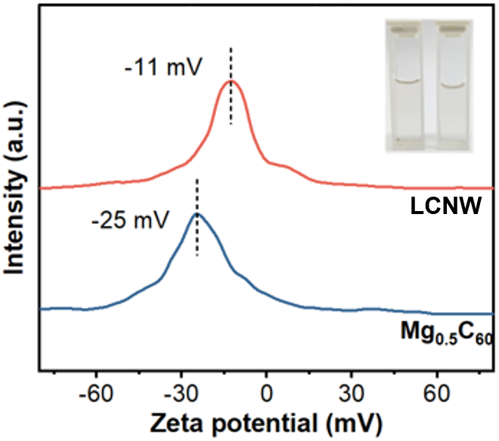
Figure S8. The average Zeta potentials of Mg_{0.5}C₆₀ and LCNW in aqueous dispersion. The measured average Zeta potential of Mg_{0.5}C₆₀ and LCNW are -25 mV and -11 mV.

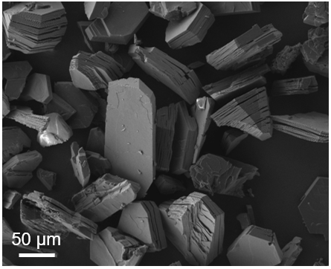
Figure S9. Typical SEM image of LCNW crystals. The LCNW presents 3D lamellar morphology composed of stacked individual nanosheets.

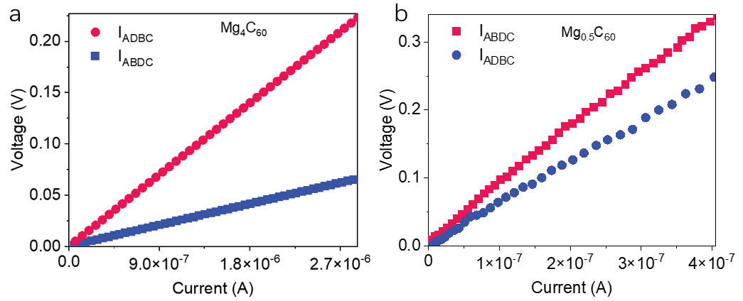
Figure S10. I-V curves of (a) Mg₄C₆₀ and (b) Mg_{0.5}C₆₀ determined by a four-probe test.

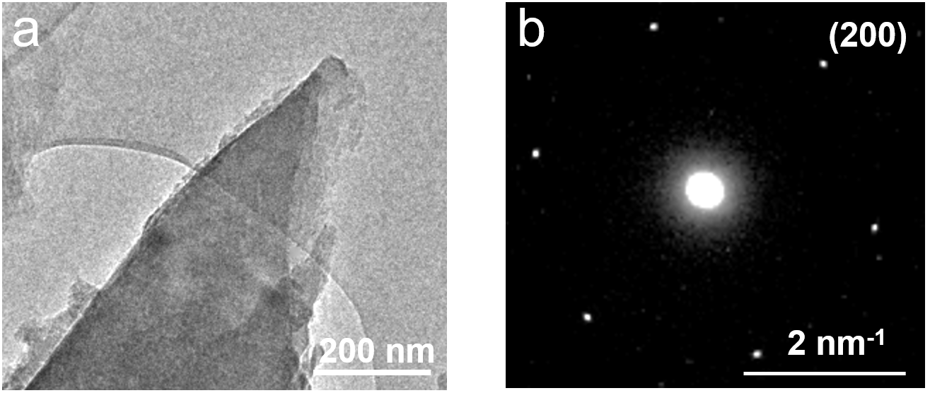
Figure S11. (a) TEM image of LCNW and (b) the corresponding SAED image. The SAED pattern exhibit a distinct hexagonal shape, suggesting the high crystallinity of LCNW.

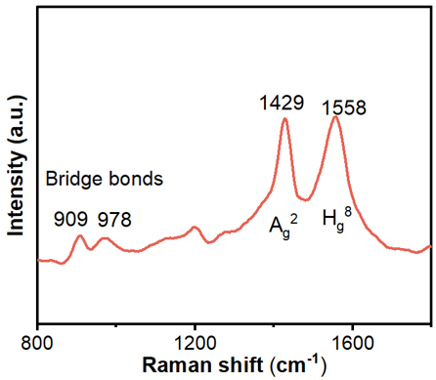
Figure S12. Raman spectrum of LCNW. The characteristic peaks located at 909, 978, and 1429 cm^{–1} can be related to interfullerene bridging bonds connecting C₆₀ structural units and Ag² symmetry pentagonal stretching vibrations.

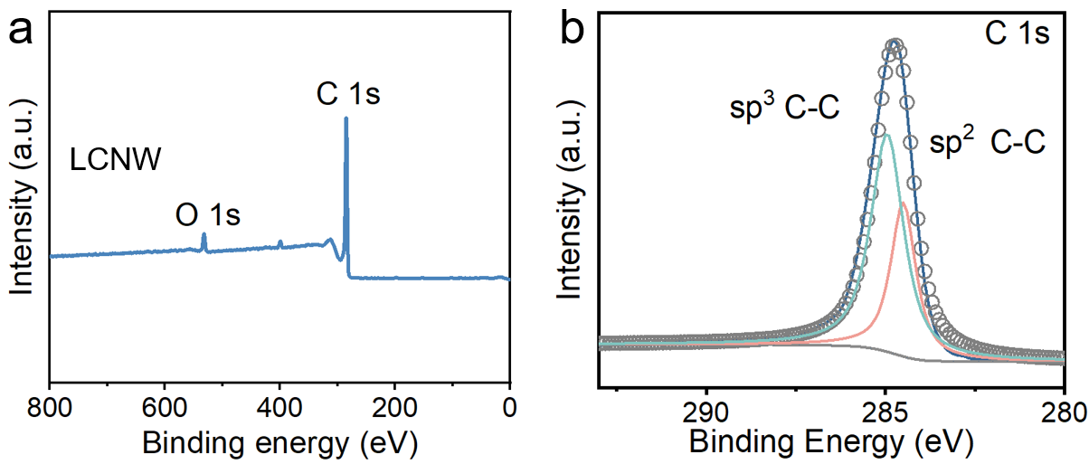
Figure S13. (a) XPS Full spectrum and (b) C 1s spectrum of LCNW. The weak O 1s peak is ascribed to the surface oxidation when exposed in air.

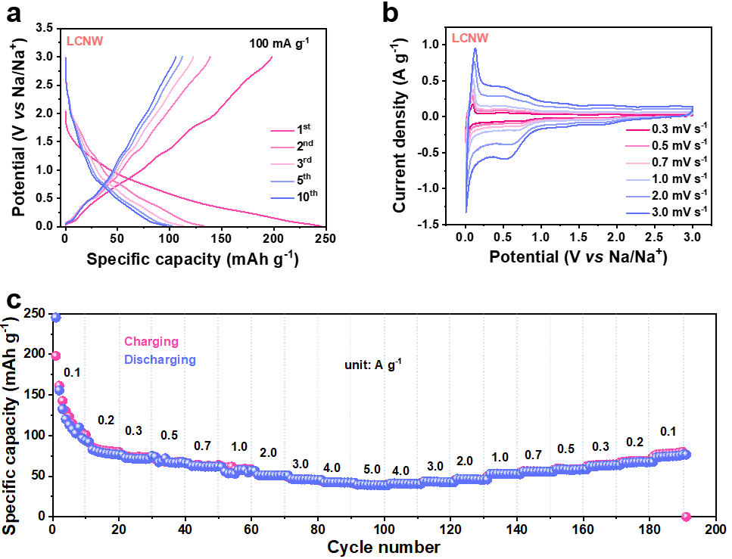
Figure S14. (a) GCD curves of LCNW in Na⁺ based half cell. (b) CV curves scanning from 0.3 to 3 mV s^{–1}. (c) The rate capability from 0.1 to 5.0 A g^{–1}.
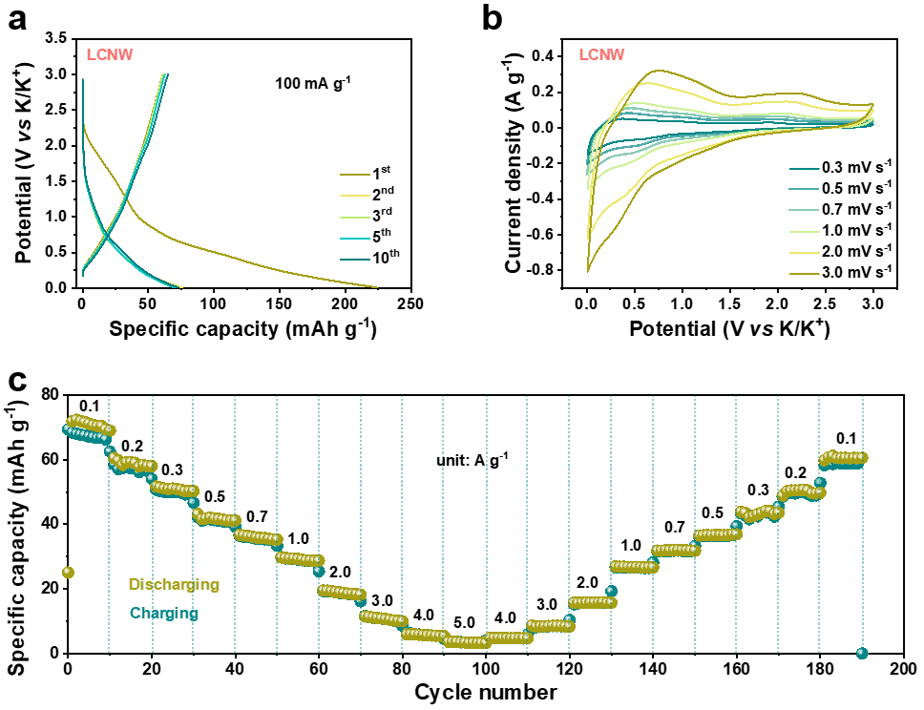
Figure S15. (a) GCD curves of LCNW in K⁺ based half cell. (b) CV curves from 0.3 to 3 mV s^{–1}. (c) The rate capability from 0.1 to 5.0 A g^{–1}.
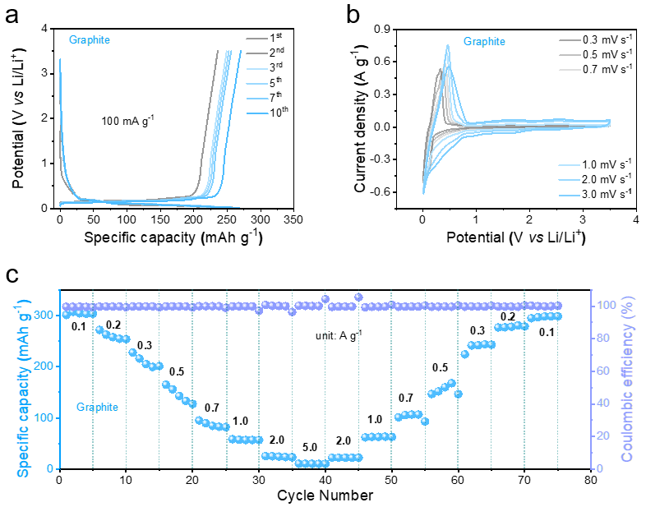
Figure S16. (a) GCD curves of graphite in Li⁺ based half cell. (b) CV curves from 0.3 to 3 mV s^{–1}. (c) The rate capability and Coulombic efficiencies from 0.1 to 5.0 A g^{–1}.
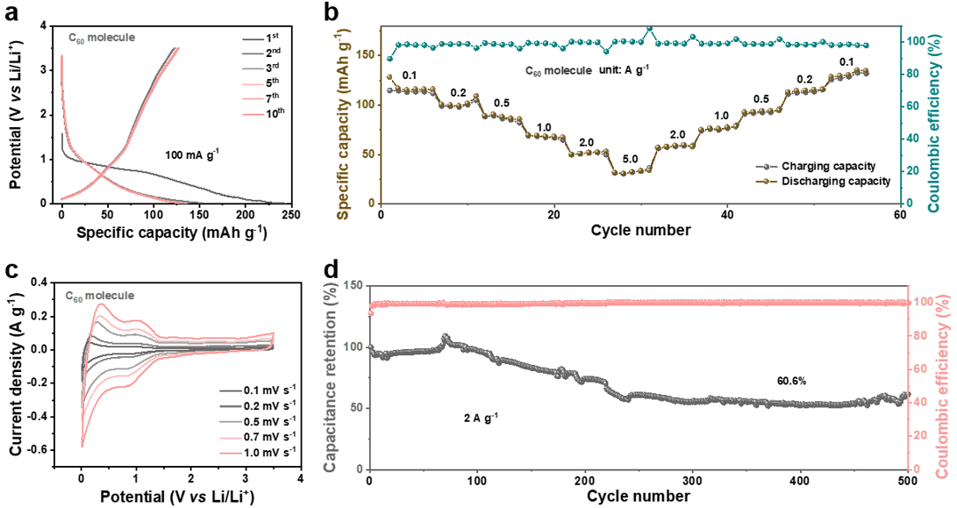
Figure S17. (a) GCD curves of C₆₀ molecule in Li⁺ based half-cell. (b) The rate capability and Coulombic efficiencies from 0.1 to 5.0 A g^{–1}. (c) CV curves from 0.3 to 3 mV s^{–1}. (d) Cycling performance at 2 A g^{–1}.

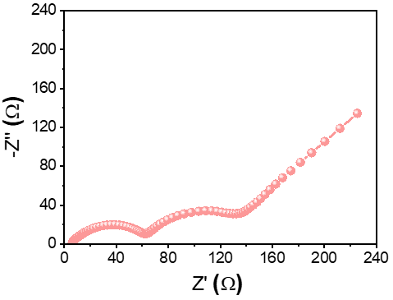
Figure S18. The Electrochemical impedance spectroscopy of LCNW in Li+ storage.

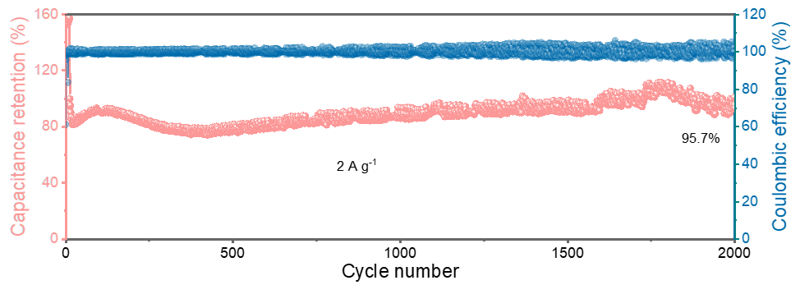
Figure S19. Cycling performance and Coulombic efficiencies of LCNW in Li based half-cell at 2 A g^{–1}.

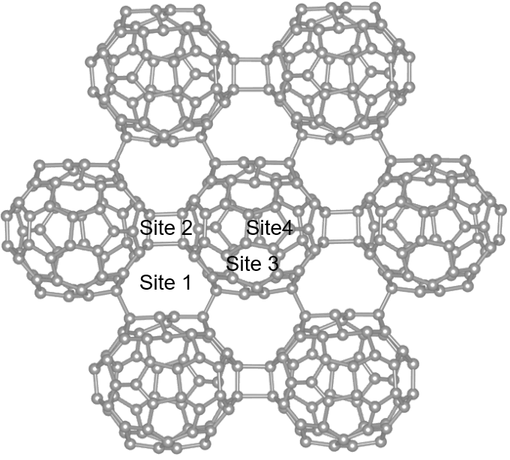
Figure S20. Possible Li⁺ adsorption sites including four-membered ring, five-membered ring, six-membered ring carbon structure, pore space formed by adjacent three C₆₀ units.
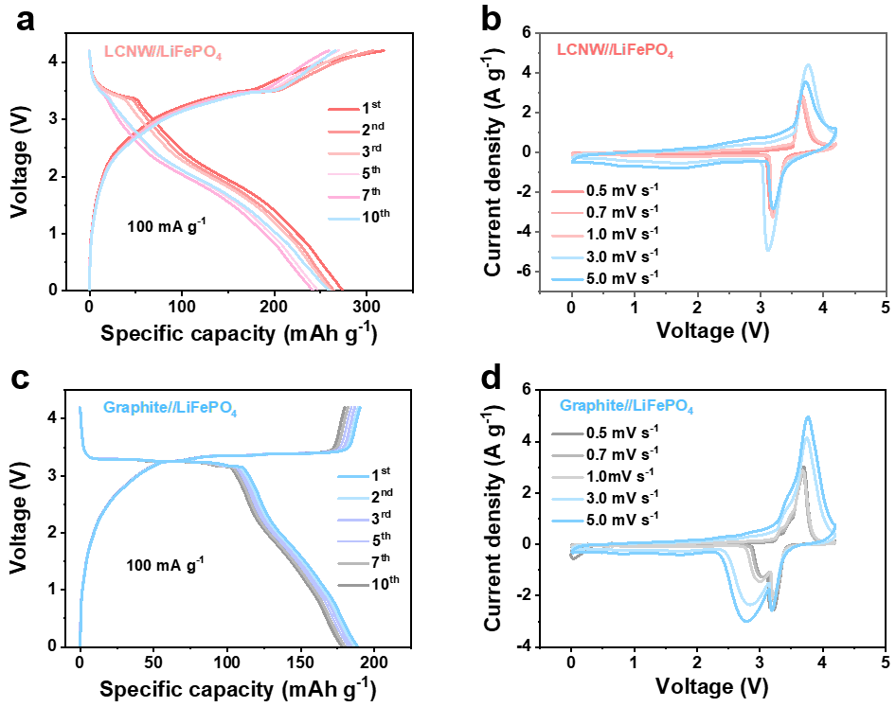
Figure S21. The full cell performance in comparison between LCNW and graphite: (a) GCD curves of LCNW//LiFePO₄; (b) CV curves of LCNW//LiFePO₄; (c) GCD curves of graphite//LiFePO₄; (d) CV curves of graphite//LiFePO₄.

Table S1. The comparison of recently reported carbon materials for the storage of Li⁺ ions.
Carbon materials | Capacity (mAh g⁻¹) | Voltage (V) | Current density (mA g⁻¹) |  | Ref.
Molecular C₆₀ | 120 | 1.2-3 | 20 | 6
Aligned Graphite | 350 | 0-1.5 | 37.2 | 7
Graphite Submicroflakes | 349 | 0-3 | 100 | 8
Dithianon | 271.2 | 1-3.5 | 271.2 | 9
Dual-shock Carbon | 375.6 | 0-3 | 37.56 | 10
Coal-derived Porous Graphene | 365 | 0-3 | 100 | 11
Onion-like Graphitic Carbon | 372 | 0-2.8 | 50 | 12
LCNW | 443 | 0-3 | 100 | This work

3. Reference
(1) Ma, X.; Han, K.; Li, H.; Song, L.; Lin, Y.; Lin, L.; Liu, Y.; Zhao, Y.; Yang, Z.; Huang, W. Stepwise MXene and MOF conversion assisted ultrathin dual-carbon-protected V₂O₃ nanosheets for ultrafast and durable Zn-ion storage. Energy Environ. Sci. 2025, 18, 897.
(2) Hou, L.; Cui, X.; Guan, B.; Wang, S.; Li, R.; Liu, Y.; Zhu, D.; Zheng, J. Synthesis of a monolayer fullerene network. Nature 2022, 606, 507-510.
(3) Meirzadeh, E.; Evans, A. M.; Rezaee, M.; Milich, M.; Dionne, C. J.; Darlington, T. P.; Bao, S. T.; Bartholomew, A. K.; Handa, T.; Rizzo, D. J.; Wiscons, R. A.; Reza, M.; Zangiabadi, A.; Fardian-Melamed, N.; Crowther, A. C.; Schuck, P. J.; Basov, D. N.; Zhu, X.; Giri, A.; Hopkins, P. E.; Kim, P.; Steigerwald, M. L.; Yang, J.; Nuckolls, C.; Roy, X. A few-layer covalent network of fullerenes. Nature 2023, 613, 71-76.
(4) Wang, T.; Zhang, L.; Wu, J.; Chen, M.; Yang, S.; Lu, Y.; Du, P. Few-layer fullerene network for photocatalytic pure water splitting into H₂ and H₂O₂. Angew. Chem. Int. Edit. 2023, 62, e202311352.
(5) Tanaka, M.; Yamanaka, S. Vapor-phase growth and structural characterization of single crystals of magnesium doped two-dimensional fullerene polymer Mg₂C₆₀. Cryst. Growth Des. 2018, 18, 3877-3882.
(6) Qiu, H.; Wan, J.; Zhang, J.; Wang, X.; Zhang, N.; Chen, R.; Xia, Y.; Huang, L.; Wang, H. L. Probing Mechanistic Insights into Highly Efficient Lithium Storage of C₆₀ Fullerene Enabled via Three‐Electron‐Redox Chemistry. Adv. Sci. 2021, 8, e2101759.
(7) Billaud, J.; Bouville, F.; Magrini, T.; Villevieille, C.; Studart, A. R. Magnetically aligned graphite electrodes for high-rate performance Li-ion batteries. Nat. Energy 2016, 1, 16097.
(8) Liang, C.; Chen, Y.; Wu, M.; Wang, K.; Zhang, W.; Gan, Y.; Huang, H.; Chen, J.; Xia, Y.; Zhang, J.; Zheng, S.; Pan, H. Green synthesis of graphite from CO₂ without graphitization process of amorphous carbon. Nat. Commun. 2021, 12, 119.
(9) Cui, C.; Ji, X.; Wang, P.; Xu, G.; Chen, L.; Chen, J.; Kim, H.; Ren, Y.; Chen, F.; Yang, C.; Fan, X.; Luo, C.; Amine, K.; Wang, C. Integrating multiredox centers into one framework for high-performance organic Li-ion battery cathodes. ACS Energy Lett. 2020, 5, 224-231.
(10) Huang, P.; Li, Z.; Chen, L.; Li, Y.; Liu, Z.; Zhang, J.; Luo, J.; Zhang, W.; Liu, W.; Zhang, X.; Zhu, R.; Chen, Y. Ultrafast dual-shock chemistry synthesis of ordered/disordered hybrid carbon anodes: high-rate performance of Li-ion batteries. ACS Nano 2024, 18, 18344-18354.
(11) Ma, X.; Li, S.; Tang, W.; Liu, R.; Fu, Z.; Wang, S. Laser‐induced coal‐based porous graphene as anode toward advanced lithium-ion battery. Adv. Sci. 2025, 2504592.
(12) Zhang, J.; Wang, D.; Zhang, L.; Liu, H.; Liu, Z.; Xing, T.; Ma, Z.; Chen, X.; Song, H. A wet granulation method to prepare graphite particles with a high tap density for high volumetric energy density lithium-ion storage. New Carbon Mater. 2022, 37, 402-410.

