Clinicopathological significance of loss of Y chromosome in male meningiomas

Maki Sakaguchi^{1,2}, Masafumi Horie^{1,3*}, Yukinobu Ito¹, Shingo Tanaka⁴, Hiroko Ikeda⁵, Mitsutoshi Nakada⁴, Akihiko Yoshizawa², Daichi Maeda^{1, 3, 6}

- Department of Molecular and Cellular Pathology, Graduate school of Medical Sciences, Kanazawa University, Kanazawa, Japan.
- Department of Diagnostic Pathology, Nara Medical University, Kashihara, Japan.
- Division of Molecular and Genomic Pathology, Department of Pathology, Kobe University Graduate School of Medicine, Kobe, Japan.
- Department of Neurosurgery, Graduate school of Medical Sciences, Kanazawa University, Kanazawa, Japan.
- Department of Diagnostic Pathology, Kanazawa University Hospital, Kanazawa, Japan.
- The Garvan Institute of Medical Research, Darlinghurst, New South Wales, Australia.
*Corresponding author
Masafumi Horie, MD, PhD
Division of Molecular and Genomic Pathology, Department of Pathology, Kobe University Graduate School of Medicine
E-mail: mhorie@med.kobe-u.ac.jp
Phone: +81-78-382-5465
FAX: +81-78-382-5479

Supplementary Fig.1
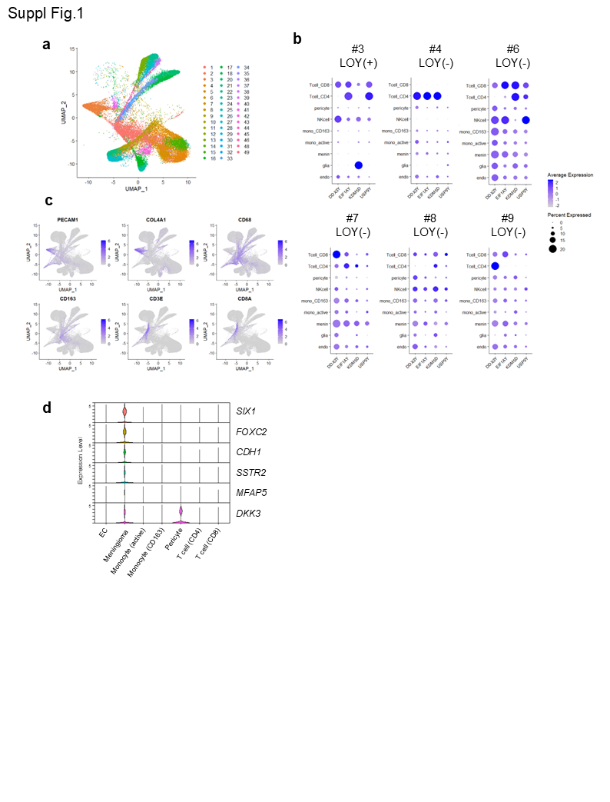

Supplementary Fig.2
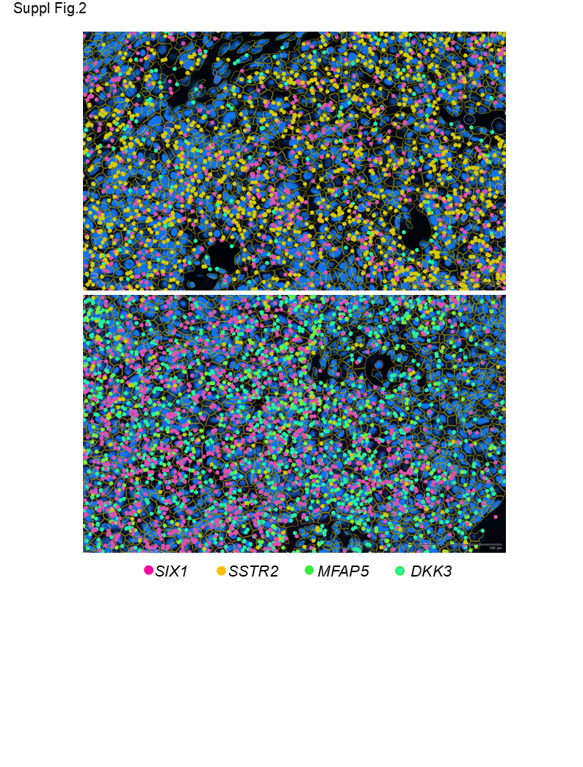

Supplementary Fig.3
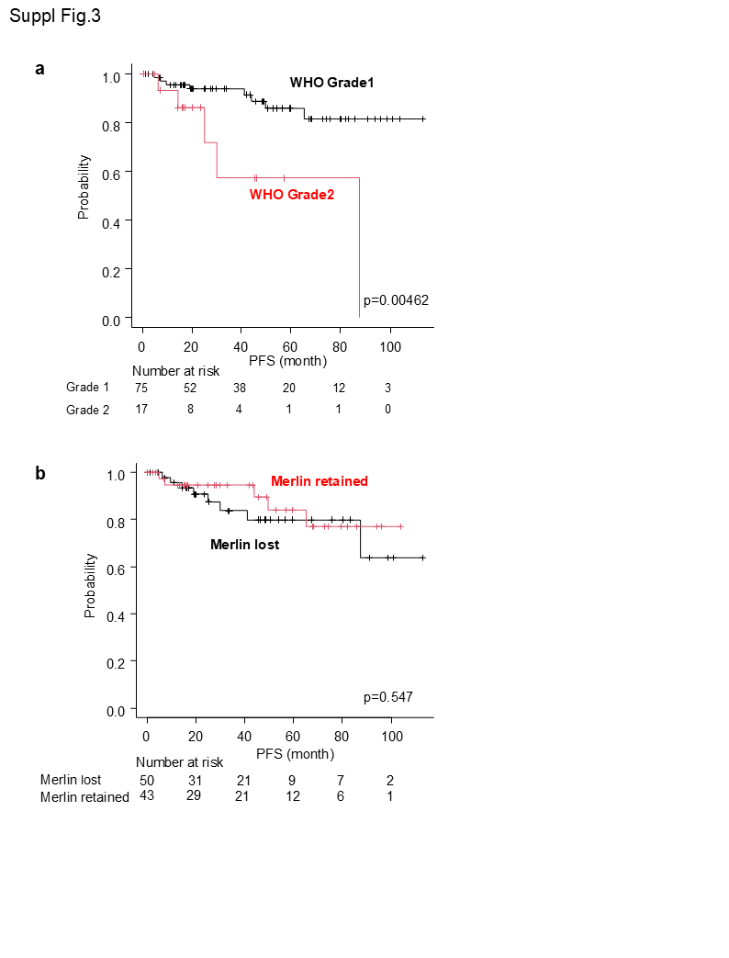

Supplementary Fig.1
- Uniform manifold approximation and projection (UMAP) visualization displaying 49 clusters identified in male meningiomas.
- Dot plot of Y chromosome gene expression across meningioma cases. Dot size indicates the proportion of cells with detectable transcript expression; color intensity reflects average gene expression levels.
- Feature plots displaying scaled RNA expression across annotated non-tumor cell types in UMAP space.
- Violin plots showing the expression levels of SIX1, FOXC2, CDH1, SSTR2, MFAP5, and DKK3 at the single-cell level.

Supplementary Fig. 2
Spatial transcriptomic maps showing expression patterns of SIX1, SSTR2, MFAP5, and DKK3. The upper panel emphasizes predominant SSTR2 expression, whereas the lower panel illustrates MFAP5 and DKK3 enrichment in spatially distinct regions.

Supplementary Fig. 3
- Kaplan–Meier survival curves for progression-free survival stratified by World Health Organization (WHO) grade 1 and grade 2 meningiomas.
- Kaplan–Meier survival curves comparing progression-free survival in meningiomas with merlin loss versus merlin retention.

