Nano-plasmonic sensing for predicting fouling on a reverse osmosis membrane

Supplementary Information

Noa Stein, Mahaveer Halakarni, Roy Bernstein*, Moshe Herzberg*

Department of Desalination and Water Treatment, Zuckerberg Institute for Water Research, The Jacob Blaustein Institutes for Desert Research, Ben-Gurion University of the Negev, Sede-Boqer Campus, 84990, Israel

*Corresponding authors
Moshe Herzberg, email: herzberg@bgu.ac.il
Roy Bernstein, email: royber@bgu.ac.il

Submitted to NPJ Clean Water on June 8, 2025

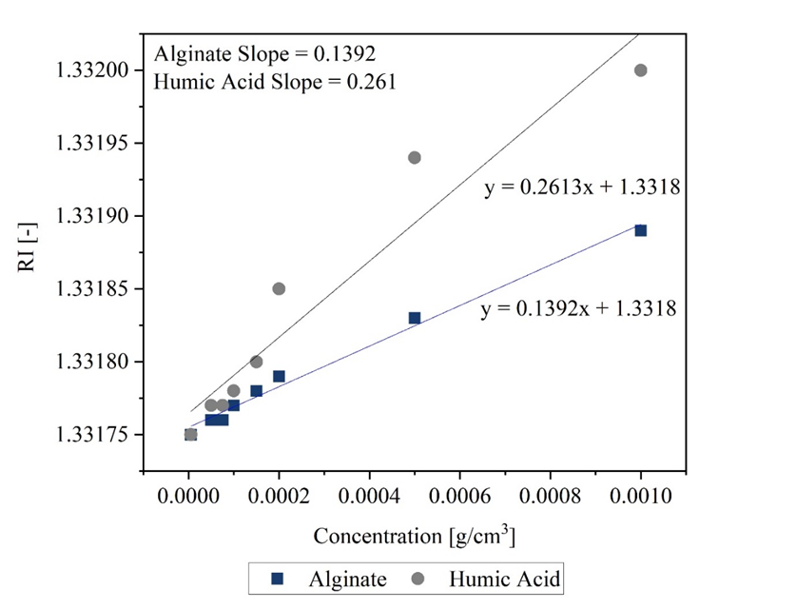

Figure S1. Refractive index (RI) increment, dn_{s}/dc [cm³/g] estimation for Alginate and Humic acid.

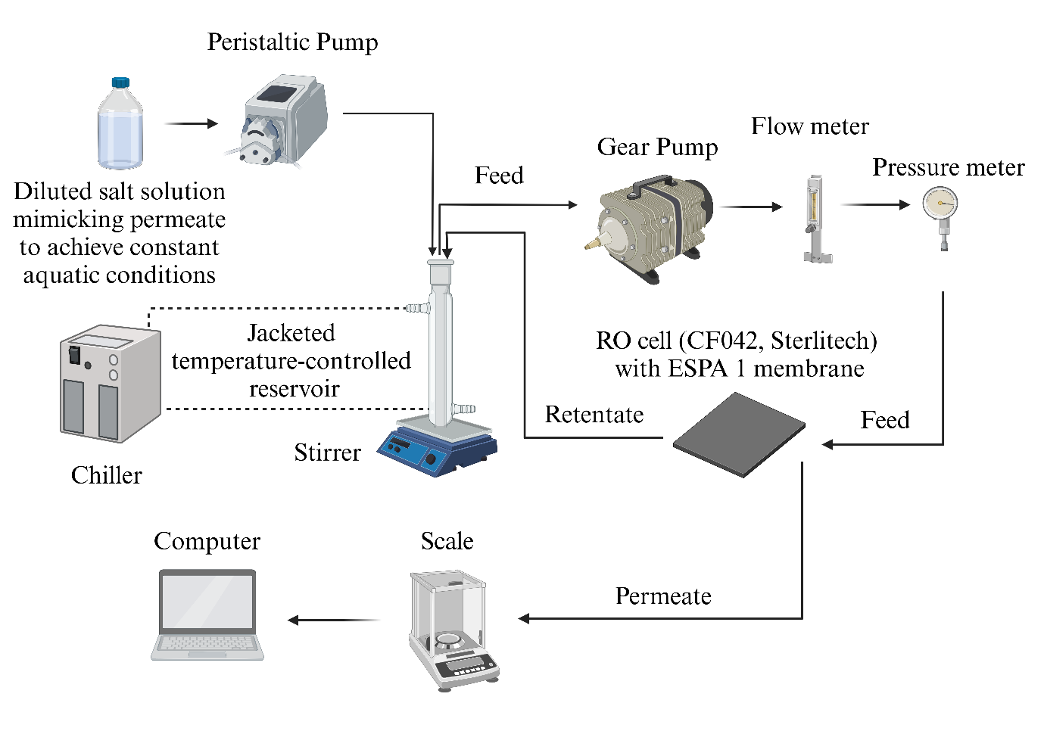
Figure S2. Overview of the laboratory-scale RO crossflow secondary wastewater desalination system used for comparison of the fouling degree of each foulant.

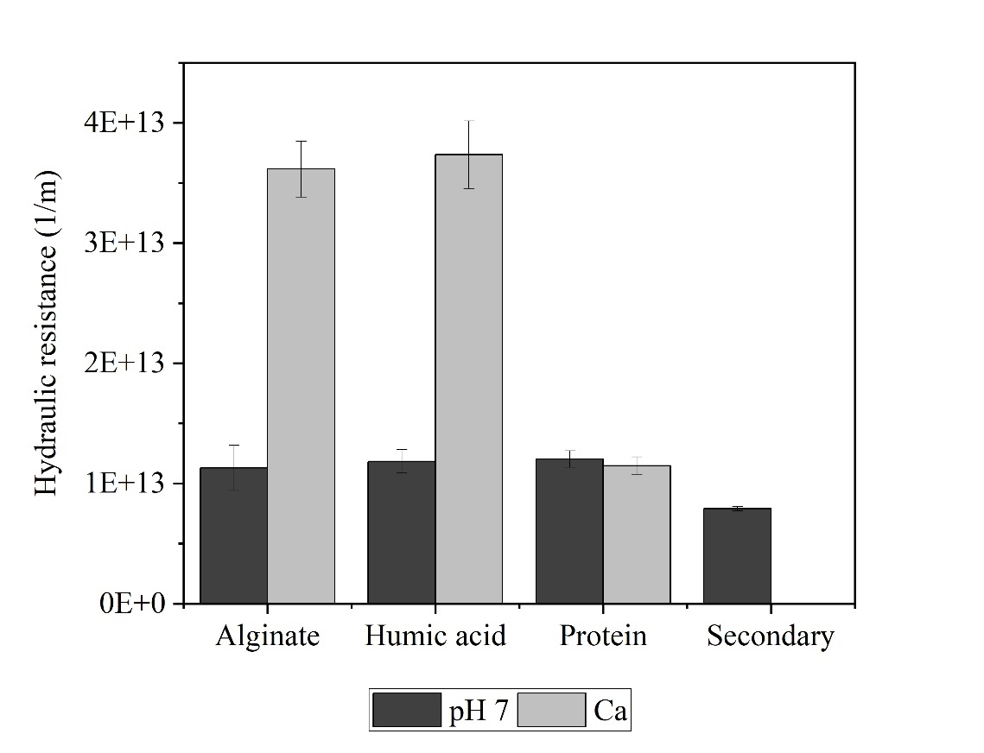
Figure S3. Hydraulic resistance of the fouling layers developed by three model foulants in 10 mM NaCl (pH 7) and 8.5 mM NaCl + 0.5 mM CaCl₂ and that formed by secondary effluent.

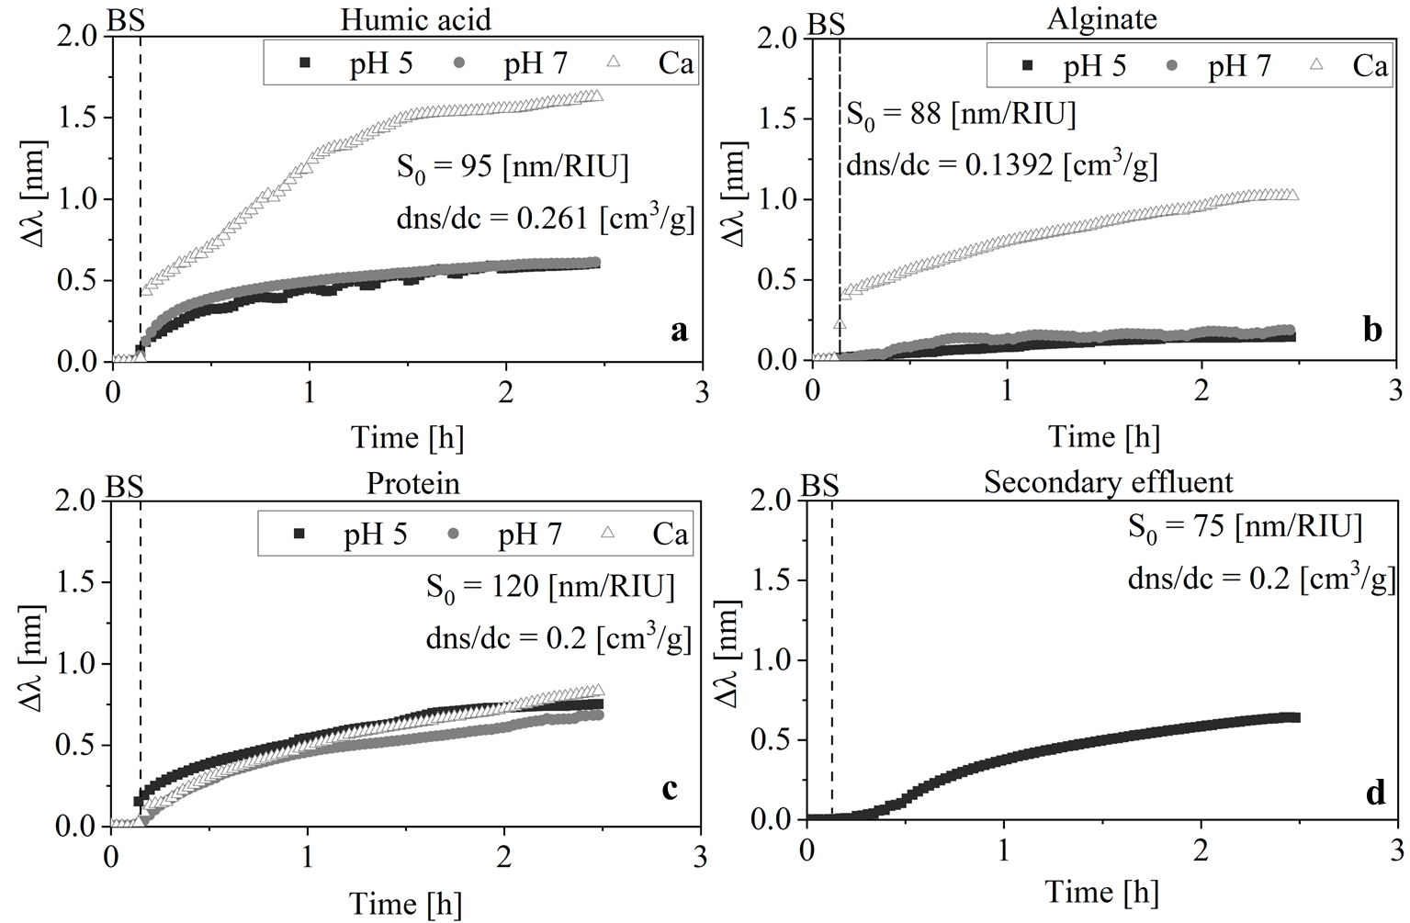
Figure S4. The shift in light-extinction maxima, Δλ [nm], over time, for three model foulants; a) Humic acid, b) Alginate, c) Athletes' Protein powder, and d) Secondary effluents dissolved organic matter accumulated on the surface of the LSPR membrane-mimetic sensor hosted in the XNano device (Insplorion AB, Gotenburg, Sweden) during 2 h adsorption period. Model foulants had a concentration of 100 mg/L (w/v), and secondary effluents had a TOC concentration of 10.73±0.203 mg/L.
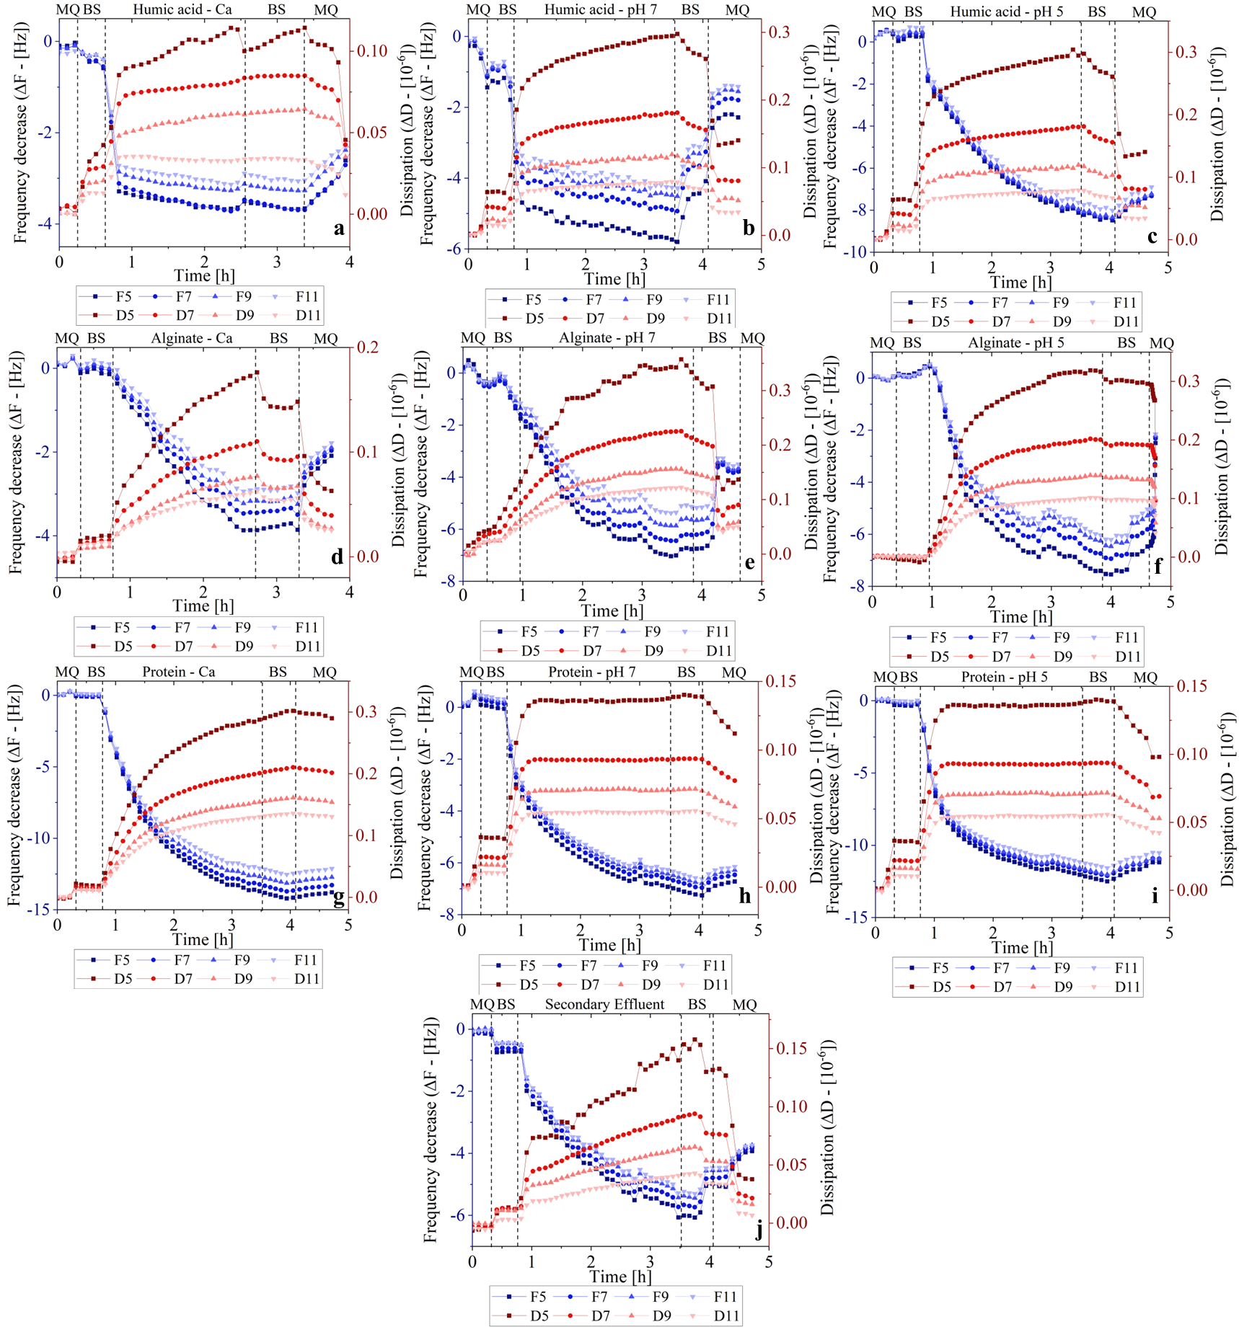

Figure S5. Adsorption of model foulants in the QCM-D on a PES coated sensor, under different aquatic conditions; a) Humic acid in 8.5mM NaCl + 0.5mM CaCl₂; b) Humic acid in 10mM NaCl in pH 7; c) Humic acid in 10mM NaCl in pH 5; d) Alginate in 8.5mM NaCl + 0.5mM CaCl₂; e) Alginate in 10mM NaCl in pH 7; f) Alginate in 10mM NaCl in pH 5; g) Athletes' Protein powder in 8.5mM NaCl + 0.5mM CaCl₂; h) Athletes' Protein powder in 10mM NaCl in pH 7; i) Athletes' Protein powder in 10mM NaCl in pH 5; and j) dissolved organic matter of secondary effluents. Different overtones (5th, 7th, 9th & 11th) of the frequency and dissipation shifts are presented. The dashed line indicates a change in solution from background solution (BS) to different foulants and back to background solution. Model foulants had a concentration of 100 mg/L (w/v), and secondary effluents had a DOC concentration of 10.73±0.203 mg/L.

Table S1. Chemical characterization of secondary effluent from the Yeruham plant.
Parameter | Value
TOC (mg/L) | 10.73
pH | 7.74
Alkalinity (mg/L) | 3.97
Electric conductivity (µS/cm) | 1121
Ca⁺² (mg/L) | 41.7
K⁺ (mg/L) | 17.9
Mg⁺² (mg/L) | 5.83
Na⁺ (mg/L) | 144
SO₄⁻² (mg/L) | 53.2
NO₃⁻ (mg/L) | 21.3
Cl⁻ (mg/L) | 157
P (mg/L) | 1.54

Table S2. Data of RO membrane fouling (permeate flux decline, fouling layer’s hydraulic resistance), SDI, QCM-D, and LSPR for Pearson t-test correlations
Foulant  Treatment |  | RO flux  Decline  [%] | Mass surface  Concentration  [ng/cm²] | QCM-D ΔF decrease  (7th o.t.) [Hz] | QCM-D ΔF decrease  (5th o.t.) [Hz] | Hydrated mass - QCM-D model [ng/cm³] | Hydraulic  Resistance  [1/m] | SDI  [-]
Alginate | pH 5 | 9.07 | 38.26 | -5.18 | -6.98 | 138.4 | N.P. | 7.28
Alginate | pH 7 | 8.8 | 26.66 | -4.24 | -6.04 | 289.1 | 1.13E+13 | 6.35
Alginate | Ca | 38.78 | 129.45 | -1.15 | -2.95 | 129.5 | 3.62E+13 | 8.45
Humic acid | pH 5 | 10.56 | 44.14 | -6.55 | -8.35 | 318.2 | N.P. | 7.2
Humic acid | pH 7 | 5.44 | 38.32 | -2.22 | -4.02 | 131.3 | 1.18E+13 | 6.68
Humic acid | Ca | 35.95 | 130.71 | -1.35 | -3.15 | 206.2 | 3.73E+13 | 7.69
Protein powder | pH 5 | 14.66 | 83.39 | -10.07 | -11.87 | 246.1 | N.P. | 4.53
Protein powder | pH 7 | 13.42 | 45.77 | -5.29 | -7.09 | 188.6 | 1.20E+13 | 6.99
Protein powder | Ca | 12.44 | 46.08 | -11.86 | -13.66 | 415.8 | 1.15E+13 | 7.33
Secondary effluents | - | 14.29 | 75.33 | -3.27 | -5.071 | 184.03 | 7.91E+12 | 4.12

