Supplementary Materials S4. Evaluation of Water-related Cooperation Modes and Projections of Conflict Mitigation Effects under Future Climate Uncertainty

Multi-Criteria Evaluation of Cooperation Modes
Interpretable Machine Learning Framework
Random Forest regression with SHAP (SHapley Additive exPlanations) is chosen for its interpretability and robustness in handling complex, non-linear relationships³⁹. Bayesian optimization is used to fine-tune hyperparameters such as the number of trees, maximum depth, and minimum samples per leaf. Data from 2011-2019 is used as test data to validate the model. Performance metrics such as Mean Absolute Error (MAE), Root Mean Squared Error (RMSE), and R-squared are used to evaluate the model. And the MAE metric is utilized to determine the optimal cooperation mode combination that can incorporate more than one cooperative modes.
$$f_{RF}\left(X_{i}\right)=\frac{1}{T}\sum_{t=1}^{T}{h\left(X_{i},θ_{t}\right)}$$
where $f_{RF}\left(X_{i}\right)$ denote the final prediction of the Random Forest regression model for an input feature vector $X_{i}$, $T$ is the total number of decision trees in the forest, $h\left(X_{i},θ_{t}\right)$ represents the prediction of the t-th decision tree parameterized by $θ_{t}$, $\frac{1}{T}$ computes the average of predictions aggregated across all trees.
$$MAE=\frac{1}{n}\sum_{i=1}^{n}{\left|y_{i}-\hat{y_{i}}\right|}$$
where $n$ is the total number of data points, $y_{i}$is the true value of the i-th data point, $\hat{y_{i}}$is the predicted value, ∣$\left|y_{i}-\hat{y_{i}}\right|$represents the absolute error for the i-th observation, and $\frac{1}{n}$ means to average the sum result.
SHAP values are used to quantify the contribution of each cooperation mode to conflict mitigation. The SHAP summary plot (Figure 3d) visualizes the impact of cooperation mode on the model's output, providing a global interpretation of the model. The SHAP values are aggregated to rank the importance of each feature, highlighting which cooperation modes and socioeconomic factors are most influential in mitigating conflicts.
$$ϕ_{i}=\sum_{S⊆F\backslash \left\{i\right\}}{\frac{\left|S\right|!\left(\left|F\right|-\left|S\right|-1\right)!}{\left|F\right|!}\left[f\left(S∪\left\{i\right\}\right)-f(S)\right]}$$
where $ϕ_{i}$ represents the SHAP value of feature $i$, $S$ is a subset of features excluding i, $F$ is the complete set of features, $\left|S\right|!$ and $\left(\left|F\right|-\left|S\right|-1\right)!$ represents the combinatorial weighting factor to balance contributions across subset sizes, $f\left(S∪\left\{i\right\}\right)$ and $f(S)$ denote model predictions with and without feature i.
Mitigative effects are calculated for hypothetical scenarios where all conflict events are provided with one certain mode of collaboration or a highly frequent combination of modes. This allows for a detailed understanding of how specific modes or combinations of modes influence conflict mitigation.
Predictor and independent variables are selected as the following. The dependent variable is the count of water-related conflicts within a 5-year period (integer). The independent variables include Event type, annotating whether the event is a conflict or a certain mode of cooperation. Climate variables include annual precipitation and water stress levels, socioeconomic controls include population density, GDP per capita, rural population, and export dependency ratio. The variables are integrated into a country-year panel dataset, ensuring temporal and spatial consistency.

Evaluation dimensions
We developed a multi-criteria evaluation framework to assess six transboundary water cooperation modes—Cross-Border Basin Agreements, Collaborative Planning and Adaptation Strategies, Joint Water Allocation Models, Joint Data-Sharing Systems, Transboundary Water Quality Standards, and Coordinated Hydropower Operations—across six dimensions. The dimensions (or criteria) are defined as follows: (1) Prescriptive – the mode’s predictive power in relation to conflict occurrence (quantified via prediction error, e.g. MAE, when the mode’s influence is considered); (2) Preventive – the capacity of the mode to proactively mitigate or reduce conflict incidence; (3) Affordable – the cost-effectiveness or feasibility of the mode for low-GDP contexts; (4) Facilitative – the mode’s alignment with and support for broader economic activities (e.g. trade-dependent economies); (5) Stress-Relieving – the degree to which the mode alleviates water stress or scarcity; (6) Complementary – the ability of the mode to synergize with or enhance other cooperation strategies.
Each criterion is quantitatively scored on a common scale from 0.5 to 6.0 (higher scores indicate stronger performance). To derive these scores, we leveraged an interpretable machine learning approach using a Random Forest model with SHAP (SHapley Additive exPlanations) values. Random Forests were chosen for their robustness in capturing non-linear relationships and their compatibility with feature importance analysis. The trained model incorporated each cooperation mode (and relevant controls) as features predicting a country’s five-year conflict count, enabling us to evaluate how strongly each mode influences conflicts.
Table S2. Multi-dimensional effectiveness evaluation of water-related cooperation modes.
Cooperation mode | Affordable | Facilitative | Stress relieving | Complem-entary | Preventive | Prescri-ptive
Cross-Border Basin Agreements | -0.0375 | -0.0766 | 0.0321 | -0.0004 | -0.7849 | 0.1469
Collaborative Planning and Adaptation Strategies | -0.0257 | -0.0623 | -0.0072 | -0.0001 | -0.8679 | 0.1019
Joint Water Allocation Models | -0.0365 | -0.0727 | 0.0632 | 0.0000 | -0.8360 | 0.1442
Joint Data-Sharing Systems | -0.0086 | -0.0270 | 0.0310 | -0.0001 | -0.8649 | 0.0922
Transboundary Water Quality Standards | 0.0689 | 0.0316 | 0.0246 | 0.0000 | -0.8789 | 0.1362
Coordinated Hydropower Operations | -0.0287 | -0.0813 | 0.0356 | 0.0000 | -0.8903 | 0.2383

Definition and evaluating the criteria metrics
The Prescriptive score for a mode is derived from its influence on prediction error – modes that significantly improve predictive accuracy (lower MAE when included) receive higher prescriptive scores. The Preventive score leverages the model’s scenario analysis of conflict mitigation: we simulate hypothetical interventions where a given mode is universally implemented and measure the reduction in conflict counts. Modes yielding larger conflict reductions in these simulations (i.e. stronger preventive effect) score higher on Preventive. The Affordable dimension is informed by socioeconomic feature interactions; modes predominantly adopted in lower-GDP settings without performance loss are rated more affordable. Similarly, Facilitative scores are guided by correlations between mode effectiveness and trade-related indicators (e.g. export dependency) – a high score indicates the mode tends to co-occur with positive economic or trade outcomes. The Stress-Relieving metric is linked to water scarcity indicators: using projected water stress levels, we assess if the mode’s presence correlates with reduced conflict under high stress, directly using SHAP contributions of the mode against a water stress feature.
Complementary scores capture each mode’s synergistic potential, measured by how often and how effectively it appears alongside other cooperation modes in historical cases (we use feature co-occurrence patterns and Pearson correlations between modes). These various metrics (MAE improvements, conflict reductions, correlation coefficients, etc.) are each transformed into a unified score on the 0.5–6.0 scale. Prior to scoring, all raw metrics underwent preprocessing and normalization to ensure comparability across disparate units and distributions. For instance, continuous measures like conflict reduction (number of conflicts prevented) were normalized relative to the best-performing mode, and categorical influences (e.g. co-occurrence frequency) were scaled by percentile ranks. This normalization yields dimension scores in 0.5-point increments from a minimum of 0.5 to a maximum of 6.0, providing a level playing field for multi-criteria visualization. No additional weighting was applied across criteria; each dimension is treated independently in subsequent analyses, while the radar chart visualization inherently presents a holistic view.

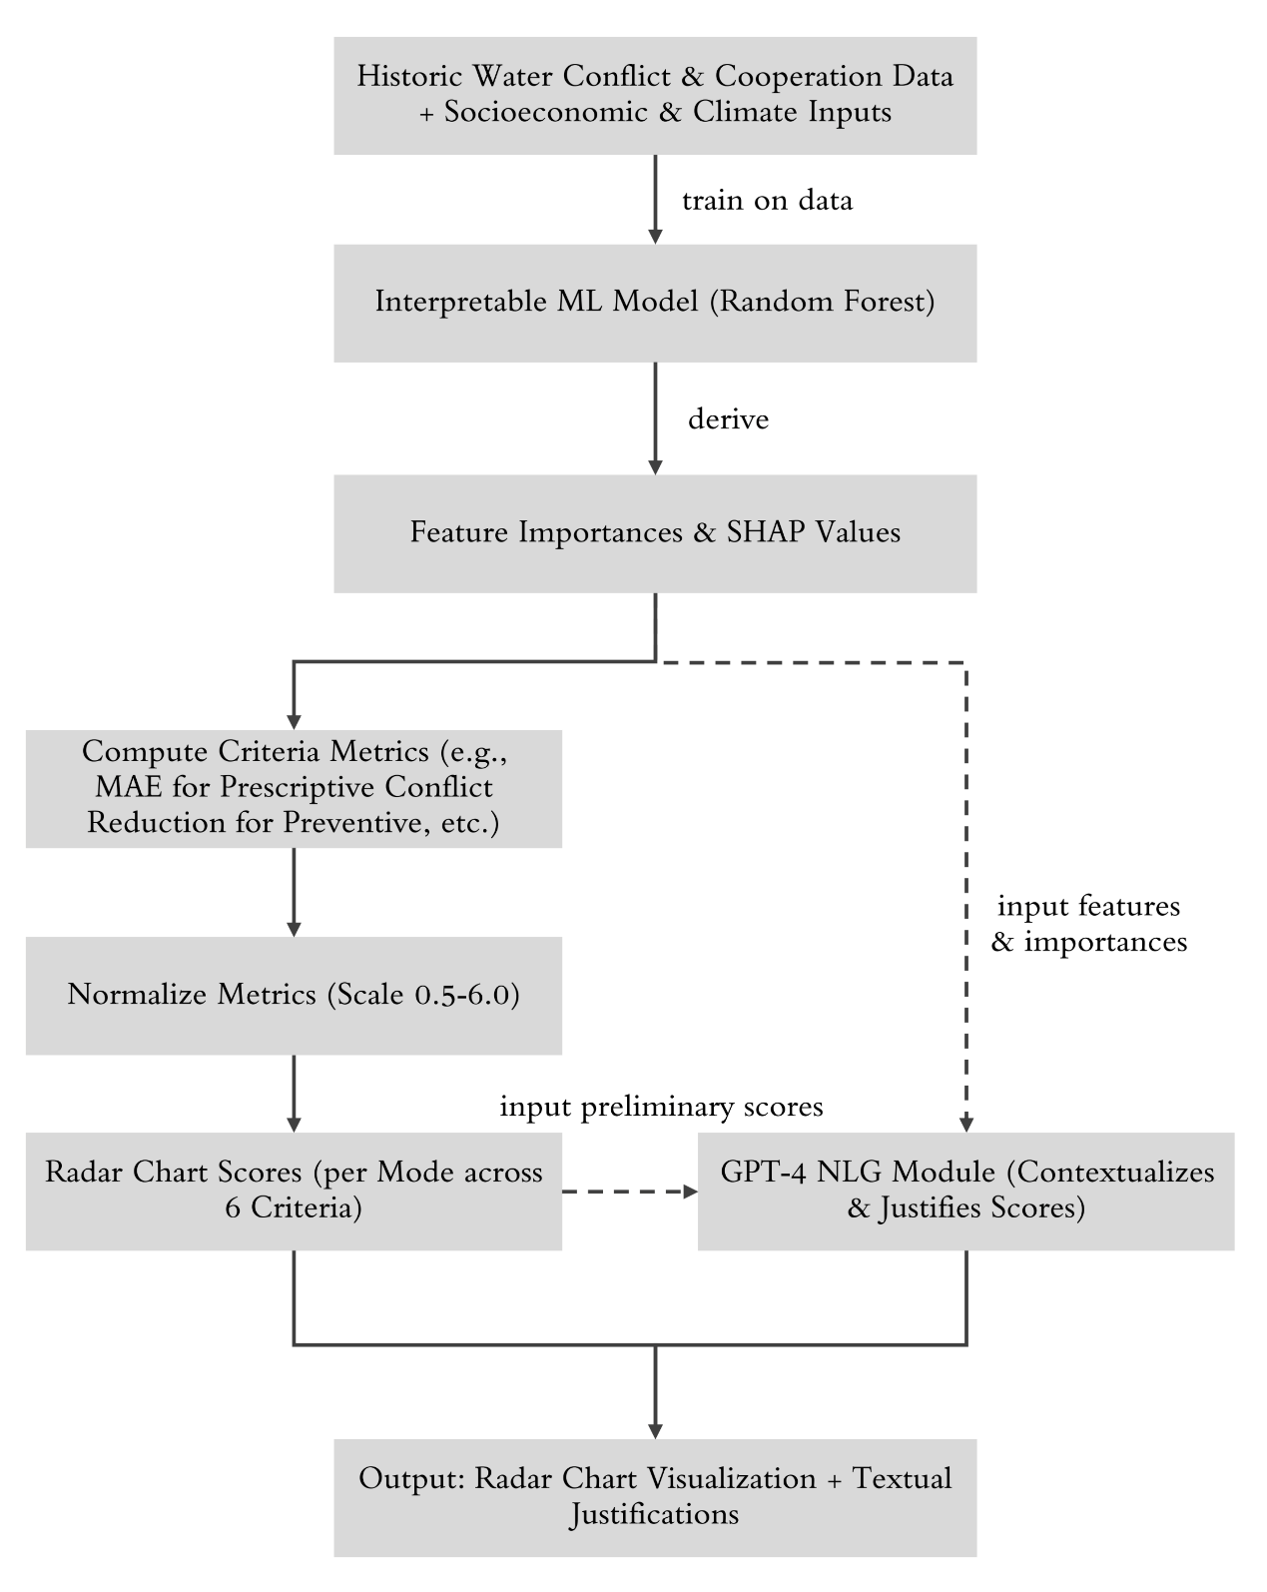
Figure S2. Workflow of the multi-criteria evaluation process integrating interpretable ML and NLP. (a) We train a Random Forest model on a compiled panel dataset of historical water conflict/cooperation events and country attributes. (b) Feature importance analysis (SHAP values) quantifies each mode’s impact on conflict risk. (c) For each cooperation mode, six criteria metrics are computed from the ML outputs (e.g., predictive error contribution for Prescriptive, simulated conflict reduction for Preventive). (d) Metrics are normalized to 0.5–6.0 scales to ensure comparability. (e) Scores are plotted on a radar chart (one axis per criterion) for each cooperation mode, and (f) a language model (GPT-4) module generates text explanations contextualizing these scores.

Natural language generation for justification
To complement the quantitative scores with expert insight, we integrated a Natural Language Generation (NLG) component using GPT-4. The language model was prompted in a retrieval-augmented generation framework to produce a brief rationale for each score, effectively tying the numbers back to real-world context. We fine-tuned GPT-4 on a small set of manually curated examples of cooperation outcomes, so it could emulate an “analyst’s explanation.” For each cooperation mode and criterion, the model was provided with: (i) the relevant machine learning outputs (e.g. the mode’s feature importance rank or its effect on conflict predictions), and (ii) a related case study snippet from our knowledge base (for instance, an excerpt from the 2006 Nile Basin Initiative memorandum, illustrating joint water allocation in practice).
We used a structured prompt template to ensure consistency: “Score [Mode] on [Criterion] (0.5–6 scale) using: – Machine Learning Output – Case study [excerpt]. Justify scoring.” Given this input, the model generates a score (in 0.5 increments) accompanied by an explanation. The explanation is grounded in both the data (e.g. “high SHAP value and lowest error, indicating strong conflict prediction power”) and the real-world narrative (e.g. referencing a successful cooperation instance that embodies that criterion). This GPT-4 assisted step adds an interpretable narrative layer to the raw scores, helping to validate that the quantitative rankings make intuitive sense and are justifiable to domain experts. We verified that the GPT-4 outputs remained consistent with the numerical scoring by cross-checking a sample of justifications – this acted as a qualitative validation of our multi-criteria assessment. Finally, the six criterion scores for each mode, along with their GPT-augmented justifications, were compiled into a radar chart visualization. In these radar plots, each axis corresponds to one evaluation criterion and extends from 0.5 (center) to 6.0 (outer edge).
Each cooperation mode is represented by a polygon connecting its six scores. This visualization enables an at-a-glance comparison of performance profiles: modes with uniformly high scores form larger, more circular polygons, whereas modes excelling in specific dimensions show spikier polygons. Such patterns highlight trade-offs; for example, a mode might score highly on Prescriptive and Preventive but lower on Affordable, suggesting it is effective but resource-intensive. The inclusion of GPT-4 generated annotations for each criterion further contextualizes these patterns, offering explanations like “Mode X scored 5.0 in Stress-Relieving because it significantly reduces conflict in high water-stress scenarios”. This integration of interpretable ML and NLG provides a robust, explainable multi-criteria evaluation of cooperation modes, forming the basis for subsequent recommendation and scenario analysis.

SSP Storylines and Conflict Mitigation Projections

Scenario framework (SSP1 vs SSP5)
To project future water conflict risks and evaluate cooperation strategies under climate change, we adopted the Shared Socioeconomic Pathways (SSPs) scenario framework. SSPs provide standardized narratives for future socio-economic development combined with climate forcing trajectories. In particular, we focused on two divergent pathways aligned with the literature: SSP5 “Fossil-Fueled Development” (a high-emissions, high-growth scenario with minimal climate policy) and SSP1 “Sustainability” (a low-emissions scenario emphasizing inclusive, green growth and robust climate action). These choices represent a reasonable worst-case and best-case socio-climatic future, respectively, for conflict outcomes. Our use of SSPs follows methodologies like Chen et al. (2020) who combined population, GDP, and urbanization trajectories to model future land-use patterns, ensuring consistency between socio-economic assumptions and climate projections. In our study, SSP5 serves as a benchmark scenario with exacerbated climate stress and unchecked development, whereas SSP1 serves as a climate-action scenario with mitigated stresses and sustainable policies. We also defined an intermediate “Increased Water Stress” scenario to specifically examine hydrological extremes: here we use SSP climate data but impose the higher-end water scarcity outcomes (e.g., from SSP5) irrespective of policy, to isolate the effect of water stress. These scenario storylines guided the retrieval of projection data and the design of our conflict modeling.

Data integration and preprocessing
We assembled country-level projections for key hydro-climatic and socio-economic variables corresponding to SSP1 and SSP5 conditions, drawing from authoritative sources. Climate variables (notably annual precipitation and temperature) for the period 2050–2100 were obtained from downscaled CMIP5 datasets via the World Data Center for Climate and CEDA repositories, ensuring alignment with IPCC AR6 regional climate patterns. Water scarcity was represented by the Baseline Water Stress index, with future values under SSP1 and SSP5 extracted from Aqueduct 4.0 (World Resources Institute). Aqueduct’s models provide basin-level water stress projections under varying development trajectories, which we aggregated to the country level for consistency. Socioeconomic indicators including population, urbanization, and GDP per capita were sourced from the IIASA SSP Database, using the “region downscaling” of SSPs into 32 global regions to approximate country-level trends. For example, a country in Sub-Saharan Africa inherits growth rates from the corresponding SSP regional pathway. Where country-specific data were unavailable, we used the regional medians as proxies.
We also factored in trade openness (e.g. export dependency) as a potential conflict stressor or mitigator; however, explicit future trade projections are scarce. As a proxy, we assumed current trade shares remain constant, and applied SSP-based GDP growth to estimate future trade volumes (with supplementary data from World Bank and Trading Economics for current baselines). All projections were aligned to a common mid-century timestamp (~2050) as an initial condition for the modeling, acknowledging uncertainty beyond near-term forecasts. We note that precise year alignment (2050 vs 2070, etc.) is less critical than capturing the general magnitude and direction of changes by late 21st century. To ensure consistency, all variables were normalized to their 2010–2020 baseline means before input into modeling – this way, our model focuses on relative changes under each SSP rather than absolute differences across data sources. For instance, if a country’s precipitation is projected to drop to 80% of its historical average under SSP5, we input a relative change of -20%. This normalization also facilitates combining disparate features (climate, economic, etc.) in the machine learning model without one scale dominating.

Conflict risk projection
Building on historical conflict data and future projections, we employed a hybrid time-series and machine learning model to simulate annual water conflict risks in 2050. Our approach is inspired by Ge et al. (2022), who modeled armed conflict probability under climate change using machine learning-integrated methods, but substitutes their autoregressive framework with adaptive exponential smoothing. The temporal dynamics of conflict frequency were captured through a dual-component model that decomposes historical patterns (1951–2019) into evolving baseline trends for each country. We integrated exogenous SSP-based predictors (precipitation, water stress, population, GDP, etc.) through machine learning correction modules.
Future climate-socioeconomic conditions from each SSP scenario dynamically adjust the baseline projections: drought intensification under SSP5 amplifies conflict risks relative to historical trends, while SSP1’s sustainability investments suppress risks even in conflict-prone regions. Projections generate annual conflict probabilities at national scales in 2050. High-risk classification was determined using Agglomerative Hierarchical Clustering, which grouped regions based on their conflict risk probability in 2050. While regional aggregations (IPCC AR6 groupings) reveal macro-scale patterns, policy recommendations prioritize country-level results. The hybrid architecture combines exponential smoothing’s efficiency in capturing temporal persistence with machine learning’s capacity to process multidimensional SSP drivers – critical for modeling path-dependent conflict systems across countries.
Table S3. Conflict probability of high-risk regions in 2050
Country | Population density | Export | GDP per capita | Rural population | Precipitation | Water stress | Conflict probability
AFG | -0.1105 | -1.2620 | 2.9621 | -0.1612 | -0.3039 | 1.0312 | 0.3200
AUT | -0.0828 | -0.4995 | 4.0492 | -1.2174 | 10.7712 | -0.8472 | 0.2400
BGD | 1.6791 | -0.2334 | 1.2991 | -0.8019 | -1.2430 | 0.3805 | 0.1900
CHN | -0.0574 | 2.5374 | 2.3625 | -1.2650 | -1.2205 | 0.4689 | 0.1900
CRI | -0.0970 | 0.4958 | 2.2595 | -1.8275 | 6.9324 | -0.7870 | 0.2100
CZE | -0.0598 | -0.3337 | 3.2477 | -1.5300 | 5.9222 | 0.2343 | 0.2300
DJI | -0.1832 | -1.2592 | 0.4599 | -1.7780 | -1.2430 | -1.0804 | 0.1900
DZA | -0.2352 | 0.8080 | 0.6370 | -1.4971 | -1.2006 | 1.6623 | 0.1800
ETH | -0.0220 | -1.2571 | 0.0646 | -0.0228 | -0.2472 | -0.5626 | 0.2100
GBR | 0.2268 | -0.8719 | 4.0404 | -1.6694 | -1.1326 | -0.4316 | 0.1800
GIN | -0.1535 | 0.1773 | 0.0785 | -0.8425 | -1.2430 | -0.9267 | 0.1900
IND | 0.4604 | 1.6388 | 1.0042 | -0.7198 | -1.2430 | 1.1213 | 0.2300
IRN | -0.1790 | -0.1671 | 0.9413 | -1.5117 | -0.9372 | 1.5771 | 0.2800
JOR | 0.0089 | 1.4353 | 0.5814 | -1.8618 | -1.2430 | 1.8319 | 0.2100
LBR | -0.1577 | -1.2620 | -0.2987 | -1.2348 | -1.2430 | -1.0804 | 0.2600
LSO | -0.1481 | -1.2453 | -0.2314 | -0.4750 | -1.2430 | 0.2944 | 0.4100
MAR | -0.1316 | 0.0480 | 0.7519 | -1.2119 | -1.2407 | 1.2188 | 0.1900
MEX | -0.1616 | -0.1859 | 1.9564 | -1.5938 | 2.2195 | 0.9278 | 0.2600
NGA | 0.3229 | -0.0782 | 0.0955 | -0.9957 | -1.2430 | -0.4841 | 0.1700
NIC | -0.1820 | -0.3017 | 0.6134 | -1.3936 | 6.8126 | -1.0217 | 0.2000
PHL | 0.4664 | 1.1828 | 1.2434 | -0.9357 | 14.3102 | -0.2281 | 0.1900
PRI | 0.1027 | 0.3291 | 3.1322 | -1.9677 | -0.3966 | -0.6768 | 0.1700
PRY | -0.2423 | 0.6408 | 1.3480 | -1.3613 | 10.7269 | -0.9958 | 0.2500
PSE | 1.5683 | -0.5920 | 2.9621 | -1.7432 | -1.0392 | 0.8057 | 0.2700
ROU | -0.1733 | -0.8432 | 3.4143 | -0.9495 | -1.2430 | -0.2272 | 0.3300
SDN | -0.2125 | -0.4262 | -0.1785 | -0.7629 | -1.2430 | 0.6139 | 0.2400
SOM | -0.1997 | -1.2603 | -0.3157 | -1.0080 | -1.2404 | 0.3642 | 0.3500
SSD | -0.2491 | -1.2300 | -0.4357 | -0.0207 | -1.0706 | -0.6308 | 0.3700
SVN | -0.1076 | -0.3663 | 3.2375 | -1.2809 | 8.5291 | -0.6527 | 0.2300
SYR | -0.0338 | 0.8285 | 2.9621 | -1.0504 | -1.2148 | 1.4275 | 0.1900
TUR | -0.0839 | -0.2383 | 3.6374 | -1.5199 | -1.0764 | 0.8593 | 0.2300
USA | -0.2077 | -1.0387 | 4.9406 | -1.6052 | 0.4706 | 0.0897 | 0.3300
YEM | -0.1312 | 0.6183 | -0.1913 | -0.8025 | -1.2430 | 1.6996 | 0.1900

Quantile-Based Country Clustering
To tailor cooperation recommendations, we segmented countries into clusters based on their future risk profiles and key driver variables. Rather than hard categorical groupings, we used a quantile-based approach: for each relevant variable (e.g. projected GDP per capita, baseline water stress, transboundary water dependency, population density), countries were assigned a percentile rank (0–100th percentile) within the 2050 world distribution. We then defined clusters by combining these percentile indicators into interpretable categories. For instance, a country with GDP in the 10th percentile (very low) and water stress in the 90th percentile (very high) might be labeled “Low-Income/High-Stress”. This particular combination suggests a need for affordable, water-stress-alleviating cooperation measures. We formed a small set of such composite clusters reflecting common strategic contexts: e.g. “High Income/Water Scarce”, “Low Income/Water Scarce”, “Low Income/Water Abundant”, “Trade-Dependent/Moderate Stress”, etc. These groupings were not strictly disjoint – they serve as guiding personas for the recommendation engine. Each country can be associated with the closest matching persona based on its quantile profile. For example, Somalia fell into a Low-Income/High-Stress cluster, whereas a country like Hungary might be Upper-Middle Income/Moderate Stress but High Complementarity Potential (owing to many neighbors and shared basins). By framing clusters in this way, we capture geopolitical and resource-based contexts that influence which cooperation modes are most applicable. We used the quantile data directly in prompt generation for the LLM (described next), allowing the model to reason with terms like “high transboundary dependency (85th percentile)” rather than raw numbers.

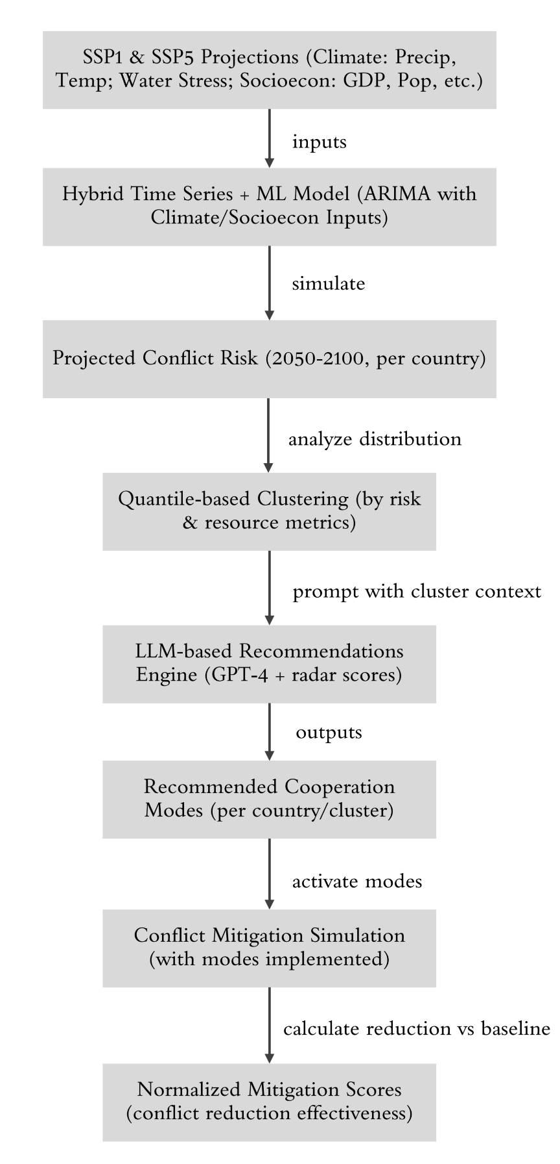
Figure S3. Integration of SSP scenarios, conflict modeling, and recommendation generation. (a) Socioeconomic and climate projections under SSP5 (high-emission) and SSP1 (sustainable) provide inputs (e.g. precipitation, temperature, water stress, GDP) for each country. (b) A hybrid ARIMA-based time series model integrates historical conflict trends with these SSP drivers to project annual conflict risk for 2050–2100. (c) Countries are categorized by their projected conflict risk and driver levels, using quantiles to form clusters (risk profiles such as “high-conflict, high-stress, low-income”). (d) A recommendation engine, powered by GPT-4 and informed by the earlier multi-criteria scores (“radar” profiles), generates cooperation mode suggestions tailored to each cluster’s context. (e) These suggestions (one or two top cooperation modes per country) are then fed back into the conflict model by simulating the implementation of those modes (activating their mitigating effects in the projection). (f) Finally, conflict outcomes with cooperation are compared against baseline scenarios to compute normalized mitigation scores for each pathway.

LLM-based recommendation framework
With countries grouped by scenario-specific needs, we employed a large language model (GPT-4) to recommend the most suitable cooperation modes for each country or cluster profile. This AI-assisted decision frameworkcombined the contextual country data (as text) with the performance insights from our radar evaluation. For each target country, a prompt was constructed incorporating its key attributes and scenario narrative. For example, “Country X exhibits high transboundary water dependency (85th percentile), low GDP per capita (USD 1,200, bottom decile), and extreme water stress (score 4.8/5). Under a sustainability-focused future (SSP1), recommend cooperative strategies to reduce conflict risk.”
The prompt explicitly listed the six candidate cooperation modes and asked the model to suggest the top 1–2 modes most likely to help mitigate future conflicts. By phrasing the input in natural language with quantitative cues (percentiles, stress scores), we leveraged GPT-4’s ability to interpret the country’s situation in a policy-relevant way. Importantly, the model’s knowledge was constrained to the six predefined modes and their general characteristics (learned from the fine-tuning phase and possibly augmented by brief descriptions); this ensures recommendations remain within scope.
We also injected the previously computed radar scores indirectly – rather than providing the raw scores, we gave the model qualitative summaries of each mode’s strengths (essentially encapsulating the radar chart insights). For instance, the model was informed that “Joint Data-Sharing Systems are highly complementary and facilitate broader cooperation” if a country’s profile indicated need for multi-party data transparency. In cases where multiple modes seemed relevant, the model was allowed to list two, but no more, to maintain focus on the most effective interventions. We further reinforced the decision-making by implementing a simple reinforcement learning loop: after initial recommendations, we examined historical analogues.
If a recommended mode had clear past success in similar contexts (e.g., Cross-Border Basin Agreements had resolved disputes in analogous river basins), we retained it with higher confidence; if not, we iteratively adjusted the prompt or model parameters. This feedback mechanism, though manual in this implementation, conceptually mirrors reinforcement learning by rewarding suggestions that align with known successful outcomes. For example, the model noted the Nile Basin case where dam negotiations succeeded via a basin agreement; thus for countries in that cluster, it increased the likelihood of recommending Cross-Border Basin Agreements. Throughout this process, the radar evaluation metrics ensured that the LLM’s suggestions were not only context-appropriate but also mode-appropriate – i.e. a mode would only be suggested if its profile (from the evaluation) matched the country’s needs in the scenario. All recommendations were generated separately under SSP5 and SSP1 conditions, since some modes might be more crucial under high stress (SSP5) than under sustainability (SSP1), and vice versa.
Table S4. Recommendation mode of high-risk regions based on LLM in 2050. 1 denotes recommendation of the mode and 0 denotes non-recommendation.
Country | Cross-Border Basin Agreements | Collaborative Planning and Adaptation Strategies | Joint Water Allocation Models | Joint Data-Sharing Systems | Transboundary Water Quality Standards | Coordinated Hydropower Operations
AFG | 0 | 0 | 0 | 1 | 1 | 1
DZA | 1 | 1 | 0 | 1 | 0 | 0
AUT | 1 | 1 | 0 | 1 | 0 | 0
BGD | 0 | 0 | 0 | 1 | 1 | 1
CHN | 1 | 1 | 0 | 1 | 0 | 0
CRI | 1 | 1 | 0 | 0 | 0 | 1
CZE | 1 | 1 | 0 | 1 | 0 | 0
DJI | 1 | 1 | 0 | 0 | 0 | 1
ETH | 0 | 0 | 1 | 0 | 1 | 1
GIN | 1 | 1 | 0 | 1 | 0 | 0
IND | 0 | 0 | 0 | 1 | 1 | 1
IRN | 1 | 1 | 0 | 1 | 0 | 0
JOR | 0 | 0 | 0 | 1 | 1 | 1
LSO | 1 | 0 | 1 | 0 | 0 | 1
LBR | 1 | 1 | 0 | 0 | 0 | 1
MEX | 1 | 1 | 0 | 1 | 0 | 0
MAR | 1 | 1 | 0 | 1 | 0 | 0
NIC | 1 | 1 | 0 | 1 | 0 | 0
NGA | 1 | 1 | 0 | 0 | 1 | 0
PSE | 0 | 0 | 0 | 1 | 1 | 1
PRY | 1 | 1 | 0 | 1 | 0 | 0
PHL | 1 | 1 | 0 | 1 | 0 | 0
PRI | 1 | 1 | 0 | 1 | 0 | 0
ROU | 1 | 1 | 0 | 0 | 0 | 1
SVN | 1 | 1 | 0 | 1 | 0 | 0
SOM | 0 | 0 | 1 | 0 | 1 | 1
SSD | 1 | 1 | 0 | 0 | 0 | 1
SDN | 0 | 0 | 0 | 1 | 1 | 1
SYR | 0 | 0 | 0 | 1 | 1 | 1
TUR | 0 | 0 | 0 | 1 | 1 | 1
GBR | 0 | 0 | 0 | 1 | 1 | 1
USA | 0 | 0 | 0 | 1 | 1 | 1
YEM | 1 | 1 | 0 | 1 | 0 | 0

Mitigation effect simulation and normalization
The final step was to quantify how effective the recommended cooperation modes would be in mitigating future conflicts under each scenario. To do this, we fed the selected cooperation modes back into the conflict projection model as interventions. In practice, this meant toggling certain features or rules in the model to represent the presence of a cooperation mode. For example, if Joint Data-Sharing Systems was recommended for Country Y, we simulated an optimistic case where from 2050 onward data-sharing is active – in the model this could reduce the impact of water stress on conflict likelihood (since transparent data can alleviate uncertainty-driven tensions). Technically, we adjusted the model’s parameters for that country such that conflict propensity was dampened by an amount corresponding to the historical conflict reduction associated with that mode (derived from our earlier SHAP analysis of mitigation effects).
We then re-projected conflict counts for 2050–2100 under each scenario with these cooperation modes “activated” (set to 1) vs. a baseline without cooperation. Comparing these two runs yields the conflict mitigation effect attributable to the interventions. We aggregated total conflict events (or risk probability) over the period and computed a normalized mitigation score. This score is defined as the ratio of conflicts in the intervention scenario to conflicts in the no-intervention baseline, normalized to the SSP5 baseline for reference. Thus, under SSP5 (high-conflict baseline), the baseline is 1.0 by definition, and an effective intervention might bring this ratio down to, say, 0.7 (meaning 30% fewer conflicts than expected).
Under SSP1, baseline conflict levels are generally lower; we still normalize relative to SSP5 to facilitate cross-scenario comparison of effectiveness. A value below 1 indicates conflict reduction, and the farther below 1, the greater the effectiveness of the cooperation mode mix.For clarity, if multiple modes were recommended for a country, we activated them together to capture any synergistic effect, but we also checked single-mode activations to understand individual contributions. Finally, results were summarized at regional scales to incorporate spatial spillovers and uncertainty.
The normalized mitigation scores were visualized (see main Figure 6 in the article) to compare how cooperation interventions under SSP1 vs SSP5 could offset the increased conflict risks. Across our ensemble of models, we found the SSP1 (sustainable) pathway coupled with proactive cooperation yields the lowest conflict ratios (often <0.5 in high-risk regions), whereas SSP5 without cooperation remains at 1.0 (by definition) or higher in some cases (if compounding stresses lead to non-linear surges in conflict). These findings underscore the importance of both global socio-economic pathways and targeted cooperation in shaping future water security outcomes. By quantifying the impact of cooperation modes in a rigorous, reproducible manner, our approach provides actionable insight for policymakers crafting long-term water conflict mitigation strategies under uncertainty.
Table S5. Projection of mitigation effects of each mode under climate future scenario from 2050 to 2100. Projected numbers of conflicts in baseline scenario (SSP5) is normalized to 1.00.
Region | Baseline | Water stress effect | Time trend effect | Climate action mitigation | Mitigation by cooperation
Central Southern Asia | 1.0000 | -0.4286 | 1.4286 | 0 | 0
Eastern Africa | 1.0000 | -0.2208 | -0.0519 | -0.0390 | -0.0260
Eastern Asia | 1.0000 | 8.0000 | 0 | -8.0000 | -0.5000
Eastern Southeastern Asia Oceania | 1.0000 | 0 | 0 | 0 | -1.0000
Europe | 1.0000 | 0.6923 | 0.6538 | -0.9615 | -0.5000
Middle East | 1.0000 | 0.4167 | 0 | -0.6042 | 0
Middle Southern Africa | 1.0000 | 1.7143 | -1.2857 | -0.7143 | 0
North America | 1.0000 | 0.1053 | 0 | -0.0877 | -0.5965
Northern Africa | 1.0000 | -0.0222 | -0.2222 | 0 | 0
South America | 1.0000 | 1.0000 | 1.6667 | -3.1667 | -0.1667
Southern Asia | 1.0000 | -0.9524 | 0.3810 | 0 | -0.0952
Western Africa | 1.0000 | 0.7500 | 0.1250 | -1.1250 | 0
World | 1.0000 | 0.2489 | 0.1285 | -0.5021 | -0.2694

References
- O’Neill, B. C. et al. (2017). The roads ahead: Narratives for shared socioeconomic pathways describing world futures in the 21st century. Global Environmental Change, 42, 169–180.
- Chen, G. et al. (2020). Global projections of future urban land expansion under shared socioeconomic pathways. Nature Communications, 11, 537.
- Ge, Q. et al. (2022). Modelling armed conflict risk under climate change with machine learning and time-series data. Nature Communications, 13, 2839.
- Lyu, H. et al. (2023). LLM-Rec: Personalized recommendation via prompting large language models. arXiv preprint arXiv:2305.15780.
- Shevchenko, V. et al. (2024). Climate change impact on agricultural land suitability: An interpretable machine learning-based case study. IEEE Access, 12, 15748–15763.
- Chambers, J. M. et al. (2021). Six modes of co-production for sustainability. Nature Sustainability, 4, 983–996.

