Supplementary Figures
Supplementary Figure 1. Daily flow of online clinical practice using sEHR.
LMS: learning management system, sEHR: simulated electronic health records organized in Microsoft Excel
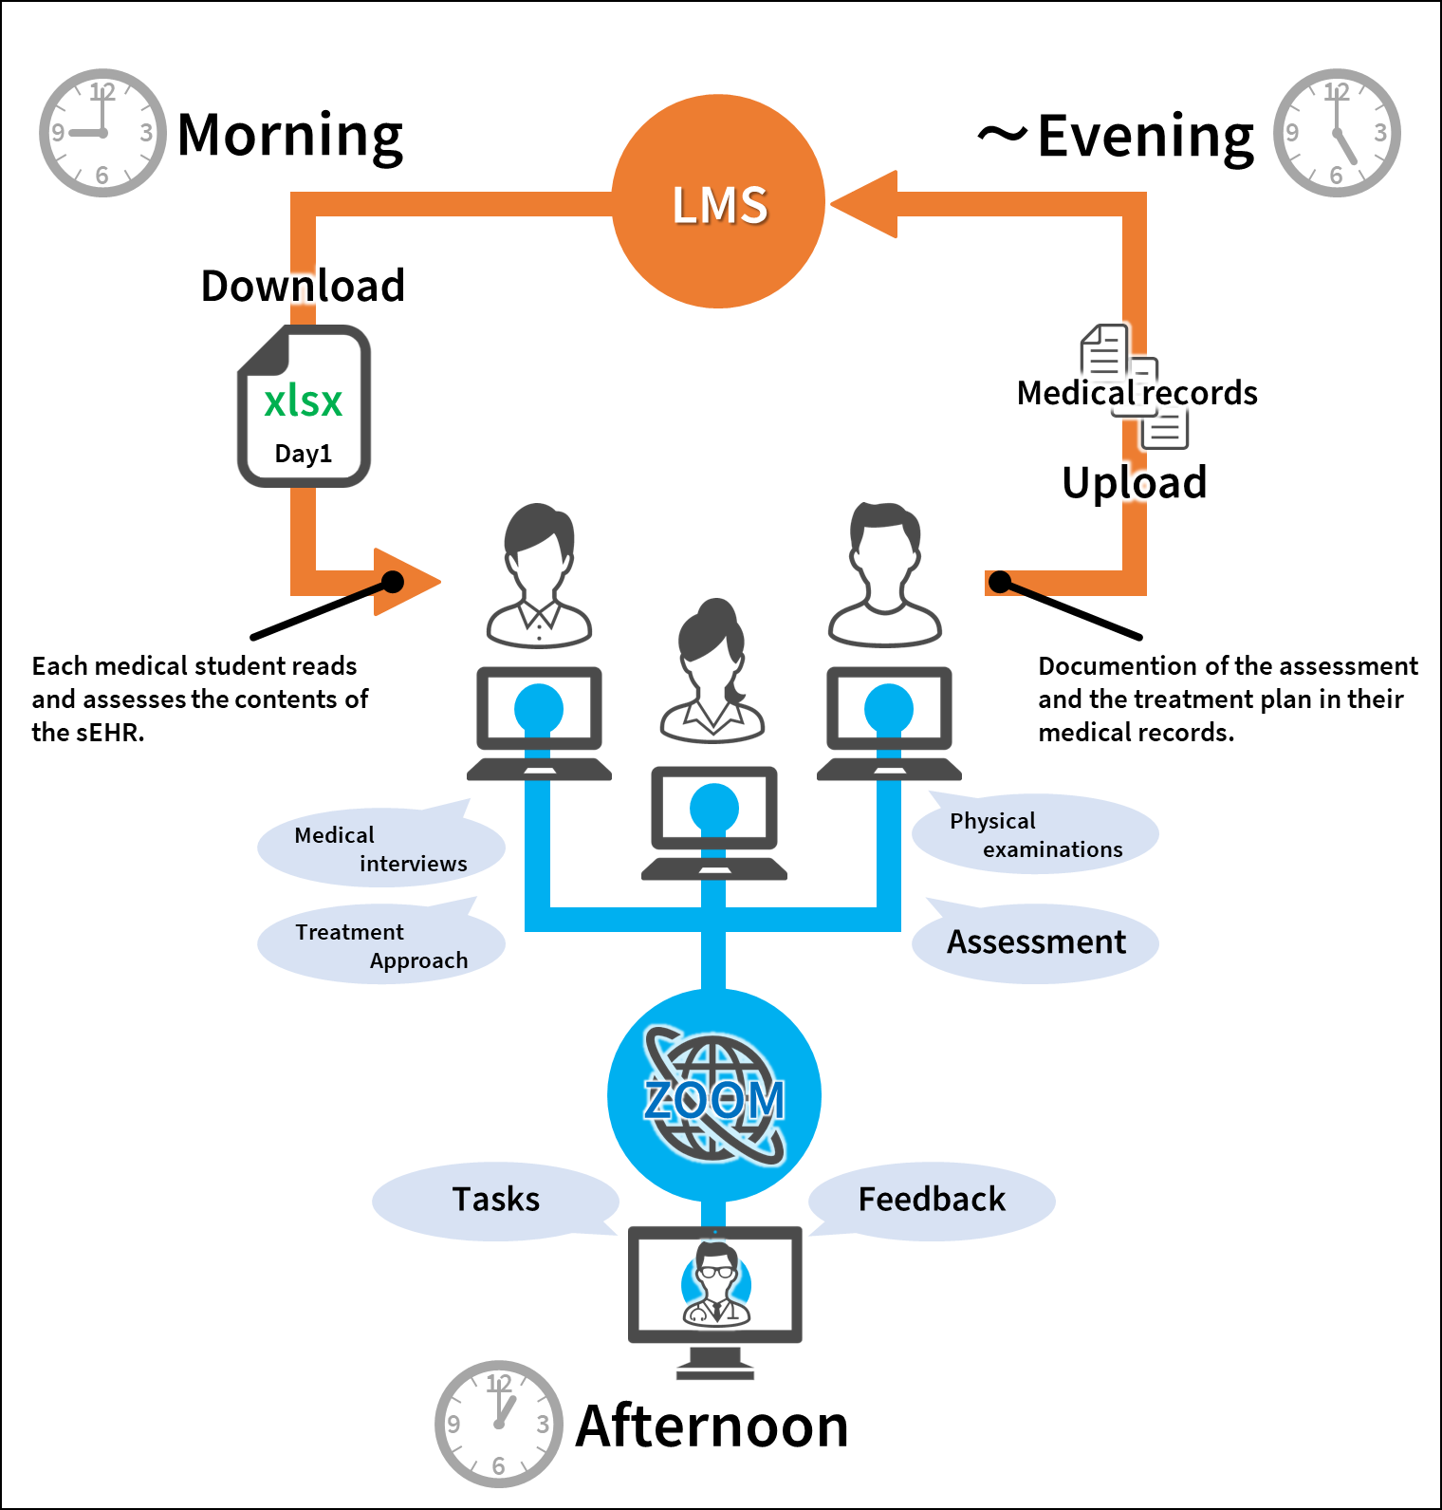

Supplementary Figure 2. Electronic problem-based learning using the LMS.
LMS: learning management system.
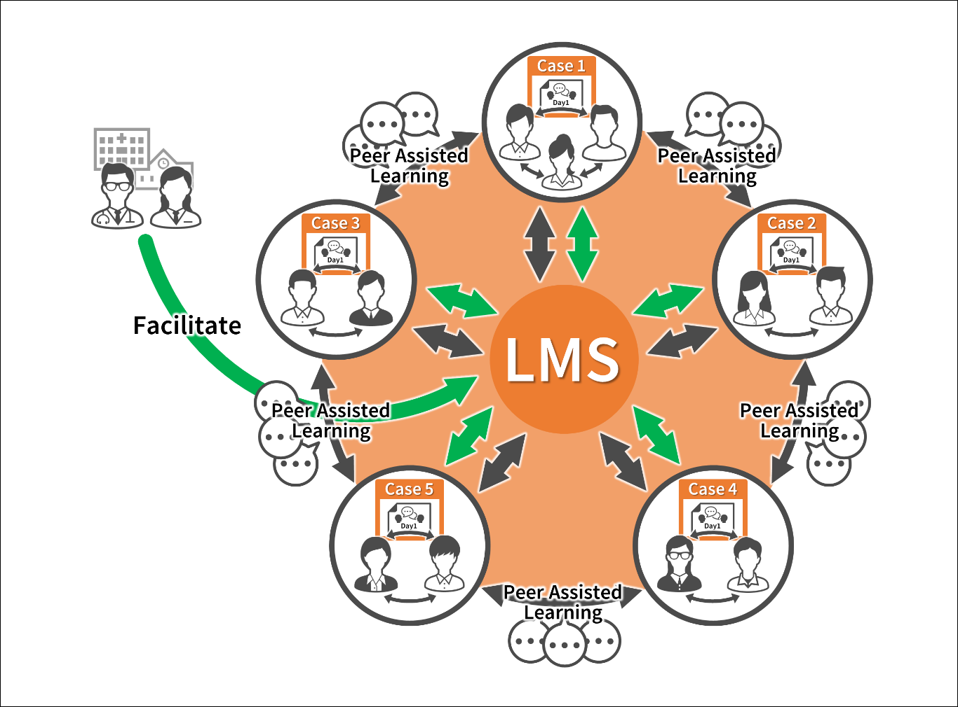

Supplementary Figure 3. Process of online virtual medical interviews.
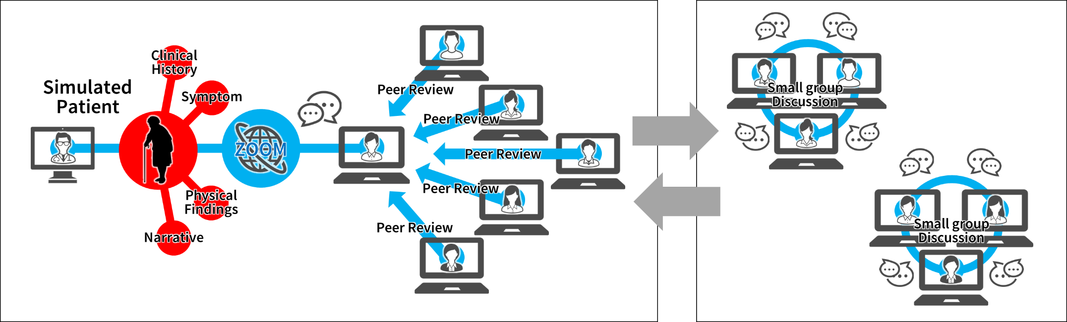
Supplementary Figure 4. Flow diagram for the study.
Online-sCP: online simulated clinical practice
