Supplementary Figures
Supplementary Figure 1. Daily flow of online clinical practice using sEHR.
LMS: learning management system, sEHR: simulated electronic health records organized by Microsoft Excel
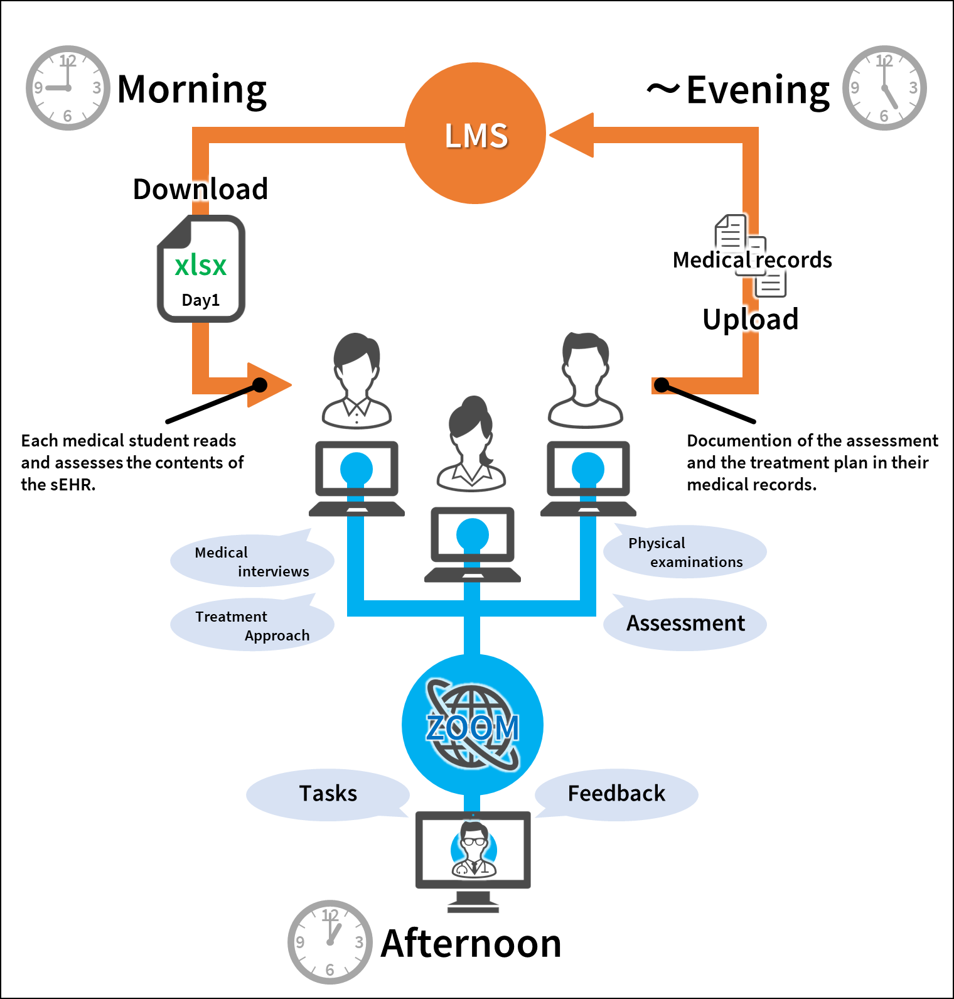

Supplementary Figure 2. Electronic problem-based learning using the LMS.
LMS: learning management system.
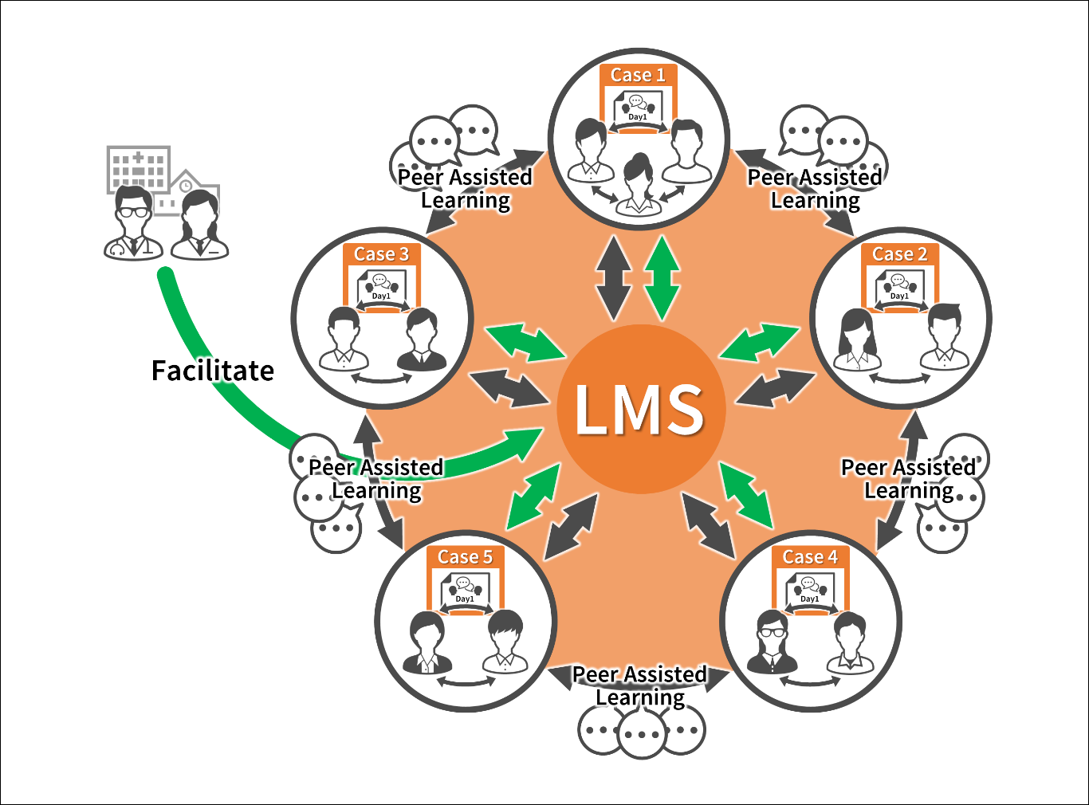

Supplementary Figure 3. The process of online virtual medical interviews.
