ANNEXES

Annex I Sample collection sheet for laboratory analysis

Animal  ID | Date of collection | Sex of  the animal | Age of the  animal | Body condition  of the animal | Tests
 |  |  |  |  | RBPT | CFT

Annex II: Test procedures
Rose Bengal Plate Test

- Each circle on the plate received 30 μl of RBPT antigen, 30 μl of test serum was added next to the antigen, and the two were properly mixed with a wooden applicator. The plate was then shacked for four minutes.

- The degree of agglutination reactions was measured after four minutes and recorded as follows: + + + + (coarse clumping and clearing), + + + (clumping and some clearing), + + (visible fine agglutination), + (weak fine agglutinations using magnifying glass), and in the case of positive reactions, 0 (no agglutinations).

Source (Alton et al. 1975)

Complement Fixation Test (CFT)

- To inactivate the native complement, the sera were prediluted to 1:5 and incubated for 30 minutes at 580°C in a water bath.
- The wells of the first and second rows of the U-bottom plate were filled with 25 μl of diluted test sera, and all wells save the first row were filled with 25 μl of veronal buffer.
- After that, 25 μl of serum from the second row was transferred to create serial doubling dilutions, which continued for at least four dilutions.
- Antigen was diluted to working dilution in 25 μl, with the exception of the anticomplementary controls, who were given 25 μl VCM.
- All wells, with the exception of the control wells, received 25 μl of complement in working dilution.
- Serum control contains serum + complement + diluent, while antigen control has antigen + complement + diluent. Before the haemolytic system was added, the complement control had complement + diluent, and the haemolytic system had diluent set up to include 75 μl total volume in each case.The plates were incubated at 370C for 30 minutes with agitations (warm fixation)
- Each well received 25 μl of a volume-sensitized 2% SRBC solution. After sealing, the plates were incubated again for 30 minutes at 370C while being stirred.After the plates were centrifuged for four minutes at 2500 rpm to deposit unlyzed red blood cells, the data were read.

Interpretation: Sera with a strong reactivity were categorised as positive if they had at least 50% fixation of complement (2+) at a dilution of 1:10 and above, or more than 75% fixation of complement (3+) at a dilution of 1: 5. (Alton et al., 1975; OIE, 2000).

Annex III: Images displaying the outcomes of the complement fixation and rose bengal plate tests

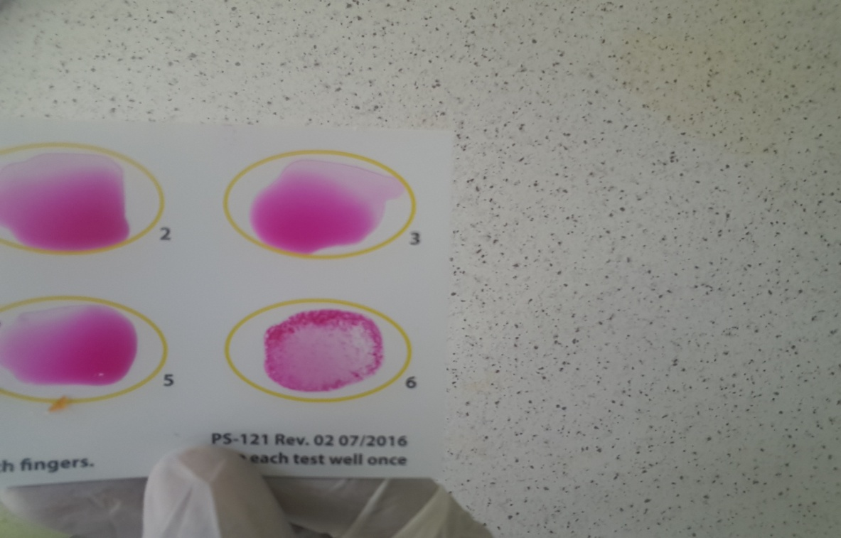
Rose Bengal plate test with visible fine agglutination
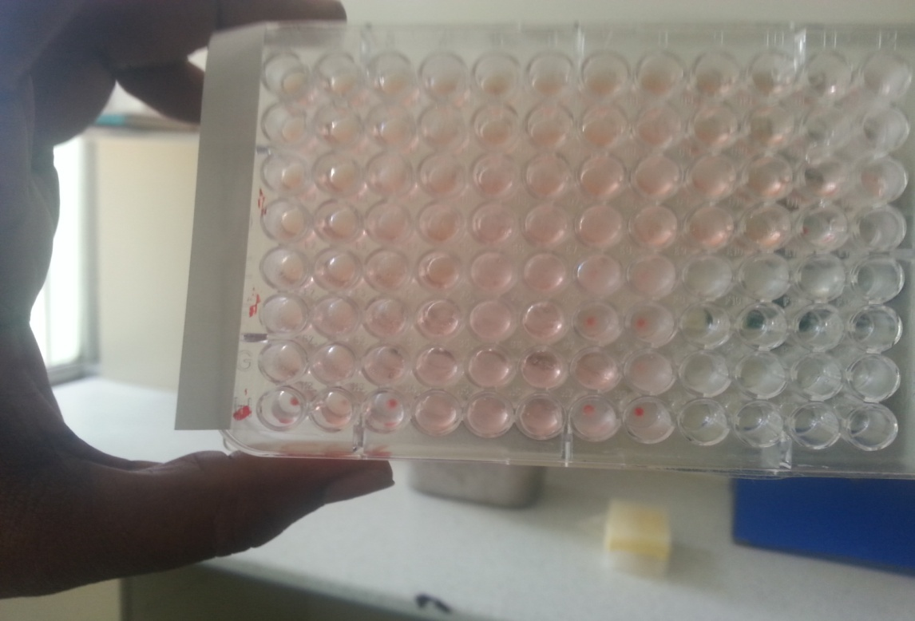

Complement fixation test with visible fixation of complement

